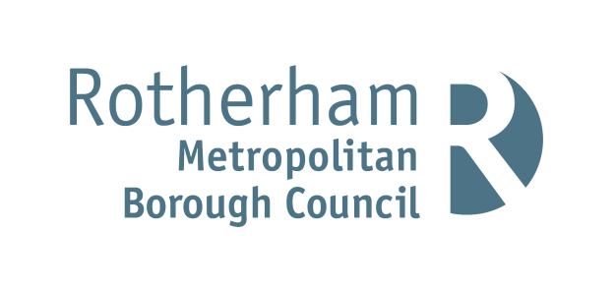

Public Right of Way Coronavirus (Covid 19) – Please Use Temporary Alternative Path

This path passes through a private garden / working farmyard / working stables.

An alternative and safe permitted path is available to maintain social distancing and protect residents and local communities. If you wish to use the alternative route, please follow the way markers along this temporary route.

In line with Defra and Public Health England advice: Maintain social distancing requirements

• Ensure you keep at least 2 metres away from other people
• Hand wash / sanitise after touching any shared surfaces, e.g. stiles / gates
• Keep dogs on a lead around livestock and away from other people/dogs
• Leave gates as you find them.

