Our Rotherham, Our Borough

Consultation Report
November 2021

‘Our Rotherham, Our Borough’ Consultation Report

Contents

- Background and methodology Page 3

- Engagement profile Page 4

- Findings from the consultation and engagement methods Page 7

Focus groups Page 7
Short interactions Page 14
Rotherham show Page 17
Online/postal survey Page 21

- Conclusion Page 28

Appendix 1 – Map showing locations of respondents Page 30

1. Background and Methodology

The new Council Plan sets out the strategic aims for Rotherham Council for the period 2022 to 2025, providing a foundation on which all council activities are based. To help inform this, a public consultation and engagement exercise took place from 9th August to the 19th September 2021 to seek the views of Rotherham residents and other local stakeholders. The plan will be signed off by Cabinet in December 2021 before being adopted by the Council and launched in January 2022.

The pandemic has presented logistical issues in undertaking consultation and engagement, particularly around engaging with vulnerable groups that were understandably reluctant to meet in person. Other groups were reluctant to engage virtually as they were not comfortable with the virtual platform. Following the Government’s gradual easing of restrictions, a combination of virtual and face to face consultation took place. However, consideration was taken to ensure that any face-to-face consultation and engagement was conducted in a Covid-secure manner. Despite the issues posed by the pandemic, over 1,300 interactions took place in total across all methods of engagement.

The consultation was conducted in a semi-structured manner, in that there were set themes that formed the parameters for discussion. The focus then centred around what people thought the issues and priorities were under each theme. The following methodologies were used to capture broad range of views:

- Focus Groups – 4 focus groups took place in August, each on a particular theme. An external facilitator was used for impartiality and attendees included members of the public and staff from voluntary and community sector organisations. 48 people took part in total.

- Short Interactions – 3 questions were discussed with groups both virtually and in person with triangular consultation ‘towers’ and people using sticky notes to answer the questions:
- What do you most like about where you live?
- What is one thing you would improve?
- What is your one wish for the future for Rotherham?
There were 274 responses across all questions (not including the Rotherham Show).

- Online and Postal Survey – An online survey was hosted on the Council website that went ‘live’ on the 20th August and closed on the 19th September. Questions were based on 4 themes which split the survey into different sections. Residents could then select which sections they want to answer questions on. A postal survey ran concurrent to this which included a paper version of the online survey questions sent out to 500 randomly selected households across the borough with a freepost envelope included. There were 298 respondents in total online, and 52 postal survey responses were received.

- Rotherham Show – The ‘tower’ and questions from the short interactions were used to consult with the public over the 3 days of the show, staffed by the Policy, Performance and Intelligence team in the Assistant Chief Executive’s directorate. There were over 700 responses across all the questions.

This consultation is seen as part of an ongoing dialogue between the Council and members of the public. Feedback will continue to be sought and the consultation ‘towers’ will continue to be used for short interactions to feed into the Year Ahead Delivery Plan, the Rotherham Plan, the equalities review and the refresh of the equalities strategy.

2. Engagement Profile

There was a total of 350 responses to the postal and online surveys. Overall, there were more responses from women than from men, with women made up 62% of the respondents, as compared to 34% male respondents.

The age profile of the respondents are as follows:

Compared to the age profile of the borough, survey respondents were older – 26% over 65s, as compared to 20% borough-wide – and only 4% of survey respondents were under 24, compared with a borough figure of 29%. There was a good representation of the middle age groups (25-44 year olds), while 45-54 year old were overrepresented, with 21% respondents from that age bracket, as compared to a Rotherham figure of 14%.

In terms of sexuality, respondents largely align with national figures, with 92% identifying as heterosexual, 2% as bisexual, gay or lesbian, and 6% as other.

The religious beliefs of respondents are as follows:

These differ from Rotherham figures, with less of the respondents identifying as Christian (57% as compared to 67%), and more stating no religion (37% as compared to 22.5%) – though the borough-wide figures are dated. 1.2% of the respondents identified as Muslim, compared to the dated borough-wide figure of 3.7%, which is expected to have increased.

The ethnic make-up of respondents also differed from borough-wide figures, with more respondents identifying as White British or White Irish and less as BAME, with only 0.8% identifying as Asian/Asian British 0.8%, 0.8% as dual heritage, and a further 0.8% as other, while Rotherham had over 8% BAME residents in 2011, which is expected to have increased since.

Out of the respondents, 29% reported to have a disability. Of the 29% that stated they have a disability, a further breakdown of these is shown in the pie chart below:

This compares with 22% of Rotherham residents who reported a long-term illness or disability in 2011, and an estimate of 18% of residents having common mental disorders in 2017, although the rate is lower in over 65s. 19% of respondents stated they were unpaid carers.

Focus groups aimed to make up some of the engagement gaps, by engaging stakeholders working with some of the groups whose views were underrepresented in the survey, and in particular those sharing protected characteristics. It should be noted that this representation through stakeholders is not sufficient substitute to participation, and for future consultations it would be preferable to aim at equal representation across the protected characteristics (as representative of the population of the borough) within all methods of data collection. Representatives from the Rotherham Ethnic Minority Alliance, the Unity Centre, Rotherham Wah Hong Chinese Association aimed to fill some of the gaps in responses from BAME residents and Rotherham Muslim Community Forum for Muslim residents.

Several organisations represented vulnerable residents, such as Victim Support (support for victims of crime), Rotherham Rise, (support for domestic abuse victims), as well as more specialised support: for Black and minority ethnic women experiencing violence (Apna Haq), for those with learning disabilities from minority ethnic communities (Nayi Zindagi), a BME & Young People Carers group, Mama Africa (support for Refugees and Asylum seekers), holistic support for BME women (Tassibee), support for those with learning disabilities and autism (Speakup). There were also organisations working with older people, such as Age UK and the Older People’s Forum. With support from Rotherham service providers the short interactions engagement method also allowed us to engage with a broad range of people from communities of interest and protected characteristic groups.

Other important voluntary sector organisations represented were Voluntary Action Rotherham and Rotherfed, and further participating were sports organisations (Rotherham United Community Sports Trust, Active Regen and a grassroots football club), physical activity and health organisations (Pivotal Health and Wellbeing, Rotherham Health Watch, the Rotherham Carers Forum) as well as other organisations such as South Yorkshire Fire and Rescue Service and litter picking groups.

3. Findings from the Consultation and Engagement Methods

Focus Groups
The consultation included four focus groups, each one centred around one of four themes, that were held on the following dates:
- Safe and resilient – 09 August 2021
- Securing a greener future for Rotherham – 09 August 2021
- Improved wellbeing and quality of life – 16 August 2021
- An economy that works for everyone – 16 August 2021
Focus groups were composed of stakeholders including partners, voluntary and community sector (VCS) organisations and members of the public. Stakeholders were invited to participate in a theme corresponding to their area activity; for example stakeholders that support particularly economically vulnerable residents in Rotherham were invited to participate in the “economy that works for everyone” discussion. There was a total of 48 participants across all four focus groups.
Focus group discussions used a semi-structured format; several broad questions and prompts were used to guide the conversation that was otherwise shaped by participants. A third-party facilitator asked these questions and ensured that conversations stayed focused and relevant to the theme whilst allowing participants to independently raise issues from their own perspectives.

Findings
Across all focus groups

As well as specific thematic insight, the following cross-cutting areas of discussion were observed across all focus groups:

- Themes are linked to one another: In all thematic focus group discussions links were made with other themes. For example, conversations about health and wellbeing made links to economic vulnerability, and vice versa.

- The need for partnership working: All groups agreed on the need for more joined-up partnership working to address key issues. This focus is driven by the participants mostly being partners, VCS organisations and similar stakeholders.

- Engagement is seen as a key issue: All focus groups emphasised the need to focus on engagement - communicating information to communities and seeking and acting on their input. An important component of engagement is collaborative and multi-agency work; there were mixed responses on how well this was being done; it was highlighted that the Council needs to play a central role in forming diverse and adaptable networks that can identify and respond to problems faced by residents and communities.

- Vulnerability was a key theme across thematic discussions: The experience of the pandemic has created new vulnerabilities, added new dimensions to existing ones, and made pre-existing issues apparent. There is a need to focus on those that do not appear vulnerable but require support. Consensus that tackling issues requires a comprehensive definition of what vulnerability entails and a joined-up strategy to address its facets. Emphasis was placed on difficulties in accessing support that must be addressed. Discussions included addressing vulnerability through building positive environment / society rather than solely focusing on vulnerable people.

- Equalities emerged as a cross-cutting issue: Inequalities were both exacerbated and made increasingly apparent by the experience of the pandemic. Equalities was mentioned in all focus groups and linked with the need for services and support to be adaptable and to rely on co-delivery.

- All groups expressed uncertainties or concerns around delivering services and activities in a post-covid landscape: These ranged from how effective online services are, to the practicalities of organising work with communities. From service delivery partners, many questions were raised about shortfalls in funding since the experience of the pandemic.

- Digital services: Concerns were raised about inequalities of access and risk of disengagement from digital services. Conversely, some participants reflected that the digital shift has offered advantages in service delivery.

Focus Group 1: Safe and resilient
This focus group discussion covered a range of vulnerabilities facing residents and communities: mental health, loneliness, hate crime, anti-social behaviour (ASB), bullying, and socioeconomic issues were directly raised. It was noted that the definition of vulnerability needed to be re-understood post-pandemic. This was largely framed around understanding the emergence of new issues facing vulnerable residents and new dimensions to existing issues, as well as identifying vulnerability that may be pre-existing but had previously gone unnoticed. The question was also raised by participants as to how we understand vulnerability generally – which led into a discussion of the risk of targeting support based on arbitrary labels or indicators of vulnerability.
This risk was framed in the context of invisible vulnerabilities or support needs that may go unnoticed; respondents reported a focus of support on those who are visibly vulnerable, while others that have a real need for support but do not obviously present as such may go unnoticed.
Health, particularly mental health, was at the centre of this discussion. Participants noted a large increase in service users experiencing mental health issues. These were linked to a holistic set of wider issues (e.g. housing difficulties, socio-economic and family circumstances) as well as general wellbeing issues such as loneliness induced by self-isolation. Loneliness and boredom emerged as significant issues across all groups and may have consequences on general wellbeing as well as wider impacts (such as driving rates of ASB). Difficulties accessing support or long waiting lists exacerbate mental health issues further, while mental health impacts were reportedly significant across the participants’ workforce and volunteers. Participants also speculated that the disruption of services and other issues since the pandemic may bring on a “mental wellbeing pandemic”.
It was expressed that support offers do not seem to be sufficient in addressing such vulnerabilities in Rotherham: one respondent explained them as "reactive" rather than "proactive” – seeking to address vulnerability where it is apparent, but failing to address the underlying issues that give rise to vulnerability. Mental health was a particular area where respondents expressed concern regarding the level of support available. Participants noted that providers engaging with each other was important to share learning and develop a shared understanding of issues faced by service-users, and that engaging with communities was important to better understand the type of support needed. The need to gather this learning and insight was related to a reported increase in the complexity of emerging support needs. One example reported was the increase in difficulty of people involved in domestic abuse to remove themselves from these situations due to financial issues or difficulties in leaving the house that have been compounded since the pandemic.
Participants reflected on the experience of adapting their support offers during and since the pandemic, noting the logistical complication of staff working from home and the practicalities of social distancing with services being offered digitally where possible. Strong signs of service adaptation were reported: one example being a participant reporting the use of digital services as a way of monitoring service users "going quiet" as a sign that they are struggling, which can be then tackled with targeted proactive engagement. Participants also positively reported that digitalisation largely allowed services to continue in some form, and even increased accessibility of services in some cases. This was supported by positive collaborative working which the council was frequently involved with. In spite of this, the following consequences were still noted: some support, even where offered online, has still been more limited and some services had unfortunately been halted by necessity. Some groups are still not able to easily access digital services, whereas other groups are increasingly likely to disengage from digital services. It was also noted that the limits of specialist support offers have increased the burden on “generic” services attempting to support individuals.
Given the direct focus of this discussion on vulnerability, the group also covered several key equalities issues while addressing vulnerabilities that may uniquely or disproportionately affect groups of specific characteristics, particularly:
- Older people have been uniquely affected by the pandemic; in terms of physical health and the effect of isolation. Restrictions on being unable to see older relatives in residential care is both harmful in terms of mental health and in terms of scrutiny; hoping this should improve. Participants with particular interests in the welfare of older people suggested that the issues faced by older residents have not received proportionate attention and described need to think about how “age-friendly” Rotherham is generally.

- Younger people have also been affected significantly by recent changes in their circumstances: loss of friendship groups and social networks, uncertainty around education or (for older groups of young people) employment prospects. Vulnerability of young people linked to exposing them to risks, as well as potentially driving them to be involved in "risky behaviour", including gang culture, knife-crime and joyriding.

- BAME communities were also discussed, particularly the disproportionately high Covid death rates in these communities, and wider issues such as increases in hate-crime. Participants noted that certain groups in the BAME community may also experience distance from local institutions and therefore require specific focus in terms of engagement.

Focus Group 2: Securing a greener future for Rotherham
This focus group covered various areas relating to the environment. Firstly, a great deal of concern was raised around littering (as a large proportion of participants in this focus group were involved in litter picking community groups). Conversation around this issue focused around visible but uneven improvements since the aforementioned community group took action, with some areas showing a marked improvement whilst other areas were still full of litter. The group also raised the issue around the difficulties in getting people to take proactive action against littering.
Following from this initial focus on littering, several other environmental issues were raised. Concerns were expressed around increases in flooding, which were linked by respondents to a reduction in drainage, largely arising from uncontrolled housing development. Housing was also raised as a concern itself, with participants predicting that existing developments will not be “future proofed” to make a positive contribution to carbon reduction. Biodiversity and green spaces were also put forward as important issues by respondents who thought these should be considered priorities due to their positive impacts on mental and physical health. Respondents expressed concern regarding both the extensiveness and maintenance of green spaces, with one respondent suggested many green spaces without function could be better utilised and maintained by being donated to local community groups. Concern was also raised around the limited “green” jobs and industry in Rotherham, one respondent suggesting that this must be the focus of investment priorities, and that this must be based in a clearer idea of what “sustainability” is in industry.
Participants appeared to link the natural environment to pride in one’s community, particularly in narratives around littering. This was most strongly expressed through comparisons between the local environments of other locations and Rotherham’s. Similarly, this link to local pride was articulated by the desire to see Rotherham Council as a “leading light” on environmental issues. The natural environment was also important to participants because of its impact on physical health (e.g. air quality) and mental health. Sustainability was also prioritised by respondents to ensure that the ecological services provided by the local environment could be “enjoyed by future generations”.
Participant discussion of action that could be taken was, reflecting the composition of the focus group, most detailed around waste. Respondents reflected a negative view on the current provision of waste services: participants expressed frustration with the Council’s waste collection offer, and the limited provision of community litter bins which was linked to increases in the level of littering; a desire was expressed for the Council to work more closely with community groups around this area. Similarly, a desire was expressed for improvement in recycling and commercial/residential waste collection with participants identifying these as insufficient and costly for the service user. Participants also noted that the following actions would be beneficial:
- The social implications of action around climate change (the example given was that the legislative shift to electronic vehicles and hybrids will have a potentially huge social impact that needs to be accounted for by the local authority)
- Raising awareness and increasing societal understanding of issues, and solutions we can all take. It was particularly emphasised that emissions and "net zero" are not particularly well understood ideas
- Better utilising relevant assets (e.g. unused green spaces could be donated as sites for things like growing food, etc)
- Future-proofing housing and ensuring developers are to as high a standard as possible
- Otherwise shaping the "green" agenda - e.g. setting clear priorities for instance on investment initiatives that prioritise "green business" - clarity from the Council on what "sustainable industry" looks like

Participants also emphasised the importance of engagement in delivering effective action. Firstly, this was around education on relevant issues and the promotion of environmental priorities to communities. Secondly, participants observed a need for greater transparency on “what the Council will and won’t do”. This was linked to an acknowledgement from participants that many issues relating to the environment may be outside the Council’s direct control or subject to competing priorities in the context of limited resources. Greater clarity on how the Council is intending to act, and a clearer understanding of priorities and how these priorities should translate to practical action was perceived as important to fostering collaborative activity with communities and stakeholders.

This discussion of the Council’s responsibilities also fed into a wider discussion of responsibility for the environment. Private companies were given a great deal of attention here. In the case of littering, it was noted that the products of private firms largely fuelled littering and other environmental issues, and it was subsequently expressed that companies that extract profit from these products shared responsibility for associated environmental issues. Some respondents suggested that action here, and a wider set of environmental actions, may need to come from central Government (e.g. in the form of taxes or regulations on commodities), however others pointed out that the Council and even smaller community groups could take action. One respondent reported their own experience as part of a small community, pressuring a chain takeaway operating in their area to contribute to litter picking efforts. Participants also noted the responsibility of individuals and groups across Rotherham to “go greener” but expressed significant barriers here: particularly around general understanding (participants expressed that “net zero” and “decarbonisation” are not well understood ideas) and the significant cost that can be attached to environmental measures. Connecting these boundaries of responsibility were related ideas given by respondents of being "joined up" and of “reciprocity” both between national and local government, and between the Council and its residents.

Focus Group 3: Improved wellbeing and quality of life
The focus group on wellbeing and quality of life understood the theme as encompassing personal mental and physical welfare, ranging from the fundamental ability to move around to more complex mental health needs; as well as a wide range of contextual environmental and socioeconomic factors (e.g. neighbourhoods, access to green and open spaces, financial deprivation, etc.). One respondent noted that health and wellbeing may be understood differently by individuals, but will rely on an individual being happy, comfortable, and motivated. Respondents emphasised the “collective” component of health and wellbeing which was linked to the importance of emphasising positive action to create communities that achieve health and wellbeing, rather than simply seeking to promote health provision for those who are not well.
As with Focus Group 1, a significant focus on this theme was on vulnerability. The barriers to achieving good health and wellbeing that were identified included both personal circumstances (such as finances, family circumstances, etc.), and the environment around an individual. The state and relative deprivation of a neighbourhood, and availability of certain features (e.g. open green spaces, local and cultural activities) are linked to the circumstances of individuals within them, particularly around mental health. Additionally, participants noted that significant barriers may exist in accessing support; particularly an awareness and understanding of available services and the confidence to access support were identified. Overall vulnerability was understood as being multi-faceted and as such cannot be addressed with a “one-size fits all approach”.
The focus group highlighted the need for joined-up multi-agency work to enable comprehensive support. It was expressed that institutions have not been engaging adequately as providers – frequently working as voices within specific communities rather than across them. Some examples were given of universal initiatives, but it was thought that this was not general practice.
Participants shared their views on the key existing issues in service provision, which included:
- the overall impact of Covid, which had forced some services to be more limited, move online, or cease functioning altogether
- an observed apathy towards Zoom/Teams and declining engagement with services
- the tendency for hidden vulnerability to go unnoticed
- tightening funding streams to carry out services
- the way funding is administered was identified as a barrier to the collaborative multi-agency work that participants prioritised – they reported that this was because funding usually appeared in silos with rarely there being opportunities for joint bids, and with competitive funding being a barrier to collaboration

As with Focus Group 1, conversations around vulnerability here were wrapped up in equalities’ considerations. Firstly, it should be noted that, whilst not a legislated equalities characteristic, levels of personal and community deprivation were considered cross-cutting determinants of one’s health and wellbeing. Additionally, participants linked inequality around health and wellbeing to a lack of representation of vulnerable voices in various aspects of life, ranging from the workplace to service provision itself. As noted above, participants emphasised how these inequalities had been exacerbated and became more apparent over the course of the pandemic, particularly with issues such as loneliness.
However, whilst this group did pay attention to inequality between groups, participants also spoke against treating all groups the same. Individuals sharing the same characteristic may face a widely different set of circumstances. For example, there could be significant inequality across disabled people in terms of accessing support, which was in turn linked to confidence and understanding of relevant institutions, as well as awareness of support available, deprivation, education, etc. Participants also emphasised the value of “one whole community voice.” One respondent in particular supporting older people noted a desire to open their community group, initially focused on supporting older people, to all members of the community. These considerations for both the differences and connections between groups were again linked to a need for collaborative action to provide comprehensive support. Participants also connected this to the need to better personalise services.
Focus Group 4: An economy that works for everyone
The focus group discussion on the economy theme largely centred around the human experience of the economy and factors that determined economic wellbeing. Within this context, a broad range of economic issues were identified by participants:
- The economic impacts of COVID-19 have driven many people to the point of economic crisis; participants noted an increase in people accessing services at the point of financial crisis, particularly those who have not had to access support/benefits previously
- One participant from the business community noted the difficulties in seeking support as a small business, and particularly expressed frustration over the clarity of information available, while another expressed concern at lengthier timescales required to access funding compared to immediate overheads being faced by businesses
- Rotherham’s social care sector will require significant growth, however participants pointed out that it may be difficult to encourage entry into this work force with current rates of pay in the sector
- Impacts on funding streams have put organisations supporting individuals and communities under strain
- Participants noted that small businesses were frequently set up in Rotherham, with a low survival rate
- Concern was expressed that poor opportunities in the local job market may lead to “talent” (i.e. skilled and educated workforce) leaving Rotherham, with negative subsequent results for growth and productivity

These issues were understood as significant because of the human impacts they created. It was felt that the gaps in Rotherham are widening between “haves” and “have-nots”, or, a widening gap between those who are relatively well off and those experiencing economic deprivation. Several examples of this were put forward, ranging from digital access driving economic inequality, to inter-generational differences in wellbeing that were pointed out. The perceived impacts of economic deprivation were largely focused around the physical and mental wellbeing of the individual, again mental health emerged as a strong theme. Participants noted that economic deprivation may additionally perpetuate barriers to accessing support; for example it may be difficult to encourage people to participate even in cost-free training and education when their focus is on seeking and maintaining employment “to put food on the table”.

Given the focus on “haves” and “have-nots,” equality and inequality emerged once again as an important theme in this focus group. As in other focus groups participants emphasised the importance of understanding the specific needs and issues facing each community, whilst also understanding that there is diversity within these communities, and that understanding and addressing the needs of groups “in silos” is not desirable. Particular equalities concerns relating to the economy were raised around older people, younger people, people with disabilities, and the BAME community.

Respondents identified a number of areas where action is needed, expressing the “need to do things differently” and take ambitious action:
- Focus on apprenticeship opportunities for both younger and older people; it was expressed that the Council should take an active role in providing apprenticeship opportunities directly, and working with others to support the provision of opportunities
- An increase in the emphasis of social value in the Council’s spending
- Provide further support to small businesses, particularly around advice. One participant noted this could be done through facilitating mentoring links in the business community
- Participants noted a desire for investment and economic measures be integrated with other priorities, for example stimulating green growth and the social care sector.
- Collaborative action; this both refers to the collaborative multi-agency support identified in other focus groups, as well as ensuring council services themselves are not working in silos (e.g. business support teams and compliance teams)
- The Council should take an active role in facilitating positive networks between agencies and stakeholders, for example developing lines of contact between support providers, the DWP, and businesses to efficiently direct people to opportunities
- The Council should prioritise on proactive communication and engagement with individuals and communities

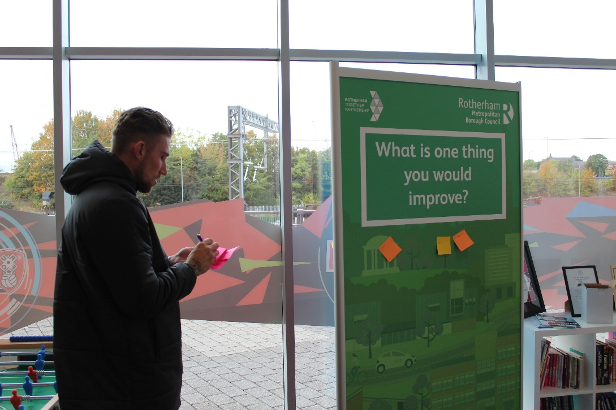

Photos show Rotherham United FC players Angus MacDonald (above) and Kieran Sadlier (below) taking part in the consultation

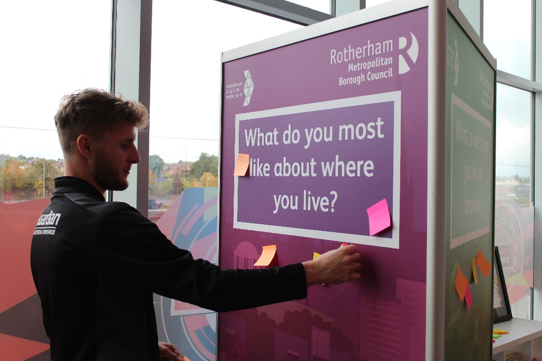

Short Interactions

The consultation included a series of short interaction activities which took place with participants in various ways, using the same three questions:

- What do you like about where you live?
- What one thing would you improve?
- What is your one wish for the future for Rotherham?

This is a simple engagement exercise, a conversation starter. It has the capacity to collect substantive qualitative data, but due to its informal nature it is difficult to collect monitoring data. Therefore, the analysis is based on number of responses to determine common denominators.

During the time this activity was taking place, many groups were still not meeting face to face, and many didn’t feel comfortable using virtual platforms. Therefore, to reach out to as many characteristic groups as possible given the situation, we tailored the activity to encourage people to engage in a way that suited them.

This activity took place with:
- Housing Involvement Panel – held via Microsoft Teams on 15th July with council tenant representatives.
- Rotherham Minster’s Social Supermarket – A consultation tower was placed at the Rotherham Minster for 2 days on 18th and 19th August to engage with people visiting the social supermarket (those suffering from financial deprivation, isolation, and hardship).
- Rotherham Youth Cabinet – a hybrid style workshop took place on 24th August at Ferham Children’s Centre.
- The Unity Centre - a consultation tower was placed at the Unity Centre throughout September and their staff facilitated the exercise with their users including students from ESOL classes.
- Healthwatch hosted an event held via Zoom on 15th September which allowed for the collection of information concerning disability/sensory matters.
- Deaf Futures Group - with the support of Rotherfed and the help of a British Sign Language interpreter, a face-to-face session took place at Springwell Gardens on 17th September with Rotherham’s profoundly deaf community.
- BME Disabled Young People & Parent/Carers Group – the questions were circulated to group members and responses were collated and sent back.

In total there were over 274 individual responses across all questions.

Question 1: What do you like about where you live?

There were 75 responses to this question across all the above events. The most common attribute that featured throughout to this question was that of having good neighbours, welcoming communities, and a willingness to help each other. Of comparatively equal standing was having access to parks and green spaces, with references to the countryside as well. Many also reflected on good local amenities and facilities where they live, and the wealth of places to visit. However, there were also more negative responses where some people said they liked nothing about where they lived.

Question 2: What is one thing you would improve?

There were 135 responses to this question. A diverse range of groups engaged with the activity and each one had their own key headlines for this question. However, a common theme running through all events was a desire to see Rotherham town centre vibrant, flourishing, clean, and safe. There were many suggestions as to how this may be achieved including incentives such as freer parking, reduced rents to encourage a wide range of shops and businesses, plus investments made to attract families with children, and young people into the town centre.

Linking to messages concerned with the town centre, retaining business and encouraging trade and industry into the area, were responses concerned with local jobs for local people. Street scene matters were also frequently mentioned for the town centre and across the borough. Rotherham people would like to see cleaner streets free from litter and fly-tipping stating that this could be achieved by more pro-active measures such as awareness raising and education around these matters, coupled with greater enforcement put in place to encourage prevention. People expressed that they would like to see roads kept in good repair and pavements well maintained and to remain accessible for disabled and young families.

A common theme running through all events, particularly if there was a disability, health condition, and/or from a different culture was on communication, engagement, and access to appropriate services. Many responses from those within these communities are feeling unheard, undervalued, and ignored; this includes carers. Responses received express a want for services to deliver and engage in ways so that these communities feel listened to, included, and informed. Linked to this, some responses alluded to a need for Council services to be more aware, sensitive, and understanding of Rotherham’s diverse communities; particularly those that follow other religions. Other issues mentioned referred to better provision for those with mental health issues, those who are isolated, and more things for children and young people to do. Weaving through all these responses were references to be safe and secure and for improved safety and security measures put in place in certain areas and the town centre.

Question 3: What is your one wish for the future for Rotherham?

There were 68 responses to this question across all the events. The common theme running across all events for this question was for welcoming and harmonious communities, where everyone comes together to help each other. A wish for a cohesive society was also frequently mentioned.

To complement these responses around neighbourliness and community cohesion, another conversation common across all events was a wish for more community-based action, and activities. Many felt that this would support a range of matters including aiding preventative measures for mental health, providing opportunities to reduce isolation, and break down barriers associated with segregated communities. Responses included an aspiration for action that promotes strong, resilient, and cohesive communities, equality and a respect for diversity, a greater awareness of the needs of those with disabilities and/or special needs, and facilities and activities for families, children, and young people – places where they can go and feel safe and secure.

Aspects of Rotherham Town Centre was also frequently mentioned, and Rotherham people have high aspirations to see the town centre flourish, be vibrant, safe and attractive to all.
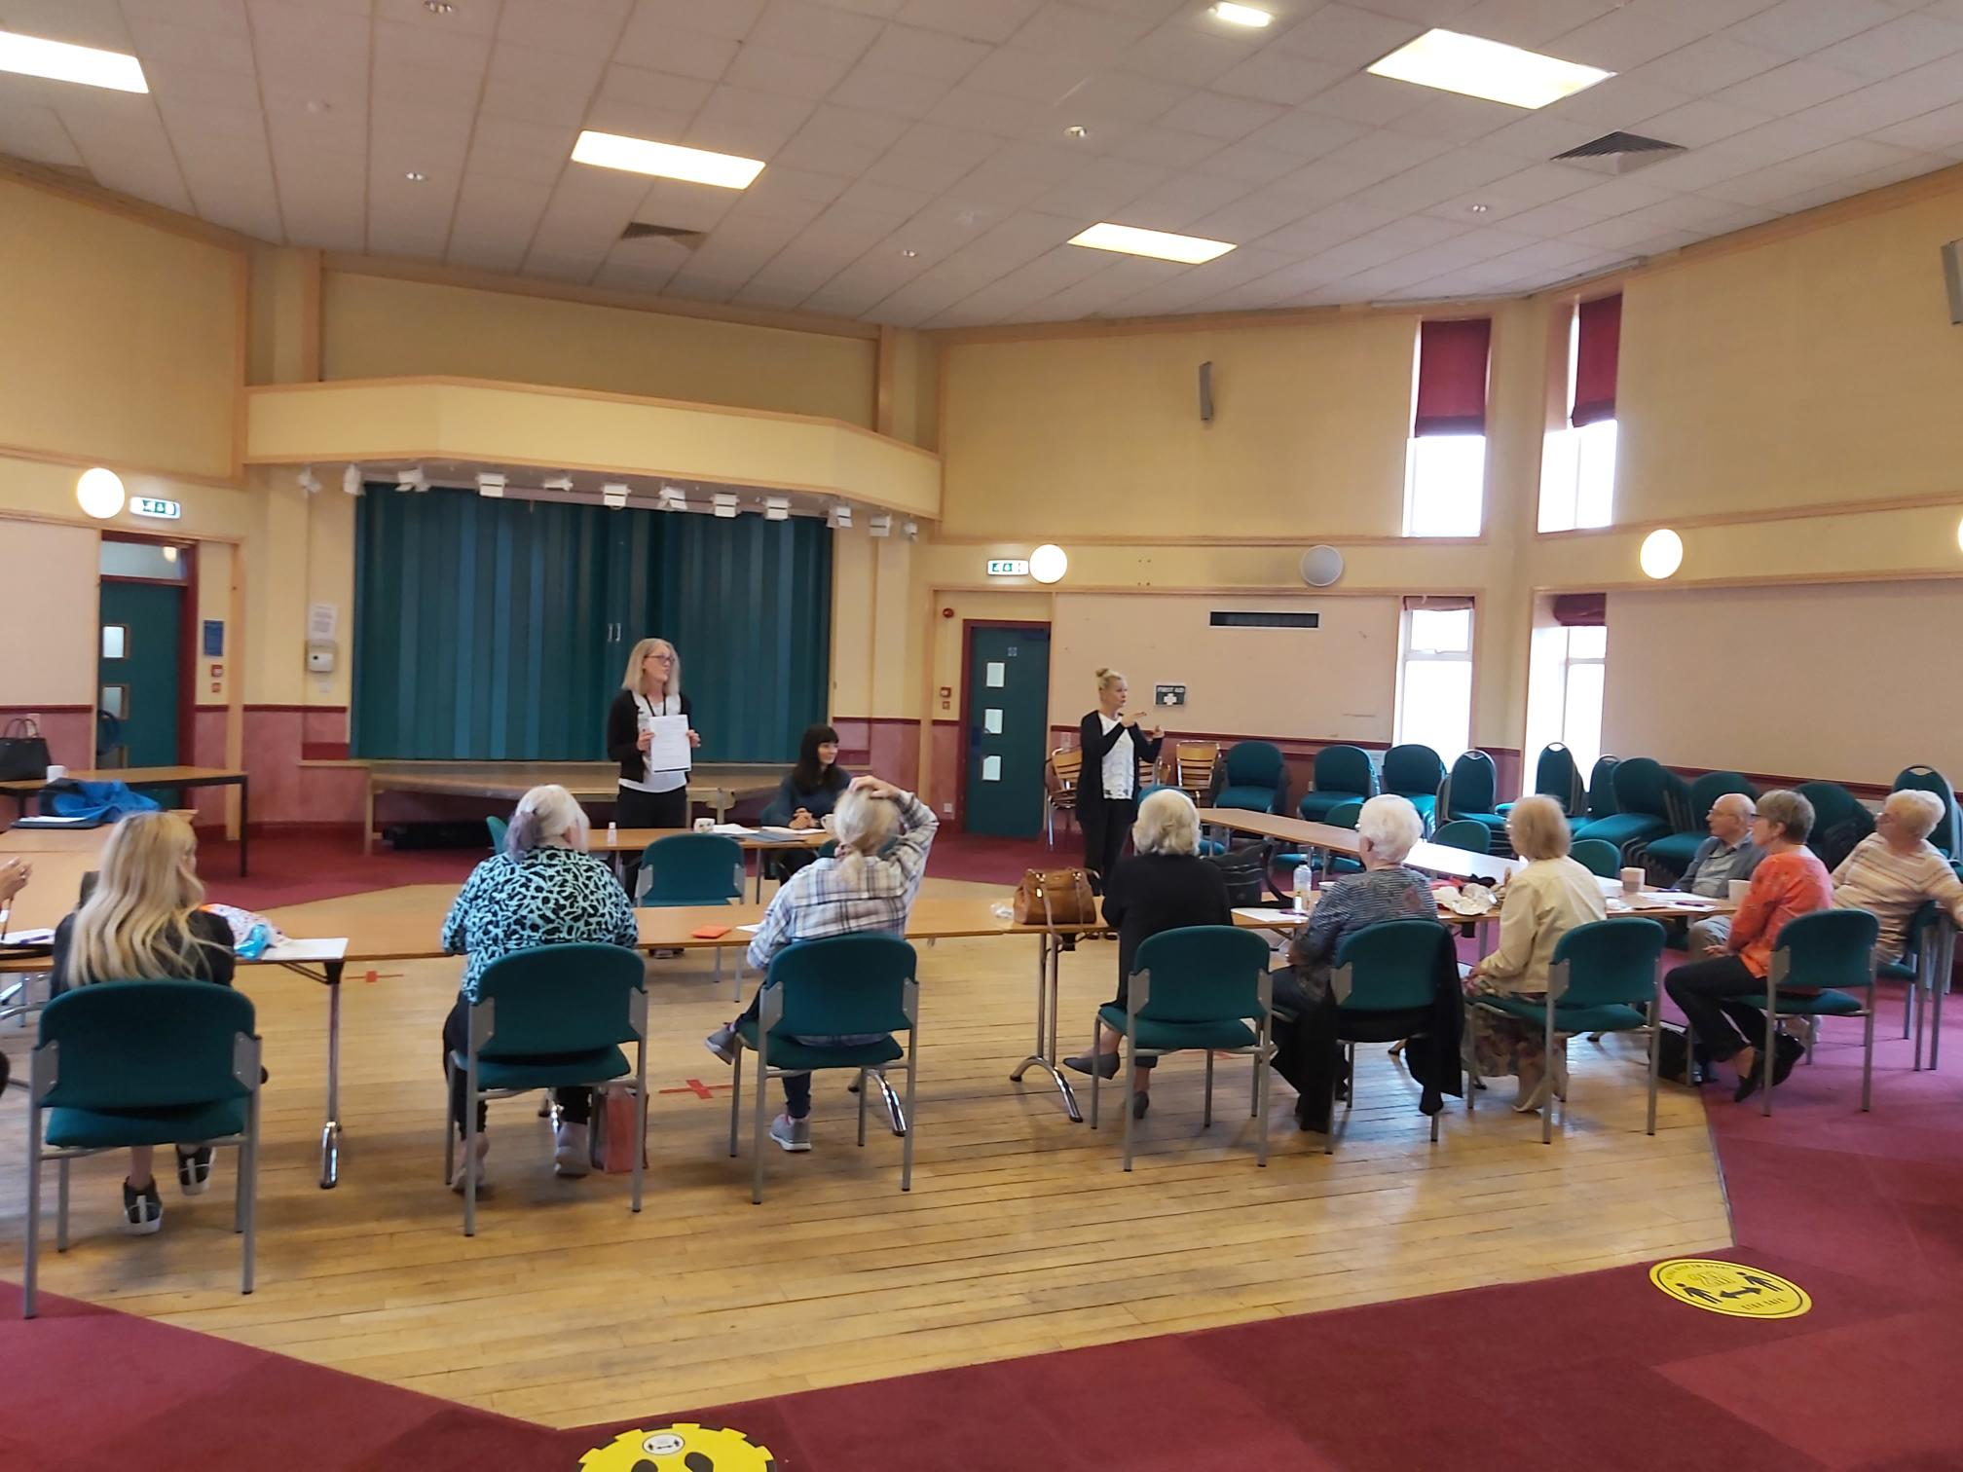

Photo from Deaf Futures Group Session

Rotherham Show

The short interactions activity took place at the Rotherham Show held on 3rd - 5th September. Two consultation towers were used. One was situated in the ‘Made in Rotherham’ area next to Voluntary Acton Rotherham, and the other situated in the Children’s and Families area in the Libraries and Neighbourhood Hubs Service marquee.

Across the three days over 700 responses were received for all 3 questions; 152 of these responses were from children and young people and are analysed separately. This was an exercise conducted with the public who attended the Rotherham show. No monitoring data was collected for this informal exercise but from observation it seemed that a diverse range of people engaged with the activity.

Question 1: What do you like about where you live?
There were 144 responses to this question over the three days of the show. The most universal feature was an appreciation of the beautiful countryside and woodlands. People adore the views and enjoy the opportunities for out-door recreational activities like walking, site seeing, and visiting historic buildings. This theme continued with many warm references to Clifton Park (this may have been because this consultation was taking place there) and a fondness for Rotherham’s green spaces in general.
The second most common feature was that people considered having good neighbours and friendly communities as key aspects of what they liked about where they lived; often associated with the need to feel connected and supported. Often mentioned in the same response was that having clean streets was also a reason why they liked where they live. Many, possibly older people, also reflected on the fact that what they liked about where they lived was the peace and quiet. People also reflected on the good transport networks and having easy access to the motorways and major roads as a positive feature of Rotherham. There were also many comments that expressed a warmth and connection to Rotherham.
Question 2: What is one thing you would improve?
There were 265 responses to this question over the three days of the show. By far, the most common subject mentioned was Rotherham town centre. Many responses related strongly for the need to make the town centre a place that people want to visit, and shops to prosper. There was a passion for Rotherham town centre to be vibrant, for it to succeed and to be prosperous. Common topics raised were concerned with its recovery.
Many comments related to aspects of the public realm and responses included: clean up the streets and buildings; promotion on awareness about littering and keeping the centre clean and tidy; ensuring accessibility for families with young children, and disabled. Linked to these comments were responses relating to the town centre shopping experience. Many expressed a desire for a wider range of “decent” shops, more activities for families with young children, and greater accessibility for disabled and those with sensory impairments.
Concerning borough wide matters, the most common feature referred to be the plea for roads to be repaired and maintained. There were also clear messages for a wish for the pavements to be kept clear and accessible.
Responses on other borough wide matters related to a need for more support for Rotherham’s young people to help them to achieve and aspire. There was a consensus for a demand to invest in, and resource more facilities and activities for this age group.
As well as a focus on supporting Rotherham’s young people, there was a wider conversation concerned with supporting whole communities. Many responses referred to a wish for more leisure, culture & community-based hubs/activities because respondents feel that this approach can contribute towards alleviating isolation, help combat mental health issues, support those in financial hardship, assist families with young children, and bring people together from diverse communities. People also wanted to see more help and support for those with disabilities. People also wanted to see greater provision for families with young children and comments included a wish for more low-cost childcare, for the children’s centres to remain open, and more activities for children of working parents.
Many responses referred to a wish for greater police presence, for anti-social behaviour and crime to reduce, and for more help for the victims. Drugs’ awareness was also mentioned frequently. Linked to many of the comments mentioned above there was a desire for better cross sector working between key statutory organisations such as the Council, NHS, Police, and public transport.
There were also some references on caring for the local environment. People wished for good quality housing and buildings that are built to meet the demands of the climate emergency. As well as a desire to respect the environment and wildlife, there was a call for action towards reducing pollution, more cycle ways, and creating areas that can encourage more biodiversity.
Question 3: What is your one wish for the future for Rotherham?

There were 184 responses to this question over the three days of the show. There were three key themes that came out of this part of the exercise, all interrelated with a common set of issues running through. The main feature that came out was a strong association with Rotherham town centre and many responses showed a passion for the centre to be prosperous, vibrant, welcoming, and clean. The second most popular theme was an aspiration for harmonious, active, and welcoming communities. Linking to both themes above is the desire to feel safe, secure, and to live in a clean environment.

Several people also highlighted the need for more awareness and sensitivity for those with disabilities and sensory impairments, and a wish for the vulnerable to be protected. As well as the desire for clean streets in local areas, other environmental issues mentioned included the wish for more biodiversity and an overall respect for the environment.
Children and Young People (Rotherham Show and Short Interactions)

As mentioned above, there were 152 responses from children and young people at the Rotherham Show. There are a further 74 responses across all questions from a variety of youth groups including the Looked After Children’s Council, as well as the 48 comments from members of the Rotherham Youth Cabinet, the latter analysed with the initial data collected for the short interactions. The gathering of this information has been achieved by working with Children’s and Young People’s Services.
All the children’s and young people’s responses have been solely gathered for analysis to gain an understanding as to what they like, what their concerns are, and what they wish for the future for Rotherham.
Question 1: What Do you like about where you live?
There were 104 responses to this question across all events. There were two key features that children and young people like about where they live. The first one is about living in a safe and secure environment where there is a sense of community where people are kind and friendly. There were many references to liking where they live because of friends, school, family, and neighbours.

The second most common feature, from the responses received, is that children and young people like where they live because they have access to the parks, green spaces, woodlands, and can explore Rotherham’s heritage with references to Roache Abbey and the Wentworth Estate.

Young people also said they liked the easy accessibility to Sheffield and Meadowhall, with good public transport links. There were also some very warming responses on how children and young people associate with Rotherham.

Question 2: What is one thing you would improve?

There were 82 responses to this question across all events. There were three common features that children and young people would like to see improved. The first one being that children and young people want to feel safe and secure when out in their communities and the town centre. Several suggestions were put forward including improve street lighting, more activity that reduces crime and vandalism rates – and to be informed of this, plus a want for a larger police presence. Linking to this, young people and children would like to see action that promotes cleaner streets and parks, and they would like to see less litter.

Third common feature is that children and young people would like to see better facilities and activities for their age groups – music and youth clubs were frequently mentioned, as well as better play areas. Improving the town centre was also mentioned and for it to be more appealing for young people to visit with their friends. Young people also would like to see more local job opportunities, degree apprenticeships to help retain talent and so they do not have to move away from their friends and family.

Question 3: What is your one wish for the future for Rotherham?

There were 78 responses to this question across all the events. From these responses the most common feature a wish for harmonious communities with people that support, help, and accept each other for who they are. To also feel safe, and to live in a clean environment. Young people also wished for Rotherham town centre to be a place that people want to visit, for there to be more shops, activities, and places for young people to go.

On a borough wide basis, many young people want to see more creative/arts facilities/hubs, and more leisure and sports activities; music venues and clubs were also mentioned.

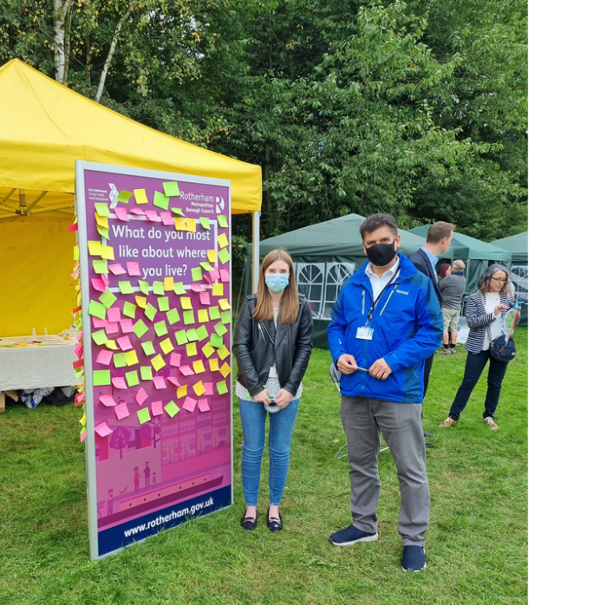
Photo from Rotherham Show Consultation

Online and Postal Survey

The online survey went ‘live’ on the Council website for 4 weeks, from 17th August to 19th September 2021. There were 45 questions in total across the following four themes:

- Thriving Neighbourhoods
- Everyone Safe, Well and Resilient
- An Economy that Works for All
- Improving the Local Environment

Participants could choose whether to fill in questions on each of the themes or just answer certain sections. The majority of respondents answered questions on all four themes. There were 298 responses to the online survey in total.

The postal survey ran concurrent to the online survey. A paper version of the online survey questions was sent out to 500 randomly selected households across the borough with a freepost envelope provided. 52 postal survey responses were received in total, which is an 11% return rate. This was a higher percentage than predicted, as nationally the average return rate on a postal survey is between 1%-2%.

Of the 52 postal survey responses, 96% were White British and mainly from older/retired people with 63% of respondents who provided their age being 65 or older. Only 12% of respondents who provided their age were aged between 18-44 (with no responses received from people aged 18-24).

41% of postal respondents were male and 56% female, with 75% of respondents stating that their religion was Christianity and the remainder stating that they had no religion. No other religions were selected by postal respondents.

Key findings from the postal responses included:

- More respondents feeling that their neighbourhood/community had become more (15%) rather than less (8%) supportive since the start of the pandemic, and 63% feeling that there had been no change. However, when asked ‘do you feel safer in your local neighbourhood compared to 12 months ago’ more respondents now feel less safe (25%), with 10% feeling safer and 62% citing no change
- Respondents cited road safety issues including increased traffic, parking problems and access to bus services as areas of concern
- Anti-social behaviour was a specific area of concern, with many suggestions that more investment should be made in activities aimed specifically at older children/teens
- ‘Feeling safe’ was the top response when asked ‘what would have the biggest positive impact on your wellbeing and quality of life?’

Aside from the above observations, the postal survey results have been added to the online survey responses and analysed together for the purposes of this report.

Below are the key findings in both the online and postal survey responses combined for each of the four themes:

Neighbourhoods are vibrant and thriving

The survey opened with an open text question asking respondents ‘what is the best thing about your neighbourhood?’. Many respondents talked positively about the people, their communities and the access to parks and the countryside. In open comments residents listed Rotherham abundance of green space as the best thing about their neighbourhood. 20% of comments mentioned proximity to green spaces, woodland, and wildlife as the best thing about living in their area. 19% mentioned a strong community spirit helped create a sense of belonging. 13% spoke highly of supportive good neighbours. Other comments included friendliness (12%) and quietness (11%).
The next question was ‘what is the one thing within your neighbourhood / community that you would like to change?’. Most comments on neighbourhood/community improvement were around street cleanliness. 22% highlighted litter and dog fouling as an area for improvements, alongside, more rubbish bins in communities. 20% mentioned anti-social behaviour, especially high-speed motorists being a nuisance. Parking (14%) needed improvement with responses mention motorists parking on kerbsides, blocking driveways and accessibility for disabled road users. Other comments include drug use (10%), public space maintenance (10%) and bus services (7%).
31% of respondents said that they believed that people in their local area were more supportive since the start of the pandemic.
The main reasons given for participating in cultural activities were as follows (respondents could choose more than one option):

65% said for pleasure, 43% to improve health and wellbeing and for 35% for social reasons.
Prior to lockdown, the most popular visitor venues/activities were parks (81%), events (46%) and museums (40%). The least popular were Herringthorpe Stadium (3%), Civic Theatre (29%) and libraries (33%). When asked what would make cultural venues more appealing, comments included making them easier to get to on public transport, more publicity around events and activities and more historical events.
63% considered facilities for children and young people locally either good or adequate. 59% wanted to see improved play areas and cheaper access to sports/activities for children and young people, and 56% wanted to see more youth work. There were a number of comments linking a lack of things to do for older children/teens and anti-social behaviour, with suggestions that the Council should invest more in youth services and activities specifically aimed at older children.

When asked if they volunteered to help out family, friends or neighbours, the responses are as follows:

20% did so every day, 26% on a weekly basis, 24% did so 2-3 times a week, and 20% monthly. Only 9% said they never volunteered to help.

In terms of more formal volunteering opportunities offered by the Council, the Rotherham Heroes initiative had the highest levels of awareness amongst respondents, with 35% aware of the scheme and 3% volunteering as Heroes. There was a general lack of awareness amongst respondents of all of the Council led initiatives, with awareness levels ranging between 16% and 35%. Around 13% of those who said they were aware of the initiatives actually volunteered or participated in one of the schemes. 62% of respondents said they knew who their local Councillor is.

There was an even split response to the question on whether respondents felt that people are able to buy or rent quality affordable housing in their neighbourhood, with 48% saying yes and 51% saying no.

Improving road safety/speeding, access to busses and tackling problem parking were the three most important priorities for transport investment in local neighbourhoods. 10% of other comments focused on investment in new train stations for Maltby and Waverley.

People are Safe, Well and Resilient

When asked if they felt safer in their local neighbourhood compared to 12 months ago, only 8% said yes and 54% felt that there was no change. For the people that said they felt less safe (38%), the main reasons given were an increase in crime, ASB and an increase in traffic issues.

The three most important community safety issues for respondents included tackling ASB (79%), tackling crime (67%) and protecting vulnerable older people (62%). Over a third (34%) of open comments pointed to increased theft, especially pet and car theft, making them feel less safe. 10% said knowing neighbours and having a neighbourhood watch made them feel safer.

Awareness levels around the support available for children and young people to be resilient and safe against the wider challenges of pandemic were low at 14%, with 50% not aware and 30% answering ‘don’t know’. 64% said that they were aware of how to report a safeguarding concern regarding a child, and 59% were aware of how to report a safeguarding concern regarding an adult. 18% of open comments said children and vulnerable adults knowing their local community support and police officers would help many feel safer.

Access to specific groups and activities for young people was considered top priority (36%) for encouraging children and vulnerable adults to feel safer and more resilient. 25% of open comments mentioned having more affordable activities and programs for children and vulnerable adults

Specific questions were asked regarding resilience, the impact of the pandemic and leading a healthier life. When asked what is the most important action that you feel would help you to live a healthier life, the answers were as follows:

The top three answers were maintaining a healthy diet (21%), better access to healthcare (19%) and maintaining a healthy weight (17%).
57% stated that the pandemic had significantly or slightly negatively impacted on their mental health, 33% had seen no change and 9% had seen their mental health improve slightly or significantly. The top three ways in which the virus had negatively impacted on respondents’ mental health were: 44% had gained weight, 37% were less physically active and 35% were worried about contracting the virus.

When asked about the positive effects the pandemic has had on respondents’ lives, 27% said they had a better work/life balance and 19% reported being more physically active. 52% said that none of the options applied to them. Respondents were asked how positive they felt about the future, (at this stage of the pandemic) 36% gave a positive response, 34% were negative and 30% were neutral.

Respondents considered environmental improvements (23%), financial security (22%) and feeling safe (21%) the top three things that would have the biggest positive impact on their wellbeing and quality of life (see graph below):

Men (30%) and those without a disability (27%) were more likely to state environmental improvements (23% overall), while more women and those with a disability stated ‘More things to do in the community’ (16% women, 22% with disability, 13% overall). Male respondents (14%) and those with a disability (12%) were also more likely to state ‘improved working conditions’ as factors (8% overall).

An Economy that Works for All

25% of respondents were retired, 43% were full time employed, 20% part-time employed, 5% unemployed and 7% self-employed or other.

Only 20% of respondents felt that there were enough job opportunities in their area, 45% said there were not enough and 35% were unsure. When asked about the quality of opportunities in their area only 16% agreed that they were good, with 40% disagreeing and 44% giving a neutral response. 69% of respondents were not very/not at all optimistic about economic opportunities for young people in Rotherham and South Yorkshire more widely, with only 31% providing a positive response.

To improve the number/quality of jobs in the area the Council should prioritise the following:

The top 3 responses were improve access to education and training (58%), invest in localities (50%), and improve transport links (42%). The things that were considered to make the most difference and improve job prospects and economic opportunities for young people leaving school over the next few years were more local training opportunities or apprenticeships (76%), creating more jobs in the local economy generally (63%) and more work experience opportunities (48%).

Respondents considered job satisfaction (23%), income (21%), and work/life balance (20%) the most important factors in a job. When asked what they thought the main barriers to people accessing jobs were, the results are as follows:

The top 3 answers included skills/education (61%), household circumstances (52%) and personal wellbeing (including health, mental health and disability) (46%).

The pandemic has had some economic impact on respondents, with 30% working from home, 9% furloughed, 6% being made redundant, 3% on reduced hours, 2% undergoing a career change and 44% not impacted at all by any of these measures. 33% stated that family members or friends had been out of work during the past 12 months.

Caring for the Local Environment

The survey revealed a real and deep appreciation for parks and open spaces, particularly during the pandemic and also generally with 86% of respondents saying that since the start of the pandemic they had visited parks and green spaces more often. 98% of respondents considered their local park or open space to be very (91%) or somewhat (7%) important to their local community.
Comments revealed other uses for parks and open spaces included children play (17%), running (13%), bird watching (13%), dog walking (10%), litter picking (10%) and socialising with friends (10%). When asked how often they use their local parks and green spaces, the results are as follows:

70% used their parks or green spaces at least weekly and 50% of respondents felt that their local park or green spaces were important to their community in terms of improving their health and wellbeing. Men were more likely to say they used parks daily (46%) than women (28%), while women were more likely to never use parks at all (7%), than men (1%).
The most important environmental issues in local areas were identified as (first choice ranking) fly-tipping (30%), littering (22%) and potholes (14%), with respondents identifying climate change (53%) and pollution (15%) as the environmental issues that they felt were most important to the next generation.
When asked about how they were taking action to reduce their impact on the environment, the results were as follows (respondents could choose more than one option):

88% were recycling more, 66% were controlling energy use at home and/or work, 48% were shopping sustainably and 44% were driving less.

4. Conclusion

Overall, the consultation was extensive with over 1,300 interactions taking place in total across all methods of engagement. This was despite the issues posed by the pandemic and where the majority of the consultation had to take place over the school summer holidays. Therefore, the consultation was designed to ensure that there were a number of opportunities for people to participate over the course of 6 weeks, both virtually and face to face, digitally and at various locations across the borough.

There was a lot of positive feedback from the focus groups and people were pleased to be involved and asked for further ongoing engagement. In future consultations, the Council will seek to develop ways to ensure wider resident participation; to capture more diverse perspectives and ensure even greater representation from protected groups.

For the short interactions, responses from all three questions correlated well with each other. The initial question “what do you like about where you live?” Rotherham people associate neighbourliness, clean, and welcoming communities as being key to what they liked about where they lived, along with good local amenities and access to green spaces and the countryside. The second question, “what one thing would you improve?” highlighted Rotherham people’s association with the town centre and their aspirations for it to be prosperous, safe, and clean. Closely linked to this is the concern for local jobs for local people and the need to retain local talent.

People would like to see an improvement with Council service communication and engagement in that people want to feel that they are being listened to and kept informed; as well as a need for Council services to be aware and sensitive to Rotherham’s diverse communities. There is a concern for mental health, those living in isolation, and a greater awareness of the needs of those living with disabilities is required, along with the needs of carers. The final question, “What is your one wish for the future for Rotherham” was a desire to be living in welcoming, diverse, and cohesive communities, where local action takes place, where there are accessible facilities and activities where people feel safe and secure, neighbourhoods are clean and free from crime and anti-social behaviour.

Topics raised at the Rotherham Show were very similar to those mentioned by the groups involved with other short interaction events. From this exercise people in Rotherham associate strongly with the town centre and wish to see it prosper. People want to live in welcoming, clean communities where they know their neighbours, feel safe, where everyone shows respect towards one another, and where there is support no matter what their circumstance is, their background, or where they live.

Children and young people’s responses have been analysed separately. The responses correlate well with the replies from adults across all three questions. For the first question many children and young people relate to liking where they live because of their friends, family, and kind people. They feel safe and secure, and where they live is clean. As with adults, this age group also related strongly with being able to access parks, woodlands, and the countryside. For the second question, issues came forward concerned with what improvements would like to be seen associated with the need to feel safe and secure locally and in Rotherham as a whole. As with adult responses there were messages for cleaner streets and parks, appropriate security measures, wishes to accept people for who they are, and better facilities and activities for young people to participate in. On the final question, a wish for the future for Rotherham, this age group want to live in harmonious, welcoming communities that are safe, secure, and clean. A place that is filled with opportunities to allow children and young people to succeed.

Overall, the online and postal survey was successful in terms of collecting useful data that could be analysed easily and the results broken down further using the equalities data. On the whole, participants agreed with the proposed themes of the Council plan and more than 72% of people chose to complete each theme section of the online/postal survey. However, there were issues with online survey in terms of pages ‘timing out’ after 10 minutes, which meant that people lost the information they had inputted and had to go back and do it all again. The timeout was a security feature built into the software which couldn’t be changed. Residents reporting this pointed out potential equalities implications for those who may require more time to complete the survey. To address this, users were encouraged to open a ‘Your Account’ with the Council and log in with their email address to fill out the survey so they wouldn’t lose any of the information they had completed. With the postal survey responses, there were a number of forms returned where people had misunderstood the ‘ranking’ of questions (either chosen more options than asked for or ranked all their responses as equally important rather than ranking them numerically based on 1 being the most important etc.). When looking at similar surveys in the future where question responses are ranked, there needs to be consistencies in the questions and possibly example answers given in the first instance.

As stated previously, this consultation is part of an ongoing dialogue between the Council and members of the public. Feedback will continue to be sought and the consultation ‘towers’ will continue to be used for short interactions to feed into the year ahead plan, the Rotherham Partnership Plan, the equalities review and the refresh of the equalities strategy.

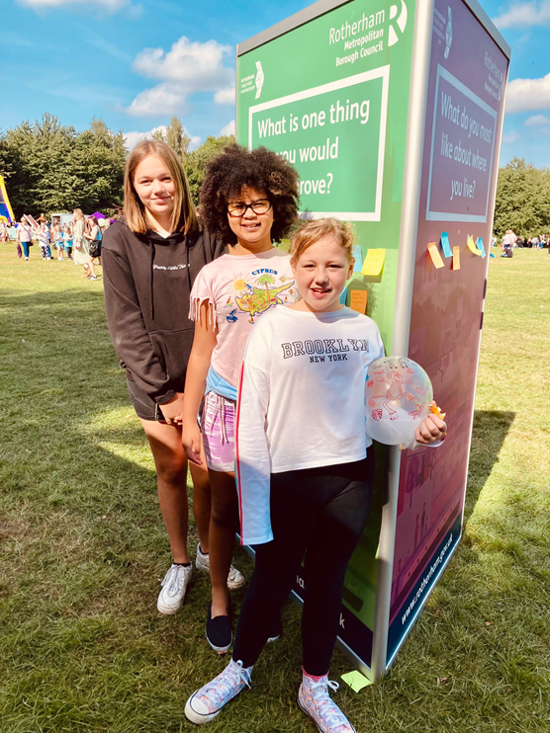
Photo from Rotherham Show Consultation

Appendix 1 – Respondent map locations
225 full postcodes were given by respondents and 223 were Rotherham based. The map below shows the postcode spread for all survey respondents. All 25 Rotherham wards were represented in both online and postal surveys.
© Crown copyright. Rotherham MBC Licence No. 100019587

