Housing Online – Uploading Documents/Photos User Guide
This guide specifically relates to Uploading Documents and Photos. Should you need help finding your way around other parts of your Housing Online account, please refer to the All User Guides section which you can access by clicking here

Contents Page Number
Uploading a Document/Photo from My Accounts | 3
Uploading a Document/Photo from My Repairs | 6
Uploading a Document/Photo from Get in Touch | 10

This guide will explain how to upload a document within the ‘My Accounts’, ‘My Repairs’ and ‘Get in Touch’ section of your Housing Online account.
Please refer to the ‘Registering and Logging in Guide’ for details of how to register for the first time and/or log in with a previously registered account.

Once you have successfully logged in you will see the ‘My Summary’ page as per the below:
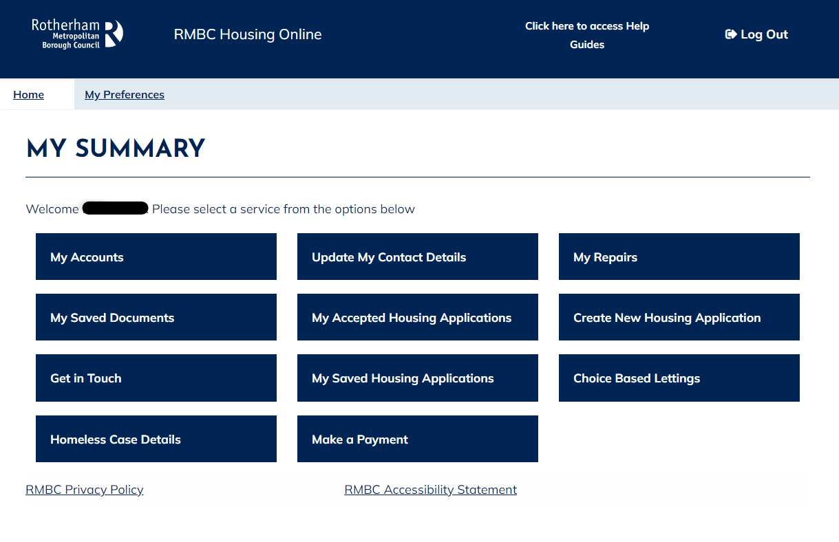

Uploading a Document/ Photo from ‘My Accounts’
Select the ‘My Accounts’ option:
The ‘My Accounts’ page will then show where you can view your account details. Select the ‘Actions’ option and then select ‘Upload a Document’.
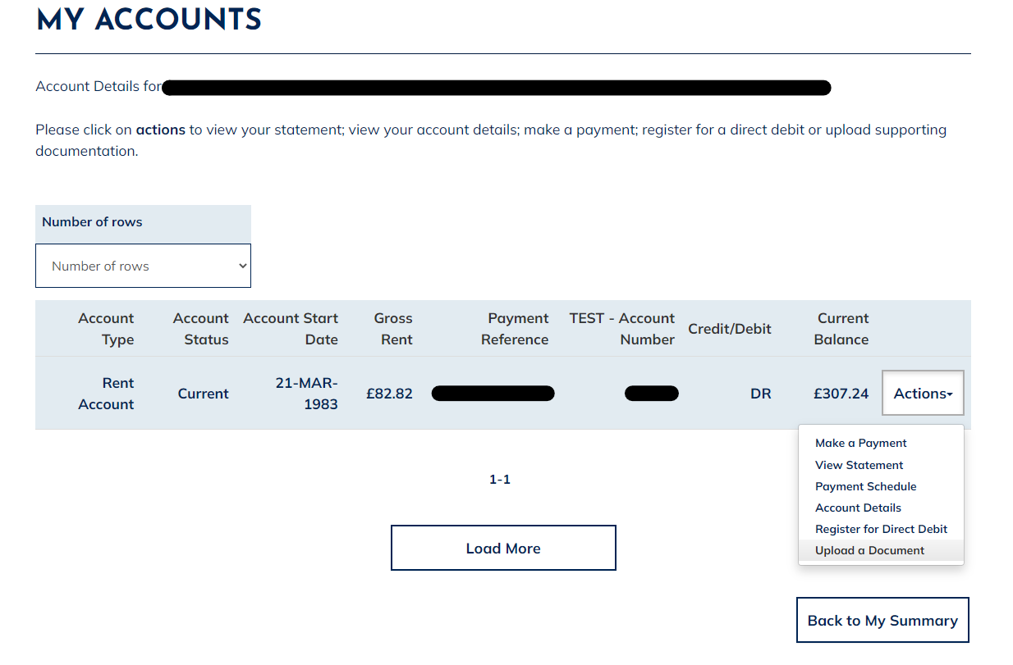
The ‘Upload Documents and Files’ page will show.
On this page you can upload your supporting documentation.
Complete the relevant fields as outlined below:
- Choose File: Browse the file you want to upload
- Document Name: Give the document a relevant name (keep it short)
- Type of Document: Choose ‘Attachment’ from the drop-down options
- Comments: Optional, add any relevant comments
- Association Type: This field is auto populated, no further action required
- Association Reference: This field is auto populated, no further action required
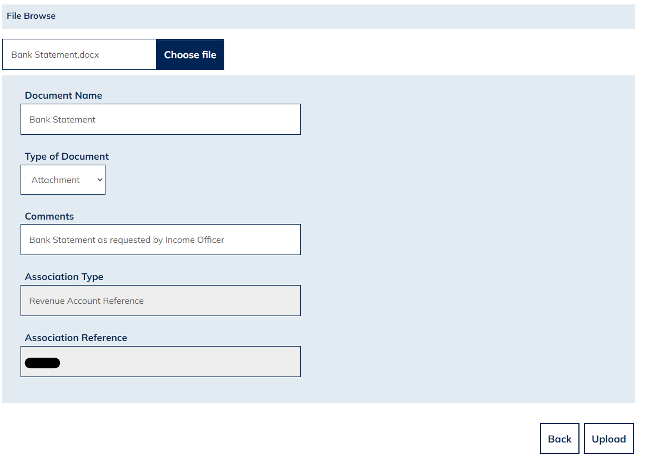

Then select the Upload option and you will be returned to the ‘My Accounts’ page.
Once you have completed this task, you will be able to view your documents in the ‘My Saved Documents’ area on your Home/Summary page.
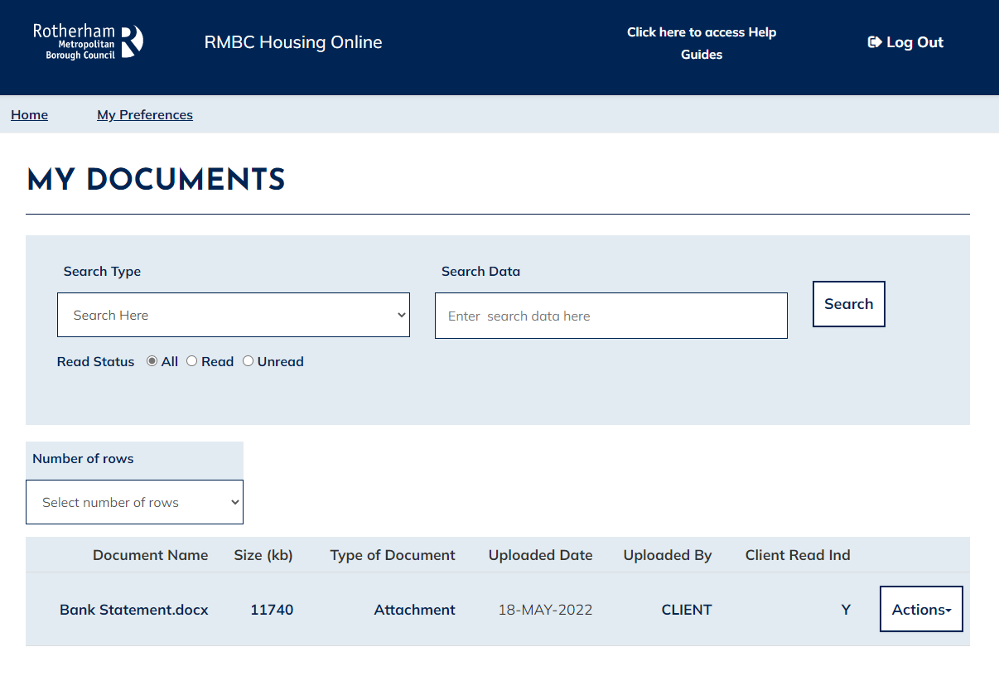
If you upload a document in error, please go to ‘My Saved Documents’ select the ‘Actions’ option and select ‘View Document Details’.
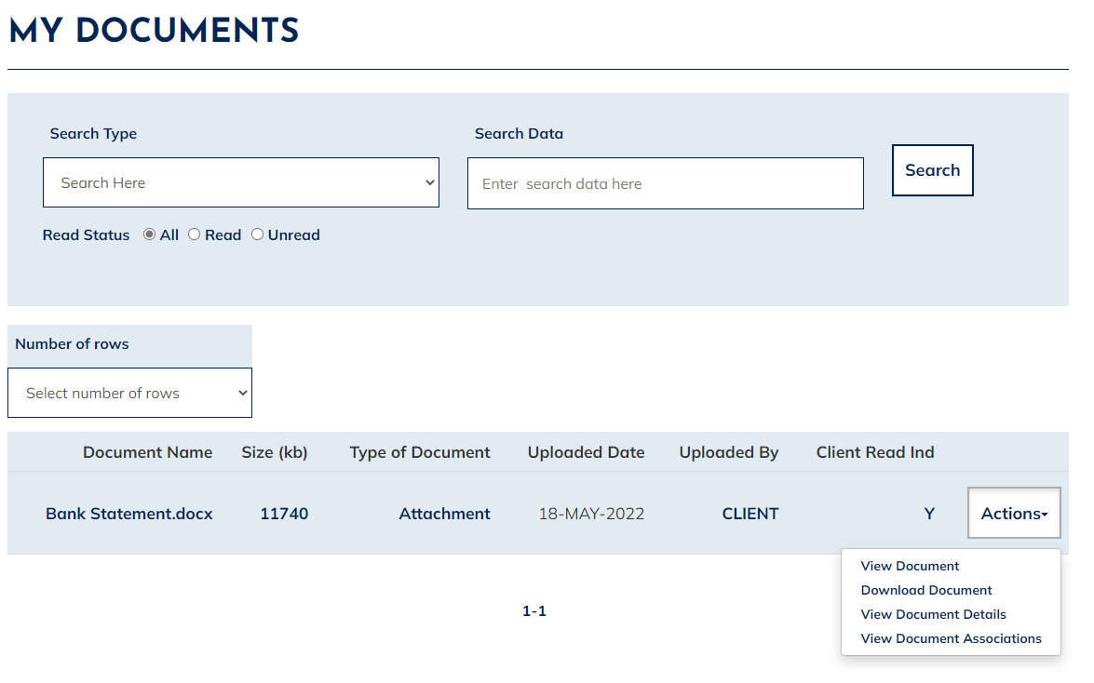
Select ‘Delete’ using the option which will be on the bottom right-hand corner of that page.
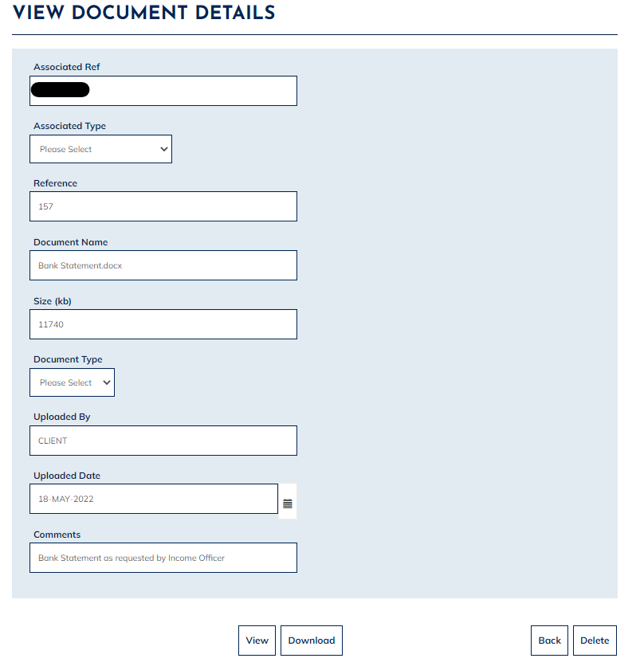
Please note that documents can only be deleted if they have not already been viewed by RMBC.

Uploading a Document/ Photo from ‘My Repairs’
Select the ‘My Repairs’ option
The ‘My Repairs’ will show where you can view your account details. Select the ‘Actions’ option next to the relevant repair job and then select ‘Upload a Document’.
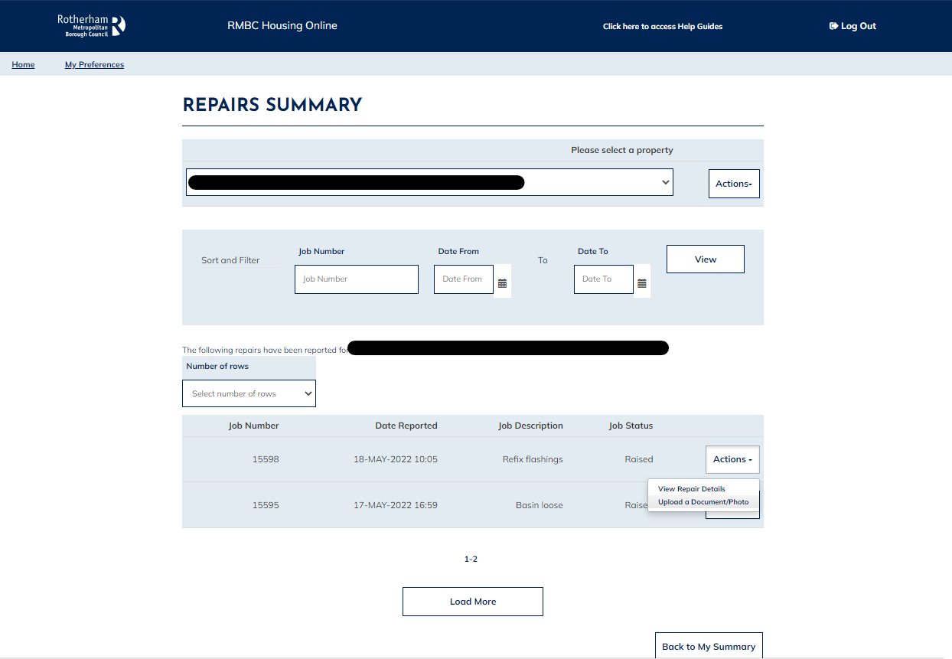
The ‘Upload Documents and Files’ page will be displayed.
On this page you can upload your supporting documentation.
Complete the relevant fields as outlined below:
- Choose File: Browse the file you want to upload
- Document Name: Give the document a relevant name (keep it short)
- Type of Document: Choose ‘Attachment’ from the drop-down selection options
- Comments: Optional, add any relevant comments
- Association Type: This field is auto populated, no further action required
- Association Reference: This field is auto populated, no further action required
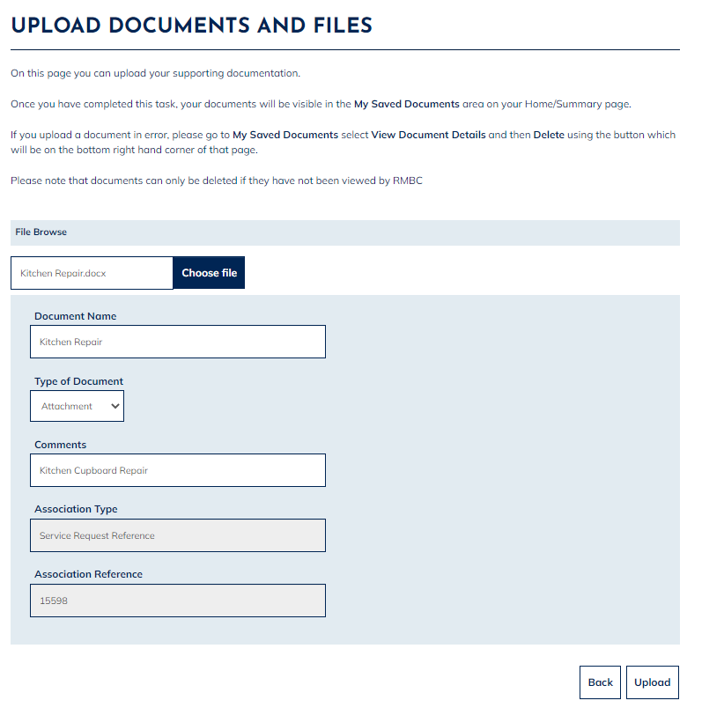
Select the ‘Upload’ option and you will be returned to the ‘Repairs Summary’ page.

Once you have completed this task, you will be able to view your documents in the ‘My Saved Documents’ area on your Home/Summary page.
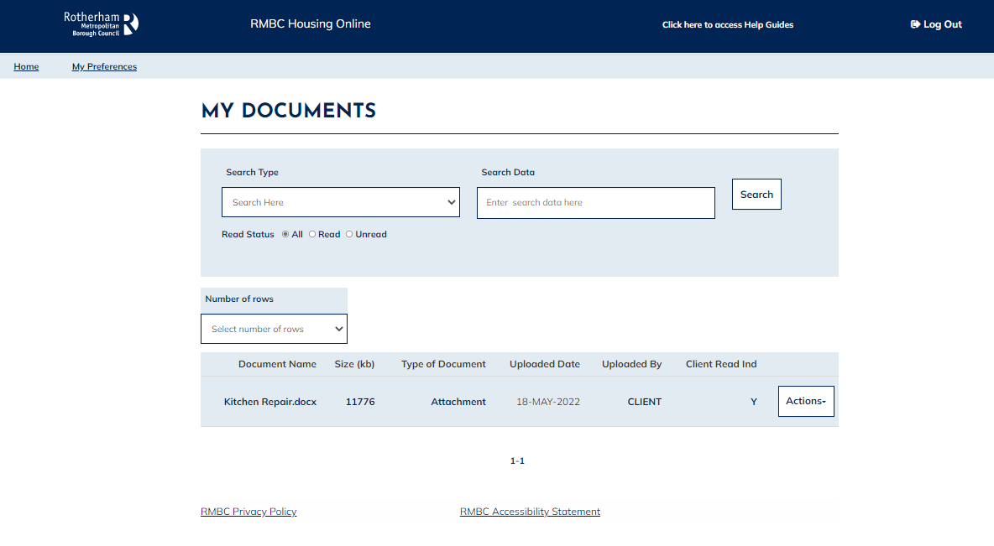
If you upload a document in error, go to ‘My Saved Documents’ and select the ‘Actions’ option., Select ‘View Document Details’
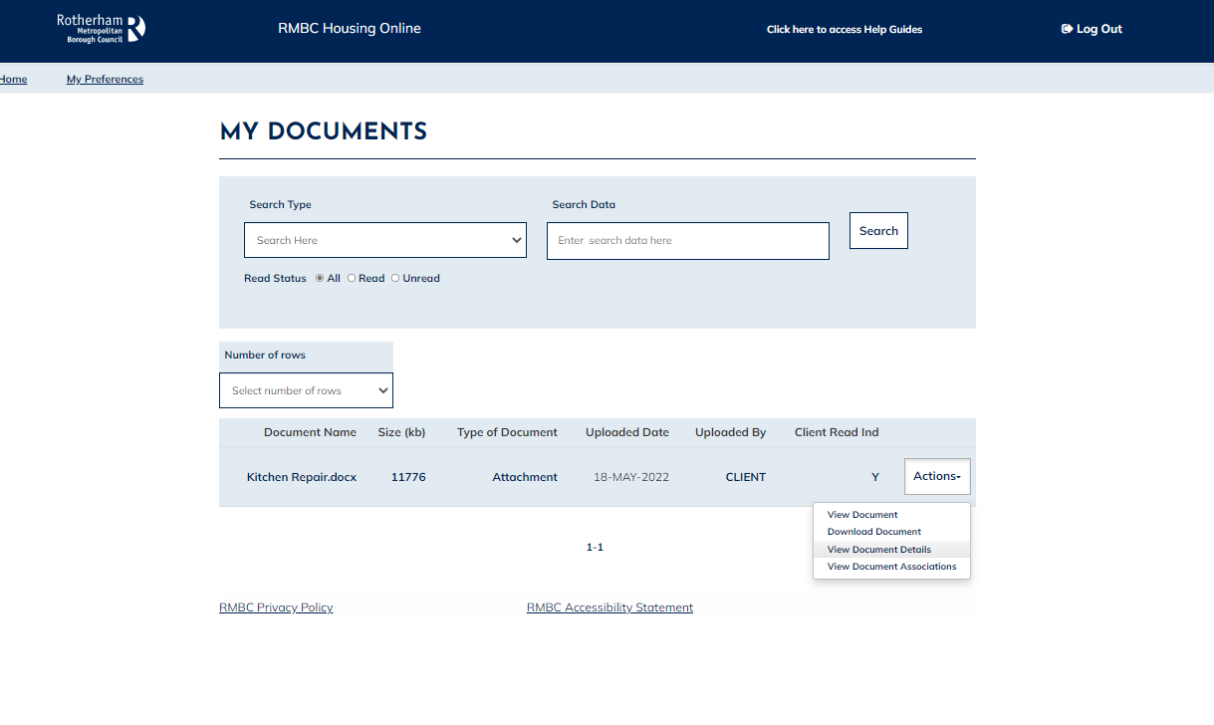

and then ‘Delete’ using the button which will be on the bottom right-hand corner of that page.
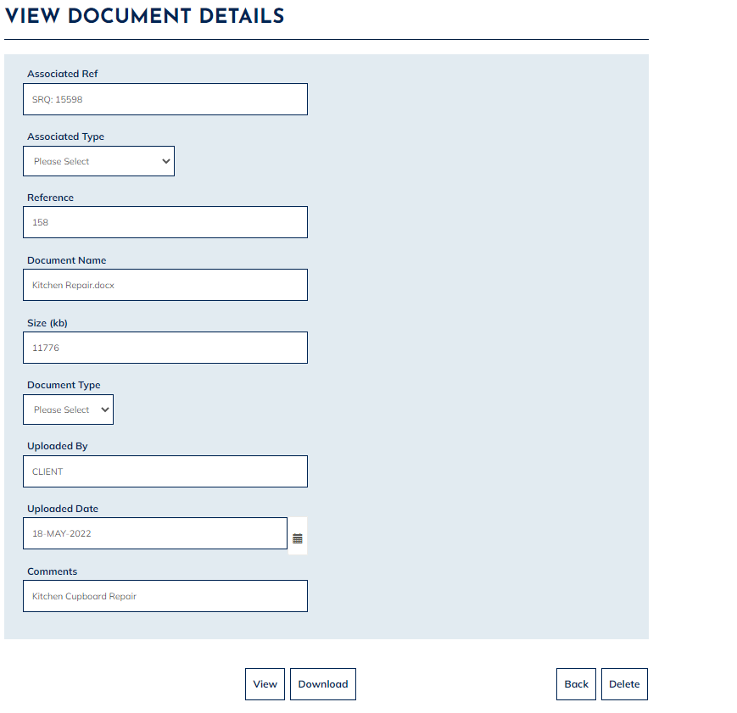
Please note that documents can only be deleted if they have not already been viewed by RMBC.

Uploading a Document/ Photo from ‘Get in Touch’
Select the ‘Get in Touch’ option:
The ‘My Enquires and Requests Summary’ page will show. Select the ‘Actions’ option next to the relevant ‘Enquiry Request’ and then select ‘Upload a Document’.
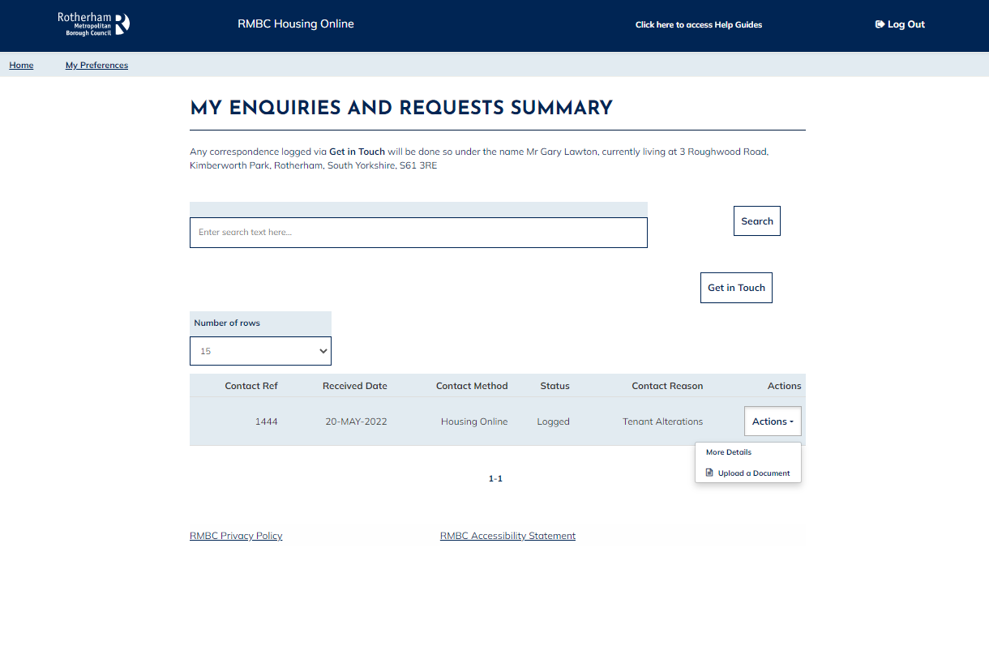
The ‘Upload Documents and Files’ page will show.
On this page you can upload your supporting documentation.
Complete the relevant fields as outlined below:
- Choose File: Browse the file you want to upload
- Document Name: Give the document a relevant name (keep it short)
- Type of Document: Choose Attachment from the drop-down selection options
- Comments: Optional, add any relevant comments
- Association Type: This field is auto populated, no further action required
- Association Reference: This field is auto populated, no further action required
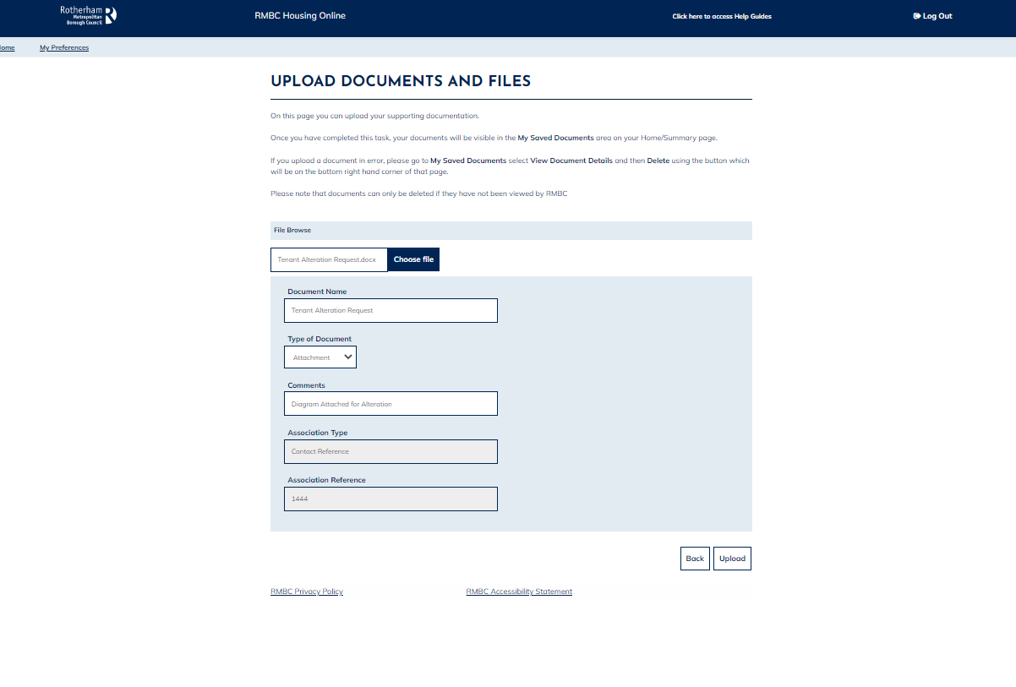
Then select the ‘Upload’ option and you will be returned to the ‘My Enquires and Request Summary’ page.
Once you have completed this task, you will be able to view your documents in the ‘My Saved Documents’ area on your Home/Summary page.
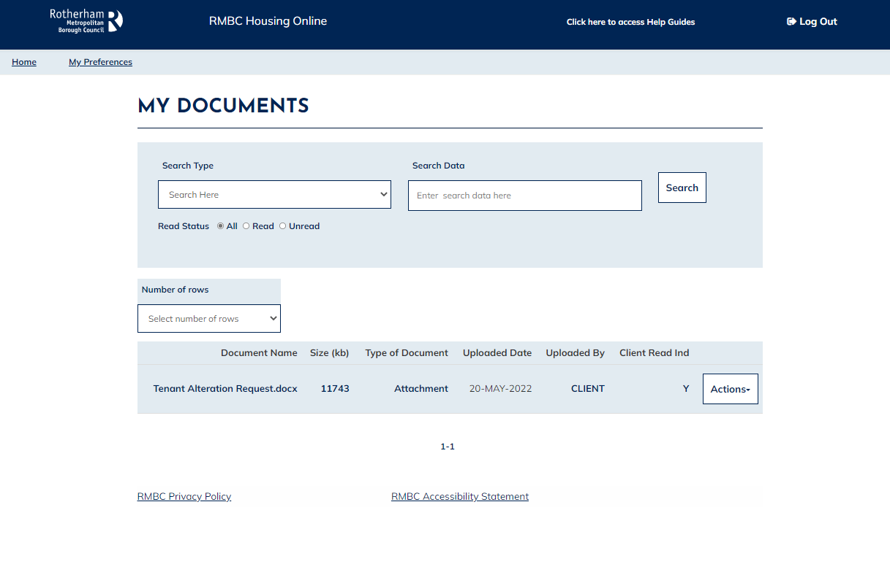
If you upload a document in error, please go to ‘My Saved Documents’ select the ‘Actions’ option. Select ‘View Document Details’
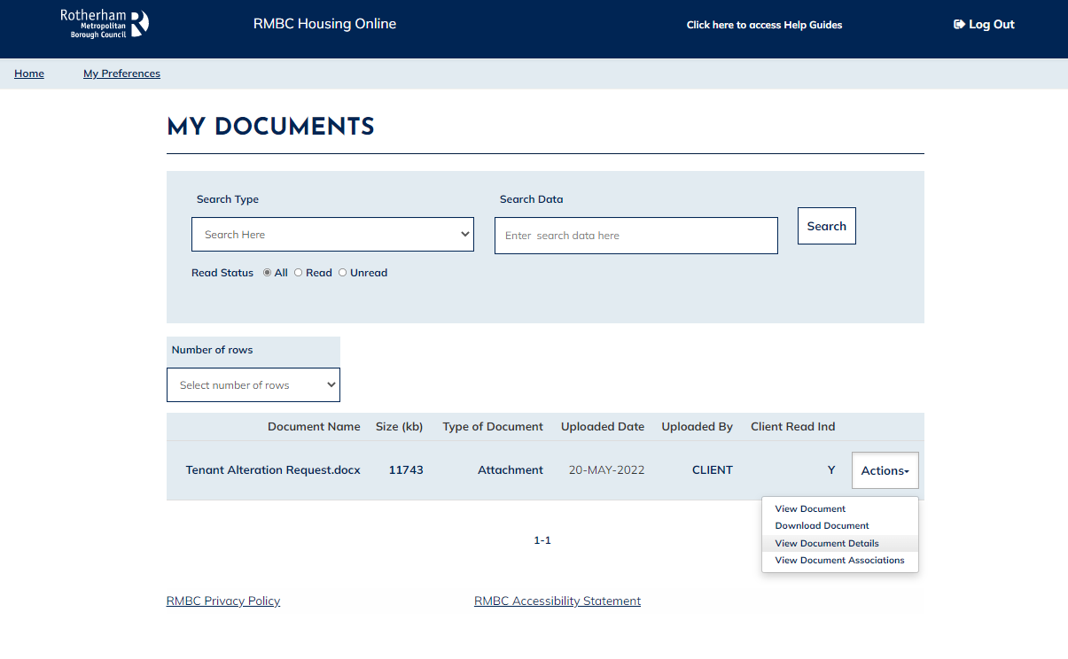

and then ‘Delete’ using the option which will be on the bottom right-hand corner of that page.

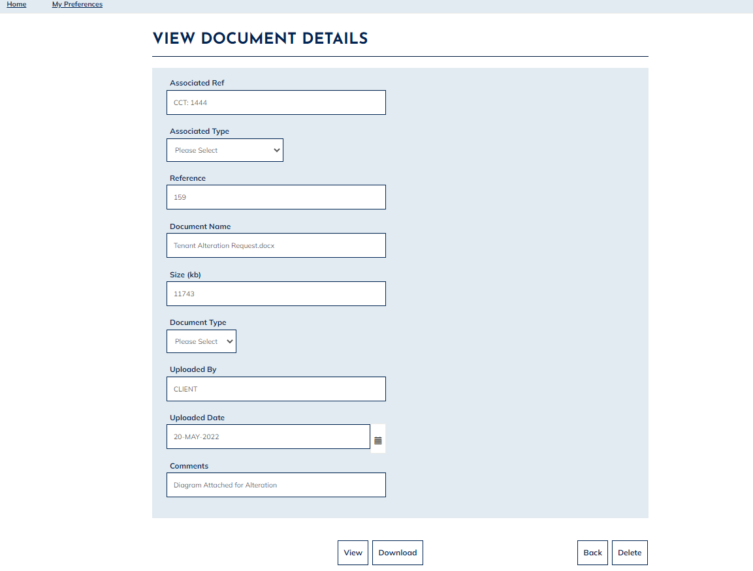
Please note that documents can only be deleted if they have not already been viewed by RMBC.

