Housing Online – Updating Contact Details User Guide
This guide specifically relates to Updating Contact Details. Should you need help finding your way around other parts of your Housing Online account, please refer to the All User Guides section which you can access by clicking here

Contents Page Number
Update Contact Details | 2

Please refer to the ‘Registering and Logging in Guide’ for details of how to register for the first time and/or log in with a previously registered account.

Update Contact Details
Once successfully logged in you will see the ‘My Summary’ page as per the below:
The ‘My Summary’ page displays. From here select ‘Update My Contact Details’
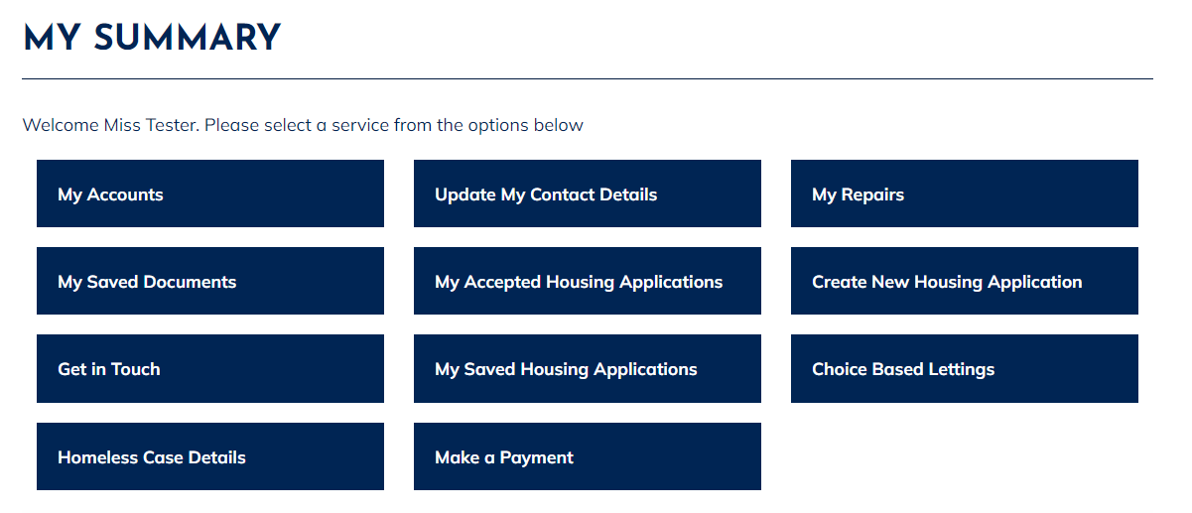The ‘Maintain Contact Detail’ page will show as per the below. From here you can add or amend your contact details. Please be aware that if you update your email address, this will automatically update your log in username to the new email address you have just entered. Once you have added/amended the contact information select ‘Update’.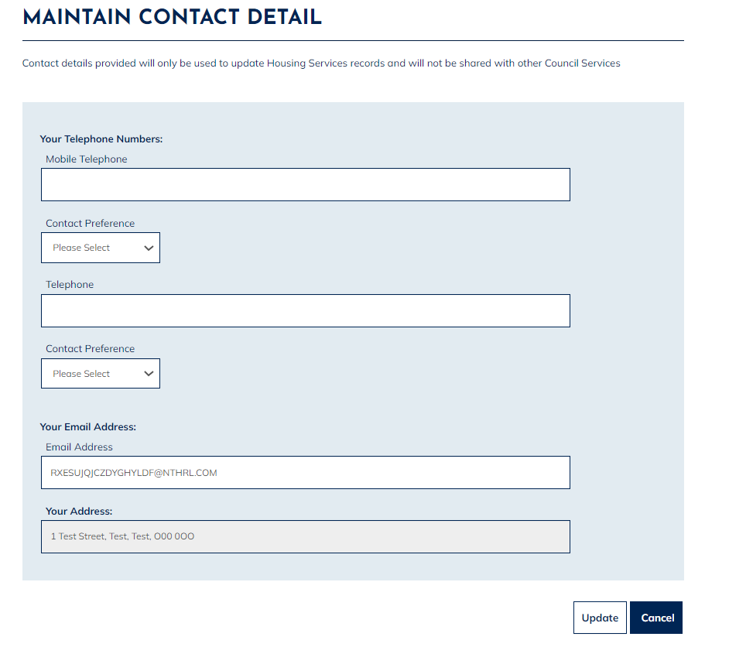
Once you have clicked ‘Update’, a message will show to advise that your contact details have been updated successfully.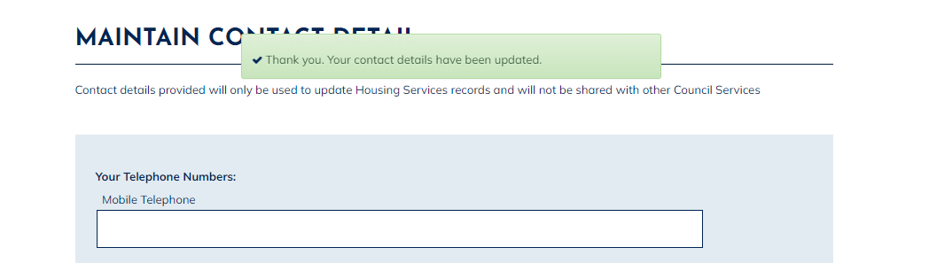

Contact details provided will only be used to update Housing Services records and will not be shared with other Council Services

