Housing Online – My Repairs User Guide
This guide specifically relates to viewing previously reported repairs and reporting a new repair. Should you need help finding your way around other parts of your Housing Online account, please refer to the All User Guides section which you can access by clicking here

Contents Page Number
Accessing My Repairs | 2
To Report a New Repair | 4
To View Repair Details | 11
To View Planned Work | 13

Please refer to the ‘Registering and Logging in Guide’ for details of how to register for the first time and/or log in with a previously registered account.

.

Accessing ‘My Repairs’
Once successfully logged in you will see the ‘My Summary’ page as per the below:
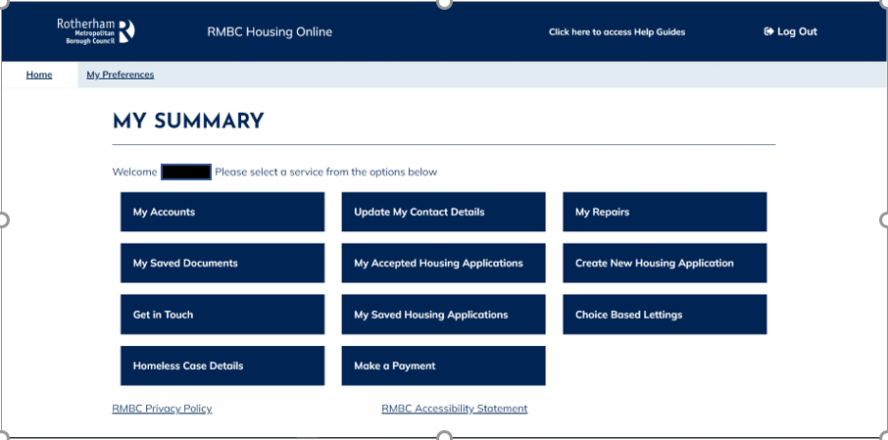
To view details of repairs you may have already reported within the last 90 days or to report a new repair, you will need to select the ‘My Repairs’ option as per the below:

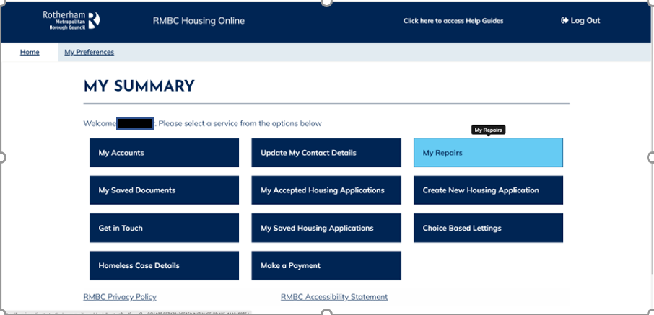

After selecting the ‘My Repairs’ option, the ‘Repairs Summary’ page will open and from here you will be able to view a 90day history of any repairs you may have reported.
You will also be able to view details of the repair, upload supporting documents and photos, view planned work as well as being able to report a new repair.

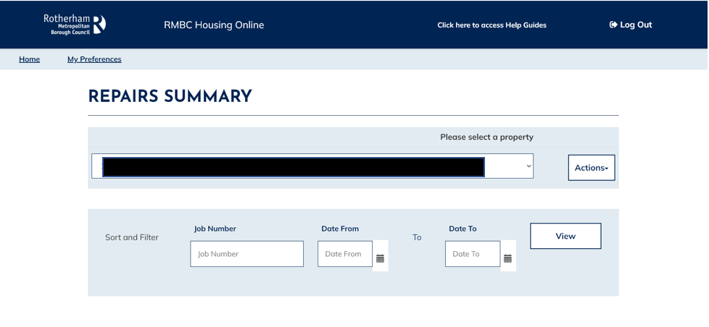
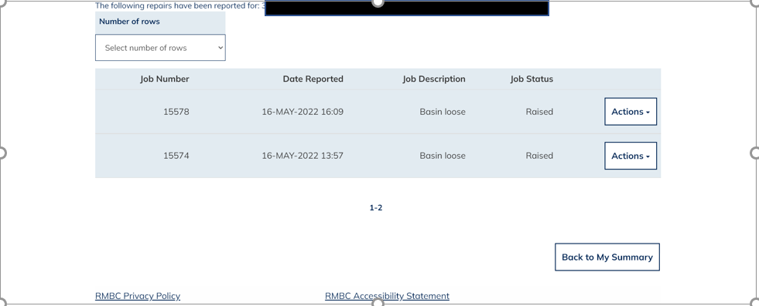

To Report a New Repair
You may have more than one property address linked to your account for example a home and a garage so it is important that you select the correct property needing the repair by selecting the corresponding property details from the drop-down list as per the below: -

Click on the ‘Actions’ button to the right-hand side of the property address box and select ‘Report a Repair for this Address’ as per below:

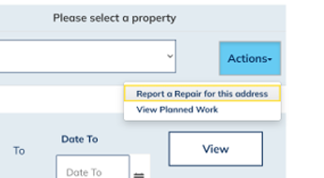

You will be taken through to the ‘Welcome’ screen where you will find information relating to repairs that cannot be reported online such as an Emergency Repair which you will still need to report to us by calling 01709 336009.
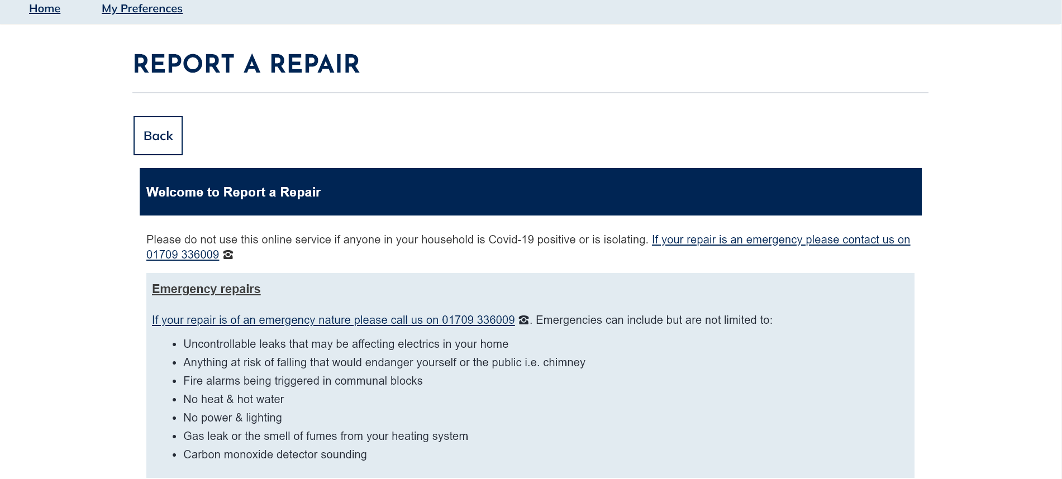
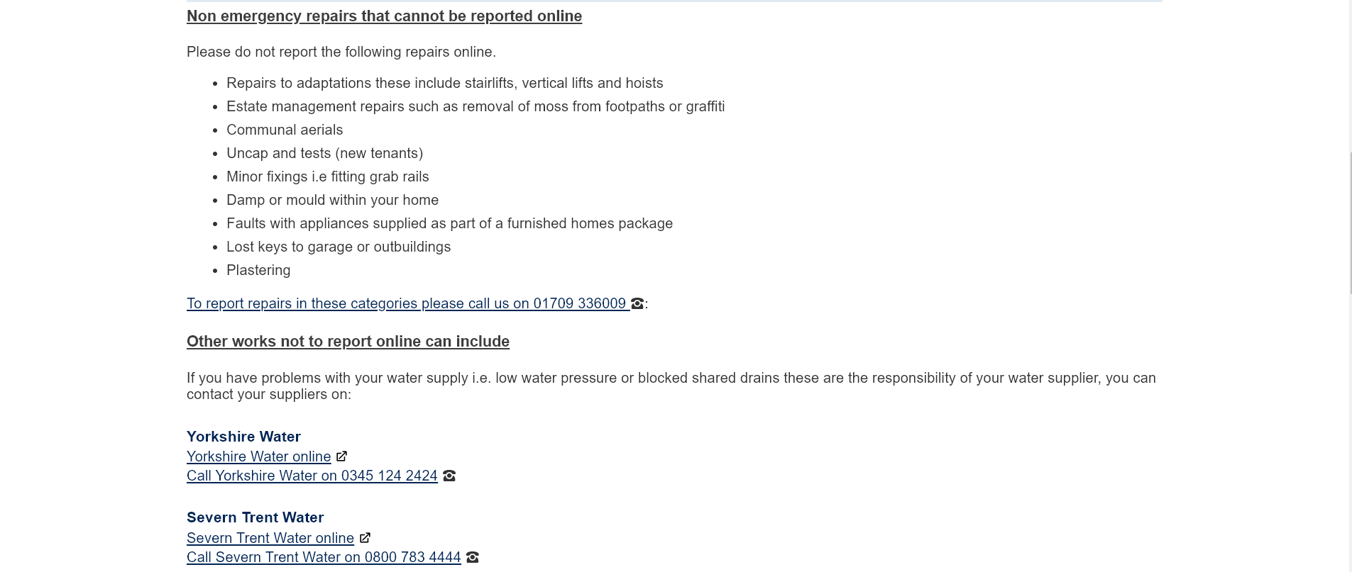
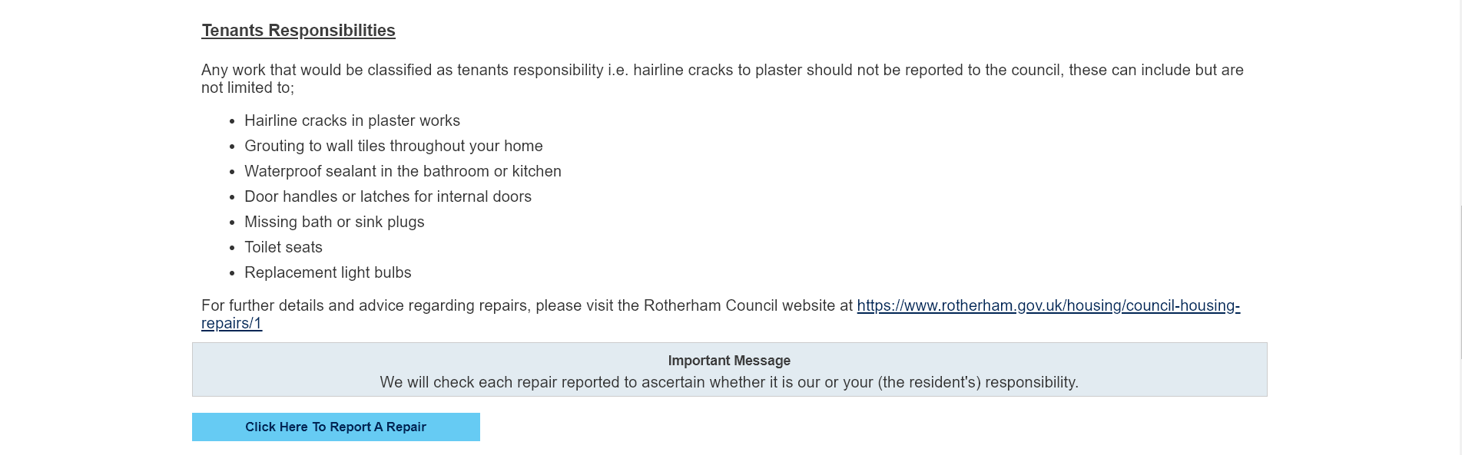
Select ‘Click here to report a repair’ located at the bottom of the Welcome screen
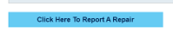

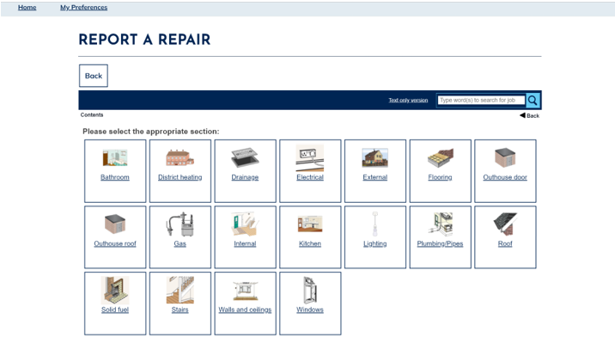
The ‘Report A Repair’ screen will then launch as per the below: -

There are two ways to search for the jobs you wish to report online. Either by the Search box or by using the image options.
- Using the Search Box
Enter a Keyword into the Search box as displayed below: -
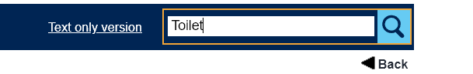
All jobs containing that keyword will be returned as per the below. Select the repair you wish to report: -
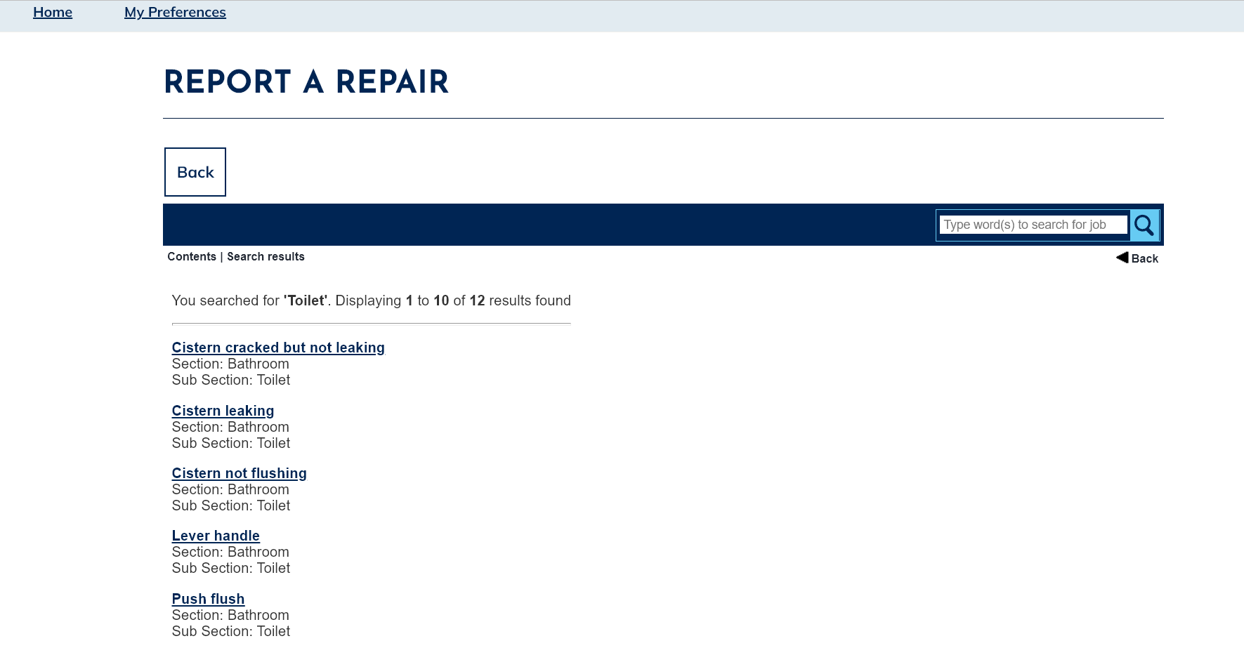

- Using the Image Options
Select the most appropriate image based on the repair:

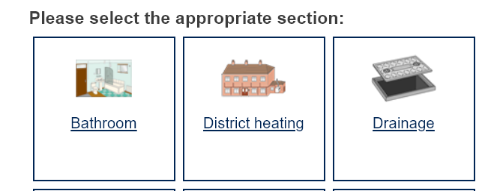

Then select the image option for the most appropriate category

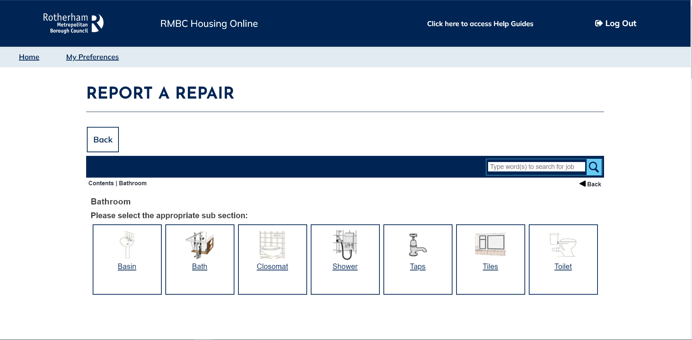

Details of all the repairs that can be chosen from this category will be displayed. Select your chosen repair by clicking on the box next to its description: -

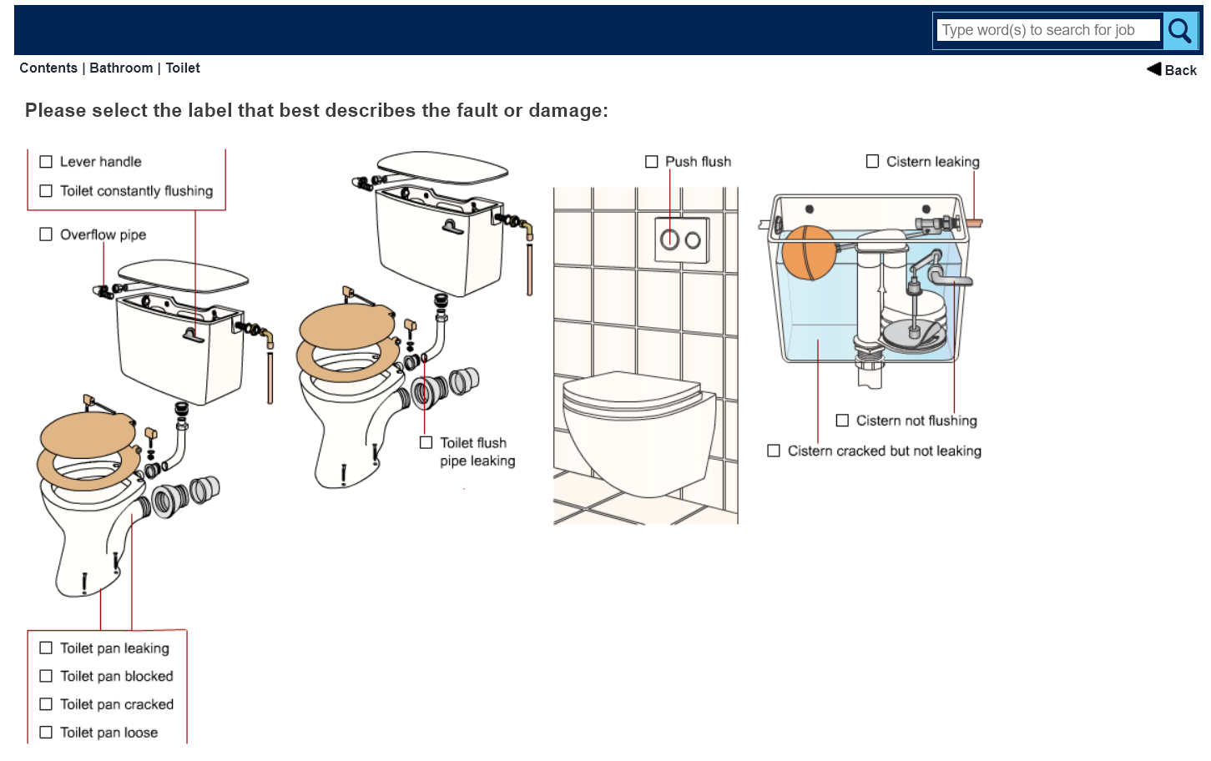
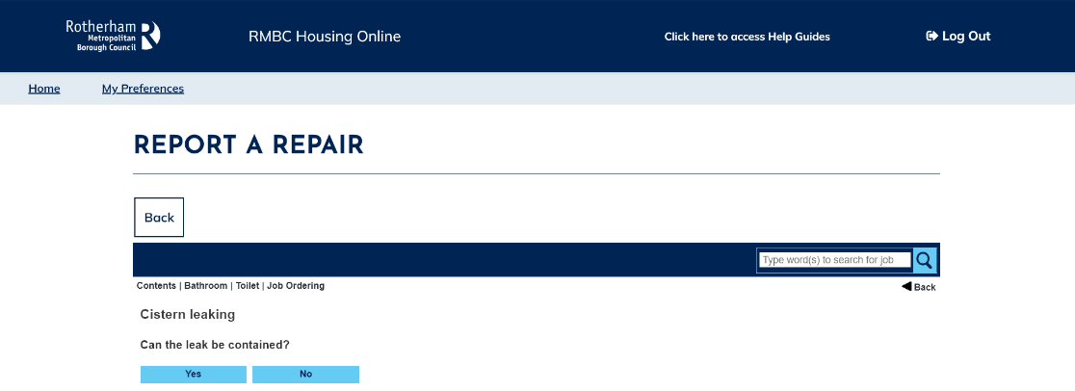
There are some repairs where we will need further information from you to make sure that they are not classed as an emergency repair (as emergency repairs need to be ordered over the telephone). If this is the case, further fields will need to be completed as per the below: -

In the example above if the leak cannot be contained, then this would be categorised as an emergency repair and further progress would be blocked as per the below: -
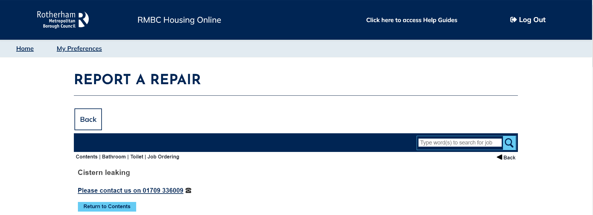

If in the example above the leak could be contained, the online reporting process would continue and progress through to the ordering screen as per the below: -
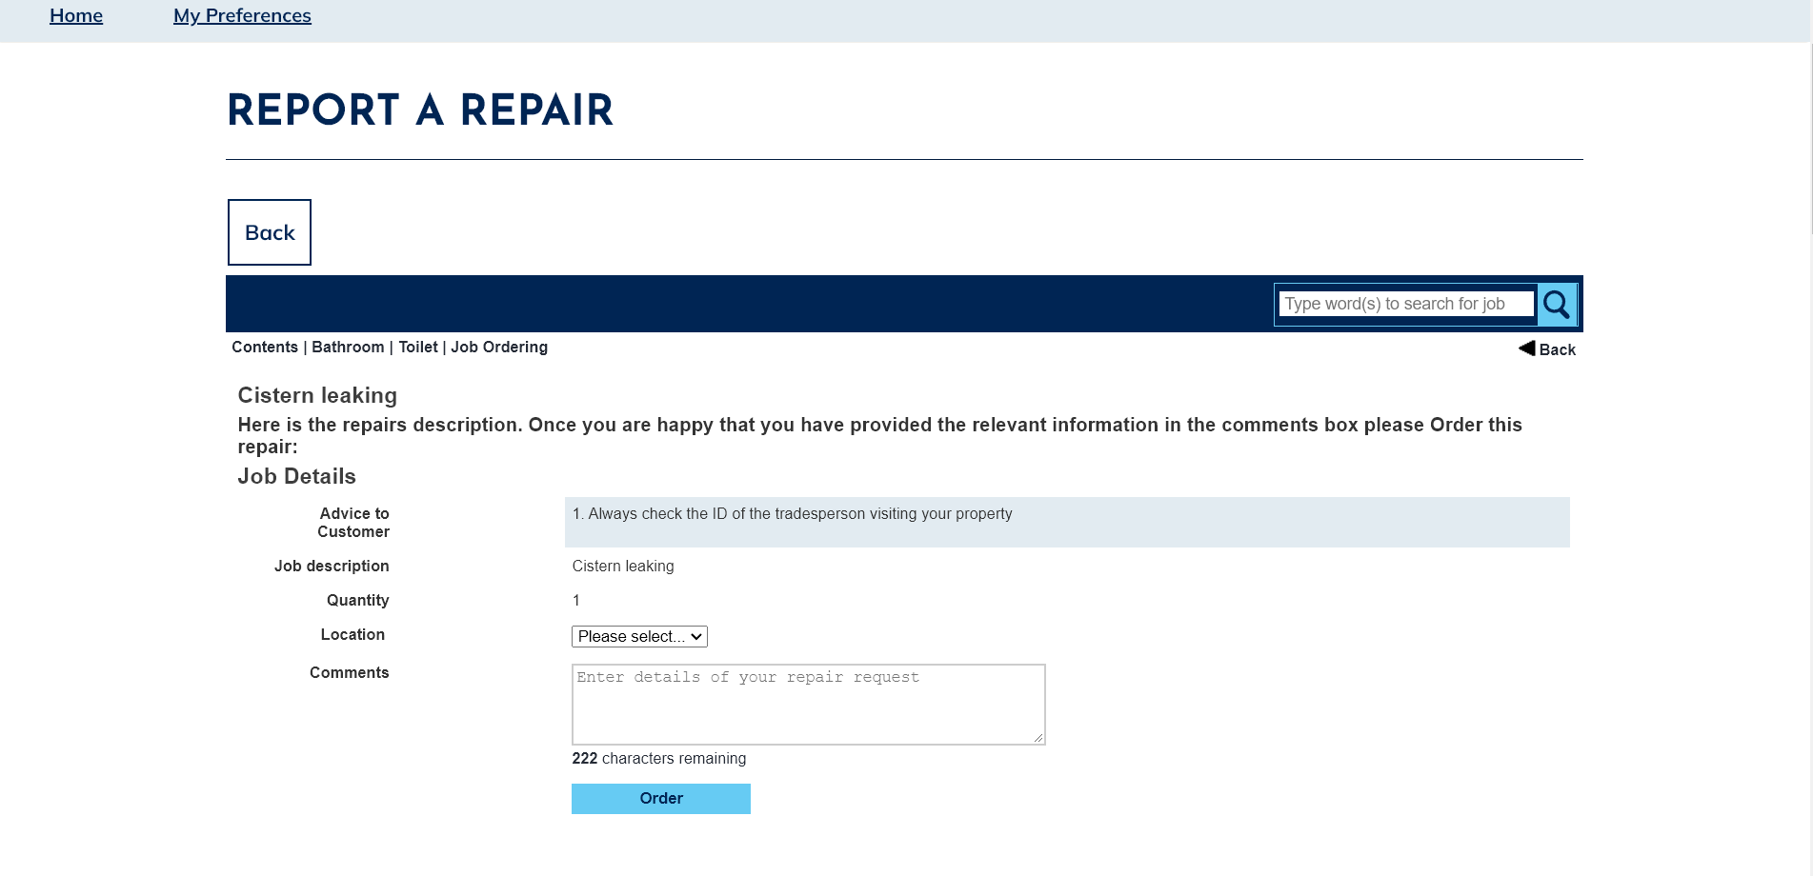
On the above screen, select the appropriate ‘Location’ from the drop-down list and enter any supporting comments (optional)
Select ‘Order’ and the screen would then change to the following. Please be aware that it may take up to 45 seconds before your order number and confirmation message are displayed: -

A screen will then be displayed as per the below showing your job number and displaying the date/time appointment slots available for the repair to be carried out by our operatives:
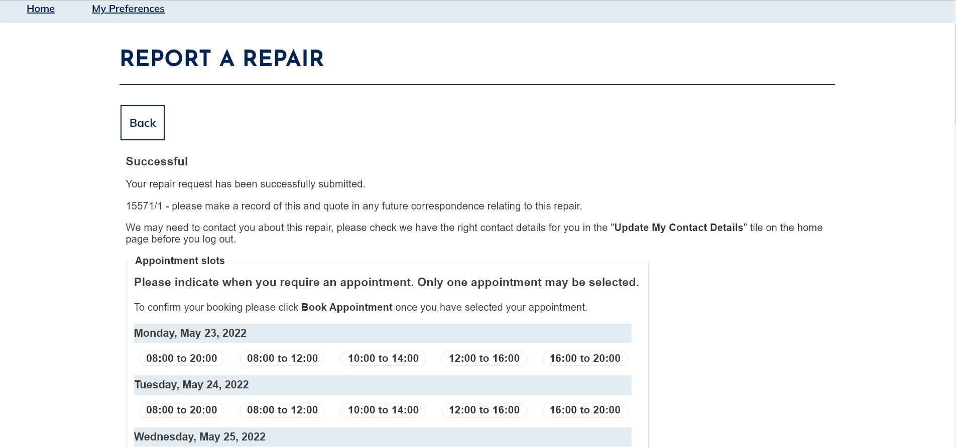
Select the most desired date/time slot before selecting ‘Book Appointment’. A pop-up confirmation window opens as per the below: -
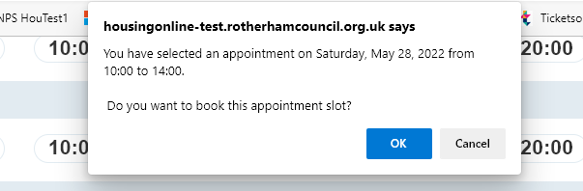
Select ‘OK’ to confirm the appointment booking.
An appointment confirmation screen will then be displayed as per the below: -

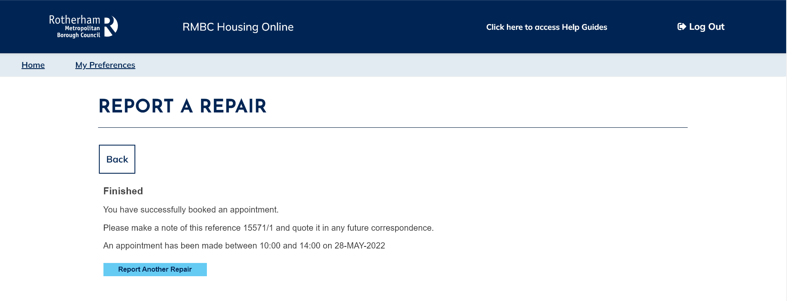
Select either of the three options above to report another repair, go back to the repair summary screen or return to the home screen

To View Repair Details
Once you have logged a repair, details can then be viewed in the ‘Repairs Summary’ page as per the below:

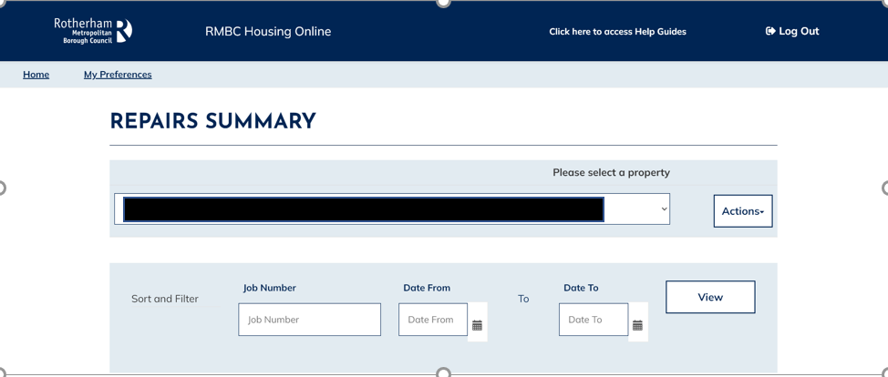
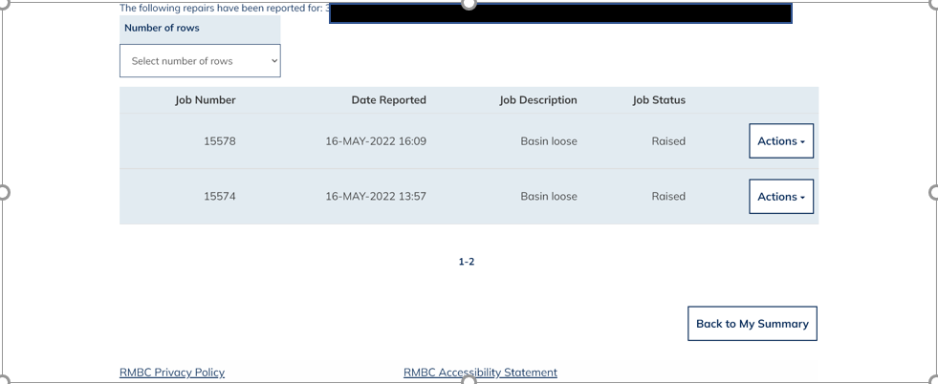

To view further details in relation to a repair, select ‘Actions’ at the end of the row and select ‘View Repair Details’ to see the following details:

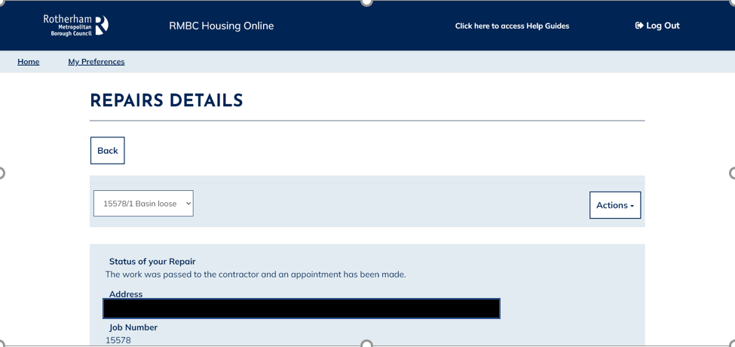

To upload a supporting document or photo – please refer to the ‘Upload a Document user guide’

To View Planned Work
To view any planned work at the property address, select ‘Actions’ to the right hand-side of the Property address field as per the below: -

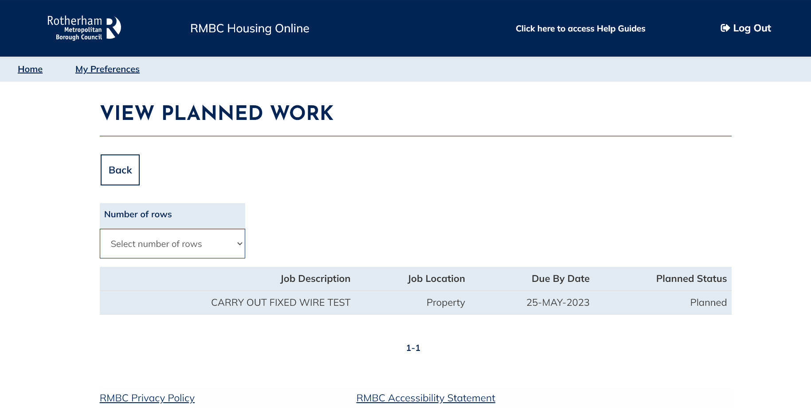
Planned work at the property can then be viewed as per the below: -

