Improvements to
East Herringthorpe Cemetery

IMPROVEMENTS TO EAST HERRINGTHORPE CEMETERY

Improvements to the Muslim burial area of East Herringthorpe Cemetery include the installation of a new drainage system, landscaping and 32 additional tombs.

The historic additional charge for weekend burials has been removed. Extended burial times have been introduced.
This is just part of Dignity’s wide-reaching commitment to develop and improve all the cemeteries we manage in Rotherham.

WHO ARE DIGNITY?

Dignity operates 46 crematoria and 28 cemeteries across England and Scotland. The company also provides funeral services through a network of 770 funeral directors and is a regulated provider of funeral plans. In 2021, Dignity conducted 80,000 funerals including 16,000 burials.

Since 2008, Dignity has operated the crematorium and nine local cemeteries in partnership with Rotherham Council.

At the heart of Dignity is a core purpose to help people say goodbye, to remember and to celebrate the life of lost loved ones. We are proud of how we care for the bereaved and aim to continuously improve and deliver high-quality service and standards. Our colleagues come from within the communities they serve and are empowered so their decision making can respond quickly and effectively to client needs.

WHAT HAVE WE DONE SO FAR?

Cemetery visits and community engagement
Dignity’s Property Director has spent a significant amount of time visiting the cemeteries in Rotherham. This and a series of meetings with the local community have helped us to better understand how we can further develop the services and facilities we help provide.

As the first stage of our commitment to improve these facilities we are now making a number of improvements to the Muslim area of East Herringthorpe Cemetery.

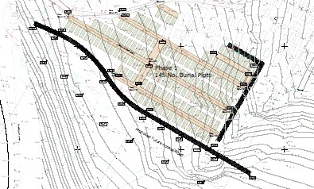Maintenance of driveway and paths
Phase o e pla as proposed
Phase 1 plan as proposed
During 2022, we have resurfaced the driveway and all footpaths at East Herringthorpe Cemetery to improve accessibility and the appearance of the surroundings.

Improved accessibility
Accessibility will also be greatly enhanced by putting in place a permanent path and the installation of handrails where appropriate. This will make it easier for visitors, particularly the elderly or infirm, to reach the grave of their loved one and will also provide a more secure route for those carrying a coffin. This work will also see an additional water tap installed and the current one relocated.

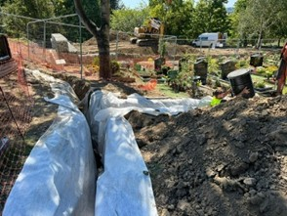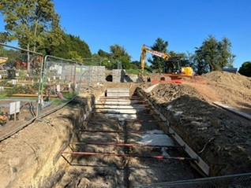

A new drainage system is being installed to alleviate ground water concerns.
Additional tombs are being created

Water testing and drainage
Water testing took place in July. The sample, although mainly uncontaminated, did have a high ammoniacal nitrogen content which prevented us from discharging water into the existing local drains. We believe this may have been caused by contamination from digging trial holes at the time the samples were obtained and a new borehole is being created adjacent to the new soakaway to gain undisturbed samples for future testing.

All the current drainage has been repaired and work has now commenced to alleviate concerns about ground water in the Muslim area of the cemetery by developing a new drainage system.

Additional tombs
Work has also begun to provide further burial spaces by creating an additional 32 tombs created in locations agreed with the local Muslim community.

WHAT IMPROVEMENTS HAVE BEEN MADE TO SERVICES?

Removal of additional fee for weekend burials
In common with other cemetery operators across Yorkshire, there has traditionally been an additional fee in Rotherham if a family required a burial at a weekend. This was intended to cover the overtime rates of the gravediggers and to pay for the cemetery supervisor to identify the burial site and oversee any practical requirements during the service.

Dignity has reviewed its cemetery prices in Rotherham, and after consulting the Council and local community, has decided to waive the additional fee of £481 and absorb the extra costs. We also plan to refund any grave owner that has previously paid the additional weekend fee.

Extension to last burial times
Improvements to services have also been introduced to assist those whose religious beliefs require a deceased persons to be buried within 24 hours of their passing. The last burial time of the day has been extended to 6.30pm during the summer and the times for other periods of year will be reviewed during the coming months.

Portable lighting will be made available to maintain the safe conditions for visitors when burials take place during the late afternoon or early evening.

We hope that this will provide additional capacity to meet this need from local residents and ensure loved ones can be buried within 24 hours.

WHAT HAPPENS NEXT?

Initial discussions have already taken place between Dignity and the Council Planning Department regarding a potential extension to East Herringthorpe Cemetery. Dignity will submit a planning application by the end of September to seek authorisation to extend the cemetery ensuring burial space for future generations of families in Rotherham.

Further community engagement events are to be scheduled for later this year to discuss the development and maintenance of all the cemeteries in Rotherham and we look forward to welcoming you to these meetings.

