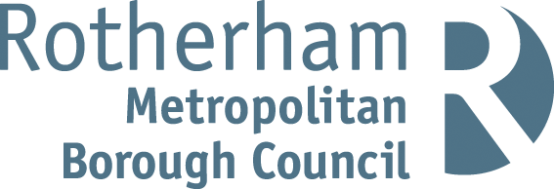
Rotherham MBC Parking Account 2021 / 22
Statistical Information
Number of higher level Penalty Charge Notices (PCNs) issued | 7,447
Number of lower level PCNs issued | 5,420
Number of PCNs paid | 9,039
Number of PCNs paid within 14 days | 4,041
Number of PCNs against which a formal or informal representation has been made | 7,210
Number of PCNs cancelled (i.e. where an informal or statutory representation is successful) | 1,621
Number of PCNs written off | 32
Number of vehicles wheel clamped | 54
Number of vehicles removed | 32

The above statistics are accurate as of 30th September 2022. These statistics can be subject to change on a daily basis due to the ongoing debt collection procedures.
Financial Information
The total income and expenditure of the on-street and off-street parking account for 2021 / 22 was as follows:
Expenditure £880,616
Income
Income source | £
Penalty Charge Notices | 319,209
Off street paid parking | 348,581
On street paid parking | 255,228
Permits | 96,269
Enforcement Agents (bailiffs) | 57,489
Miscellaneous income | 3,588
Total income | 1,080,364

Net Surplus £199,748
Note: Income for PCNs issued in 2021/22 may increase because, in cases where PCNs remain unpaid beyond the statutory period, the Council has a policy of registering the debts at the Traffic Enforcement Centre (TEC) at Northampton County Court. This is the Court which deals with all parking debt in England (outside London). Once a debt is registered the debtor is given a further 21 days to settle the debts before Enforcement Agents (formerly known as bailiffs) are appointed. Any income collected after 31/03/2022 from PCNs issued during 2022/23 will be credited to the Parking Account for 2022/23.

