Cohort Early Years Transition Document – Prime and Specific Areas of Learning 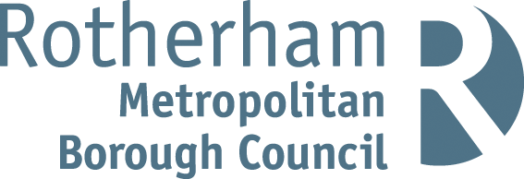
Please indicate using a X to indicate if each child is NOT achieving typically expected milestones for their age.
NOTE: For any child who is NOT meeting typically expected milestones for their age, you should use a more detailed transition document offering further details to the child’s new setting.
Name of setting this cohort is transitioning from: | Contact Number:

Child’s Name | Communication and Language | Personal, Social, and Emotional Development | Physical Development | Literacy | Mathematics | Understanding the World | Expressive Arts and Design
NOTE: Please use a specific Speech, Language and Communication assessment tool to help you in deciding which of the statements above to tick. You could consider using Rotherham’s own SLC Assessment tool, or our ‘Tiny Talkers’ milestones that can be found here, Developmental Stages – Tiny Talkers Developmental Stages – Tiny Talkers or those found on websites like ‘Universally Speaking’ found here Universally Speaking (speechandlanguage.org.uk) Universally Speaking (ican.org.uk) Alternatively you might like to use the ELKLAN SLC Assessment Tool, found in the back of the ‘Early Language Builders Book’.
Note: To help identify if this child is working in line with typical child development milestones, please consider referring to a helpful guide like Rotherham’s Child Development Charts, OPAL documentation, NHS Guidelines or the checkpoints found within ‘What to Expect in the EYFS; a guide for Parents’.

