Foreword
I am pleased to introduce our Local Account which allows us to celebrate that we have accomplished over the last year and commit to our aims for Adult Social Care for the coming year.
In Rotherham we believe in a strength-based person-centred approach to achieve our aim of "People are safe, healthy and live well". To achieve this, we must put our residents at the heart of what we do, and Adult Social Care is committed to this ethos.
We are proud of the relationships we have built within our local communities to improve our services and of the improvements we have made in terms of timeliness of the services that we offer. Looking forward, we are committed to gaining meaningful feedback that will actively shape future services that we deliver for the residents of Rotherham.
We will also continue to work collaboratively with partners to ensure that what we offer enables our residents to thrive and live their best lives.
Councillor David Roche, Cabinet Member for Adult Social Care and Health.

ADULT CARE & SAFEGUARDING
ABOUT THE LOCAL ACCOUNT
The Local Account aims to summarise our achievements and celebrate the hard work and dedication from our teams over the last year. We will set out our priorities for the coming year and highlight where we still need to improve and make progress and how we plan to do that.

The Adult Social Care Context
Our ambition is to support our residents to be independent and resilient. We do this by:
- Enabling them to be the healthiest they can be to lead full active lives, live independently and play an active part in their communities
- Ensuring choice about how they live their lives so they feel happy, safe and secure
- Focusing on prevention so that people have more control over their lives
- A "doing with" and not "doing to" approach so that our interventions respond to the needs of the person.
There have been many achievements in the last 12 months, and we have a number of key priorities for the coming year to support achieving our ambition for residents.

SAFEGUARDING ADULTS
Safeguarding is about protecting people from abuse or neglect and educating those around them to recognise the signs and how they can report their concerns. To keep our residents safe, we know there are lots of actions we currently do and more we can do. Amongst our aims are improving mental health, developing resilience, and giving choice and control to support people stay as safe as possible.
As a council we have a Safeguarding Adult Pathway to protect vulnerable residents and ensure we make safeguarding personal to the person at risk of harm or abuse. Our Rotherham Safeguarding Adults Board (RSAB) is committed to taking a partnership approach to help protect adults at risk of or experiencing neglect, harm or abuse.
In 2022, Adult Social Care reviewed the safeguarding adult pathway to further strengthen practice and legal compliance with the Care Act 2014.
During the 2022/2023 year, 449 people were subject to a new Safeguarding enquiry and 631 people had an enquiry completed. The majority of enquiries related to older people and happen in a person's own home. Of the enquiries completed 432 people felt they had their voices heard in the safeguarding process under Making Safeguarding Personal.

SUPPORTING OUR RESIDENTS
During the last 12 months we have provided support services for 5,273 residents.
At the end of March 2023, there were 3,579 people receiving 4,018 services (meaning that some people access multiple services) from Adult Social Care.
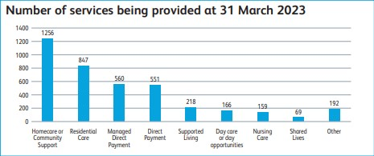
31% of people being supported were aged 18-64 and 69% were aged 65+.
Primary Support Reason | Age 18 - 64 | Age 65+ | Total
Physical Support | 414 | 1,570 | 1,984
Learning Disability Support | 698 | 87 | 785
Mental Health Support | 230 | 150 | 380
Support with Memory and Cognition | 11 | 247 | 258
Social Support | 48 | 34 | 82
Sensory Support | 37 | 24 | 61
Not yet recorded | 3 | 26 | 29
Everyone on the service at 31st March 2023 | 1,441 | 2,138 | 3,579

During the 2022/2023 year, 59% of residents receiving support identified as female and 41% of residents identified as male.
Of the 3,579 people accessing services at the end of March 2023, 53% also received support from an unpaid carer.
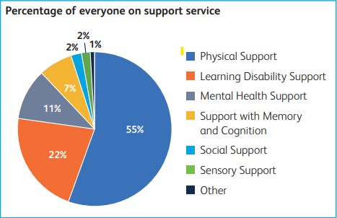
Equality, diversity and inclusion
There is under-representation of people from Ethnic Minority Communities for residents who access our services. 4% of people who received services are from these communities.
This is low compared to the Rotherham Ethnic Minority population rate of 10%. One of our priorities and areas of focus is to ensure more representative take up of adult social care across all our local communities.
OUR ACHIEVEMENTS OVER 2022/2023
- Supported an increasing number of residents to live independent, safe and well lives
- Increased the number of reviews offered to people with care and support needs above regional averages
- Worked with health partners to develop the Community Hub which aims to improve the support available to people being discharged from hospital and admission avoidance to keep people safe and well at home
- The number of families living in temporary accommodation has reduced following the introduction of the Domestic Abuse Housing Officers
- Community Connectors have continued to work closely with local community groups to ensure people’s social outcomes are met individually and through the ongoing development of a wide range of community groups
- Conway Crescent Respite Service was rated ‘Good’ by the Care Quality Commission (CQC)
- Funding was secured for Dual Diagnosis workers to support people with the impact of substance misuse
- The Community Catalyst project has led to the creation of at least 20 enterprises that now provide quality, creative support for people with a learning disability in Rotherham. By the end of the project enterprises provided 555 day opportunities and created 137 new jobs for local people.
- Launched our Mental Health Recovery Flexible Purchasing System to develop a range of services within Rotherham to support people with mental ill health
- Completed the Department of Health and Social Care national exercise to ensure that we are paying a fair price for care services and that care workers are paid an appropriate wage to provide quality care services to vulnerable adults living in the Borough
- The Integrated Discharge Team won the ‘South Yorkshire Teaching Partnership Team of the Year Award’
- The Localities Service won awards for Social Worker of the Year, Social Care Assessor of the Year and Long Service Award at the South Yorkshire Teaching Partnership Awards
HOW WE USE OUR RESOURCES
Our latest financial data shows Rotherham spent a total of £74.8 million on Adult Care and Support services in 2021/22 (for which the latest full financial year figures are available). This was funded through a mixture of Council Tax, Adult Social Care Precept and grant. The spend was broken down as follows;
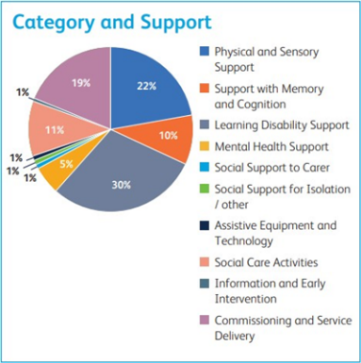
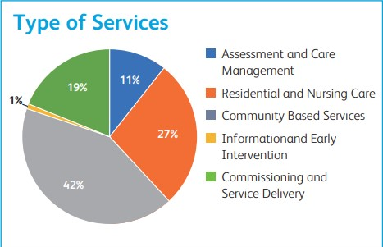

OUR PRIORITIES FOR THE YEAR AHEAD
- Develop a new Adult Social Care Strategy and Vision for Rotherham in partnership with residents and partners
- Work with partners to develop an approach to prevention for adult social care which supports people to maintain their independence and maximise their wellbeing
- Ensure completion of Care Act Assessments are timely for people needing support
- Access to Assistive Technology to support people to live independently is expanded by Rothercare
- Collaboratively work with partners to complete the Mental Health Service Review and implement a future delivery model which operates 24/7
- Ensure take up of adult social care services is representative of our local communities
- Identify areas of good practice and areas for improvement to ensure we are fully prepared for regulation
- Design and implement a feedback mechanism to capture the voice of the resident with care and support needs following dealings with Adult Social Care. Use this feedback to actively shape future services
- Co-produce a new Strategy for Learning Disability Services
- Design and begin construction of ‘Castle View’ day opportunities for people with complex support needs
- Work with partners to develop an approach to prevention for adult social care which supports people to maintain their independence and maximise their wellbeing
- Launch the Borough that Cares Strategy and work with unpaid carers to develop services that meet the identified priorities
- Publish the Learning Disability/Autism Supported Living Flexible Purchasing System to enable us to continue to expand the opportunity for people to live as independently as possible
- Develop and publish a Flexible Purchasing System to further increase the number of day time opportunities for people with a Learning Disability and Autistic people
- Continue to ensure that commissioned services are of a high quality and can effectively meet peoples care and support needs
- Ensure there is a vibrant care market in Rotherham which can continue to meet the demand for services.

VOICE OF THE RESIDENT
During 2022/23 we received 166 compliments compared to 62 complaints.

“They often go above and beyond to ensure patients do not become delayed transfers of care” and they were described as “warm, friendly, dedicated and knowledgeable”.
Compliment for a Social Worker in the Access Team.

“The service from all the staff visiting has been exemplary and they have gone above and beyond what was expected”.
Compliment for the Reablement Team.

“They took the time to assess my needs and explain how different bathing aids would help me. They were professional and friendly and allowed me to ask questions”.
Compliment for a Community Occupational Therapist.

“On behalf of the family thanks to you and the Together Housing team for your help and support. In their time there, my parents were able to enjoy living at Potteries Court because the staff and carers were very compassionate and professional”.
Compliment for Potteries Court.

“Thank you for all your support and hard work over the past four or five months. I know it’s not been easy and very stressful at times but you got us there in the end and we do really appreciate the time and effort from all of you”.
Compliment for Potteries Court.

“Thank you for your valuable help and support recently. You have clarified everything for me and gone above and beyond to find answers to my questions”.
Compliment for a Social Worker in the Localities Team.

Complaints reduced by 18.4% on the previous year with the majority being around the actions or attitude of a social worker, insufficient provision of information and delays in service. This reflects the high demand for support and we are working to improve access to our services. We are doing this by an improved information and advice offer, increasing capacity in care services to provide services quicker and having clear practice standards for Social Workers. Of the 62 complaints received, 55 (88.7%) were satisfied at stage one without further escalation.

THE BEST WORK OF OUR LIVES
Sally was open to the Complex Lives team following concerns that she was being exploited in the community. Sally had periods of low mood due to her circumstances and had frequent hospital admissions due to her physical and mental health. Sally was supported to engage with services including tenancy and crisis support. A new bank account was set up to reduce Sally’s dependence on others, she was supported to apply for benefits and attend appointments to manage her own affairs. Sally now lives independently and safely and has reconnected with supportive family members.
Billy was experiencing falls, had heart problems, recurrent chest infections and could not walk independently. Billy was admitted to hospital for treatment of a chest infection and a fall. Billy went home with services to support him in his recovery but shared concerns that his family could no longer provide the support he needed and chose to move into a Care Home. Billy’s health has now improved, and he has treated himself to new clothes. Billy’s family visit him regularly, as does his Social Worker, who is on hand to support as he settles into his new routine and environment.
Paul was matched with a Shared Lives couple for day support alongside two of his friends. The match flourished and Paul, his friends and his Shared Lives carers enjoy many activities together such as visits to local places of interest, local cafés and parks. Paul made an instant connection with his Shared Lives carers and their family and soon they all agreed to extend his support to overnight stays. This arrangement has enabled Paul’s mum to keep caring for her son from the family home whilst the Shared Lives Carers ensure he maintains good health and wellbeing, enjoys his time with his friends and mum can take a break from caring. Paul is enjoying his best life with support from his mum and Shared Lives family and says “I am happy spending time with my friends”.
Elaine has motor neurone disease which has affected the use of her upper limbs and significantly impacts on her ability to feed herself independently. Elaine tended to leave her food rather than ask for help as the family have two young children who require supervision at mealtimes. Elaine was assessed by adult social care, and it was agreed with Elaine to commission a Neater Eater Robot. The Neater Eater Robot is a piece of assistive technology that helps Elaine to eat independently with her family as she can operate the robot with a foot switch. Elaine and her family can now sit down at mealtimes to eat their meals together which makes such a difference to both her and her family’s quality of life. Elaine’s nutrition is also significantly improved which is vital for her wellbeing.

