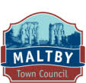
Maltby Neighbourhood Plan 2017-2028
Maltby Town Council |  | Adopted February 2024

forEWord
Welcome to the adopted neighbourhood plan for the historic parish of Maltby.
In 2013 a Town Plan was published for Maltby. The product of consultation with the community and other interested bodies, it identified the main issues that affect individuals living and working in Maltby and proposed realistic approaches to address them. It was a sound plan. However, its non-statutory nature meant that it had limited influence on planning and other important matters affecting the Town.
In 2017 Maltby Town Council decided to build on the Town Plan by taking into account the opportunities presented by the Localism Act for communities to develop neighbourhood plans which have more weight in the planning making process.
It was adopted followed a referendum of Maltby residents in February 2024, in which the majority voted in favour of it.
It reflects the hard work of officers and members of Maltby Town Council, other members of the Steering Group, local ward members and officers from Rotherham Metropolitan Borough Council (‘Rotherham MBC’), neighbourhood planning consultants andrewtowlertonassociates, as well as many other people and bodies with an interest in the future development of Maltby. Thanks must also go to the financial and other support provided by ‘Locality’ which has met most of the financial costs of producing this Plan.
However, it is your involvement and support that have been most valued. Without it, this Plan could not have been developed. Every effort has been made to ensure that the policies in this Plan reflect the views of residents.
Whether we like it or not, inevitably, Maltby is going to change over the next 10 years or so.
The Plan sets out the vision and objectives of the community, which will ensure Maltby develops for the benefit of everyone. However, it also reflects the importance of ensuring that Maltby continues to be a great, distinct and proud community.
Councillor John Kirk – Town Councillor and Chairman of the Maltby Neighbourhood Plan Committee

Contents

1. Introduction Page

1.1 Why we HAVE decided to prepare thE plan 5

1.2 how the plan fits into the planning system 6

1.3 The plan preparation process 9

1.4 what happens next 10

2. about MaLtBY parish 11

3. what we want it to achieve 14
3.1 VISION 14
3.2 OBJECTIVES 14

4. policies for MalTBY parish 15

5.1 PROMOTing GOOD QUALITy AND DISTINCTIVE DESIGN 16

POLICY M1: PROMOTING GOOD QUALITY AND DISTINCTIVE DESIGN 18

POLICY M2: MALTBY cHaRACTER Buildings OF LOCAL HERITAGE INTEREST 21

COMMUNITY ACTION 1: MaltbY HISTORIC CORE AND MALTBY MODEL

VILLAGE Local Areas of Special CharactER 24

6.1 Promoting Good HOUSING For ALL 24

POLICY M3: HOUSING MIX 26

POLICY M4: AFFORDABLE HOUSING 27

COMMUNITY ACTION 2: HOUSES IN MULTIPLE OCCUPATION 29

7.1 SHOPS AND MALTBY CENTRE 29

POLICY M5: SHOPS OUTSIDE OF MALTBY TOWN CENTRE 32

POLICY M6: HOT FOOD TAKEAWAYS 35

8.1 Community facilities 35

POLICY M7: Supporting New and Enhanced Community Facilities 37

POLICY M8: ASSETS OF COMMUNITY VALUE 38

9.1 NaTURAL ENVIRONMENT 38

POLICY M9: Nature Conservation 40

10.1 getting around AND tRAFFIC mANAGEMENT 41

POLICY M10: Traffic Management 43

11.1 Developer contributions 43

12. Monitoring and review 45

figures

Figure 1: Maltby Parish – the Neighbourhood Plan Area 5
FIGURE 2: MALTBY TOWN CENTRE (AS DEFINED IN THE ROTHERHAM LOCAL PLAN) 46
FIGURE 3: MUGLET LANE LOCAL CENTRE (AS DEFINED IN THE ROTHERHAM LOCAL PLAN) 47

Appendix
APPENDIX 1: MALTBY CHARACTER BUILDINGS AND STRUCTURES OF LOCAL HERITAGE 48-61
INTEREST (MAPS)

INTRODUCTION
- This is the adopted version of the Plan for Maltby Parish. It has been prepared by the Maltby Neighbourhood Plan Steering Group. This body has brought together town councillors and other members of the local community and has been led by Maltby Town Council.

- A neighbourhood plan is a planning document that gives local people an opportunity for a measure of greater control and say over how their community develops and evolves. It is an opportunity for local people to help deliver a sustainable future for the benefit of all who live or work in that community and those who visit it.

- As the Government National Planning Policy Framework (‘NPPF’) states, ‘Neighbourhood planning gives communities the power to develop a shared vision for their area. Neighbourhood plans can shape, direct and help to deliver sustainable development, by influencing local planning decisions as part of the statutory development plan’.

- It enables a community to create a vision and set clear planning policies for the use and development of land at the neighbourhood level to realise this vision.

- Neighbourhood plans can be general or more detailed, depending on what local people want. They must, however, be in general conformity with Rotherham-wide planning policies, have regard for national planning policies and must be prepared in a prescribed manner.

- Each time a planning decision has to be taken by Rotherham MBC, or any other body, and for applications within the neighbourhood area, they will be required to refer to the Plan (alongside the Local Plan and other relevant documents) and check whether the proposed development is in accordance with the policies that the community has developed.

- The Plan area encompasses the whole of the parish of Maltby and covers the period up to 2028, a timescale which deliberately mirrors that of the Rotherham Local Plan.

Figure 1: Maltby Parish – the Neighbourhood Plan Area
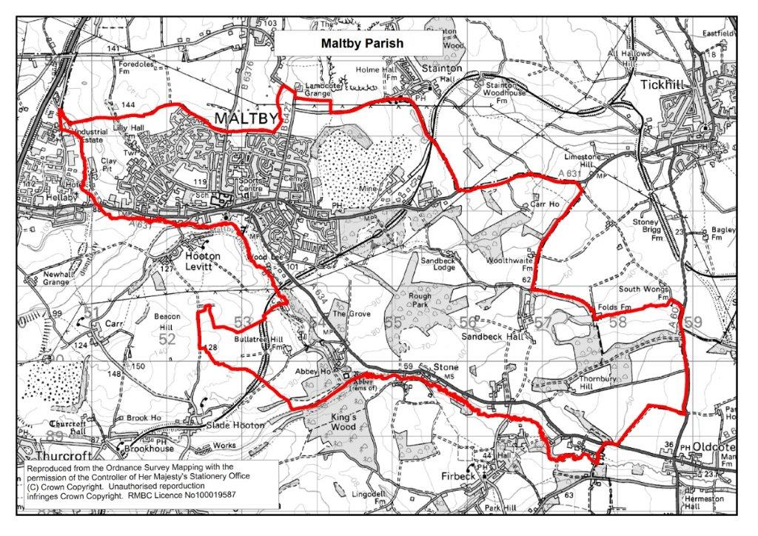
- The Plan will be kept under review and may change over time in response to new and changing needs and requirements.

Why we have decided to prEPARE the Plan
- It was decided to produce a neighbourhood plan as the community wanted to play a much stronger role in shaping how Maltby develops.

- A neighbourhood plan provides the opportunity for the community to set out a vision and plan for how they want Maltby to develop over the next five years and beyond in ways that meet identified local need, make sense for local people and make Maltby an even better place to live and visit.

- It enables the community to put in place locally formulated planning policies that will help deliver an agreed vision for Maltby provided those policies are in general conformity with the strategic policies for Rotherham Metropolitan Borough as a whole. It provides the opportunity to specify in more detail what we expect from development in Maltby and how and where it should take place, if at all. Furthermore, unlike parish or town plans or other kinds of documents that may be prepared by a community, a neighbourhood plan forms an integral (statutory) part of the development plan for an area.

- Having a neighbourhood plan will also result in direct financial and other benefits to Maltby. Specifically, Rotherham MBC has introduced a levy on future development called the Community Infrastructure Levy (CIL). Without a neighbourhood plan, the Town Council would receive 15% of any CIL collected from qualifying developments. However, with a neighbourhood plan it would receive 25% of the CIL collected to be spent in Maltby. With the many hundreds of new homes and other forms of development to be built in the parish over the period of the Plan, this could be a substantial sum, potentially tens if not hundreds of thousands of pounds to be spent by the Town Council on behalf of the residents and businesses of Maltby.

How the Plan fits into the Planning SysteM
- The right of communities to prepare a neighbourhood plan was established through the Localism Act 2011. The Plan once ‘Made’ will form part of the statutory development framework for Rotherham and will be an important consideration in the determination of planning applications.

- There are national rules governing the preparation of neighbourhood plans. These rules are known as ‘Basic Conditions’.

- One of the key ‘Basic Conditions’ is that a neighbourhood plan must have regard to national planning policies, primarily contained in the NPPF and associated National Planning Practice Guidance (Guidance). ‘The National Planning Policy Framework sets out the Government’s planning policies for England and how these should be applied’ (para 1).

- A further important ‘Basic Condition’ is that a neighbourhood plan must also be in ‘general conformity’ with, and not promote less development than, the strategic policies of the development plan for the area.

- In the case of Maltby, the key local development planning document for the parish, and the wider borough that it must have regard to, is the Rotherham Local Plan. The Rotherham Local Plan consists of several documents that provide a long-term development strategy for Rotherham for the period, 2013 to 2028, setting out ‘…policies and proposals for new housing, shopping and employment, and how you travel in the area. The Local Plan is used to make planning decisions and decide planning applications’.

- The Rotherham Local Plan contains many elements that are relevant to the Plan, and which it must be in ‘general conformity’ with.

- The key elements are contained in the Core Strategy. Adopted in 2014, this sets out the spatial strategy for the whole of Rotherham and ‘identifies the broad locations for delivering new housing and employment, including provision for retail, leisure and community facilities, how much new development we need, where it should go and when it should happen’.

- The Core Strategy in Policy CS1 identifies Maltby Parish with the adjoining settlement of Hellaby as one of a number of ‘Principal settlements for more limited growth opportunities’. It requires that the Maltby and Hellaby Principal Settlement accommodate approximately 700 new dwellings and 5 hectares of new employment land up to 2028.

- The Core Strategy also contains many other policies that are relevant to the development of the Plan. These include:
- CS4 (Green Belt), which protects the Green Belt.
- CS7 (Housing Mix and Affordability) requires new housing developments to deliver a mix of dwellings sizes, type and tenure.
- CS12 (Managing Change in Rotherham's Retail and Service Centres) identifies Maltby as a designated Town Centre where proposals will be expected to contribute to maintaining and enhancing its viability.
- CS15 (Key Routes and the Strategic Road Network) aims to improve connectivity in the borough.

- Special mention here should also be made to the Sites and Policies document. This part forms part of the Rotherham Local Plan. It ‘…identifies development sites across the borough to meet the targets set out in the Core Strategy. This is for new homes and employment development. It also includes detailed policies to guide decisions on planning applications. This also contains many policies and proposals that are of importance to the development of Maltby. These include:
- Policy SP1 (Sites Allocated for Development) in the Sites and Policies document, sets out the sites required to accommodate the about 8,500 new homes and over 200 hectares of additional employment land to meet the targets set out in the Core Strategy. This includes the specific sites allocated for new homes and employment use, which are required to meet the targets in the Core Strategy.
- Policy SP18 (SPA2 Former Maltby Colliery), identifies the Former Maltby Colliery as a major (35 hectares plus) employment site. A masterplan is advocated for the redevelopment of the site.
- Policy SP19, (Development Within Town, District and Local Centres) identifies Maltby as a Town Centre and sets out the policies and proposals to ensure its vitality and viability.

- Rotherham MBC has introduced various Supplementary Planning Documents (‘SPDs’) which will provide detailed policy guidance in support of the Rotherham Local Plan and are relevant to the Plan. These SPDs include guidance covering:
- Householder Design Guide.
- Development in the Green Belt.
- Equal and Healthy Communities.
- Town Centre Uses and Developments.
- Air Quality and Emissions.
- Shop Front Design.
- Developer Contributions.
- Biodiversity Net Gain.
- Trees.
- Preparing a Soil Strategy.
- Development in the Green Belt (revised).

- All the Rotherham Local Plan Supplementary Planning documents are available on the Rotherham MBC website at https://www.rotherham.gov.uk/downloads/download/67/planning-guidance

- In accordance with Basic Conditions, the Plan has been developed to generally conform with the strategic policies contained in the Rotherham Local Plan.

- The aim of the Plan is not to replicate existing planning policies, but to add value to them by providing locally formulated policies and proposals that are specific to Maltby and reflect the needs and aspirations of the community. Where there are national and borough planning policies that reflect and meet the needs and requirements of Maltby, they are not duplicated here.

- The legislation also requires neighbourhood plans and Local Plans to contribute to the achievement of sustainable development, which is ‘development that meets the needs of the present without compromising the ability of future generations to meet their own needs.’ The Plan has sustainable development at its heart. Examples of how this will be achieved include:
- Protecting and enhancing the natural and built environment.
- Meeting present and future needs for housing, work and facilities that support the well-being of the community.
- Supporting actions that build prosperity.
- Ensuring that local people can shape their surroundings.

- A neighbourhood plan must be compatible with EU regulations of relevance and be compliant with the Strategic Environmental Assessment (SEA) and Habitats Directives until these have been replaced by UK legislation after the end of the Brexit transition period.

- The Plan, and the policies it contains, comply with the Basic Conditions. Full details of how the Plan complies with these legislative requirements are set out in the Basic Conditions Statement (available with the Submission version of this Plan).

- It is important to note that not having a neighbourhood plan does not mean that development will not happen. Development will still take place, but without locally specific and formulated policies influencing the type and design of new development taking place.

The Plan preparation process
- Maltby Town Council decided to champion and undertake the formulation of the neighbourhood plan. They appointed a steering group to take the process forward. The Town Council also commissioned neighbourhood planning consultants andrewtowlertonassociates to advise and assist the steering group and Town Council.

- The mandate was to drive the process, consult with the local community, gather evidence to support the development of policies and deliver the plan.

- At the outset, the steering group made clear that the Plan would be based on sound evidence. This includes analysis of relevant national and local planning policies; statistical and other data including from the 2011 Census and existing reports and studies, notably the Maltby Town Plan published in 2013.

- In particular, the findings from community consultation have been paramount to the development of this evidence base. This is key to ensuring that it fully reflects local needs and priorities.

- Further details regarding community consultation can be found on the Town Council website at https://www.maltbytowncouncil.co.uk/neighbourhood-plan/.

1.4 What happens next
- The Plan has been formally adopted.

- The adoption of the Plan followed a referendum of Maltby residents in February 2024, in which the majority voted in favour of the Maltby Neighbourhood Plan.

- The Maltby Neighbourhood Plan does not allocate sites; this has been done in the Sites and Policies document. Decision makers will have regard for the Neighbourhood Plan along with other planning material considerations to make a balanced judgement in determining planning applications. This means that the residents of Maltby will have far greater influence over where development takes place, and what it looks like.

2. About MALTBY Parish
- Maltby is a historic, former mining village about 6 miles east of Rotherham Town Centre.

- It is a popular place to live with a strong sense of identity and community spirit.

- It has a long and proud history. It is mentioned in the Domesday Book as ‘Maltebi’ which Smith (1961) interprets as the Danish personal name ‘Malti’ followed by the ‘by’ suffix meaning ‘farmstead.’ Historically, this spring-line settlement was small and clustered around its Parish Church of St Bartholomew. It has always been the largest of several small settlements in the parish which were associated with agriculture, quarrying and the exploitation of waterpower along Maltby Dike.

- By the late 19th century, technical developments were such that deep resources of the Concealed Coalfield (below younger rocks) to the east of Rotherham began to be exploited. Efforts were made to identify routes for the mineral lines needed to transport coal and equipment and the South Yorkshire Joint Line Bill was given Royal Assent in August 1903. The first Maltby mineral lease was sealed in 1904 and sinking began in 1907. On the 18th of June 1910 coal was proved at Maltby, and production was significant by 1912. These developments are well documented. Fred Kitchen in his autobiography ‘Brother to the Ox’ is just one good example, heralding a considerable increase in Maltby’s population. A large, purpose-built colliery housing estate, known first as ‘New Maltby’ and later as 'Maltby Model Village', was built to accommodate the mineworkers and their families. This soon proved insufficient and further colliery company housing was built before the First World War.

- Throughout the 20th century and up to the present day, there have been major residential and other forms of development. These have been predominantly to the north, east and west of the Town Centre. Maltby’s urban morphology can be described as semi-circular bounded to the south by Maltby Crags and the valley of Maltby Dike.

- Its population had grown from about 500 at the beginning of the 19th Century to 16,688 in the 2011 Census. Reflecting the national trend, it has an ageing population.
- In common with the national decline of the coal industry, Maltby Colliery was closed in 2013. This, together with the loss of jobs in the steel and engineering industries, had profound social, economic and cultural implications for the town.

- Major housing development from the 1970s to the Millennium, and employment investment, have contributed to a diversification of the range of jobs undertaken by local people.

- The parish is likely to see some further housing and employment-related development over the coming years. This includes on part of the site of the former Maltby Colliery.

- There are many hundreds of businesses. These are generally small, employing less than ten employees. Some larger businesses are located on purpose-built employment estates such as the Aven Industrial Park. A growing number of people work from home.

- Maltby has a traditional Town Centre which straddles the High Street, where many local amenities, including shops, pubs, supermarkets and cafes are concentrated.

- It has a reasonable range of community facilities and services, many of which are within walking distance from the Town Centre. These include churches, primary schools, a secondary school and a Maltby Joint Service Centre (which includes Rotherham MBC services, medical facilities, a public library, swimming pool and dry leisure facilities). There are also playing fields and a park, clubs, pubs, shops (including a Tesco Supermarket on High Street and a new Aldi Supermarket on Muglet Lane) and the public building from which the Town Council operates. Many residents look to the large Morrisons supermarket at Bramley for the weekly food shop and further afield outside Maltby to Doncaster, Meadowhall and (much less frequently) to Rotherham Town Centre, to meet some of their retail needs. The community still accesses hospital services in Rotherham and Sheffield.

- The parish is strategically well located in relation to the national road network. The A631, which bisects Maltby roughly in an east to west direction, provides convenient access to the A1(M North), M1, and M18 motorways as well as proving a primary distributor route connecting Maltby with Tickhill in Doncaster Borough (which it shares a close relationship with). The A634 links Maltby to the A1M south junction at Blyth. However, internal links to the main road network are variable. Many of the housing estates are poorly connected to the wider public transport network. Maltby is less than six miles away from Doncaster/Sheffield Airport, albeit has no direct bus service to it. Reasonable bus services connect Maltby with Rotherham, Doncaster, Meadowhall and Sheffield.

- Stretching to over 2,027 hectares, it has extensive green spaces that surround and intersperse the town. The rural nature of Maltby provides the setting for the town, as well as nationally recognised important heritage assets such as Sandbeck Hall and Estate and Roche Abbey Cistercian Monastery (‘Roche Abbey’).

- There are many buildings and structures that have been identified as being of national significance and interest.

- Levels of deprivation, ill-health and disability are major challenges and well above the national norms, especially in the east of Maltby town where there is a concentration of long-term income, skills and education, employment, crime, health and disability deprivation. As a consequence, part of the parish is within the top 10% most deprived areas nationally (2015 Indices of Multiple Deprivation). Crime, anti-social behaviour are concerns.

- A full statistical profile (Maltby Ward Profile 2019) for Maltby can be found on the Town Council website at https://www.maltbytowncouncil.co.uk/neighbourhood-plan/.

3. What we want it to achieve

Vision
- The Plan seeks to shape and address the development challenges and opportunities that face the parish of Maltby. It focuses on those areas where the evidence has identified the most pressing need for action and on which the Plan can have the greatest impact.

- It has at its heart a vision, which is derived from consultation and is informed by the one contained in the approved Maltby Town Plan.

‘That Maltby is a proud, distinct, self-contained and friendly community in which people enjoy living, visiting and working, with a vibrant Town Centre and good-quality local facilities and housing that meets and responds to existing and future needs and challenges’

- This vision will be realised by a small number of planning policies which, consultation shows, matter most to the community and to which the Plan can add the greatest value.

Objectives
- A small number of objectives have been established to help realise the Vision for Maltby and to provide a policy framework to guide the development necessary to deliver it.

- To sustain and reinforce Maltby’s distinct identity and character.
- To conserve and enhance its built heritage.
- To ensure a safe, pleasant and healthy environment.
- To promote a suitable range and type of good quality housing for all.
- To protect, support and enhance community and recreational facilities and services.
- To regenerate Maltby Town Centre.
- To protect, conserve and enhance the countryside and important green spaces.
- To support improvement to the transport network that meets the needs of all users.
- To help ensure that residents have a greater say over housing and other forms of development.

4. Policies for MALTBY ParisH

INTRODUCTION TO THE PLANNING POLICIES
- This part of the Plan contains the detailed policies that will help deliver the community’s vision and aims for Maltby.

- In accordance with neighbourhood plan rules and regulations, they relate solely to the use and development of land – i.e. planning issues.

- The policies have been grouped by key theme for clarity and ease of reading.
- Design.
- Housing.
- Shops and Maltby Town Centre.
- Community Facilities.
- Natural Environment.
- Getting Around and Traffic Management.
- Developer Contributions.

- Each theme has its own section. In addition, each theme is supported by a small number of policies with accompanying text to explain how and why the policies are needed and why its requirements should be met.

- Neighbourhood plan policies must relate to development and land use. However, this does not mean that neighbourhood plans cannot include other non-planning related policies that the community would like to achieve. It is important that the Plan makes a clear distinction between planning and non-planning policies. This Plan achieves this by referencing the former as a ‘Policy’ and the latter as a ‘Community Action.’

- While every effort has been made to make this, and other parts of this Plan, easy to understand, the wording of the actual policies is necessarily more formal so that it complies with statutory requirements.

- As mentioned earlier, the Plan does not seek to replicate existing planning policies. Where there are national and borough planning policies that reflect and meet the needs and requirements of Maltby, they are not duplicated here.

- It is important to note that when using the Plan to form a view on a development proposal or a policy issue, all the policies in the Plan, together with local and national planning policies, should be considered together.

Promoting GOOD QUALITY AND DISTINCTIVE DESIGN
- It is the strong view of the community that the design and type of development (including site allocations) should be of good quality and respond positively to the local context, as well as Maltby’s existing and changing needs. Indeed, this was one of the main reasons why it was decided to prepare a neighbourhood plan.

- There is concern that some of the recent developments in Maltby have consisted of standard, ‘generic’ buildings that look the same as developments elsewhere and could be anywhere in the country, having little regard to the local character, context and needs of the community.

- The Plan requires that all new development in Maltby should respond in a positive way to the needs and characteristics of Maltby through careful and appropriate design, including the use of materials, detail, layout and siting. This is especially important where development proposals are located within, adjacent or near to a historic building, in the countryside or any other sensitive location. It is considered unnecessary to have a uniform series of developments, but instead ensure that development proposals reflect the character and qualities which make Maltby a sustainable and distinctive place.

5.1.1 MALTBy NEIGHBOURHOOD PLAN DESIGN CODE and MasterPlan (2022)
- As part of the development of the Plan, specialist planning consultants and urban designers from consultants ‘AECOM’ were commissioned using Government funding to develop design options and proposals on how the quality of the built environment in Maltby could be enhanced, with a particular focus on Maltby Town Centre.

- In 2020 AECOM published its recommendations and associated guidance and design principles.

- It recommended that ‘masterplanning approaches for the Maltby town and selected development sites should be undertaken’, adding that ‘Based on national best practice, the aim is to provide a holistic set of design principles and conceptual masterplans for development in Maltby, which will allow Maltby to protect and enhance its character for future development’. It subsequently prepared two documents, which set out the proposed design proposals and masterplans. These documents are summarised below.
Maltby Neighbourhood Plan Masterplan Report 2022 (‘Maltby Masterplan’)
- Its objective is to ‘inform a Spatial Strategy plan for Maltby and to develop options for public realm improvements in the local centre and for five sites identified within the neighbourhood plan area’. It ‘will be used as a tool to control any potential development and to enhance the quality of the public realm in Maltby’ (both p6).

- This Maltby Masterplan, which can be found at https://www.maltbytowncouncil.co.uk/neighbourhood-plan/, makes several recommendations and associated interventions on how this could be improved, in support of the above objectives.

- These include:
- A detailed design strategy for the improvement of the Maltby High Street area (which includes the Town Centre).
- Design concepts for each of the identified development sites.

- It is recognised that it is a long-term plan. Some of the interventions can be introduced quickly and with little resource requirements. For example, the design concepts for each of the identified development sites and some of the public realm improvements in the Town Centre. Others such as traffic calming measures along the High Street may take more time and resources to bring to fruition. The intention is to focus initially on a small number of priority interventions in order to concentrate resources and investment rather than risk spreading available resources too thinly. The Town Council will work with Rotherham MBC and other partners to identify these priority interventions and any associated costs. The Town Council has identified and confirmed that enhancing the Town Centre is a priority for their share of any CIL receipts (see Section 11.1).
Maltby Neighbourhood Plan Design Code (2022) (‘Maltby Design Code’)
- AECOM have also prepared a Maltby Neighbourhood Plan Design Code (2022) (‘Maltby Design Code’) in support of the Plan. This can be found at https://www.maltbytowncouncil.co.uk/neighbourhood-plan/.

- Based on best practice and a detailed analysis of the local area, this document describes the character of Maltby (dividing Maltby into 8 distinct focus areas, see below) and sets out a series of design codes that will inform and shape development to ‘ensure that local character is considered and local distinctiveness is enhanced and protected’ (p.34).

- The design code is broken down into 6 categories:
- Heritage Assets (Protecting Local Distinctiveness).
- Urban Structure and Built Form.
- Movement.
- Green Infrastructure.
- Safety and Crime Prevention.
- Ageing population.

- It also divides Maltby into 9 distinct focus areas. Each one with its own distinctive local character. These focus areas are:
- Historic and Community Core.
- Central Greens and Residential Area.
- Employment Gateway.
- South-East communities.
- Eastern Residential Area.
- North-east Frontage.
- North-west Residential Area.
- Cliff Hills Residential Area.
- Former Quarry Site.

- The Maltby Masterplan and Maltby Design Code have been considered by the Town Council, wider community and key partners such as Rotherham MBC. It is considered that they provide a sound basis and framework to improve the character and appearance of Maltby.

- The Masterplan and associated Design Code and the provision they contain are at the heart of the Plan - not only the design section, but all sections of it.

- Developers will be required to have regard to the general design principles and masterplans they contain to understand the design quality they are expected to achieve, and to protect and enhance its character and appearance. Their incorporation as an integral part of the Plan will also give them greater ‘weight’, importance and recognition in the planning system.

- They are intended to provide further detail to accompany existing and emerging borough-wide planning policy, such as the Householder Design Guidance Supplementary Design Guidance aimed at promoting good and distinctive design.
POLICY M1: PROMOTING GOOD QUALITY AND DISTINCTIVE DESIGN – Development should enhance and conserve local distinctiveness by demonstrating high quality design that both respects the existing character and responds to the distinctive character of Maltby. Proposals should demonstrate regard to Local Plan Policy SP55, and respond positively to, the design principles of the Maltby Design Code. Proposals should also demonstrate how they have been informed by the general principles and concepts of the Maltby Masterplan.

Nationally and LOCALLY Important Buildings
- Maltby has a rich and proud historic built legacy. This is an important element of its distinctive identity and sense of place, both of which the community is anxious to preserve.

- It has significant built heritage assets, many of which have been identified as being of national importance. The National Heritage List in England currently includes 42 Listed Buildings, an extremely significant Scheduled Ancient Monument at Roche Abbey, and the Grade II* Historic Park and Garden at Sandbeck Park and Roche Abbey.

- The village itself is based on a medieval settlement focused around the 2* listed parish church of St Bartholomew, which retains its 11th century Saxon Norman Overlap tower and late medieval tower top and spire, the remainder being rebuilt in 1858-9 to a design by Philip Boyce. The lower stages of the tower can claim to be the oldest building in Rotherham still used for its original purpose. Maltby village has five other buildings and structures nationally Listed at Grade 2 and the parish has five milestones.

- It is also home to Sandbeck Park, a major country house. The house dates from the 17th century and was extensively expanded and remodelled in the 18th and 19th centuries. The house is a Grade I Listed Building, with 18 other buildings and structures on the estate also Listed. The house has been the seat of the Earls of Scarbrough since the early 18th century. The garden was designed by Lancelot Brown and is a Grade 2*Parks and Gardens Listed.

- Also of note are the historic ruins of Roche Abbey, which can be found in the south eastern corner of the parish close to Sandbeck Park. The Abbey was founded in 1147 by Cistercian monks. Managed by English Heritage, the site is in Guardianship as a Scheduled Monument and is also Grade II* Parks and Garden listed. Five further Listed Buildings are associated with Roche Abbey and others associated with the outlying settlements of Stone and Yews.

- The condition of these buildings is generally good, with no buildings featuring on Historic England’s Heritage at Risk Register in 2021.

- The designation of these buildings and structures as Listed Buildings, Scheduled Monuments and Registered Parks and Gardens gives them special legal protection and recognition beyond that which can be provided through a neighbourhood plan. It is important, however, that the Plan highlights the important contribution they make to the distinct character and identity of the parish and the need to conserve and enhance this.

Maltby CHARACTER BUILDINGS AND STRUCTURES OF LOCAL HERITAGE INTEREST
- There are other buildings and structures that, while not of sufficient special historic or architectural interest to warrant designation as Listed Buildings, the community holds dear, and which make a valuable contribution to a local sense of history, place and quality of life.

- There are 66 non-designated heritage assets in Maltby listed in the Historic Environment Record (HER) - a Government sponsored database of all known sites of archaeological or historic importance. These historic features are important to the story of Maltby and how it has developed and include Roman and Bronze Age finds, remnants of the local coal mining industry, the site of the former Maltby railway station and a possible prehistoric cave site. These ‘HER’ assets have limited protection through the planning system.

- National and local planning policy enables a neighbourhood plan to offer HER and any other historic assets that are special to the community, and do not have some form of existing statutory protection, some level of protection by identifying them as non-designated heritage assets. Such assets are typically buildings, but can be monuments and archaeological remains, for example.

- While their identification as non-designated heritage asset will not change any of the planning controls affecting alteration or demolition, many buildings have permitted development rights which allow some minor building operations and, in some cases, demolition to be carried out without recourse to planning or other permissions. Where a planning application is needed, then its identification as a non-designated heritage asset will be a ‘material consideration’, i.e. the asset’s local heritage significance will be taken into account when making a decision on the development proposals.

- Through the preparation of the Plan, including the specialist and detailed input of the current Hon. Sec. of Maltby Local History Society and officers from Rotherham MBC, several buildings and structures have been identified as particularly important to the character of the parish. This includes several that were put forward during the formal ‘Regulation 14’ consultation stage of the Plan.

- The Plan seeks to help their conservation and appreciation through their identification as Maltby Character Buildings and Structures of Local Heritage Interest. This approach is supported and encouraged by national and local planning policies, with para 5.6.88 of the Core Strategy making specific reference to the significant number of historic buildings which contribute to the distinctive local character of the borough, but do not have specific protection in the planning system. The supporting policy CS23 Valuing the Historic Environment then seeks to protect the heritage significance and setting of locally identified heritage assets.
POLICY M2: MALTBY CHARACTER BUILDINGS AND STRUCTURES OF LOCAL HERITAGE INTEREST – The following buildings and structures (see maps in Appendix 1 of the Neighbourhood Plan) are identified as Maltby Character Buildings and Structures of Local Heritage Interest:
- Former White Swan, 9 Blyth Road.
- The Queen’s Hotel, Tickhill Road at the junction with Muglet Lane.
- Abbeyfield House, 43 Blyth Road.
- The Wesley Centre, Blyth Road (formerly Maltby Wesleyan Methodist Chapel).
- Former Anglican Church of the Ascension, Firth Crescent (now Ascension Mews Flats).
- St Mary Magdalene Roman Catholic Church, Morrell Street.
- Former Anglican Church of The Venerable Bede, Salisbury Road (now Bede House).
- Former Maltby Grammar School (including Rotherham Road Frontage), Braithwell Road (now within Maltby Academy).
- Former Maltby Church of England School, Church Lane.
- The Crossley Memorial, Makins Hill, Maltby.
- Barn to the rear of Roche Abbey Mill Farm, Kings Wood Lane, Stone.
- The Nook, Blyth Road, Stone.
- No’s 1 & 2 Stone Cottages, Blyth Road, Stone.
- The Old School House, Blyth Road, Stone.
- Stone Lodge, Blyth Road, Stone.
- Stone Cottage, Blyth Road, Stone.
- The Cottage, Horseshoe Lane, Stone.
- Stone Mill Bridge, Horseshoe Lane, Stone.
- Stone Grange, Blyth Road, Stone.
- Stone Grange outbuildings fronting Blyth Road, Stone.
- Four Lane Ends, Blyth Road.
- The Old Barns (Four Lane Ends), Blyth Road.
- Yews Lodge, The Yews, Firbeck
- Yews Cottages, The Yews, Firbeck.
Development proposals will be supported which conserve or enhance the heritage significance and setting of a Character Building and Structure.
Development proposals will be required to take into account the character, context and setting of these locally important assets, including important views towards and from them.
Development proposals must be designed appropriately taking account of local styles, materials, detail and heritage value.
Development proposals that may impact upon any Maltby Character Building and Structure shall be accompanied by a heritage statement which considers the impact of the specific development proposed with regard to the character, context and setting of the assets on or in the vicinity of the site.

Maltby HISTORIC CORE and MALTBY MODEL VILLAGE LOCAL AREAS oF SPECIAL CHARACTER
- Some parts of Maltby are of special historical or architectural interest. This special character is derived not only because of the historically and architecturally important buildings to be found within them, but also because of its history, layout and open spaces.

- The Plan wishes to ensure that their special character is fully recognised and conserved in the planning system, especially because of the contribution they make to local distinctiveness, history, sense of place and identity.

- To help ensure this, the Plan seeks their designation as Local Areas of Special Character. A Local Area of Special Character is a recognised local planning designation designed to capture historically or architecturally important areas that do not meet the more demanding criteria for designation as a Conservation Area.

- Their identification as such does not introduce any specific planning restrictions or measures, for example, restricting permitted development rights. It is, however, an important and proven mechanism to ensure that the development is in keeping with the character of the surrounding area and does not result in harm.

- Through the preparation, two areas have been identified which it is considered would benefit from designation as Local Areas of Special Character and their designation as such the Plan supports. These are:

Maltby Historic Core

- Most of the Listed Buildings and other historic buildings are located between and around High Street and Blyth Road. This is the oldest part of the Maltby area and dates back to the origins of the Town.

- Although Maltby has expanded significantly, the origins of this area are still evident with many historically and architecturally important buildings and structures, as well as a historic layout and street pattern.

- Indeed, much of its built and street form has changed little since the late 18th century. It is recognisably the same as that shown on Thomas Jeffery’s map of 1772, on the Maltby Tithe Award c1841 and on the Ordnance Survey maps from the 1850s and 1890s.

- The importance of the Historic Core was highlighted in the Maltby Masterplan. It stated, ‘This masterplan encourages the Historic Core to be recognised as an area of value and encourages any future development to draw upon existing heritage assets’. Adding, ‘this Masterplan supports the recognition or allocation of the Historic Core as a Historic Character Area or similar designation, subject to a future detailed appraisal’ (both p.20).
Maltby Model Village
- Maltby Model Village is located between Blyth Road, Muglet Lane and Morrell Street and was built to house the mine workers and their families at the (then) recently opened Maltby Colliery.

- It was the earliest permanent housing built for the Maltby Main Colliery Company between 1909 and 1912.

- Maltby, a ‘pit village’, has a long and cherished identity with the Maltby Main Colliery, which for many years it looked to for jobs, wealth and identity.

- It provides one of Rotherham’s best examples of a planned model village layout, the intention of which was to create a bright, healthy living environment for the mining community which was at the heart of the village's economic prosperity. This was considered to be a highly innovative planning/design concept for a mining village.

- Their designation as Local Areas of Special Character will be progressed with Rotherham MBC as well as the residents of the concerned areas and other interested bodies and individuals.
community ACTION 1: MALTBY HISTORIC CORE and MaLTBY MODEL VILLAGE LOCAL AREAs OF SpECIAL CHARACTER – The Town Council will pursue with Rotherham MBC and others the designation of Maltby Historic Core and Maltby Model Village as Local Areas of Special Character.

PROMOTing GOOD Housing FOR ALL
- One of the most important aspects of the Plan is to consider the quality, type and design of housing in Maltby for the next eleven years.

- Maltby’s semi-rural location, good transport connections, sense of identity and good range of community, recreational and cultural facilities, means that it is a good and attractive place to live.

- In recent years, it has seen a lot of (mainly private) housing development, especially to the west of the town. This trend in significant new house building is expected to continue.

Housing Provision
- The Core Strategy housing target (2016 - 2028) provides for a total of 14,371 dwellings for Rotherham borough (see Core Strategy, Map 5 Housing and Employment Land Distribution 2013-2028).

- The Core Strategy breaks the overall borough wide housing target into proposed numbers for each of the main settlements in the borough. For Maltby and the adjoining smaller settlement of Hellaby, the proposed target is approximately 700 new homes (see Policy CS1 Delivering Rotherham’s Spatial Strategy) between 2016 and 2028. This represents just over 5% of the planned new homes to be built in the borough.

- The Rotherham Sites and Policies Document (2018) sets out in detail, including site specific allocations, how the housing target for Maltby and the wider area will be met. This document allocates six sites in Maltby for residential and mixed-use development (including housing). It considers these sites to have the potential to deliver 757 new homes as well as 54.25 hectares for industrial and business use. These six sites (some of which have been built or are being developed) are:
- Park Hill Lodge (Ref H66) – site area 0.81 hectares.
- Newland Avenue/Braithwell Road/Chadwick Drive (Ref H67) – site area 3.09 hectares.
- H68 Tarmac Site Off Blyth Road (Ref H68) – site area 0.95 hectares.
- H69 Land to The South of Stainton Lane (Ref H69) – site area 16.17 hectares.
- Recreation Grounds/Allotments off Highfield Park (Ref H70) – site area 13.91 hectares.
- Land off Rotherham Road (Ref H99) – site area 1.03 hectares.

- Given that the Rotherham sites and policies document was approved in 2018 following a detailed and lengthy consultation, it was agreed to leave strategic decisions regarding the scale and location of future housing growth, including specific allocations of land, to it. Instead, the Plan should focus on the quality, design and type of housing. It is of critical importance that it is of the right quality and type to meet the existing and future needs of Maltby and of good design. The Plan has a key role to play here.

- In particular, the Maltby Masterplan and associated Design Code examined how each of the allocated sites could best support and connect with the wider area of Maltby. For each one, site specific masterplan and design principle have been prepared. This includes design requirements (or ‘rules’) that new development within the specified site should follow, such as in relation to landscape, open space and movement (e.g., access and ease of pedestrian movement), etc. Further details about each site-specific design codes are mainly set out in Section 5 of the Maltby Masterplan and Section 5 of the associated Maltby Design Code.

- Development of any of the allocated sites (not already consented or commenced) is expected to comply with the master planning and design principles described in the Maltby Masterplan and Maltby Design Code in accordance with Policy M1 in the Plan and Local Plan provisions.

- These design concepts were tested through the Plan preparation process and considered to be sound.

Housing MIX
- The consultation revealed a strong wish that the housing growth planned for Maltby is of the right type that helps provide for the changing needs of all its population and supports a balanced and integrated community.

- This issue is of special significance as there is strong evidence from the available data, such as the 2011 Census, as well as from the findings from community consultation undertaken as part of the preparation of the Plan, that the housing stock of the parish may not reflect its changing needs and requirements.

- As part of the development of the Plan, a review of the available data from the 2011 Census and other sources on housing needs in the parish has been undertaken. This can be found at https://www.maltbytowncouncil.co.uk/neighbourhood-plan/.

- The 2011 Census shows that Maltby is largely characterised by semi-detached and detached dwellings. At 69.1%, the proportion of dwellings that have 3 or more bedrooms is above the Rotherham (66.7%) and England & Wales (60.2%) average, according to the 2011 Census.

- There is also some evidence that the main growth in the housing stock in recent years has been larger types of dwellings. According to the Government’s Valuation Office Agency, over the last ten years, 77% of the 520 new homes built in the parish have been detached, and 3% flats.

- However, the evidence points to a strong need for smaller properties. These would not only help meet the needs of its ageing population and those with disabilities, including those that wish to downsize and remain in the parish, but would also appeal to young families and young people (especially first-time buyers). The Census shows that the proportion of people aged over 65 is above the national average and growing fast. This is further supported by data from Rotherham MBC which shows that Maltby Ward has a relatively high number of younger council tenants.

- This evidence is supported by the findings from the consultation, which also strongly favours the provision of smaller and more affordable homes (see affordable housing section below) in future housing developments, with a particular emphasis on bungalows and houses (there is some evidence that flats are not a popular housing choice). This is partly in response to an ageing population, but also due to the identified needs of young people and young families and the need for more affordable housing (smaller housing types tend to be less expensive).
POLICY M3: HOUSING MIX – In order to help meet the present and future housing needs, including the needs of local residents, new housing development proposals should provide a mix of housing sizes, type and tenure based on the most up to date SHMA available, supplemented by a more up to date assessment of housing need, including local housing need, if appropriate.

AFFORDABLE HOUSING
- The provision of affordable housing is a significant issue in Maltby. Whilst compared to many parts of the country the cost of a property to rent or buy in Maltby may appear to be relatively low, it remains a major barrier to local residents, especially to those on low incomes. According to the Government’s Office for National Statistics, the average cost of a low-to-medium property in the parish was £108,500 (2017). Assuming a 15% deposit, those entering the property market in the area at that time would require a household income of £20,494 and savings of £18,275 (£16,275 for a 15% deposit, together with £2,000 for legal and moving costs), which is a challenge for many households. Further, at 18.5% the proportion of the housing stock which is socially rented, while just above the England and Wales average (17.7%), is well below the Rotherham average (21.5%).

- Consequently, people who wish to live in Maltby, including those with a local connection, may be unable to do so as they cannot find suitable accommodation either to buy or rent.

- The Rotherham Local Plan sets out the detailed policy concerning the provision of affordable housing. This requires that sites of 10 dwellings or more, or developments with a gross site area of 0.5 hectares or more, should provide 25% affordable homes on site. If a commuted sum is taken in lieu of affordable housing delivery then the amount of this commuted sum is set as a percentage of the open market value of the required house type - and averages 40% of that open market value.

- The evidence gathered does not support the Plan developing its own specific affordable housing policy as regards the proportion of newly built dwellings to be affordable, but does support national and local planning policies aimed at providing for affordable housing that clearly reflects and meets local (Maltby) housing need. In particular, it underlines the importance and compelling case to, at the very least, meet local targets for affordable housing provision in the parish, especially in relation to the housing and Maltby Colliery allocations in the Rotherham Local Plan. Further, the Plan supports the prioritisation of local residents in the allocation of affordable housing in the parish. These were all major themes of the consultation.

- Further, the Town Council, in partnership with Rotherham MBC and other relevant parties, will keep a close eye on the issue of the demand for, and availability of, affordable housing in Maltby. Should a clearly identified need for affordable homes be identified in the future, which cannot be addressed through local planning policies, other options to secure the provision of more affordable housing in the parish will be investigated.
POLICY M4: AFFORDABLE HOUSING - Housing development proposals should comply with, and wherever possible exceed, Rotherham MBC requirements with regard to the provision of affordable housing. Affordable homes should be made available at social rent levels or for affordable home ownership to assist those people wishing to purchase a home.
The provision of smaller homes (3 bedrooms or less) and types that are suited to the needs of young people, young families, older people or those with a disability will be supported across all affordable housing tenures and types.

The Existing HOUSING STOCK
- In addition to providing new build housing, it is important that the housing stock is of good quality.

- Generally, the housing stock is in good condition, as evidenced from the findings of the 2011 Census. Major regeneration programmes in the 1980 and 1990s saw the replacement and refurbishment of some of the poor-quality housing stock with new, more modern housing, such as at the former ‘White City’ and ‘Tarran Estate’.

- There are, however, some issues with the housing stock. As identified earlier, many homes are relatively under occupied. Elderly households occupying large family housing, for example, is an issue locally and nationally.

- A particular concern is some of the private rented properties. Reflecting the national and local trend, Maltby has seen a massive and above-average expansion in its stock of private rented properties. At the time of the 2021 Census, 23% of properties were in the private rented sector. This is a rate that is above the national average (19%), and half as high again than the Rotherham average (15%).

- The vast majority of private rented properties are not an issue as they are in good condition, well-managed and make an important contribution to local housing choice. However, there is a concern with some of the private rented stock. It is often in poorer condition than other forms of housing and there have been concerns about noise and anti-social behaviour with some of the tenants. In addition, properties being deliberately left vacant is a problem.

- The negative impact the poor management and condition of some properties is having on some areas of Maltby, especially where private rented properties are concentrated, is well-known and documented. In May 2015, Rotherham MBC designated four areas for Selective Licensing with the aim of delivering improved conditions within the private rented sector. South-eastern Maltby was one of the four areas designated. In 2019 the ‘Little London’ Estate was formally considered by Rotherham MBC for designation as a Selective Licensing Area though, following consultation, it was decided not to designate it as such.

- While it is recognised that a neighbourhood plan has limited powers regarding improving and maintaining the condition of the housing stock as the policies must relate to development and land use planning, it is considered that it can still make an important contribution in supporting actions by Rotherham MBC and others aimed at improving the housing stock, including the private rented sector.

- Special mention here should be made to the management of Houses in Multiple Occupation (HMO). An HMO is typically a single dwelling occupied by a number of households that share some facilities, e.g. a kitchen or bathroom. Maltby has seen an increase in HMOs, often through the conversion of what was previously a family home for this purpose. Existing planning rules mean that, generally, planning permission would not be required to convert a family house or other building into an HMO, but, where it is required, the Plan seeks that it be done to the highest standards for the benefit of occupiers, as well as the wider community.

- An Article 4 direction, enables a local planning authority (i.e., in this instance Rotherham MBC) to withdraw specified development rights across a defined area. They are intended for use in exceptional circumstances and must be supported by robust evidence which demonstrates harm to local amenity and the suitable planning of the area. The Town Council is in discussions with Rotherham MBC and others about the introduction of an Article 4 Direction that would mean that planning permission would be required to convert a family home into an HMO in the designated Selective Licencing Areas, and perhaps a wider area. It is considered that there are strong grounds to introduce one.
COMMUNITY ACTION 2: HOUSES IN MULTIPLE OCCUPATION – The Town Council will progress with Rotherham MBC and others the introduction of an Article 4 Direction which will withdraw permitted development rights to enable conversion of a dwelling, or other building, into a House of Multiple Occupation without planning approval in the four designated Selective Licensing Areas in Maltby.

Shops and MALTBY TOWN CENTRE
- There is a good choice of small shops that serve Maltby and, to a lesser extent, the wider area. These include supermarkets, a post office, hairdressers, a newsagent, cafes, estate agents, solicitors and hot food takeaways. This provision is focused in Maltby Town Centre.

- Consultation shows that these shops are highly valued by residents, especially for the above average number of people in the parish with mobility issues or without access to a car. They provide a valuable service in meeting the day-to-day needs of residents, as well as providing opportunities for investment and local employment close to where people live. They also reduce the need to travel and act as a focal point for community life and interaction.

- The community wishes to see shopping provision and, more specifically, the Town Centre maintained and enhanced.

Maltby TOWN Centre
- Most of the shopping provision is concentrated in Maltby Town Centre. This follows a broadly linear pattern on both sides of the High Street towards its junction with Tickhill Road. The High Street is the main thoroughfare of the parish and historically its main shopping destination. It contains multiple retail shops, as well as a Tesco Superstore and some local independents.

- Many of the Maltby key community facilities are to be found in or close to it. These include the Town Council offices, Coronation Park, churches and Maltby Neighbourhood Hub (which brings together several key services such as the library, leisure centre, and other services provided by Rotherham MBC, as well as a pharmacy, medical and other providers into a single building). These complement its shopping function and add to its value as a community hub.

- Policy CS12 (Managing Change in Rotherham's Retail and Service Centres) of the Core Strategy identifies and designates Maltby as a defined Town Centre. This means that retail, leisure, service and other main town centre uses will be directed to the Town Centre as long as it is of a scale compatible with the centre and will not undermine its vitality and viability (i.e., no large supermarkets, for example). It specifically highlights and supports development proposals that will, ‘Improve pedestrian mobility / accessibility, the quality and range of comparison shopping outlets, and environmental quality’.

- While the Town Centre continues to be well-used and provides an important and much valued role, it faces challenges. A recurring theme of the consultation was that its attractiveness as a shopping, social and cultural destination is declining, and if action is not taken to reverse this, its long-term viability may be in doubt. This is a theme reflected in the Maltby Masterplan, which on page 44 in its general description of the Master Plan Approach stated that ‘The town centre area is in dire need of improvement and investment’.

- AECOM, the consultants preparing the overall Maltby Masterplan, were specifically asked to look at the Town Centre and develop proposals as part of the overall Masterplan to ensure its future viability, vitality and general revitalisation. Their findings and recommendations are detailed in sections 5 and 6 of the Masterplan.

- Consultation with the community and partners such as Rotherham MBC has confirmed that the proposals provide a sound basis to improve the Town Centre. This will be used to work with developers, Rotherham MBC, the Town Council and other relevant organisations to realise improvements. Rotherham MBC supports the Maltby Masterplan but with conditions and has provided comments on the Maltby Masterplan to improve its soundness. It is recognised that this is a long-term masterplan. Some of the interventions can be introduced quickly and with little resource requirements, for example, new wayfinding signage; others such as traffic calming measures along the High Street may take more time and resources to bring to fruition. The intention is to focus initially on a small number of priority interventions in order to concentrate resources and investment, rather than risk spreading available resources too thinly. The Town Council will work with Rotherham MBC and other partners to identify these priority interventions and any associated costs. The Town Council has identified and confirmed that enhancing the Town Centre is a priority for their share of any CIL receipts (see section 11.1 on Developer Contributions).

- It is not considered appropriate to have a detailed policy for the Town Centre as this will duplicate existing local planning policies, as well as Policy M1 which specifically promotes good quality design in the Town Centre and more widely in the parish. However, it is important to state and emphasise that the Plan supports suitable development proposals that maintain and enhance the attractiveness, vitality and viability of Maltby Town Centre as the primary local location for retail, leisure, community and other uses appropriate to a Town Centre.

SHOPS OUTSIDE MALTBY TOWN Centre
- Outside of Maltby Town Centre, there are a small number of individual local shops and small shopping parades. These are scattered across the parish.

- All are important for meeting the day-to-day needs of the communities they serve, especially for the above-average number of people in the parish without access to a car and with mobility issues.

- The consultation shows residents would also like to see these maintained and enhanced wherever possible, especially as there is concern about the number of local shops that have been lost to non-shopping uses and hot food takeaways in recent years.

- This is also in accordance with, and in support of, national and local planning policies which aim to retain and promote neighbourhood shops that meet a local need.

POLICY M5: SHOPS OUTSIDE OF MALTBY TOWN CENTRE - Development proposals requiring planning permission that would result in the loss of, or significant effect on, a neighbourhood shop located outside Maltby Town Centre (defined on the map of page 46 of the Neighbourhood Plan) that serves the day-to-day of a local community will not be supported unless it can be demonstrated that:

- the benefits of the development outweigh the impact and the opportunities to mitigate the impact have been considered; or
- it can be demonstrated that the use is no longer viable, and the site has been actively and appropriately marketed in accordance with the requirements set out in Policy SP62 (Safeguarding Community Facilities) in the adopted Rotherham Sites and Policies Document, or any subsequent replacement policy.
The development of local shopping facilities to serve the day-to-day needs of their immediate community will be supported subject to satisfying the sequential and, where appropriate, the impact test requirements set out in NPPF and Policy CS12 in the adopted Rotherham Core Strategy, and satisfying other planning policy requirements including transport, environmental and amenity considerations.

Hot Food Takeaways
- Recent years have seen a gradual decline in traditional forms of shops such as greengrocers, post offices and banks, some of which have been replaced by other forms of shops, notably hot food takeaways.

- There is a concern that if this trend is allowed to continue, it will undermine the function of the Town Centre to provide shops and services for the local community.

- Hot food takeaways include shop types such as chip shops, kebab shops, Indian and other takeaways. In recent years, there has been a big increase in the number of hot food takeaways in the village and Maltby more widely. Whilst it is recognised that hot food takeaways can contribute to the mix of shopping uses and provide a popular service to local communities, as well as providing employment opportunities, the view is that the parish is now saturated with them. They are detracting from the retail offer in Maltby. They are displacing other shops to the detriment of the Town Centre and residents. Also, the clustering of hot food takeaways is leading to dead frontages during daytime hours. The community is concerned about some of the negative aspects sometimes associated with these uses, including noise and disturbance, antisocial behaviour and increased litter, especially if several of these uses are clustered together.

- They are also linked to the growing levels of obesity in the parish, and more widely. This is one of the greatest health challenges facing Maltby and the wider area. There is a clear link between increased body fat (obesity) and risk of medical conditions, including Type 2 diabetes, cancer, heart and liver disease.

- Rotherham has one of, if not, the highest levels of people who have poor health and are overweight. According to Sport England’s Active People Survey (2013-2015), 76% of adults in Rotherham are overweight or obese, a rate well above the national average (65%), and the highest of the 300 plus local authority areas in England. The level in Maltby is considered to be above the Rotherham average.

- Diet is a key determinant both of general health and obesity levels. Hot food takeaways are a source of cheap, energy-dense and nutrient-poor foods. Research indicates that once a child or adolescent develops obesity they are more likely to remain obese through adulthood, have poor health and reduced life expectancy. The proliferation of hot food takeaway shops in the parish is, therefore, a cause for concern.

- The proportion of hot food takeaways in the Town Centre in 2019 is about 10% (8 units out of 82). It is considered that this is far above the minimum required to retain a vital and viable shopping area. With this in mind, proposals for new hot food takeaways will be resisted until there has been a rebalancing of units in favour of shops.

- The Planning system can make an important contribution here, as paragraph 004 of the Government’s Planning Practice Guide on Health and safe communities states, ‘Planning can influence the built environment to improve health and reduce obesity and excess weight in local communities. Local planning authorities can have a role by supporting opportunities for communities to access a wide range of healthier food production and consumption choices’. Planning policies and supplementary planning documents can, where justified, seek to limit the proliferation of particular uses where evidence demonstrates this is appropriate (and where such uses require planning permission)’. Adding, ‘Local planning authorities and planning applicants could have particular regard to the following issues:
  - proximity to locations where children and young people congregate such as schools, community centres and playgrounds;
  - evidence indicating high levels of obesity, deprivation and general poor health in specific locations;
  - over-concentration and clustering of certain use classes within a specified area
  - odours and noise impact;
  - traffic impact;
  - refuse and litter’.

- The Rotherham Local Plan recognises that whilst hot food takeaways can contribute towards the vitality and viability of retail centres they can also have detrimental impacts, particularly in terms of the shutters which can be closed for large parts of the day, and clustering which can have a harmful effect on the character and function of an area. As such, Rotherham Local Plan Policies (including SP19 (Development within Town, District and Local Centres), SP20 (Primary shopping Frontages) and SP21 (Secondary Shopping Frontages), restrict hot food takeaways within town and district centres to those areas outside the Primary and Secondary Shopping Frontages. Rotherham Local Plan Policy SP22 (Hot Food Takeaways) also controls the harmful impacts of these uses by ensuring that they do not become dominant within centres, reducing the opportunities for clustering (within or outside of defined centres) and ensuring that consideration is given to highway safety and amenity issues and any appropriate mitigation. Additionally, Rotherham MBC has prepared a Supplementary Planning Document ‘Equal and Healthy Communities’ to address this issue across the borough .

- The Plan provides further detail and context to accompany this more general borough-wide planning policy. It also reflects that their spread and some of the associated issues are more of a challenge in Maltby than Rotherham and the UK. Other similar approved neighbourhood plans, such as Edlington and Rossington in Doncaster and Dinnington St John’s in Rotherham, have successfully introduced such a policy reflecting local need and preferences.

- Some of the key aspects of the policy are that it will not permit hot food takeaways within 800 metres of a primary school, secondary school and college. It is considered that 800 metres is an appropriate distance as research and studies (The Takeaway Toolkit developed by the Greater London Authority, and in the Rotherham Local Plan, for example) indicate that pupils and students may view any figure below 800 metres as an acceptable walking distance to access a takeaway. Further, it is considered necessary to include primary as well as secondary schools as, while primary school age children are not allowed out of school at lunchtime and are usually accompanied to and from school, there were concerns about the use of takeaways by them and their parents on the way home from school.

- This approach is supported by the community, health and welfare partners (including Rotherham MBC) and others.
POLICY M6: HOT FOOD TAKEAWAYS – Hot food takeaways (including Use Class E restaurants with takeaway facilities) will not be supported where they are within 800 metres walking distance of a primary school, secondary school or college (measured from any pedestrian access to the school or college), except where they are within Maltby Town Centre and Muglet Lane, Local Centre, as defined in the Rotherham Local Plan and satisfy the provisions of Policy SP22 (Hot Food Takeaways) in the Rotherham Sites and Policies Document or any subsequent replacement policy.

Community facilities
- Community facilities, such as schools, libraries, churches, medical facilities, pubs and sports and leisure centres, are an integral part of a strong, healthy and sustainable community.

- It is important that such facilities are available locally and are accessible to everyone, including the above-average amount of people in Maltby with mobility issues. They provide essential services and facilities and act as the focal point for community interaction. They are the glue that helps bind communities such as Maltby together.

- Maltby generally has a reasonable range of community facilities and services, many of which are within walking distance from the Town Centre. These include churches, medical facilities, pubs, shops, a public building from which the Town Council operates, Maltby Wesley Centre, Maltby Joint Services Centre, medical facilities, wet and dry leisure facilities, as well as primary and secondary schools.

- With an ageing population and above average levels of disability, the provision of locally based community facilities is especially important in relation to Maltby.

- There is, however, some concern about the gradual decline in community facilities, such as banks and traditional shops. This has resulted in residents having to travel further to access these facilities. This presents problems, especially for the (above average number of) people who have limited mobility.

- Through the preparation of the Plan, several community facilities were identified as being especially important to the community due to their location, accessibility to all sections of the community, and generally the valuable role they play. These include the public building from which the town council operate, Maltby Leisure Centre, Maltby Joint Service Centre, primary and secondary schools, doctors’ surgeries and other medical facilities.

- Policies SP62 (Safeguarding Community Facilities) and SP63 (Loss of Public Houses) contained in the Rotherham Local Plan protect important community facilities. The list, and types of important community facilities protected through the Rotherham Local Plan, have been considered as part of the preparation of the Plan and are considered to be sound. As these sites already have existing protections, the Plan does not seek to replace these. It does, however, underline their importance to the community and the need to protect and enhance this.

- Further details about these important facilities protected through the Rotherham Local Plan, including their locations where available, can be found at the Rotherham MBC website at A guide to the Local Plan – Rotherham Metropolitan Borough Council.

Supporting NEW AND ENHANCED COMMUNITY FACILITIES
- The need for community facilities to meet the existing and future needs of the community was a strong theme of the consultation. The quality of some of the existing facilities was considered to be variable and some would benefit from refurbishment or enhancement.

- Specific mention in this context was also made to the Town Council offices on Tickhill Road. While popular, much prized and conveniently located, many considered that the building is dated, insufficient for future needs and should be modernised.

- Another major theme of the consultation was that to ensure the future vitality and sustainability of the parish, it is essential that Maltby retains and develops community facilities that respond to its changing needs. Many residents specifically highlighted the impact that Maltby’s ageing population will have on the capacity of the already stretched doctors’ and other medical related facilities. There is strong public support for enhanced medical facilities. Improvements to facilities for children and young people were also mentioned by many residents.

- In addition, local cemetery and burial ground provision is near to capacity, and in the next few years there may be a shortage of burial spaces. As the local population ages, the demand for further provision of burial grounds is expected to increase. It is important that burial grounds are accessible and do not adversely affect the amenity of local residents.
POLICY M7: SUPPORTING NEW AND ENHANCED COMMUNITY FACILITIES – Development proposals involving the provision of a new or enhanced community facility will be supported where it can be demonstrated that it contributes to the health and wellbeing of local communities. Where possible, facilities should:
- be co-located and seek, where applicable, to integrate services including health, education, social services, arts and leisure;
- support public transport use or opportunities for pedestrian/cyclist movement; enabling convenient, safe and attractive access;
- be of a siting, scale and design which respects the character of the surrounding area, including any historic and natural assets; and
- demonstrate that the local road network is capable of safely accommodating the additional movements.
Development proposals involving the provision of new or enhanced Town Council offices, cemetery provision or medical related facilities will be supported.

ASSETS OF COMMUNITY VALUE
- The registering of Community Assets is a separate (non-planning) legal process, initiated by a town or parish council or a community group, and undertaken by Rotherham MBC. The inclusion of these sites on Rotherham MBC’s Register of Assets of Community Value will provide the Town Council, or other community organisations, with an opportunity to bid to acquire them on behalf of the local community, should the asset come up for sale on the open market.

- To date, no assets in Maltby have been registered with Rotherham MBC. However, during the preparation of the Plan, the community has identified several community assets, such as Maltby Miners Welfare Football Ground, Coronation Park and Maltby Services’ Centre, which are considered especially important for community life. The Town Council, therefore, intends to put them forward to Rotherham MBC for designation as an Asset of Community Value. The legislation does not permit a neighbourhood plan or the Town Council to designate them.

- The Plan can, however, support the retention and, where possible, the enhancement of any assets in Maltby designated by Rotherham MBC as an Asset of Community Value.

- Further, the inclusion of a specific policy in a neighbourhood plan, with respect to Assets of Community Value, provides the opportunity to give it formal recognition in the planning system. It ensures that the Listing of an Asset of Community Value is a material consideration (i.e., it must be taken into account in planning decisions).
POLICY M8: ASSETS OF COMMUNITY VALUE - Development proposals that support the longevity, appreciation and community value of an Asset of Community Value (in the Register of Assets of Community Value held by Rotherham MBC) will be supported. Development proposals for a change of use that would result in the loss of an Asset of Community Value will only be supported where it is demonstrated the asset is no longer viable or no longer required by the community, or the asset is replaced by an equivalent, or better facility, in terms of quantity and quality, in an equally suitable location.

Natural ENVIRONMENT
- Maltby is fortunate to be set within, and interspersed with, green spaces and large areas of open countryside. This includes formal public green spaces such as parks, recreation grounds, allotments and children’s playgrounds. There are other important, albeit less formal, open spaces such as woodlands, commons, agricultural land, ponds and dykes. The River Torne also rises in the parish.

- This proximity and ready access to open and varied natural environment makes a significant contribution to the distinctive and attractive character of the parish, as well as providing opportunities for informal and formal recreation and improving health and well-being. It is a much prized and loved asset.

- The importance of natural environment has been recognised nationally and locally. The Green Belt, and other important green spaces in Maltby, are variously designated as ‘Green Belt’, ‘‘Geodiversity’ and ‘Sensitive Landscape Character Area’ and ‘Green Infrastructure’ in the Rotherham Local Plan. Indeed, most of the Parish lies within Maltby Strategic Green Infrastructure Corridor as defined in the Local Plan - for a settlement of this size this situation is unique to Maltby. All of these statutory and non-statutory designations seek to protect and improve the quality of the natural environment and provide strong general protection against unsympathetic development. A map showing the extent of the Green Belt in and around Maltby can be found at https://www.rotherham.gov.uk/downloads/file/682/strategic-green-belt-review-2012.

- In addition, within Maltby Town (and not within the Green Belt) there are also several green spaces and playing fields distributed across the built-up part of Maltby. The Rotherham Local Plan includes a number of detailed policies and proposals that protect these important open spaces in Maltby Town from inappropriate development. Further details about these important open spaces, including their boundaries, can be found on the Rotherham MBC website at https://maps.rotherham.gov.uk/mapping/.

- The Plan does not seek to replace or duplicate these protections. It does, however, underline the strong local support for, and pride in, these protections and designations afforded to these important and much valued green spaces.

Nature Conservation
- This natural environment provides an important refuge for wildlife, including rare and declining species. Great crested newts, water voles, badgers, bats and nesting birds have all been recorded in the local area. Indeed, in recognition of their substantive nature and conservation value, several sites in the parish have been recognised nationally and locally.

- There are three designated Sites of Special Scientific Interest (SSIs). These are:
- Maltby Low Common SSSI.
- Roche Abbey Woodlands SSSI.
- Wood Lea Common (‘Maltby Crags’) SSSI.

- A site of Special Scientific Interest is a site designated by Natural England, as one of the country's very best in terms of its value in terms of wildlife, geology and landform. It has statutory protection.

- There are several other areas identified as a Local Wildlife Site by Rotherham MBC because they contain important habitats, or support priority species or locally uncommon or rare species. These are:
- Sandbeck Park.
- Maltby Common and Woodlands.
- Greenland Plantation.
- Lilly Hall.
- Hellaby Bridge Brickworks.
- Hazel Road Wood.
- Larch Plantation.
- Wood Lee Common.
- Seed Hill Wood.

- Consultation shows that the biodiversity and ecological value of the parish is highly valued by the community (as well as its wildlife and wildflowers). They wish to see it protected and, where possible, enhanced. This is especially important, particularly in the context of biodiversity losses nationally and locally due to a variety of reasons, including development pressure, climate change and changes in agricultural practices.
- Special mention here should be made to trees and woodlands. These are a distinctive feature of the parish, especially to its south and east, which includes large wooded areas such as Roche Abbey Woodlands SSSI. Some groups of trees and hedgerows act as a natural village boundary, especially on the east and west of the parish. Their enhancement was a major theme of the consultation, not only in terms of the contribution they make to the character and physical appearance of the parish, but also the important contribution they make to improving the environment.

- The Plan seeks to conserve, restore and enhance nationally and locally important habitats (including trees) and wildlife, as well as the natural environment of the parish more generally. All new developments, large and small, are encouraged to consider how they can contribute to enhancing nature conservation. Good examples include the use of native species for ornamental planting, including areas of open space and varying mowing regimes within areas of amenity grassland.
- An approach that is supported by local and national planning policies, the 2021 Environment Act introduces a mandatory requirement for Biodiversity Net Gain in the planning system, to ensure that new developments enhance biodiversity and create new green spaces for local communities to enjoy. The Maltby Design Code includes specific locally tailored measures and design principles in support of this. These are contained in Section 5.5 of the Design Code, which specifically deals with ‘Green Infrastructure’. Developers are required to have regard to the provisions in accordance with Policy M1.
POLICY M9: NATURE CONSERVATION - The wildlife sites of Maltby, both locally and nationally important, should be protected and enhanced. Development which impacts on wildlife sites, ecological corridors, or areas of importance for wildlife will need to demonstrate a net gain in biodiversity and reversal of habitat fragmentation that may be caused. Where appropriate, development proposals should include biodiversity enhancements such as the installation of bat and bird boxes, swift boxes, and hedgehog holes.

ACCESSIBILITY TO GREEN SPACES
- Access to good quality green spaces close to where people live is important to the health and wellbeing of a community. At the same time, it is important that such green spaces are protected from damage due to overuse and vandalism.
- An accessible natural environment is something which the community is very keen to preserve, a fact clearly expressed in the consultation which highlighted the importance of footpaths/rights of way, cycle paths, and protecting the countryside and green spaces more generally. It is also something which local people are keen to enhance. The need for safer, better equipped and more accessible spaces close to where they live was especially highlighted.

- Also requested was that greater consideration be given to how these green spaces could be better linked together to provide corridors for wildlife and recreation. That there are several green spaces which are poorly connected with each other and Maltby Town Centre was a theme of the consultation.

- This was identified in the Maltby Masterplan, which specifically highlighted, ‘The masterplan also recommends potential strategic green links along Lilly Hall Road to High Street and along Braithwell Road, because these sections can connect the important green spaces in Maltby with the Town Centre area. The links will also offer a wide range of ecological, environmental and social benefits, and ultimately determine the overall appeal of Maltby to residents and visitors’ (P.44). A view echoed in consultations with the community and other stakeholders, with Rotherham MBC’s Ecology Team, specifically highlighting the important role green infrastructure corridors, such as Hellaby Brook and Maltby Dyke play in both promoting access to the countryside as well as contributing to the settlement character and quality and that these should be carefully protected and enhanced.

GETTING AROUND and Traffic Management
- During the preparation of the Plan, concerns were raised about the frequency and quality of services of public transport, and inconsiderate parking. These issues are not essentially planning matters and, therefore, the national rules mean that they cannot be addressed in a neighbourhood plan. However, rather than ignore these important concerns, the Town Council has decided that they should be highlighted in the Plan and that the Council will raise these concerns and work with others to deal with these through related non-planning activity.

- The transport situation in Maltby has been identified as a significant issue for many involved in the development of the Plan, not only residents, but also employers, visitors and AECOM (the body that prepared the Maltby Masterplan). This is seen as one of the main negative aspects of living, visiting and working in the Town Centre, and Maltby more generally. Its improvement is a top priority.

- The local road network, and wider transport infrastructure, have developed over many years, and much of it was not designed for, nor suited to, the significant and growing amount of vehicular traffic which uses it. As a consequence, congestion, parking, highway and pedestrian safety issues are growing concerns on some of the roads, especially in and around the Town Centre and some of the older housing estates.

- Furthermore, while Maltby is conveniently located to the main transport network, especially the A1(M), M1 and M18 motorway corridors, internal links by vehicle, bicycle and foot are sometimes poor. For example, some of the housing estates, especially in the west of the parish, are poorly connected with the wider area, with single access points or restricted dual access points, and limited pedestrian and cycleway provision.

- These concerns were reflected in the Maltby Masterplan which states, ‘The masterplan proposes that Maltby creates a connected sustainable movement network across the town’ (p.44).

- Whilst it is recognised that there has been significant investment in the transport network, and further improvements are planned, such as along the A631, there is concern that this investment has not kept up with the existing and future needs of Maltby. That the anticipated further development, especially in relation to the redevelopment of Maltby Colliery if not properly managed and planned, will put the transport infrastructure under even greater pressure, especially along the A631 and in and around the Town Centre, was raised often during the consultation.

- During the preparation of this Plan, several specific suggestions have been made about other actions that could be taken forward for how the transport situation could be improved.

- One suggestion is that the former South Yorkshire joint Railway line, part of which runs through Maltby, could be reopened. The line, which remains intact, and recently maintained, runs from Worksop through to Doncaster, via Dinnington and Maltby. It first opened in 1909. While it is many decades since it was last used for passenger services, it has been in constant use for freight since. An initial Government study, which was completed in December 2018, found that it was technically feasible to re-open the line, and further work by the Department for Transport is underway to assess the freight demand and the commercial viability of the scheme. While it is recognised that decisions about the reopening of the railway are beyond the narrow scope of the Plan, the Plan can underline and emphasise the strong local support for its reopening.

- Other suggestions were also received about action that could be taken to improve traffic management and movement issues in some areas such as the Town Centre, along the A631 and other ‘hot spots’. This includes recognising the needs of cyclists and the consideration of dedicated cycle lanes, as well as acknowledging the poor condition of pavements in the area, making travel on foot less desirable than it might otherwise be. The formulation of transport policy at a local level is primarily a matter for Rotherham MBC as the Highway Authority. However, the Plan does support and encourage actions that can be taken to improve traffic management and movement issues in areas where these have been identified as a significant local concern.

- Concerns were also raised about the frequency and quality of public transport provision and inconsiderate parking. These issues are not essentially planning matters and, therefore, the national rules mean that they cannot be addressed in a neighbourhood plan. However, rather than ignore these important concerns, the Town Council has decided that they should be highlighted in the Plan, and they will raise these concerns and work with others to deal with these through related non-planning activity.
POLICY M10: TRAFFIC MANAGEMENT – Development proposals must respect highway safety. Development proposals that incorporate design features to improve localised issues of vehicular and pedestrian safety and movement will be supported where those design features do not harm local character or amenity. There should be a particular focus on where highway safety and movement issues have been identified locally as a priority, especially along the A631 and the Town Centre.

11.1 DEVELOPER CONTRIBUTIONS
- Good access to local services is a key element of a sustainable and healthy neighbourhood, and additional services will be required to support new development. Not doing so will place pressure on existing services.

- New infrastructure to support planned growth, including growth in Maltby, will be funded through a combination of planning obligations, Community Infrastructure Levy receipts, and other mechanisms negotiated by Rotherham MBC. An assessment of existing infrastructure capacity and future requirements is provided in the Infrastructure Delivery Schedule in the RCS (RCS Appendix A).
- Community Infrastructure Levy (CIL) is a levy that is being raised on certain forms of new development, including housing. CIL requires developers to make a payment to Rotherham MBC based on the size and type of development that is proposed. The proceeds of the Levy will then be used to provide the infrastructure necessary to support growth across Rotherham. A proportion of these CIL receipts will automatically be devolved to the local area (in parished areas, the concerned town or parish council) for allocation to neighbourhood priorities. This proportion is set at 25% in areas where there is a neighbourhood plan in force. CIL is to be used alongside Section 106 agreements and any other site-specific planning obligations. It should be noted that the CIL Regulations enable greater discretion on the types of projects that town and parish councils can support through their share of any CIL receipts than the local planning authority.

- The amount to be charged through CIL is set out in the Charging Schedule adopted by Rotherham MBC in December 2021 It is expressed as pounds sterling (£) per square metre (sq.m), on the gross internal floorspace of net additional liable development. For residential uses, the CIL charge rates vary across the borough, for Maltby it is £30 per sq.m.

- More information about CIL can be found at Rotherham MBC website at https://www.rotherham.gov.uk/planning-development/community-infrastructure-levy/1

- Through the preparation of the Plan, the Town Council has identified a small number of local priorities for investment for which they wish to secure funding for (either in whole or in part) through the use of planning obligations. The Parish Council will seek to prioritise the use of financial contributions, whether from CIL, Section 106 agreements or other mechanisms, for improvements to and enhancement of, the identified projects in response to support planned growth. These are identified below and will be kept under review.
- Actions to improve the attractiveness of Maltby Town Centre, in line with the Maltby Masterplan (2022) and associated Maltby Design Code (2022).
- More affordable housing especially for rent.
- Improved leisure and community and medical facilities, including doctors’ surgeries, Town Hall and cemeteries.
- Enhanced green and other spaces.

- The Town Council will encourage engagement with developers prior to the submission of planning applications, with the purpose of confirming what the local priorities are, to ensure that, where appropriate and viable, the facilities proposed complement any development proposals and reflect these aspirations.

12. MONITORING AND REVIEW
- It is anticipated that the Plan will last up to 2028. During this time, the circumstances that the Plan seeks to address may change. Neighbourhood plans are only valuable when kept up to date.

- The Plan will be monitored by the Town Council in conjunction with Rotherham MBC on at least an annual basis. Progress against the policies contained in the Plan will form the core of the monitoring activity, but other data collected and reported at the parish level relevant to the delivery of the Plan will also be included.

- Where the need for change is identified, the Town Council will work with Rotherham MBC to produce updates and amendments where necessary, in accordance with neighbourhood plan rules and regulations.

- The Town Council proposes to formally review the Plan on a five-year cycle or to coincide with the review of the Rotherham Local Plan, if this cycle is different.

Figure 2: Maltby Town Centre (as defined in the Rotherham Local Plan)
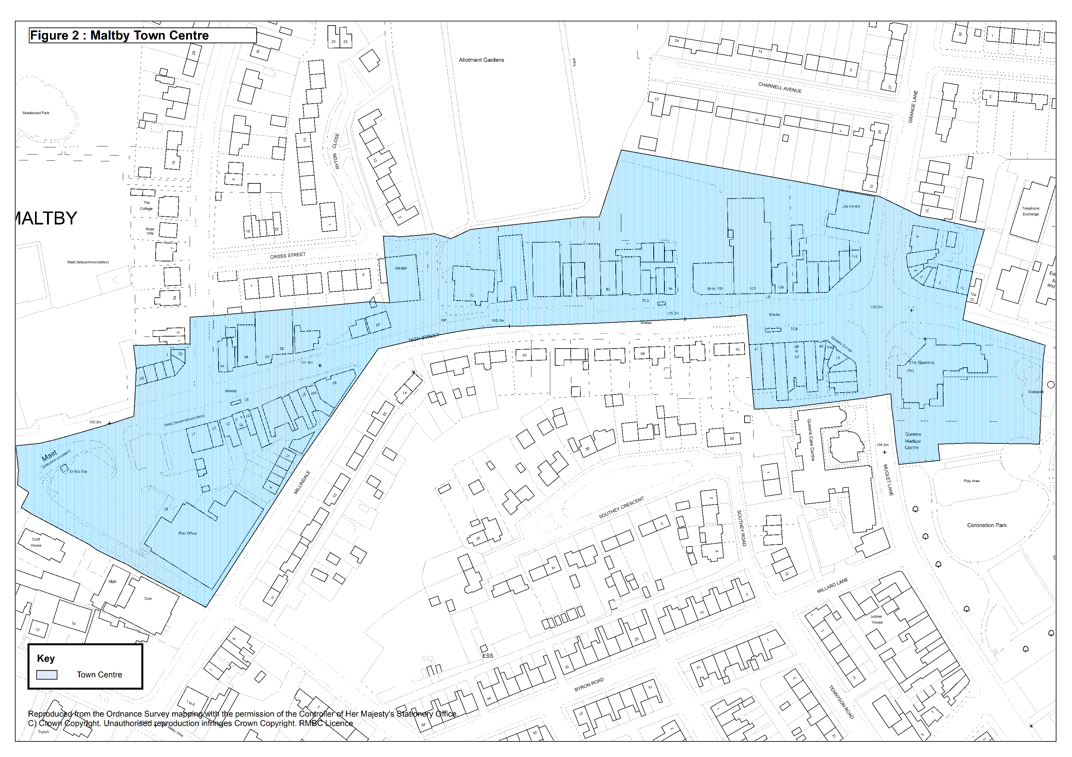

Figure 3: Muglet Lane Local Centre (as defined in the Rotherham Local Plan)
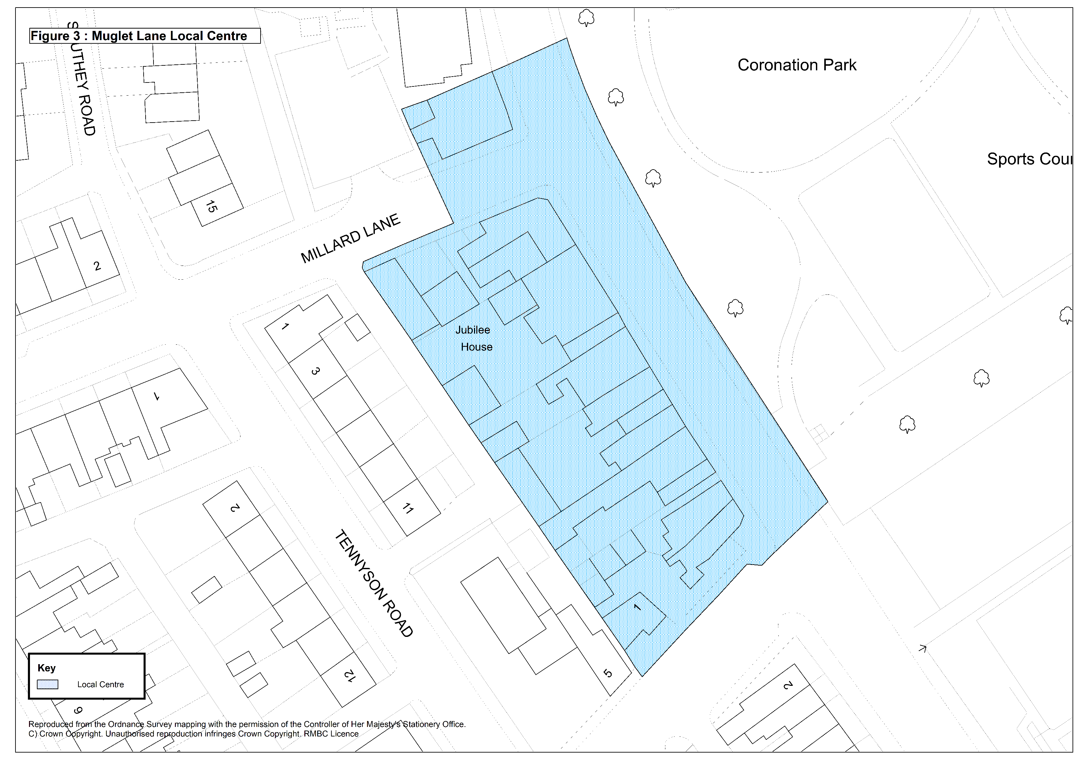

Appendix 1: MALTBY CHARACTER BUILDINGS AND STRUCTURES OF LOCAL HERITAGE INTEREST
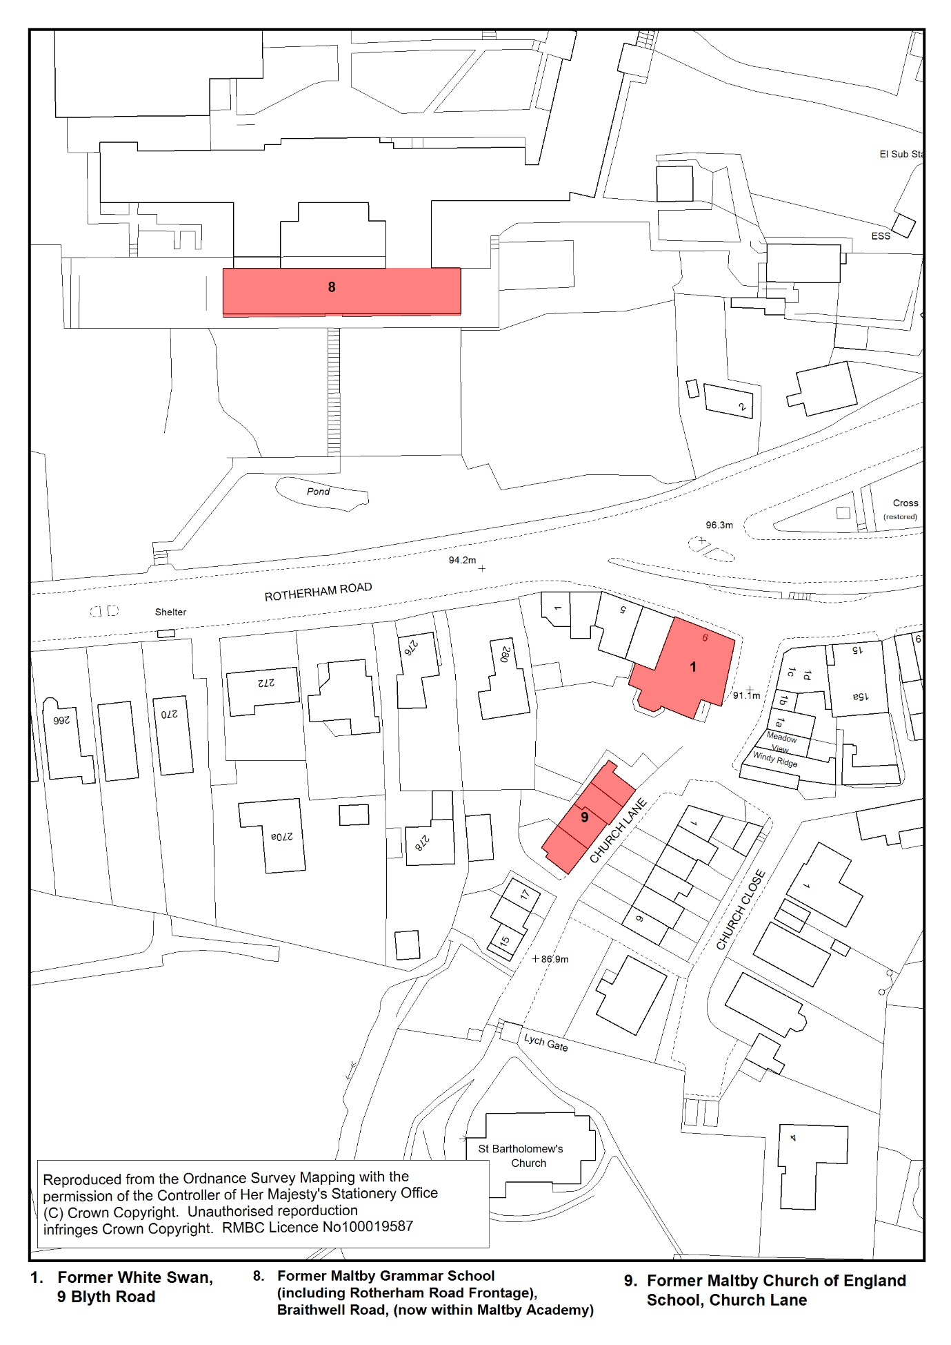
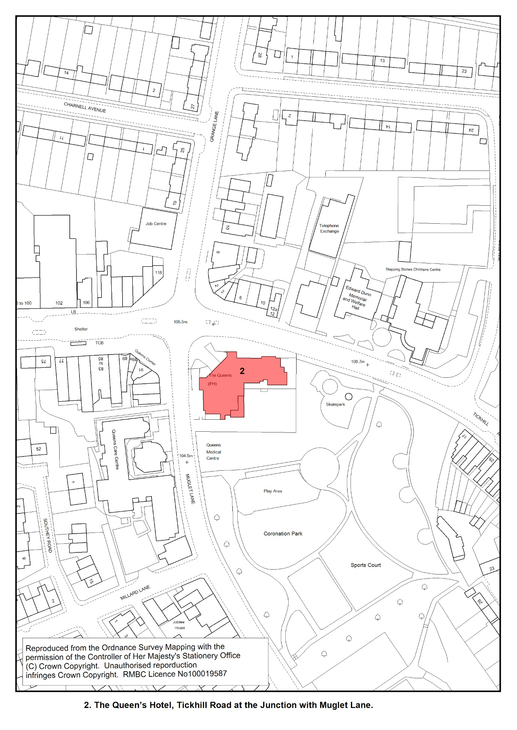
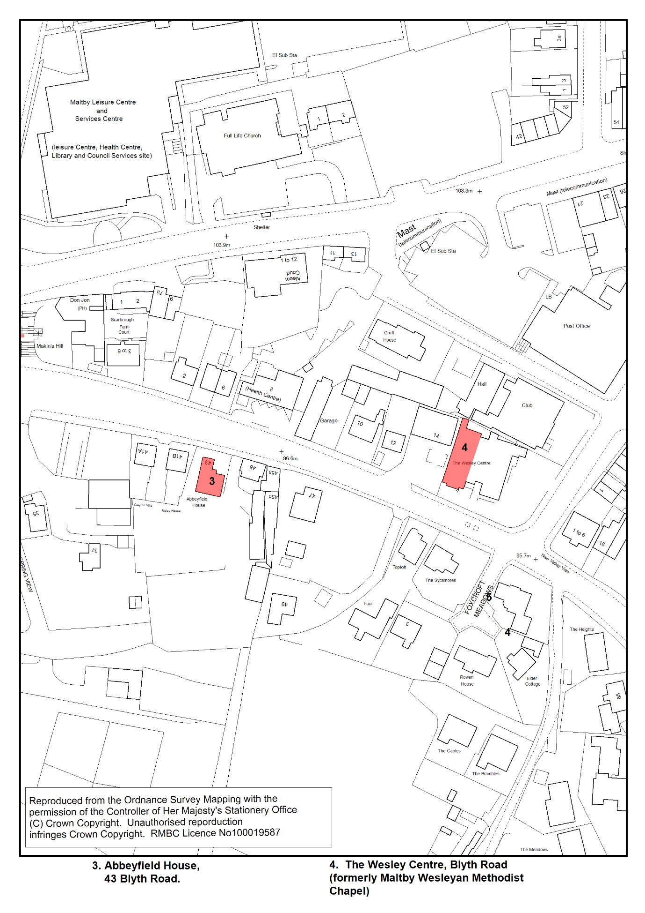

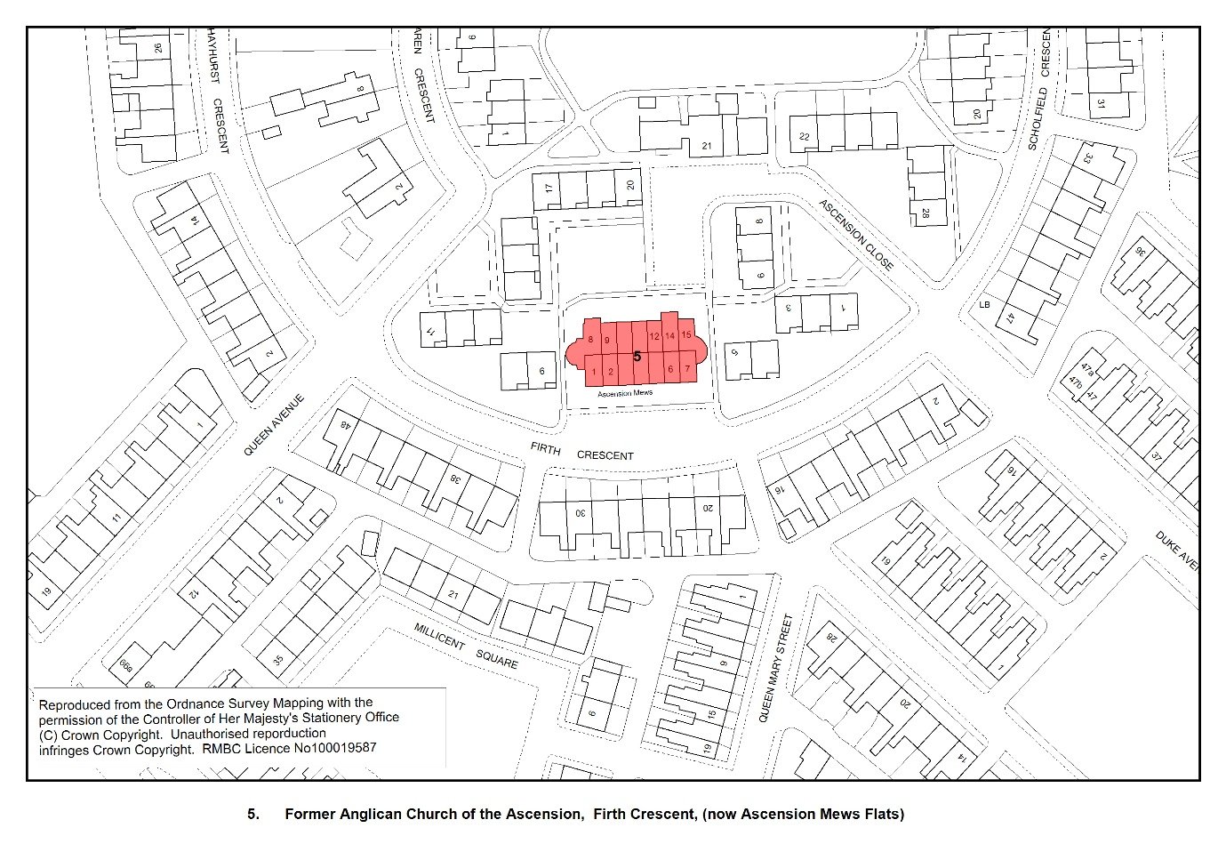
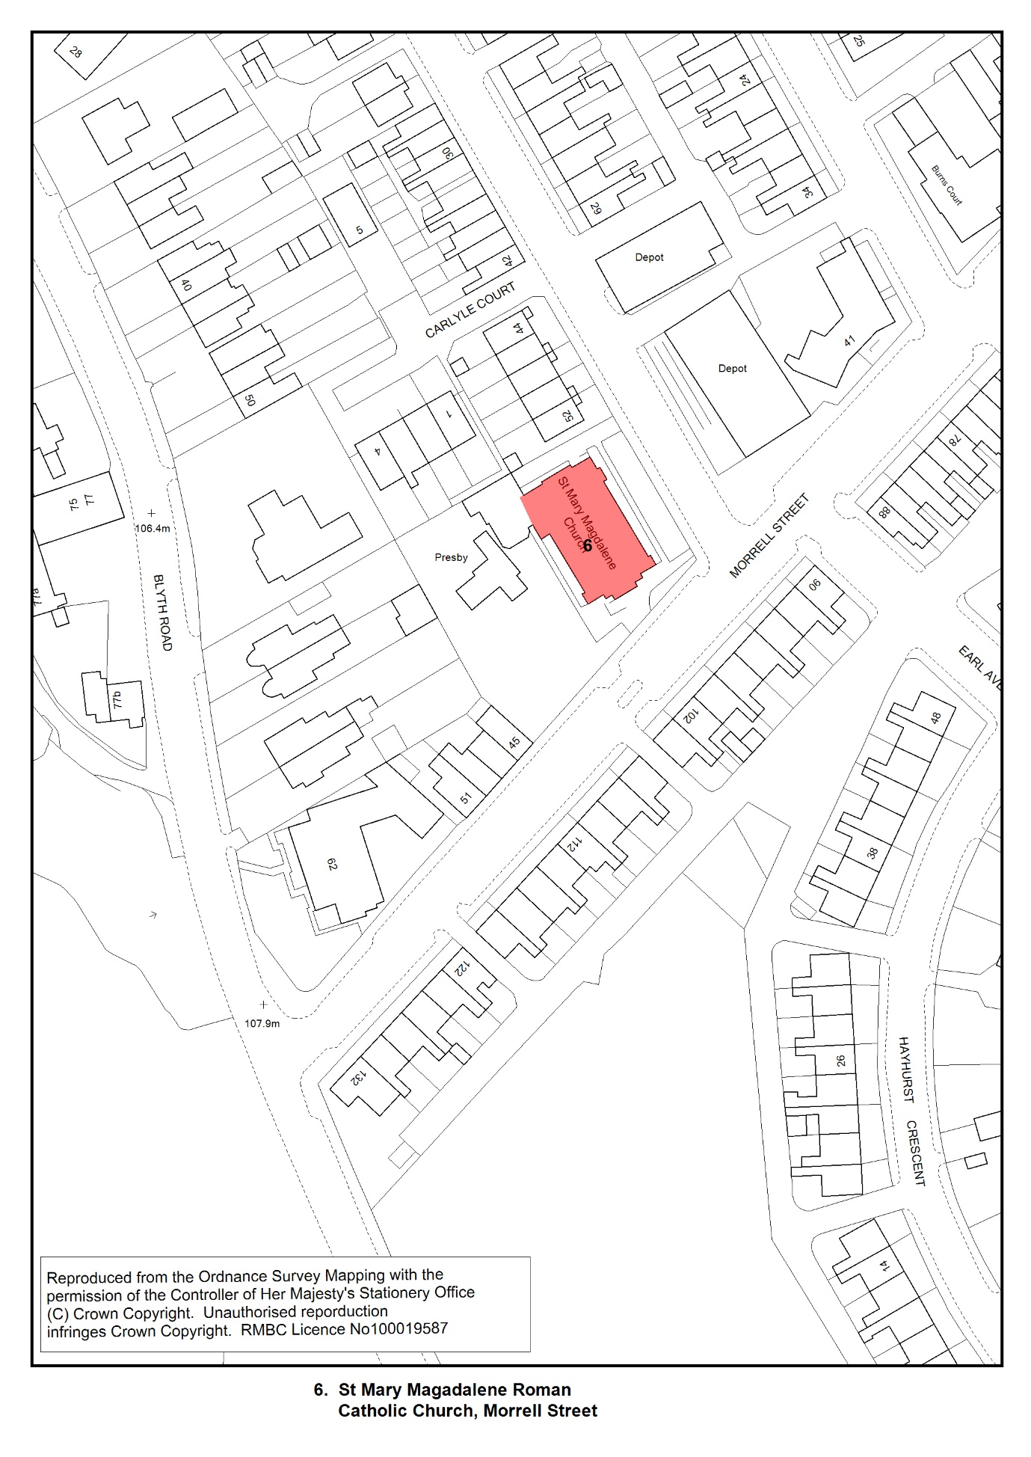
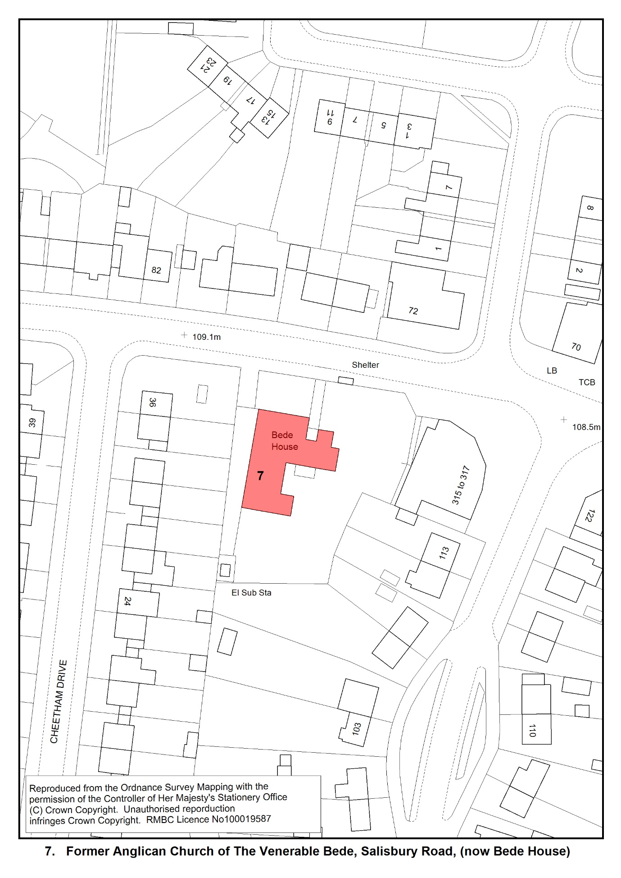
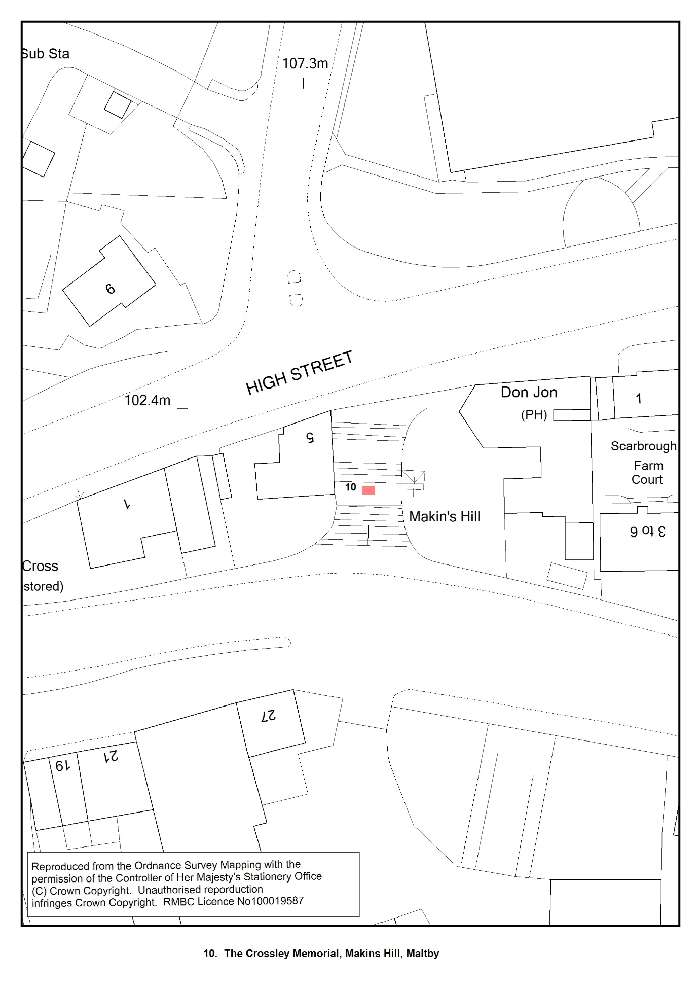
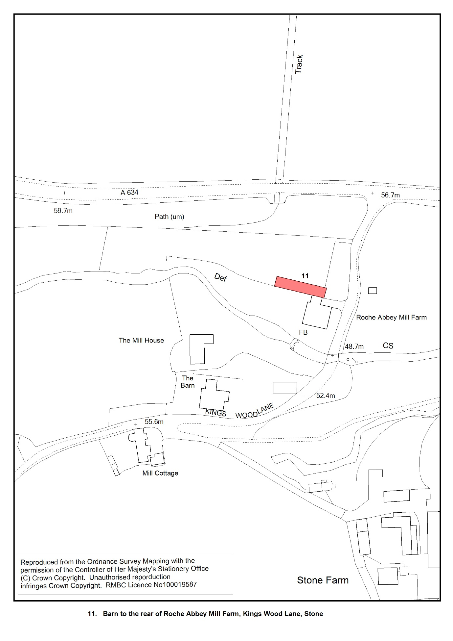
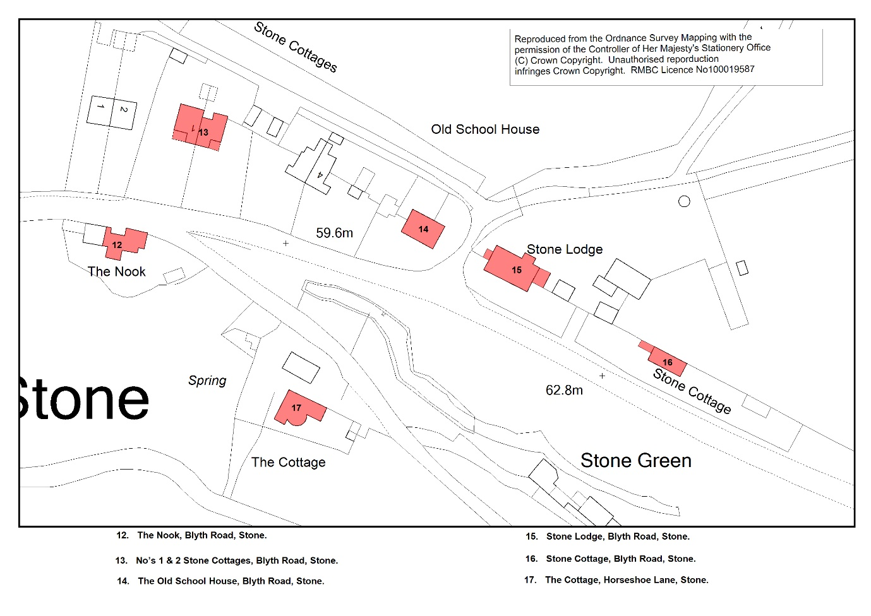
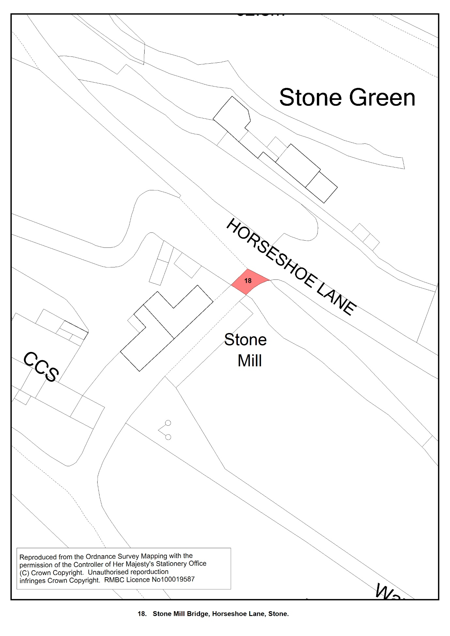
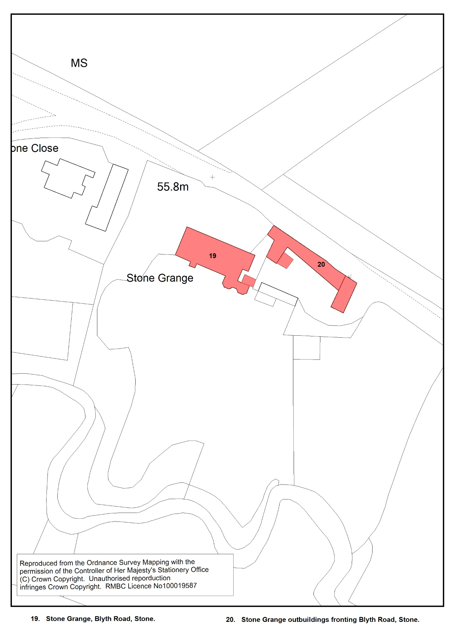
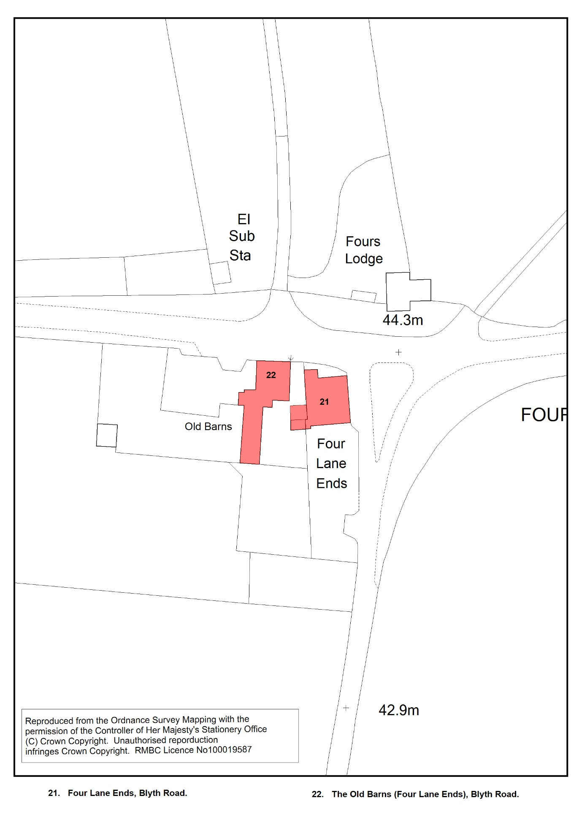
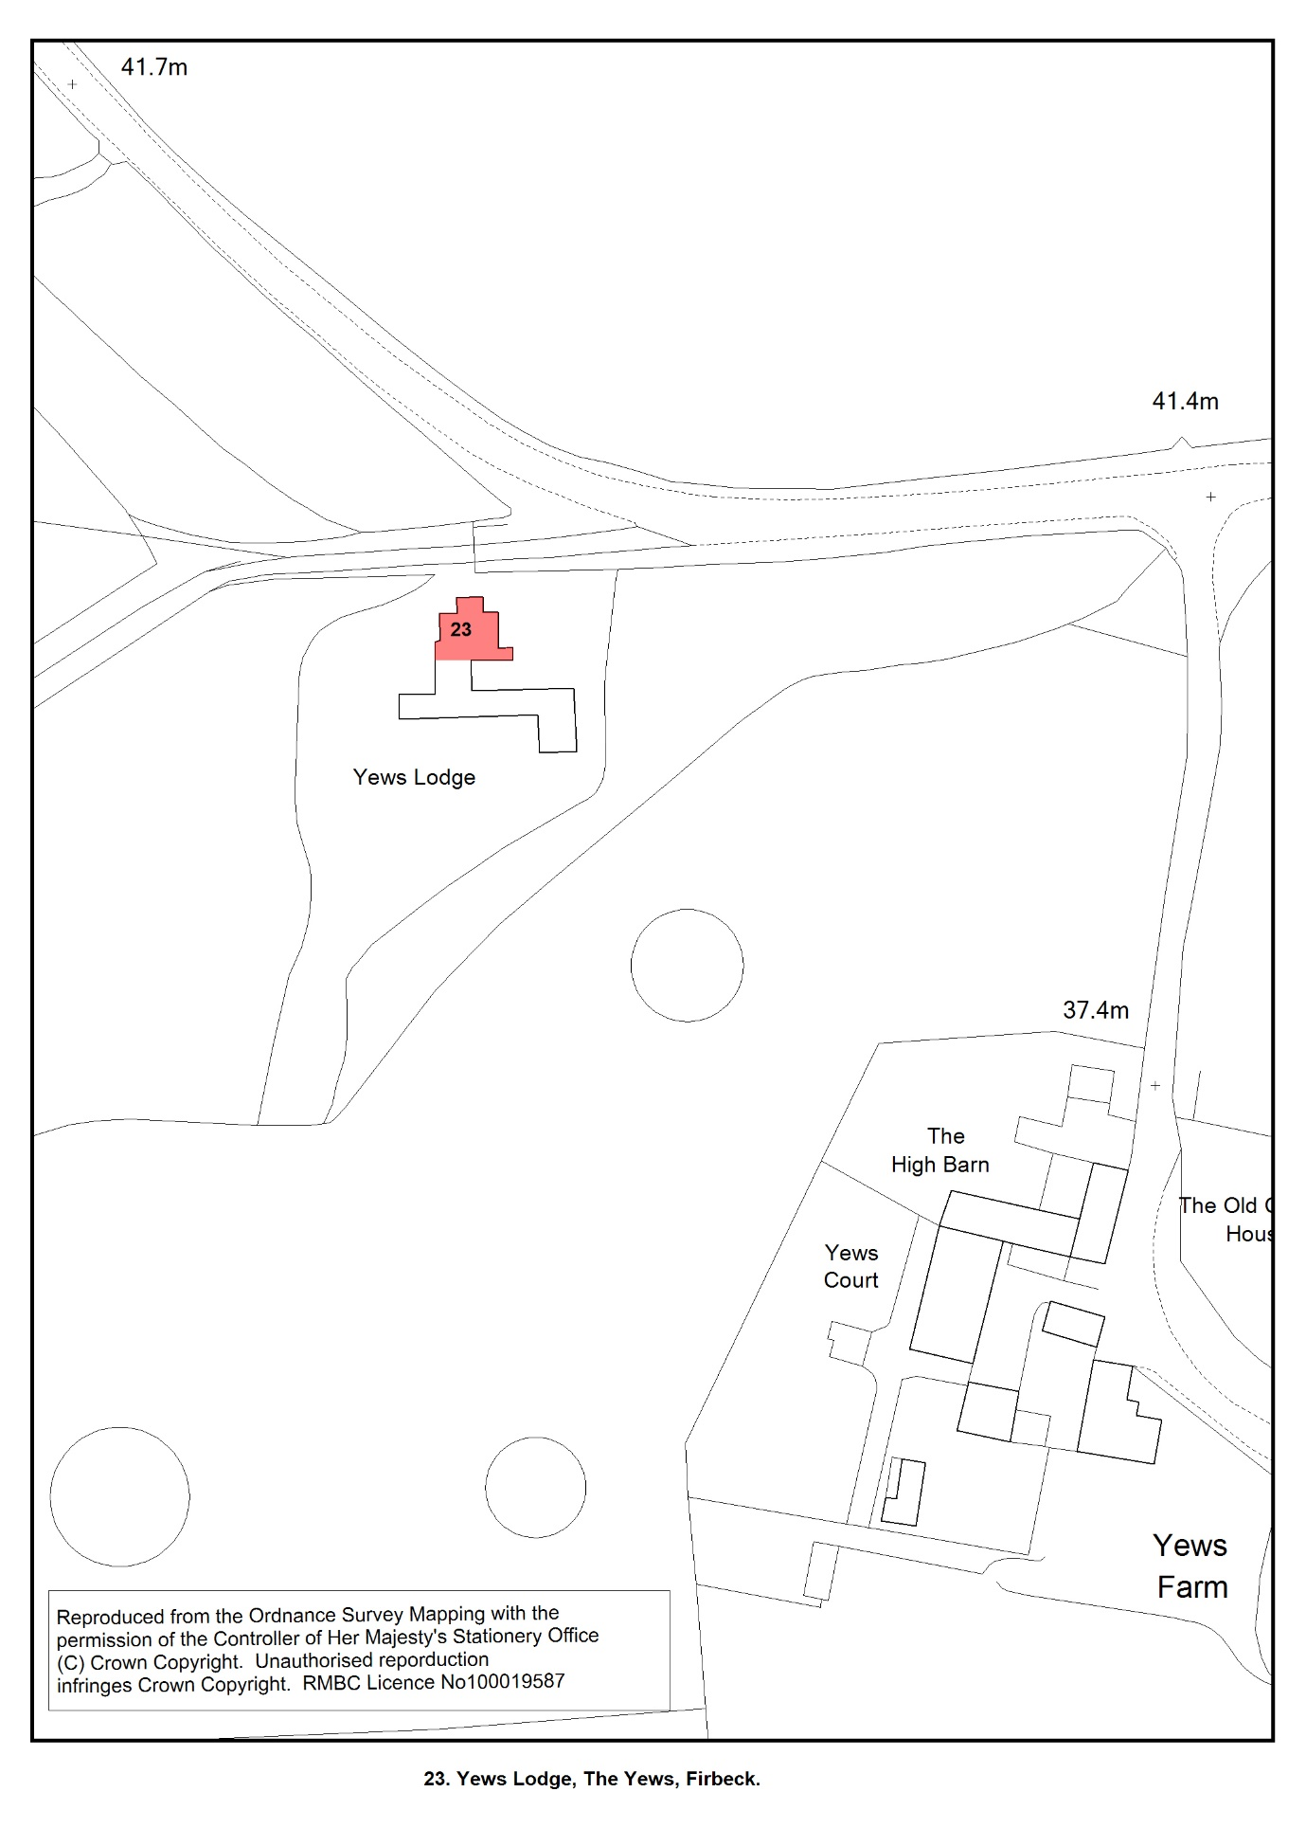

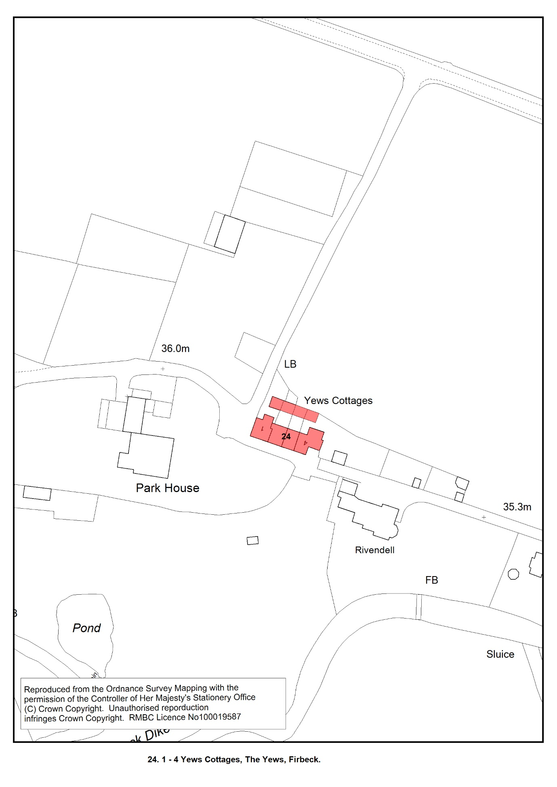

National Planning Policy Framework - Guidance - GOV.UK (www.gov.uk) (para 29)
National Planning Policy Framework - Guidance - GOV.UK (www.gov.uk)
A guide to the Local Plan – Rotherham Metropolitan Borough Council
A guide to the Local Plan – Rotherham Metropolitan Borough Council
Achieving sustainable development - National Planning Policy Framework - Guidance - GOV.UK (www.gov.uk)
Smith, A.H., (1961) The Placenames of the West Riding of Yorkshire’ vol 1 English Place Name Society, Cambridge University Press
https://www.rotherham.gov.uk/planning-development/planning-guidance/1
https://historicengland.org.uk/advice/heritage-at-risk/search-register/
https://www.heritagegateway.org.uk/Gateway/
More information about conservation areas can be found at What Is a Conservation Area? | Historic England
Permitted development enables certain types of development to be undertaken without needing to apply for planning permission.
Social homes are provided by housing associations (not-for-profit organisations that own, let, and manage rented housing) or a local council (‘council housing’)
Public health profiles - OHID (phe.org.uk)
Rotherham MBC monitoring data (September 2019)
https://www.gov.uk/guidance/health-and-wellbeing
Equal and healthy communities (rotherham.gov.uk)
takeawaystoolkit.pdf (london.gov.uk)
Sui Generis in the 2020 Use Class Order
Local Wildlife Sites do not have statutory status but do receive protection through the planning system (NPPF para. 179)
Rotherham Infrastructure Study - Final Report May 2012
Community Infrastructure Levy (CIL) – Rotherham Metropolitan Borough Council

