

RISK ASSESSMENT FINDINGS

Department/Service
Date
Assessor
Approved By
Review Date

Relevant Legislation:

The Management of Health and Safety at Work Regulations 1999

RISK ASSESSMENT RECORD

ACTIVITY and/or ENVIRONMENT TO BE ASSESSED: Main Hall
DATE:

KEY (People at risk) | Likelihood (L) | Severity (S) | Risk Calculation | Risk Rating
E = Employee YP = Young Persons  P = Public  C = Contractors  V = Visitors  EM = Expectant Mothers | 1. Very Low (rare/very unlikely)  2. Low (unlikely)  3. Medium (could occur/possible)  4. High (likely to occur/probable)  5. Very High (near certain to occur) | 1. Insignificant (nuisance/discomfort)  2. Minor (no lost time)  3. Moderate (time loss)  4. Significant (serious/incapacity to work)  5. Major (Death) | Likelihood x Severity  =  Rating | 1- 6 LOW RISK Monitor  - MEDIUM RISK Monitor, review & reduce risk where possible  14-25 HIGH RISK Further Action Required

1.Hazards Identified and potential harm it could cause | 2. People  At Risk | 3.Controls in Place | 4.Risk Rating |  |  |  | 5. Further Action Required/ Recommendations | 6.Target Date for Completion
1.Hazards Identified and potential harm it could cause | 2. People  At Risk | 3.Controls in Place | L | S | Score | Risk | 5. Further Action Required/ Recommendations | 6.Target Date for Completion

Defective flooring – slips, trips, falls |  | - Inspection of flooring  - Prompt maintenance of defects
Under stage storage areas – injury, fire |  | - Restricted pupil access to area  - No flammable liquids or gases to be stored under the stage
Raised stage area – falls |  | - No unsupervised access onto stage by pupils  - Regular inspection of stage  - Stage edgings clearly defined by high visibility tape, paint etc.  - Temporary staging should be erected following Manufacturers guidance, checked prior to use and of an appropriate height for pupils age range and physical abilities.  - Steps provided to access the front of stage.
Trailing electrical cables – trips falls |  | - Avoid use of extension leads wherever possible  - Ensure sufficient sockets  - Use of cable covers where cables are a trip hazard
Electrical equipment and sockets – electrocution |  | - Portable appliance testing and regular visual inspection  - Fixed installation testing
Hot radiators / heaters – burns |  | - Low surface temperature radiators /appropriate guarding
Large numbers of people congregating – insufficient escape, crushing |  | - Establish safe maximum number of visitors to hall  - Layout of seating allows sufficient space for emergency evacuation  - Emergency exits clearly signed and kept clear
Open windows - falls |  | Opening limiters fitted to all windows above ground level
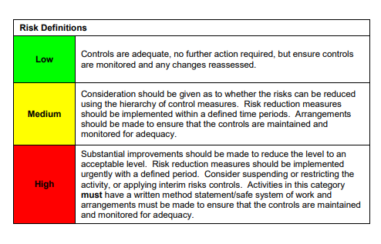

ACKNOWLEDGEMENT OF RISK ASSESSMENT Version:

PLEASE READ THE NOTICE BELOW BEFORE SIGNING THIS FORM
I acknowledge that I have read and understood the Risk Assessment/s associated with this task/event/equipment etc

Forename | Surname | Employee Signature | Date | Manager’s Signature

