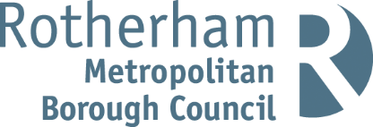

Rotherham Healthy Homes Plan
August 2025

Executive Summary

Housing conditions are arguably one of the most influential wider determinants that impact our health. Without a safe, secure and healthy home, residents in Rotherham are at risk of adverse health effects, reducing their healthy life expectancy and quality of life.

The NHS spends an estimated £1.4 billion annually to treat illnesses related to poor housing, whether that be from homes with excess cold or homes suffering from damp and/or mould. In England, up to an estimated 27% of homes have damp or mould problems, nearly a quarter of a million households have excess cold and 11% of households are living in fuel poverty. It is estimated that the proportion of fuel poverty in Rotherham is even higher at 14.5% of households living in fuel poverty. Levels of category 1 hazards are also high in Rotherham as identified by national research and local selective licensing inspections. Research also shows 1 in 5 people suffer mental health problems related to housing.

Rotherham has higher levels of deprivation than the national average (35th most deprived local authority) along with higher rates of overcrowded houses (3.5%). Poor housing conditions lead to poorer mental and physical health and has a knock-on effect to the whole community through economic costs to the NHS and adult social care as well as slowed economic growth due to sickness and productivity losses. There are also additional impacts on education and attainment of children.

Rotherham has a variety of strategies and plans in place to improve housing and health in the borough including the Health and Wellbeing Strategy, Council Plan and Rotherham’s Housing Strategy. These all aim to reduce inequalities across the borough and tackle the housing issues which impact negatively on the health of residents and form the foundation for this plan.
This new Healthy Homes Plan sets out three main themes for improvement: Intelligence and evidence gathering, reducing fuel poverty in Rotherham and increasing support and assistance to tackle housing related health risks.

Contents

Executive Summary 2
Contents 3
Background 5
Aim of the Healthy Homes Plan 5
Health and Wellbeing Strategy 5
Council Plan 6
Rotherham’s Housing Strategy 6
SYMCA Housing Framework 7
National Housing Plans 7
Energy Efficiency 8
Net Zero Targets 8
Fuel Poverty 9
Provision of the Rotherham Energy Network 9
Housing Health Cost Calculator 10
The Local Picture 10
Rotherham Population & Health Demographics 10
Rotherham Housing Data 11
Housing Associations 13
Temporary Accommodation, Homelessness & Other Accommodation 14
Fuel Poverty in Rotherham 14
Housing Hazards 17
Identifying Concerns Across Private Rented Housing Stock 17
Council Housing Budgets 18
Planning of New Homes 19
Housing Related Health Concerns 19
The Link Between Housing and Health 19
Damp and Mould 20
Cold Homes 21
Hot Homes 22
Indoor Air Quality and Chemical Hazards 22
Hoarding 23
Mental Health & Isolation 23
Overcrowding 23
Climate Related Risks 24
Additional Home Risks 24
Risks of Poor Housing on Children and Young People 25
Cost of Living 25
What Support is Available? 26
Support Summary 26
Rotherham Energy Network Group 26
ECO4 Scheme 29
Energy Crisis Support Scheme – Historic Support 29
Great British Insulation Scheme 30
Warm Homes: Social Housing Fund 30
Additional Bills Support 30
Winter Fuel Payments 31
Employment Solutions 32
Support For Private Landlords 32
RMBC Training Offer 32
Action Plan 35
Theme 1: Intelligence and Evidence Gathering 35
Theme 2: Reducing Fuel Poverty in Rotherham 37
Theme 3: Increasing Support and Assistance to Tackle Housing Related Health Risks 38

Background

Aim of the Healthy Homes Plan
The overall health and wellbeing of Rotherham residents is influenced by many factors including physical health, mental health and the environments in which people live and work. Housing has arguably one of the biggest impacts on our health and wellbeing and is one of the key priorities in Maslow’s Hierarchy of Need. This plan aims to link together the current housing strategies with the health risks associated with various housing issues and outline an action plan to improve local housing intelligence, reduce fuel poverty and reduce ill-health related to poor housing. The action plan will bring together teams across Rotherham Metropolitan Borough Council (Public Health, Housing, Regeneration & Environment) and our wider partners especially those in the voluntary sector in order to achieve joint goals which will improve health in Rotherham by targeting the housing sector.
This document will be annually refreshed but the action plan will be tracked throughout the year. Data within this document is the most up to date available data as of July 2025. The Governance process for this document is through the Health and Wellbeing Board.

Health and Wellbeing Strategy
The Rotherham Health and Wellbeing Board have produced an overarching framework for health and care commissioning plans known as the Health and Wellbeing Strategy 2025- 2030. This strategy has 4 priority aims:
- Aim 1: Enabling all children and young people up to the age of 25 to have the best start in life, maximise their capabilities and have influence and control over their lives
- Aim 2: Supporting the people of Rotherham to live in good and improving physical health throughout their lives, accessing and shaping the services and resources they need
- Aim 3: Supporting the people of Rotherham to live in good and improving mental health throughout their lives, accessing and shaping the services and resources they need
- Aim 4: Sustaining an environment where detrimental impacts from commercial and wider determinants of health and reduced and opportunities for healthier living are nurtured

This Healthy Homes Plan contributes to all these areas in the Health and Wellbeing Strategy as housing has a significant impact on the wellbeing of children, mental health of residents as well as people’s physical health and safety. However, housing is specifically referenced as part of Aim 4 in relation to these main points:
- The link between poor housing and increased NHS costs due to treating illnesses linked to cold, damp and dangerous homes
- Increased housing requirements due to an ageing population
- Impact of housing on wider mental health concerns and community cohesion
The Health and Wellbeing Board Strategy will be renewed in 2025 as but will not be published until after this document so updates on the relevant aims as well as a link to the document will be in the Healthy Homes Plan 2026 refresh. The previous Health and Wellbeing Strategy 2019-2025 is available here - rotherham-joint-health-and-wellbeing- strategy

Council Plan
The new council plan will run from 2025-2030 and will be called Forging Ahead - Appendix 1
- Council Plan 2025-30 FINAL.pdf. The housing related priorities include:
  - 400 homes to be built as part of the town centre new community
  - 1000 new council homes by summer 2027 alongside improving the quality of existing council homes
  - Improving prevention outcomes for those at risk of homelessness and reducing use of emergency hotel accommodation.
  - Work with developers to facilitate delivery of good quality and affordable homes
The previous Rotherham Council Plan 2022 to 2025 set out an ambitious programme to improve lives in Rotherham with one of the key themes being that people are safe, healthy and live well. The following key performance indicators on the 2024/25 Year Ahead Delivery Plan relate to healthy homes:
  - PE05 – The proportion of council housing repairs completed ‘Right 1st time’ 2024/25 target was 93%, RMBC Achieved 94.5%
  - PE06 – The number of new homes delivered with Council support, including affordable homes. 2024/25 target was 200, RMBC Achieved 213
  - PE07 – The proportion of council housing stock that meets the "Decent Homes" standard. 2024/25 target was 100%, RMBC Achieved 95.1%
  - PE08 – The proportion of households prevented or relieved from homelessness. 2024/25 target was 85%, RMBC Achieved 85.2%
  - PE09 – The number of households in temporary accommodation. 2024/25 target was 130, 2024/25 number is 148 (lower is better)
  - EN06 – The proportion of council housing with an Energy Performance Certificate (EPC) rated C and above. 2024/25 target was 50%, RMBC Achieved 58%

Rotherham’s Housing Strategy
Rotherham’s 30-year Housing Strategy was published in December 2012 and sets out the Councils long-term vision for housing in the borough. This is refreshed every three years with the latest issue being the Housing Strategy 2022 to 2025. The six key priorities for the 2022-25 period are:
  - Building high quality new homes
  - Building affordable homes to meet local need
  - Investment in existing homes
  - Bringing empty homes back into use
  - Supporting people to live independently
  - Strengthening communities
The next update of the Housing Strategy will run from 2025 to 2030 and will contain reference to the Healthy Homes Plan as well as how householders will have support to improve the thermal efficiency of their home. Priorities in this strategy will include a variety of housing issues such as independent living, preventing homelessness, building of new homes, improving quality of existing homes and ensuring neighbourhoods and safe and thriving. The priority on existing homes will aim to reduce fuel poverty, ensure landlords are operating to the highest standard and ensure residents live in safe, decent homes.
Another key Rotherham Housing related Strategy is the Homelessness Prevention and Rough Sleeper Strategy 2023-2026 which comprises of six key priorities linking housing and health including:
  - Increasing access to affordable housing options

  - Improving access to housing support, employment and health services

SYMCA Housing Framework
South Yorkshire Combined Mayoral Authority (SYMCA) have a Housing framework which outlines these key statistics related to health and housing in Rotherham:
  - The population of Rotherham is expected to increase by 20,000 in the next 20 years (based on national figures of approximately 2.2 people per household, this will require over 9,000 new houses to be built in Rotherham as well as additional infrastructure such as GP practices and schools)
  - The largest increase in housing demographics will be in single occupant households over the next decades
  - Rotherham has 1,108 long term vacant dwellings (2021). Since the SYMCA framework was published, this figure has decreased to 963 vacant dwellings in Rotherham (CTB1 Council Taxbase 2024)
  - 39% of houses in Rotherham are at EPC C and above (2022). This figure is continually improving as retrofit works improve existing stock, and new homes are built to higher energy efficiency standards
  - Almost 20,000 households in Rotherham are in fuel poverty as calculated by the LILEE method (2024)

SYMCA Land Development and Disposal Plan (LDDP) outlines the key aims for housing and regenerations across South Yorkshire which are:
  - Improve the quality of existing and new housing stock, whilst maintaining housing growth
  - Ensure the supply of good quality, attractive and sustainably developed employment land that is widely accessible
  - Proactively work on strategic planning opportunities to unlock potential through joined-up investment packages

National Housing Plans
A Strategic Housing plan for England has been produced in collaboration with the Department for Levelling Up, Housing and Communities (DLUHC). This document (Homes- England-strategic-plan-2023-to-2028.pdf) sets out a plan for 2023-2028 to ensure housing is not only built to a good quality but also improves local communities, reduces inequalities and has minimal environmental impact. It states some key facts around the housing sector which are impacting on livelihoods such as:
  - The affordability ratio of buying a house has increased across England from 3.5 times salary in 1997 to 8.3 times salary in 2022
  - As of 2020, 21% of homes in Yorkshire were non-decent, the highest for any English region. The England average is 15%.
Under the previous method of building houses to meet need in the UK, the target of houses per year for Rotherham Council to build was 544. With new legislation and a new UK government as of July 2024, this target has been increased to 1,080 houses per year to be built in Rotherham, a 98% increase. This aligns with new government plans to build 1.5 million new homes across the country in 5 years (before June 2029). This new target is therefore a mandatory housing target for Rotherham and will be supported by the refresh of the National Planning Policy Framework. In total, if the targets in South Yorkshire were met, it would require 28,060 homes to be built in 5 years in the region, a significant increase which will hopefully reduce homelessness, reduce demand and prices and provide more good quality, energy efficient homes. The UK Government have recently announced that £10 billion from the Affordable Homes programme will be made available for social housing nationally.

Awaab's Law came into effect from October 2024 and forces social landlords to fix dangerous homes. This law was introduced in honour of a two-year-old boy, Awaab, who died as a result of prolonged mould exposure in his socially rented home. Further information on Awaab's Law can be found on the Government page - Awaab’s Law to force landlords to fix dangerous homes - GOV.UK

Guidance on this legislation was also offered to private landlords. Additionally, the Renters Rights Bill (RRB) will create legislation that will align all sectors to ensure that damp and mould related issues are minimised. The RRB will also include extensions of the Decent Homes Standard to the private sector and the abolition of Section 21 ‘no fault evictions’.
Further information on RRB is available here - Guide to the Renters’ Rights Bill - GOV.UK

Energy Efficiency
Energy performance certificates (EPCs) are a rating scheme to summarise the energy efficiency of buildings. The building is given a rating between A (Very efficient) - G (Inefficient) as well as practical advice on how to improve the energy efficiency. All buildings which are being sold or rented out require an EPC and an EPC certificate is valid for 10 years.

Having an EPC helps provide prospective buyers and renters with an idea of how energy efficient the home is and therefore an indication of the energy cost required to heat the home as well as ways in which the energy rating can be improved over time. Since April 2020, all rented properties must be an EPC E rating or above with the aim of getting as many properties as possible upgraded to a C or above. This process will reduce heating bills for tenants as well as reduce the carbon emissions from housing stock in the area helping to reduce fuel poverty and make a significant contribution to achieving net zero targets. It is important to note that as EPCs are only required when properties are sold or rented and are valid for 10 years, EPC data is likely out of date. A recent government consultation on raising the EPC requirements of private rented properties opened in February 2025 to seek opinions on raising the EPC requirements on private rented properties to an EPC C. More information on the consultation is available here - Improving the energy performance of privately rented homes: consultation document (HTML) - GOV.UK. Social housing is already required to be working towards an EPC C in all properties by 2030.
Independent Age have done research on the views of older residents and EPCs. Here are the key points raised:
  - Only 38% of landlords were aware of existing grant schemes, suggesting a need for better promotion
  - Improving a home from EPC E to EPC C could halve the energy bill for that property
  - Lots of tenants and landlords are sceptical about the validity of EPCs The full research paper can be found here - Turning the dial

Net Zero Targets
Rotherham Council are committed to their net zero targets including net zero in council buildings and fleets by 2030 and net zero throughout the borough by 2040. The national target for net zero is 2050. ONS Statistics from 2022 show that 26% of current UK greenhouse gas emissions are from households which is very similar to the Rotherham estimations. Therefore, our housing stock must undergo significant improvements over the next decades to reach the net zero targets. The first step to achieving this is ensuring as many homes as possible have an Energy Performance rating (EPC) rating of C or above.

Carbon emissions from council buildings throughout 2023-24 increased by 4.77%, against a Council Plan target of 10% reduction by 2024. This is linked to the use of carbon-based fuel to generate electricity, delays in the decarbonisation of the grid, as well as a slight increase in electricity demand.

Fuel Poverty
Fuel poverty varies across the UK and each UK country has a different definition. The England definition means that only homes with a lower energy efficiency rating (band D to G) who fall below the poverty line after energy costs are considered to be in fuel poverty. This definition excludes over 2.5 million households in England who are in the two most deprived income deciles but have efficiency ratings of a C and above. This definition is known as the LILEE method (Low Income, Low Energy Efficiency).
Data published by the Department for Energy Security and Net Zero (Figure 1) shows that the proportion of houses in fuel poverty has declined over the past decade from 22% in 2010 to 13% in 2023 however due to the rising cost of energy since 2021, the average fuel poverty gap has increased from £251 in 2020 to over £400 in 2024. Fuel poverty rates in Yorkshire & the Humber are at 14.7% of households due to lower average salaries in the area and lower average energy efficiency ratings. (Source - Sub-regional fuel poverty in England, 2025 report (2023 data) - GOV.UK)
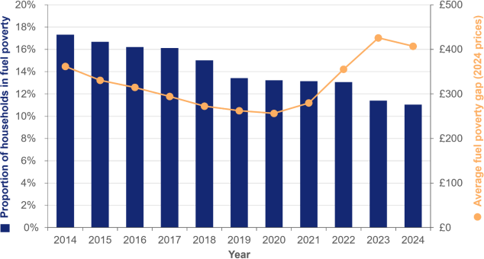

Figure 1: Following a steady decrease over time, the proportion of fuel poor households has remained very consistent since 2019. The average fuel poverty gap has increased by 66% in real terms since 2020.

Provision of the Rotherham Energy Network
The Rotherham Energy Network (REN) is a huge project being built to take waste heat from nearby cooling towers at Templeborough and upgrade the heat to 80°C using a water-to- water heat pump. This heat will then be distributed across Rotherham Town Centre using over 10km of pipework and 34 connections across the town centre and surrounding area.
The project is funded by a share of the governments Green Heat Network Fund totalling £25 million. Construction is underway. More information on the project is available at Heat Network Procurement Pipeline: 2023 Q2. Developments of houses within the town centre new development area can benefit from this project.

Note: There is also a Rotherham Energy Network group which is separate to this project

Housing Health Cost Calculator
The Housing Health Cost Calculator (HHCC), offered by Building Research Establishment (BRE), measures the cost savings to the NHS and society of repairing poor housing stock. The HHCC enables environmental health practitioners to measure the quantitative health impact of the work undertaken to reduce and mitigate hazards defined under the Housing Health and Safety Rating System (HHSRS). The calculation provides mathematically based estimates of the cost to the NHS as a result of incidents occurring due to these hazards, with research estimating that the cost to the NHS account for only 40% of the cost to society as a whole.
For 2025/26, the HHCC has been purchased by the RMBC Regulation & Enforcement Team at a cost of £1,500 per year. The usefulness of the HHCC will be evaluated throughout the year before it is considered for re-purchasing in subsequent years.
The HHCC, has been used in the analysis of the selective licensing scheme which ran from 2020-2025.

The Local Picture

Rotherham Population & Health Demographics
The population in Rotherham as of the 2021 census is 265,807, a 3.3% increase from 2011. This equates to a population density of 928 residents per square km, more than double the national average of 438 residents per square km. Assuming this rate of population increase has continued, in 2025, there are approximately 270,000 people in Rotherham. The Director of Public Health report 2024 include a 2040 Rotherham population projection of 290,166 (Rotherham+Director+of+Public+Health+Annual+Report_Final.pdf)

Rotherham has a median age of 41 years. 61.5% of the population are aged between 16 and 64. 51% of the population is female. Rotherham has an ageing population so the percentage of people 65+ is increasing each year. (Figure 2). This results in an increase in the number of single person homes in the borough.
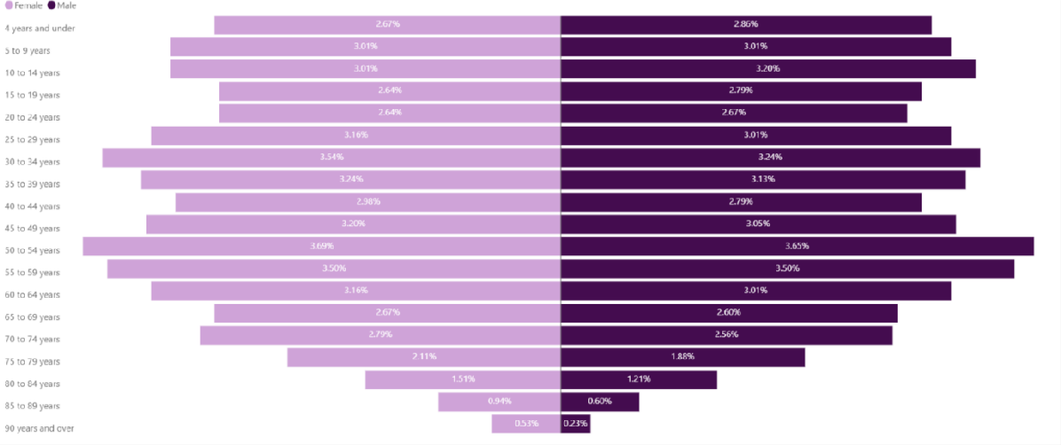

Figure 2 – Age and gender split in Rotherham at 2021 Census

Deprivation is high in Rotherham as it ranks as the 35th most deprived local authority out of
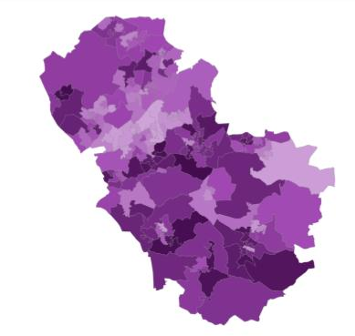
151. 36/167 (20% of Lower Super Output Areas (LSOAs) in Rotherham) are in the 10% most deprived in England. No LSOAs in Rotherham are in the 10% least deprived (Figure 3). In terms of households, 22% of households in Rotherham reside in the most deprived decile. 69% of the working age people are economically active, against the national average rate of 78.4%. The gap between Rotherham and the national rate, neighbouring authorities and statistical neighbours is widening.

Figure 3 – Map of LSOAs in Rotherham shaded according to deprivation, compared to each other. Deeper shading indicates less

deprivation.

Life expectancy in Rotherham is 77.8 for males at birth and 80.9 for females at birth. This is lower than the life expectancy in England which is 79.1 for males and 83 for females. From 2011-13 to 2020-22, life expectancy in Rotherham has
decreased by 11.4 months for males and 14.3 months for females. Healthy life expectancy in Rotherham males however is only 58.7 years compared to the England average of 63.1 years. Healthy life expectancy for Rotherham females is 56.5 years, significantly lower than the England average of 63.9 years. This means that overall, women in Rotherham live nearly 30% of their lives in poor health. Life expectancy for local areas of Great Britain - Office for National Statistics

Rates of chronic illnesses in Rotherham are generally higher than the national average and some of the key ones that could be attributed to poor housing include:
- 2.3% prevalence of stroke in 2023/24 (England prevalence was 1.9%)
- 7.9% prevalence of asthma in 2023/34 (England prevalence was 6.5%)
- 990 per 100,000 hospital admissions for COPD (England rate was 357 per 100,000)
- 55.9 per 100,000 mortality rate from lung cancer in 2023 (England prevalence was 47.5 per 100,000)
- 22.8% reporting musculoskeletal problems in 2023 (England proportion was 17.9%) Further figures on health statistics and the trends of the above statistics are available on Local Authority Health Profiles - Data | Fingertips | Department of Health and Social Care

Satisfaction with the borough as a place to live has improved (Resident Satisfaction 2024) - 66% of respondents said, overall, they were satisfied with the Rotherham borough as a place to live, which is above the Council Plan target of 62% and average across previous surveys (higher is better). Satisfaction with the local area as a place to live (Resident Satisfaction 2024) - 75% of respondents said, overall, they were satisfied with their local area as a place to live, which is below the Council Plan target of 80% (higher is better). (Source - Council Plan and Year Ahead Delivery Plan Quarterly Progress report)

Rotherham Housing Data
As of the 2021 census, the total number of households in Rotherham is 113,925. However, more recent council tax data put this figure at nearly 122,000. The tenure split of these houses as of the 2021 census is: 33.6% of houses are owned outright, 30.4% are owned with a mortgage or loan, 20.7% are rented social housing (council or housing association)

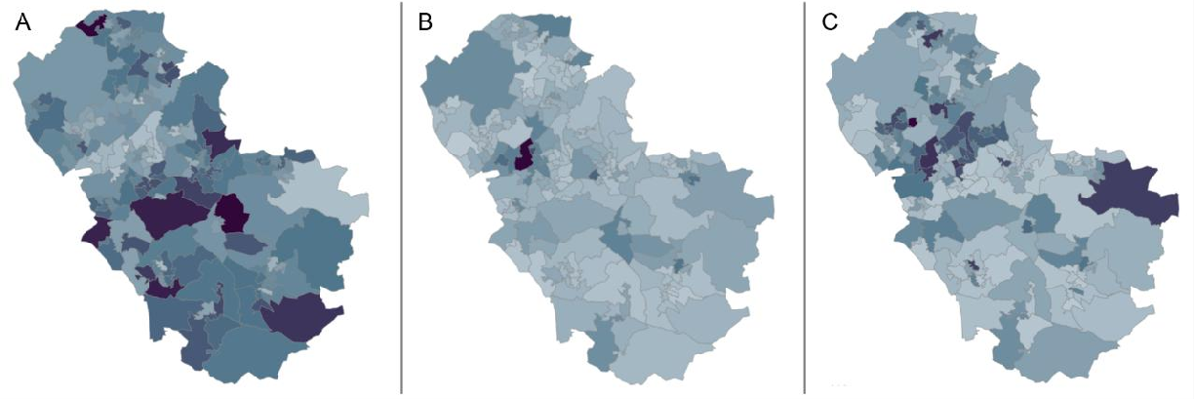
and 15.3% are privately rented. These figures, however, differ massively by LSOA (Figure 4). Further breakdown of this data and LSOA figures is available at - Housing – Rotherham Data Hub

Figure 4 – LSOA map of Rotherham shaded according to how many properties in each area fit in the following categories: A) Owner occupied housing B) Private rented

housing C) Social rented housing. Darker shading indicates a higher proportion of that type of tenure

Across the different Middle Super Output Areas (MSOAs) in Rotherham, the demographics of the population in each tenure type vary a lot. The table below shows the range (highest and lowest percentages) of each tenure type by age group.

 | Owned Outright | Mortgage/ loan/ shared ownership | Social Rent | Private Rent
66+* | 83.4% (Rotherham South) | 7.1% (Maltby West & Hellaby) | 49.5% (East Herringthorpe) | 13.8%  (Wickersley North)
 | 40.8% (East Herringthorpe) | 2.4% (Rotherham Central) | 8.6% (Rotherham South) | 3.4%  (Kimberworth Park)
18-65** | 38.6% (Anston & Woodsetts) | 51.8% (Catcliffe, Treeton & Waverly) | 46.4% (East Herringthorpe) | 44.6%  (Rotherham Central)
 | 11.3% (Rotherham Central) | 13.3% (Rotherham Central) | 6.4% (Ravenfield & Bramley North) | 8.2%  (Kimberworth Park)
Children  *** | 14.8% (Rotherham South) | 68.9% (Ravenfield & Bramley North) | 54.7% (East Herringthorpe) | 41.1%  (Rotherham Central)
 | 4.9% (East Herringthorpe) | 14.2% (Rotherham Central) | 5.5% (Ravenfield & Bramley North) | 13.5% (Swinton South)
*66+ includes houses where at least one resident is aged 66 or over
**Children includes all houses where there is at least one person under 18
***18-65 includes houses where all residents are aged between 18 and 65

As of 31st March 2024, Rotherham has a total of over 20,000 council homes (including shared ownership) and half of these are houses. The breakdown of those houses is: 19.6%

are 2 beds, 77.6% are 3 beds and 2.7% are 4 beds or above. The highest demand on council houses in Rotherham is for 3-bedroom houses which in 2023 had an average of 126 bids per house (an increase from 26 bids per 3-bedroom house in 2016). (Source – Rotherham JSNA). The relet time for a council property as of Q3 2024/25 was 31.8 days, well below the target of 42 days. The most recent statistics on the council housing performance can be found here - Housing Service Performance – Rotherham Metropolitan Borough Council

The average house price in Rotherham was £193,000 in May 2025, up by 10.9% since May 2024 and up 160% over the last 20 years (£73k in March 2004). Projections show this figure will likely be £200,000 by the end of 2025. (Source - Housing prices in Rotherham (ons.gov.uk) The average house price per ward is available on the JSNA. The largest percentage increase in housing prices this year has been in detached properties.

Private rents rose to an average of £653 per month in June 2025, an annual increase of 7% from £610 in June 2024 (Figure 5). The average cost of a private 3-bedroom house is £800 per month. The annual gross salary in Rotherham in 2023 is £30,056 compared to £25,636 in 2018. This means that the average private 3-bedroom house rent for the year is nearly 1/3 of the gross average annual salary.
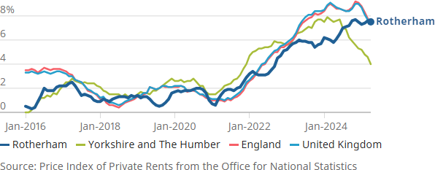

Figure 5 – Annual percentage change in rents from 2016 to 2025 comparing Rotherham to Yorkshire and The Humber, England and Great Britain. Source – Price Index of private rents from ONS

Housing Associations
In total housing associations provide approximately 5,500 tenancies in Rotherham. The providers have regular meetings with the strategic housing team and are constantly striving to improve the accommodation and support offer they provide to Rotherham residents.
Several of the key housing association information and contacts are listed here - Housing Associations – Rotherham Metropolitan Borough Council
Additional housing associations include:
- YWCA provides 20 houses for young women and their children - Rotherham — YWCA Yorkshire
- Roundabout provide support for young people aged 16-25 (12 young people at Rush House, 4 beds in emergency accommodation and 50 young people in their own tenancies) Rotherham Services - Roundabout Homeless Charity

Temporary Accommodation, Homelessness & Other Accommodation
The number of new homelessness cases rose from 987 in 2021/2022 to 1,521 in 2023/24. In a typical month around 130 homelessness cases are accepted (Source - REPORT TEMPLATE FOR CABINET & COMMISSIONER (rotherham.gov.uk). The main reasons for homelessness applicants are:
- Family no longer able to accommodate (26.5%)
- End of private rented tenancy (21.4%)
- Relationship with partner ended (non-violent breakdown) (10.8%)
- Domestic abuse (8.6%)
Between 2019 and 2022, 22.8% of homelessness applicants were under 24 years old. Homeless applicants often have extra support needs such as a history of mental health problems (12.9%), a history of offending (5.2%), at risk of/or experienced domestic abuse (5.1%) or drug and alcohol dependency (5.1% and 3.1% respectively). These figures are significantly higher than the general population statistics showing the correlation between homelessness and general health. Stable and secure housing can therefore have a huge positive impact on the general wellbeing of the population and reduce the demand for other public health commissioned services and NHS services as well.

In 2023/24, councils in the UK spent nearly £2.3 billion combined on temporary accommodation (Source - Spending Review: Local Government Association)
In Rotherham there is a variety of temporary accommodation options including hostels, refuges and hotel use. Here is the council policy on Temporary Accommodation Placement temporary-accommodation-placement-policy-pdf-
There is also separate temporary accommodation for DA victims including an 8-bed refuge and 10 dispersed properties. These are usually at maximum capacity, with constant need for this service. (Rotherham Domestic Abuse Strategy available here- safer-rotherham- partnership-domestic-abuse-strategy-2022-27)
Residential care homes in Rotherham include both private and in-house provision of services. The 2 council commissioned care homes have a combined total of 120 beds with independent sector residential, nursing and EMI beds total 1593. More information on this is available on the council's adult care market position statement (Adult Care, Housing and Public Health Market Position Statement: Adult Care Market and Demand – Rotherham Metropolitan Borough Council
As of May 2024, Rotherham had 502 Children in Care some of which are in supported accommodation, children’s homes or foster placements. Further breakdown of these figures is available on this RMBC document (mgConvert2PDF.aspx)

Fuel Poverty in Rotherham
The Department for Business, Energy and Industrial Strategy calculated fuel poverty in Rotherham to be 16.1% as of 2021, higher than the England average of 13.1%. This rose to 16.6% in 2022 which equates to nearly 19,000 households in Rotherham. (Fuel poverty is measured by LILEE methodology – Low Income Low Energy Efficiency) -Public health profiles - OHID (phe.org.uk). As of 2023, fuel poverty in Rotherham has decreased to 14% but this percentage can be skewed by the LILEE methodology which excludes any households of an EPC C or above from being included in the metrics. Therefore, as more households improve their EPC ratings, more households are excluded from the fuel poverty calculations. Overall, in England, fuel poverty is higher in rented accommodation compared

to owner occupied properties with estimates showing that up to 24.1% of people in private rented properties live in fuel poverty.

There is a massive disparity in fuel poverty across the Rotherham borough as well ranging from 52.4% of households in fuel poverty in some areas compared to 5.1% depending on LSOA. Rotherham ward data on fuel poverty shows highest fuel poverty areas to be central of the borough and out to Maltby East (Figure 6). Due to the current LILEE method for calculation of fuel poverty, one of the main factors is energy efficiency. Energy efficiency ratings (EPC) vary across Rotherham from 57.9 in Rotherham East to 63.3 in Rother Vale. For reference, an EPC rating of a C requires a score of 69. As new build properties with higher EPC scores are built and retrofit works are done to existing properties, the average EPC ratings will rise over time. This is particularly needed in the private rented sector where as of the 2018 Stock Condition Survey, more than 75% of private rented sector properties have an EPC of D or below.

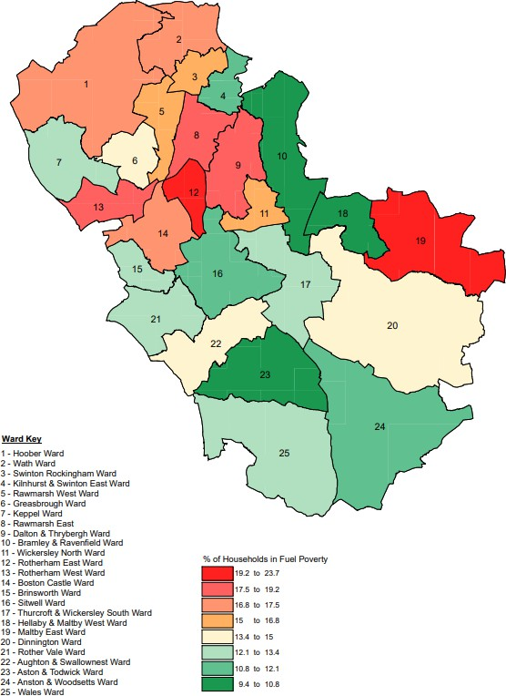

Figure 6 - LILEE proportion of fuel poor households by Rotherham Ward in 2023

There is also a huge disparity in fuel poverty across different ethnicities in the UK. For example, in the 2 years to March 2021, an average of 12.6% of white households were in

fuel poverty, compared with 19.1% of households from all other ethnic groups combined. Fuel poverty - GOV.UK Ethnicity facts and figures Fuel poverty rates are also higher in terraced properties, small properties and old properties (all data available here - Fuel poverty detailed tables 2025 (2024 data) - GOV.UK)

Overtime the number of fuel poor houses in Rotherham has fluctuated (Figure 7). The highest proportion of fuel poor households in Rotherham was in 2012 at 18.2%. From 2014 to 2020, rates of fuel poor households have been significantly lower between 9% and 11.4%. Since 2021 and the beginning of the cost-of-living crisis, these rates have gone back up to pre-2014 levels. The recent decrease in 2025 data cold be due to more households upgrading to EPC C and above or a slight reduce in energy costs.
Percentage of Fuel Poor Households
Number of Fuel Poor Households
2012 2013 2014 2015 2016 2017 2018 2019 2020 2021 2022 2023 2024 2025
20.00%
18.00%
16.00%
14.00%
12.00%
10.00%
8.00%
6.00%
4.00%
2.00%
0.00%
0
10,895 9,984 11,51111,67012,61811,27210,814
5,000
17,005
19,467
18,831
19,68020,889
19,79618,447
10,000
10.1% 9.5%
9.0%
10.5% 10.6% 11.4%
9.8%
15,000
14.5%
20,000
16.1% 16.6%
17.0% 17.9%
16.7%
25,000 18.2%
Number and percentage of Fuel Poor Households (Rotherham)

Figure 7 – Percentage and number of fuel poor households by Rotherham over time from 2012 to 2025 assessed by LILEE method. Note: these dates are based on when the data is published

Fuel type can play a huge role in fuel poverty as well. In Rotherham 83% of homes are heated by mains gas only and only 235 homes are heated by renewable energy only (Table 1).

Type of fuel | Proportion of households (%)
Mains gas only | 82.8
Two or more types of central heating (not including renewables) | 8.7
Electric only | 3.3
District or communal heat networks only | 1.1
Other central heating only | 1.0
No central heating | 0.8
Two or more types of central heating (including renewables) | 0.5
Solid fuel only | 0.5
Oil only | 0.5
Tank or bottled gas only | 0.5
Renewable energy only | 0.2

Wood only | <0.1

Table 1 – Proportion of Rotherham households using each type of fuel. Source – 2021 Census

Housing Hazards
There are 29 main category 1 hazards as defined by the Housing Health and Safety Rating System (HHSRS) which are split into 4 main categories (physiological, psychological, infection protection and accident protection). Physiological requirements include, damp and mould, excess cold or heat, asbestos, biocides, carbon monoxide, lead, radiation, uncombusted fuel gas and volatile organic compounds.
The estimated proportion of homes with category one hazards in the Rotherham private rented sector ranges from 21.75% of the stock in Rotherham East to 10.79% of the stock in Bramley and Ravenfield (2018 Building Research Establishment). This is higher than the national estimate of 10% of properties in England containing at least one category 1 hazard. In addition to this, many homes in the private rented sector are also in disrepair with estimates ranging from 17.98% in Rotherham East to 4.57% in Hellaby & Maltby West.
Category 1 hazards and homes in disrepair have a direct physical health effect on Rotherham residents as well as indirect implications to mental health, education, employment and social isolation. It is important to stress that these Rotherham related data are now 7 years out of date and current property inspections via selective licensing are indicating that the true rates of these hazards are much higher than the quoted data.

Identifying Concerns Across Private Rented Housing Stock
Selective licensing is a scheme under the Housing Act 2004 that allows local councils in England to require landlords in designated areas to obtain a licence for privately rented properties, aiming to address issues like poor housing conditions, anti-social behaviour, and low housing demand. Landlords must meet specific standards and conditions to obtain a licence, and failure to comply can result in significant penalties, including fines and rent repayment orders. The scheme is intended to improve housing quality, tenant safety, and community well-being by ensuring better property management and accountability from landlords. More information is available at - Selective licensing in the private rented sector: a guide for local authorities - GOV.UK
For between 2020 - 2025, six areas of Rotherham are in selective licensing zones:
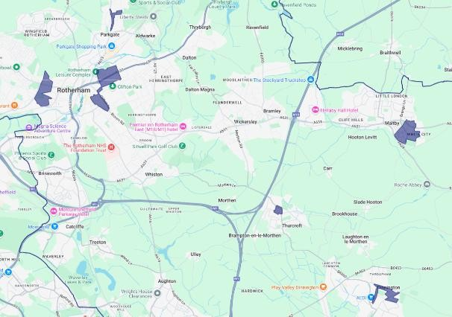
- Eastwood / Town Centre
- Masbrough
- Maltby
- Dinnington
- Thurcroft
- Parkgate

Selective Licensing 1 May 2020 to April 2025 – Rotherham Metropolitan Borough Council

This public notice was active from 1st May 2020 to 30th April 2025 and enables Rotherham council to inspect private rented properties to ensure they are meeting housing standards. 2,377 properties were inspected and category 1 hazards were found in 292 properties with category 2 hazards found in 1,470 properties. The cost savings of these repairs has been

calculated as £148,543 savings to the NHS from removing hazards and £1,860,797 wider societal benefits from preventing ill health (BRE Housing Health Cost Calculator).

The most prevalent hazards types were fire (18.45% of hazards) and damp and mould growth (16.78% of hazards) with falls, electrical hazards, excess cold and carbon monoxide all significant proportions of the detected hazards.

The EPC ratings of these properties was commonly D rated and 77% of the stock is below a C rating in these areas.

A consultation was carried out (Selective Licensing Consultation in Rotherham 2025 to 2030 – Rotherham Metropolitan Borough Council) to assess views towards continuing the selective licensing scheme in the same areas plus Brinsworth.

Council Housing Budgets
Currently, the council receives no additional financial support and funding other than the (Energy Company Obligation) ECO4 programme and the Great British Insulation Scheme in order to improve energy efficiency in the private sector. The total income from council house rents in 2023/4 was £86,732,578. With total income (including other council provided services and facilities) being £96,759,270 (Source - Council Housing - Annual Reports – Rotherham Metropolitan Borough Council).

The breakdown of expenditure is as follows:
- 44% is used for major repairs and investments, new Council housing, and interest on borrowing and depreciation charges.
- 23% goes toward day-to-day repairs of houses
- 20% is allocated to managing estates and tenancies, including house letting and rent collection
- 11% supports central services like management, administration, and business support
- 2% is dedicated to developing new housing projects
Performance statistics on tenant satisfaction within council properties are available here- Housing Performance – Rotherham Metropolitan Borough Council. Key council housing statistics from the 2023/24 annual report include:
- 88% of homes meet the Decent Homes Standard
- 99% of emergency repairs are completed in time
- 74.1% of tenants’ are satisfied with the repairs service

The Thermal Improvement Scheme in Maltby is a £4.3 million project which has delivered external wall, cavity wall and loft insulation, and new high-performance doors and windows in 130 council homes, improving energy efficiency and reducing tenants bills by up to £400 a year. Here is a tenant quote from the process:

“The whole process has been more than worth it. In previous years I would have had to put my heating on in September but not now. It's lovely and warm and I'm already starting to notice the difference in my energy bills, which would have gone up substantially had the work not been carried out.” Maltby tenant - Mrs Russell (Thermal Improvement Scheme)

The Towns and Villages Fund 2021-2024 – Rotherham Metropolitan Borough Council was a multi-million pound commitment to delivering improvements to Rotherham’s town centre and

villages across the borough. Plans are currently being developed by ward members alongside neighbourhood coordinators.

Planning of New Homes
The 2022-2025 RMBC Housing Strategy outlines the building needs for new homes and the challenges faced in Rotherham by the Housing sector - Housing Strategy 2022-2025 The planning of new houses in Rotherham is documented in the local plan 2013-2028 - Core Strategy Adopted September 2014
All social housing must be an EPC C by 2030, but currently new homes don’t have to meet this standard as long as they have a valid EPC certificate.
Rotherham Council implemented a Green Space Strategy in 2021 which recommended that “All new homes should be within five minutes walking distance of a local green space providing space for informal recreation, and fifteen minutes’ walk of a larger green space providing a wider range of facilities and services. Where new green space is required, 16 square metres per person is proposed.” Here is the link to the strategy - Microsoft Word -
$linflaip.doc and the local plan.
National home building standards can be found here - Technical housing standards – nationally described space standard - GOV.UK
A Supplementary Planning Document (SPD) is a document that provides additional detail and guidance on policies within a Local Plan, but it is not part of the statutory development plan itself. SPDs clarify how policies should be interpreted and applied in specific situations, often relating to site-specific or thematic issues. SPDs can be found of the council webpage - Planning guidance – Rotherham Metropolitan Borough Council. Bassingthorpe Farm is a huge new planning development in Rotherham with plans indicating approximately 2000 houses will be built on this site. As a result, it requires its own SPD which is currently under consultation. This site will definitely include affordable homes.

Housing Related Health Concerns

The Link Between Housing and Health
The wider determinants of health (Figure 8) are made up of a variety of social, economic and environmental factors that affect health. A large proportion of the wider determinants of health involve living conditions, working conditions and housing environments. This section outlines the key health implications caused by poor quality housing such as category 1 hazards (including cold homes), overcrowding and indoor air pollution. These hazards and the poor housing stock costs the NHS an average of £1.4billion a year in treatment costs (Source – Building Research Establishment 2021).

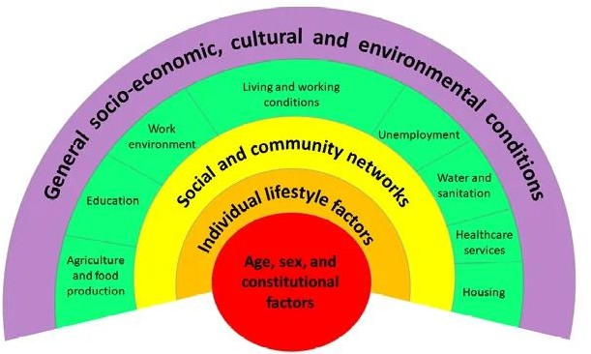

Figure 8 – Dahlgren and Whitehead rainbow model showing the wider determinants of health

Damp and Mould
Rotherham Council has a Damp, Mould and Condensation policy (Damp Mould and Condensation.pdf (rotherham.gov)) which outlines the causes of damp and mould in homes, the associated health risks, ways to reduce damp and mould and the policies relating to private and council rented properties. In 2021, it was estimated around 904,000 homes in England have damp problems (English Housing Survey). More recent government estimates of the number of homes in England with damp or mould have increased and range from 4% to 27% of homes depending on area. (Source - Understanding and addressing the health risks of damp and mould in the home - GOV.UK). Relating these estimates back to Rotherham would indicate that between 5,000 and 33,000 properties have damp or mould concerns. Due to higher rates of deprivation and fuel poverty in Rotherham, the local estimate could be towards to upper end of the England estimates.

Condensation can be caused by inadequate heating of the property, poor ventilation, high humidity levels, poor insulation and overcrowding. These issues are very much linked to deprivation and highlight the effects of inequalities in Rotherham, for example:
- People living in deprived areas are likely to be classed as fuel poor due to household income and lower quality, older housing and therefore are much more likely to not be able to heat their home to adequate levels
- Overcrowding is much more likely in areas of high deprivation
- Poor insulation is more common in deprived areas
Penetrating damp can be caused by both external and internal leaks which cause damp and damage to internal surfaces. Rising damp is caused by moisture rising from the ground often due to missing or defective damp proofing.
Mould is a fungus which grows best in poorly ventilated, damp homes. Mould can then reproduce and make spores which are airborne allergens leading to allergic reactions, asthma exacerbation and respiratory infections. The health effects of damp and mould in the

homes are exacerbated in vulnerable populations such as children, people with existing health conditions, pregnant women and older people.

Owner occupiers are advised to deal with damp and mould as soon as possible to avoid the health risks associated with them. However, this relies on them being able to identify issues, contact people who can do repairs or offer support and financial fund any repairs needed which adds in many additional barriers for owner occupiers.

Council homes should comply with the Decent Homes standard which includes having no category 1 hazards, therefore the council is responsible for ensuring damp and mould are prevented and dealt with in all council properties.

Private landlords are also expected to comply with the regulations and landlords have a duty to ensure their properties are free of damp and mould. If landlords, don’t take action to fix the problem, the council can take enforcement action.

Cold Homes
Excess winter deaths directly correlate to low average winter temperatures, and the majority of this is attributable to cold homes (Figure 9). The temperature perceived as a cold home is indoor air temperatures below 18 degrees. On average, over the past 10 years, an average winter temperature drop of 1 degree, leads to 6,000 excess winter deaths across England. Excess cold in Rotherham's private rented stock varies by ward with the highest proportion being 4.96% in Hoober down to 0.4% in Wickersley North. In England, it is estimated that 653,000 households have excess cold.
Comparison on Excess Winter Deaths to Average Winter temperature
6
5.5
5
4.5
4
3.5
3
2.5
2
0
2,000 4,000 6,000 8,000 10,000 12,000 14,000 16,000
Excess Winter Deaths Due to Cold Homes
Average Winter temperature (C)

Figure 9 - Comparison on Excess Winter Deaths to Average Winter temperatures in England using ONS statistics from 2011 to 2022.

Cold homes have a huge impact on health, primarily through increased risk of illnesses such as cold, flu, heart attacks and pneumonia. People with existing health conditions such as arthritis, diabetes and circulatory problems are also at increased risk. Cold homes also causes other issues not directly related to physical health such as increased social isolation, increased loneliness, poor mental health and reduced sleep quality.

Hot Homes
In addition to excess cold, excess heat is also listed as a category 1 hazard in the Housing Health and Safety rating system (HHSRS). Climate change is resulting in higher summer temperatures and England temperatures reached 40°C in July 2022. With this temperature extreme expected to occur every other year from 2050 and hot spells increasing in temperature and length throughout the century, excess heat will become a serious risk to health.

Impacts of hot homes include heat stroke, dehydration, poor mental health, poor sleep quality and exacerbation of current health conditions. Periods of extreme heat lead to an increase in mortality, especially in vulnerable populations such as over 65s, people with neurodiverse conditions and those with current health conditions. In the 2022 LeDeR report, it showed that 13% of notified deaths in 2022 in the neurodivergent population occurred in the 2-day extreme heat wave in July (LeDeR report - 20231019_LeDeR_action_from_learning_report_FINAL.pdf)
The UK Met Office have a heat health alert system which people can sign up to, so they are aware when periods of extreme heat are expected. Heat-health Alert service - Met Office This can help people prepare themselves but also ensure those they care for are prepared. Rotherham Council has an adverse weather plan in place which covers our response to periods of extreme heat – Heatwave Action Plan Rotherham Metropolitan Borough Council.

Indoor Air Quality and Chemical Hazards
Indoor air quality has a massive impact on health and some sources of indoor air pollution are listed as category 1 hazards including carbon monoxide and asbestos. Second hand smoke inhalation is not directly listed as a hazard but is a huge contributor to poor indoor air quality.

Up to 2 million children in the UK are exposed to smoke in their home leading to increased likelihood of childhood cancers, emphysema development and asthma development. In a national survey of young people, 7% of respondents aged 11-18 reported that they lived in a home where people smoke (Source - ASH Smokefree GB Youth Survey 2019). There is also increased risk to pregnant women who inhale second-hand smoke in the home environment. Rotherham has a Tobacco control action plan which being currently updated and has actions covering the above areas of concern. The main service for smoking cessation support in Rotherham is HealthWave - Rotherham Healthwave - Helping Boost Health and Wellness

Fuel burning in the home causes the release of fine particulate matter (PM2.5) which can be toxic and causes various illnesses such as bronchitis, throat and lung irritation and over long periods of time, increase the risk of cancer and premature mortality.
Carbon monoxide is a poisonous gas with no taste, smell or colour created when gas, oil, coal or wood don't burn fully. Houses should be fitted with a carbon monoxide alarm as part of the Smoke and Carbon Monoxide Alarm (England) Regulations 2022. In 2023, carbon monoxide was responsible for the deaths of 77 people in England and Wales (Source - Number of deaths due to accidental poisoning by carbon monoxide, England and Wales, deaths registered in 2023 - Office for National Statistics)

People can be exposed to asbestos in the home environment via breathing in asbestos fibres or direct skin contact. Asbestos fibres are hazardous and cause a variety of serious health problems such as inducing cancers, asbestosis and mesothelioma. In Great Britain, there are over 5,000 asbestos-related deaths per year. (Source - Asbestosis, mesothelioma,asbestos related lung cancer and non-malignant pleural disease in Great Britain 2024 (hse.gov.uk))

Lead exposure is also a risk in housing in homes built pre-1970 and is significantly more prevalent in the most deprived decile of households. Lead exposure has a variety of health implications associated with it including brain and kidney damage in high doses. More information is available on the government website - Lead: information for the public - GOV.UK

Hoarding
Another housing hazard is hoarding which presents both safety concerns and mental health concerns. Hoarded homes are a fire risk due to the blocking of exits, increased concentrations of flammable items and reduced ability to contain fires due to doors not being able to close. There is also an increased chance of mould growth due to moisture build up on hoarded items, a lack of air circulation and blockage of seeing leaks. Exact figures on hoarding are not available but estimates range between 2-6% of households with higher prevalence in people aged 55+ (Source - Hoarding Disorder | OCD-UK).

There is more information and a safety statement on Hoarding on the South Yorkshire Fire and Rescue website - Hoarding - South Yorkshire Fire and Rescue

Mental Health & Isolation
One in five people suffer mental health issues linked to housing (source - Housing and mental health | Mental Health Foundation) due to a variety of issues such as dangerous, unhealthy living environments, uncertainty of accommodation and overcrowding.

Mental Health concerns and loneliness play a huge role in people's home environments. Loneliness can affect anyone of any age but is more prevalent in those who live alone or live in deprived neighbourhoods. If people have poor living conditions (damp, mould or other hazards), they could be less likely to invite people over and maintain social connectivity. The percentage of older people (65+) living alone at the 2021 census ranges from 26 to 41% depending on MSOA. RMBC have a Loneliness Action Plan which runs from 2023-2025 aimed at addressing loneliness concerns in Rotherham (Loneliness Action Plan update.pdf).
Self-reported wellbeing statistics show that 10.43% of adults in Rotherham have a low happiness score. The prevalence of depression in 2022 was 17.29% and this is increasing each year. Further mental health data is available on the JSNA - Microsoft Power BI

In Rotherham, 12% of households are classed as being rural. This can have an impact on mental health, for example, rural areas often have increased community connection and access to nature for increased health benefits but conversely have less access to key services which are predominantly located in the town centre.

To ensure our Rotherham Council residents have access to mental health support, mental health questions are included in the tenant health check which is delivered by housing staff.

Information on the mental health support available in Rotherham can be found on RotherHive - RotherHive – The wellbeing and mental health resource for Rotherham

Overcrowding
Occupancy ratings measure whether a household is overcrowded. This is calculated based on how many bedrooms a household requires to how many available bedrooms the house has. 3.5% of Rotherham households are classed as overcrowded from this metric, split between 2.9% requiring one extra bedroom and 0.6% require two or more bedrooms. (2021

census). This is similar to the England figure which was measured at 3% in 2023 but was only 1.8% in the Yorkshire and Humber region. However, overcrowded housing is much more prevalent in some groups compared to others.

Overcrowding rates vary massively by ethnicity, for example in England, 25.3% of Arab households are classed as overcrowded compared to 1.7% of White British households. In terms of tender types, 1.1% of owner occupiers, 5.6% of private renters and 8% of social rented households are classed as overcrowded. (Source – English Housing Survey and Overcrowded households - GOV.UK Ethnicity facts and figures (ethnicity-facts- figures.service.gov.uk))
Overcrowded households disproportionately affect children with approximately 1 in 6 living in overcrowded conditions. Research on children in overcrowded properties is available here - briefing-note-children-overcrowding.pdf. Overcrowding in properties including children is highest in the social rented sector.

Health risks associated with overcrowding include:
- A decline in mental health due to less privacy and a greater risk of conflict
- Increased spread of diseases due to close contact and an increased number of contacts
- Reduced ability to study/work due to restations with space, suitable work environment and increased distractions.

Climate Related Risks
Climate change effects such as increased average temperatures, increased rainfall and increased storms can have harmful implications to Rotherham residents and the housing stock. All climate related risks and data for Rotherham are outlined in the Climate JSNA page - Climate Change – Rotherham Data Hub
Rotherham Council have a flood risk management strategy - Flood Risk Management Strategy – Rotherham Metropolitan Borough Council and a heatwave policy - Rotherham Metropolitan Borough Council to ensure the safety and health of residents during climate related weather events.

Additional Home Risks
People aged 65 and older have the highest risk of falling. Around 30% of adults who are over 65 and living at home will experience at least 1 fall a year (approximately 2.5 million people in England). This rises to 50% of adults over 80 who are either at home or in residential care. The risk increases in patients with cognitive impairment and dementia - Patient falls manual (prevention and management) – Rotherham Doncaster and South Humber NHS Foundation Trust (RDaSH)
Data shows that in 2025, there are 1 million people living in the UK with Dementia. Home adaptations significantly improve quality of life and reduce falls but majority of homes don’t have them. Alzheimer's UK have developed a dementia friendly housing guide - Dementia Friendly Housing_Guide.pdf
Substance Misuse adds additional risks within the home environment, particularly in homes with children present. The key service for substance misuse support in Rotherham is ROADS - Drug and Alcohol Support in Rotherham (ROADS) | WithYou. Full statistics on substance misuse are available on - NDTMS - ViewIt - Adult and the Rotherham JSNA

pages (Alcohol – Rotherham Data Hub and Substance Use – Rotherham Data Hub). Here are the statistics related to substance misuse and housing:
- In 2024, 23% of substance misuse clients in Rotherham lived in a household with a child. 440 are parents and 65 live with a child that is not theirs.
- In 2022, 12% of new presentations to Rotherham’s Drugs and Alcohol had a housing need with 4% having an urgent housing need (30 adults).
Access to pharmacies is a key aspect of the built environment. Pharmacy needs assessments shows the access to pharmacy services in the borough but also provides a thorough outline of medical needs of the population. rotherham-pharmaceutical-needs- assessment-2022-to-2025 An updated Pharmacy Needs Assessment will be going for approval at the Health and Wellbeing Board in September 2025.
Local high rates of crime decrease people’s feeling of safety in their community and home environment. Rates of crime vary across the borough and are detailed on the South Yorkshire police maps: Rotherham North | Police.uk , Rotherham Central | Police.uk and Rotherham South | Police.uk

Risks of Poor Housing on Children and Young People
Children are disproportionately affected by poverty and poor housing conditions both nationally and locally. Rotherham Councils, ‘No Family Left Behind’ child poverty strategy ( No Family Left Behind Strategy - Rotherham Council) outlines that almost one third of children in Rotherham are living in poverty. This compares to around 1 in 5 adults living in poverty locally in Rotherham. During the consultation of the No Family Left Behind strategy, children quoted that they relate ‘bad house conditions’ and ‘homelessness’ as the first things they think of when taking about living in poverty.
Children are more susceptible to respiratory issues such as asthma attacks which are exacerbated by mould in households (Childhood asthma and mould in homes—A meta- analysis - PMC). This study found that mouldy homes increase the risk of childhood asthma by 53%.
There are also profound impacts on education and attainment if children do not have safe hazard-free housing in which to complete homework, revision and other hobbies. The average attainment 8 score in Rotherham in 2023 was 43.1 compared to 46.2 nationally, equating to more than 3 grades worth of difference in the combined core subject areas (Fingertips | Department of Health and Social Care). For the least deprived areas nationally, the attainment 8 score is well over 50, meaning that students achieve on average 1 grade higher in all subjects than those in deprived areas like Rotherham.
Areas of Rotherham with higher levels of deprivation also have higher levels of children living in socially and private rented properties. These areas also have higher levels of overcrowding which again, is more likely to affect households with multiple children.

Cost of Living
The cost of living crisis has had a huge effect on people in countries across the world including England where annual inflation rates in October 2022 reached 11.1%, a high proportion of which was driven by energy price increases (Source - Cost of living and inflation - House of Commons Library (parliament.uk)) According to public opinions on energy prices, 4/10 of adults said it was somewhat or difficult to pay energy bills. This is resulting in 44% of adults using less energy in their homes then necessary. This has huge implications on health and wellbeing and the growth of mould in properties (Data - Cost of

living insights - Office for National Statistics (ons.gov.uk)) The annual inflation rate for housing and household services was 7% in April 2025, up from 5.1% in March 2025 (Consumer price inflation, UK - Office for National Statistics)
Age UK have written a report on older people and their current situation regarding cost of living and rising energy prices. Some key facts in this report are:
- 44% of pensioners in Yorkshire & the Humber have cut back on heating or powering their home
- 34% of pensioners in Yorkshire & the Humber feel less financially secure than a year ago
- Nearly one in four (23%) said their home is colder than they would like it to be ‘all the time’ or ‘most of the time’ – equivalent to 2.8 million people. This is an increase on the 17% giving the same answer in January 2024.
Quotes from this research from residents include:
- “My monthly payment for gas and electric takes more than my weekly pension. [I] heard that it will be rising again, along with my water bills. Living is a struggle, NOT what I imagined my later years would be.” – Patricia, 76
- “I struggle, I missed the deadline for [the] winter fuel [payment] as I still haven’t received Pension Credit guaranteed. It’s been 8 weeks now. It’s cold but I have duvets and extra clothes. I would rather [not] eat than go into debt to pay heating.” – Anonymous
- “I am on palliative care for my cancer and need to keep warm. I do not want my elderly wife to be left in debt because of my having to have our house kept warm.” – Anonymous
The full report from Age UK is available here - cost-of-living-report_0325.pdf

Housing costs contribute a huge amount to debt and poverty issues in the UK. On average white British adults spend approximately 11% of their income on housing compared to 21% for Black African adults and 23% for Bangladeshi households for example. (Source - The Reality of Ethnic Inequalities in Housing: Heritage and Home Research by The Resolution Foundation - Resolve - Antisocial Behaviour)

What Support is Available?

Support Summary
National and local support for cost of living and other payments change regularly due to changes in funding, changes in government and other related changes to the economy and energy prices. A variety of the support which has been available in recent years in detailed in the sections below including the ECO4 scheme (4th iteration of the ECO programme), Energy Crisis Support Fund and Winter Fuel payments.
General information on bills, money and up to date household support is available on Money matters – Rotherham Metropolitan Borough Council

Rotherham Energy Network Group
The Rotherham Energy Network is a group of third sector organisations who alongside RMBC’s Community Energy Team, Public Health, Neighbourhoods and Strategic Housing teams meet bi-monthly to discuss issues and resources around energy support, fuel poverty and financial issues. This group also shares members with the Humanitarian group which is chaired by RMBC Neighbourhoods team. (Note: this group is not related to the Rotherham town centre Energy Network infrastructure). Below is the information of each member of the Rotherham Energy Network Group and the support they provide to Rotherham residents:

Community Energy Team
The team offers advice and support to Rotherham residents and council staff regarding living in fuel poverty and/or a cold/damp home. Rotherham residents can contact the team via social media, email or via the website.
The team can provide help with:
→ Referring to the relevant support services available on a case-by-case basis.
→ Providing information on which energy schemes and support grants are available to residents.
→ Help people understand energy bills and how to make their home more energy efficient.
Here is the link to the Community Energy Teams council pages: Community Energy Rotherham – Rotherham Metropolitan Borough Council
Email address to contact the team: community-energy-rotherham@rotherham.gov.uk

Age UK Rotherham
A local part of the national Age UK charity that help to support older people, their families and carers.
The team can provide help with:
→ Advice and information particularly benefits support
→ Home help services such as cleaning and shopping
→ EngAge project which helps people stay connected in their local community Website - Welcome to Age UK Rotherham

Citizens Advice
Citizens Advice Rotherham & District offer advice for a range of services including energy, debt, legal rights, housing and healthcare. They offer advice through detailed information packs via their website or 1 to 1 telephone appointments or at home visits.
Website link - About Us - Citizens Advice Rotherham

RotherFed (Rotherham Federation)
Support communities through a variety of projects designed to strengthen communities, improve lives and promote unity. Four current key projects are:
→ More Energy Know How project, has now acquired funding until May 2027. This scheme runs energy sessions with groups, offering advice and information on saving energy and reducing energy bills.
→ Make Our Money Go Further project, support people to reduce expenditure, increase income and renegotiate outgoings
→ Money Skills for Life project helps people over 19 to heat their homes for less and understand more about their finances
→ Open Arms project (detailed below) Website link - About Us - Rotherham Federation Open Arms Project

The Open Arms project is a multi-operation project, involving Citizens Advice Rotherham, Rotherfed, Lazer Credit Union and Voluntary Action Rotherham (VAR). The project plans to deliver support sessions across all 25 wards in Rotherham, until March 2026.
The project aims to support people with:
→ Money Management including debt, benefits and budgeting support.
→ Energy Advice
→ Cost-of-living support
→ Digital skills support
→ Community support via family events and groups
Open Arms website - Open Arms - Community Support Hubs - Rotherham Federation

Green Doctor (Groundwork)
Groundworks is a charity based on South Yorkshire which run a project called Green Doctor. The Green Doctor project offers free advice to residents within Rotherham through home visits or telephone calls.
The eligibility for Green Doctors service occurs a broad range of criteria, covering those on low income, living in debt and poor housing accommodation. Other eligibility criteria cover those with health conditions, disabilities and underrepresented groups.
These services can be accessed through:
Phone - 0300 303 3292
Email - greendoctoryorkshire@groundwork.org.uk Website - Get Energy Help - Groundwork

Live Inclusive
Live Inclusive is a Charity supporting disabled people and people living with long-term health conditions in Rotherham and Doncaster. Their aim is to support people to live their lives as independently as possible and receive all benefits they are entitled to.
Website - Live Inclusive | Access to Independence

Home Heating Hub
The Home Heating Hub is a free service provided by Communitas Energy CIC. With a focus on the heating system, the service aims to help residents understand energy efficiency and low carbon technology upgrades they could make to their homes, to help reduce costs and carbon emissions and improve comfort. The service checks what measures could be suitable for their home and if there is any funding available to them. The service also provides advice and support on a range of related topics, such as assessment and application for the Priority Services Register (PSR), Carbon Monoxide risks/safety information, energy saving tips and advice, benefit checks and financial debt advice. Some of the specialist advice is provided by other organisations they are working with. With funding from Northern Powergrid, they are able to provide the service for free to residents across the Northern Powergrid network area.
Contact Information - hello@ce-cic.org.uk | 0113 486 2941 homeheatinghub.org.uk

For more information and/or to discuss working with us contact: chris.sowerbutts@ce- cic.org.uk | 07758216238

ECO4 Scheme
The Energy Company Obligation (ECO) is a Government programme designed to offset emissions created by energy company power stations via retrofitting low income and vulnerable households. ECO4 is the 4th period of this programme running from 2022 to 2026. The range of measures available through the scheme include heating upgrades, solar panels, wall and roof insulation. The provision of these measures is designed to help vulnerable families reduce their energy bills and assists with the Governments 2050 net zero target.
Government estimates show that over its four years, ECO4 will upgrade around 450,000 homes in Great Britain, most of them to EPC band C, ensuring that current and future households living in those homes will not face fuel poverty. It will reduce household bills by around £290 on average but for the least efficient homes this could be up to £1,600. It will also support around 18,000 jobs across Great Britain and improve the general skillset.
Further information is available at - ECO4: 2022 -2026: government response (publishing.service.gov.uk). 7,215 energy efficiency measures have been installed in private sector houses under the previous iteration of the scheme, Energy Company Obligation (ECO3) in Rotherham.

The ECO4 scheme operates through a general and FLEX route, with 50% of suppliers' contribution going to each route. The ECO4 FLEX route is set and monitored by local authorities, with RMBCs flex route focusing on widening the eligibility of the general scheme.

As of June 2025, 1,455 ECO4/GBIS-FLEX applications had been signed off since the beginning of the scheme in July 2022. An average household installation cost saving for this period is £6,500. The distribution of these application sis shown in Figure 10.
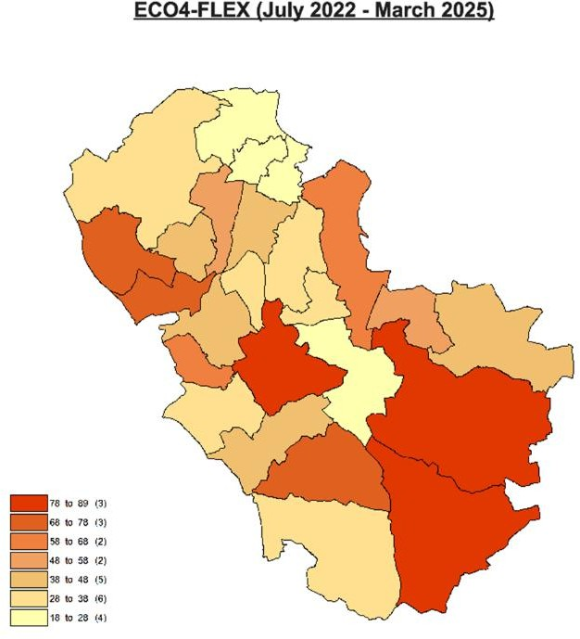

Figure 10 – Distribution of ECO4/GBIS flex applications across wards in Rotherham.

Energy Crisis Support Scheme – Historic Support
The Energy Crisis Support scheme provided a payment of up to £400 to any households struggling to pay for energy costs. The qualifying criteria was to have less than £150 a

month left after paying all essential costs (food/rent/bills). This scheme had been made available again for the winter of 2024/25 and applications for this opened in November 2024 with a maximum payment offer of £250. The need for the Councils Energy Crisis Support varies across Rotherham (Figure 11).

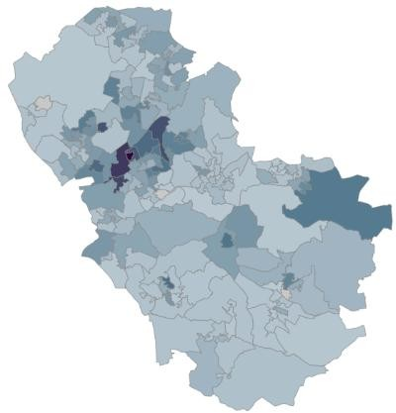
Figure 11 – Distribution of Energy Crisis Support scheme funds across Rotheram at an LSOA level

Great British Insulation Scheme
If a home has an EPC of D to G and the house is in a council tax band of A-D (A-E in Scotland and Wales) it will be eligible for this scheme. It applies to homeowners, landlords and tenants and enables people to access cheaper home insulation including cavity wall insulation, loft insulation and solid wall insulation (internal or external). This scheme was announced at the end of the 2022/23 financial year and is scheduled to run for 3 years. The estimates in how many properties this could help is 300,000 but in the first 8 months of the scheme, only 3,526 measures have been installed in 2,979 households across Great Britain up to December 2023. 61% of the installations have been cavity wall insulation. Further information is available at - Summary of the Great British Insulation Scheme: January 2024 - GOV.UK
Great British Insulation Scheme (GBIS) also operates through the FLEX route, similar to the ECO4 scheme. There has been little uptake of GBIS across Rotherham households due to ECO4 operating as a whole house approach and including more home energy improvement measures.

Warm Homes: Social Housing Fund
This was previously known as the Social Housing Decarbonisation Fund Wave 3. This fund supports social housing providers to insulate social homes, improve energy efficiency and upgrade heating systems. Together with matched funding from housing associations it helps retrofit social homes and tackle fuel poverty for residents, deliver carbon savings to progress toward net zero by 2050, and grow the housing retrofit sector. The Council have submitted a bid to the Fund, and it was successful.

RMBC originally submitted a bid for £14,926,471 (with an additional £12,413,130 in co- funding from RMBC) for the Warm Homes Social Decarbonisation Fund from the Department for Energy Security and Net Zero (DESNZ). However, RMBC have been awarded £8,791,994 from DESNZ and will be contributing £9,636,435 in co-funding. This work will be carried out in partnership with our contactor Mears.

Additional Bills Support
The Household Support Fund has been provided to Rotherham Council by the Department for Work and Pensions to cover a variety of services such as:

- Discretionary housing payments are extra payments to help people pay rent. They can be awarded to people who are already receiving Housing Benefit or get the housing element of universal credit but need more help with housing costs.
- Food vouchers for school holidays worth £15 per week provided to people eligible for free school meals.
- Local Council Tax support top ups which ensures that the lowest income households don’t have to pay the minimum Council Tax payment for 2025/26
- Provision of household goods via Open Arms Project (project extended to March 2026).
- Support for care leavers is provided through the Children and Young People Services directorate to care leavers who needs additional support for food and utility bills.
The following cabinet report detailed the 2025/26 allocation - https://moderngov.rotherham.gov.uk/mgConvert2PDF.aspx?ID=151846
More information on this is available at - The Household Support Fund – Rotherham Metropolitan Borough Council
Further support and advice on bills are available on RotherHive – The wellbeing and mental health resource for Rotherham, Money matters – Rotherham Metropolitan Borough Council and About Us - Citizens Advice Rotherham.

Winter Fuel Payments
The Winter Fuel Payment is an annual tax-free payment for households that include someone born on or before 22 September 1959 (for 2025-26). It's designed to help you cover your heating costs in winter, with households receiving either £200 or £300 depending what year you were born in. The UK government have announced in 2024 that this payment will become means tested from winter 2024/25. The qualifying benefits are Pension
Credit, Universal Credit, Income Support, income-based Jobseeker’s Allowance or income- related Employment and Support Allowance, or an award of Child Tax Credit or Working Tax Credit of at least £26 for the tax year 2024-25. This decreased the number of households receiving this payment from 11.4million to 1.5million and put significant pressure on a lot of households who rely on this payment. Additionally, some households will find it more challenging to heat their home this winter due to a predicted 10% rise in energy bills for the winter of 2024/25. However, this decision has been re-assessed for winter 2025/26 and the eligibility criteria will be increased to £35,000 of taxable income. There is a significant correlation between the Rotherham areas with higher rates of fuel poverty and the proportion of pensioners in those areas that receive means tested winter fuel payments (Figure 12).
Age UK have produced a Pension Credit Information guide - Pension Credit downloadable information guide | Age UK

Figure 12 – Correlation between percentage of fuel poverty and percentage of pensioners eligible for Winter Fuel Payments
Fuel Poverty Compared to Winter Fuel Payments by MSOA
30
28
26
24
22
20
18
16
14
12
10
5
10
15
20
25
30
Percentage of pensioners eligible for Winter Fuel Payment
Percentage of Households in Fuel Poverty

Employment Solutions
Employment is a key aspect influencing someones living environment as it impacts what type of accomondation someone can afford to live in but also what repairs and upgrades someone can do to their property. The employment solutions team at RMBC offer support for people wanting to get back into work. Here is the website link - Employment Support – Rotherham Metropolitan Borough Council

Support For Private Landlords
Let Zero Project is an 18-month pilot initiative led by the South Yorkshire Mayoral Combined Authority (SYMCA), funded with £2.4 million from Innovate UK. Its goal is to support private sector renters by helping landlords make better decisions about property renovations and energy efficiency improvements, especially for vulnerable tenants. More information is available at News - South Yorkshire MCA. Rotherham council housing and Public Health departments have been involved with consultation for this project.

RMBC Training Offer
Rotherham council staff from Public Health and the Community Energy team have collaborated to create a training offer for front line staff on the topic of damp, mould and energy support. This training will run with the Making Every Contact Count (MECC) theme to coincide with healthy chats training on other topics already delivered by Public Health. This training will be offered to RMBC and NHS staff as well as volunteer staff working in Rotherham. The main aims of this training will be:
- Explaining the MECC approach and how to initiate conversations about damp and mould
- Differences between damp types and the associated health risks
- What support is available for Rotherham residents around damp, mould and energy?

As of the end of the 2024/25 financial year, more than 280 people have been trained on this topic across various sectors. This content is being reviewed, and further sessions will commence in September 2025.

Action Plan

Theme 1: Intelligence and Evidence Gathering

Action to be completed | Description | Lead Department / Organisation | Completion date | Progress
Actions Completed in the last period
Housing Health Cost Calculator subscription | Identify a means of funding the annual subscription to the Housing Health Cost Calculator for 2025/26 – This was funded by Regulation & Enforcement | Public Health and Regulation & Enforcement | March 2025
Produce Support Data | Collate the data for the Energy Support section on uptake of the scheme – This data was produced and is included in this document | Community Energy Team and Housing | June 2025
Healthy Homes Planning Map | Production of a Rotherham map detailing areas of concern for flooding as well as location data for healthcare accessibility, green/blue space access, food accessibility, school locations and bus stop accessibility | Public Health Intelligence | July 2025
Review of selective licensing data | Understand the comprehensive picture of the health risks faced by Rotherham residents in private rented properties and allow more opportunities for action. It needs to be ensured that all properties with identified issues should be followed up to ensure repairs and offer advice and support information to the tenants | Housing | July 2025
Slips trips falls | Reviewing slips, trips and falls data helps to identify vulnerable people living in potentially dangerous homes. This allows for an intervention opportunity to ensure all Rotherham homes are free from hazards and dangers.  This data will be added into the Healthy Homes Plan | Public Health and Adult Social Care | July 2025

 | document from the 2025 refresh to highlight the issue. This data was reviewed but it not publicly available.
Other housing hazard data | Expand data on other household related hazards such as substance misuse and mental health and detail these in the plan with appropriate links. | Public Health | July 2025
Data input into Housing Health Cost Calculator | Input all internal housing records of hazards and completed work into the calculator | Public Health Intelligence and Regulation & Enforcement | July 2025
Actions to be completed in the next period
Demographic Damp and Mould Index | Creation of the Damp and Mould risk index tool that combines various data points to establish a risk of damp and mould in housing by LSOA | Public Health Intelligence | December 2025
Data analysis from the Housing Health Cost Calculator | Utilising the Housing Health Cost Calculator to conduct cost benefit analysis. Data provided from the tool includes cost savings to the NHS and cost savings to society. This needs to be compared to the costs spent on completing this work. | Public  Health Intelligence and Regulation & Enforcement | December 2025
Performance Monitoring Tool | Creation of tool to monitor the performance of internal housing teams on areas related to reducing housing hazards within council stock | Public Health Intelligence & Housing | February 2026
Review of Housing Health Cost Calculator | Conduct review of the system and assess whether there is beneficial data collected from it in order to reprocure for future years | Public  Health Intelligence and Regulation & Enforcement | April 2026

JSNA updates to include health in all policies | Review housing sections of JSNA and ensure elements relating to health risks detailed in this Healthy Homes Plan are detailed in JSNA. This will continue to enhance the health in all policies approach across the council. | Public Health Intelligence | Next JSNA refresh – April 2026
Energy Performance Certificate | Reviewing EPC ratings allows for constant identification of households that could benefit from further support. All opportunities should be made to inform households with low ratings of the support that is available. | Strategic Housing | June 2026
Utilise personal quotes | Use quotes and experiences of Rotherham residents from the Health and Wellbeing Board refresh and the Maltby and Dinnington study to embed throughout document. This is key to ensure the voice of Rotherham residents is referenced throughout. | Public Health | June 2026

Theme 2: Reducing Fuel Poverty in Rotherham

Action to be completed | Description | Lead Department/ Organisation | Completion date | Progress
Actions Completed in the last period
Produce a list of interventions available for reduction of fuel poverty | Produce a digital offer of all interventions to ensure people have access to all necessary information they need. Also allows other council departments to have a central location to signpost people to. This will include council and voluntary services related to fuel poverty | Community Energy Team | December 2024  (will be refreshed every winter)
Minimum Energy Efficiency consultation response | To collate a response from across council partners to the government consultation on the new MEES requirements for private rented housing | Strategic Housing | April 2025

Councillor Engagement | Organise and deliver an awareness sessions from local councillors to ensure the issues surrounding fuel poverty are a priority for councillors. | Rotherham Energy Network Group, Housing and Financial Inclusion | May 2025
Let Zero Engagement | Initial discussion with Let Zero project to outline key areas of interest in Rotherham | Strategic Housing and Public Health | May 2025
Actions to be completed in the next period
Healthy Homes Checklist | Creation and adoption of the healthy homes planning checklist for future planning projects related to housing | Public Health & Planning | October 2025
Let Zero Promotion | Connect Let Zero up with local private rented sector tenants and landlords to ensure as many people as possible can be involved in the project | Housing | December 2025
Rotherham Energy Network utilisation | The new heat network being built in Rotherham is scheduled to become operational in 2027. Information about this and potential benefits will need to be monitored and added to future updates of the Healthy Homes Plan | Rotherham Energy Network | Once the system is operational (Likely 2027)
Social Housing Decarbonisation | Delivery of energy efficiency upgrades to social housing stock in order to decarbonise the stock and reduce energy bills for residents | Housing Property services | August 2026
EPC targets | Continue to make improvements to social housing stock with target of all social housing being EPC C by 2030 | Housing Property Services | 2030

Theme 3: Increasing Support and Assistance to Tackle Housing Related Health Risks

Action to be completed | Benefit of action | Lead Department/ Organisation | Completion date | Progress

Actions Completed in the last period
Delivery of Damp & Mould MECC training | Increase knowledge and confidence of RMBC staff and Rotherham frontline workers to have conversations about damp and mould and offer support to tenants using the MECC approach. There will also be a help sheet available for all those who attend the course with key information on. | Public Health | Started September 2024. Aim of 2 sessions per month from September 2024 to March 2025
Evaluation of MECC training | The Damp and Mould MECC sessions delivered in 2024/25 will be evaluated | Public Health & Community Energy Team | August 2025
Promotion of health and housing correlation to other key partners in Rotherham | Ensure all partners are aware of the current work happening across the sector and allow opportunities for joint working. The Healthy Homes plan will be brought to the attention of the Humanitarian group every 6 months to highlight changes and progress and allow the members a chance to add to the action plan | Humanitarian Group | April 2024 (Next update in November 2025)
Brunch and Learn session about climate change and energy | To inform the adult social care workforce of the challenges posed by increased heat in homes as well information about the fuel poverty picture and support available in Rotherham | Public Health,  Climate Change and Community Energy Team | July 2024
Expand training sessions to library staff and children’s sector | Ensuring front line staff across all council departments know about the availability of energy support to create a united support offer across the council. | Public Health and Community Energy Team | March 2025
Awareness session in Riverside | Raising awareness of available support in Rotherham for cold homes and energy/cost of living issues. Public Health will have representative at the event as well to provide | Community Energy Team | October 2024

 | information on the mental and physical health support services in Rotherham.
Actions to be completed in the next period
Town Centre Awareness session | Coordination and delivery of an awareness session on available energy, bills and housing support hosted in Rotherham town centre (exact location TBC) | Rotherham Energy Network Group | October 2025
Winter 2025/26 Comms | Work with RMBC Comms team to create winter comms related to fuel poverty, damp and mould | Public Health, Community Energy Team and Comms | October 2025
Landlord newsletters | Collating information on support for landlords about damp, mould and energy support. The newsletter goes out to approximately 1100 landlords | Public Health, Community Energy Team and Comms | October 2025
Expand awareness sessions | Replicating the awareness session held in Riverside House in October 2024 into other areas across the borough to ensure everyone can access them without having to travel into the town centre. | Community Energy Team | March 2026

