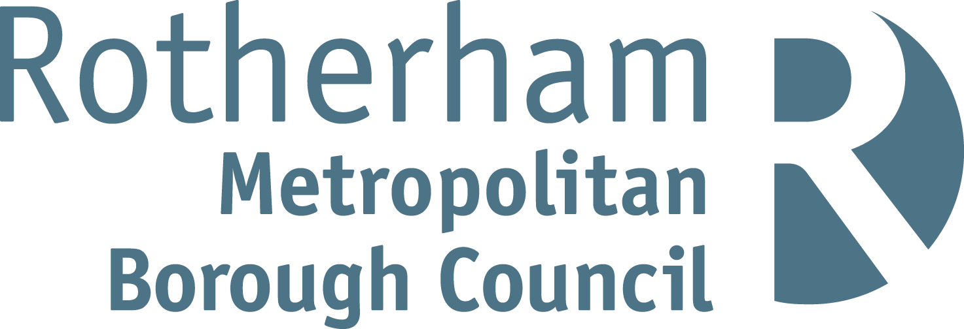
NEAR MISS REPORT

PLEASE COMPLETE ALL SECTIONS

What is a Near Miss?
- An unplanned event which could have caused an injury or ill health, or
- An incident that eventually may lead to an accident.

How do you respond?

If an employee observes a near miss:

- Immediately make the situation safe, if safe to do so. (e.g. Take any equipment out of use, place barriers/cones, or correct the unsafe behaviour.
- Report to a Manager or Supervisor.
- Complete the near miss report form.
- Managers should investigate and take action to prevent reoccurrence.

1. Details of Near Miss | Date: |  |  | Time:
Location / Address:
Department:
Persons Involved:
Description of how incident / near miss happened (Note any equipment/machinery involved which could be a contributory factor). - Please continue on a separate sheet if necessary.
Likelihood of an Injury: High/Med/Low
Name and status of any witnesses:
Contact Details:

2. Investigation
PLEASE ENSURE THIS SECTION IS COMPLETED by Manager, Supervisor, Dept. Head etc. without delay. Attempt to identify any factors which may have contributed to the near miss and any action needed to prevent a repetition. Are safe working procedures in place and were they being followed?
Please provide details on the following:
Immediate cause:
Root cause:
Risk Control Measures required:
Further Action:

Have you got a risk assessment for this work activity:
Date the risk assessment was last reviewed:
If no risk assessment is in place, give reasons why not:
Further Comments:
Manager’s Name (please print):
Manager’s Signature: |  | Date:
Managers Contact Number:
Managers e-mail address:

E-mail this form immediately to:- healthandsafety@rotherham.gov.uk
Tel: 01709 823878 From Internal: 23878

