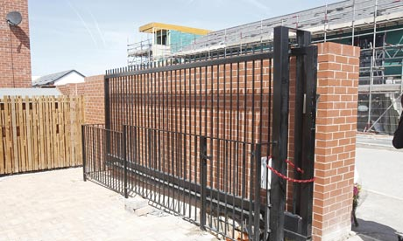

Safety Alert

Risks to pedestrians from crushing zones on electrically powered gates

The purpose of this Safety Notice is to advise facilities managers of properties with Powered Perimeter Gates, what they must do to ensure the safety of people in the vicinity of such gates

Introduction:

The purpose of this Safety Notice is to alert users of electrically-powered gates to potential safety risks to pedestrians. It is also of relevance to organisations in control of the use and/or maintenance of existing electrically-powered gates.
It will be of particular interest to organisations in control of premises where persons other than their own employees may have access to such gates. agents.
The information will aid in identifying any particular hazards in relation to gate design, and then to undertake suitable and sufficient risk assessments as part of their work activities to ensure risks to pedestrians are eliminated and/or controlled.

Background:

During the summer of 2010 two children died after becoming trapped in powered gates. They were trapped because:
- Their presence at the closing edge was not detected; and
- The closing force of the gate when they obstructed it was too high.
The powered gates involved in the incident were installed across a driveway leading to a block of privately owned flats. They consisted of two wrought-iron style gate leaves which were hung on two brick pillars, one either side of the driveway.
Two design issues meant that when the gates were in the closed position a gap existed between the spine of each gate and the brick pillars - large enough for a child to put their head and upper body through. This gap then reduced in size when the gates were opened.

The design issues were;
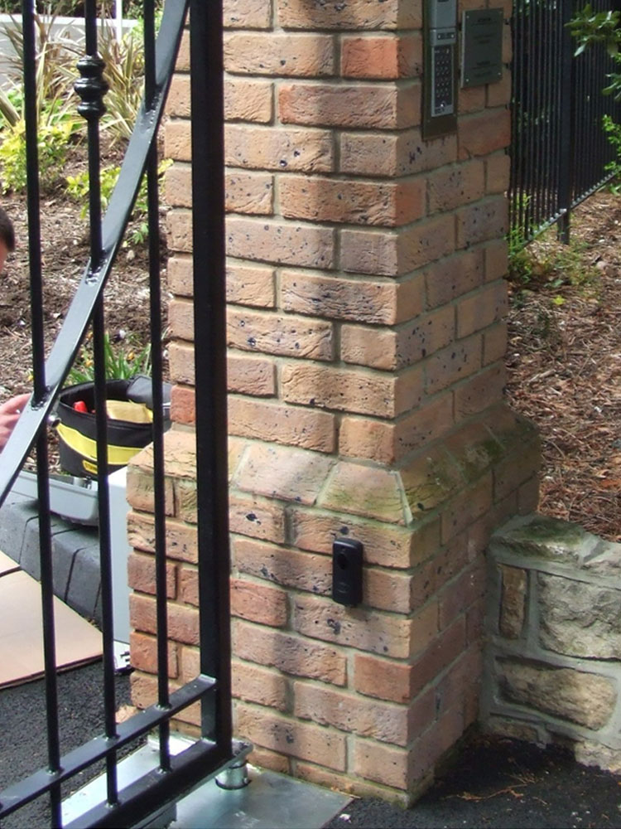

Photograph 1: Brick Pillars - Corbelled brick pillar increasing gap size
That the brick pillars were constructed in such a way that they were 'corbelled', or 'stepped-in' on their central portion (The base of the pillars were wider than the central portion - see photograph 1);
The spine of the gates were sat forward of the mounting pin on the motorised arm (located at the heel of the gates). In this instance the term 'spine' is intended to refer to the vertical steel bar located closest to, and parallel to, the face of the brick pillar (see photograph 2).
The installation left a gap of 160mm at its widest point between the two vertical surfaces of the gate spine and brick pillar.

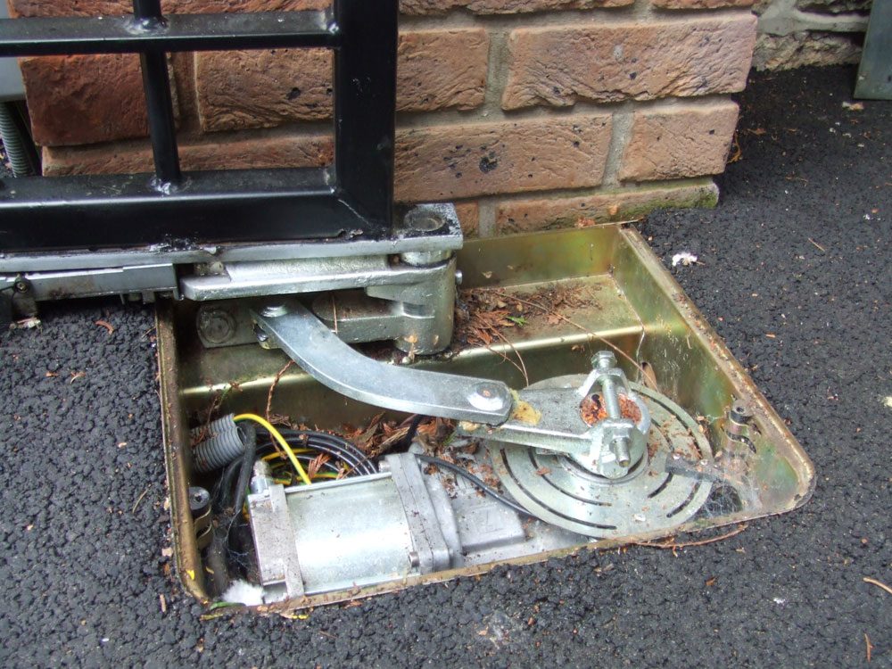

Photograph 2: Gate & Motor Arm - Spine of gate sat forward of mounting pin on motor, increasing gap size and creating a crushing hazard
When activated, the gates would begin to open. The forward position of the spine in relation to the mounting pin on the motorised arm meant that the gap of 160mm between gate and pillar would reduce. In this instance the gates reduced to a gap of 110mm once fully opened.
A pedestrian egress button had been placed on the rear of one of the two brick pillars, inside the development. This was intended to allow pedestrians within the development a simple means of activating the gates when leaving the site. The design of this installation meant that the button was within reach of persons on the outside of the development, effectively allowing an unsafe means of activating the gates.
On the day of the incident the child approached the gates in order to activate them without using the intercom system or keypad entry system that had been installed. The child reached through the gap between the gate and pillar to press the internal pedestrian egress button.
As the gate opened the gap between the spine of the gate and the pillar reduced. As the gap reduced the child became trapped and crushed.
The motors on the gates were fitted with amperometric sensors to detect obstacles in the path of the gates once the gates were in motion. If the gates struck an obstacle and met resistance they would stop moving.
In this instance the sensors were ineffective due to the forces involved at the spine of the gate.
The gates had also been fitted with a light beam sensor between the two pillars. This was intended to detect an obstacle between the pillars to prevent the gates from closing onto a vehicle. It was not designed to identify the presence of a person in the crushing zone nor prevent a person from activating the gates.

Action required:
When designing, constructing, installing and/or commissioning electrically powered gates, or where managing sites where electrically powered gates exist, employers and the self employed must ensure so far as is reasonably practicable that:
They have undertaken a suitable and sufficient risk assessment to identify any hazards and associated risks to persons using the gates. This should include consideration of the following;
the identification of any trapping and/or crushing zones where employees or persons not in your employment (such as contractors or members of the public) may become trapped and injured;
the identification of ways in which safe operating systems (such as key-pad or key-fob systems) may be defeated or by-passed and place employees, non-employees (such as contractors), or members of the public at risk. This is particularly relevant where children, members of the public, or persons not familiar with the safe use of any installation have access to electrically powered gates and may not recognise a risk to their safety;
The identification of ways in which persons may be harmed by the gates should they be activated automatically, or by another person (for example, by a sensor under the road surface activating a gate when a car drives over it, or by a remote button or key fob pressed by a third person);
Risk assessments should be undertaken as early as possible. Undertaking a risk assessment at the design phase will allow an opportunity to design out risks at an early stage;
Any design changes should be subject to a revised risk assessment to ensure the changes have not introduced new hazards or risks;
When the installation is complete, a final risk assessment should be undertaken
They have eliminated and/or controlled any risks identified from the risk assessment(s). Wherever possible risks should be eliminated, but where they need to be controlled technology such as fixed guards, pressure sensitive strips, safety sensor flooring, light barriers or infra-red detectors may help control and/or reduce the risk, but consideration needs to be given to how a person may still be harmed if one of these systems fail;
Any component parts (such as motors and motor arms) supplied by separate manufacturers should be installed in accordance with the manufacturers guidance, and used in accordance with their instructions for use;
Where the gates are defined as a machine under the Supply of Machinery (Safety) Regulations 2008 a conformity assessment must be undertaken by a responsible person prior to their use, and a technical file compiled.
Any information or instructions required on how to operate the gates should be made available to the person(s) or organisation that the gates are produced for. An EC declaration of conformity should be produced, and the gates CE marked; One way of achieving this is to follow EN12635 from the outset of the project.
Persons adopting the responsibility for the management and maintenance of the gates should be provided with the appropriate safety documentation, instructions for use, and training in how to operate and maintain the gates safely. Persons using the gates regularly should be given appropriate information, instruction and training on how to operate them safely;
Regular reviews or assessments are undertaken to ensure that the gates are maintained in a safe condition.

Section 4: Hazards, hazardous situations, hazardous events

Sub-section 4.1.1: Hazards caused by crushing, shearing and drawing-in points
A hazardous point is considered to exist up to a height of 2.5m above the floor or any other permanent access level, and when it occurs:
- between the main closing edge of any door and an opposing edge, and between secondary closing edges of hinged, folding, tilting and sliding doors and opposing edges;
- between closing edges and obstacles within the closing area of the leaf;
- between leaves passing each other;
- between leaves and the perimeter of openings in leaves and fixed parts in the vicinity;
- between gaps and openings of the leaf which change in their size during the leaf movement;
- at parts of the leaf which project;
- at moving parts of the drive which are capable of causing injury
Sub-section 4.5: Influence of the type of use and the level of risk
The location of the door and the type of door control can have an influence on the level of risk created by a power operated door.
This level of risk increases when
- children, infirm or elderly persons are able to use the door;
- it is not possible to instruct, train or supervise the door users;
- it is not possible to select the persons who are the only ones allowed to operate the door (authorised persons);
- the number of persons who may come in contact with the power operated door is high;
- the number of users, and/or the frequency of use is high;
- the degree of automation is high.
Conversely, the level of risk is reduced when doors are used by a limited number of users, are not equipped with any automatic function and are not opening directly onto a public area, i.e. non automatic domestic garage doors used by one household only and which do not protrude directly onto a public area.

Section 5: Requirements

Sub-section 5.1.1: Avoiding or safeguarding hazards caused by crushing, shearing and drawing-in points
All danger points as listed in 4.1.1 shall be avoided or safeguarded.
This can be achieved by one or a combination of the following measures:
- creating safety distances;
- installing guards such as enclosures, covers, enclosing guards, fixed protection leaves;
- shaping in a proper way any leaf surfaces and parts which protrude;
- operating the door in the hold to run control mode;
- limiting the forces generated by the door leaf when meeting a person or an obstacle;
- Installing sensitive protective equipment (PSPE or ESPE

