New The BS Standard – School Chairs

All Schools

Nov 2016 SAf34

BS EN 1729

GUIDE TO BRITISH & EUROPEAN FURNITURE STANDARDS

For information only and to be considered when purchasing furniture in the future.

A guide to purchasing school furniture with compliance to the British and Europeans Standards.

The British and European Standards for “Chairs and table for educational establishments and institutions” were approved in 2007.

Size marks ensure that the table to seat height ratio provides the highest levels of comfort and support for the child, encouraging good posture. The size marks featured in the diagram below are based on the standard for furniture in all UK and European educational establishments and institutions.

The standards are: BS EN1729 Part 1 – Functional dimensions. BS EN1729 Part 2 – Safety requirements and test methods.

Popliteal Height: Popliteal height defines the correct seat height. The measurement is taken from the floor to the back of the knee when seated, with thighs horizontal and lower leg vertical with feet flat to the floor.

Sitting Work Height: Sitting work height defines the correct standing table height, which is the distance from the floor to the underside of the elbow whilst sitting with the upper arm vertical and the lower arm horizontal.

Stature: Stature is from floor to top of the head.

Standing Work Height: Standing work height defines the correct standing table heights. The measurement is determined by standing elbow height, which is the distance from the floor to the underside of the elbow of a standing person with the upper arm vertical and lower arm horizontal.



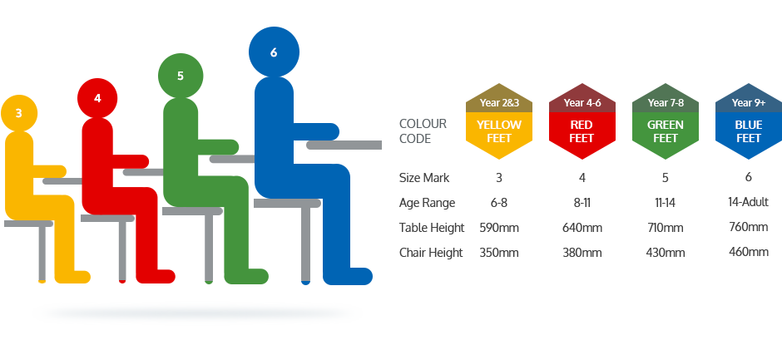

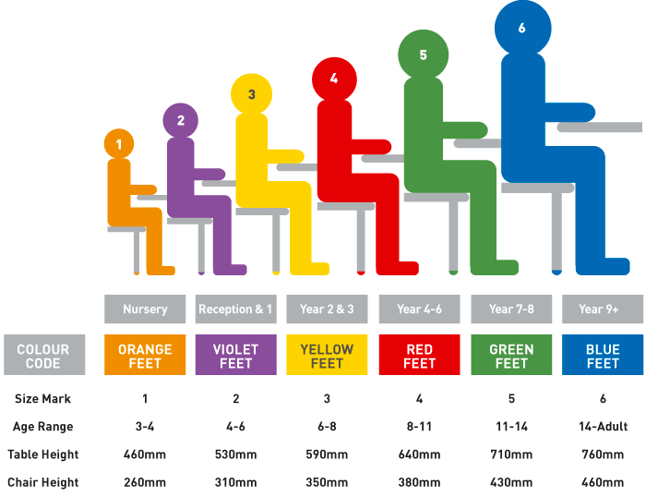

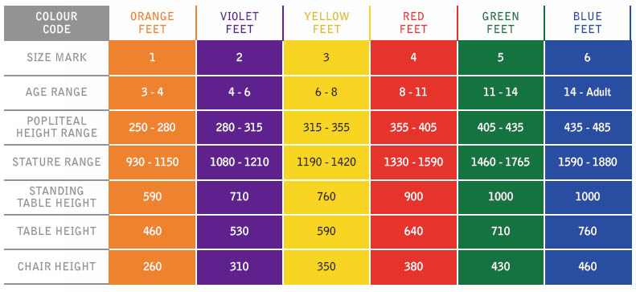

If you require any further information, please contact the Emergency and Safety Team on 01709823720 or email healthandsafety@rotherham.gov.uk

