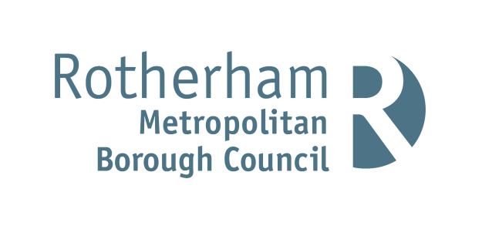

Public Rights of Way COVID 19 Advisory Notice

Please use your discretion and understanding when
using public paths and respect others including property
owners and farmers, especially those who may be
self-isolating and shielding.

- Consider using paths that do not cross gardens or
yards.

- Keep at least two metres apart and follow the latest
Government Advice.

- Follow the Countryside Code.

- Leave no trace of your visit.

- Take your litter home.

- Keep dogs under effective control

- Leave gates as you find them or follow instructions
on signs.

Thank you for your patience and understanding.

