Evaluation of the support given to people rough sleeping or at risk of rough sleeping during and after the COVID-19 Spring lockdown

The Ministry of Housing, Communities and Local Government (MHCLG) is undertaking an evaluation of the support provided to people sleeping rough or at risk of sleeping rough during and after the COVID-19 national lockdown. MHCLG is responsible for housing in England.

MHCLG are commissioning an independent research organisation to carry out the research.

What is this research?
MHCLG would like to find out:
- How well services work for people who were homeless or sleeping rough in ending homelessness and rough sleeping for them;
- What the benefits are for people receiving these services; and
- How services can best help people address the wider issues which can accompany homelessness and rough sleeping.
For this, MHCLG want the researchers to collect information directly from people who have received support, about their history, and experiences of homelessness and housing. This will be done through telephone interviews.
What personal information is being shared?
Rotherham Metropolitan Borough Council will share your personal information with the researchers so that they can use it to select people to be part of the study. If they select your details, they will contact you and invite you to take part in an interview. If they don't select your details, they will be deleted within 1 month of the final selection being made and by March 2021 at the latest. The Council has this information because it is responsible for homelessness in the area and holds information on people who are being helped. This information will include your name, date of birth and contact details, such as address, email address and telephone numbers (where these are held). Information on your nationality, or preferred language (if this is not English) will also be shared so the researchers know that they might need to contact you in a language other than English. They will use your address or email address to write to you about the research and your mobile number to call you, if you have one.
You will receive a £10 voucher as a thank you for taking part in an interview.
In the interview you will be asked for more personal information, such as your age, gender and your ethnicity, and whether you have spent time in prison or in hospital. This information will help MHCLG understand if services work better for some people than others. It will be up to you whether you answer these questions.
Any information you provide during the interview will be kept strictly confidential, unless a researcher thinks that you or someone else is at risk of harm.
If you agree to do the first interview, you will also be asked if you agree to being contacted again in the future. If you agree, researchers will use your mobile number to get in touch with you and invite you to take part in more interviews. When you are contacted again you can choose whether or not to take part in another interview. You may be asked to do 3 more interviews. You will receive a voucher each time you complete an interview.
If the researchers can’t contact you directly about taking part in another interview, they will ask for help from the council. This may include Rotherham Metropolitan Borough Council sharing your updated contact details with the researchers.
If researchers are still unable to contact you, they will ask the council to provide some information on your housing situation. This may include information on stays in hospital or prison.
You can choose to complete the interview without agreeing to take part in any further interviews and you don’t have to answer anything you don’t want to.
Agreeing to join interview answers to other information
MHCLG is doing another similar research project on homelessness and rough sleeping, but instead of interviews, it uses information collected by Government Departments. This information will be held by the Office for National Statistics (ONS) on behalf of MHCLG.
It will include information about:
- homelessness applications made to the council
- contact with the criminal justice system
- drug and alcohol services received
- benefits received
- health services used
This research is likely to include information on your use of public services and benefits. If you agree, your personal information (name and date of birth) and your interview answers will be shared with ONS so that your interview answers can be used for this other research project and linked to information on your use of public services and benefits.
You can take part in the interviews even if you don’t want your interview answers to be linked with this other information.
For further information on the data that will be held by ONS please see:
Statistics at MHCLG - Ministry of Housing, Communities & Local Government - GOV.UK (www.gov.uk)
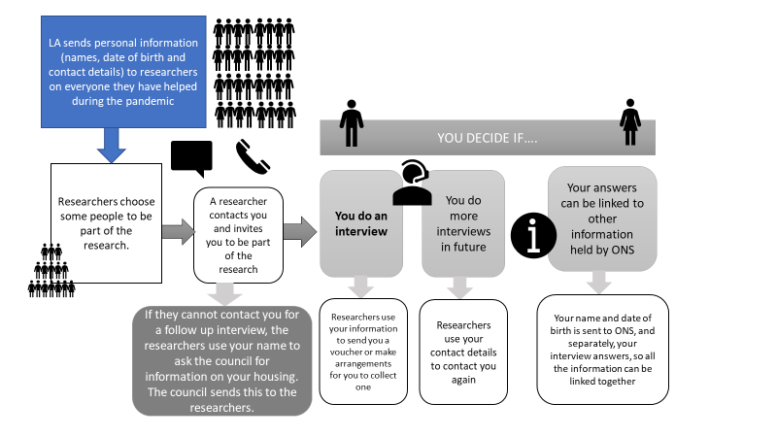

What happens to my personal information if I can’t be contacted at all and don’t participate in any interviews?

When the Council shares your personal information, they will also share the number that is unique to you that they hold with information about your housing and homelessness applications. This information is also held by MHCLG with the same unique number (this is referred to as the H-CLIC data - Homelessness Case Level Information Collection). If the researchers can’t contact you at all, they will delete your personal information after 6 months, but keep your unique number. This will be used to collect information about everyone who MHCLG wanted to be part of the research but weren’t, to see if they are different to the people who did do interviews. The researchers will not know whose information they are looking at.
Why are the council and MHCLG able to use my personal information for this research?

Your personal information can only be used by the council and MHCLG if it is done in a way that fits with the law.

MHCLG is able to use your personal information for the research because the research is expected to help the government make better decisions about homelessness and rough sleeping services in the future.

The law states that personal information can be used if it is in the public interest to do so and there is a separate basis in law to allow this. MHCLG believes that it is in the interests of the public for this research to be carried out so that homelessness services can be improved in the future.

The council is able to share your personal information to help with this research because processing is necessary for the performance of a task carried out in the public interest or in the exercise of official authority vested in the controller. Rotherham Council will use the Homeless Reduction Act 2017 as the lawful basis.

The law also states that extra care has to be taken with personal information that is more sensitive. This includes information about, for example, your ethnicity and any contact you might have had with the criminal justice system. These are referred to as ‘special category’ personal data and criminal offence data. These are things that are asked about in the interview. It will be up to you if you answer them. Where this information is shared by the council or you are asked to provide it, there is a clear reason for doing so – MHCLG believes it is necessary to make sure the research can be the most useful it can be.

If you would like more information on what the law says about how your personal information can be used please see the ‘Further Information’ section below.

Data security and data storage
All your information will be kept safely and securely. The council will only share your personal information in a way that is secure and the researchers have very clear instructions from MHCLG about how to keep your data safe, what it can be used for and when it will be deleted. The personal information of those who take part in the interviews will be stored until March 2023 at the latest, after which this will be securely deleted. If the researchers do not select your details they will be deleted within 1 month of the final selection being made and by March 2021 at the latest.
Your Personal Data will not be sent outside of the EU for the purposes of data processing.
Automated decision-making
We will not use your data for any automated decision making.
What if I change my mind about the interview?
If you change your mind about completing an interview, you can let the researchers know. They will delete your answers if they haven’t already been used for the research. Interview answers are expected to be used 4-8 weeks after an interview. You can also tell them to delete your personal details, which they will do within 1 month. This won’t affect your legal rights or the support you receive.
You will be sent the email address/mobile number by text, email or post after the interview has finished and reminded that you can contact the researchers to let them know you have changed your mind.

What are my rights?
Your personal information (names, dates of birth, addresses) will not be kept longer than needed for the research and it will not be used for anything else. It will be held securely and kept in accordance with the law.

If you are unhappy with how your personal information is handled, you can complain about this matter to the Independent Information Commissioner. You can contact the Independent Information Commissioner at:
ico.org.uk/livechat

helpline number 0303 123 1113

Information Commissioner’s Office, Wycliffe House, Water Lane, Wilmslow, Cheshire SK9 5AF.

You also have the right to object to the use of your personal information, the right to see your personal information (name, address etc) and the right for it to be changed if it is wrong, by contacting MHCLG’s Data Protection Officer at dataprotection@communities.gov.uk or at the below postal address:
MHCLG Data Protection Officer, 2 Marsham St, Westminster, London SW1P 4DF
What will happen to the results of this research?

Aggregate level results of this research will be published, e.g. the characteristics of the people helped. MHCLG will publish reports on the gov.uk website. You will not be identified in any research report.

Where can I get more information?

If you would like further information about the research, what will happen to your information, and your rights please speak to your support worker or contact phillip.hamilton@rotherham.gov.uk if you would like to have more information.

Further Information

Legal basis for processing your personal data
Data protection legislation sets out when we are lawfully allowed to process your personal data. The personal data which MHCLG and Rotherham Metropolitan Borough Council will process will include special category personal data and may include criminal offence data. The following specific pieces of legislation will allow the lawful processing of personal data.

- Article 6(1)(e) of the General Data Protection Regulation (GDPR): “the processing is necessary for the performance of a task carried out in the public interest or in the exercise of official authority vested in the controller.”

- Article 6(3) of the GDPR: the basis for the processing is laid down in law. MHCLG is relying on its common law powers as its basis in law in order to process your Personal Data. The Council is relying on its common law powers afforded by the General Power of Competence (GPC) under the Localism Act 2011.

- Section 8 of the Data Protection Act (DPA) 2018: “personal data that is necessary for the performance of a task carried out in the public interest or in the exercise of the controller's official authority includes processing of personal data that is necessary for—… (d) the exercise of a function of the Crown, a Minister of the Crown or a government department”.

- Article 9(2)(g) of the GDPR: processing of special category personal data is “necessary for reasons of substantial public interest, on the basis of Union or Member State law which shall be proportionate to the aim pursued, respect the essence of the right to data protection and provide for suitable and specific measures to safeguard the fundamental rights and the interests of the data subject”.

- Article 10 of the GDPR: processing of criminal offence data “shall be carried out only under the control of official authority or when the processing is authorised by Union or Member State law providing for appropriate safeguards for the rights and freedoms of data subjects.”

- Section 10 and Schedule 1, Part 2, paragraph 6 of the DPA: the processing of special category personal data and criminal offence data is necessary for reasons of substantial public interest and necessary for the purpose of “the exercise of a function conferred on a person by an enactment or rule of law” or “the exercise of a function of the Crown, a Minister of the Crown or a government department.”

