Request for a re-inspection for re-rating purposes  The Animal Welfare (Licensing of Activities Involving Animals) England Regulations 2018 | 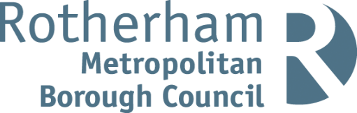

Notes for businesses:

- As the licensed operator of the establishment, you have a right to request a re-inspection for the purposes of re-rating if you have taken action to rectify the non-compliances identified at the time of inspection.
- The fee is £179 please telephone 01709 823161/01709 823164 to make the payment. The re-inspection/reassessment will be carried out within three months of the receipt of your request and payment. There is no limit on the number of requests you may make.
- You can make your request at any time after the statutory inspection provided that you have made the required improvements.
- You must provide details of the improvements made with your request, including supporting evidence where appropriate. If we consider that you have provided sufficient evidence that the required improvements have been made, an announced/unannounced inspection will take place.
- We will give you a ‘new’ star rating based on the level of compliance that is found at the time of the re-inspection - you should be aware that your rating could go up, down or remain the same.
- To make a request for a re-inspection, please email your request and supporting information to food.health&safety@rotherham.gov.uk and make the payment.

Business details
Licensed operator/proprietor

Business name

Business addresses

Business tel. number |  | Business email

Inspection details
Date of inspection |  |  |  |  | Rating given
Date notified of Rating |  |  |  |  | Official Use

Action taken
Please describe the remedial action you have taken with reference to the issues identified in the inspection letter/report provided to you by your local authority with your score:

Please provide any other supplementary evidence (e.g. photographs, invoices, copies of relevant

Signature
Name in capitals

Position |  | Date

Please return this form to: The Head of Service
Regeneration & Environment Services, Community Safety & Street Scene – Animal Health & Welfare,
Riverside House, Main Street, Rotherham, S60 1AE Email: food.health&safety@rotherham.gov.uk

