Application for a Variation of Licence  The Animal Welfare (Licensing of Activities Involving Animals) England Regulations 2018 | 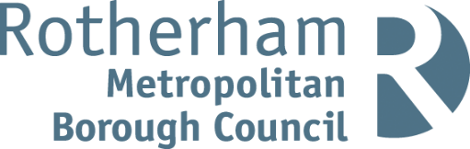  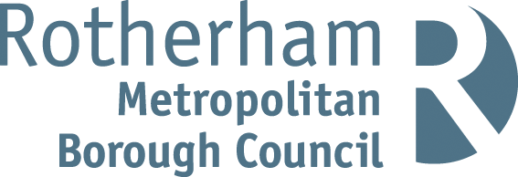

Notes for businesses:

- As the licensed operator of the establishment you have a right to make an application for a variation of your licence.
- The fee for a variation is £34.
- A local authority may at any time vary a licence on the application in writing of the licence holder, or on its own initiative with the consent in writing of the licence holder
- To make an application for a variation of licence, please complete this application form and return it to food.health&safety@rotherham.gov.uk and telephone 01709 823161 / 823164 to make the payment.

Business details
Licensed operator/proprietor

Business name

Business addresses

Business tel. number |  | Business email

Licence details
Existing Licence Number

Reason for the variation
Please give details

Signature
Name in capitals

Position |  | Date

Please return this application form to: The Head of Service

Regeneration & Environment Services, Community Safety & Street Scene - Food, Health & Safety,
Riverside House, Main Street, Rotherham, S60 1AE Email: food.health&safety@rotherham.gov.uk

