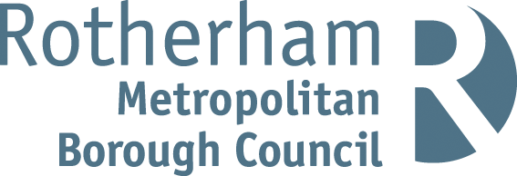

Rotherham MBC Parking Account 2020 / 21
Statistical Information
Number of higher level Penalty Charge Notices (PCNs) issued | 4,522
Number of lower level PCNs issued | 3,021
Number of PCNs paid | 5,069
Number of PCNs paid within 14 days | 4,041
Number of PCNs against which a formal or informal representation has been made | 2,020
Number of PCNs cancelled (i.e. where an informal or statutory representation is successful) | 907
Number of PCNs written off | 21
Number of vehicles wheel clamped | 34
Number of vehicles removed | 25

The above statistics are accurate as of 30th September 2021. These statistics can be subject to change on a daily basis due to the ongoing debt collection procedures.
Financial Information
The total income and expenditure of the on-street and off-street parking account for 2020 / 21 was as follows:
Expenditure £837,212
Income
Income source | £
Penalty Charge Notices | 186,647
Off street paid parking | 195,603
On street paid parking | 131,288
Permits | 102,263
Enforcement Agents (bailiffs) | 27,340
Total income | 643,141

Net Deficit £194,071
Note: Income for PCNs issued in 2020/21 may increase because, in cases where PCNs remain unpaid beyond the statutory period, the Council has a policy of registering the debts at the Traffic Enforcement Centre (TEC) at Northampton County Court. This is the Court which deals with all parking debt in England (outside London). Once a debt is registered the debtor is given a further 21 days to settle the debts before Enforcement Agents (formerly known as bailiffs) are appointed. Any income collected after 31/03/2021 from PCNs issued during 2020/21 will be credited to the Parking Account for 2021/22.

