Adult Care
Housing
Public Health

Market Position Statement

www.rotherham.gov.uk

Contents
Foreword 4
1 Introduction 5
What is a Market Position 6
Statement?
Rotherham Context 6
- Geography
- Population Details
- Housing
- Demographic of the Rotherham Borough
2a Adult Care Market and Demand 8
Older People 8
- Demographic
- Home Care and Support
- Capacity and Activity
- Residential and Nursing Care Homes
- In-House Provision
- Trend
- Primary Need
- Length of Stay
- Extra Care Housing Schemes
- Dementia
- Support with Memory and Cognition
- Commissioning Intentions Summary
- Supporting People to Remain Independent
- Assistive Technology

Learning Disabilities, Autism and Preparation for Adulthood 17
- Demographic
- People Receiving Support
- Transformation
- Preparing for Adulthood – Transitions
- Current Services and Accommodation Requirements
- Direct Payments
- Residential and Nursing Care Homes
- Supported Living
- Peer Support Network
- Extra Care Housing
- Shared Lives
- Respite
- Day Opportunities
- Commissioning Intentions Summary
Mental Ill-Health 25
- Demographic
- People Receiving Support
- Residential and Nursing Care Homes
- Mental Health Housing Related Support
- Commissioning Intentions Summary
Housing Related Support 30
- What is Housing Related Support?
- Homeless Applicant Needs
- Current Services and Pathways
- Commissioning Intentions Summary
Physical Disabilities 34
- Demographic
- Commissioning Intentions Summary

Unpaid Carers 36
  - Demographic
  - Dementia Cafés and Dementia Support Worker Service
  - Carers Emergency Scheme
  - Unpaid Carers Home Care and Support Service
  - Commissioning Intentions Summary
Voluntary and 38
Community Sector Services
  - Advocacy Support
  - Sensory Needs Offer – Sight and Sound
  - Local Healthwatch
  - Commissioning Intentions Summary

2b Public Health Commissioning - Market and Demand 41
  - Introduction
  - Drug, Alcohol, Recovery and Treatment Service
  - 0-19 Children’s Public Health Nursing
  - Sexual Health Service
  - Public Health and Lifestyle Behaviour Change Service
  - Commissioning Intentions Summary

3 Market Overview 44
Quality 44
- CQC Regulated Services
- Quality Assurance
- Adult Social Care Early Warning System
- Adult Social Care Workforce
- Adult Social Care Skills, Recruitment and Retention

Self Funders 47
- Who Are Self Funders?
- Rotherham Self Funders
- Self Funders in Care Homes
- Self Funders in Home Care and Support
Resources and Finance 47
- Key Financial Facts
- Resource Commissioning Intentions
- Budget All Commissioned Services
- Residential and Nursing Care Homes Older People
- Home Care and Support Services
- Specialist Provision
- Direct Payments

- Procurement
Overview 50
All Procurement Opportunities 50
Table
Social Value 50
Ethical Care Charter 50
How to Keep Up-to-Date Date 51
with the Council’s Procurement Opportunities

- Commissioning
Approach 52
Building Relationships 52
  - Co-production
  - Market Testing
Meet the Commissioners 53
Contact Us 53

- Resources
- Useful Links 54

Foreword

This Market Position Statement details information about commissioned services across Adult Care, Housing and Public Health, with a predominant focus on Adult Social Care in Rotherham. It presents the opportunities available for new providers and services.
As a Council we are committed to ensuring that we are creating a Rotherham where everyone can live independently, safely, and healthily in their community for as long as possible.
This Market Position Statement supports this ambition by providing an overview of the opportunities available to you in Rotherham. It presents the Council’s future strategic priorities and upcoming procurement opportunities that may be of interest to you.
The Market Position Statement also aims to provide the background information and context to support any future business proposals. It outlines the details of the number of people we support through our many commissioned services, the predicted future demand and our overall commissioning intentions.
Please utilise the information shared and navigate the specific sections that are relevant to you in this pdf document or alternatively use the live webpage. Please note the webpage is more dynamic and is regularly refreshed and therefore the content may differ between the webpage and the pdf. document
Together, we as the Council, along with our partners in the health system, can, with you, create an offer in Rotherham that promotes high-quality, person-centred care and support for all of our customers.
The Council welcomes suggestions of innovative ways of working and new partnerships.
Thank you for taking the time to visit the Market Position Statement and we look forward to working with you.

Ian Spicer
Strategic Director of Adult Care, Housing and Public Health
June 2023

4

Introduction
Rotherham Metropolitan Borough Council (the Council) is pleased to present the Rotherham Market Position Statement (MPS) which has been produced to:
  - Provide an overview of the demographic profile,
  - Define our current market and the current and projected demand,
  - Describe our strategic priorities and,
  - Indicate to the market our commissioning intentions to generate active market engagement.
The Council is committed to developing a care and support market with services which are safe, of high quality, achieve positive outcomes for our customers and offer value for money.
The overall objective of the MPS is to support the achievement our ambitions set out in The Council Plan, The Year Ahead Delivery Plan and The Health and Wellbeing Strategy.

Figure 1. The Council’s Themes

The Council Plan describes the role of Adult Social Care, Housing and Public Health as:
Neighbourhoods People are
are vibrant and safe, healthy
thriving and live well
One Council
The environment is cared for
Children and young people fulfil their potential
Everyone has economic opportunities

“….creating a Rotherham where everyone can live independently, safely and healthily in their community for as long as possible.”

The MPS acknowledges the formation of the South Yorkshire Integrated Care System (ICS) that is now live. The current version of the MPS incorporates joint commissioning with Health colleagues across the Rotherham Place System, primarily NHS South Yorkshire Integrated Care Board (ICB)(Rotherham Place).

  - What is a Market Position Statement?
A key document which summaries supply and demand in a local authority area or sub-region, identifies future strategic priorities and signals business opportunities within the care market in that area.
Source: IPC (2016). Market Shaping Review, Market Position. Statement Guidance.
This MPS is a dynamic statement and will be updated regularly.

Rotherham Context

Geography:
    - Rotherham Borough covers 286 square kilometres (110 square miles)
    - 70% of Rotherham is open countryside.
    - 25 wards covering a wide range of urban, suburban, and rural areas.
    - Rotherham is one of four metropolitan boroughs in South Yorkshire with good transport connections including the nearby Doncaster Sheffield Airport.

Population Details:
    - The 2021 Census (the most recent ethnicity data) found that 91% of the population are White British and 5.3% identified their ethnic group within the Asian British or Asian Welsh category.
    - 29.3% of the Borough’s BAME population live in Rotherham’s three central wards.
    - In Rotherham schools, 16% have a BAME background (2020) whereas only 2.6% of pensioners (65+) are BAME. The BAME population is estimated to have risen since the 2011 data.
    - Life expectancy in the most deprived areas of Rotherham is 9.9 years lower for men and 9.5 years lower for women than in the least deprived.
    - According to the Indices of Deprivation (2019), deprivation in Rotherham has increased. With the most severe key driver of deprivation being Health and Disability.
    - There are significant gaps in healthy life expectancy, meaning those from more deprived communities can expect to live for more years in poor health.

Housing:
  - Currently house prices are on average around £140,000.
  - In 2020, there were 116,955 households and dwellings across the borough. 3% are usually empty properties.
  - 566 new homes were built in 2020/21 across all sectors.
  - The Council owns a large stock of social housing, owning 20,393 units, although this number reduces by approximately 200 annually through Right to Buy purchases.
  - There are over 20 other housing organisations operating in Rotherham to provide a further 5,000 additional homes for social rent.
  - The private rented sector in Rotherham has grown significantly and currently provides 16% of the total housing stock in the borough.
  - There are currently 7,319 households on the Council’s housing register.
  - The provision of Council owned rented properties can be broken down by type of household; 19.7% houses, 6.5% bungalows, 19,7% flats, 5.4% other, 0.8% supported housing, 0.7% bed sits and 0.7% maisonettes.

Demographic of the Rotherham Borough:
  - Rotherham’s total population is 265,800 in 2021 (Census Data, 2021), the population size has increased by 3.3% from 257,280 in 2011.
  - 0-14 years olds make up 17.7% of Rotherham’s population (47,100).
  - 15-64 years olds make up 62.6% of Rotherham’s population (166,500).
  - 65 and older residents make up 19.6% of Rotherham’s population (52,200).
  - Number of residents aged 65+ is predicted to reach 61,907 by 2030, increasing Rotherham’s ageing population.
  - The Rotherham population has increased steadily by about 1,000 per year from an estimated 257,716 in 2011 to 265,800 in 2021 (+3.3%), due to more births than deaths and a net inward migration.
  - In 2020 Rotherham experienced a fall in population (to 264,984) for the first time since the year 2000, this is due to having more deaths than births registered: 3,454 deaths (623 of which were from covid) and 2,736 births.

2a Adult Care Market and Demand

Older People

Demographic:
The population aged 65 and over in Rotherham is estimated at 55,400 in 2023, this is predicted to increase by 3.2% to 57,100 by 2025 and by 11.5% to 61,800 by 2030. The age group of 75+ is showing the greatest rate of increase (POPPI June 2023).
Support needs:
In 2023 it was estimated that the number of people aged 65 and over who need help with at least one self-care activity, was 15,788. This number is expected to increase by 3.4% to 16,354 by 2025 and by 13.5% to 17,867 by the year 2030 (POPPI May 2023).
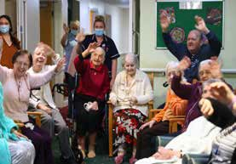
People receiving service:
There are approximately 2,126 older people receiving service (June 2023). Based on ONS projections this number is predicted to rise by 9.8% to 2,210 people by the year 2027, and by 14.2% to 2,342 by the year 2032.

Table 1. Older People Service Provision - All Service Types (June 2023)

Support Service Type | Existing Cohort (No) | Predicted Demand for future Cohort | Commissioning Intentions Summary
Total number of adults 65 or over in receipt of social care support (Excluding people with a primary support need of learning disability/autism and mental ill health) | 1909 | Increase | In line with demographic change the Council will continue to engage with the market to manage demand appropriately.
Reablement
In-house reablement service and therapy provision. | 60 | Increase | The Council will continue to support older people, with a reablement ethos and home first approach.
Personal Budgets
Direct Payment – Using a service provider | 245 | Increase | The Council supports the use of direct payments for more flexible and personalised solutions.
Direct Payment – Employing a Personal Assistant | 33 | Increase | The employment of personal assistants is encouraged where appropriate.
Care Services
Home Care and Support Service | 1019 | Increase | Strength-based and outcome focused service. Applications for appointment to the open framework are ongoing.
Care Home Beds
Residential Care | 263 | Decrease | The Council will continue to support older people, to remain at home in the community for as long as possible. Residential care services are provided for people who are unable to be supported safely at home and to provide unpaid carer respite support.
Nursing Care | 48 | Increase
Residential EMI | 260 | Decrease
Nursing EMI | 51 | Increase
Other Accommodation
Supported Living | 38 | Increase | The Council will continue to support older people, to remain at home in the community for as long as appropriate and would like to expand housing related support provision such as Supported Living, Extra Care and Shared Lives models and other models of support such as ‘live in’ care.
Shared Lives | <5 | Increase
Extra Care Housing | 81 | Increase
Other Services Community Support
Day Opportunities | 2 | Increase | The Council will continue to support older people, to remain at home in the community for as long as appropriate and to further utilise micro enterprises to support people to do so.
Community Support | 39 | Increase | Increase signposting to community support to reduce isolation and loneliness

Home Care and Support:
The Council operates a joint home care and support contract with South Yorkshire ICB (Rotherham Place) within a Flexible Purchasing System (FPS) arrangement. The contract will be in place until 2025 (minimum of five years) and operates using a tiered approach.
  - Tier 1: Nine providers work on a geographical footprint and are expected to accept 75% of requests for service.
  - Tier 2: Any CQC registered home care provider, rated Good or above, can apply to be a Tier 2 provider. Tier 2 providers work borough wide and are offered packages that the Tier 1 providers cannot undertake.
  - The Framework also operates a specialist Lot that enables providers with a specialism such as providing services to people with a learning disability or mental ill-health to apply and provide service to that client group.
  - Another Lot provides the opportunity to provide home care and support that benefits unpaid carers.

Capacity and Activity
On average in 22/23, the Council commissioned around 15,795 hours per week for 1,189 people (all ages and cohorts). Around 382 people are supported with multiple carer visits. The service specified offers support to enable people to continue living as independently as possible in their own home. Supporting people to access enabling technology/equipment and community assets, the service supports people to maintain the levels of independence achieved following a period of reablement, which is a service delivered by the Council.
Where people have a need for end of life care this service offers person centred support tailored according to the individuals needs and wishes.
The service is undergoing transformation and providers have a role in the organisation, adjustments, and reviews of care arrangements to the benefit of people accessing the service.
The Council invites suitably qualified and experienced providers to apply for a position on the framework.

Residential and Nursing Care Homes:
There are 1,593 independent sector residential, nursing and EMI beds for older people in Rotherham across 32 care homes. The Council owns two additional care homes supporting older people.
There has been a significant shift in the types of ownership relatively recently with large national providers exiting from the market i.e., from a position of 50% market share to 20% market share.

Table 2. Older Peoples Care Homes Market Split as of May 2023.

Owner | Market Split
National | 20%
Regional | 62%
Charitable Sector | 6%
Sole owner/standalone incorporated companies | 6%
Council owned | 6%

In-house Provision:
The Council provides two residential care homes (Lord Hardy Court, Rawmarsh and Davies Court, Dinnington). Together, these offer a total of 120 beds providing support to older people, made up of:
- 30 intermediate care beds.
- 15 surge beds – to support hospital discharges during peak times.
- 59 residential / residential EMI care beds.
- 16 beds currently utilised on a temporary basis to support people living with a learning disability.

Trend:

In Rotherham, there is a long-term trend moving away from traditional care home provision that mirrors the national picture. People are being supported at home for as long as possible and are entering 24-hour care for the last 2 to 3 years of their life when the complexity of needs has increased, and they are unable to manage their long-term conditions in their own home.

The number of older people admitted to residential care who are financially supported by the Council has declined over the last previous years from:

• 310 in 2017/18
• 292 in 2018/19
• 297 in 2019/20
• 227 in 2020/21
• 324 in 2021/22
• 341 in 2022/23

The increase in admissions in 2022/23 is recognised as the Council continuing to support people to remain independent in their own homes as far as possible plus continuing to support hospital discharges, to reduce pressure but this in turn has also added pressure to the social care system.

Primary Need:

The primary need for people aged 65 and over in residential/nursing care homes are:
  - 66.1% Physical support,
  - 22.0% Support with memory and cognition,
  - 9.5% Mental health support,
  - 2.3% Learning disability support,
  - 1.0% Sensory support and
  - 1.1% Social support.
The age of older people being admitted into care homes is also slowly increasing from an average of 83 years in 2015/16 to 85 years in 2018/19. In 2022/23 the average age for admission into a care home has decreased slightly to 84 years.

Length of Stay:
In 2022/23 the average length of long term stays in older peoples care homes was 30 months, a similar rate as 2021/22.
Care Type Demand:
There are low level numbers of vacant nursing and nursing EMI beds and an over-supply of residential and residential EMI beds. The low occupancy in residential EMI beds may be due to the dementia diagnosis prevalence decreasing due to the impact of Covid-19, although this is predicted to increase in the coming years.
The current vacancy level across all older people’s residential and nursing care homes is around 16% and has slowly recovered from its highest vacancy rate of 26% in July 2020 (Covid-19 Pandemic). Prior to the pandemic the vacancy rate was around 14%.
The Council supports 58 older people to live in out of Borough long term residential and nursing care homes.
There are 17 people under the age of 65 living in care homes which are designed to care for older people, and 16 people under the age of 65 in older people’s short-term accommodation.

The Council expects a downward demand for residential care due to increasing supply of alternate provision in response to the Home First and Reablement ethos, provision of equipment, assistive technology and adaptations, an increase in older people’s accommodation and changing customer attitudes.
A reprovision of residential beds to nursing and nursing EMI beds should be considered for some providers through transparent dialogue with the Council.
The Council is keen for care home provision to be modernised through additions of technology enabled care.

    - Extra Care Housing Schemes:
Extra Care Housing in Rotherham is based across three sites providing 108 units of accommodation at Potteries Court, Swinton (35 units), Oaktrees, (Stag) (20 units), and Bakersfield Court, Herringthorpe (53 units). Each site provides accommodation aimed at enabling people to remain independent within their home for longer. There is a dedicated team of staff who work across the Extra Care Housing sites. The Council works in conjunction with the landlord Together Housing. Personal care is delivered by the independent sector at all 3 sites through the Council’s contracted Home Care and Support Service.
Extra care housing combines a safe secure environment in a community setting and is seen as a way forward to provide older people with their own high-quality accommodation, with access to housing related support and a personal care when required.

The Council is keen to expand supported housing options for older people and encourages providers and developers to enter into dialogue with the Council.

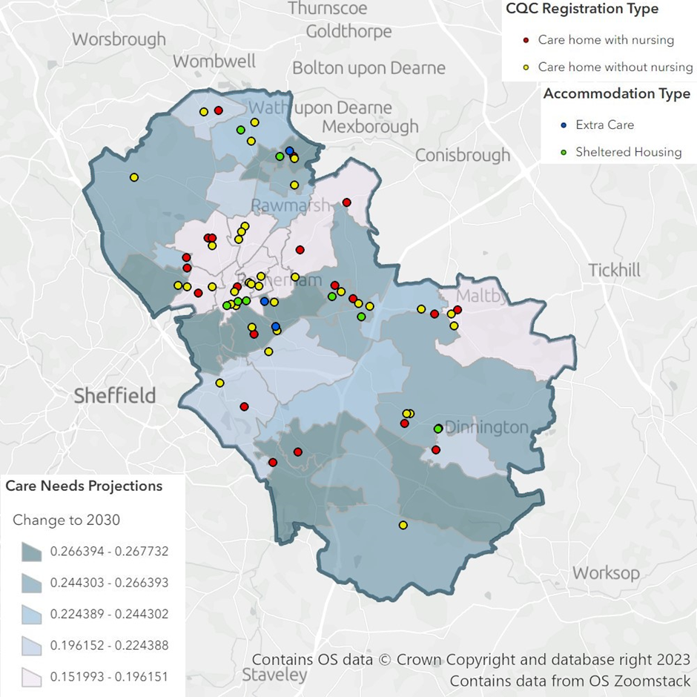
Figure 2. Estimated percentage change in care demand by MSOA 2030 and the current accommodation provision across Rotherham (Source: ONS mid-year population forecasts 2019)

Dementia:

Dementia prevalence rates in Rotherham are increasing despite a decline in formal dementia diagnosis during COVID-19 due to the circumstances in primary care, in line with the national picture.
In March 2023, there are 2,260 older people (aged 65 years and over) registered with GP practices in Rotherham who have received a dementia diagnosis. The expected number based on national modelling is 2,951, giving Rotherham a diagnosis rate of 76.6%. This is higher than the national rate of 63% (Source: NHS Digital)
As of 2023, 3,859 people aged 65 and over are predicted to have some levels of dementia. By 2040, the prevalence is expected to increase to a predicted 5,327 people aged over 65 with dementia. The prevalence increases with age, and diagnosis rates are higher in women (Source: POPPI, May 2023).

Support with Memory and Cognition:
The Council currently supports 411 older people who have a primary need of memory/cognition and who may be diagnosed with dementia (Source: Insight). According to ONS data this number is expected to increase by 23% over the next 10 years to 480 older people.
Of the 411 older people currently receiving service the majority (315 or 77%) are living in a care home indicating more needs to be done to support people to remain in the community.
Please go to our Unpaid Carers Section to learn about services to support carers who care for someone with dementia.

Commissioning Intentions Summary:

  - The Council will continue to support people to live independently at home through provision of equipment, adaptations to property and digital innovation.
  - The Council welcomes the opportunity for discussions with housing providers and developers to explore housing options for older people.
  - The Home First model (a model where the emphasis across the health and social care system is to care for people at home whenever we can, or if they are admitted to hospital, get them back home again as soon as possible) will continue to be adopted. This will increase the amount of home care and support needed, and the Council invites new applicants to the Home Care and Support Framework.
  - Care homes will continue to support older people with the most complex needs and an increase in nursing and nursing EMI care home capacity is required. A reduction of residential and residential EMI beds is expected as alternative provision develops.
  - The Council will continue to ensure people approaching the end of their life receive high quality care, wherever that care is delivered.
  - The Council is keen for care home provision to be modernised through additions of technology enabled care.

  - The Council will continue to support the emerging priorities from the Framework for Enhanced Health in Care Homes, (england.nhs.uk) to ensure joined up primary, community and social care to promote the good health of residents in care homes. The framework is centred on the needs of individual residents, their families and care home staff. Such care can only be achieved through a whole-system, collaborative approach.
  - The Council is working with the South Yorkshire ICB (Rotherham Place) to provide a joint service specification for care homes during the financial year 2023/24.

Supporting People to Remain Independent:

As well as a home care and support service the Council and the NHS Rotherham South Yorkshire ICB (Rotherham Place) jointly commission a range of services together to improve the lives of the most vulnerable people. These services are funded from the Better Care Fund (BCF) and include the Community Occupational Therapy Service, Intermediate Care Service, Reablement Service and Urgent Response services. These services all have a strong focus on delivering early intervention and prevention.
Other jointly commissioned services procured from the independent sector include:
- Integrated Community Equipment and Wheelchair Service provides a wide range of equipment, aids and wheelchairs to children, young people and adults with physical and sensory disabilities, and to older people, so that they can continue to remain in their own homes.
This is a jointly funded service between the NHS and the Council. The lead provider provides the community equipment element of the contract, and the wheelchair element is subcontracted; both are nationally recognised independent sector providers.
The Integrated Community Equipment Service is currently operating on 7 days a week basis to support discharge processes to ensure timely discharge from hospital.
The contract term runs until 2024 with an option to extend for a further two 12 month periods.

- The Intermediate Care Service is an integrated service which includes provision in a person’s own home and within short stay intermediate care beds. The service is working with nurses, social care, GPs, occupational therapy, physiotherapists and reablement teams to promote recovery from illness, prevent acute hospital admissions and premature admission to long term residential care, support timely discharge from hospital and maximise independent living. This service operates 7 days a week.

Assistive Technology:
Adult Social Care has an ambition to fully utilise the benefits and opportunities provided by assistive technology to enable individuals to live healthy, fulfilled, and independent lives within their homes.
This ambition links to the Council’s Corporate Digital Strategy.
The Council intends to:
  - Increase awareness of assistive technology and its benefits.
  - Explore new ways to support people to prevent, reduce and delay the need for formal care Expand the provision of assistive technology across formal and informal care sectors.
  - Develop a Strategy for Technology Enabled Care, to give a clear vision for provision of assistive technology in Rotherham.
The current offer includes:
- RotherCare Community Alarm – this is an installed alarm in the person’s home. Should the person have an emergency they can raise the alert, or it may be done automatically depending on the individual’s assessed needs and help and advice is available 24 hours a day, 365 days a year.
- Assistive Technology Service – this service supplies and installs a wide range of Technology Enabled Care equipment such as falls alert pendants, bed sensors, and memory support devices. Some of these link with the RotherCare system and others can be used independently. Assessment for these items can be accessed through the Council’s Adult Social Care contact centre.
- Rotherham AccessAble (formally known as Disabled-Go) – AccessAble provides detailed guides to people with physical, sensory, learning difficulties and/or autism of the accessibility of facilities they may wish or need to visit within Rotherham. The provider visits the facilities to independently review the physical environment, as well as identifying if other needs are considered and catered for. The guides are reviewed and updated on a regular basis. The provider has been awarded a 3-year contract in 2022/23, with an option to extend for a further 3 years.

The Council is keen to expand the current assistive technology offer to fulfil the ambition of assistive technology being widely utilised to promote independence in home environments.

Learning Disabilities, Autism and Preparation for Adulthood
    - Demographic:
The population of people living with a primary need of a learning disability in Rotherham was estimated to be 5222 in 2023. This number is predicted to increase by approximately 100 people every 5 years, with an overall increase of 5% by 2032.
The population of people predicted to have Autism Spectrum Disorders (ASD) in Rotherham in 2023, is 1553 people aged 18-64 and 514 people aged 65 and over. By 2030 the overall number will increase, this is expected to be driven by an increase in the number of older autistic people receiving a diagnosis as the number of younger autistic people remains static.

People Receiving Support:
There are approximately 753 people with a primary need of a learning disability receiving a service (June 2023). Based on ONS predictions, this number will remain relatively static over the next 10 years, however the demographic of people receiving support will change. There will be a greater increase in young people with a learning disability (aged 15- 24), middle aged people (aged 35-49), people aged 60-69 and older adults 80+.
As of June 2023, there were 1278 people being supported by an Education Health Care Plan (EHCP) aged 14-25, 194 of these young people received support provided by the Adult Social Care Transitions Team. This number is predicted to increase over the next 5 years as more young people are in receipt of an EHCP.

Transformation:
Both the learning disability and autism offer has begun to transform across Rotherham following the creation of the My Front Door Project and the release of the All Age - Autism Strategy. The aim in Rotherham is for all autistic people and people with a learning disability to live a full and rich life, and access services that promote independence. However, further innovation is welcomed.

Table 3. Learning Disability and Autism All Ages (Cohort snapshot June 2023)

Support Service Type | Existing Cohort (No) | Predicted Demand for future Cohort | Commissioning Intentions Summary
Personal Budgets
Direct Payment – Using a service provider | 243 | Increase | The Council supports the use of direct payments for more flexible and personalised solutions.
Direct Payment – Employing a Personal Assistant | 65 | Increase | The Council welcomes use of personal budgets to employ personal assistants.
Care Services
Home Care and Care Support Services | 24 | Increase | The Council invites CQC registered specialist home care and support providers to apply for a place on its Home Care and Support Framework
Care Homes
Specialist Learning Disability Residential and Nursing Care | 111 | Neutral | The Council aims to ensure that specialist learning disability residential and nursing care in the Borough is best in class and of sufficient number to reduce the use of out of area placements.
Out of Borough Specialist Residential and Nursing Care | 24 | Decrease | The Council would like to provide the option to return to Rotherham, for people who would like to.
Other Accommodation
Supported Living | 160 | Increase | The Council intends to increase the amount of supported living accommodation available throughout the Borough. Evidence shows that around 12 additional units of accommodation will be required annually over the next 10 years.
Shared Lives | 128 | Increase | The Council is looking for local people to consider registering as shared lives carers to be able to offer this type of care and support option more widely in Rotherham
Extra Care Housing | 3 | Increase | The Council is keen to expand extra care housing with care delivered by staff onsite.
Peer Support Networks | 30 | Increase | The Council is keen to expand peer support networks across Rotherham with a range of providers.
Respite
Independent Sector Respite | 42 | Neutral | Data indicates that there is currently sufficient capacity, within residential respite in Rotherham, to meet assessed need and also accommodate some emergency respite. Data also suggests that the future needs for younger cohorts moving through into adult services is likely to require alternatives to the traditional provisions.  The Council will continue to explore a range of alternatives to residential respite care. The development of a flexible purchasing system to attract providers offering innovative respite options is being developed and will be advertised to the market during 2022.
RMBC In-house Respite | 55 | Neutral
Day Opportunities
Independent Sector | 72 | Increase | The Council will continue to increase day opportunities for people with complex needs.
RMBC In-house Service | 28 | Neutral | The Council will continue to offer building-based support for day opportunities for people with complex needs.
Micro-enterprise Day Opportunity Services (non-commissioned) | 275 | Increase | The Council is keen to encourage the development of micro enterprise services for the provision of day opportunities.
NB: People access multiple services.

Preparing for Adulthood - Transitions:
The number of young people with special educational needs and disability transitioning to adult services is set to increase. Transitions for young people is undergoing significant transformation within the Council to improve the experiences of young people transitioning to adult services. There is noted gaps in our current offer including supported living that is focused on younger adults.
A new website has been created to showcase the Rotherham Special Educational Needs and Disability (SEND) Local offer from 0-25 years, including resources of use for preparing for adulthood.
  - Rotherham SEND Local Offer

Current Services and Accommodation Requirements:
Accommodation-based service provision needs to expand across the whole of the Rotherham Borough to allow opportunities for people living with learning disabilities and autism to have choice about the location in which they live. The geographical areas of Wath and Maltby are sufficiently supplied with this type of accommodation.
The Council is keen to support the development of accommodation-based provision, which is future proofed, incorporates assistive technology and is bespoke to the needs of tenants.

Figure 3. Map of the current service provision supporting people with a learning disability and or autism.
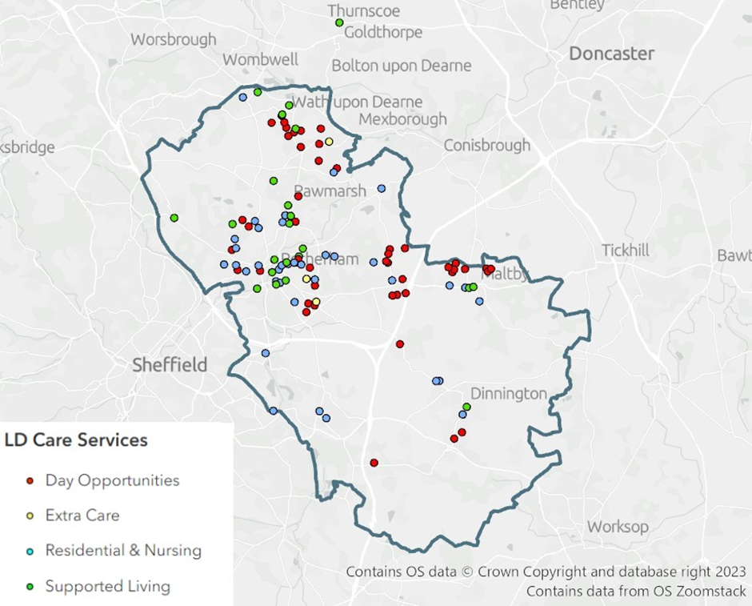

Direct Payments:
Direct Payments are currently predominately used to purchase home care and support services, day opportunities and community support from agencies. A smaller number of people use their personal budget as a Direct Payment to employ a personal assistant. The Council encourages the use of direct payments in this way.

Residential and Nursing Care Homes:
There are 45 care homes that provide specialist support for people with a learning disability, autism, mental ill-health, or a combination of these. This includes the Council’s in-house residential care homes, offering a total of 483 beds. In June 2023 there were 44 vacancies within these services, a vacancy rate of 9.1% giving an occupancy rate of 90.9%.
The Council will explore whether a reposition of residential and nursing services may be needed to expand the suitability for certain cohorts of people, e.g., young people with complex needs accessing temporary care and specialist dementia care for people with learning disabilities who suffer from early onset dementia.
Providers of residential care may wish to consider a change in registration to provide supported living services and proactive engagement with the Council is encouraged.
Providers should continue to build in day opportunities and maximise the use of assistive technology where appropriate to support greater independence.
The Council supports providers adopting a standardised breakdown of the cost of care.

Supported Living
Rotherham’s current offer consists of nomination rights to 196 units of supported living.
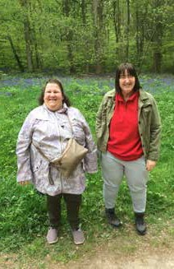
The new Integrated Care System Market Position Statement (ICS MPS), launched in July 2022 sets out accommodation needs for people with learning disabilities and autism in South Yorkshire.
The ICS MPS is the result of extensive research and collaboration across the NHS South Yorkshire Integrated Care Board, endorsed by Rotherham, Doncaster, Barnsley, and Sheffield Councils, with the support and expertise of Campbell Tickell.
This research identified that, on average, Rotherham will require 12 new supported living units each year over the next 10 years, this will include core and cluster models, a community living model and bespoke accommodation where the need is identified for an individual.
The Council’s ambition is that all supported living properties fulfil the real tenancy test with a distinct separation between housing and support. Read here for more information (ndti.org.uk)

Rotherham is planning to develop a flexible purchasing system for the Care and Support delivered into supported living services to increase the number of providers working in Rotherham and support choice for the people accessing these types of accommodations.
The Council welcomes providers to join the framework when operational.

Peer Support Network:
The Council recommissioned a local charity to provide peer support networks in Rotherham, these are currently based in Kimberworth, Thurcroft and Thrybergh supporting a minimum of 10 people in each area to continue to live independently in their own home.
This is seen as the next step towards independent living and a step down from traditional supported living. Each person lives in their own house/flat but is within walking distance to one another. This provides mutual support and companionship. Paid support workers promote the development of skills to facilitate independence and support access to a weekly drop in session providing additional support and opportunities for people to socialise with their peers.
The Council is keen to expand peer support networks across the whole of Rotherham.

Extra Care Housing:
Three people with a primary need of learning disability and or autism are supported currently by extra care housing.
Extra care housing is currently provided in three areas across Rotherham. High quality accommodation paired with dedicated on-site support staff assist people with different levels of housing and support needs to remain living independently in a community setting for as long as possible.

Shared Lives:
Shared Lives is a CQC registered service where adults with a learning disability and/ or autism can spend time with approved shared lives carers and their families. There are a variety of placements and a mixture of support including:
- Short breaks
- Respite
- Long term placements
- Day opportunities
As of June 2023, there were 86 shared lives carers registered with the Council, and 67 of these currently providing active support. Shared Lives have provided people with 30 long term placements, 30 respite placements and 68 day supports equating to 128 successful matches in total.
The Council welcomes discussions for individuals to register as shared lives carers and for shared lives carers to have closer links to peer support networks.

Respite:
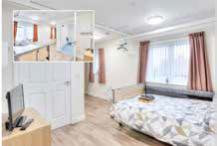
The respite offer has changed in Rotherham following the My Front Door Project, which encourages alternatives to traditional bed-based respite including supported holidays and shared lives options.
The Council currently commissions 12 external respite beds and in 2020 opened Conway Crescent a new in-house respite service providing 8 beds. Together, 97 people accessed respite over the last 12 months.
The Council continues to encourage alternatives to traditional bed-based respite and will be looking to develop options for supported holidays and increasing the offer that shared lives can provide.

Day Opportunities:
The Council began moving away from traditional day opportunities of building-based day centres in 2019.
The Council has continued to support the most complex people with a learning disability who still require building based provision through its in-house service, where 28 people are accessing day opportunities.
Independent sector providers are also commissioned to provide specialised complex needs day opportunities, both building based and in the community.
The Council’s in-house day services are currently undergoing significant transformation. A formal consultation process has recently closed, and an in-depth analysis from the consultation is currently taking place, ready to inform the future offer for customers.
Corresponding formal reports will be published in due course.
The Community Options Projects (now ended) established a strong partnership between the Council and social enterprise Community Catalysts. The Council is progressing with the learning from this, with a dedicated officer focusing on this.
The Council will continue to further strengthen the connections between people with a learning disability and their local community.
The Council will continue to commission services and opportunities that support social inclusion and promote social value through the development of micro and social enterprises, especially for people with a learning disability and/or autism with a focus on day opportunities.
The Council also welcomes providers who can support autistic people to access employment and skills opportunities.
The Council is planning to develop a Flexible Purchasing System for Day Opportunities for People with Complex Needs and/or Autism to increase and support choice. The Council welcomes providers to join the framework when operational.

Commissioning Intentions Summary:
  - The Council will explore whether a reposition of residential and nursing services may be needed to expand the suitability for certain cohorts of people, e.g., young people with complex needs accessing temporary care and specialist dementia care for people with Learning Disability who suffer from early onset dementia.
  - New service provision, specifically future proofed accommodation incorporating assistive technology, to expand across the whole of the Rotherham Borough, with the exception of shared accommodation in Wath and Maltby due to the sufficient provision of shared accommodation in these areas.
  - The Council is keen to expand its supported living arrangements through core and cluster models and peer support networks.
  - The Council encourages new shared lives carers to register and to utilise shared lives as an alternative to residential care and bed-based respite.
  - The Council is keen to expand and increase timely planning for the provision of services and accommodation for the preparing for adulthood cohort. This aim will ensure that future support is ready for when a person reaches 18 and that the move to adult provisions are smooth effective transitions for all.
  - Rotherham aims to have a clear offer of the services that are available for young people transitioning to adult services with complex needs.
  - All day opportunities should promote social inclusion and social value with a focus on utilising micro and social enterprises.
  - Where appropriate opportunities for work like or work based opportunities are welcomed.
  - Two flexible purchasing systems will be developed, one for supported living and one for complex day opportunities and alternative respite.

Mental Ill-Health

Demographic:
According to the Office for Health Improvement and Disparities in 2017 there was an estimated 18.6% (39,582) prevalence of common mental health disorders for the population in Rotherham aged 16 and over and a prevalence 11.6% (59,286) of people over the age of 65 over. These estimates compare poorly against estimates for England at 16.9% and 10.2% respectively.
In 2019/20 Q2 there were:
  - 60 per 100,000 population (aged 18+) subject to Mental Health Act.
  - 815 people subject to Care Programme Approach

Table 4. Predictions of Mental Ill Health prevalence from the Office for Health Improvement and Disparities
Year | 2025 | 2030 | % Increase
The number of people in Rotherham Aged 18-64 predicted to have:
- a common mental health disorder is | 29,751 | 29,937 | +0.6%
- a borderline personality disorder or antisocial personality disorder is | 8,998 | 9,047 | +0.5%
- a psychotic disorder is | 1,098 | 1,105 | +0.6%
- two or more psychiatric disorders is | 11,304 | 11,378 | +0.6%

People Receiving Support:
The Council currently supports 357 people who have a primary need of mental health. 214 of which are aged 64 and under. This indicates an approximate 9% increase since January 2022. A review of the care and support provision for people experiencing mental ill health in Rotherham was undertaken in 2020 and this indicated that the market in Rotherham was undeveloped and reliant there was a reliance on the residential care model. There is a requirement to create a quality care and support market which is responsive to individual needs to achieve the best possible outcomes.
The types of services people experiencing mental ill-health require may include:
  - Community outreach to enable people with mental ill-health to live independently in their own home,
  - Supported living, designed specifically to enable people to live as independently as possible,
  - Crisis intervention support, and
  - Residential and nursing care home provision.

In 2023 a Mental Health Recovery – Flexible Purchasing System (FPS) was established. The FPS will comprise of a number of separate lots. Each lot will specify a community service with the principle of mental health recovery at its core. The community services in scope include supported living, day opportunities and preventative services. Lot 1 of the FPS specifies supported living services has been established and is open for applications.
The table below illustrates the services which are provided, current levels of dependency on the service, future expectations in terms of demand and an indication of future commissioning intentions.
Table 5. Mental ill - Health. (Cohort snapshot June 2023)

Support Service Type |  | Existing Cohort (No) |  | Predicted Demand for future Cohort |  | Commissioning Intentions Summary
Total number of people eligible for Council support with a primary need of mental health. |  | 357 |  | Increase |  | In line with demographic change the Council will continue to engage with the market to manage demand appropriately.
 |  |  |  |  |  | The Council will continue to support people living with mental ill-health to remain at home in the community for as long as appropriate.
Personal Budgets
Direct Payment – Using a service provider |  | 141 |  | Increase |  | The Council supports the use of direct payments for more flexible and personalised solutions.
Direct Payment – Employing a Personal Assistant |  | 8 |  | Increase |  | The Council welcomes the use of personal budgets to employ personal assistants.
Care Services
Home Care and Support Services |  | 61 |  | Increase |  | The Council has appointed one specialist regulated mental health home care and support provider to the Home Care and Support (Domiciliary Care) Flexible Purchasing System and invites other specialist mental health providers to apply
Care Homes
 | Residential Care |  | 83 |  | Decrease |  | The Council will continue to support people living with mental ill-health to remain at home in the community for as long as appropriate and will increase diverse support provision by introducing alternative models to residential care such as supported living.  The Council will explore the reprovision of some services to expand suitability and potential to progress to supported living.
 | Residential EMI |  | 23 |  | Increase
 | Nursing Care |  | 16 |  | Increase
 | Nursing Care EMI |  | 13 |  | Increase
 | Other Accommodation
 | Supported Living |  | 10 |  | Increase |  | The Council will continue to develop an offer of alternatives to bed based provision and will develop specialist mental health supported living provision.
 | Extra Care Housing |  | <5* |  | Increase
 | Day Opportunities
 | Day Opportunities |  | <5* |  | Neutral |  | The Council will continue to develop a range of alternatives to building based day opportunities. **
* numbers less than five have been suppressed to reduce personal identification.
**An In-house day opportunities service supports in the region of 78 people, the majority of which are not eligible under the Care Act 2014

Residential and Nursing Care Homes
There are three care homes owned by two proprietors providing specialist mental health support in Rotherham, two provide social care provision (45 beds) and one provides nursing care (20 beds). There are 135 people with a primary mental health need who are living in residential care and around 21% of this population require nursing care. Of the total population 40% are under the age of 67 years, and 16% are situated in care homes located outside of Rotherham.

Mental Health Housing Related Support
Three housing related support accommodation-based services are accessed by people with a primary mental health need in Rotherham. Collectively they offer twenty units of accommodation as self-contained apartments. The associated services aim to support people onto greater independence and move into settled accommodation.
People living in the service are tenants on assured short hold tenancies for a maximum of two years. People benefiting from the service are subject to the Care Programme Approach (CPA) i.e., experience paranoid schizophrenia, bi-polar affective disorder, psychosis, personality disorder etc.
The lack of recovery focused community support to enable people to live independently means; people are at risk of failing to sustain tenancies and experience mental health relapses. Length of stay going beyond the two- year maximum also results in the service being congested and impedes access for those requiring this type of “step down” support and move on.
Please see the Housing Related Support Section for more information.

Commissioning Intentions Summary:
The Council seeks more suitable provision in the Borough. A programme of commissioning and procurement activity is underway to create a high standard care and support market which has the relevant capacity and capability to meet the needs of people with mental ill health. The services to be developed will have a strong focus on mental health recovery, enabling and independent living.
  - The Council invites domiciliary care providers with a mental health specialism to join Tier 2 of the Home Care and Support Service FPS.
  - The Council invites suitably qualified supported living providers, with a mental health specialism, to join the Mental Health Recovery Service as a supported living accommodation-based service provider.
  - The Council intends to continue to promote the use of personal budgets for specialist mental health provision and increase the support from personal assistants.
  - The Council is keen to expand the amount of specialist mental ill-health providers to ensure services meet the needs of the people accessing services in addition to existing low level community mental health provision.
  - There is a requirement for cost-effective alternatives to traditional forms of support for people who require mental health recovery support i.e. long, and short term supported living (24-hour services), floating support services.
  - The Council is keen to expand specific mental ill-health provision for long term dispersed accommodation to ensure move on from temporary short-term accommodation is facilitated.

Figure 4. Map of the current service provision supporting people with mental ill health.
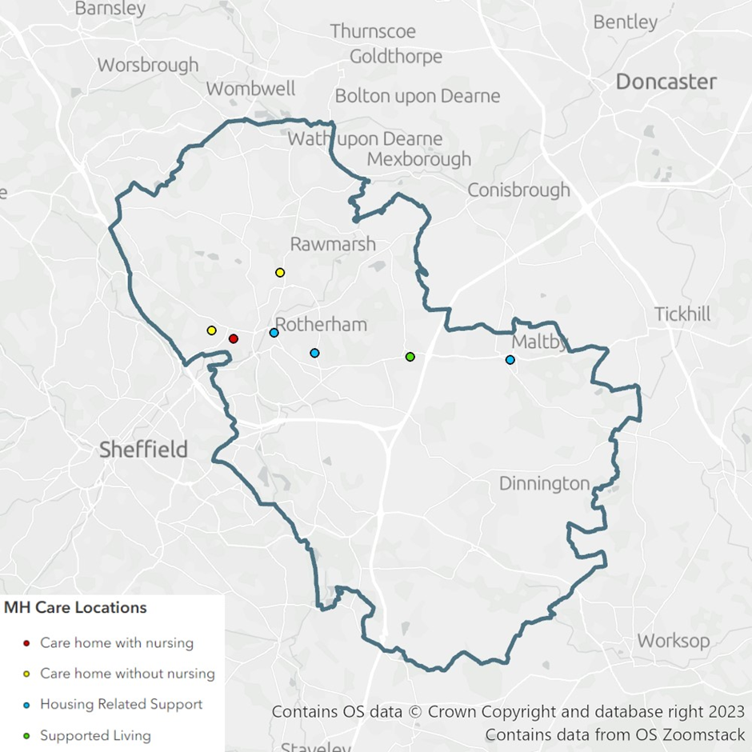

Housing Related Support

What is Housing Related Support?
The primary aim of housing related support is to address and prevent homelessness - this includes provision for young people, adults, and families.
Housing related support is a preventative programme assisting individuals with multiple needs, through a personalised package of support to gain the skills needed to maximise their independence, maintain settled accommodation, and integrate into the community.
Table 6. Housing Related Support (Cohort snapshot March 2022)

Support Service Type | Current Units (No) | Predicted Demand for future Cohort | Commissioning Intentions Summary
Homeless Interim Accommodation | 47 | TBC | The council intends to recommission these services via the newly established flexible purchasing system (FPS).
Rough Sleeper Initiative Accommodation based support Hub | Up to 8 beds | Maintained | This contract initial term runs until the 31st March 2025
Short -Term Supported Accommodation | 90* | TBC | The council intends to recommission these services via the newly established flexible purchasing system (FPS)
Floating Support Services | 290* | TBC | The council intends to recommission these services via the newly established flexible purchasing system (FPS)
Housing First | 35 | Maintained | The Council will review all commissioned housing related support services.
Domestic Abuse Refuge (including Dispersed) | 18 | Maintained | The Domestic Abuse Refuge contract was re-procured in 2021.
*Excluding short term grant funded services

Homeless Applicant Needs:
The complexity of homeless cases is increasing: In 2020/21 13.8% of cases were classed as complex, compared to 10.6% in 2019/20 and 6.7% in 2018/19.
Mental health is the most common support need identified, which has increased year on year.
The following support needs are prevalent for homeless applicants, and often applicants have multiple support needs:
  - Mental Health problems
  - Drug dependency
  - Alcohol dependency
  - Offending and repeated offending
  - Domestic abuse
  - Sexual abuse
  - Repeat homelessness
  - History of rough sleeping
  - Physical disability
  - Learning disability
  - Debt
The most prevalent reason for people presenting as homeless is that their family are no longer willing/able to accommodate.
Please read the Council's Homelessness Strategy.

Current Services And Pathways:

Table 7. Four pathways of housing related support and associating service with capacity.
Complex Needs
Vulnerable Adults
Domestic Abuse
Young People 16-25
Housing First
- 35 Units
- Recovery orientated
Interim Accommodation for Single People
- 15 Units
Refuge and Dispersed Accommodation
- Minimum 10 units
Young People 16-25
Young Parents 16-25
Short Term Supported Housing
- 15 Units
- 10 Units
Dispersed Properties
- 19 semi supported housing
Floating Support
- Total 220 units across the Borough (including short term dispersed tenancy
units)
Floating Support
- 50 units
Outreach Floating Support Services

Emergency Units
- 4 units with 24 hour support
Single Supported Accommodation
- 12 units with 24 hour support
Accommodation Based
- 27 units
Floating Support
- 20 units
Homeless Families Interim Accommodation
- 32 Units
- Range of family size properties across
the borough

Complex Needs:
This covers people with a high level of need and those scoring highly on the chaos index for example, history of rough sleeping, significant offending history and lack of engagement with support services and compounding issues (including alcohol/substance misuse).
Housing First provides a recovery orientated approach moving people into independent and permanent housing with additional support and services.

Vulnerable Adults:
This covers people who need support in order to live independently due to vulnerability, examples include people with learning difficulties, people with mental-ill health, people with alcohol/substance misuse issues and people with a repeat pattern of offending. Provision includes:
  - Interim Accommodation for Single People: Block of 15 single self-contained units with onsite support.
  - Homeless Families Interim Accommodation: delivers a range of family sized furnished supported housing across Rotherham, with floating support.
  - Short Term Supported Housing:
  - There are 2 short term supported housing services.
    - Elliott House provides single accommodation through 15 single self-contained units.
    - Browning Court provides 10 self-contained units.
  - Both services currently support people with a primary need of mental ill health and have a care pathway approach.
  - People living in the service are tenants on assured short hold tenancies for a maximum of 2 years.
  - Floating Support: two contracted services provide floating support which offers 220 up to people resettlement and tenancy support.
    - This includes short term dispersed tenancy units, which are temporary single and shared properties made available by providers for their service users.

Domestic Abuse:
This pathway supports people who have experienced domestic abuse and supports the Council’s Domestic Abuse Strategy.
It includes:
The Refuge (and dispersed) which has a minimum of 10 units of supported furnished accommodation.
Domestic Abuse Outreach which provides support to victims and survivors of domestic abuse at all risk levels.

The Domestic Abuse Refuge contract term ends on the 30th September 2024.

The Domestic Abuse Outreach Services have been re-modelled to work across all levels of risk. This contract has been awarded and commenced on the 1st October 2022, and is in place until at least 30th September 2025.

Post CSE Support Services:

The Council commissions services to support Victims/Survivors of Child Sexual Exploitation (CSE). The Post CSE Services are currently provided by three Rotherham based Voluntary and Community sector organisations, the services support Victims/Survivors of CSE through evidenced based therapeutic interventions, counselling, and trauma stabilisation.

The current contracts are in place until the 31st December 2025.

Young People and Young Parents 16-25:

Young People:
This covers accommodation and support for young people aged 16-25 experiencing homelessness, but requiring on-going support including teen parents, former child in need and looked after children.
    - 4 emergency units with 24-hour support.
    - 12 core, single accommodation units with 24-hour support.
    - 19 semi-supported housing via a range of dispersed properties, both single and shared housing.
    - 50 units of Floating Support.

Young Parents:
This covers accommodation and support for young parents aged 16-25:
    - 27 units of supported furnished accommodation.
    - 20 units of floating support.

2.4.5 Commissioning Intentions Summary:
  - Housing related support provision has been reviewed in 2022/23 to incorporate changes in demand and evidence of agile solutions and good practice following the pandemic.
  - The Council is in the process of establishing a Flexible Purchasing System (FPS) to support the HRS pathway, and future procurement opportunities will be advertised via the FPS.
  - Domestic abuse services have recently been re-procured through co-production with stakeholders, the refuge contract was awarded in 2021 and the outreach contract was awarded in June 2022..
  - The Council is currently reviewing the Post CSE Support Services as part of the recommissioning process.

Physical Disabilities

Demographic:
Rotherham has a high rate per 100,000 population of 18-64 Physical Disability customers at 274.5, for the Yorkshire and Humber Region as a whole this figure is 217.7. Neighbouring authorities of Barnsley (145.0) and Doncaster (226.3) Sheffield (204.5) have significantly lower rates (ref: SALT Return 15/16). Rotherham’s current figure is 270.02. Currently there are 431 people (age 18-64) with a primary need of physical disability accessing services.
There is a limited bespoke commissioned offer for working aged adults with a physical disability. Historically the offer has centred on direct payments, adapted housing using the Disabled Facilities Grant (DFG) and home care and support to keep people within their own home. Some adults with life-long limiting conditions are also funded through NHS Continuing Healthcare. There is a small cohort of adults living in residential care. In some instances, this may not be the most appropriate option.
Table 8. Physical Disabilities (Cohort Snapshot June 2023)
Support Service Type | Existing Cohort (No) | Predicted Demand for future Cohort | Commissioning Intentions Summary
Personal Budgets
Direct Payment – Using a service provider | 116 | Increase | The Council supports the use of direct payments for more flexible and personalised solutions.
Direct Payment – Employing a Personal Assistant | 57 | Increase | The Council welcomes use of personal budgets to employ personal assistants.
Care Services
Home Care and Care Support Services | 169 | Increase | The Council invites CQC registered specialist home care and support providers to apply for a place on its Home Care and Support Framework.
Care Homes
Specialist Residential and Nursing Care | 25 | Neutral | The Council aims to ensure that specialist residential and nursing care in the Borough is best in class and of sufficient number to reduce the use of out of area placements.
Out of Borough Specialist Residential and Nursing Care | 12 | Decrease | The Council would like to provide the option to return to Rotherham, for people who would like to.

Support Service Type | Existing Cohort (No) |  | Predicted Demand for future Cohort |  |  | Commissioning Intentions Summary
Supported Living |  | 4 |  | Increase | The Council intends to increase the amount of supported living accommodation available throughout the Borough. Evidence shows that around 12 additional units of accommodation will be required annually over the next 10 years.
Shared Lives |  | 4 |  | Increase | The Council is looking for local people to consider registering as shared lives carers to be able to offer this type of care and support option more widely in Rotherham.
Extra Care Housing |  | 7 |  | Neutral | The Council is keen to expand extra care housing with care delivered by staff onsite.
Day Opportunities
Independent Sector |  | 11 |  | Increase | The Council will continue to increase day opportunities for people with complex needs.
RMBC In-house Service |  | 1 |  | Neutral | The Council will continue to offer building-based support for day opportunities for people with complex needs.
Micro-enterprise Day Opportunity Services (non-commissioned) |  | 13 |  | Increase | The Council is keen to encourage the development of micro enterprise services for the provision of day opportunities.

Commissioning Intentions Summary:
The Council welcomes discussions with potential providers about what they can offer:
  - The Council is particularly interested in specialist equipment and digital/assistive technology solutions to keep people as independent as possible.
  - The Council also encourages developments of new properties to be designed flexibility to more easily accommodate adaptations to support independent living for people with physical disabilities. Wide doors, turning circles for powered wheelchairs and heavy load bearing ceilings/floors would allow for specialist equipment to be used in the future. Bariatric considerations would also be welcome.

Unpaid Carers

Demographic:
In Rotherham, there is a predicted 31,500 unpaid carers, meaning at least 12% of people living in Rotherham fulfil an unpaid caring role. As Rotherham’s ageing population increases, it is predicted that more people will identify as an unpaid carer. Additionally, findings from Carers UK July 2021 suggest there has been a large increase in new carers since the start of the pandemic.

“An unpaid carer is somebody who provides care in any form but does not receive an hourly rate of pay. (An unpaid carer could be in receipt of carers allowance or working whilst still caring)” Rotherham Parent Carer Forum.
The Council’s Borough that Cares Strategic Framework 2022-25 provides a strategic framework with a purpose to ensure unpaid carers can live well, be active and have fulfilled lives.

Table 9. Services to support Unpaid Carers

Unpaid Carers Commissioned Support services | Number of people supported in 22/23 | Commissioning Intentions Summary
Dementia Café and Dementia Support Worker Service | Dementia Café:  1,117  Dementia Support Worker Service (new and existing): 160 | In 2023, the Council will seek to procure services to support unpaid carers who care for people with dementia.
Carers Emergency Service | 22 | The Council will seek to procure a new service in 2023.
Unpaid Carers Home Care and Support Service | 100 | This service will continue to provide support to unpaid carers who also have eligible needs under the care act.

Dementia Cafés and Dementia Support Worker Service
A grant agreement is in place with a voluntary and community sector (VCS) provider to provide a Dementia Café and Carers Dementia Support Worker Service. This arrangement is in place until March 2024.

Dementia Cafés:
Several Dementia Cafés take place monthly at a range of locations across the borough. The cafes provide an opportunity for unpaid carers (who support a person who lives with dementia) to meet, receive support, access information, and advice whilst the person with dementia can join in a range of activities.
In April 2023, a new Golden Memories café was launched to support the BAME community.

Dementia Support Worker Service:
The Carers Dementia Support worker service provides individually tailored support, advice, and information to unpaid carers in a setting of their choice.
In 2023, the Council will seek to procure services to support unpaid carers who care for people with Dementia.

Carers Emergency Service
Commissioned through the Better Care Fund, the Carers Emergency Service provides vital replacement care in the persons home in situations where the unpaid carer (one who provides a substantial amount of care) is unexpectedly and due to an emergency, unable to undertake their caring role. Following an unsuccessful procurement process in 2021, the Rotherham Foundation Trust, is currently contracted to provide replacement care, within 2 hours of the request, as directed by the outcome of a Carers Assessment and/or Registration to the Scheme and pre-determined contingency plan, for a period of up to 48 hours. Formal care services are put in place should they still be required post the 48-hour period.
  - The current contract is in place until September 2023 with an option to extend to March 2024.

The Council will seek to procure a new service in 2023.

    - Unpaid Carers Home Care and Support Service.
  - This service is provided by a VCS provider via the Home Care and Support Framework, the service provides domiciliary care for people with eligible needs under the Care Act, where it is also identified that they have an unpaid carer that would benefit from the advice, information and additional support available from this provider.

Commissioning Intentions Summary:
  - The Council will continue to support unpaid carers and recognise unpaid carers for the invaluable commitment cares make in providing support and care.
  - The Council will review the expenditure from the BCF for the carers’ services during 2023/24 with a view to maximising the offer from the available resources.
  - In 2023, the Council will seek to procure services to support unpaid carers including specifically for unpaid carers caring for people with dementia and the Carers Emergency Service.
  - The Borough That Cares Strategy outlines three areas of focus to be delivered on from 2022-2025, Focus 1: Carer Cornerstones, Focus 2: Creating Communities of Support and Focus 3: Carer Friendly Borough.

Voluntary and Community Sector Services
A variety of voluntary and community sector organisations provide both statutory and non-statutory services.

Table 10. Voluntary and Community Sector Services

Voluntary and Community Sector Services | Number of people supported in 22/23 | Commissioning Intentions Summary
Advocacy Support | 1770 | The current contract is in place until March 2024, with an option to extend for a further 1 year.
Sensory needs offer- Sight and Sound | Circa 2,200 | The current grant arrangement is in place until March 2024.  In 2023, the Council will seek to procure services to support people with a sensory impairment.
Healthwatch | 465 | The current contract is in place until March 2024.  The Council will seek to procure a new service in 2023.

Advocacy Support
Statutory and Community Advocacy
The Council has commissioned a VCS organisation to be the lead provider for commissioned advocacy services in Rotherham.
Through the Rotherham Advocacy Hub, they provide advice and information and if required, a qualified advocate dependant on need.
They provide statutory advocacy to meet the requirements of the Care Act 2014, the Mental Capacity Act 2005, the Mental Health Act 2007 and the Health and Social Care Act 2012.
Statutory advocacy services provide support to people who:
  - Require assistance through the care and support assessment and review process.
  - Lack mental capacity to make decision about themselves.
  - Are detained under the Mental Health Act.
  - Require support to complain about services provided by the NHS.

Figure 5. Infographic explaining who independent statuary advocacy provide support too.
Require assistance during care and support assessments and review process
Lack mental capacity to make decisions about themselves
Independent statutory advocacy services provide support to people who...
Are detained under the Mental Health Act
Require support to complain about services provided by the NHS

Non-statutory (or generic) community advocacy is also provided to support people living in Rotherham who require assistance in relation other health and social care issues.
The current contract is in place until March 2024, with an option to extend for a further 12 months.
There is provision in the contract for 50% of the community advocacy hours to be subcontracted to local organisations in the voluntary and community sector that have qualified advocates.

Sensory Needs Offer – Sight and Sound
As at April 2023, the Council currently supports 61 people whose primary need is sensory support. 37 people are aged between 18-64. People with a sensory impairment access a range of services.
The Council currently commissions a sensory impairment charity to provide the Rotherham Sight and Sound Sensory Impairment Service, for people with a hearing or sight impairment via a grant agreement until March 2024.
The Service provides advice, information, and assistance to people with a sensory disability to enable them to remain independent for as long as possible and prevent or delay dependency on statutorily provided services. The service also provides regular BSL Advice and Support Service sessions.

The Council would welcome any additional provision to support the sensory needs community. However, with limited funding for new services, support from the Council is likely to be non-monetary.

    - Local Healthwatch
Healthwatch Rotherham is the independent champion for people who use health and social care services, ensuring people are at the heart of care for all services.
This is a statutory service under The Health and Social Care Act 2012.
A local citizens’ advice service is currently contracted to provide the Healthwatch service until March 2024.
Trustees, members and volunteers and the Council welcome organisations to provide support to Healthwatch Rotherham through their future Social Value commitments.

Commissioning Intentions Summary
  - The Council will continue to engage with and promote opportunities to the voluntary community sector.
  - The Council recognises the crucial work VCS sector provide through not only commissioned services but other non-Council services.
  - The Council intends to provide a strong and co-ordinated preventative offer, to be delivered in partnership with the voluntary and community sector.
  - The Council proposes that the voluntary sector will continue to provide people with information, advice, and signposting to low-cost/ no- cost options that can be accessed to support people in Rotherham.
  - In 2023 the Council will procure a Healthwatch Service.

2b Public Health Commissioning – Market and Demand

2.8.1 Introduction
The Public Health Grant is used to commission services that improve the health and wellbeing of the population. Some of these services are mandated and the Local Authority must provide them. Others have been identified as being essential to tackle health inequalities and as part of the wider health and social care system. The services have been commissioned as the following pathways:

0-19s Children’s Public Health Nursing

Sexual Health Service (all age)
  - Public Health & Lifestyle Behaviour Change Service
  - Alcohol and Drug Treatment and Recovery Service (all age)
  - NHS Health Checks

Table 11. Public Health Commissioned Services (as of June 23)

Public Health Commissioned Services | Number of People Supported Annually (approximately) | Commissioning Intentions Summary
Alcohol and Drug treatment Service – all age | 2300 | The Council re-procured the service in 2022 and the new contract commenced April 2023.  The service is now an ‘all-age’ alcohol and drug treatment and recovery service, serving the population of Rotherham.
0-19 Children’s Public Health Nursing | The Service delivers the Healthy Child Programme in Rotherham; this is a universal provision for all of Rotherham’s families | The Council awarded the new contract to the incumbent provider: The Rotherham NHS Foundation Trust (TRFT) The new contract and service model commenced on 1st April 2023.
Sexual Health Service | 16,033 | The Council re-procured the service in 2021 when the incumbent provider was successful in retaining the contract. The service will continue to provide a range of sexual health services across the Borough.
Public Health & Lifestyle Behaviour Change Service | 5580 | The Council re-procured the service and awarded the service to a new provider Connect Healthcare Rotherham CiC. The new contract and service model will commence on 1st October 2023.
NHS Health Check | 8000 | The Council re-procured the service in 2022. The NHS Health Check is a health check-up for adults in England aged 40 to 74 and is designed to spot early signs of stroke, kidney disease, heart disease, type 2 diabetes, or dementia.

Drug, Alcohol, Recovery and Treatment Service:
The current service was awarded after competitive tender to a new provider – the new contract and service model commenced on 1st April 2023. We Are With You offer opiate, non-opiate and alcohol treatment and recovery services. This is an All-Age Service.
Over 2022/23, 2092people received structured treatment support over the 12 month period under their drug and alcohol recovery treatment service.
Click here for more details: ROADS - Rotherham Alcohol and Drug Service (Provided by With You) - With You (wearewithyou.org.uk)

This current contractual arrangement expires in April 2028, see Procurement Opportunities for details.

    - 0-19 Children’s Public Health Nursing:
The Rotherham NHS Foundation Trust (TRFT) are our current providers of the 0-19 service.
They deliver the healthy child programme predominantly by Health Visitors and School Nurses.
The service aims to provide parents with the advice and support they need to sure their children make progress in their development, keep healthy and stay safe.
Promote health and healthy lifestyles through our work in schools and provide advice and support for young people.
Click here for more details The Rotherham NHS Foundation Trust

The current contractual arrangements expire, in April 2028, see Procurement Opportunities for more details.

    - Sexual Health Service:
The Rotherham NHS Foundation Trust (TRFT) were awarded the new integrated sexual health service contract through a competitive tender process. The Rotherham Sexual Health Service commenced on the 1st April 2022.
16,033 people accessed the integrated sexual health service during the 2022/23 12-month period.
Rotherham Sexual Health Service provides a variety of services, including STI testing, contraception, vaccinations and injections, free home testing and emergency contraception.
Visit their website for more details. The Rotherham NHS Foundation Trust

The current contractual agreements are in place until at least 2027.

    - Public Health and Lifestyle Behaviour Change Service:
The current service was awarded after competitive tender to a new provider. The new service will commence on the 1st October 2022 is provided by Connect Healthcare Rotherham CIC who will provide an integrated lifestyle and behaviour change service for adults.
This includes support to stop smoking and weight management.
The service aims to focus on prevention and early intervention by promoting health and wellbeing across Rotherham.

The contractual agreements will be in place until at least 2028.

    - Commissioning Intentions Summary:
Please see Procurement Opportunities Section for all Public Health Commissioning procurement activity.
The Council continues to manage all public health commissioned services through continual performance and contract management.

Market Overview

Quality

CQC Regulated Services:
The majority of commissioned adult care services including public health services are subjected to CQC ratings and inspections.
As a Council, we strive towards all providers being rated by CQC as excellent or good. The Council will continue to work with providers to collaborate to improve services. Since the last Market Position Statement was published, the number of nursing homes rated as Inadequate or Requires Improvement has reduced from 25% to 14% with residential care seeing an increase in the same ratings from 12% to 18% and community based care seeing a decrease from 10% to 7%.

Figure 6. CQC ratings as of July 2023

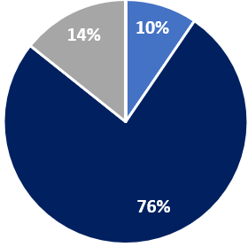
Nursing Homes (all age groups)

Inadequate (none)
Requires Improvement (3) 14%
Good (16) 76%
Outstanding (2) 10%
Unrated (none)

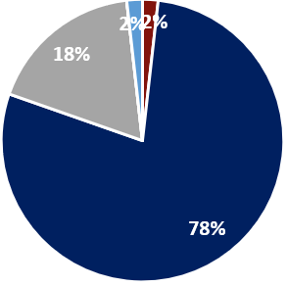
Residential Care (all age groups)
Inadequate (none)
Requires Improvement (10) 18%
Good (44) 78%
Outstanding (1) 2%
Unrated (1) 2%

Community Based Care: All Cohorts
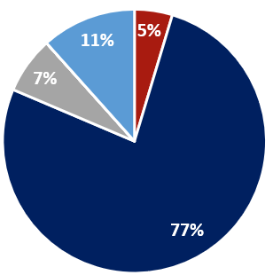
(commissioned and non-commissioned)
This includes home care and support services and supported living.
Inadequate (none)
Requires Improvement (3) 7%
Good (33) 77%
Outstanding (2) 5%
Unrated (15) 11%

Public Health CQC Regulated Services:
The Council commissions a range of Public Health services that are subject to regulation. These services are often provided as part of a larger NHS Trust and as such the specific services may not have a separate report or rating from that of the NHS Trust.

Quality Assurance
Quality standards will be clearly defined in service specifications and all of the Council’s contracted providers will be subject to an annual audit to assess their contractual compliance.
Through the Council’s established partnerships, the Council will work alongside providers to address quality issues by offering support, advice, guidance and training. The Council will continue to collaborate with providers with the aim of improving service delivery where required.
Since May 2022 the Council has been utilising an online tool to assist in the provider self-assessments and contract monitoring. This is through the use of the Provider Assessment and Market Management Solution (PAMMS).
PAMMS is used by Commissioners and Contract Managers to collate data and intelligence on both regulated and non-regulated services across the Borough and will be used to support our market shaping duties. This has been successfully implemented by Adult Care Commissioning with every provider having had an annual assessment through PAMMS or other focused monitoring.

Adult Social Care Early Warning Systems
A number of early warning systems are in place to inform the view of quality, performance and risk and assist in planning any interventions to be undertaken with services commissioned by Adult Social Care. These include:
  - Focused Inspection Visits.
  - Provider Quality Assurance Self-Assessment.
  - Contract Concerns Database.
  - Professional Questionnaire.
  - Intelligence from safeguarding alerts and investigations.
  - Home care surveys.
  - Intelligence from regular meetings with different stakeholders focusing on areas of risk.
  - Risk Dashboard.
Focused Inspection Visits
Service provider visits (announced or unannounced) are undertaken by Contract Compliance Officers to focus on service issues or to validate self-assessments.

Provider Quality Assurance Self-Assessment:
A self-assessment is completed by service providers to record evidence of compliance against specified service standards. Evidence is recorded by the provider on the Provider Assessment Market Management Solution (PAMMS). Each submission is reviewed, validated, and scored to give an overall rating of the service.

Contract Concerns Database:
The contract concerns electronic database is a real time monitoring system of market intelligence. The system facilitates a method for people accessing services, their families, and professionals to report concerns to the Council about their experience of a service.
The contract concerns database allows for the recording of the progression and outcome of the investigation of the concern including the provider’s response. It also records the theme and outcome e.g., whether the concern was substantiated or not.

Risk Dashboard
Data included in the assessment of services is extracted from a number of internal and external systems i.e., Safeguarding Team, CQC data set, NHS Capacity Tracker, and other generated reports to inform the levels of quality and compliance in a service. The Risk Matrix is an intuitive conduit for data/intelligence which calculated the level of risk rating the service Red, Amber, Green (RAG) and is used to prioritise the Contract Compliance Officers’ resources.

Adult Social Care Workforce
As of October 2021, Rotherham had an estimated 7,200 jobs in the care sector, with the following care sector split:
  - 84.7% are in the independent sector.
  - 9.7% are employed by the local authority.
  - 7.4% of jobs are working for direct payment recipients.

Adult Social Care Skills, Recruitment and Retention
Skills for Care presented the following figures from 2020/21:
  - On average 11.3 days off sickness was taken.
  - The average job vacancy rate was 4.8%.
  - The average job staff turnover rate was 30.8%.
All rates are consistent with local and national pictures.
Vacancy, turnover and sickness day trends have increased at both a national, regional, and local level since March 2021 due to the COVID-19 pandemic.
Independent sector workforce recruitment and retention has faced difficulties prior to the pandemic due to financial constraints, Britain exiting the EU, increased complexity of care, the increase in demand for carers assessment and community assets which has been further exacerbated by Covid-19.
The Council aims to make care and support a more attractive career option by improving conditions and career pathways and encourage providers new and existing to demonstrate effective approaches to value based recruitment and retention.

Figure 7. Skills for Care infographic presenting average sickness, vacancy, and turnover rates 20/21.
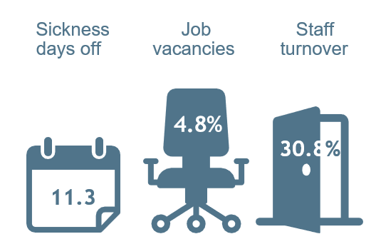

Self-Funders

The information collected and known about self-funders across Rotherham is fundamental to meet the Care Act 2014 S18(3). This section will be updated following the outcome of the consultation as guided by the DHSC as part of the Government’s Adult Social Care Reform Plans.

Resources and Finance
The Council budget recognises the reduction of Government funding over the past 10 years.
A key priority is the delivery of effective social care services, within a sustainable cost envelope and recognising the demand and market factors currently impacting these services.
The social care resources provided within the Finance Settlement for 2022/23 are welcome, but this level of additional funding still falls well short of the national social care funding gaps as calculated by the Local Government Association

Key Financial Facts:
      - The Adult Care and Public Health proposed net revenue budget for 2023/24 is
£121,131,000.
      - In recognition of the escalating demand and market costs to adult care, the council provides an extra £12m in the budget for adult social care services in 2023/24.
      - Adult Social care agreed savings as part of the Medium-Term Financial Strategy are £2m over the next 2 financial years.
      - The increase in Council Tax (excluding Parish, Fire and Police precepts) by 4%, comprising a 2% increase in the basic rate of Council Tax and a 2% Adult Social Care Precept (to raise an additional £2.4m in 2023/24 to contribute to funding increased costs of adult social care).
      - Total gross spend in 2022/23 for Adult Care and Public Health is £149m. This was partly funded through contributions from service users, the Better Care Fund (allocated £49,256m in 2022/2) and Government grants.

Resource Commissioning Intentions:
The council will successfully manage the demand, market, and provider pressures in Adult Social Care within the budget allocated, ensuring appropriate care and support is in place in accordance with the service development programme.

Budget All Commissioned Services:

Table 12. 2023/24 Gross Budget for Commissioned Services.

Cohort | 2023/24 Gross Budget for Commissioned Services (£)
 | Direct Payments | Home Care | Residential | Day Care | Supported Living
Older People | £3,918,175 | £13,341,927 | £23,277,713
Physical Disability (18-64) | £6,639,412 | £2,203,774 | £4,590,463 |  | £398,651
Learning Disability | £6,797,689 | £401,018 | £13,660,841 | £2,384,795 | £16,827,938
Mental Health | £1,189,062 | £293,191 | £4,968,839
Total | £100,893,488

Residential and Nursing Care Homes Older People

Table 13. Fees and Gross Budget Residential and Nursing Care Homes Older People.

 | Residential | Residential EMI | Nursing | Nursing EMI
Fees 2023/2024 | £606 | £632 | £622* | £690*
Gross Budget Commissioned Services 2023/2024 | £8,362,765 | £8,001,768 | £2,435,846 | £2,478,371
*Excluding Funded Nursing Care element.

Older people care homes received an uplift of 10.1% for 2023/24 fees.

Home Care and Support Services:
In 2022/23 the average hourly rate paid is £22.45.

Specialist Provision:
This includes learning disabilities and mental ill-health provision.
Costs of services reflect bespoke provision to meet individual needs and have arisen incrementally creating a range of accommodation costs and hourly rates.

Table 14. Percentage fee uplift for each service for 23/24.

Specialist Provision | % Uplift 23/24
Supported Living | 10.1%
Care Homes for people with a learning disability | 10.1%
Day Opportunities for people with a learning disability | 10.1%
Care Homes for people with a physical disability and/or mental ill health | 10.1%
Personal Budgets (excluding personal assistants) | 10.1%

Direct Payments:
The Council aims to increase the allocation within personal budgets for payment of Personal Assistants through Direct Payments to ensure compliance with the Real Living Wage from 1 April 2023 (£10.42 per hour). It is hoped that the role will continue to be a career option for people with the right skills to support individuals to live independently.
Procurement Opportunities Table for specific costs associated with procurement opportunities.

Procurement Overview

All Procurement Opportunities Table
Please see the website version for the up to date Adult Social Care and Public Health Commissioning Procurement Activity Table.

Social Value
The Council is committed to supporting the principles of the Social Value policy
Social value is defined by the Social Value hub as:
The benefit to the community from a commissioning or procurement process over and above the direct purchasing of goods, services and outcomes.
The Council has committed to a 20% social value pledge for all procurement processes over £100,000 per annum, and these providers are mandated to complete regular returns via the Social Value Portal.
The Social Value Policy sets out 6 key outcomes:
- Raising living standards for residents.
- A strong local economy with employment and skills opportunities and a growing business base.
- Young people have the opportunity to develop skills and find worthwhile employment.
- Equality of opportunity for disadvantaged people and communities including disabled people.
- Strengthened and sustainable community and voluntary sector.
- Greater environmental sustainability including accessible green public spaces.

Together the Council and providers can enhance the services delivered having measurable outcomes that will help improve the lives of people accessing cares, people delivering care and services and the environment of the Borough through our commitment to social value.
Read our Social Value Policy and our Social Value Commissioning Toolkit.

Ethical Care Charter
The Council signed up to Unisons Ethical Care Charter on the 20th February 2020.
Here is an overview of the commitments expected:
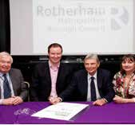
  - All home care firms contracted to work for Council will at least pay real living wage.
  - Zero hours contracts not in place of permanent contracts
  - Covered by an occupational sick pay scheme.
  - Work with providers and trade unions to agree how service quality will be monitored and compliance with the charter assured.
  - Home care workers will be paid for their travel time, travel costs and other necessary expenses such as mobile phones.
  - Workers have the freedom to provide appropriate care and will be given time to talk to their clients.

How to Keep Up-to-Date with the Council’s Procurement Opportunities
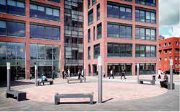
The Council utilises the YORtender regional web portal that allows local authorities to effectively manage and advertise quotations and tenders.
The portal provides access to Local Authorities managing opportunities within the Yorkshire & Humber region.
  - A single procurement approach across the Region.
  - A means to share, co-ordinate and collaborate on procurement exercises.
  - E-Enabled for all to work smarter and to reduce procurement lead times.
  - Suppliers can register their capabilities and interests in opportunities.
  - Suppliers receive email alerts of opportunities.
  - Immediate access to current opportunities.
  - Contract Management functionality to support effective management of contract for buyers and suppliers.
A simple, secure, and efficient means for managing tendering and quotation activities reducing the time and effort required for both buyers and suppliers.
Supplier Registration is easy and free – once on the home page just click ‘New Supplier Registration’ to the left.
  - Suppliers can create multiple users under one master company account.
  - We suggest you include a generic company email address (e.g. sales@) and ensure this is maintained at all times.
  - You can add CPV codes to receive free CTM Alerts for tender opportunities.
To find out about and participate in tender opportunities across the Yorkshire & Humber region please register at YORtender.
The Council’s Contracts Register including details of current contracts can be downloaded from YORtender and at Tenders and contracts – Rotherham Metropolitan Borough Council.

Commissioning Approach

Building Relationships

Co-Production
The Council is committed to embed genuine co-production into all commissioning activity to enhance our relationship-based approach.
The energy, skills, interests, knowledge, and experiences of providers must be harnessed to influence accommodation, care and support services in the borough.
Co-production benefits:
  - Collective sense of ownership
  - More effective service delivery
  - Greater outcomes for people in receipt of care and support
  - Improved relationships between the Council and providers

Market Testing
The Council commits to using formal and informal soft market testing approaches to inform service design and procurement model in the form of:
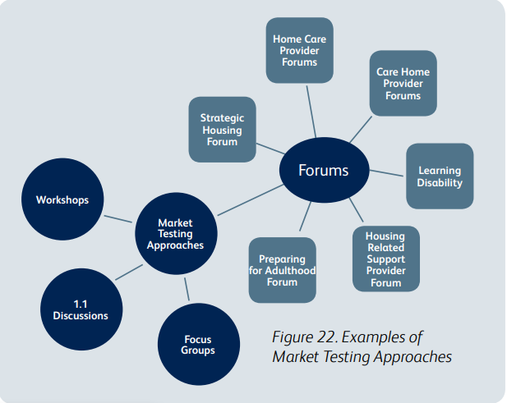
  - One to one discussion
  - Workshops
  - Focus Groups
  - Provider forums
All market testing will be well advertised in advance and attendance where applicable will be noted.

Figure 8. Examples of
Market Testing Approaches

Meet the Commissioners

Figure 9. Adult Care Strategic Commissioning Staff Structure.

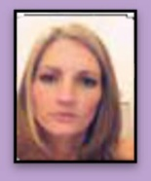
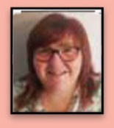
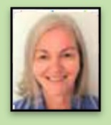
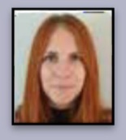
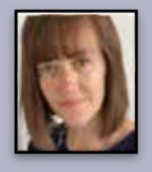
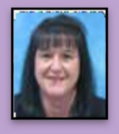
THEME 1
Mental Health NHS (MH) (Dementia)
THEME 2
Learning Disabilities (LD) Autism, Transitions
THEME 3
Older People, Long Term Conditions
THEME 4
Home Care and Support,
THEME 5
VCS, Unpaid Carers, Community Assets
Public Health, Housing Related Support, Socially Excluded/Complex Dependency

Ben Anderson
DIRECTOR OF
PUBLIC HEALTH
Scott Matthewman
ASSISTANT DIRECTOR
(Interim)
Michael Ng
Operational
Commissioner
Public Health
Jennifer Armitage
Operational
Commissioner
Public Health
Lisa Elliott
Strategic
Commissioning Manager
Anne Charlesworth
Head of Service: Public Health Commissioning Performance & Quality
Strategic Commissioning Manager

Joanne Bell
Strategic Commissioning Manager

Karen Smith
Strategic Commissioning Manager

Kay Nicholes
Head of Service: Prevention and Early Intervention

Jacqueline Clark
Head of Service (Interim):
Adult NHS

Steph Watt
Head of Service: Learning Disability/Autism & Transition

Gary Parvin
Head of Service:
Mental Health NHS

Kate Tufnell

Contact Us
For any further information about the Market Position Statement please email: commissioningenquiries@rotherham.gov.uk.

Resources

Please utilise the resources below by clicking on the relevant heading.

Council Plan Year Ahead Plan
Health and Wellbeing Strategy Rotherham Data Hub
Rotherham Integrated Health and Social Care Place Plan
Social Value Policy
Commissioning Social Value Toolkit – Rotherham YORtender
Rotherham Council Contract Register Rotherham Digital Strategy Rotherham Housing Strategy

