Housing Online – Re-Housing Application User Guides
This guide specifically relates to Re-Housing and Allocations. Should you need help finding your way around other parts of your Housing Online account, please refer to the All User Guides section which you can access by clicking here

Contents Page Number
Create an Account as an Existing Applicant | 2
Create an Account/Application as a New Applicant | 19
Update Person Details | 21
Delete a Person | 23
Add a Person | 26
Add a New Address | 29
Amend Application Questions/Answers | 36
Update Contact Details | 34
Upload a Document to a Saved Application | 38
Upload a Document to an Accepted Application | 41
Delete a Document | 44
Place a Bid | 47
How to View Current Bids and Queue Positions | 53
Withdraw a Bid | 55

Please refer to the ‘Registering and Logging in Guide’ for details of how to register for the first time and/or log in with a previously registered account.

Create an Account as an Existing Applicant
- Select the Housing Online link to open the Log In page as per the below:
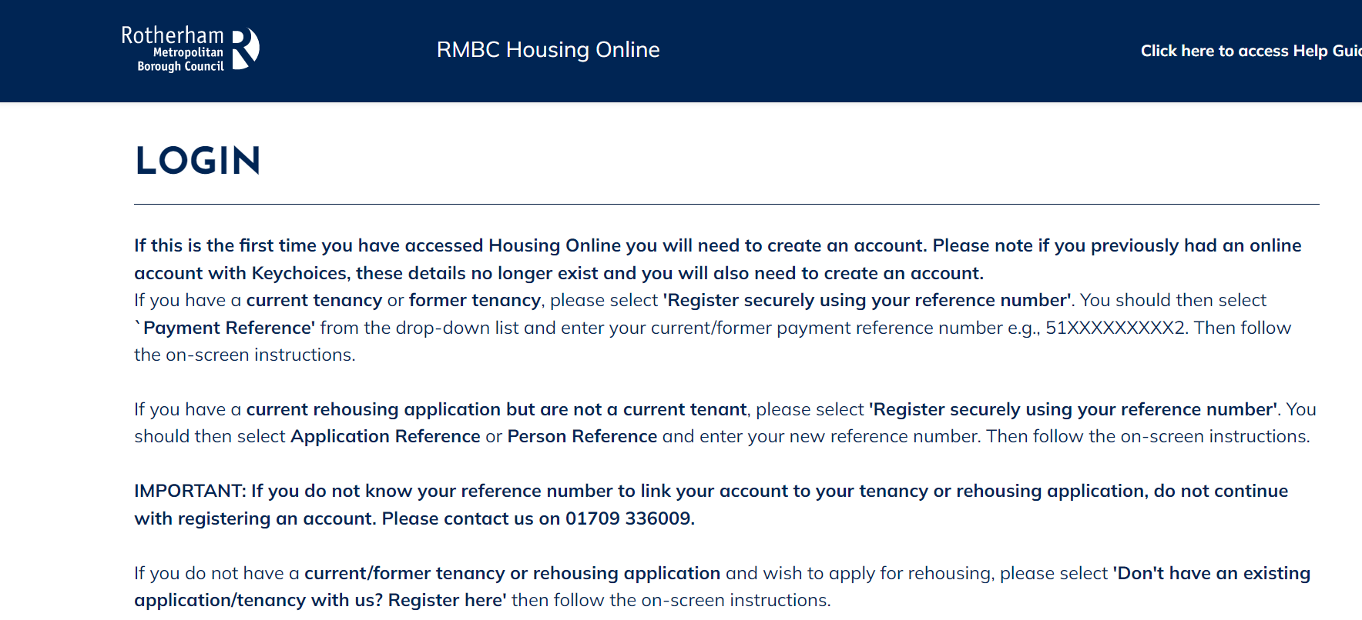

- Scroll down the page to the ‘Login to your account’ section 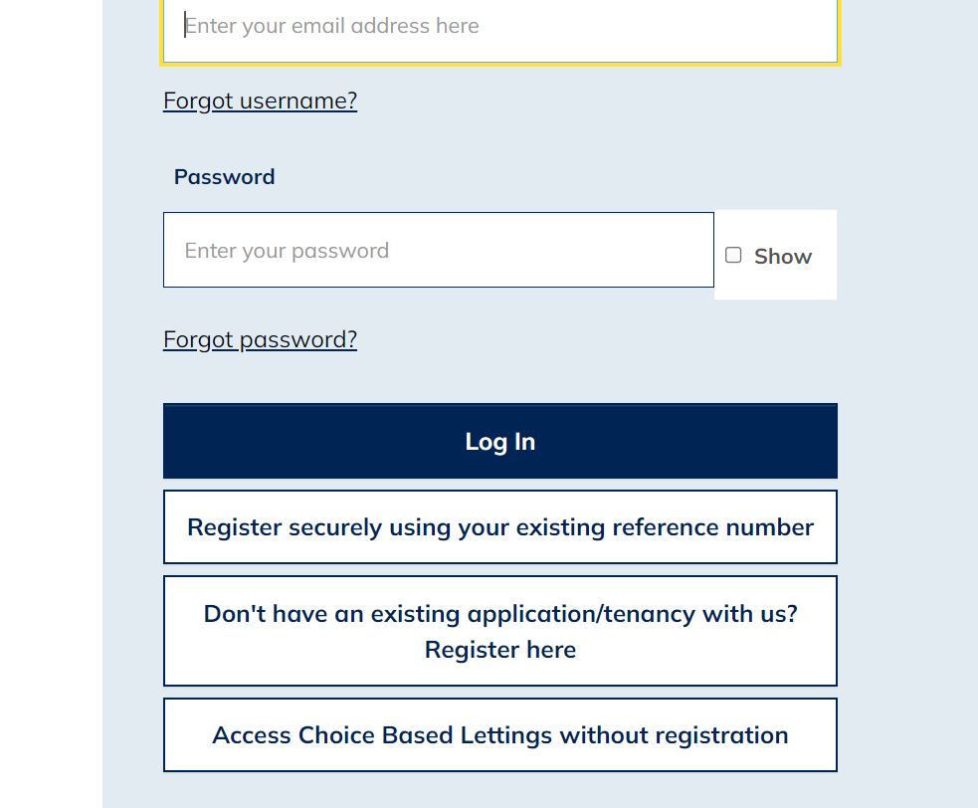
- Select the ‘Register securely using your existing reference number’ option

- The ‘Register’ page will display as shown below: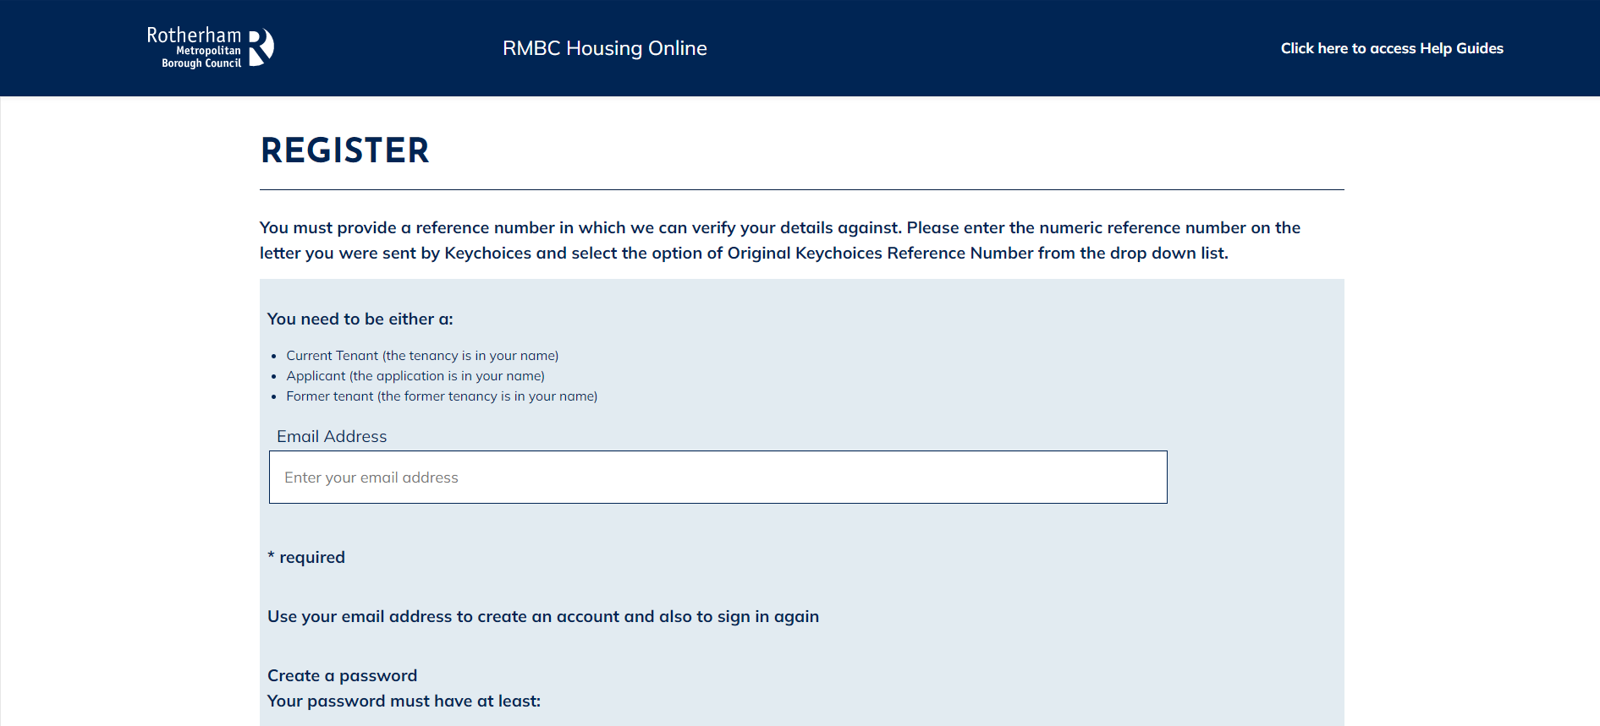

- Carefully enter your current email address and then create a password. When you’ve done this select Next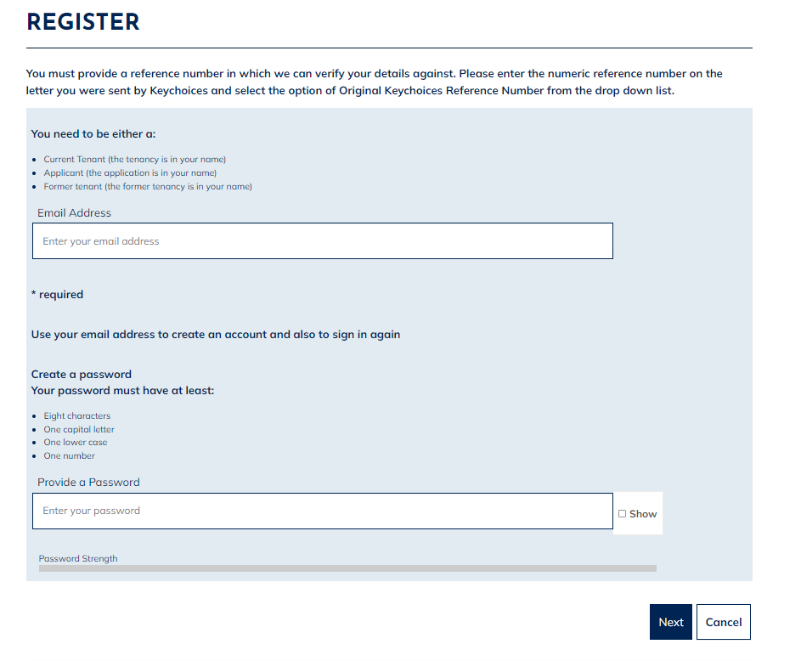

- Having selected Next, the following page will display – asking you to check your email inbox. A registration email should arrive within a few minutes. Check your junk folder if you have not received an email. If you do not receive an email, follow the above steps again to ensure no errors were made when entering your email address. 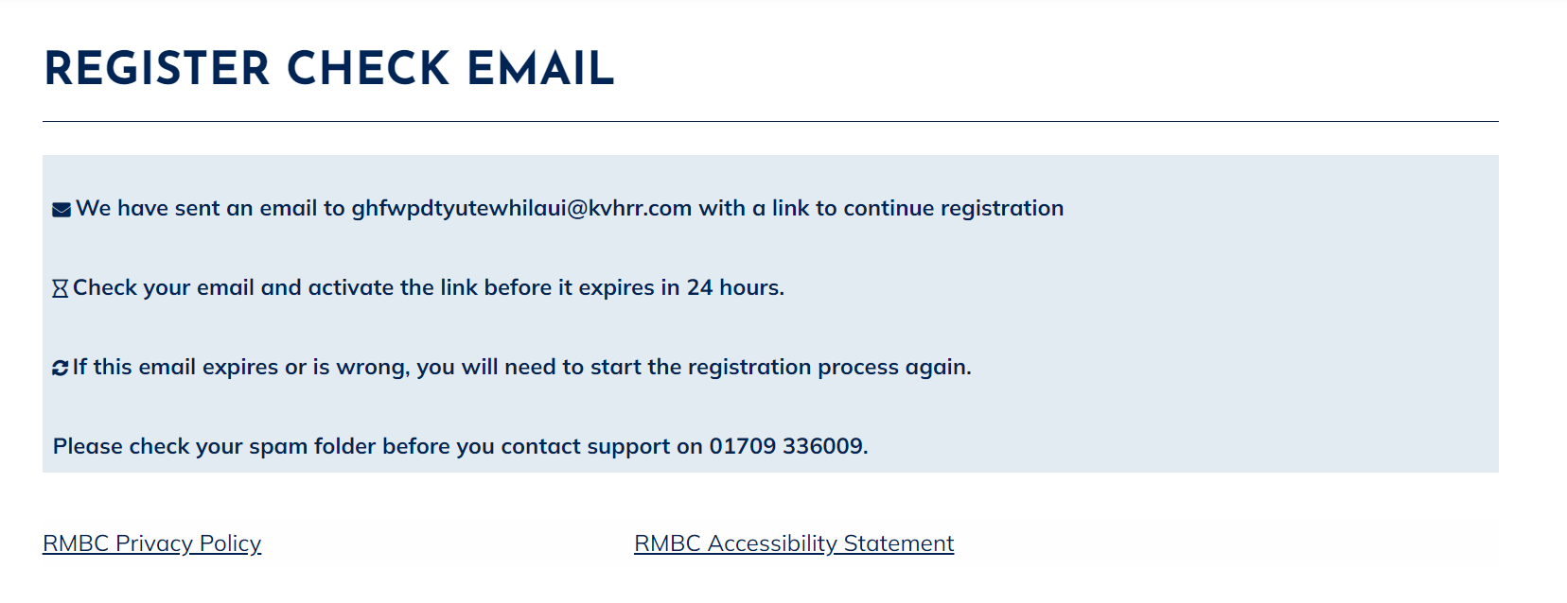

- Open the email and select the ‘Verify Me’ link. Please note this is a one time only link, therefore if you click on the link and do not complete the process the link will no longer be valid and you will have to start the registration process again.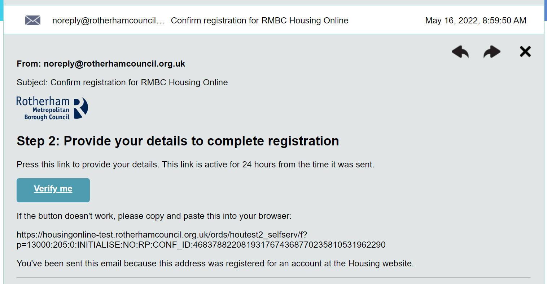

- After selecting the ‘Verify Me’ link from your email, the following page will display: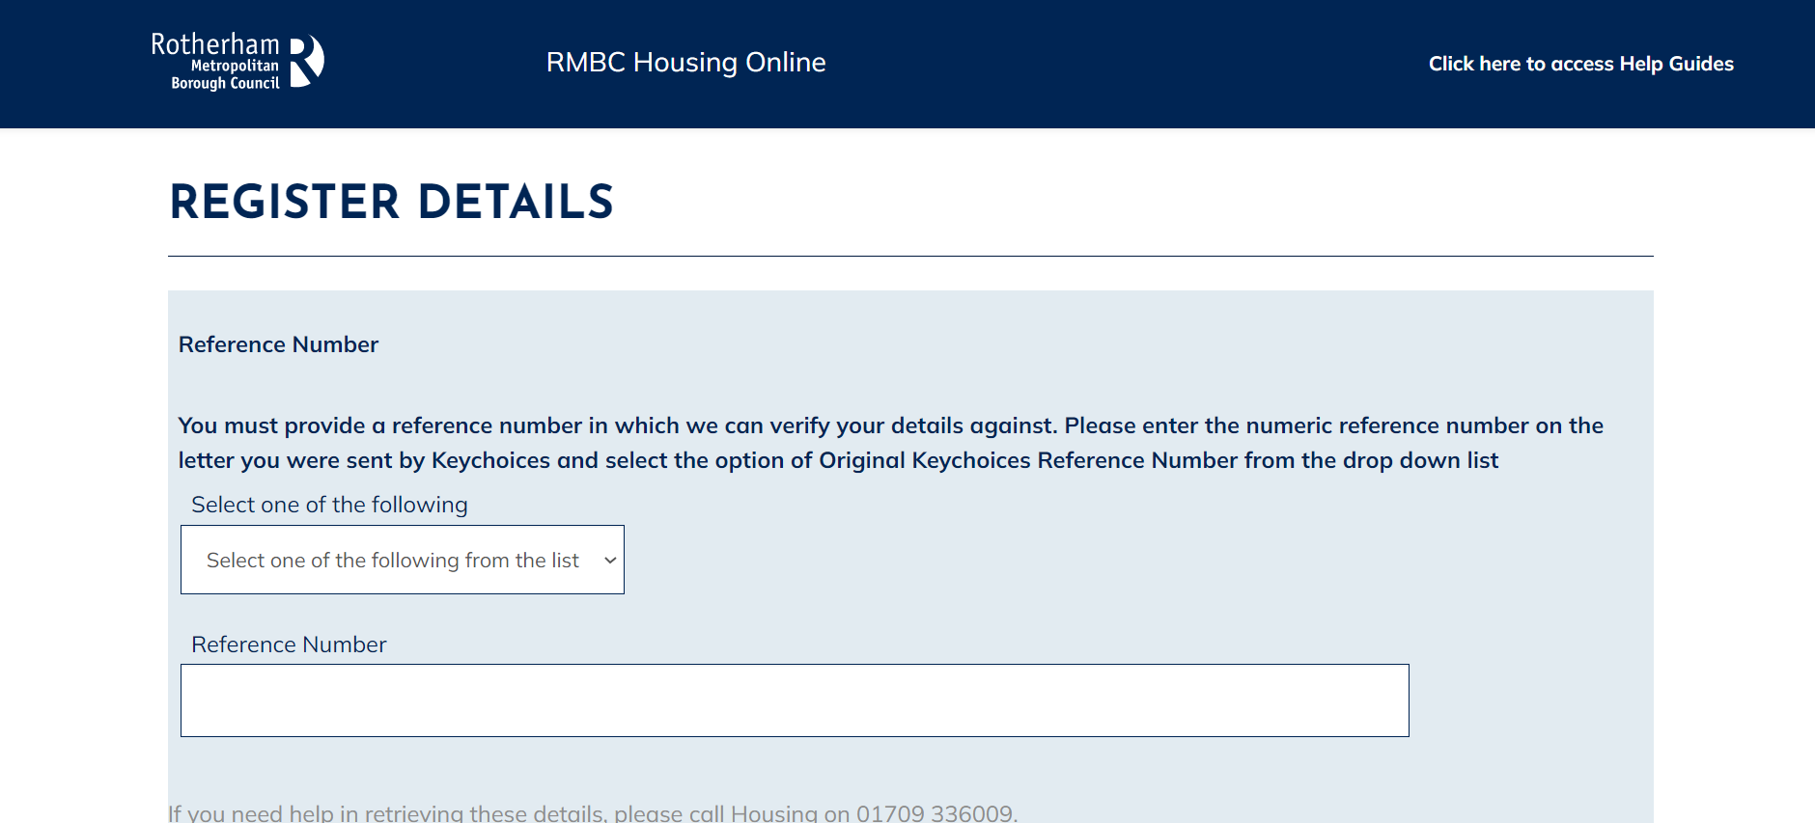

- Select Person Reference or Application Reference (if you are an exisiting Rotherham Council tenant you also have the option to select Payment Reference and enter your rent account reference number). Once you have selected an option, please enter the correct reference number to match the option you have selected.

If you create an account using the incorrect reference number or register as a new applicant, your account will not link to your existing application and/or details. If you do not know your reference number, please call us on 01709 336009.
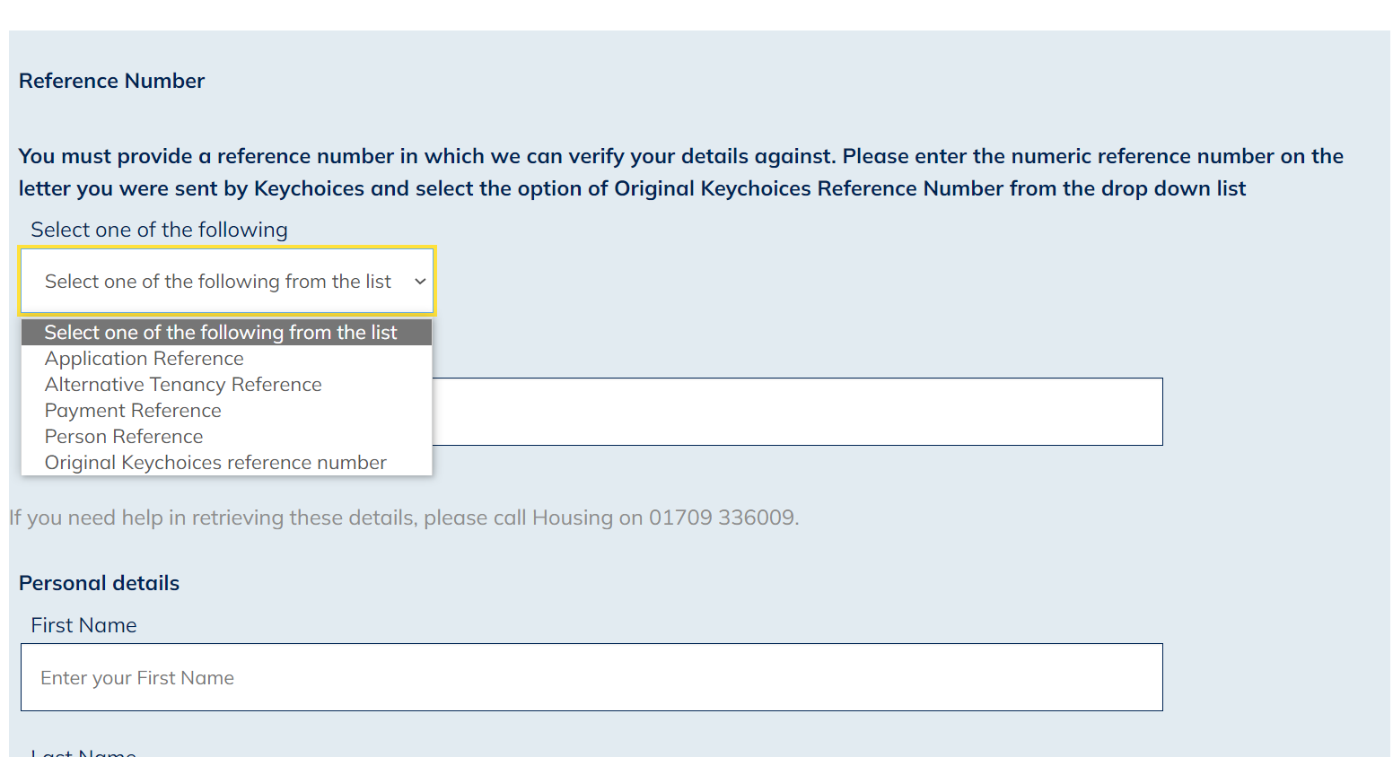

- Once you have entered your reference number, you will then need to scroll down the page to enter your First Name, Last Name and Date of Birth.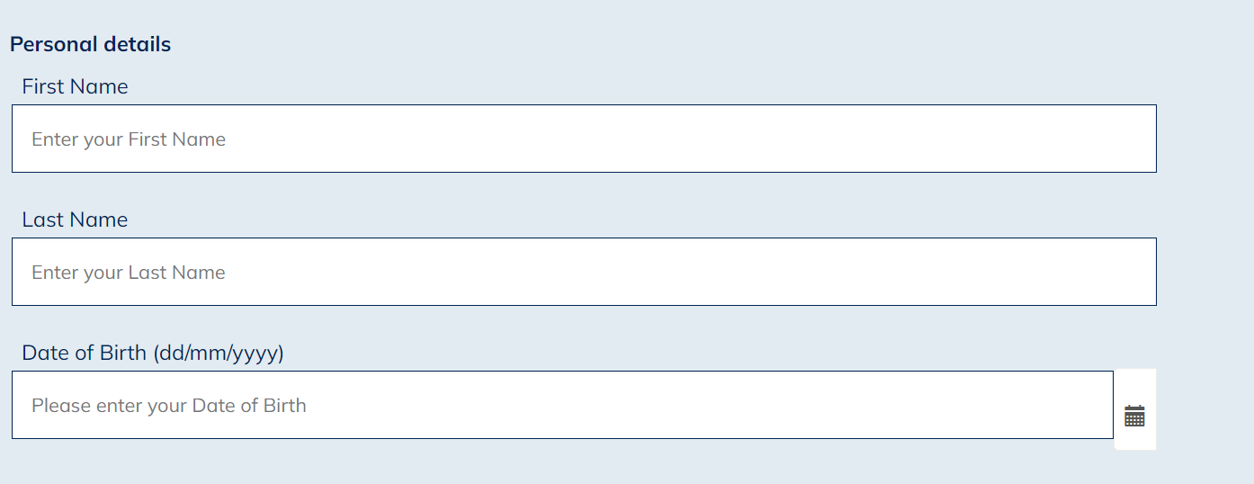

- After you have entered your name and date of birth, scroll down and select a memorable question from the drop-down list and enter a memorable answer.

- Then enter your memorable date in the format DD/MM/YYYY. You will need this information should you need to re-set your password in the future.

- Once you have done this, confirm you accept the terms and conditions of use by selecting Yes from the drop-down list.

- Finally select finish which you will find at the bottom right corner of the screen.

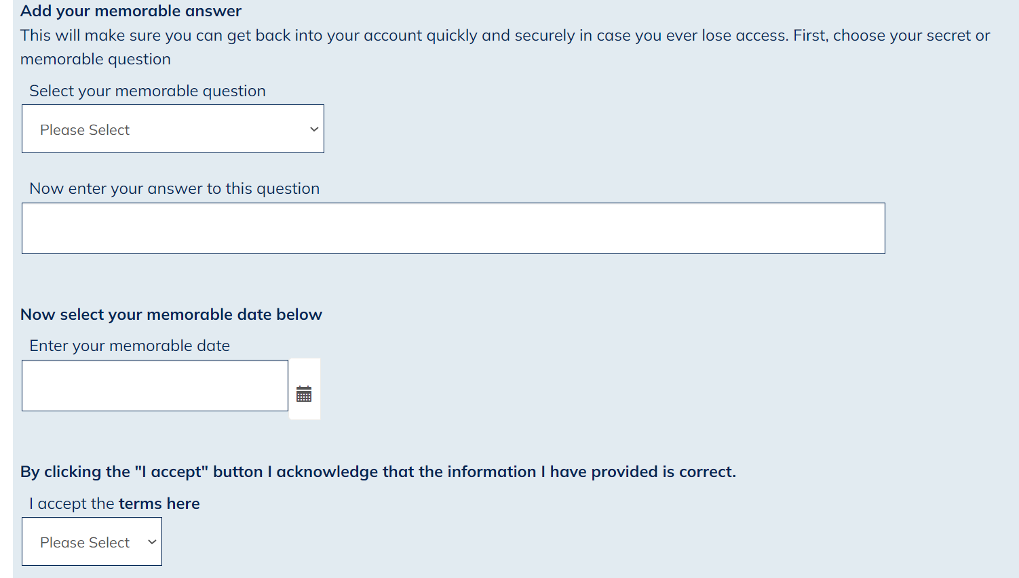

- Once successfully registered you will see the following confirmation: 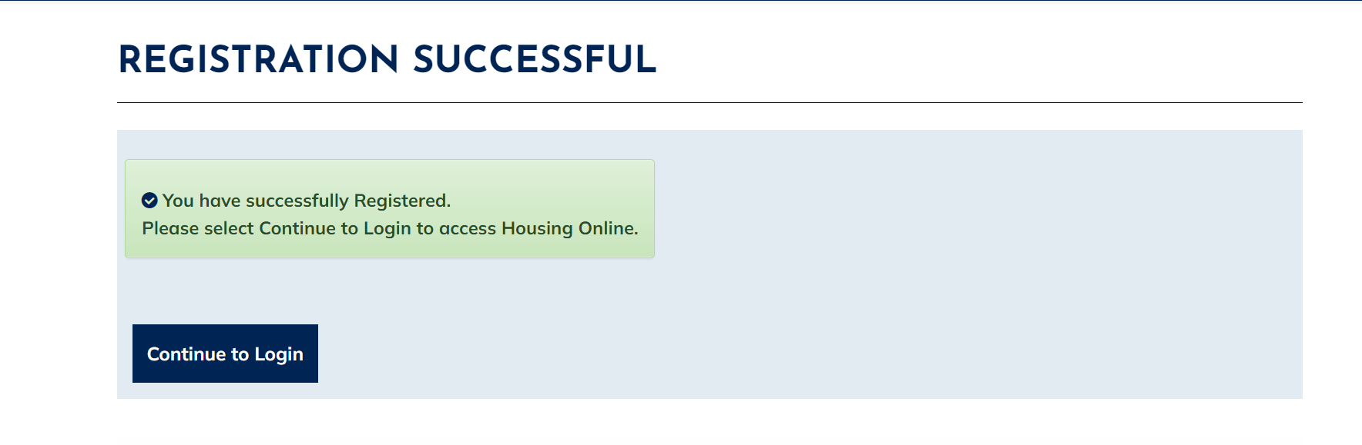

- Select the ‘Continue to Login’ option

- You will be re-directed to the log in page. Enter your email address and password then select Log In: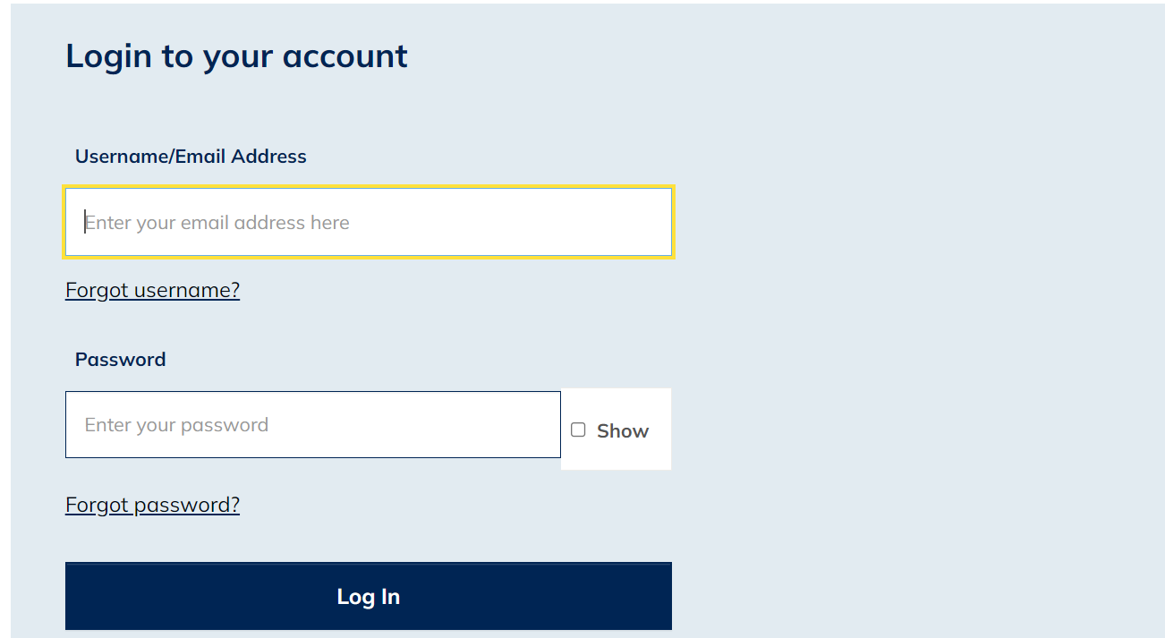

- You will now be logged into your Housing Online account and will be able to see the My Summary page as shown below: 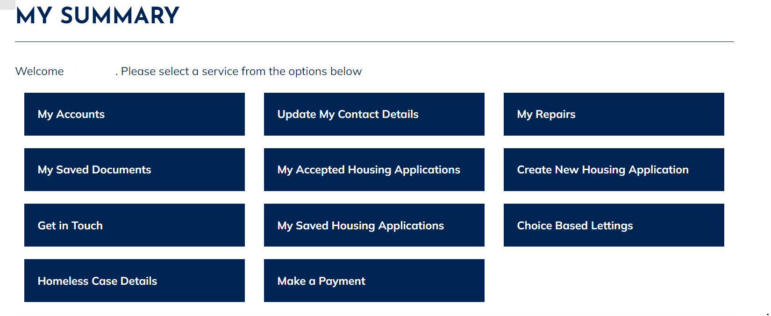

- You will now be able to view your application by clicking the ‘My Accepted Housing Applications’ option.

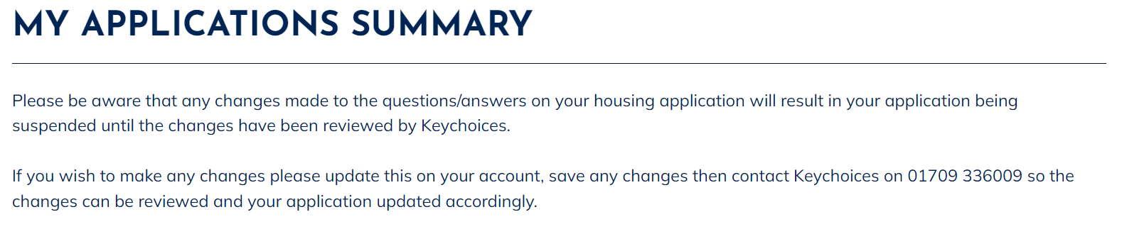

Create an Account/Application as a New Applicant

- Select the Housing Online link to open the Log In page as per the below: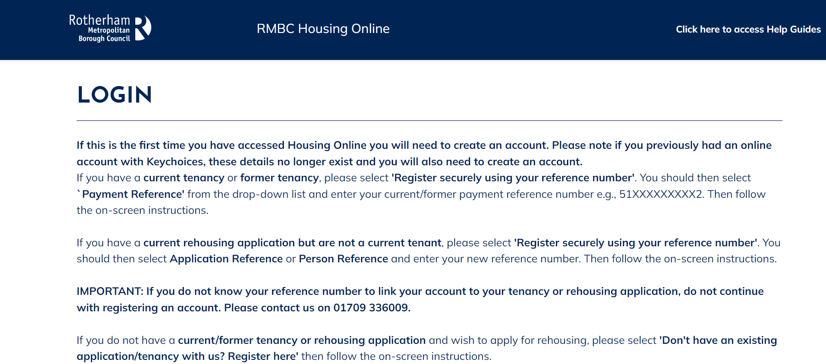

- Scroll down the page to the ‘Login to your account’ section 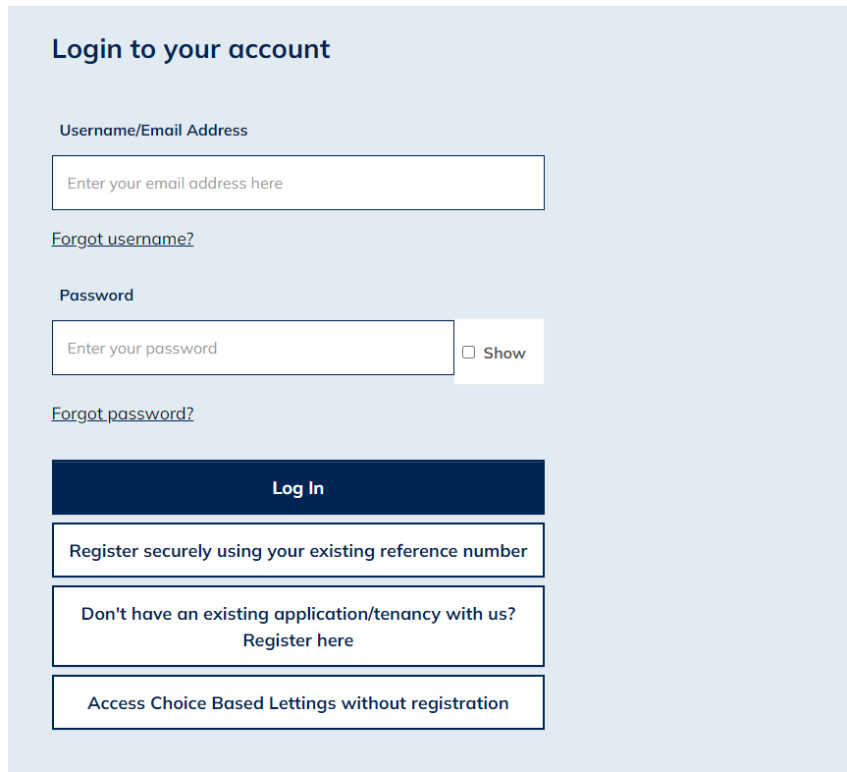

- Select the ‘Don’t have an existing application/tenancy with us? Register here’ option

- You will be re-directed to the ‘Register as a New Client’ page. Please enter your current email address and create a password. Once you have entered these details select the Next button at the bottom of the page.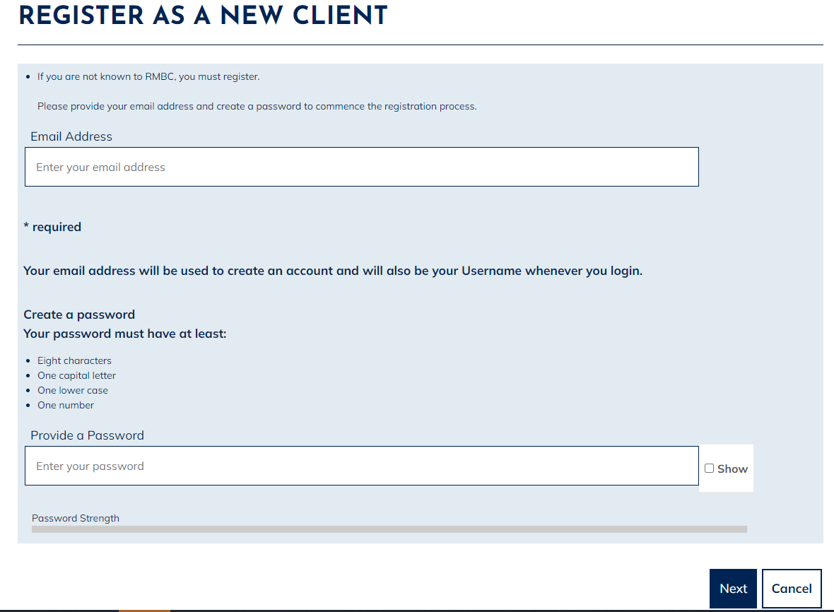

- Having selected Next, the following page will display – asking you to check your email inbox. A registration email should arrive within a few minutes. Check your junk folder if you have not received an email. If you do not receive an email, follow the above steps again to ensure no errors were made when entering your email address. 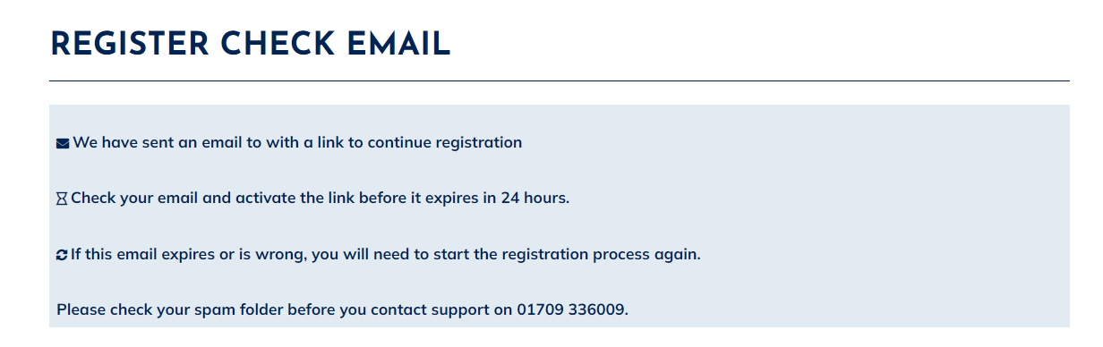

- Open the email and select the ‘Verify Me’ link. Please note this is a one time only link, therefore if you click on the link and do not complete the process the link will no longer be valid and you will have to start the registration process again.

- After selecting the ‘Verify Me’ link from your email, the following page will display: 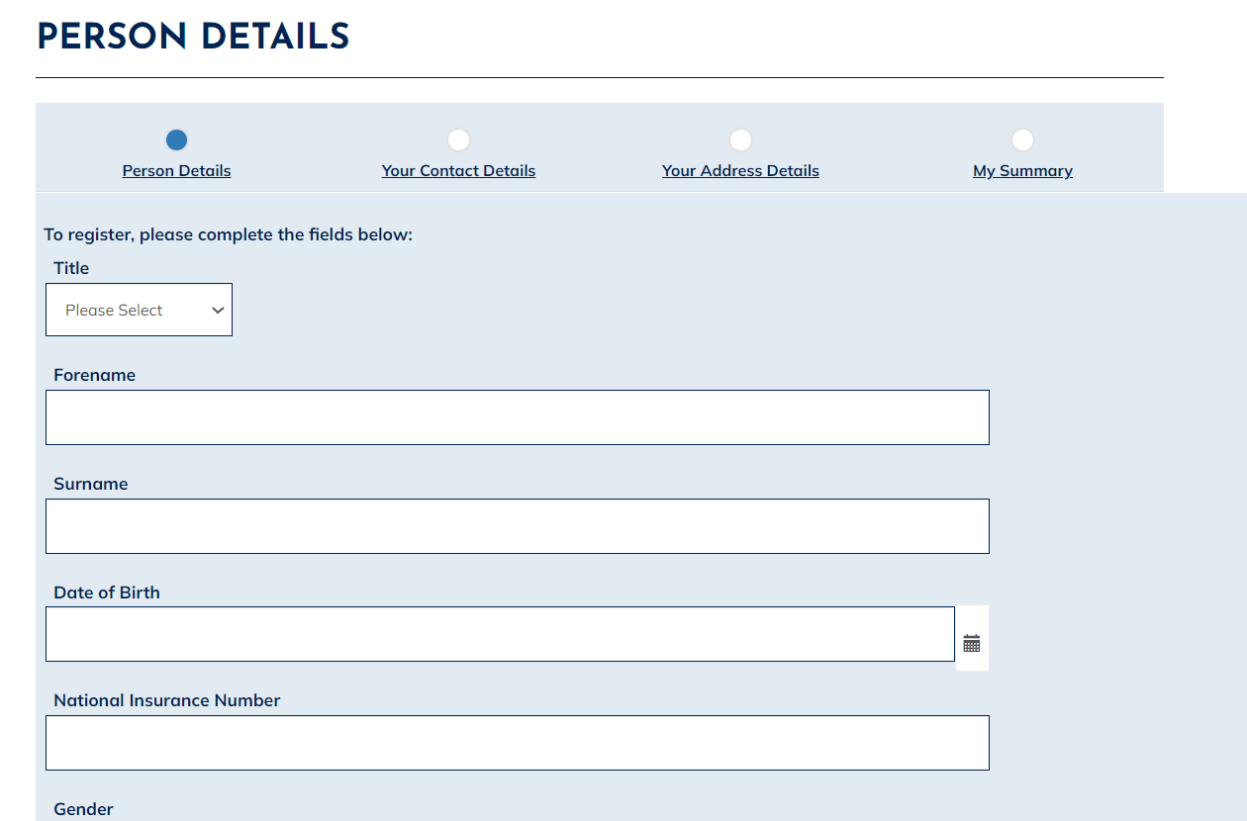

- From here, enter your details into the relevant fields

- Scroll down and select a memorable question from the drop-down list and enter a memorable answer.

- Then enter your memorable date in the format DD/MM/YYYY. You will need this information should you need to re-set your password in the future.

- Once you have done this, please confirm the information you have provided is correct by ticking the box, then select the Next button to the bottom right corner of the screen

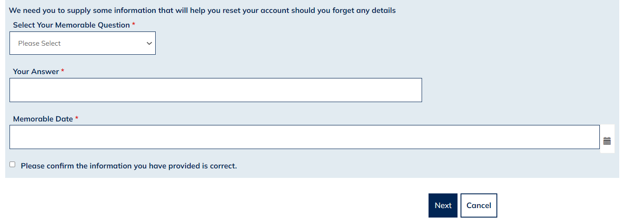

- Your Contact Details page will display, as shown below. Please carefully enter your up-to-date contact details then select Next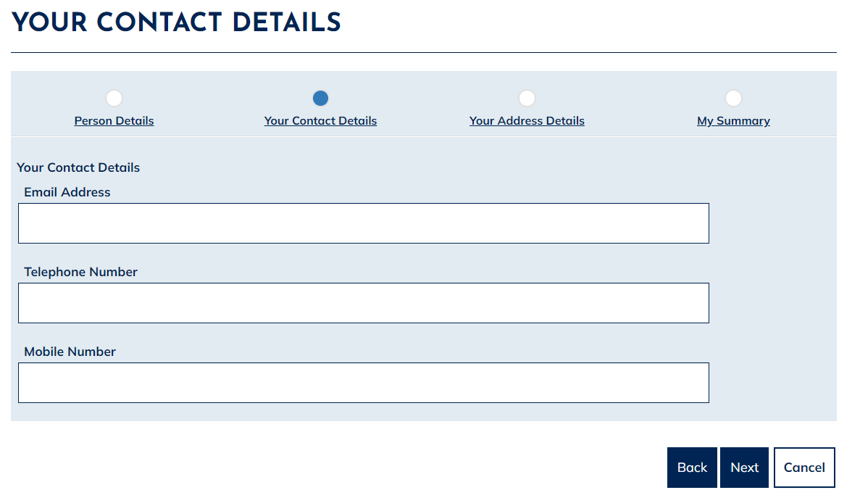

- The ‘Your Address Details’ page will display, as shown below. Select the ‘Add Address’ option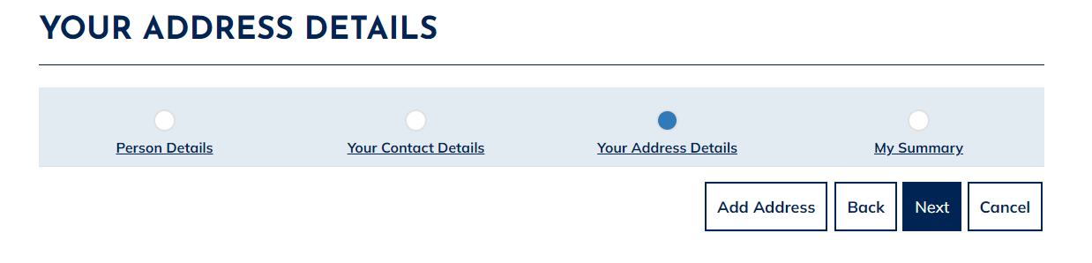

- The ‘Add Address Details’ page will now display. Please enter your full address, entering the date of when you moved into the property and a date you left the property (if applicable), scroll down and select Finish. Please note: you MUST supply a full five year address history. Therefore if you have not lived at your current address for five year or more, you will need to ‘Add Address’ for each address you have lived at within the last five years. If you have been no fixed address for a period in the last five years please enter a care of address or ‘No Fixed Address’ in the address fields listed.There should be no gaps in your five year address history.

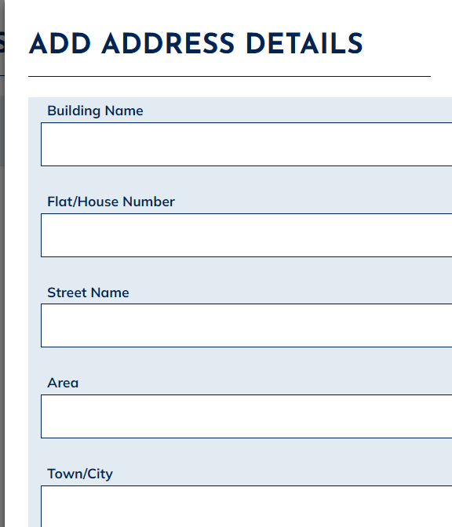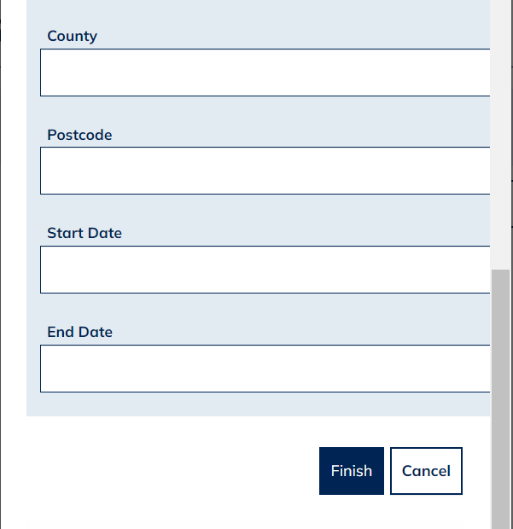

- Once you have entered your full five year address history, please select Next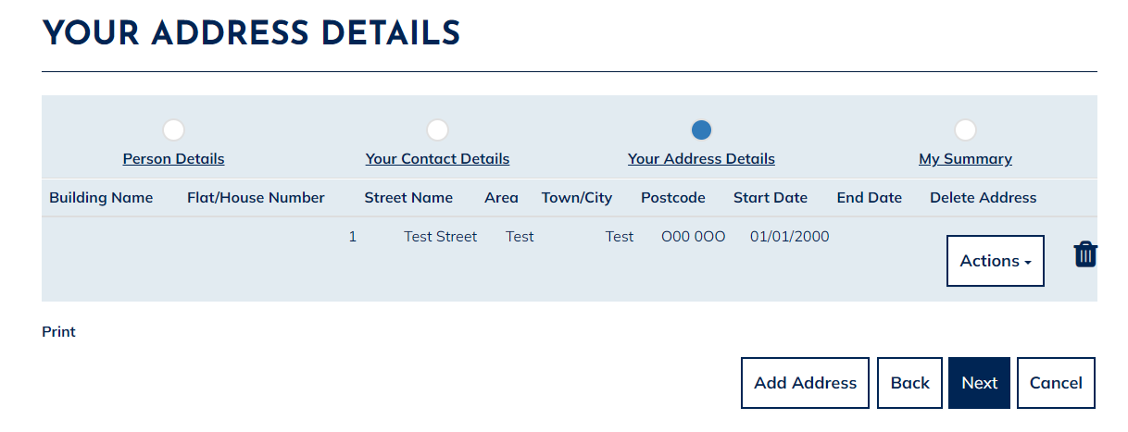
- The following ‘My Summary’ page displays, as shown below. Please check that all the details you have entered are correct, then select Finish at the bottom of the page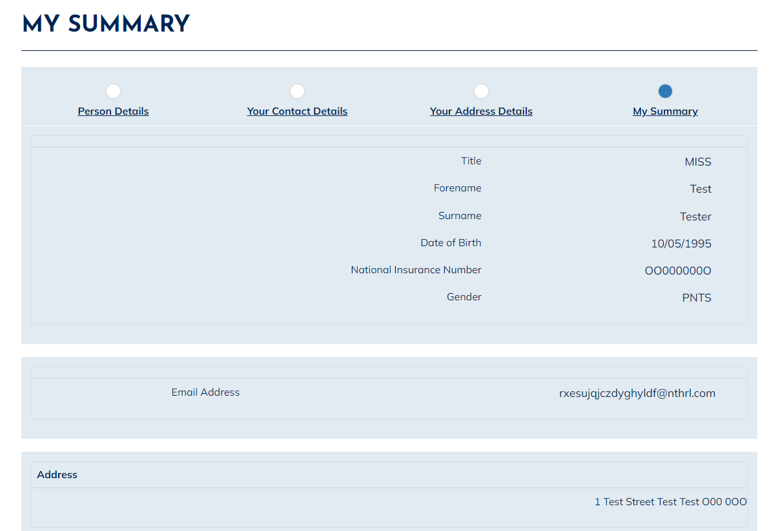

- A message will display, as shown below, to advise you that you have successfully registered your Housing Online account. Click Continue to Login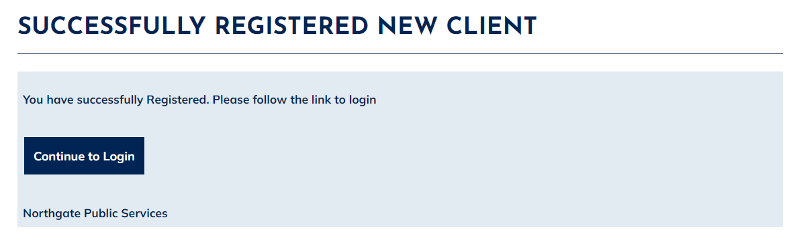

- Enter your email address and password, then select Log In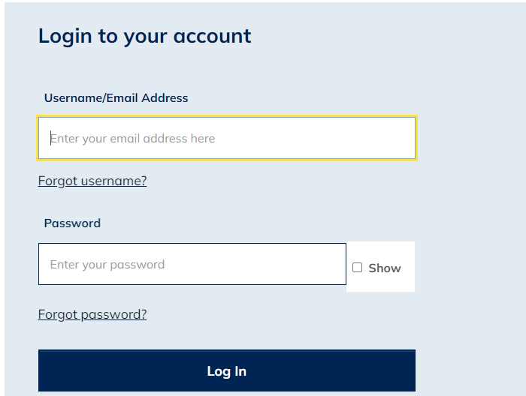

- The ‘My Summary’ page will display, as shown below. From here, select ‘Create New Housing Application’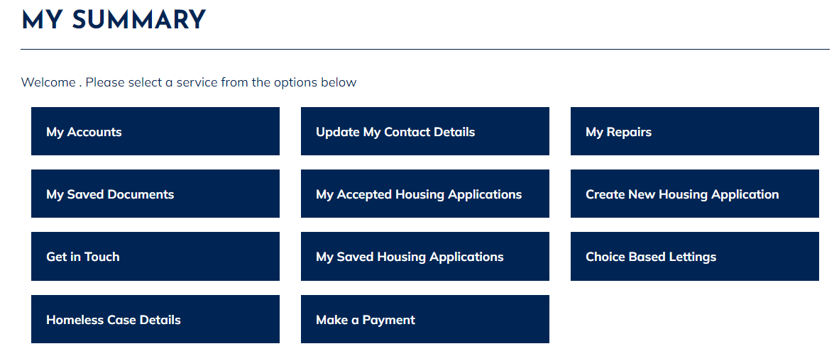

- The ‘Housing Application Form Home’ page displays, as shown below: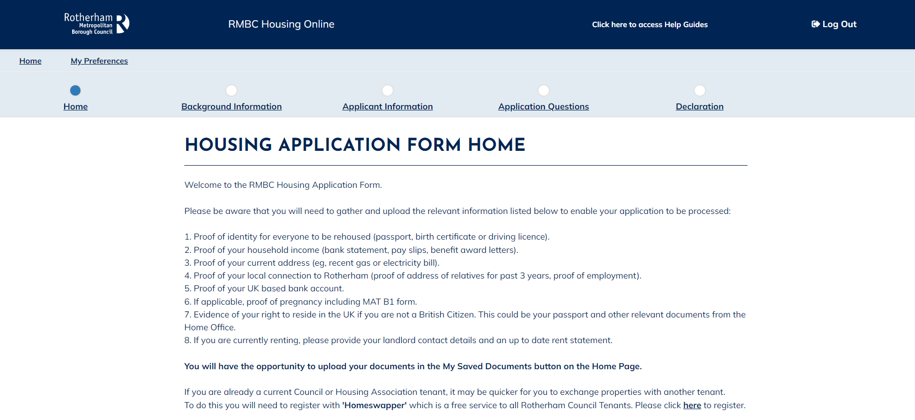

- Scroll to the bottom of the page. Select Housing Register from the drop-down list, then tick ‘Please Confirm Selection’ box. Then click Next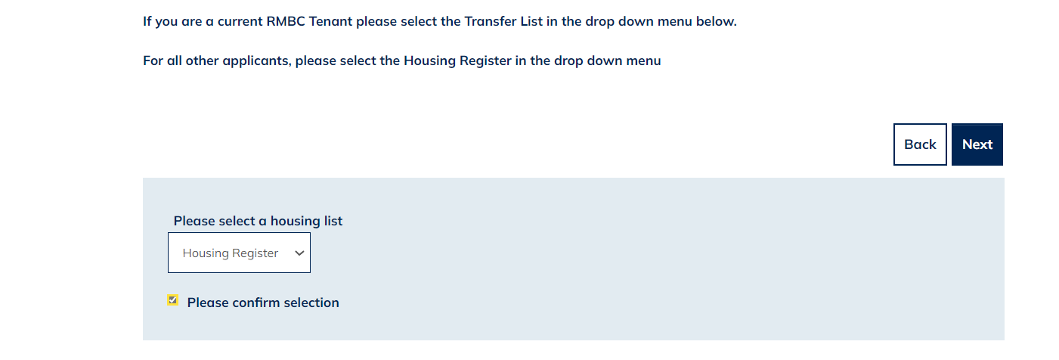

- The ‘RMBC Housing Register’ page displays. Read this information carefully and then select Next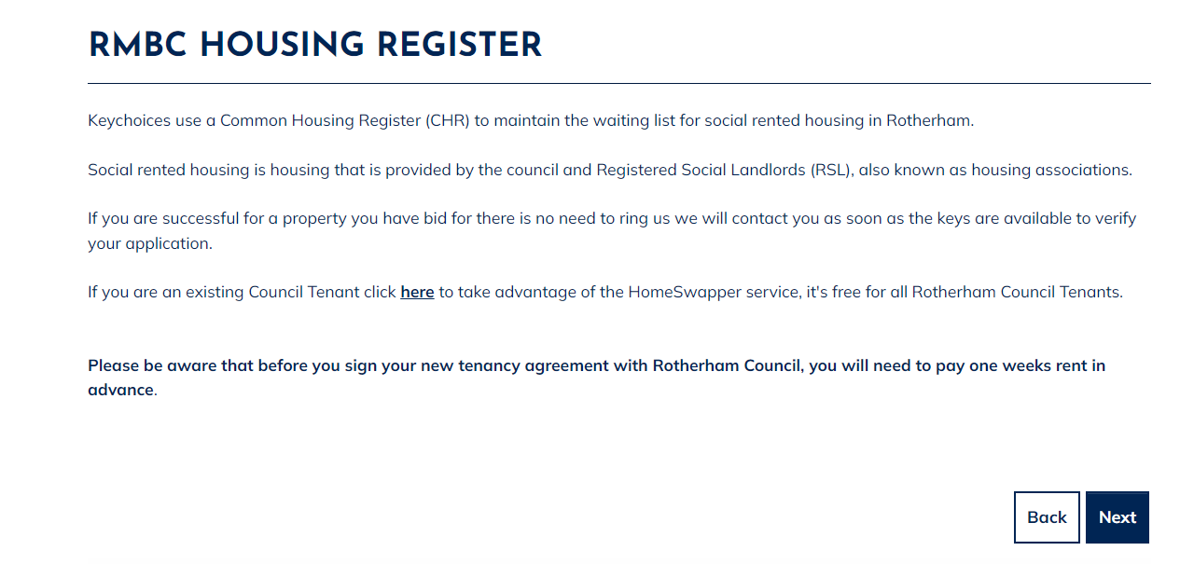

- The ‘People Summary’ page will display. Please select the ‘Actions’ menu next to the main applicant, then select ‘Update Person’ where there is an exclamation mark this indicates an incomplete section of your application. 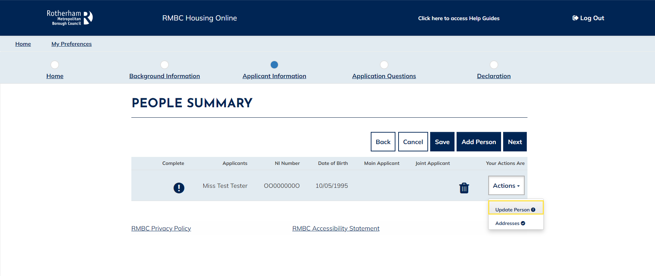

- The ‘Enter Person Details’ page displays. Please complete the person details. Any mandatory fields are marked with a red *. Once you have completed all person details, click Submit.

- If there are other household members with a exclamation warning against them, please select the Action button to complete their details as above. If you wish to add additional household members that need re-housing with you, you can do this by selecting ‘Add Person’ and then completing their details. Once you are happy that all household members are correct and updated, select Next.

- The ‘Application Questions’ page displays. Carefully respond to each set of questions, until you reach the end of the ‘Application Questions’.

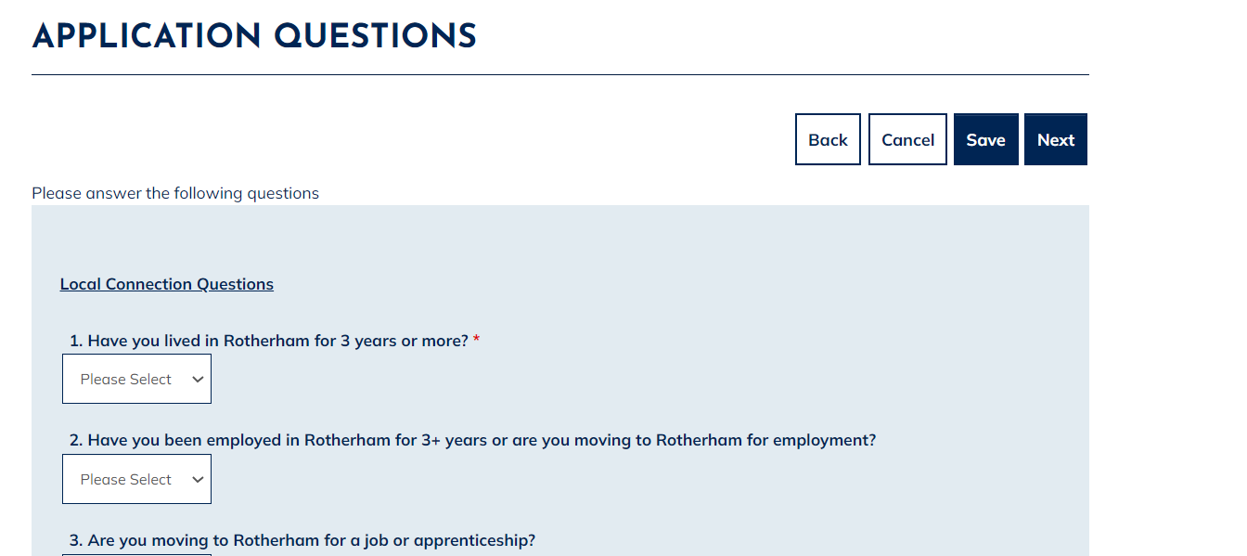

- The ‘Housing Application Form Declaration’ page will now display: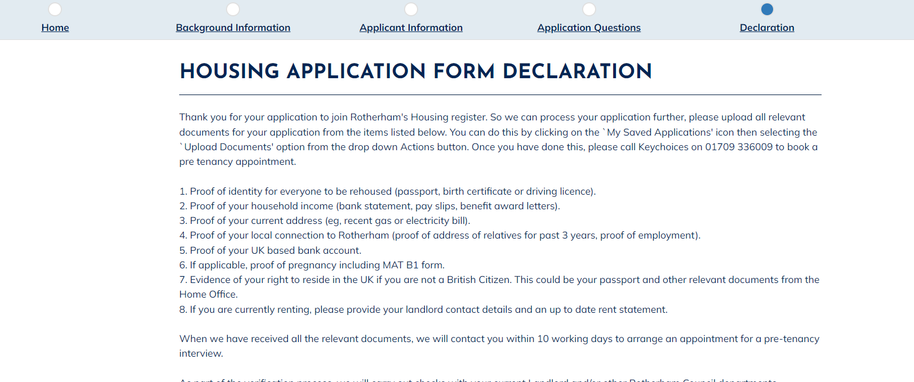

- Scroll down and confirm that the information you have provided is correct by selecting ‘Yes’ and then ‘Submit’.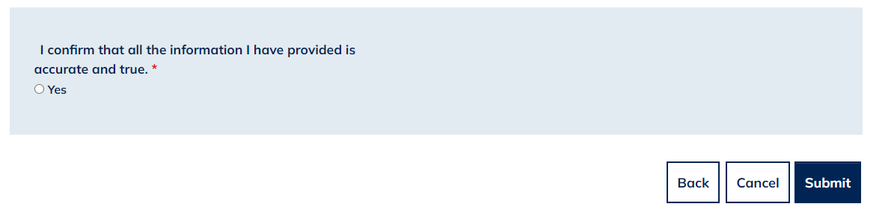

- The ‘Housing Application Confirmation’ page will then display, advising you of the documents you are now required to submit and the steps you must follow for your application to be progressed. It may be helpful at this stage to make notes of what you will need to do next as per the image below. Select Done at the bottom of the page.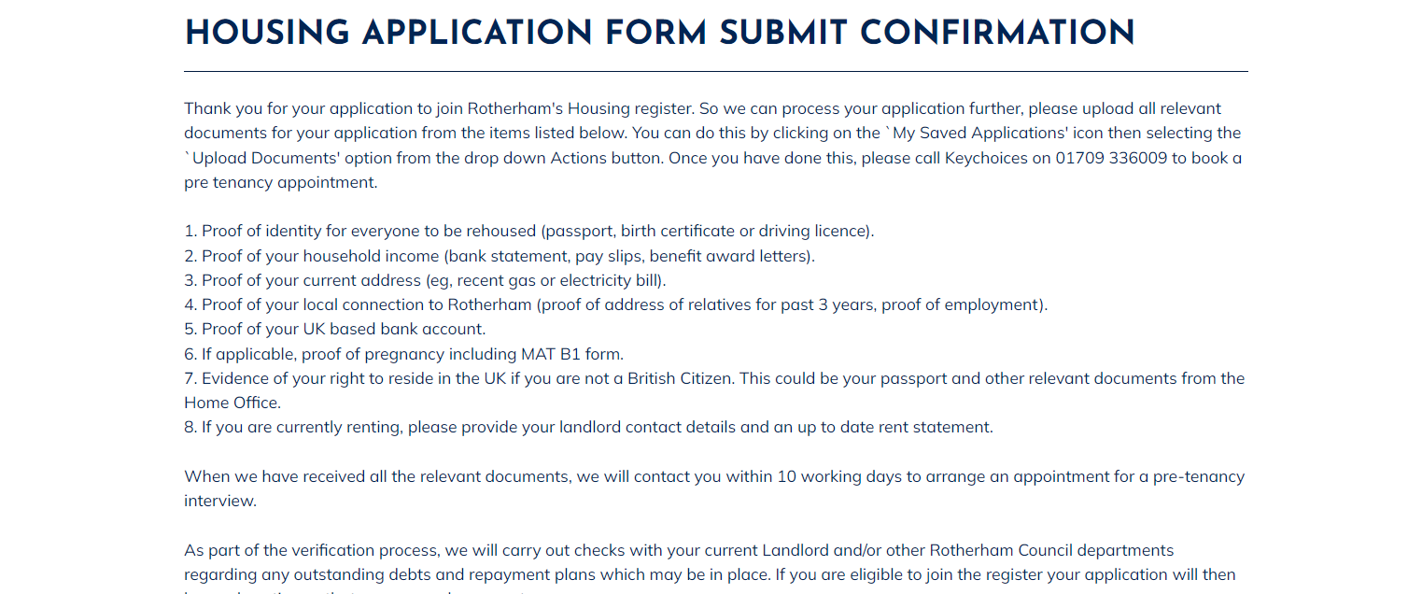

Update Person Details
Once successfully logged in you will see the ‘My Summary’ page as per the below:
- The ‘My Summary Page’ will be displayed. From here select ‘My Accepted Housing Applications’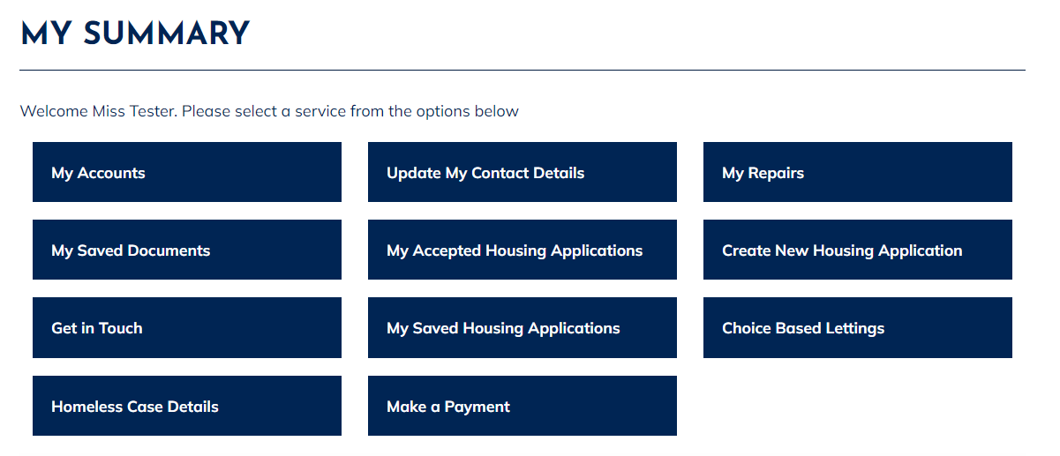
- The ‘My Applications Summary’ page will display, as shown below. From here select the ‘Actions’ option and then select ‘View Application People’.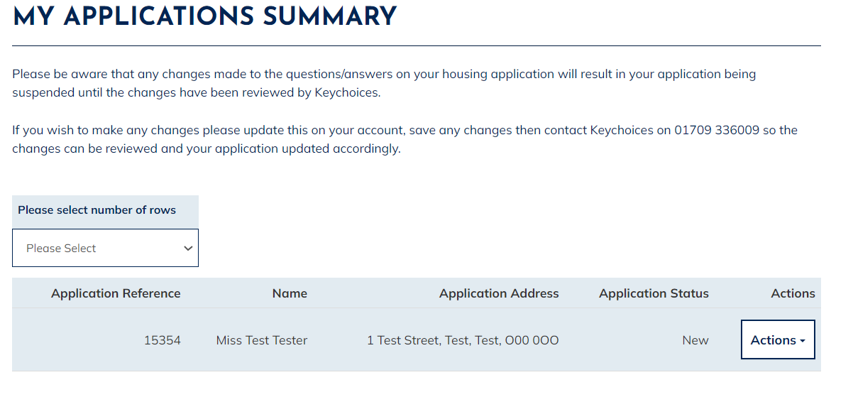
- You will then be taken to the ‘View Application People’ page as per the below: 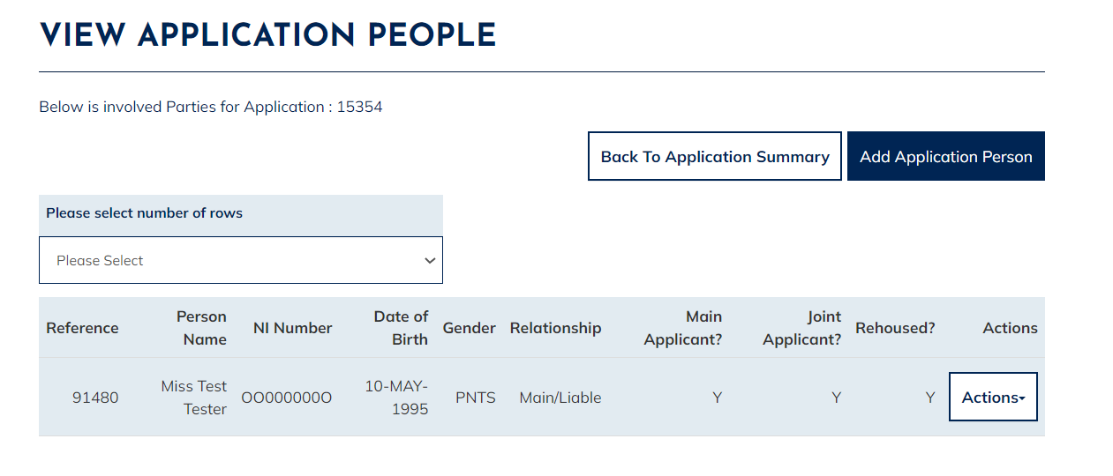
- From here, select the ‘Actions’ menu against the person you wish to update, then select ‘Maintain Person Details’
- The ‘Maintain Application Person’ page will now show. From here you can amend or add the correct details. Once you have done this, please scroll to the bottom and select Save.
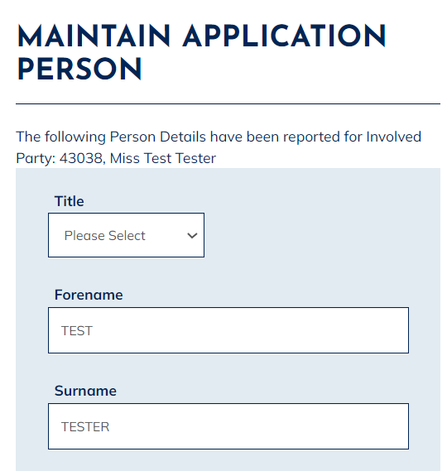
- The persons new details will have now been updated.

Delete a Person
Once successfully logged in you will see the ‘My Summary’ page as per the below:
- The ‘My Summary Page’ will show. From here select ‘My Accepted Housing Applications’
- The ‘My Applications Summary’ page will be shown as per the below. From here select the ‘Actions’ option then select ‘View Application People’.
- The ‘View Application People’ page will then display:
- From here, select the ‘Actions’ menu against the person you wish to delete, then select ‘End Application Person’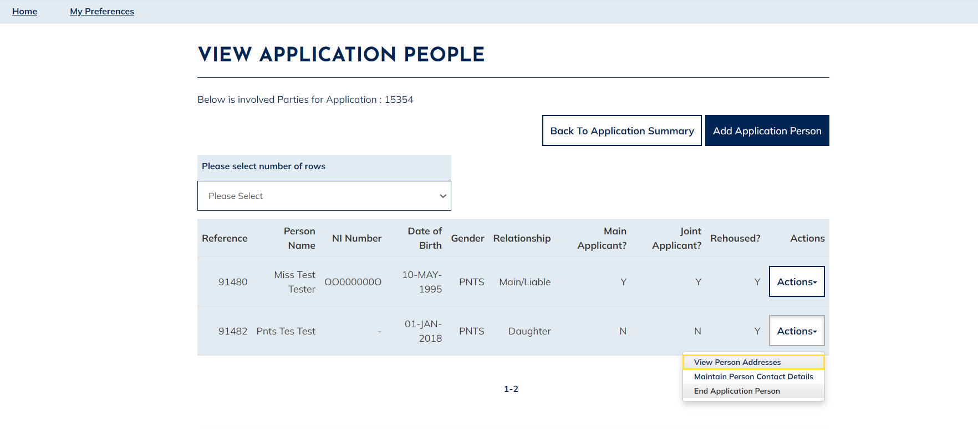
- The ‘End Application Person’ page will then show. Select a reason from the drop down list and then enter the date that the person left the household. Once you have entered this information, select ‘Submit’ 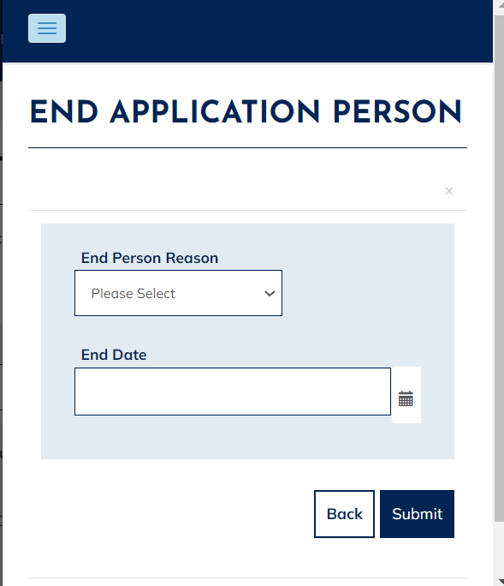
- You will then be returned to the ‘View Application People’ page, where the person you have just removed will no longer show. This will update your Keychoices Housing Application only.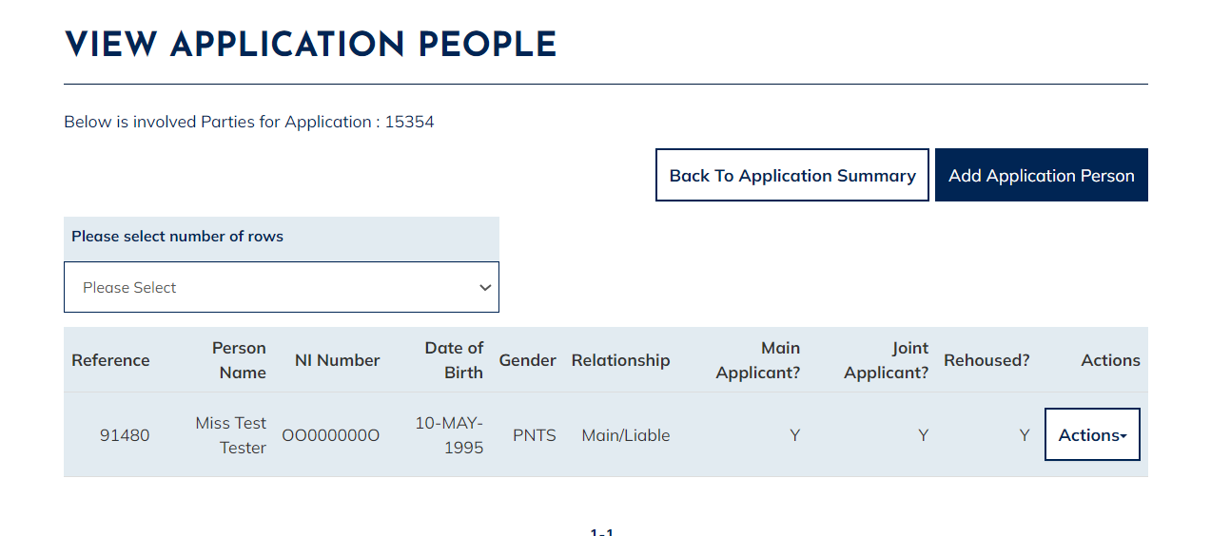

Add a Person
Once successfully logged in you will see the ‘My Summary’ page as per the below:
- The ‘My Summary’ page displays. From here select ‘My Accepted Housing Applications’
- The ‘My Applications Summary’ page will display, as shown below. From here select the ‘Actions’ option and then select ‘View Application People’
- The ‘View Application People’ page will then show:
- From here, select ‘Add Application Person’
- The Add Application Person page will show. Please ensure you enter the correct details for the person. Once you have entered all details for this person, select Save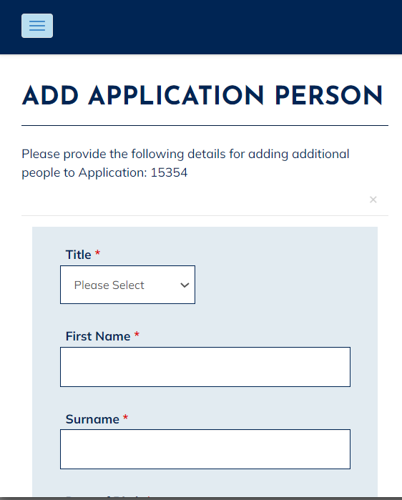

- You will then be returned to the ‘View Application People’ page where the person you have just added will now show. If you wish to add more than one person, please follow the same steps by clicking on ‘Add Application Person’. This will update your Keychoices Housing Application only.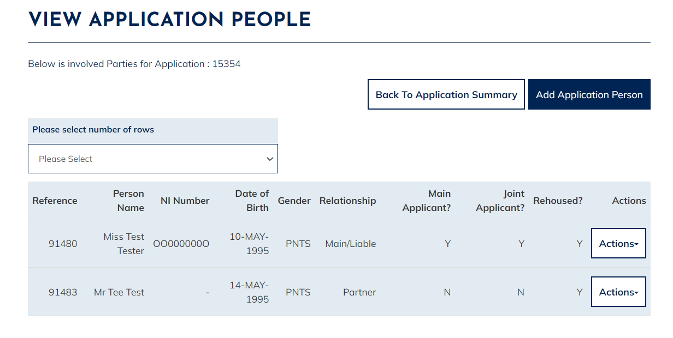

Add New Address
Once successfully logged in you will see the ‘My Summary’ page as per the below:
- The ‘My Summary’ page will show. From here select ‘My Accepted Housing Applications’
- The ‘My Applications Summary’ page will display, as shown below. From here select the ‘Actions’ option and then select ‘View Application Addresses’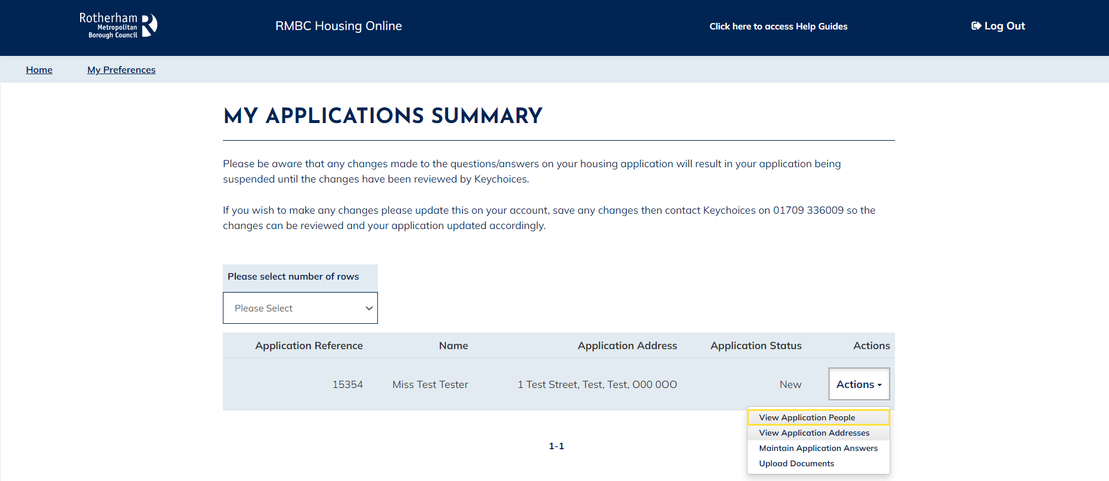

- The ‘View Application Address’ page will show. From here select ‘New Address’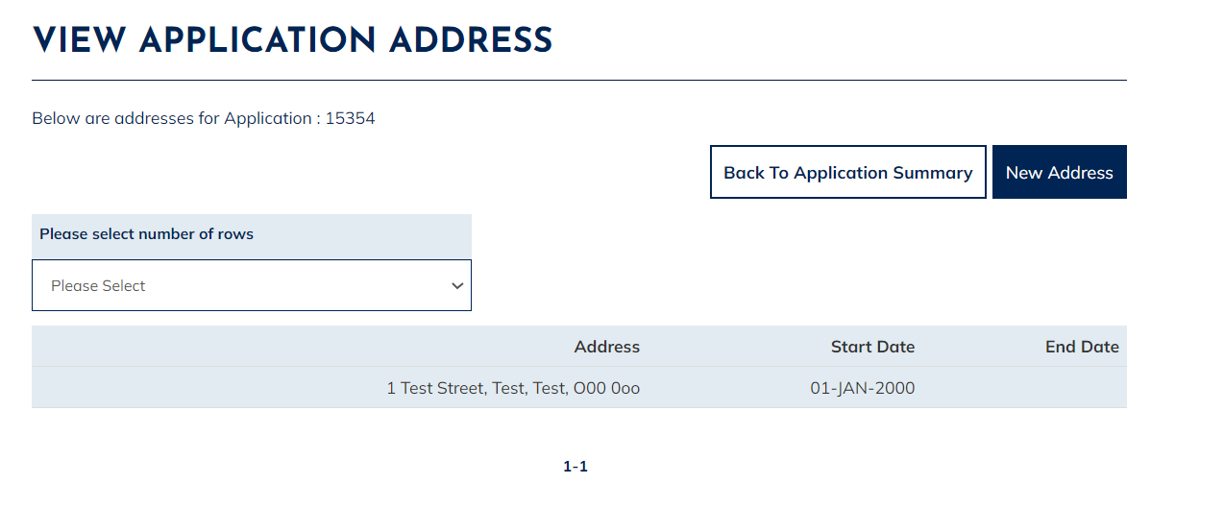

- Please note; if you have entered your current address details incorrectly and wish to amend your current address rather than add a new address, you will need to call us on 01709 336009.

- The ‘Update Application Address’ page will display. Please select the Search option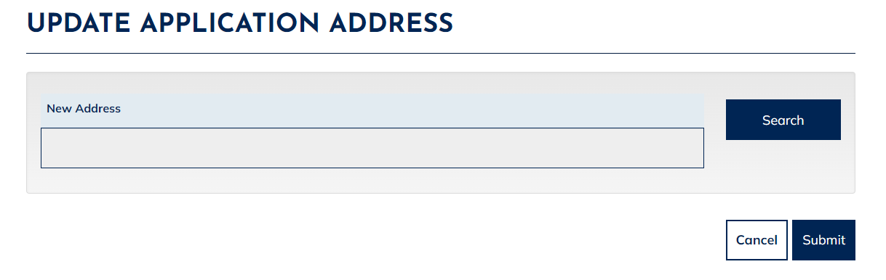

- The ‘Address Search’ page will show. Enter your full address details then select the Search option at the bottom of the page: 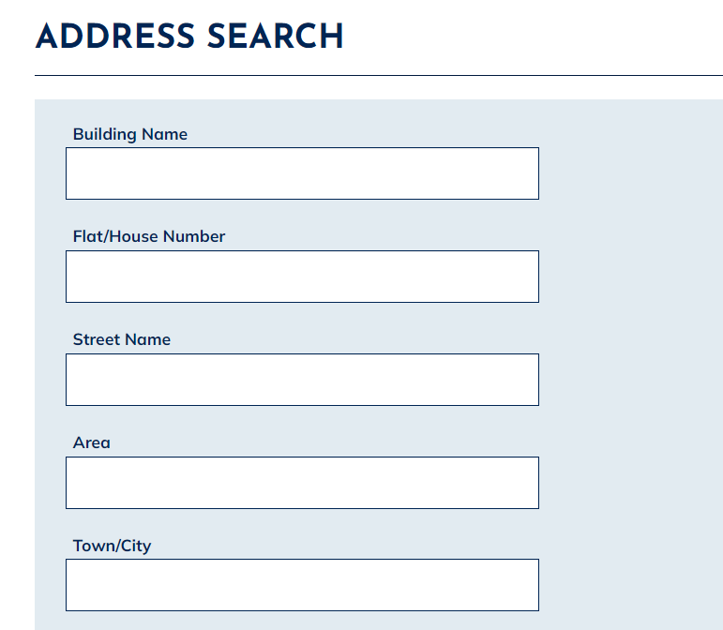

- Once you have selected ‘Search’, the ‘Address Search’ page will appear. Please scroll down to the bottom of the page. If the system does not recognise the address you have entered, you will see the screen as per below. Please select ‘Create Address’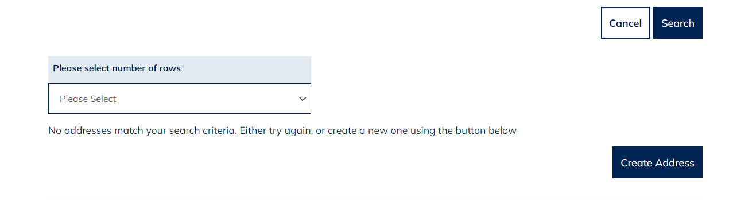

- The ‘Create Pending Address’ Page will show. From here, please check the address details you have entered and then select ‘Save’ 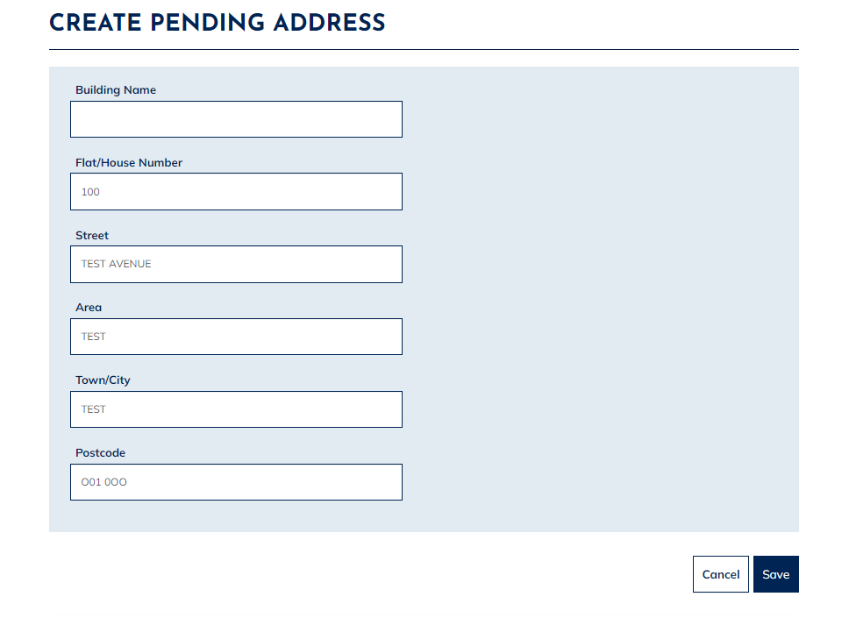

- You will now be returned to the ‘Update Application Address’ page. If this is your new address where you are currently living, please select ‘Yes’ from the drop down options list. If there are other members in your household and you wish to update their current address too, then select ‘Yes’ from the drop down options list under ‘Update other applicant addresses’. If it is only you that has changed address then select ‘No’ from the drop down options list. Enter the date in which you moved to this new address and then select ‘Submit’.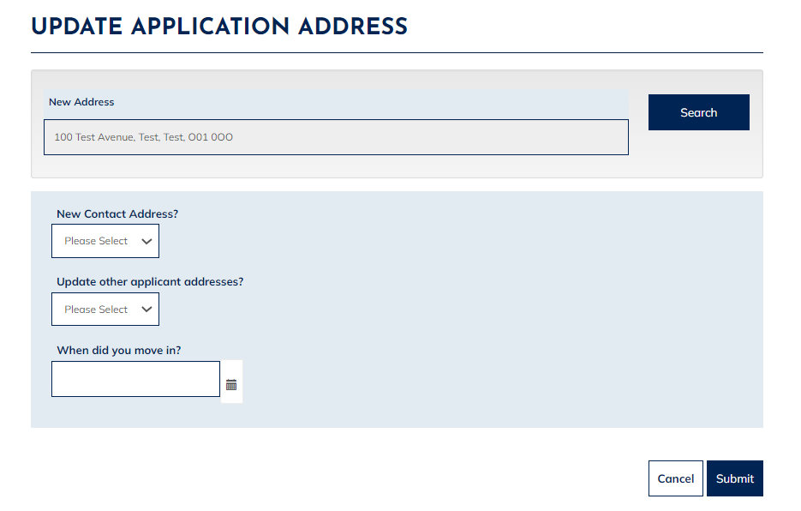

- The ‘View Application Address’ page will then show where you new address will be shown. Please note if your address has changed you will also need to update your application questions e.g. to confirm if you now have a landlord, new landlord details, different property type etc. As this can affect your banding, our Keychoices Team will need to check your new details and re-approve your application. If you have added a new address for you or any of your household members, please call Keychoices on 01709 336009 so they can verify your details.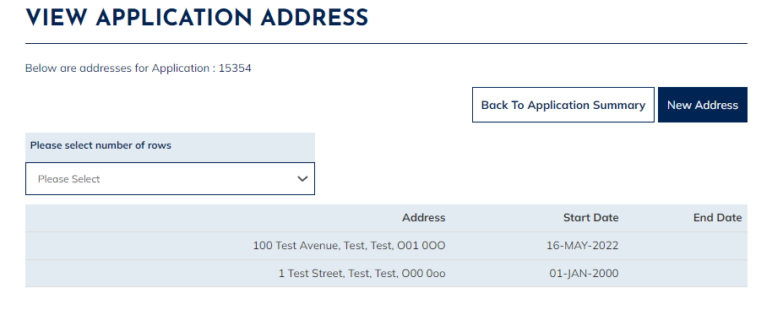

Update Contact Details
Once successfully logged in you will see the ‘My Summary’ page as per the below:
- The ‘My Summary’ page displays. From here select ‘Update My contact Details’
- The ‘Maintain Contact Detail’ page will show as per the below. From here you can add or amend your contact details. Please be aware that if you update your email address, this will automatically update your log in username to the new email address you have just entered. Once you have added/amended the contact information select ‘Update’.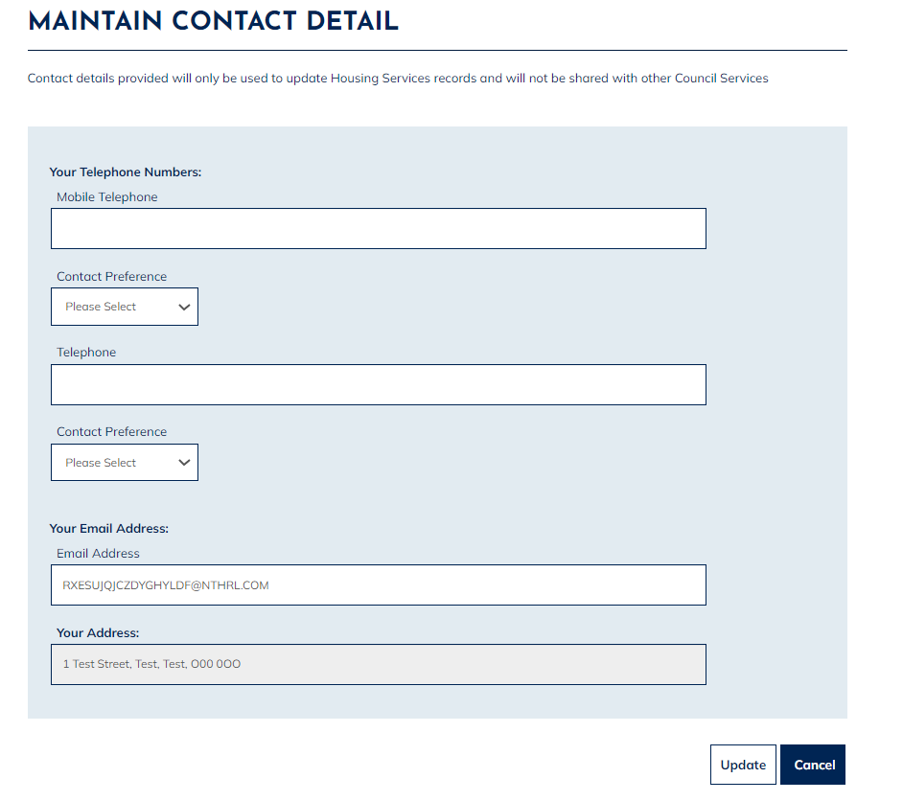
- Once you have clicked ‘Update’, a message will show to advise that your contact details have been updated successfully.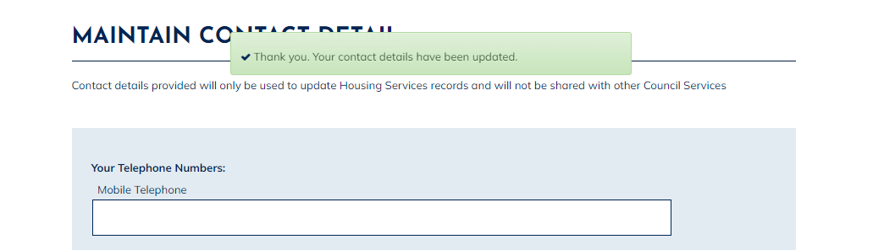

Amend Application Questions
Once successfully logged in you will see the ‘My Summary’ page as per the below:
- The ‘My Summary’ page displays. From here select ‘My Accepted Housing Applications’
- The ‘My Applications Summary’ page will show as per the below. From here select the ‘Actions’ option then select ‘Maintain Application Answers’.

- The ‘Maintain Application Answers’ page displays, scroll through the questions by selecting ‘Next’, then update the relevant answers you wish to update. Once you have done this, select ‘Submit’. 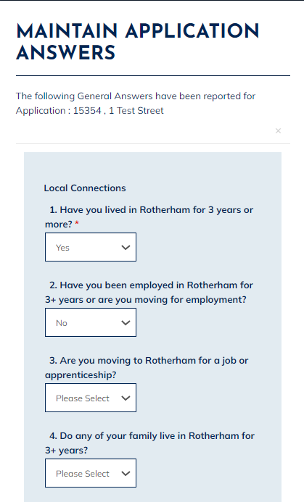

- The ‘Application Summary’ page will then show. Your housing application will go into ‘Pending Status’. You will need to contact Keychoices on 01709 336009 so they can re-assess your housing application to ensure this has not affected your banding and/or eligibility.

Upload a Document to a Saved Application
Once successfully logged in you will see the ‘My Summary’ page as per the below:
- The ‘My Summary’ page displays. From here select ‘My Saved Housing Applications’
- The ‘My Applications’ page displays, this will show your current saved Housing Applications. Select the ‘Actions’ menu then select ‘Upload Documents’.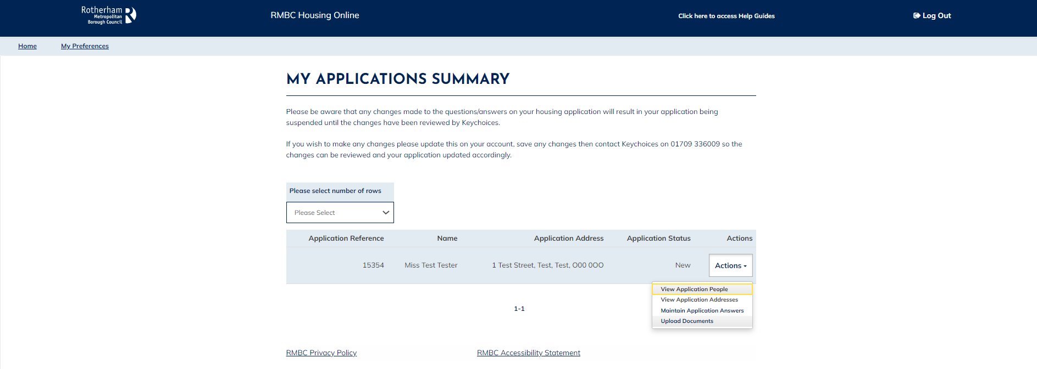

- The ‘Upload Documents and Files’ page will show as per the below: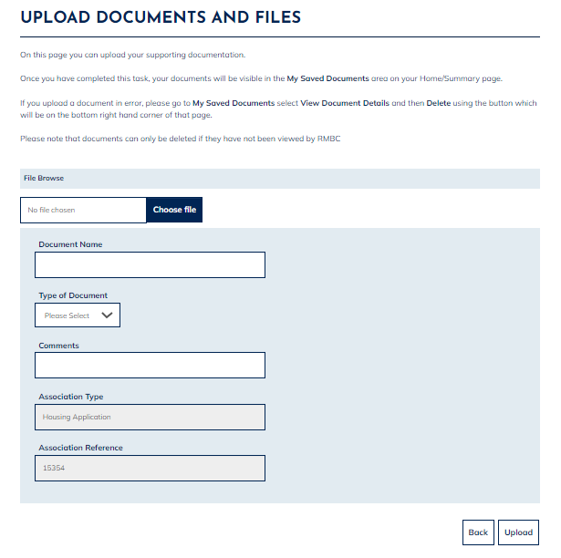

- From here select ‘Choose File’ which will then take you into your personal device storage where you will be able to select the document or photo you wish to upload.

- Once selected this will then populate into the File field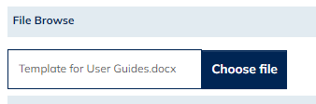

- Please enter a document name (please keep this short). Select the type of document you are attaching. You can add additional information into the ‘Comments’ field if you wish. Once you have entered the required details, select ‘Upload’.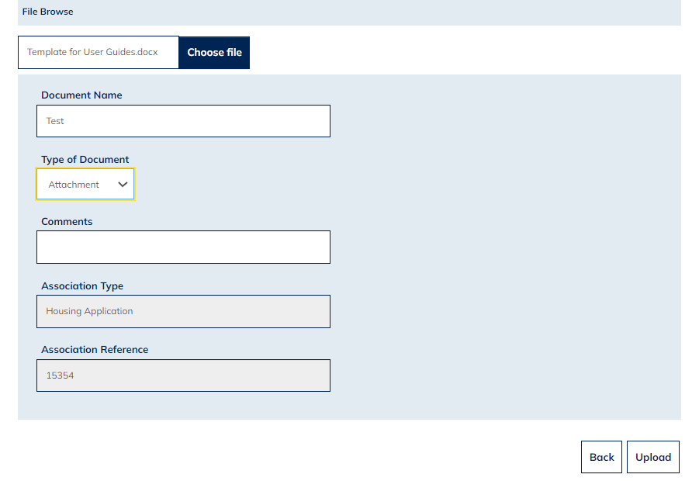

- Please note that once you have clicked ‘Upload’ you will not see a message to confirm your document has uploaded successfully. If you wish to check if your document has uploaded successfully, you can do this by returning to the ‘My Summary’ page then selecting ‘My Saved Documents’. Any documents you have uploaded will be visible here.

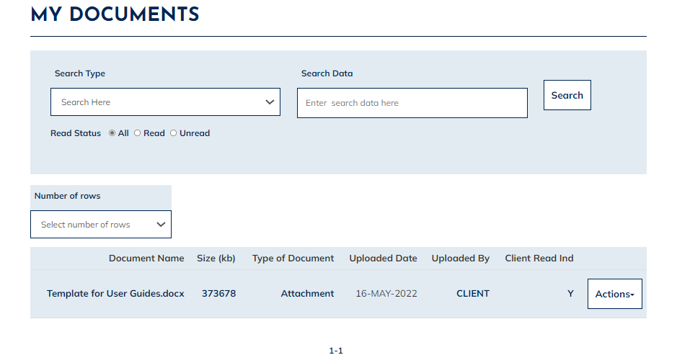

Upload a Document to an Accepted Application
Once successfully logged in you will see the ‘My Summary’ page as per the below:
- The ‘My Summary’ page displays. From here select ‘My Accepted Housing Applications’
- The ‘My Applications’ page will show from where you will be able to see your current Housing Application. Select the ‘Actions’ menu then select ‘Upload Documents’.

- The ‘Upload Documents and Files’ page displays:

- From here select ‘Choose File’ which will then take you into your personal device storage where you will be able to select the document or photo you wish to upload.

- Once selected this will then populate into the File field

- Please enter a document name (please keep this short). Select the type of document you are attaching. You can add additional information into the ‘Comments’ field if you wish. Once you have entered the required details, select ‘Upload’

- Please note that once you have clicked ‘Upload’ you will not see a message to confirm your document has uploaded successfully. If you wish to check if your document has uploaded successfully, you can do this by returning to the ‘My Summary’ page then selecting ‘My Saved Documents’. Any documents you have uploaded will be visible here.

Delete a Document
Once successfully logged in you will see the ‘My Summary’ page as per the below:
- The ‘My Summary’ page displays. From here select ‘My Saved Documents’
- The ‘My Documents’ page will display, showing any documents/photos that you have uploaded via your Housing Online account
- If you wish to view a document, select the ‘Actions’ option and then select ‘View Document’.
- If you wish to delete the document, select the ‘Actions’ option and then select ‘View Document Details’.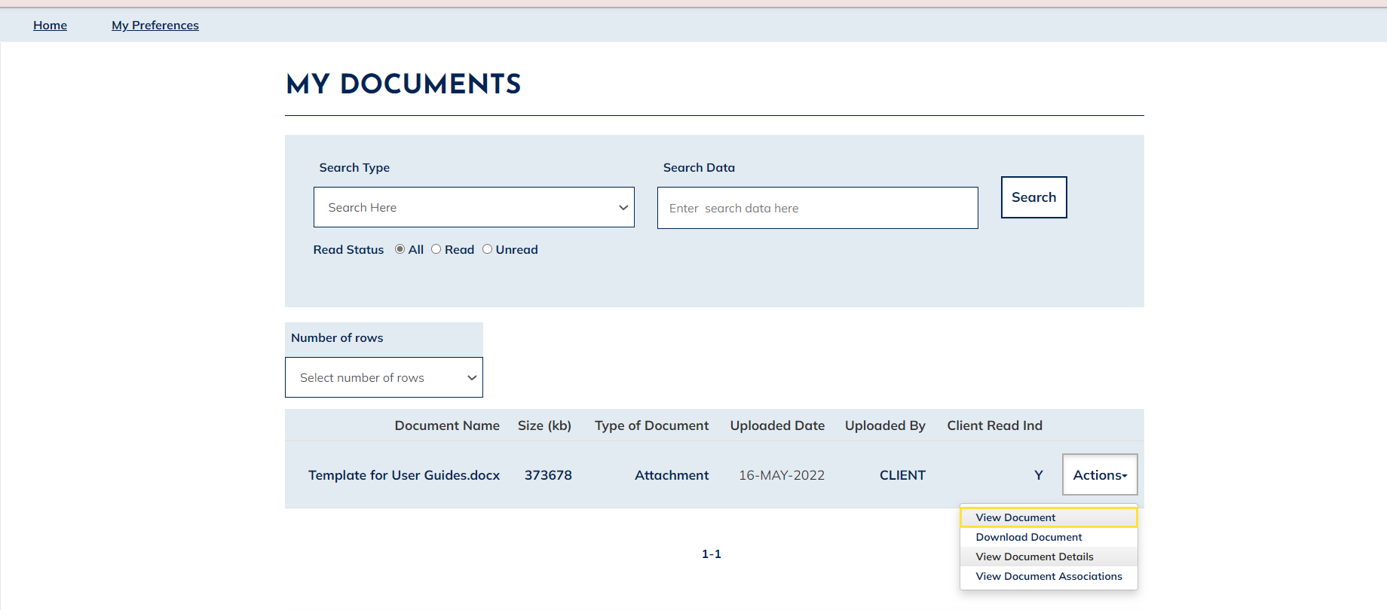
- The ‘View document details’ page will be shown as per the below 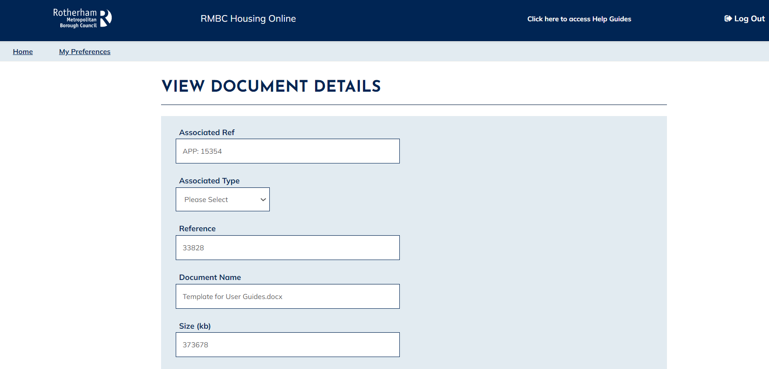
- If you wish to delete the document, please scroll to the bottom of the page and select ‘Delete’. Please note you will not be asked to confirm you wish to delete a document 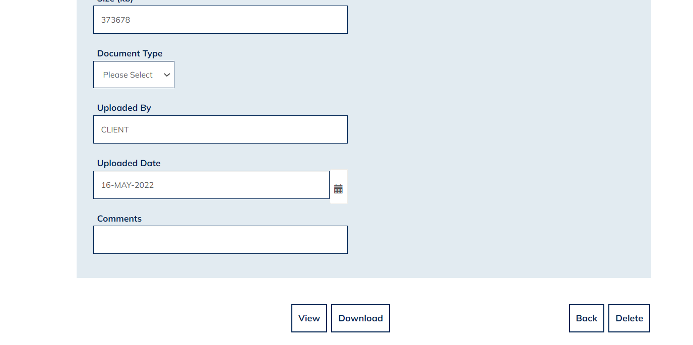
- Once you have selected ‘Delete’ (if this does not register the first time, please click ‘Delete’ again) a message will show in green to advise you that the document has been successfully deleted. You can only delete a document from your housing online account if our staff have not viewed the document already. If this is the case and you wish to delete a document, please contact Keychoices.
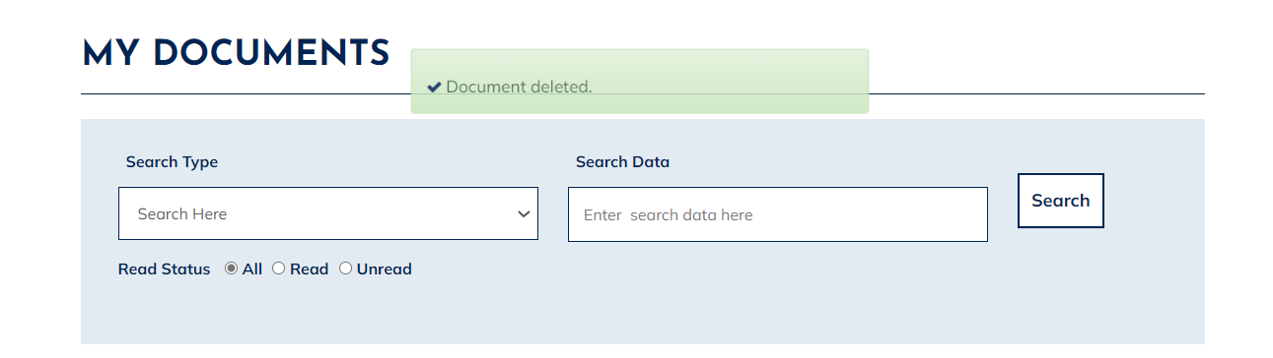

Place a Bid
Once successfully logged in you will see the ‘My Summary’ page as per the below:
- The ‘My Summary’ page displays. From here select ‘Choice Based Lettings’
- The ‘Choice Based Lettings’ welcome page will show: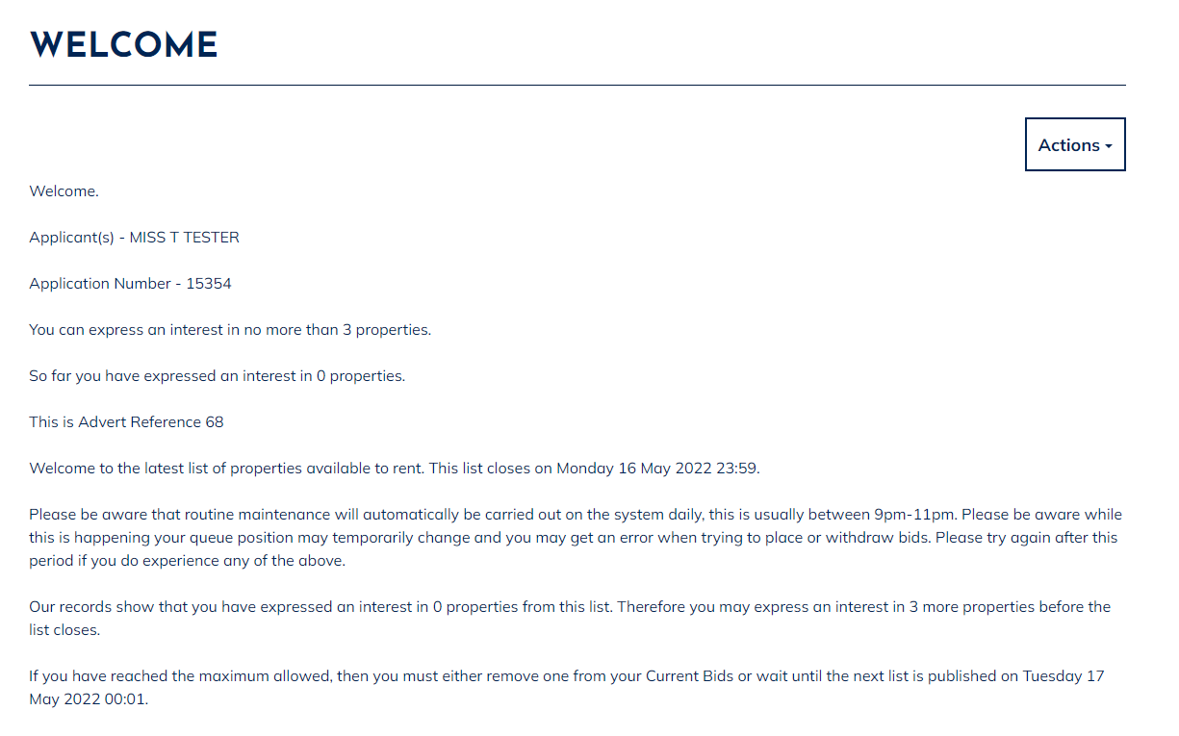
- From here select the ‘Actions’ menu then select ‘List of Available Properties’

- The current list of available properties will now show as per the example below: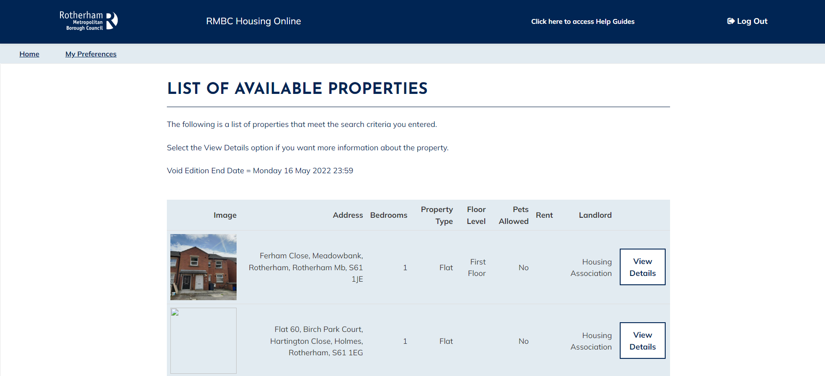

- To view more details on any property or to place a bid, please select ’View Details’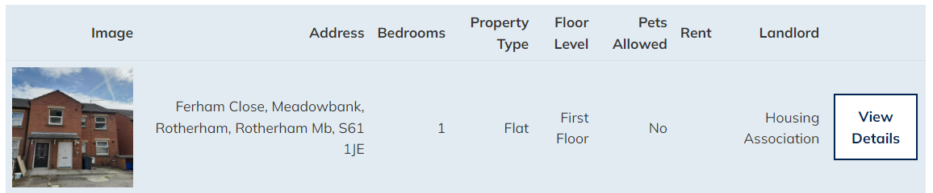

- This will display all the information relating to the property being advertised such as rent, additional charges, any adaptations and number of bedrooms etc 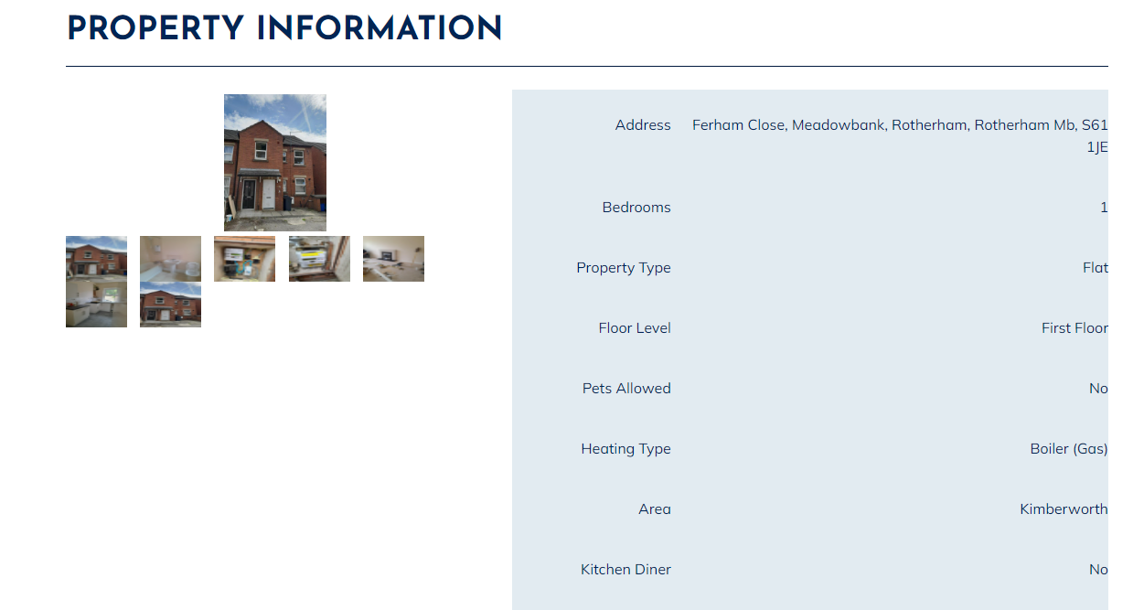

- If you wish to place a bid/apply for the property, you will need to scroll down the page then select ‘Add to Basket’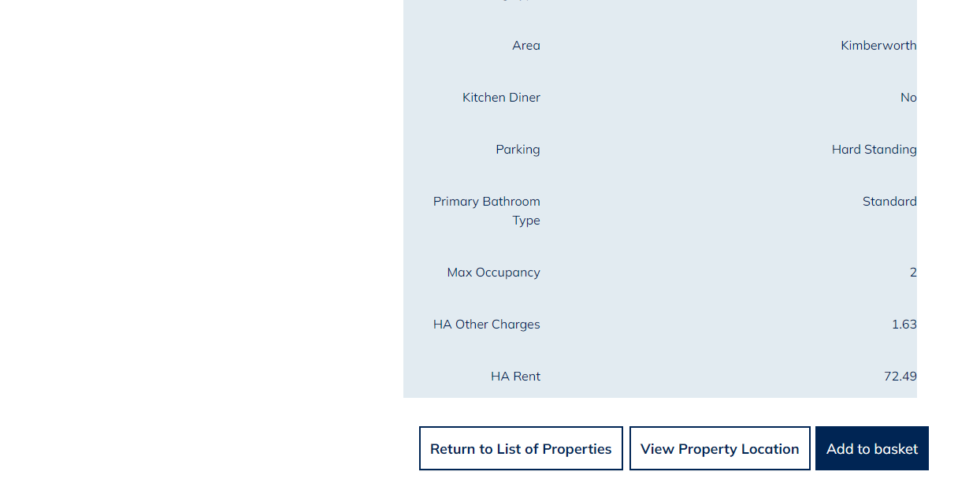

- The ‘Property Successfully Added to Basket’ page will then show 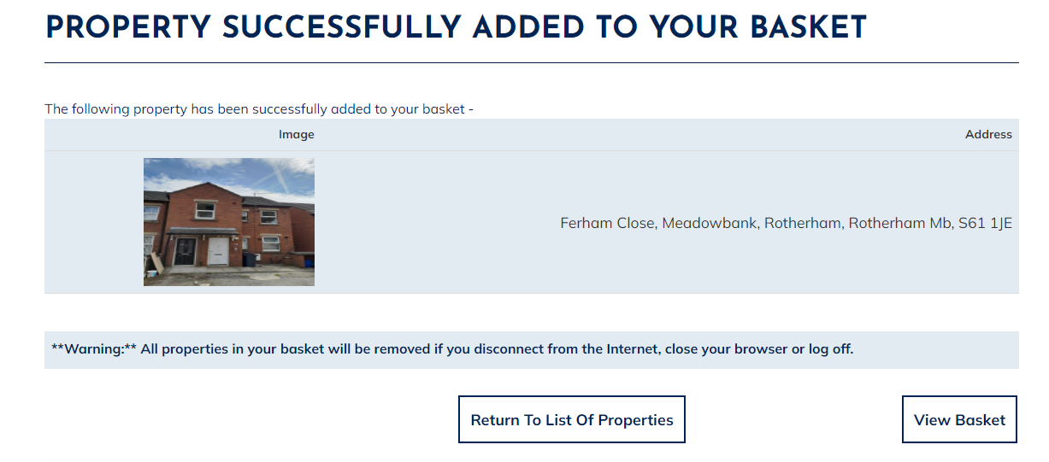

- If you wish to bid/apply for other properties or view other properties you are eligible for before submitting your bid, please select ‘Return to List of Properties’ and follow the above steps for adding the property to your basket (remember; you can only bid/apply for a maximum of 3 properties during this advert cycle).

- If you only wish to bid on the one property or have successfully added the properties you are interested in, then select ‘View Basket’.

- Your ‘Basket’ will then show as per the below: 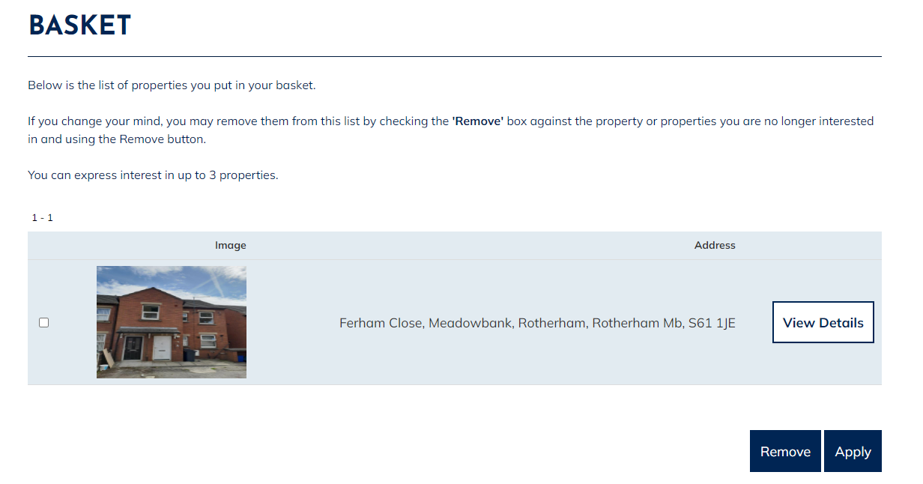

- If you only have the correct number of properties in your basket e.g. you have 3 bids remaining and you have 3 properties in your basket OR there is only 1 property you wish to bid on and this is in your basket - scroll down the page and select the ‘Apply’ option

- If you have properties in your basket you no longer wish to bid on/apply for, or you have too many properties in your basket for the number of bids you have left. Tick the box next to the properties you wish to remove from your basket then scroll down and select ‘Remove’.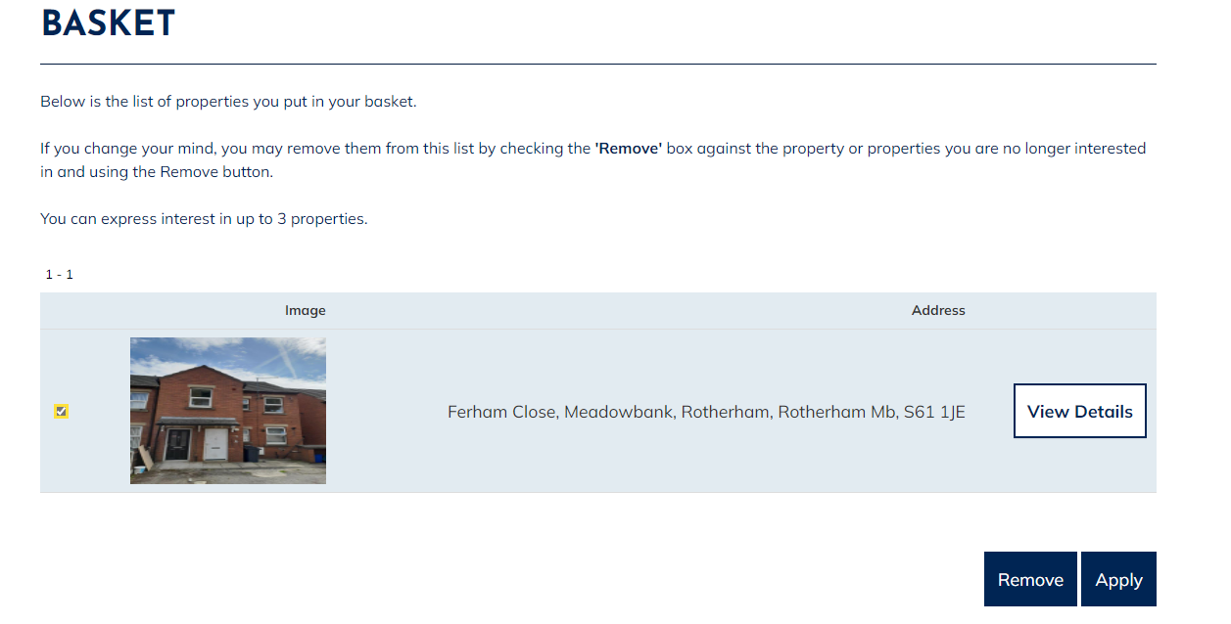

- Once you have selected ‘Apply’ from your basket, a page will show which will confirm that the bids have been successfully placed for those properties, as per the example below: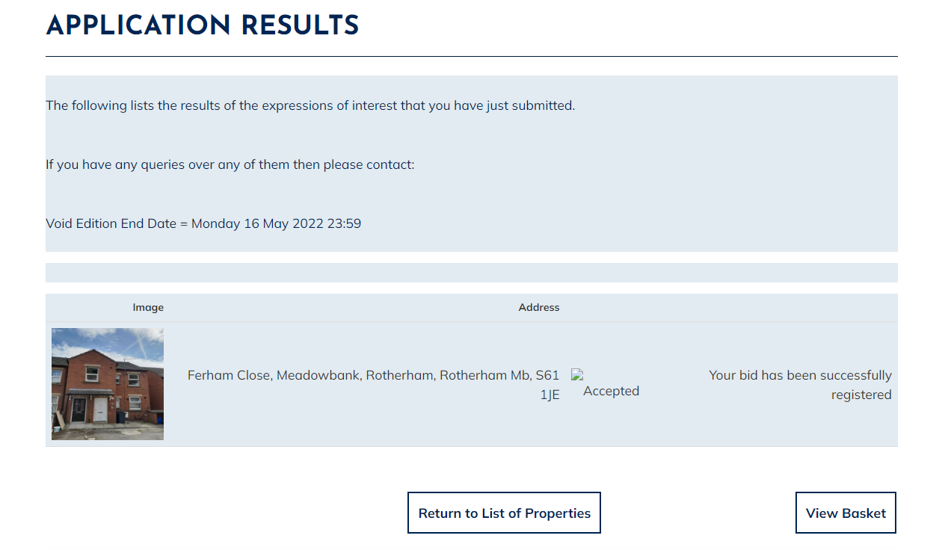

How to View Current Bids and Queue Positions
Once successfully logged in you will see the ‘My Summary’ page as per the below:
- The ‘My Summary’ page displays. From here select ‘Choice Based Lettings’
- The ‘Choice Based Lettings’ welcome page displays:
- From here select the ‘Actions’ menu then select ‘Current Expressions of Interest’.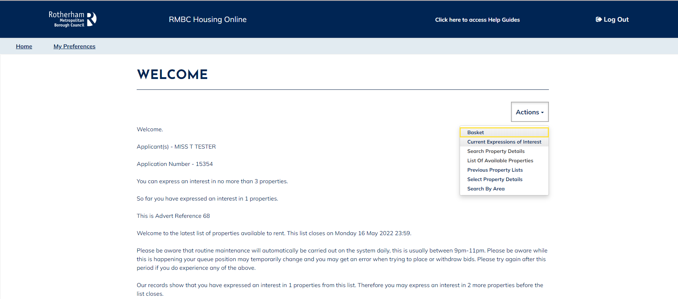

- From here you can view your current queue position for any properties you have bid on. You can also view details of the property you have bid on by clicking on the property photo.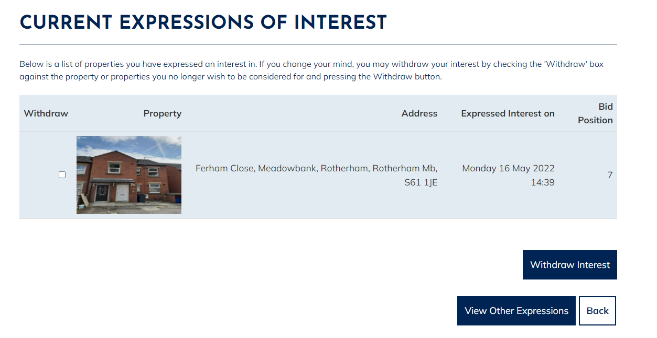

Withdraw a Bid
Once successfully logged in you will see the ‘My Summary’ page as per the below:
- The ‘My Summary’ page displays. From here select ‘Choice Based Lettings’
- The ‘Choice Based Lettings’ welcome page shows
- From here select the ‘Actions’ menu then select ‘Current Expressions of Interest’.

- The ‘Current Expressions of Interest’ page displays as per the example below.

- To withdraw your bid/interest from a property you have bid on, simply tick the box next to the property you wish to remove the bid for then select the ‘Withdraw Interest’ option

- You will then be taken back to the ‘Current Expressions of Interest’ page where the property/bid will be removed and will no longer show. The number of bids you have remaining for this advert cycle will automatically update. If you have no current bids, the page will display blank, as per the example below: