Housing Online – Re-Housing Application User Guides
This guide specifically relates to registering as a new tenant and logging in as an existing Tenant. Should you need help finding your way around other parts of your Housing Online account, please refer to the All User Guides section which you can access by clicking here

Contents Page Number
Create an Account as an Existing Tenant | 2
Create an Account as a new Tenant | 19

Create an Account as an Existing Tenant
- Select the Housing Online link to open the Log In page as per the below:
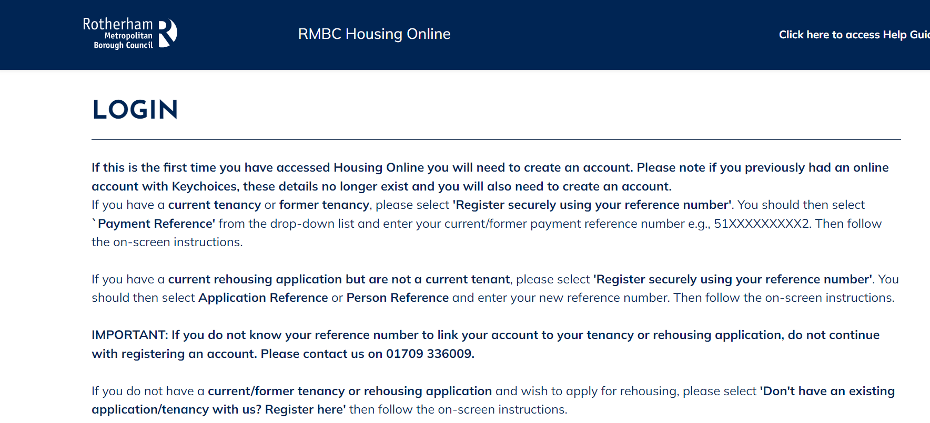

- Scroll down the page to the ‘Login to your account’ section 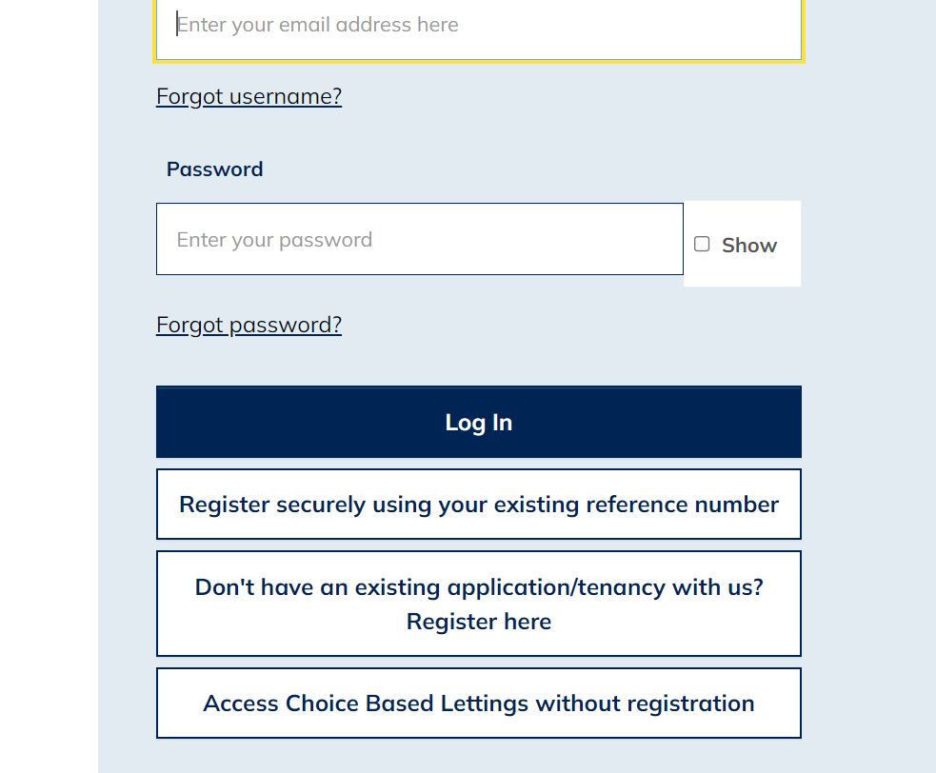
- Select the ‘Register securely using your existing reference number’ option

- The ‘Register’ page will display as shown below: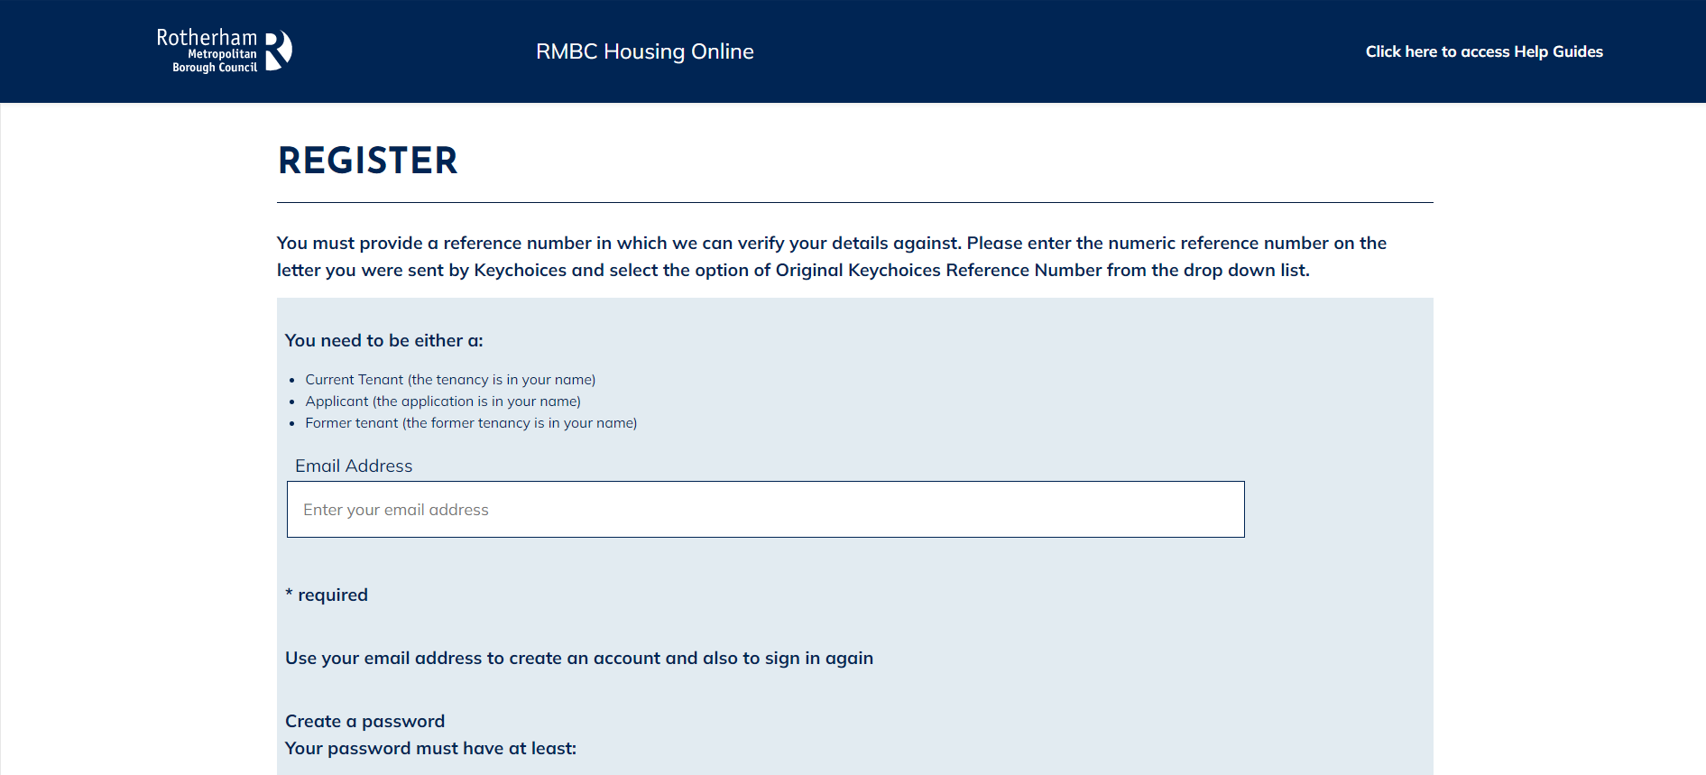

- Carefully enter your current email address and then create a password. When you’ve done this select Next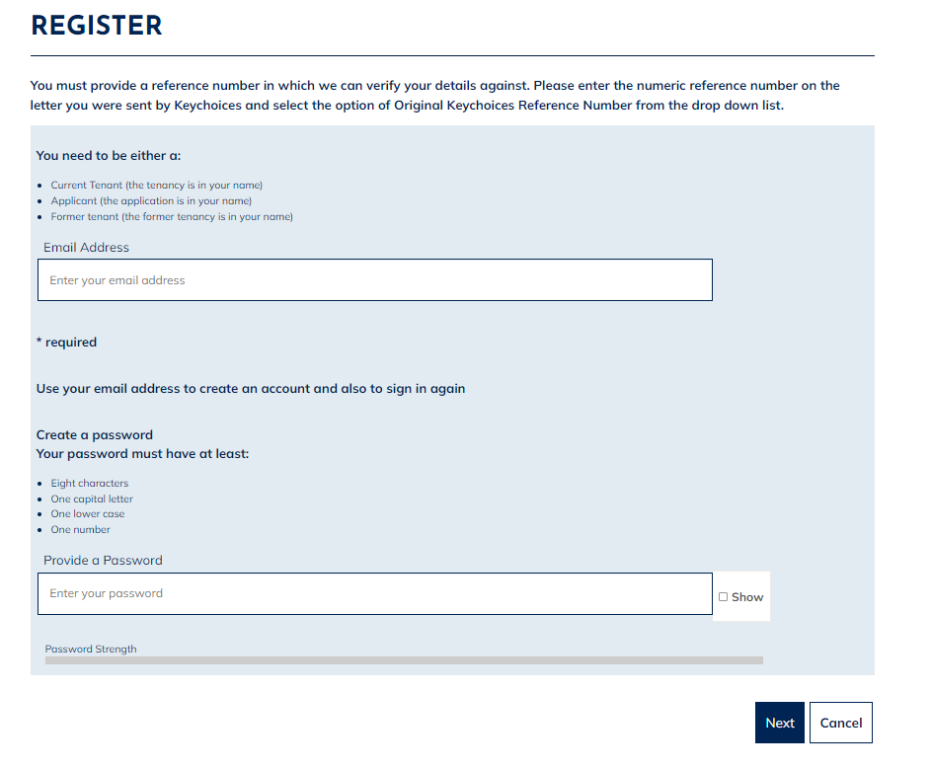

- Having selected Next, the following page will display – asking you to check your email inbox. A registration email should arrive within a few minutes. Check your junk folder if you have not received an email. If you do not receive an email, follow the above steps again to ensure no errors were made when entering your email address. 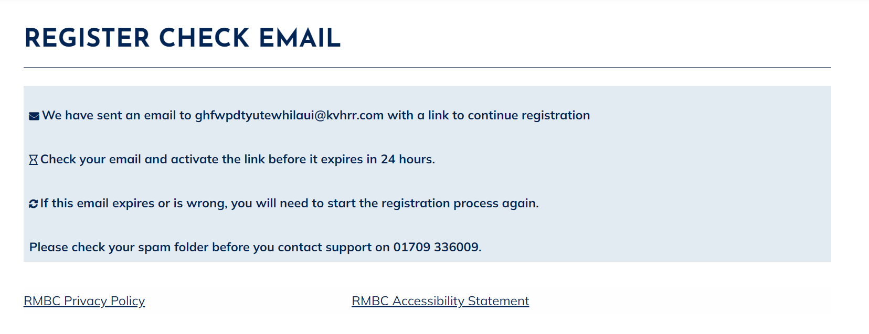

- Open the email and select the ‘Verify Me’ link. Please note this is a one time only link, therefore if you click on the link and do not complete the process the link will no longer be valid and you will have to start the registration process again.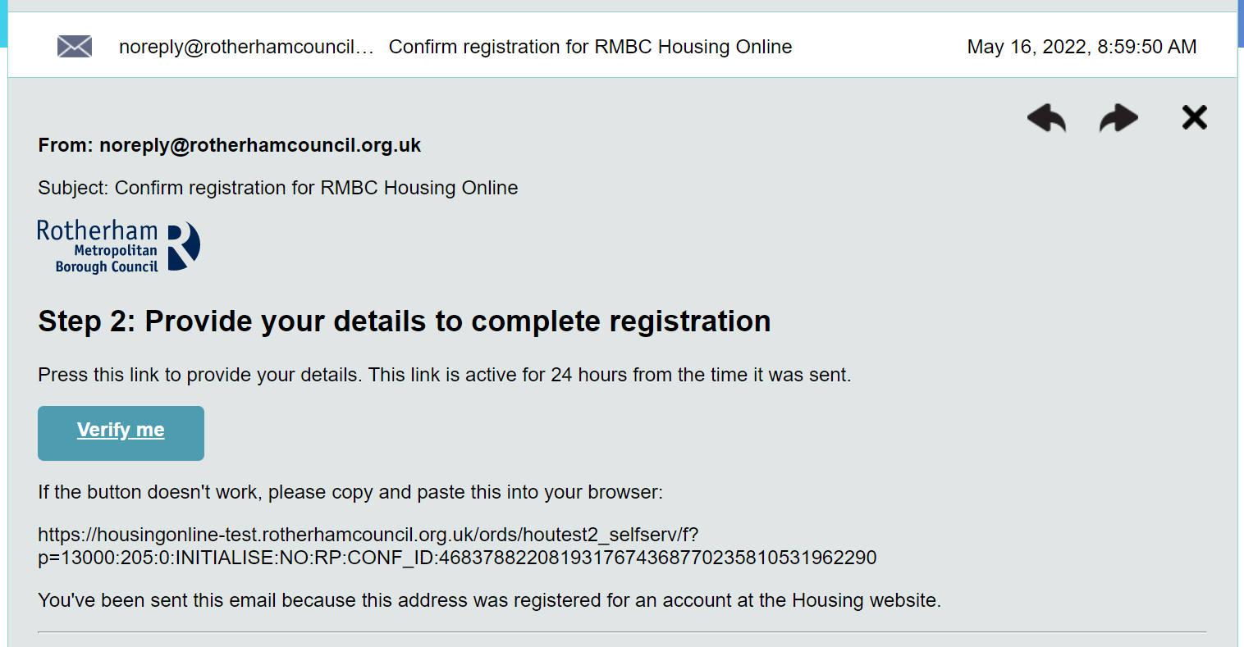

- After selecting the ‘Verify Me’ link from your email, the following page will display: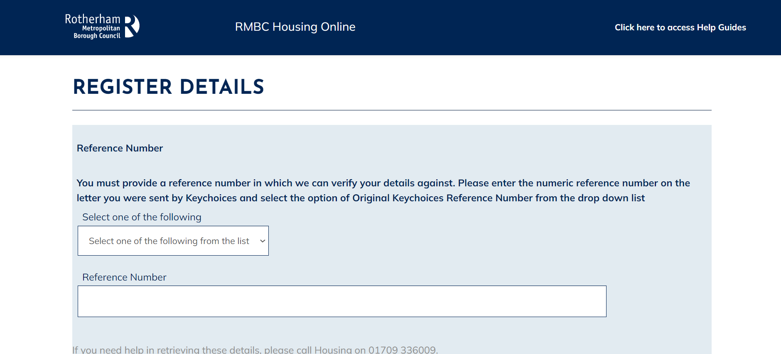

- Select Person Reference or Application Reference (if you are an exisiting Rotherham Council tenant you also have the option to select Payment Reference and enter your rent account reference number). Once you have selected an option, please enter the correct reference number to match the option you have selected.

If you create an account using the incorrect reference number or register as a new applicant, your account will not link to your existing application and/or details. If you do not know your reference number, please call us on 01709 336009.
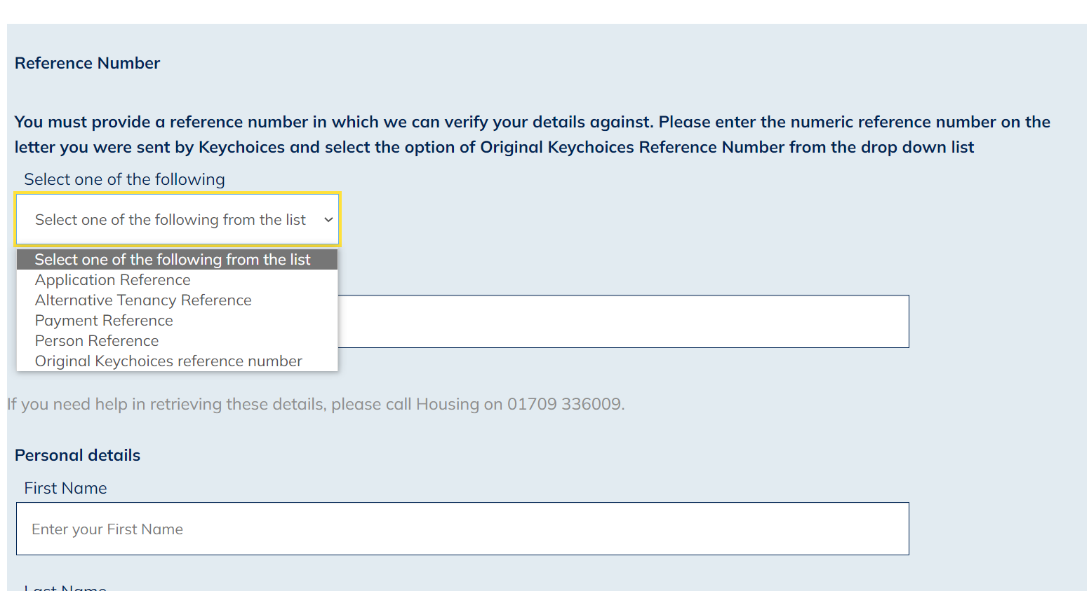

- Once you have entered your reference number, you will then need to scroll down the page to enter your First Name, Last Name and Date of Birth.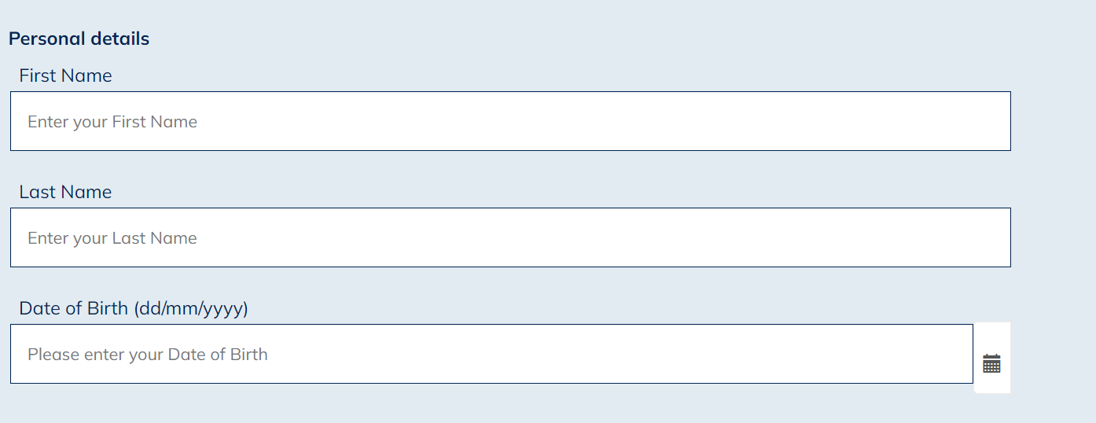

- After you have entered your name and date of birth, scroll down and select a memorable question from the drop-down list and enter a memorable answer.

- Then enter your memorable date in the format DD/MM/YYYY. You will need this information should you need to re-set your password in the future.

- Once you have done this, confirm you accept the terms and conditions of use by selecting Yes from the drop-down list.

- Finally select finish which you will find at the bottom right corner of the screen.

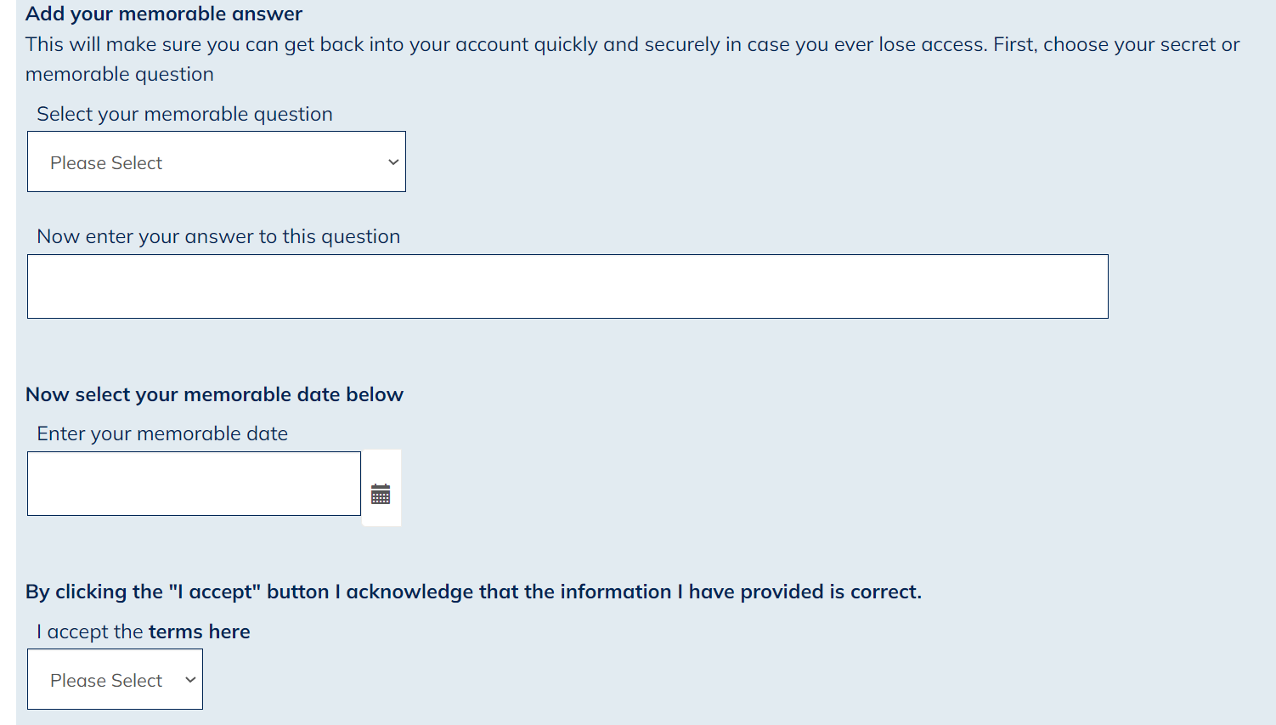

- Once successfully registered you will see the following confirmation: 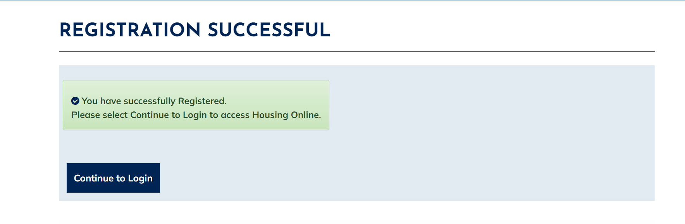
- Select the ‘Continue to Login’ option

- You will be re-directed to the log in page. Enter your email address and password then select Log In: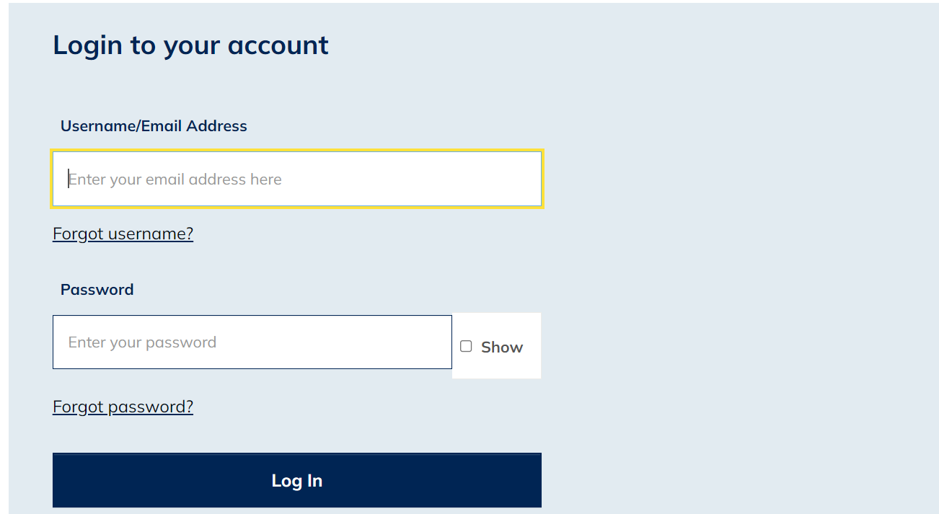

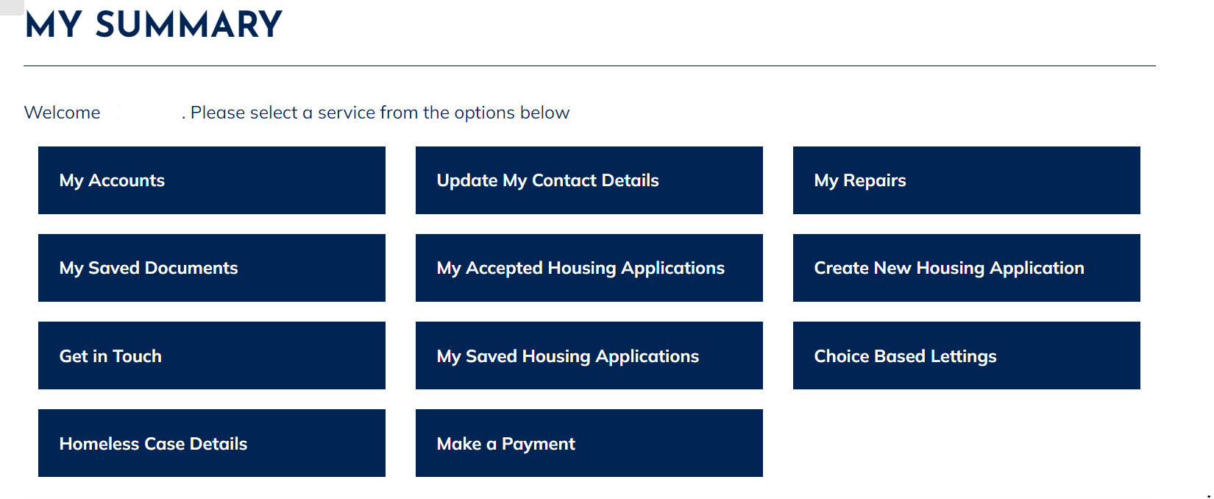
- You will now be logged into your Housing Online account and will be able to see the My Summary page as shown below:

Create an Account as a New Tenant

- Select the Housing Online link to open the Log In page as per the below: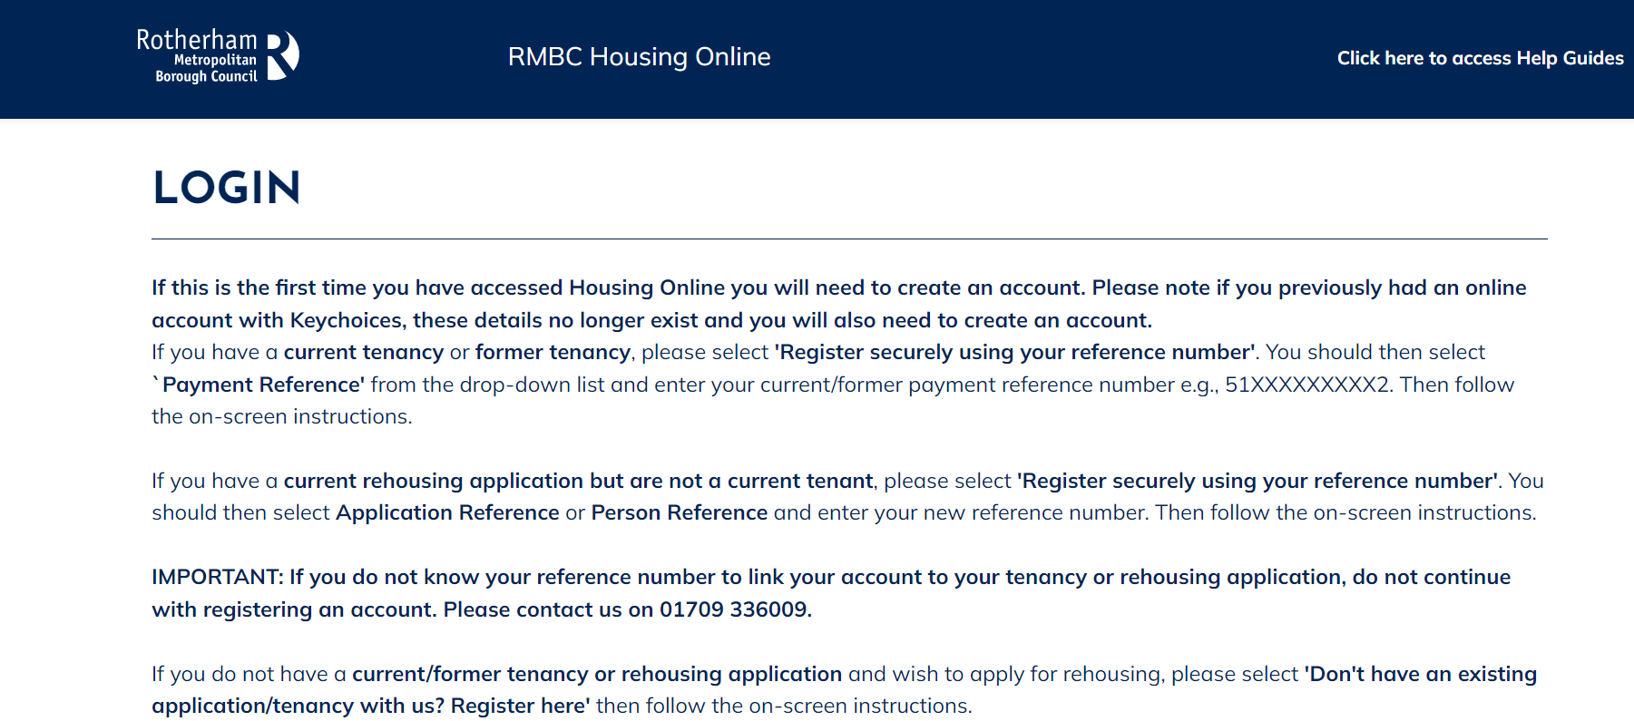

- Scroll down the page to the ‘Login to your account’ section 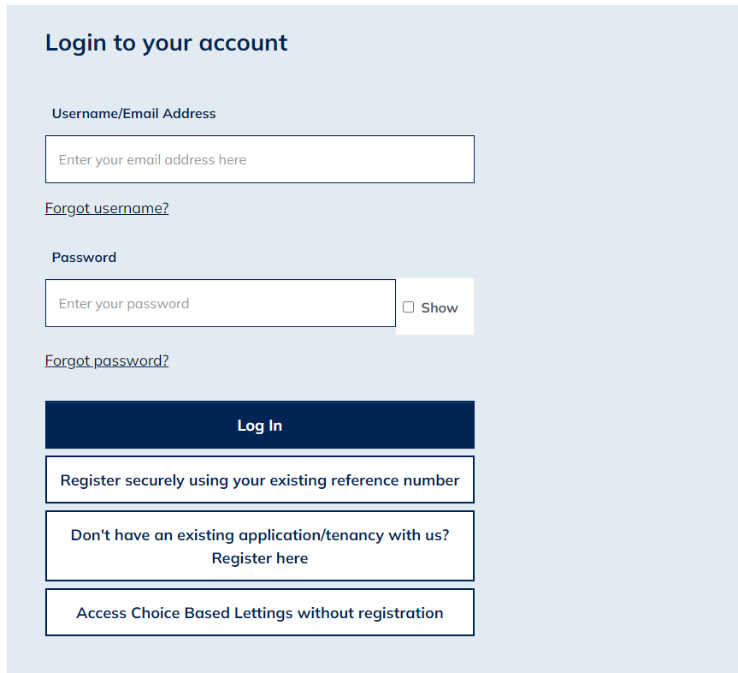

- Select the ‘Don’t have an existing application/tenancy with us? Register here’ option

- You will be re-directed to the ‘Register as a New Client’ page. Please enter your current email address and create a password. Once you have entered these details select the Next button at the bottom of the page.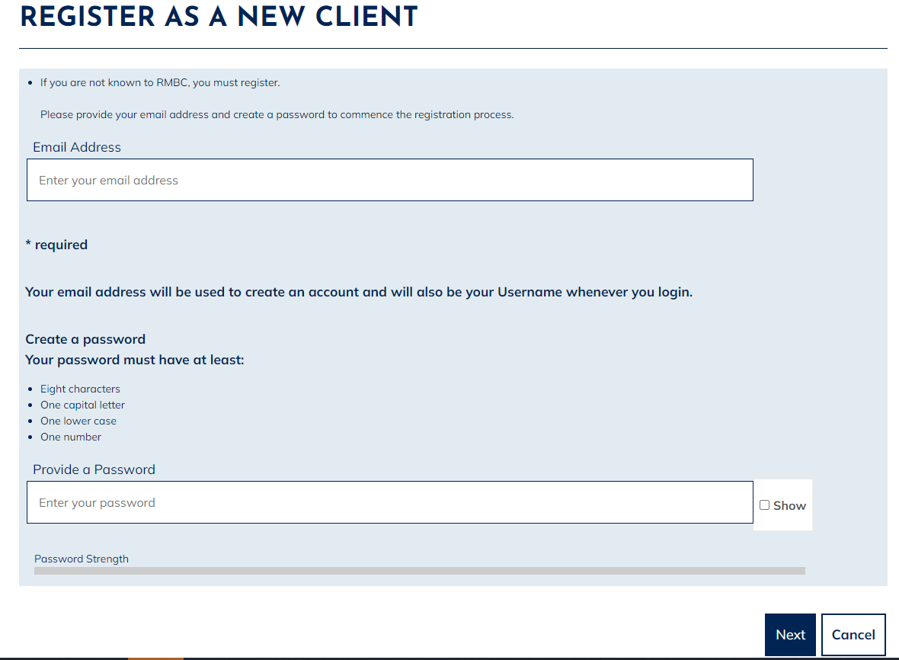

- Having selected Next, the following page will display – asking you to check your email inbox. A registration email should arrive within a few minutes. Check your junk folder if you have not received an email. If you do not receive an email, follow the above steps again to ensure no errors were made when entering your email address. 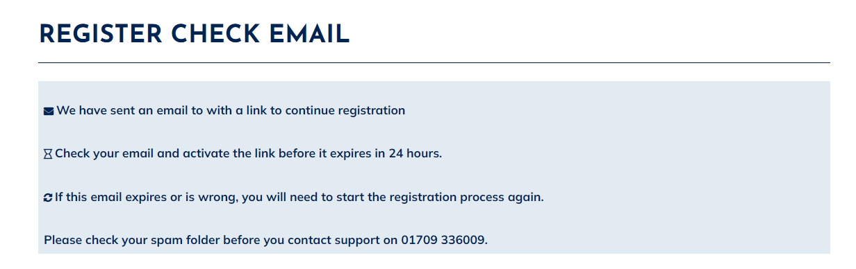

- Open the email and select the ‘Verify Me’ link. Please note this is a onetime only link, therefore if you click on the link and do not complete the process the link will no longer be valid, and you will have to start the registration process again.

- After selecting the ‘Verify Me’ link from your email, the following page will display: 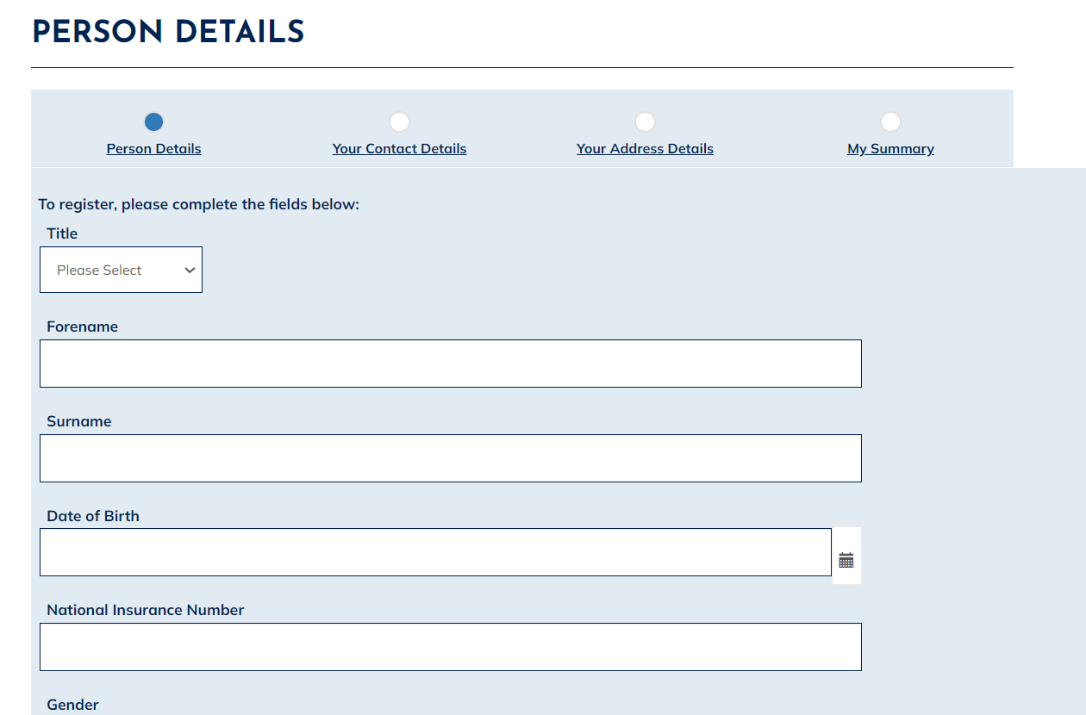

- From here, enter your details into the relevant fields

- Scroll down and select a memorable question from the drop-down list and enter a memorable answer.

- Then enter your memorable date in the format DD/MM/YYYY. You will need this information should you need to re-set your password in the future.

- Once you have done this, please confirm the information you have provided is correct by ticking the box, then select the Next button to the bottom right corner of the screen

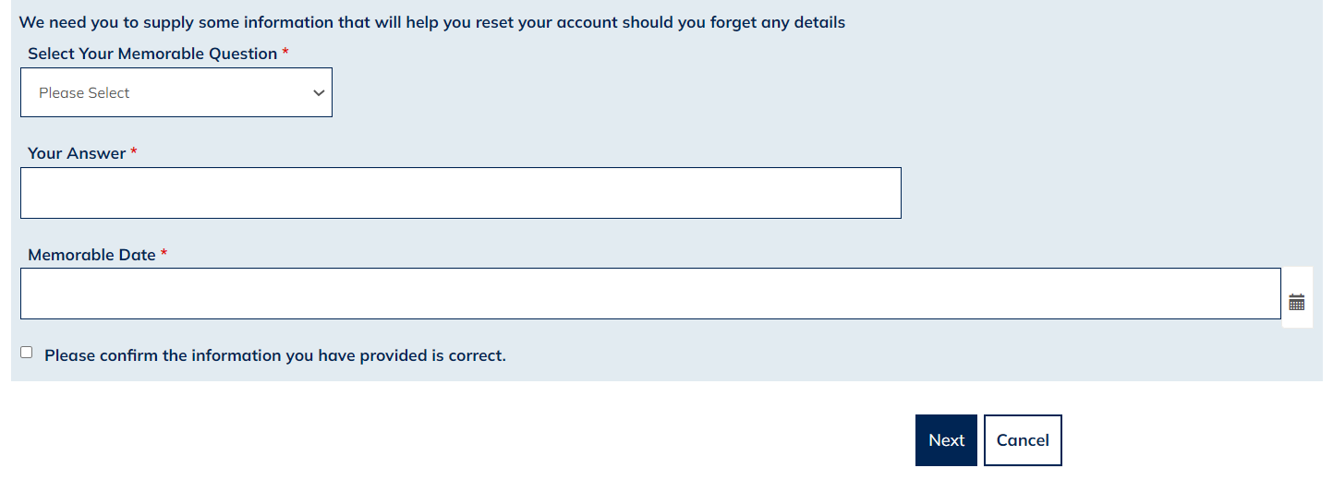

- Your Contact Details page will display, as shown below. Please carefully enter your up-to-date contact details then select Next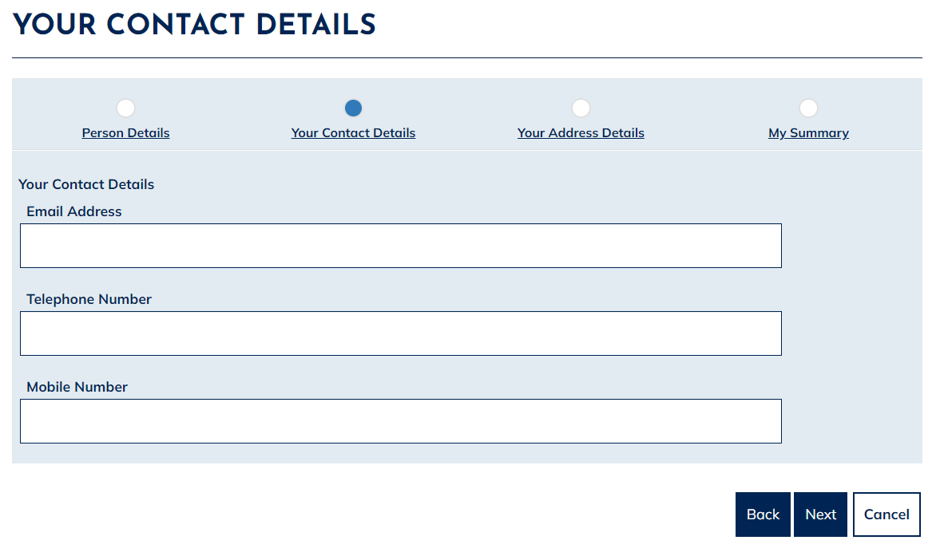

- The ‘Your Address Details’ page will display, as shown below. Select the ‘Add Address’ option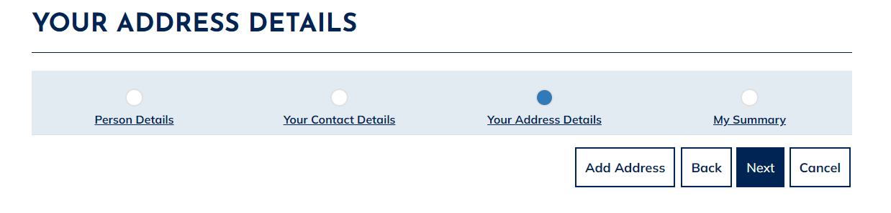

- The ‘Add Address Details’ page will now display. Please enter your full address, entering the date of when you moved into the property and a date you left the property (if applicable), scroll down, and select Finish. Please note: you MUST supply a full five year address history. Therefore if you have not lived at your current address for five year or more, you will need to ‘Add Address’ for each address you have lived at within the last five years. If you have been no fixed address for a period in the last five years please enter a care of address or ‘No Fixed Address’ in the address fields listed.There should be no gaps in your five year address history.

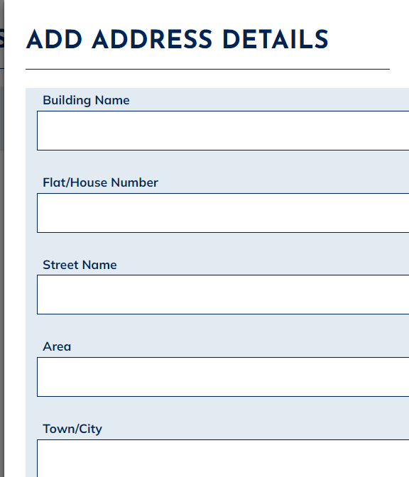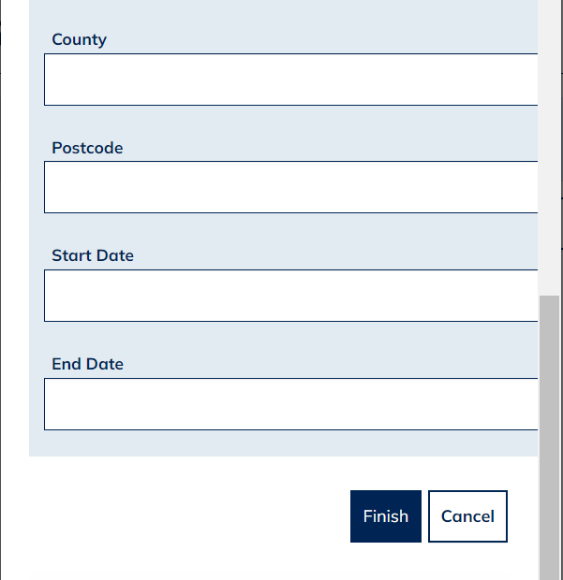

- Once you have entered your full five-year address history, please select Next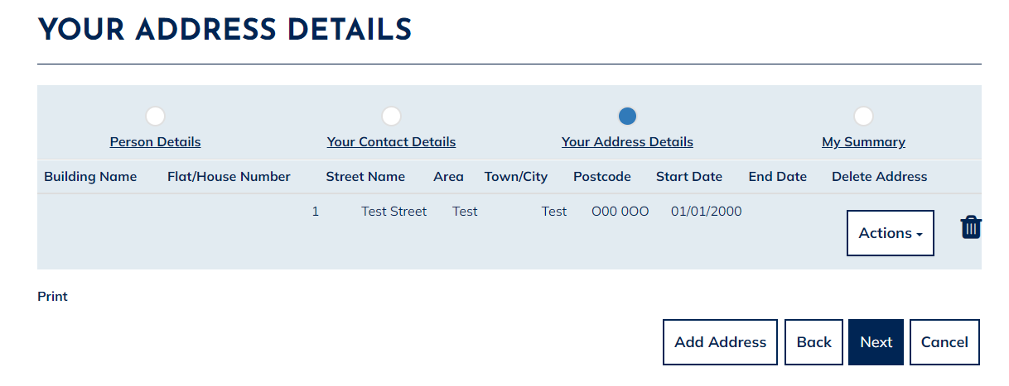
- The following ‘My Summary’ page displays, as shown below. Please check that all the details you have entered are correct, then select Finish at the bottom of the page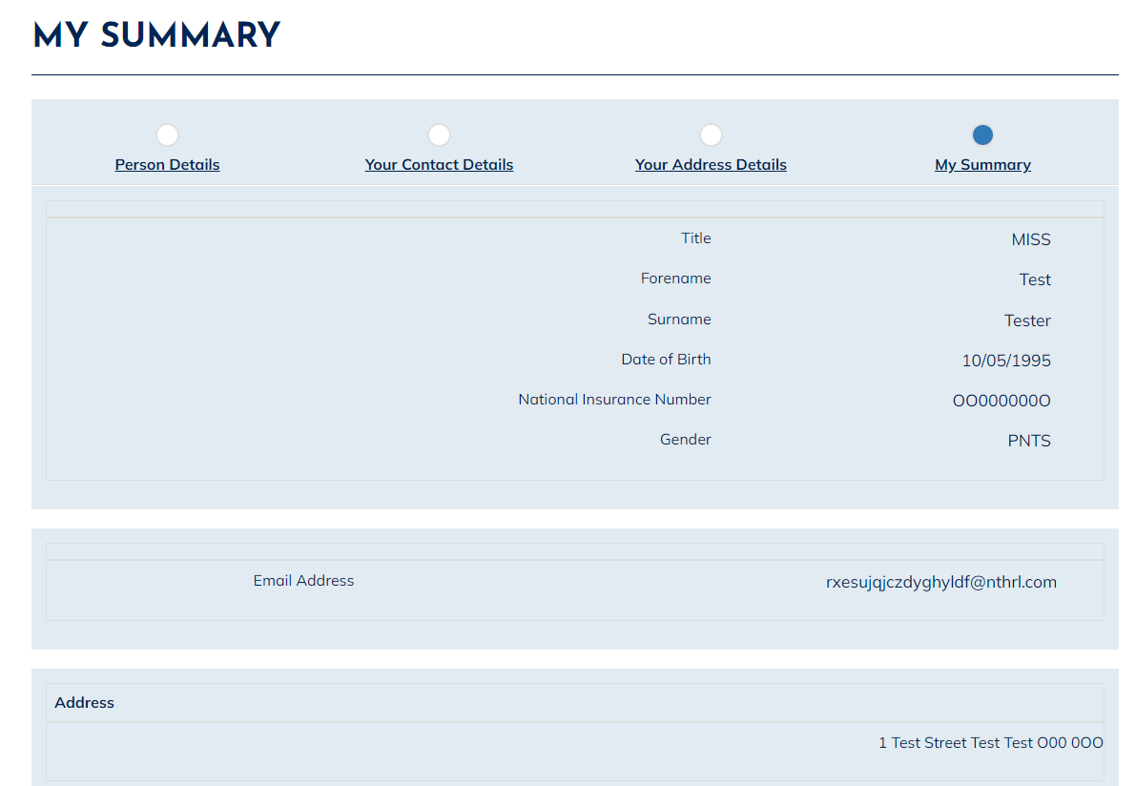

- A message will display, as shown below, to advise you that you have successfully registered your Housing Online account. Click Continue to Login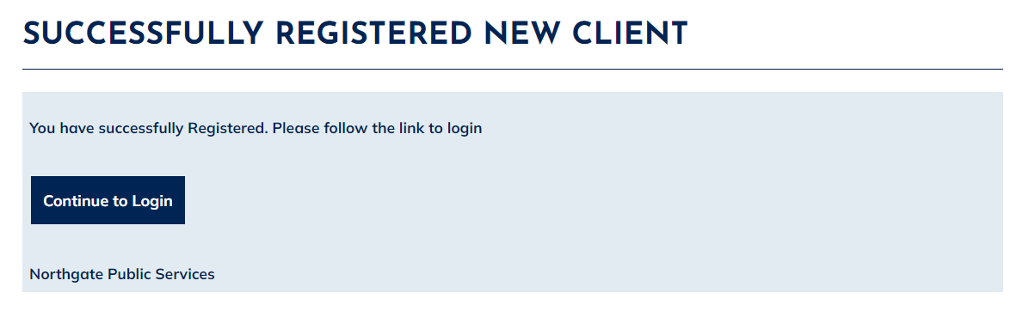

- Enter your email address and password, then select Log In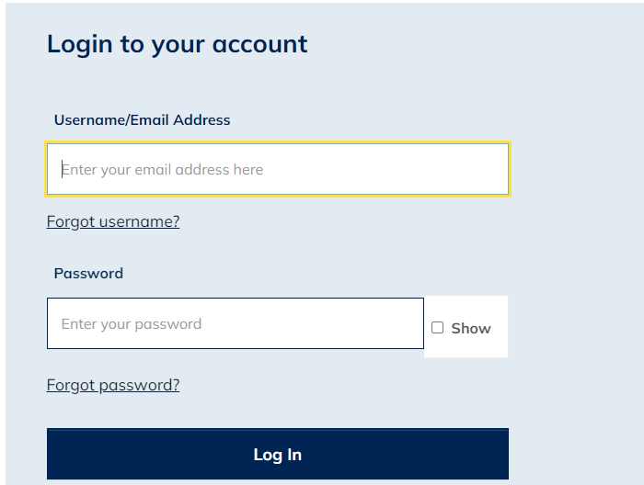

- The ‘My Summary’ page will display, as shown below. From here, select ‘Create New Housing Application’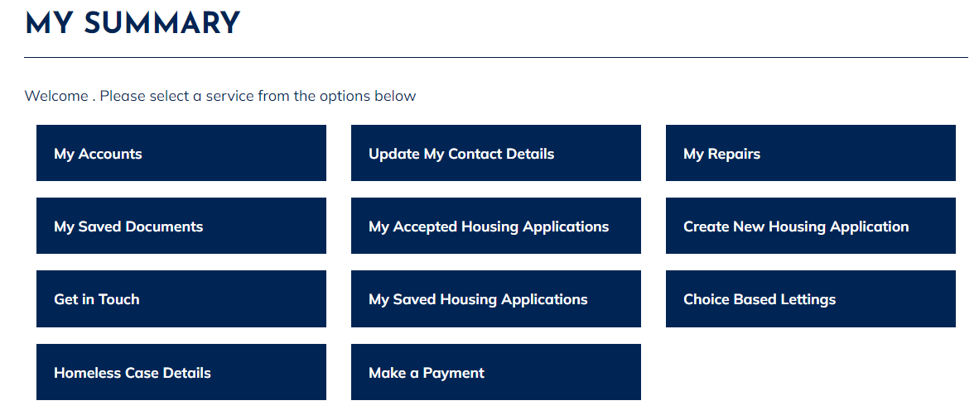

- The ‘Housing Application Form Home’ page displays, as shown below: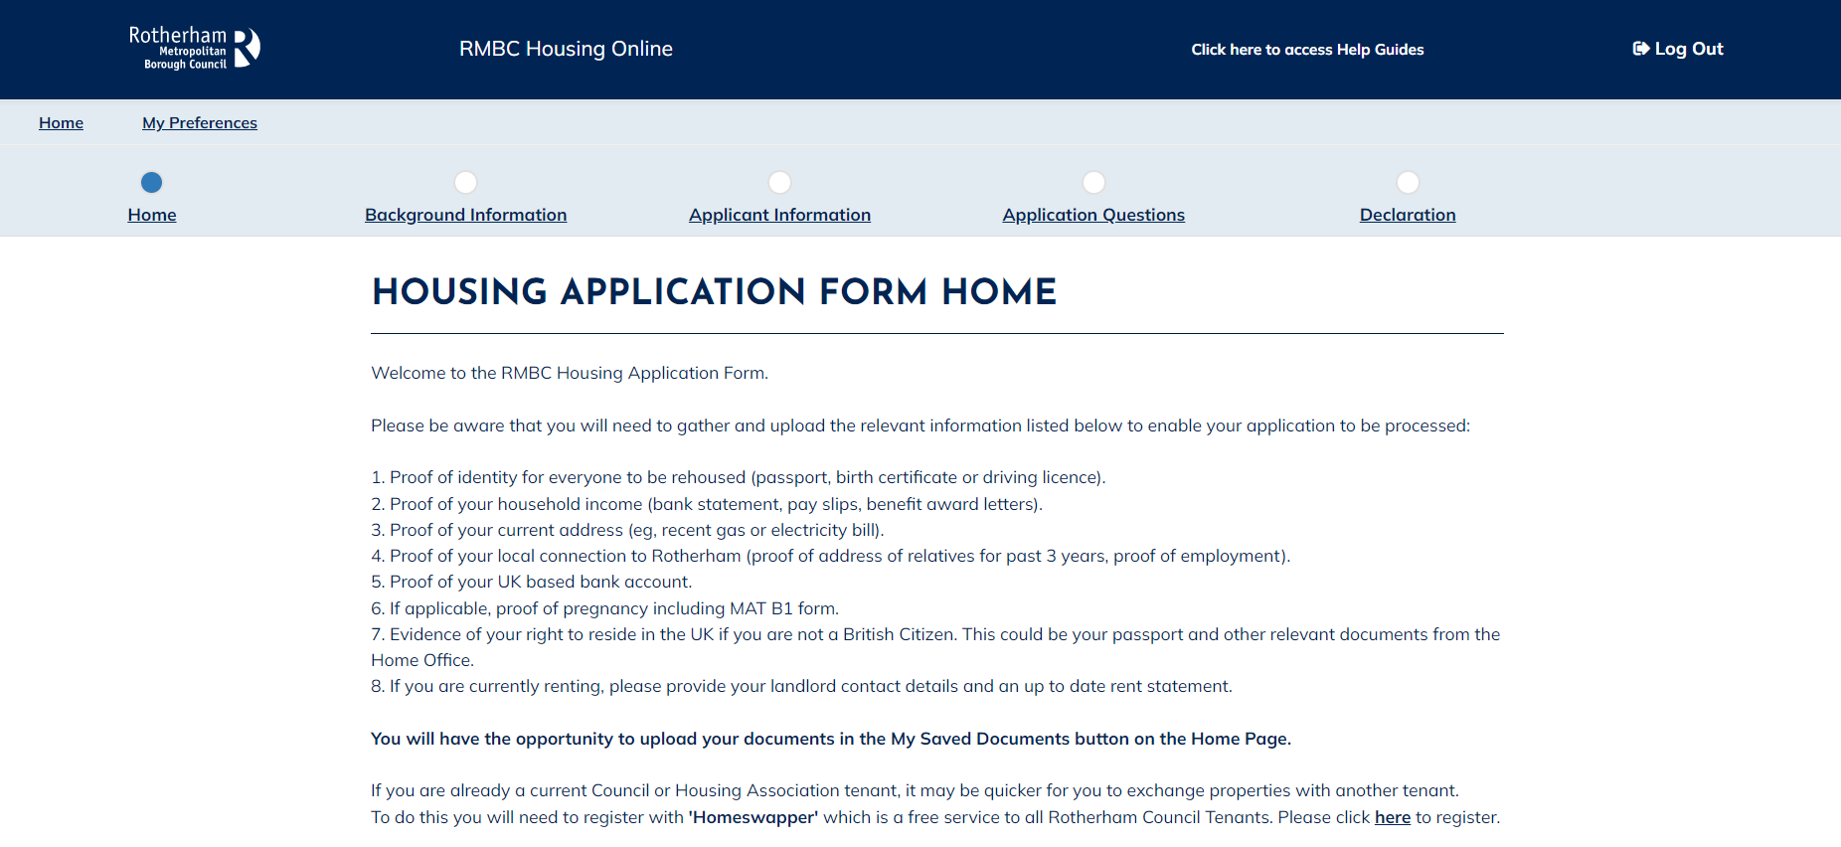

- Scroll to the bottom of the page. Select Housing Register from the drop-down list, then tick ‘Please Confirm Selection’ box. Then click Next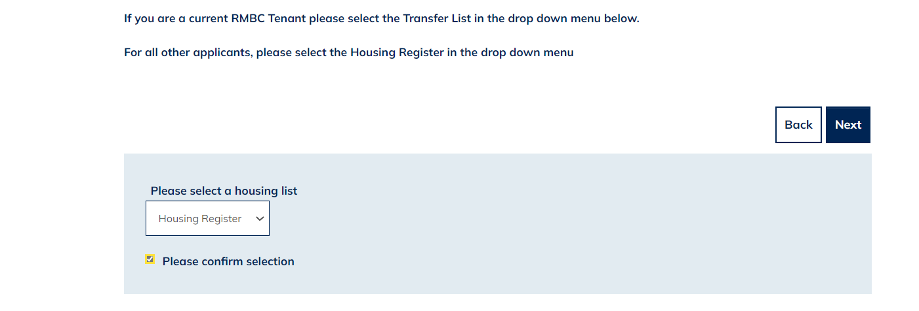

- The ‘RMBC Housing Register’ page displays. Read this information carefully and then select Next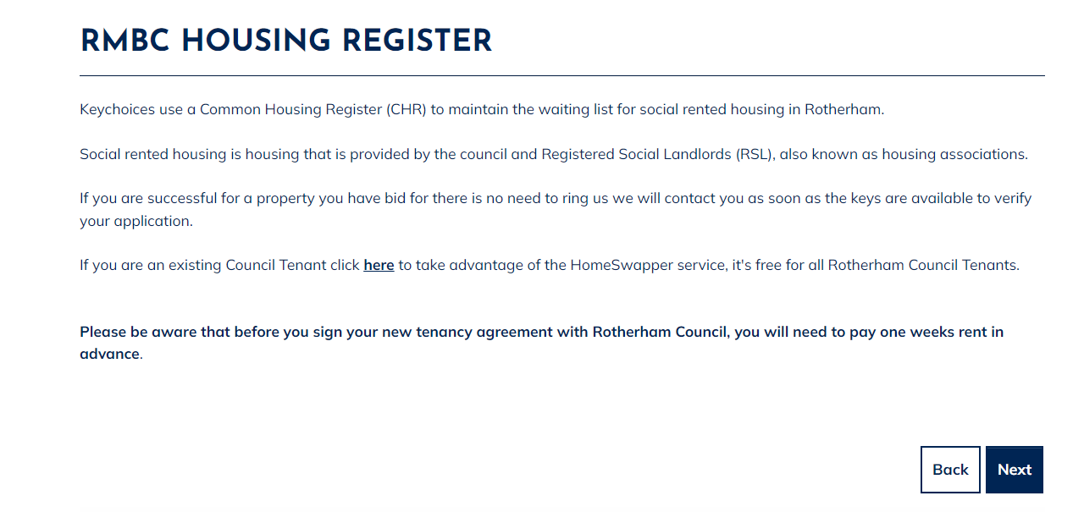
- The ‘People Summary’ page will display. Please select the ‘Actions’ menu next to the main applicant, then select ‘Update Person’ where there is an exclamation mark this indicates an incomplete section of your application. 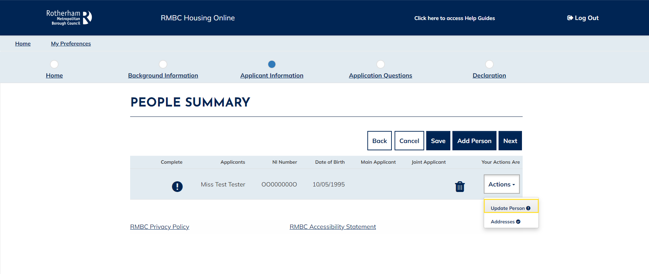

- The ‘Enter Person Details’ page displays. Please complete the person details. Any mandatory fields are marked with a red *. Once you have completed all person details, click Submit.

- If there are other household members with an exclamation warning against them, please select the Action button to complete their details as above. If you wish to add additional household members that need re-housing with you, you can do this by selecting ‘Add Person’ and then completing their details. Once you are happy that all household members are correct and updated, select Next.

- The ‘Application Questions’ page displays. Carefully respond to each set of questions, until you reach the end of the ‘Application Questions’.

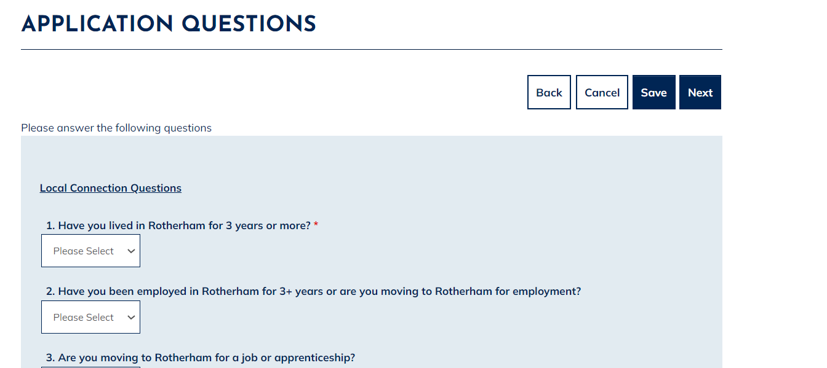

- The ‘Housing Application Form Declaration’ page will now display: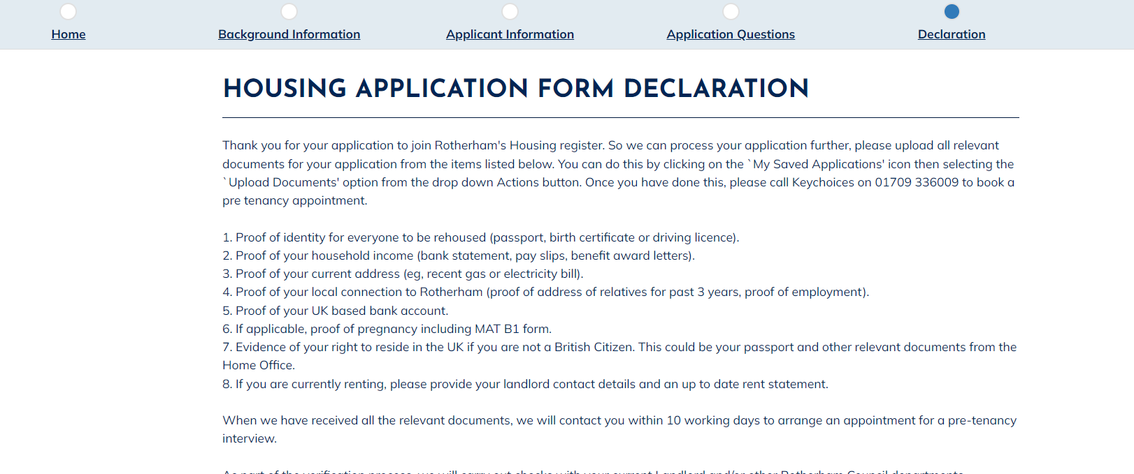

- Scroll down and confirm that the information you have provided is correct by selecting ‘Yes’ and then ‘Submit’.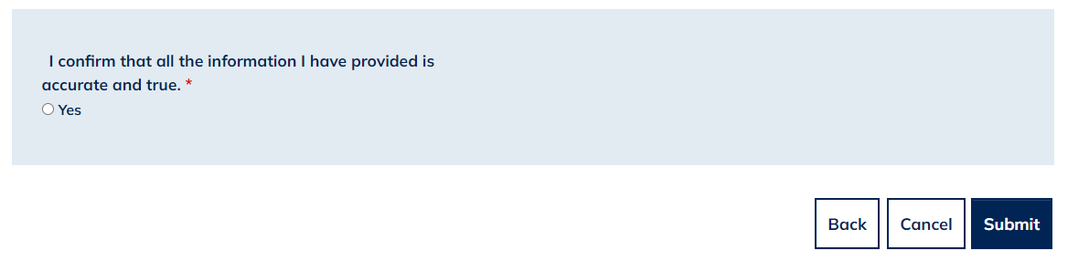

- The ‘Housing Application Confirmation’ page will then display, advising you of the documents you are now required to submit and the steps you must follow for your application to be progressed. It may be helpful at this stage to make notes of what you will need to do next as per the image below. Select Done at the bottom of the page.
