Housing Online – My Accounts (Rents, Shared Ownership & Leasehold)
This guide specifically relates to My Accounts for Rents, Shared Ownership & Leasehold. Should you need help finding your way around other parts of your Housing Online account, please refer to the All User Guides section which you can access by clicking here: https://www.rotherham.gov.uk/downloads/download/415/housing-services-user-guides

Contents Page Number
My Accounts – Rent Account | 2
- Make a Payment | 4
- View Statement | 5
- Account Details | 7
- Register for a Direct Debit | 9
- Payment Schedule | 14
- Upload a Document | 15
My Accounts – Shared Ownership Account | 16
- Make a Payment | 18
- View Statement | 19
- Account Details | 21
- Payment Schedule | 23
- Upload a Document | 24
My Accounts – Leasehold Account | 25
- Make a Payment | 27
- View Statement | 28
- Register for a Direct Debit | 30
- Payment Schedule | 35
- Upload a Document | 36

This guide will detail how to view your Accounts for your rent, shared ownership, or leaseholder property. You will be able to access functions to view your account statement, account details as well as being able to register for a Direct Debit.
Please refer to the ‘Registering and Logging in Guide’ for details of how to register for the first time and/or log in with a previously registered account.

My Accounts – Rents Account

Once successfully logged in you will see the ‘My Summary’ page as per the below:
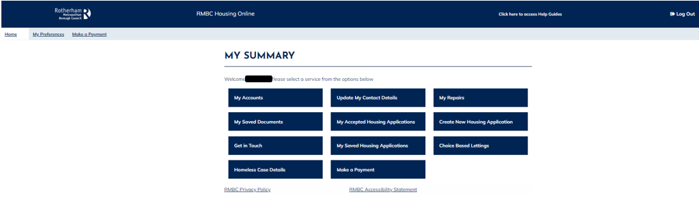
MY ACCOUNTS
Select the My Accounts option
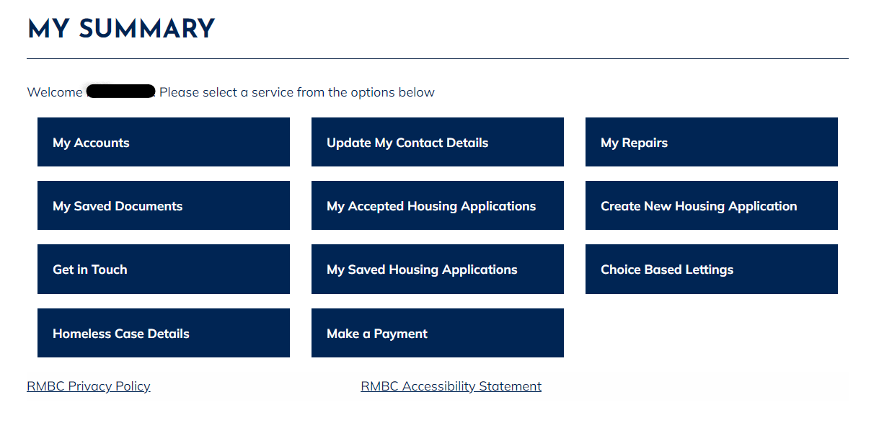

On the ‘My Accounts’ page you will be able to view your account details. The page will confirm your name and the address the accounts are linked to.
Each account linked with the property will be listed on page with an overview of the account type, account start date, gross rent, payment reference and current Balance.

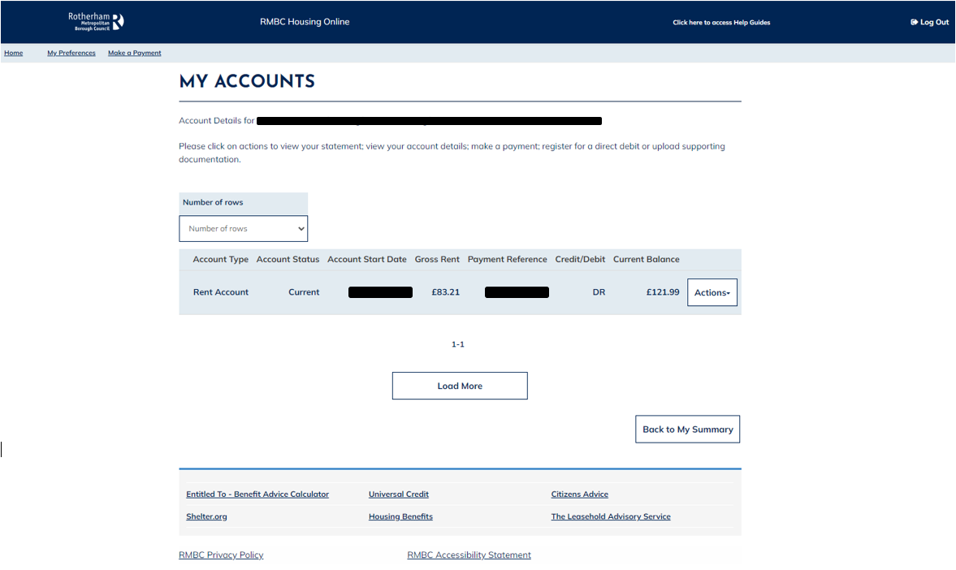
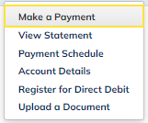
Action option which contains additional functions which are available to help you to self-serve your housing needs like viewing your account statement or registering for a Direct Debit.
Links to external websites that may be useful and provide additional help/ guidance for your tenancy such a Universal Credit, Housing Benefit and Citizens Advice
Link to ‘Make a Payment’ is available on the header on all pages. This will show the payment page.
Remember to take a note of your payment reference as you will need this to make the payment to your account.
Link to the RMBC website to view the additional Housing Online user guides to help navigate around the system.
Log Out option available on each page to securely log out of your Housing Online account.

Make a Payment
You can use this page to launch the payment page to make a manual payment towards your accounts.
Click on the ‘Actions’ option on the account record and then click on ‘Make a Payment’ from the drop-down list.
Remember to copy the payment reference which you will need to validate and make a payment against your account.
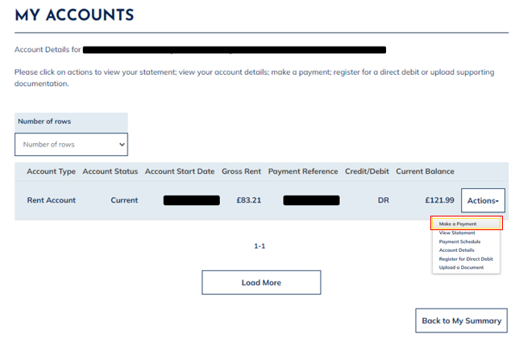

This will launch the RMBC payment portal.
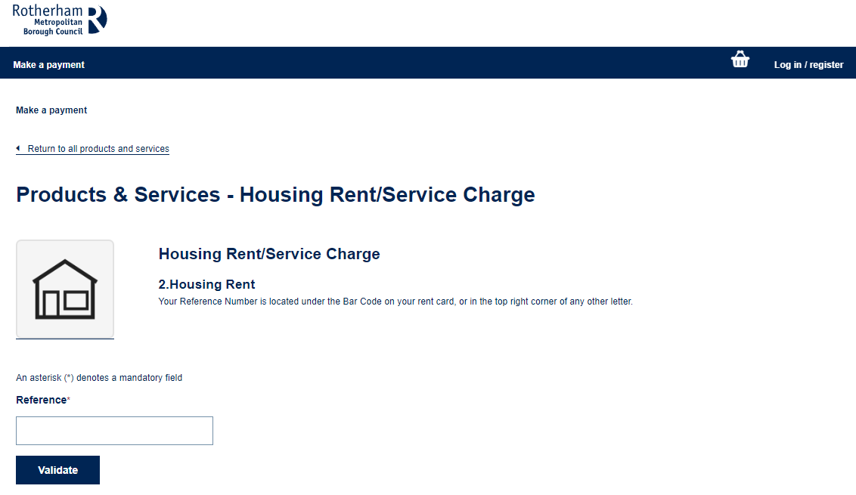

View Statement
You can use this page to view your account statement which is a summary of the charges that have been applied to your account and any payments which have been made.
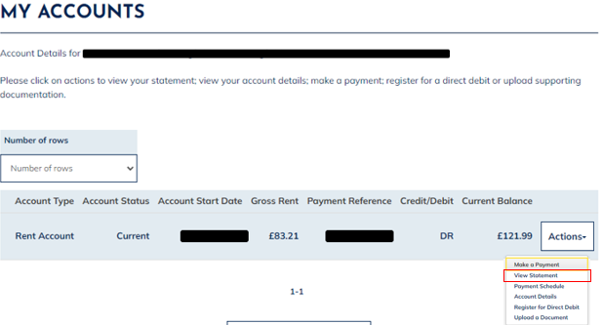
You can either click anywhere on the account record to open the ‘Account Statement’ page or you can select on the ‘Actions’ option on the account record and then click on ‘View Statement from the drop-down list.

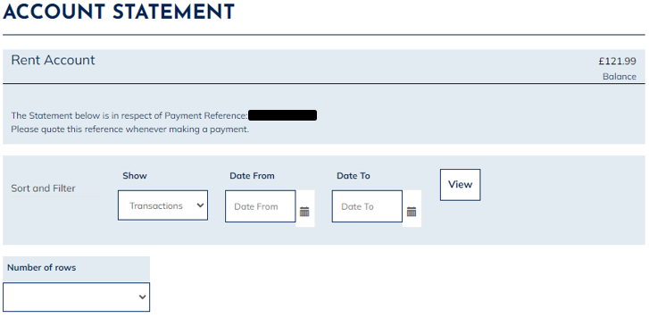
The ‘Account Statement’ page will show outlining the transaction history of the account.
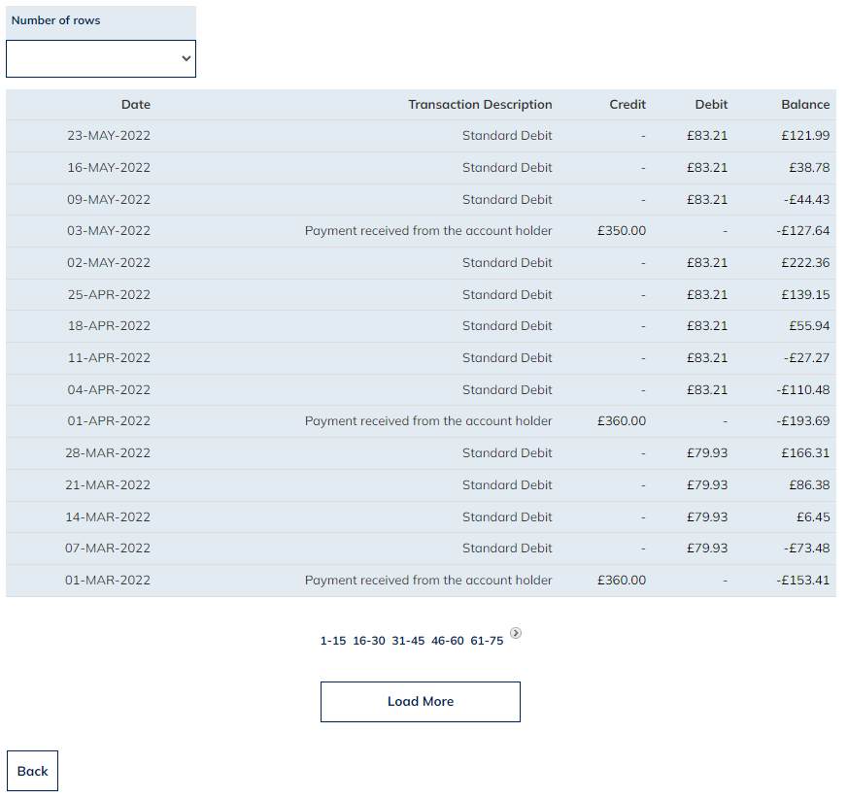
To show up the history of the transactions for this account, you select the ‘Load More’ option at the bottom of the account statement page.
To return to the ‘My Account’ summary page at any point. You can click on the ‘Back’ option located at the bottom of the page.

Account Details
You can use this page to view your account details which is a summary of your account and a breakdown of any charges applied to the account.
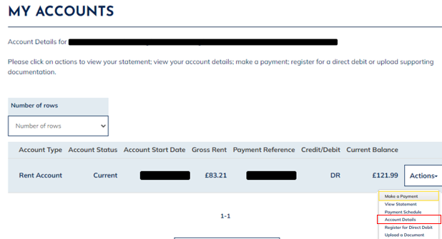Click on the ‘Actions’ option on the account record and then click on ‘Account Details’ from the drop-down list.

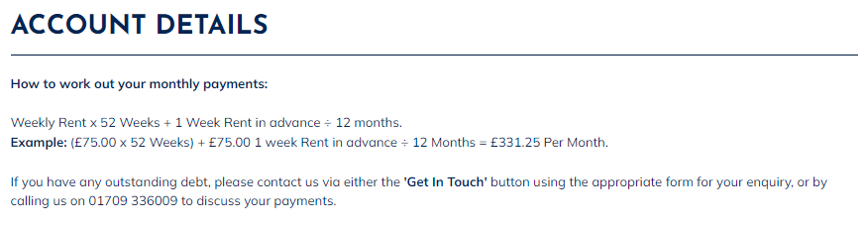
This will show the ‘Account Details’ page:

The ‘Account Details’ page summarises top-level account information for the account which is selected. For example, payment reference, account type, current balance etc…
You can see a breakdown of the account charges that are linked to the account at the bottom of the ‘Account Details’ page. These charges make up the total payable amount.
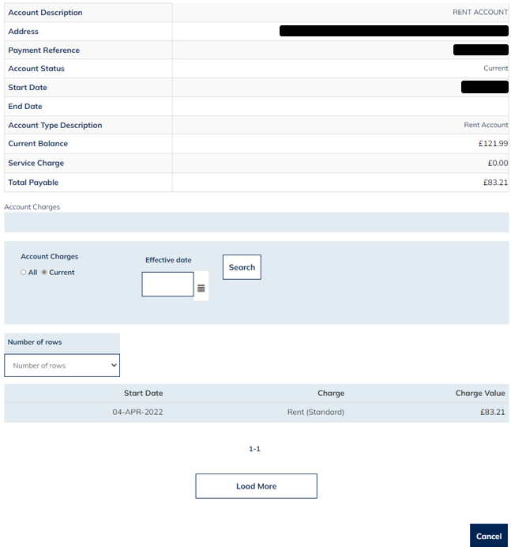
You can click on ‘Cancel’ located at the bottom of the page to return back to the ‘My Accounts’ summary page.

Register for a Direct Debit
You can use this page to Register for a Direct Debit on your account.
Select the ‘Actions’ option on the account record and then click on ‘Register for a Direct Debit’ from the drop-down list.
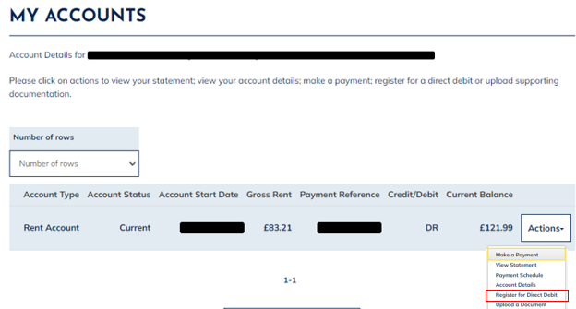
This will show the Direct Debit Agreement.
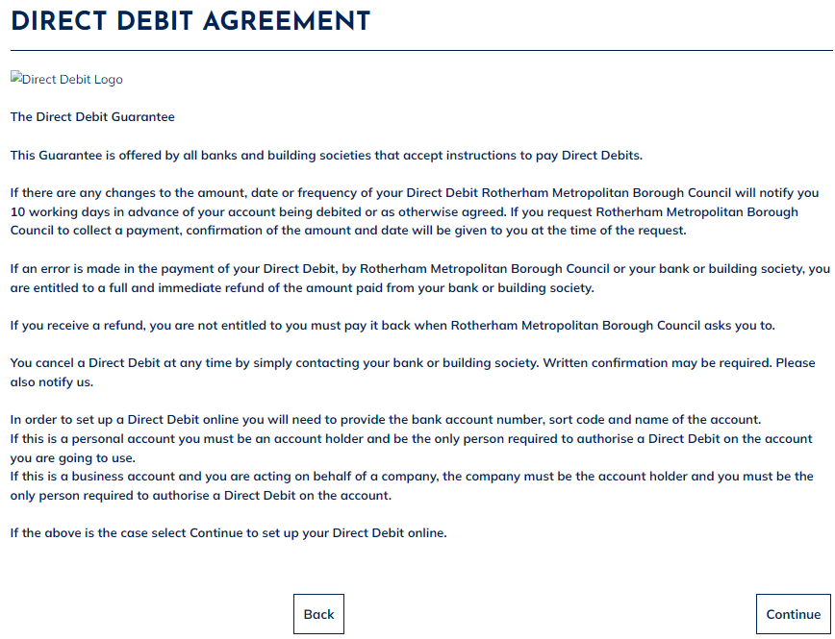
You will need to read the Direct Debit Agreement in full and if happy to proceed select ‘Continue’.

You will be presented with the ‘New Direct Debit Instruction Bank Details’ page.
You will need to populate your bank details and select a payment date from the drop-down list.
The Direct Debit payment dates available are:
- Weekly Thursday
- Weekly Friday
- 1st of the Month
- 12th of the Month
- 18th of the Month
- 24th of the Month
- 28th of the Month
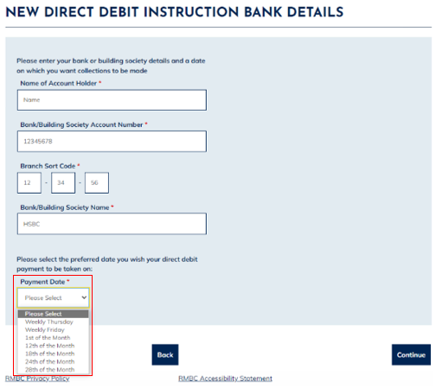
Once all details have been entered, you can select ‘Continue’ at the bottom of the page.

You will be presented with the ‘Direct Debit Instructions Summary Details’ page which outlines the details entered on the previous page.
You should confirm your details at this stage to confirm the details you have entered are correct.
- If the details are correct, select ‘Continue’ to proceed.
- If the details are incorrect, select the ‘Back’ option to return to the previous page to amend details.
- If You wish to cancel the process, select the ‘Cancel ‘option.
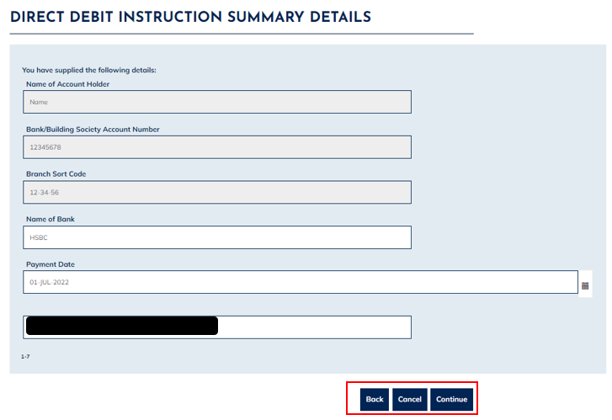

You will be presented with the ‘Direct Debit Payment Plan’ page.
This page outlines the payment amounts that have been created. You should review if the amounts generated are correct and affordable.
- If the details are correct, select the ‘Submit’ option to proceed.
- If the details are incorrect, select the ‘Back’ option to return to the previous page to amend details.
- If you wish to cancel the process, select the ‘Cancel’ option.
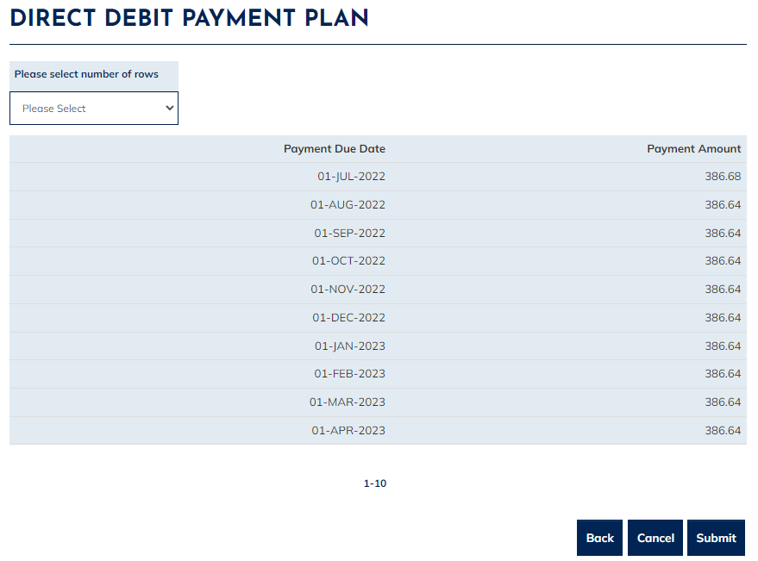

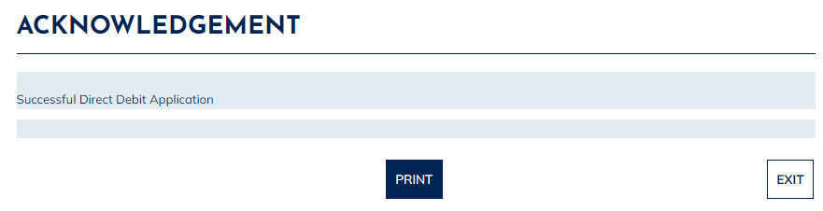
Once you have selected the ‘Submit’ option, an ‘Acknowledgment’ page will show confirming ‘Successful Direct Debit Application’

You can click on the ‘Exit’ option to finish the process or click on the ‘Print’option to view, save or print a copy of the Direct Debit mandate.
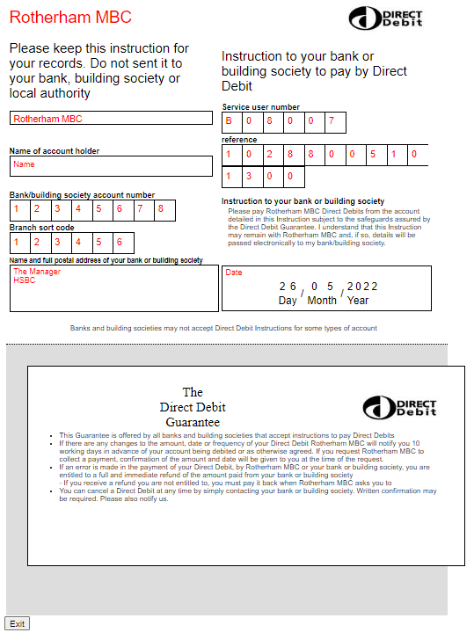
To close the Direct Debit Guarantee, select the ‘Exit’ option at the bottom of the page. Which will return you back to the ‘My Accounts’ summary page.

Payment Schedule
You can use this page to view your outstanding payment obligations if you have a Direct Debit set up against your accounts.
Click on the ‘Actions’ option on the account record and then click on ‘Payment Schedule’ from the drop-down list.
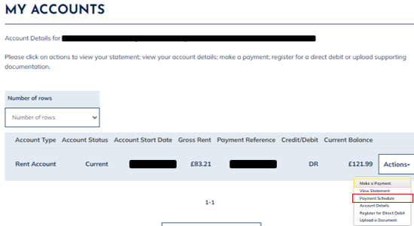

This will show the payment schedule outlining the payment type, amount and due date.
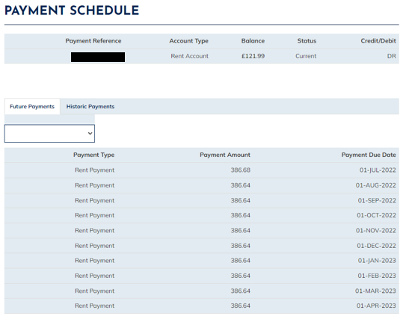

Upload Document

Please refer to the Upload a Document user guide for details of how to upload a document on the Accounts.

My Accounts – Shared Ownership Account

Once successfully logged in you will see the ‘My Summary’ page as per page below:
MY ACCOUNTS
Select the ‘My Accounts’ option

The ‘My Accounts’ page will show where you will be able to view your account details. The page will confirm your name and the address the accounts are linked to.
Each account linked with the property will be listed on this page with an overview of the account type, account start date, gross rent, payment reference, and current balance.

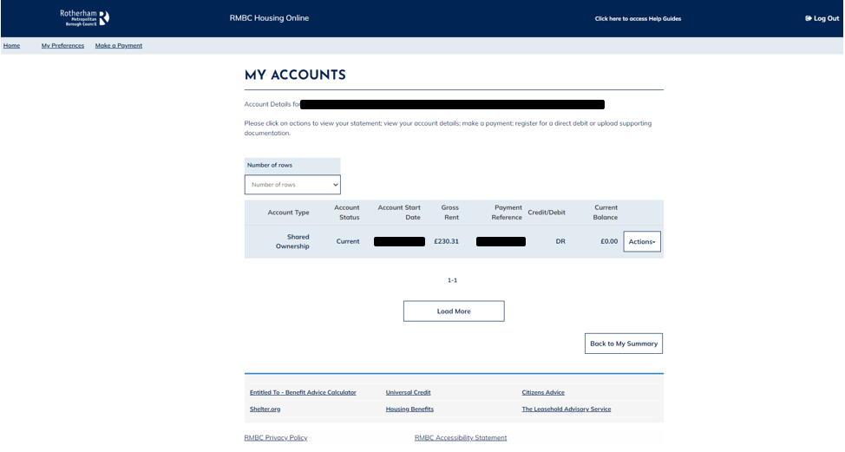
Link to ‘Make a Payment’ is available on the header on all pages. This will show the payment page.
Remember to take a note of your payment reference as you will need this to make the payment to your account.
‘Action’ option which contains additional functions which are available to help self-serve your housing needs like viewing your account statement or registering for a Direct Debit.
Links to external websites that may be useful and provide additional help/ guidance for your tenancy such a Universal Credit, Housing Benefit and Citizens Advice
Link to the RMBC website to view the additional Housing Online User Guides to help navigate around the system.
Log Out option available on each page to securely log out of your Housing Online account.

Make a Payment
You can use this page to launch the payment page to make a manual payment towards your shared ownership account.
Click on the ‘Actions’ option on the account record and then click on ‘Make a Payment’ from the drop-down list.
Remember to copy the payment reference which will be needed to validate and make a payment against your account.
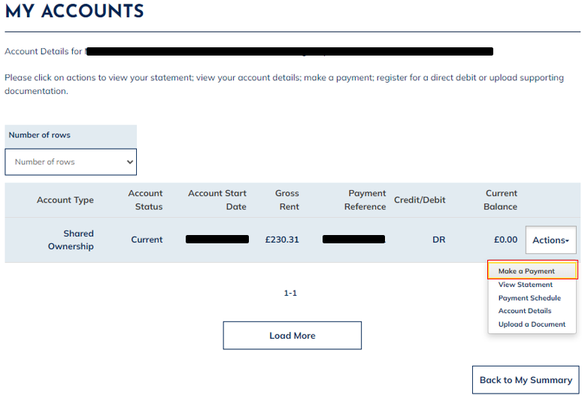

This will launch the RMBC payment portal.

View Statement
You can use this page to view your account statement which is a summary of what Charges have been applied to the account and any Payments which have been made.
You can either click anywhere on the account record to open the ‘Account Statement’ page or you can click on the ‘Actions’ option on the account record and then click on ‘View Statement’ from the drop-down list.
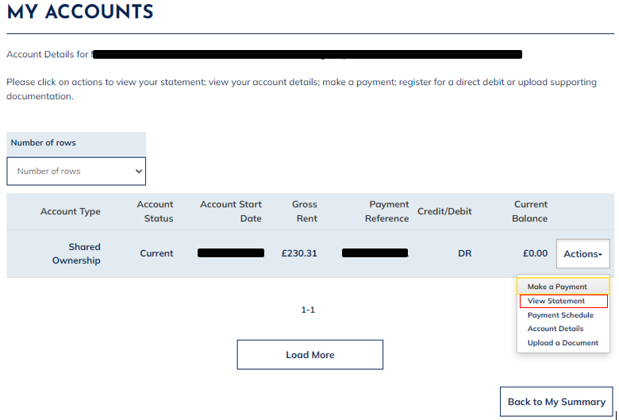

The ‘Account Statement’ page will show outlining the transaction history of the account.
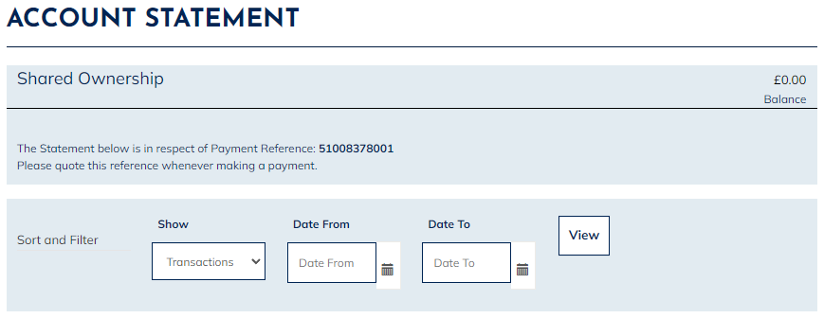
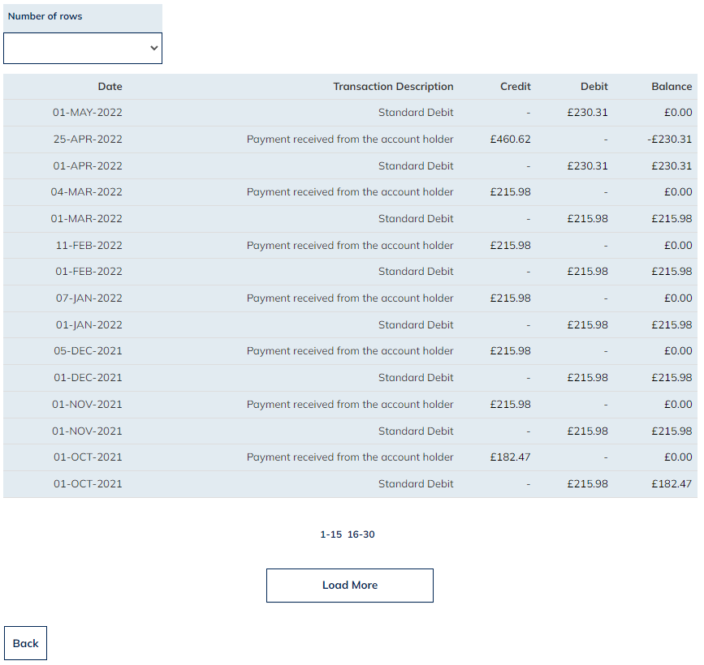
To return to the ‘My Account’ summary page at any point. You can click on the ‘Back’ option located at the bottom of the page.
To Show the history of the transactions for this account select the ‘Load More’ option at the bottom of the ‘Account Statement’ page.

Account Details
You can use this page to view your Account Details which is a summary of the shared ownership account and a breakdown of any charges applied to the account.
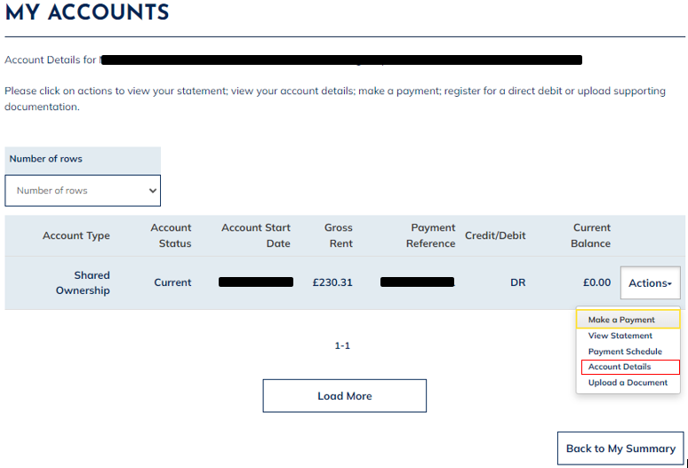Click on the ‘Actions’ option on the account record and then click on ‘Account Details’ from the drop-down list.

This will show the ‘Account Details’ page:

The ‘Account Details’ page summarises top-level account information for the shared ownership account which is selected. For example, payment reference, account type, current balance etc.
You can see a breakdown of the account charges that are linked to the shared ownership account at the bottom of the ‘Account Details’ page. These charges make up the total payable amount.
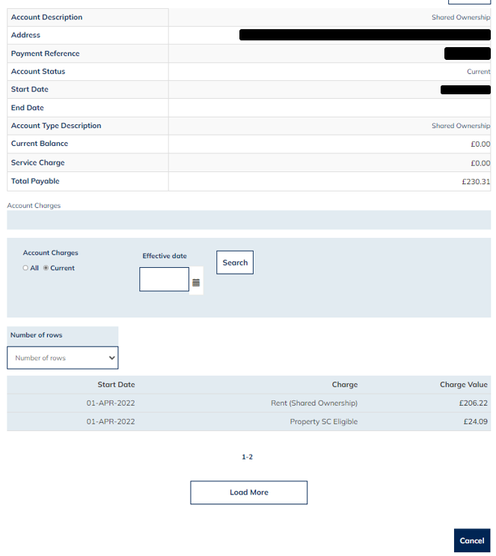
Select the ‘Cancel’ option located at the bottom of the page to return back to the ‘My Accounts’ summary page.

Payment Schedule
You can use this page to view your outstanding payment obligations if you have a Direct Debit set up against your accounts.
Click on the ‘Actions’ option on the account record and then click on ‘Payment Schedule’ from the drop-down list.
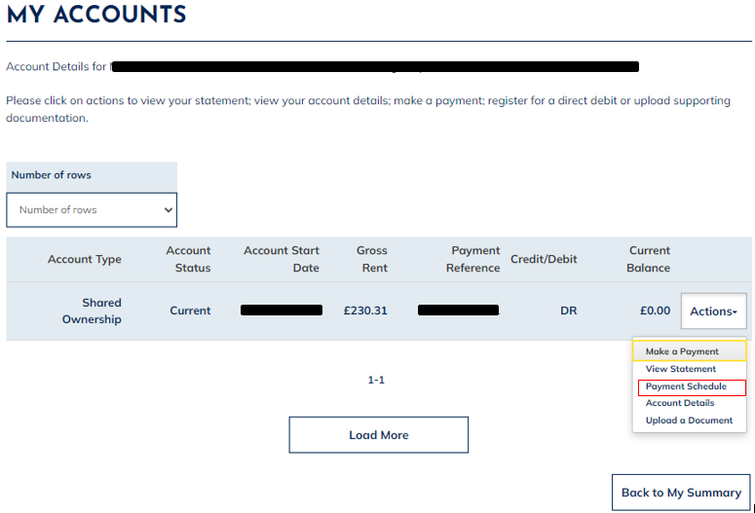
This will present the payment schedule outlining the payment type, amount and due date.
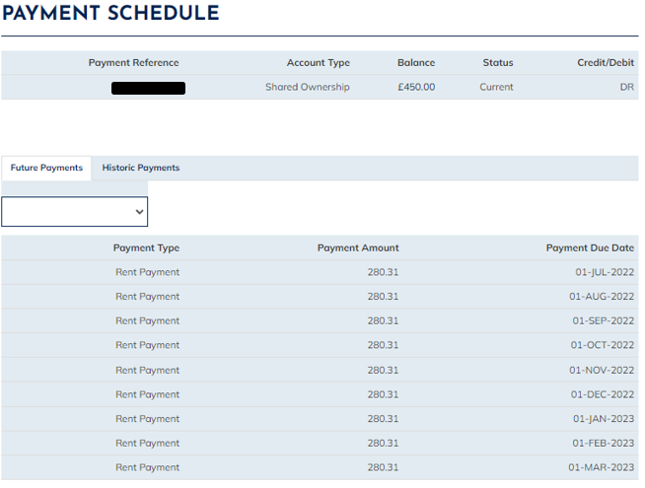

Upload Document

Please refer to the Upload a Document user guide for details of how to upload a document on to an account.

Accounts – Leasehold Account

Once successfully logged in you will see the ‘My Summary’ page as per the below:
MY ACCOUNTS
Select the ‘My Accounts’ option

The ‘My Accounts’ page will be shown where you will be able to view your account details. The page will confirm your name and the address the accounts are linked to.
Each account linked with the property will be listed on the page with an overview of the account type, account start date, gross rent, payment reference, and current balance.

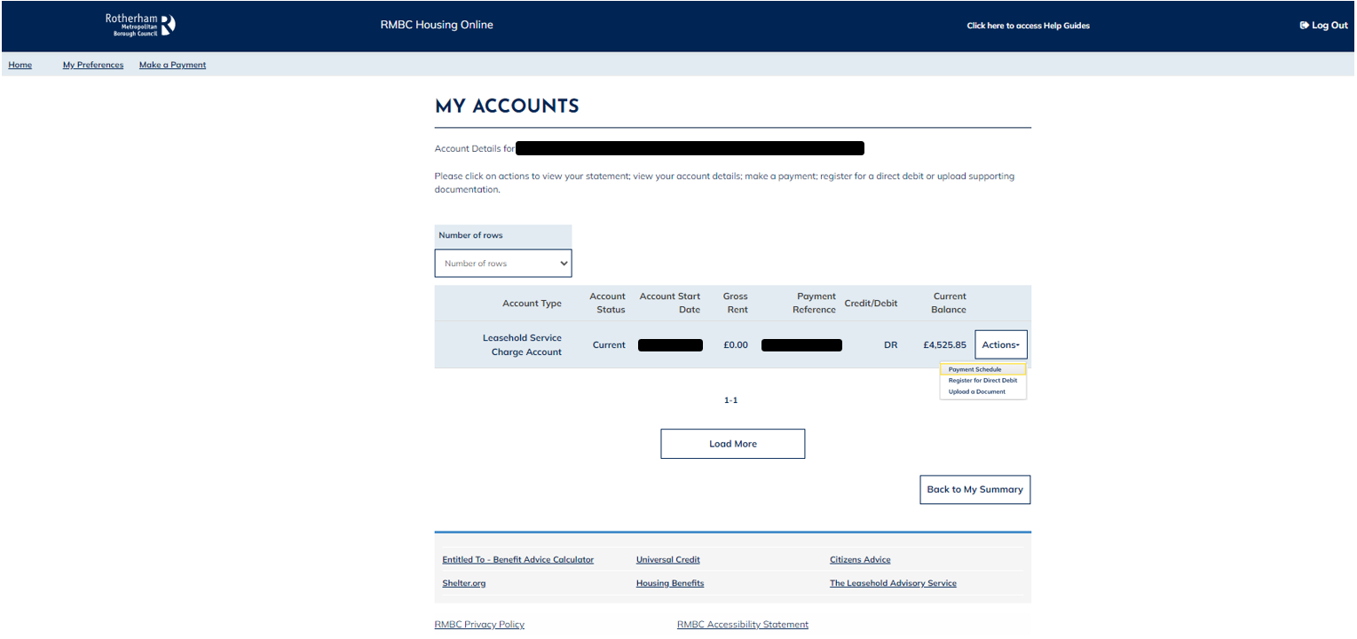
Link to ‘Make a Payment’ is available on the header on all pages. This will show the payment page.
Remember to take a note of your payment reference as you will need this to make the payment to your account.
Action option which contains additional functions which are available to help you to self-serve your housing needs like viewing your account statement or registering for a Direct Debit.
Links to external websites that may be useful and provide additional help/ guidance for your tenancy such a Universal Credit, Housing Benefit and Citizens Advice
Link to the RMBC website to view the additional Housing Online User Guides to help navigate around the system.
Log Out option available on each page to securely log out of your Housing Online account.

Make a Payment
You can make a payment manually in two ways:
- You can click on the ‘Make a Payment’ link which is visible on the header throughout the Housing Online system.

- You can click on the ‘Make a Payment option located on the ‘My Summary’ landing page.

This will launch the RMBC payment portal.

View Statement
You can use this page to view your accounts statement which is a summary of the charges that have been applied to the account and any payments which have been made.
You will need to click anywhere on the account record to open the ‘Account Statement’ page.
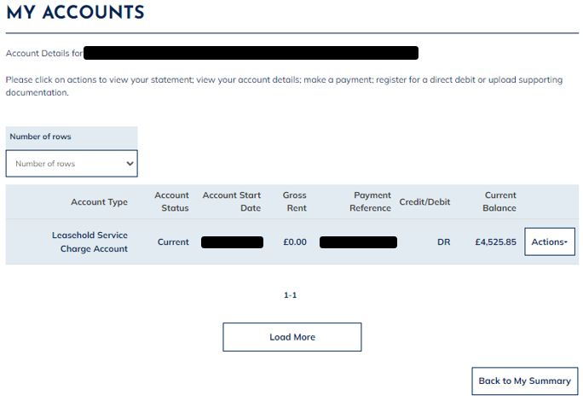
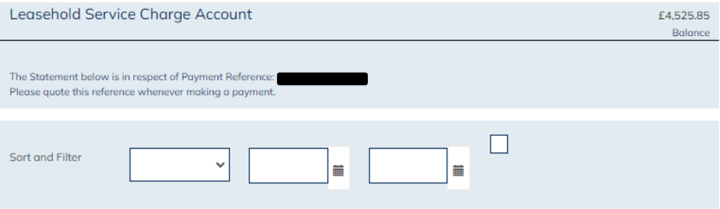The ‘Account Statement’ page will show outlining the transaction history of the account.
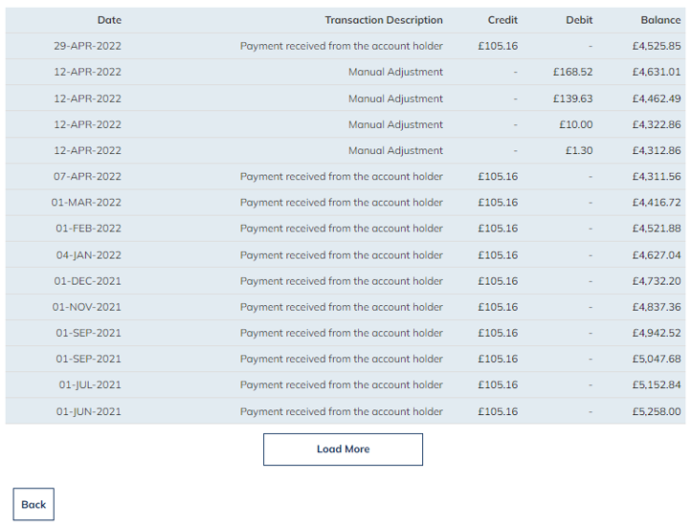
To return to the ‘My Account’ summary page at any point select the ‘Back’ option located at the bottom of the page.
To show the history of the transactions for this Account select the ‘Load More’ option at the bottom of the ‘Account Statement’ page.

Register for a Direct Debit
You can use this page to register for a Direct Debit on your Leasehold Account.
Click on the ‘Actions’ option on the account record and then click on ‘Register for a Direct Debit’ from the drop-down list.
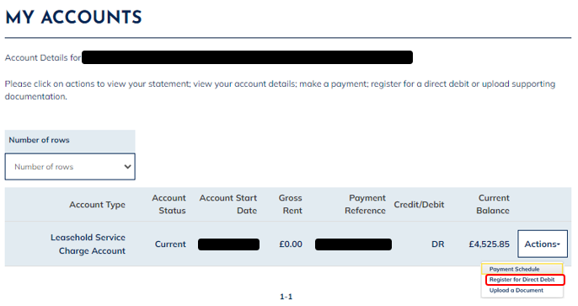
This will show the Direct Debit Agreement.
You will need to read the Direct Debit Agreement in full and if happy to proceed select ‘Continue’.

You will be presented with the ‘New Direct Debit Instruction Bank Details’ page.
You will need to populate your bank details and select a payment date from the drop-down list.
The Direct Debit payment dates available are:
- 1st of the Month
- 12th of the Month
- 18th of the Month
- 24th of the Month
- 28th of the Month
Once all details have been entered, select ‘Continue’ at the bottom of the page

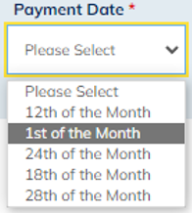

You will be presented with the ‘Direct Debit Instructions Summary Details’ page which outlines the details entered on the previous page.
You should confirm your details at this stage to confirm the details they have entered are correct.
- If the details are correct, select the ‘Continue’ option to proceed.
- If the details are incorrect, select the ‘Back’ option to return to the previous page to amend details.
- To cancel the process, select the ’Cancel’ option.
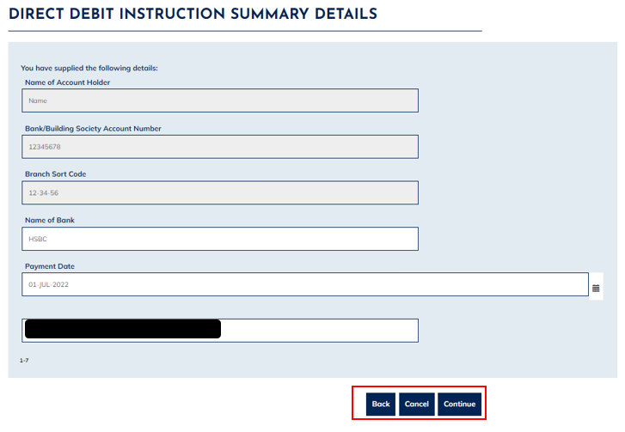

You will be presented with the ‘Direct Debit Payment Plan’ page.
This page outlines the payment amounts that have been created. You should review if the amounts generated are correct and affordable.
- If the details are correct, select the ‘Submit’ option to proceed.
- If the details are incorrect, select the ‘Back’ option to return to the previous page to amend details.
- To cancel the process, select the ‘Cancel’ option.
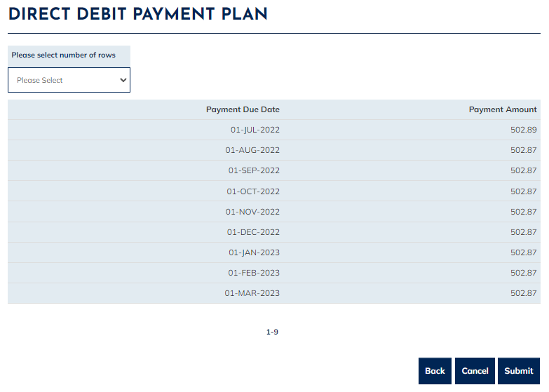

Once you selected the ‘Submit’ option, the ‘Acknowledgment’ page will be presented confirming ‘Successful Direct Debit Application’

You can click on the Exit option to finish the process or click on the Print option to view/ Save or print a copy of the Direct Debit mandate.
To close the Direct Debit Guarantee, select the ‘Exit’ option at the bottom of the page. Which will return you back to the ‘My Accounts Summary’ page.

Payment Schedule
You can use this page to view your outstanding payment obligations if you have a Direct Debit set up against your accounts.
Click on the ‘Actions’ option on the account record and then click on ‘Payment Schedule’ from the drop-down list.
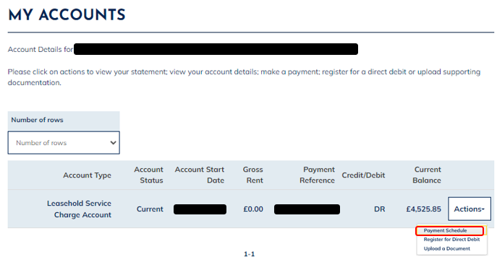
This will present the payment Schedule outlining the Payment type, amount, and due date.
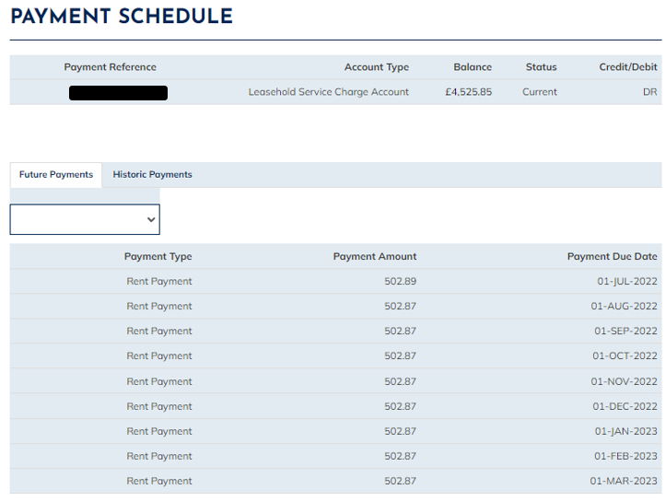

Upload Document

Please refer to the Upload a Document user guide for details of how to upload a document on to your account.

