Housing Online – Homelessness User Guides
This guide specifically relates to Homelessness and other information relating to your homeless case.
Should you need help finding your way around other parts of your Housing Online account, please refer to the All User Guides section which you can access by clicking here

Contents Page Number
View Homeless Case | 2
View Personalised Plan Tasks | 3
Add Update / Comment to Task | 5
Complete Task | 8

Please refer to the ‘Registering and Logging in Guide’ for details of how to register for the first time and/or log in with a previously registered account.

View Homeless Case
Once successfully logged in you will see the ‘My Summary’ page as per the below:
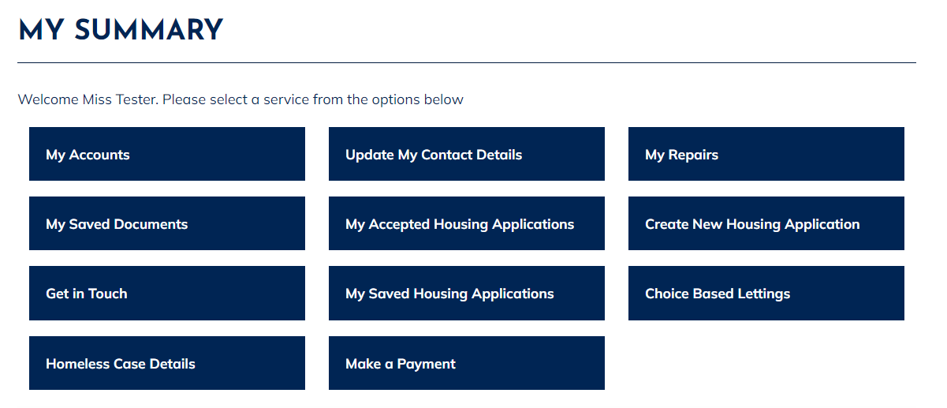
- Select ‘Homeless Case Details’
- The ‘Homelessness Advice’ page will show as per the below: 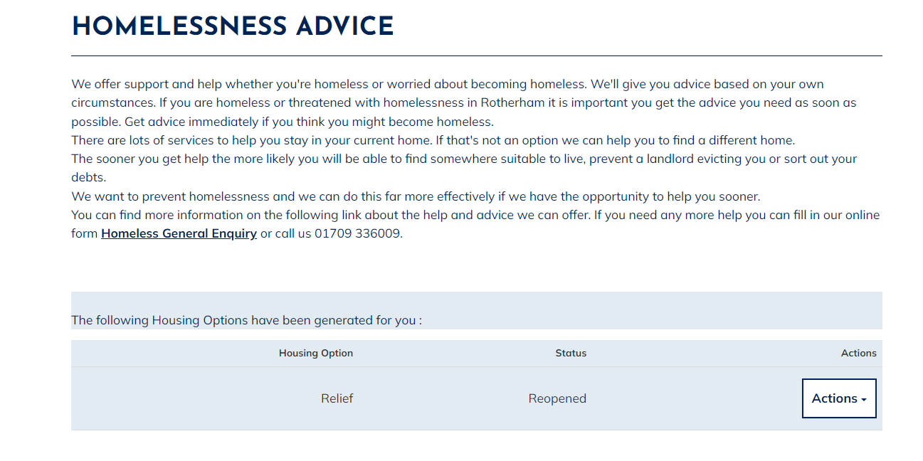
- From here you will be able to see if you have an open/closed homeless case.

View Personalised Plan Tasks
Once successfully logged in you will see the ‘My Summary’ page as per the below:
- The ‘My Summary’ page shows. The ‘My Summary’ page shows. Select ‘Homeless Case Details’.
- The ‘Homelessness Advice’ page will now show.
- From here, select the ‘Actions’ menu and then select ‘View Personalised Plan’
- The ‘My Options Personalised Plan Summary’ page will now show: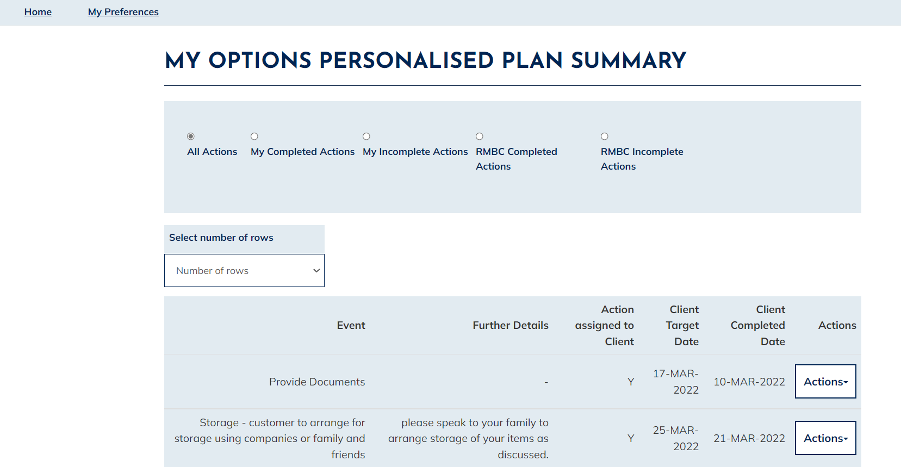

- From here you can select the different options (located at the top of the page):
- My Completed Actions – this will show any tasks you have been assigned by your Homeless Officer and have previously completed
- My Incomplete Actions – this will show you any tasks your Homeless Officer has assigned you that you need to complete. If they have requested this task is completed by a certain date, then there will be a date under ‘Client Target Date’
- RMBC Completed Actions – this will show any tasks completed by your Homeless Officer
- RMBC Incomplete Actions – this will show any tasks your Homeless Officer needs to complete

Add Update / Comment to Task
Once successfully logged in you will see the ‘My Summary’ page as per the below:
- The ‘My Summary’ page shows. Select ‘Homeless Case Details’
- ‘Homelessness Advice’ page will show as per the below:
- From here, select the ‘Actions’ menu then select ‘View Personalised Plan’
- The ‘My Options Personalised Plan Summary’ will now show:

- Select ‘My Incomplete Actions.’ This will show any tasks you have been assigned by your Homeless Officer that you need to complete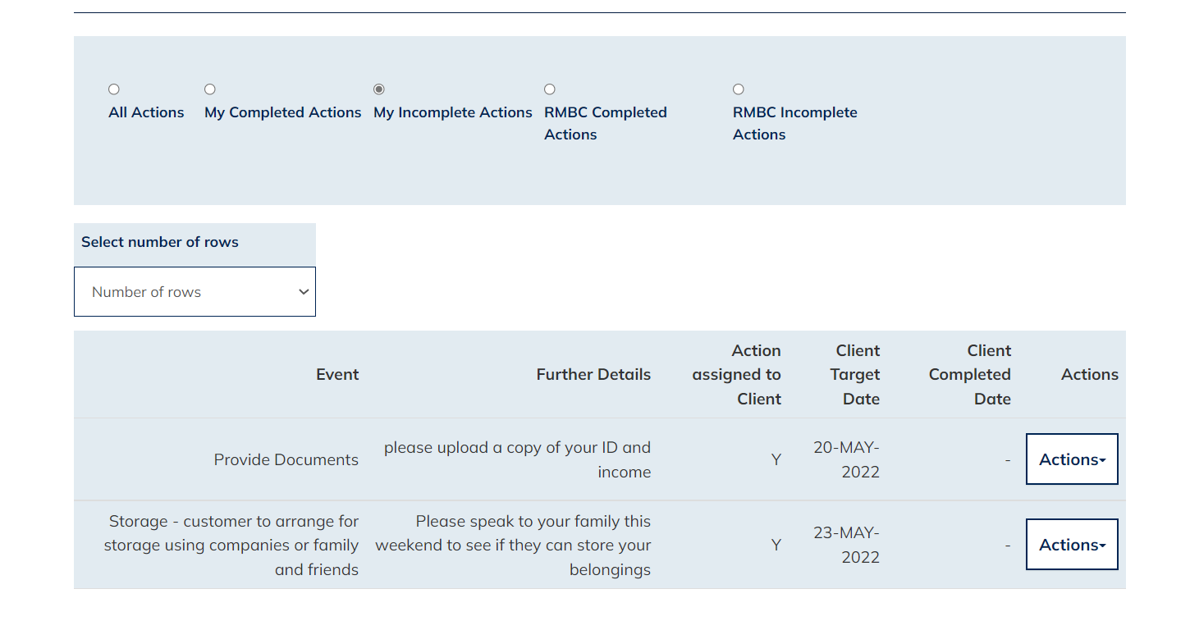
- To add an update/comment to a task, select the ‘Actions’ menu then select ‘Update Action on Plan’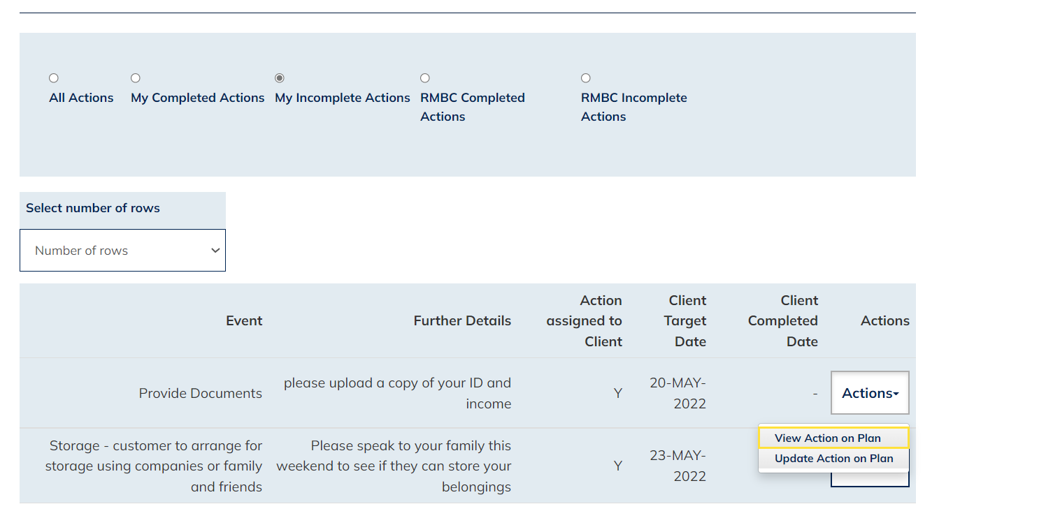
- The ‘My Options Update Action on Plan’ page shows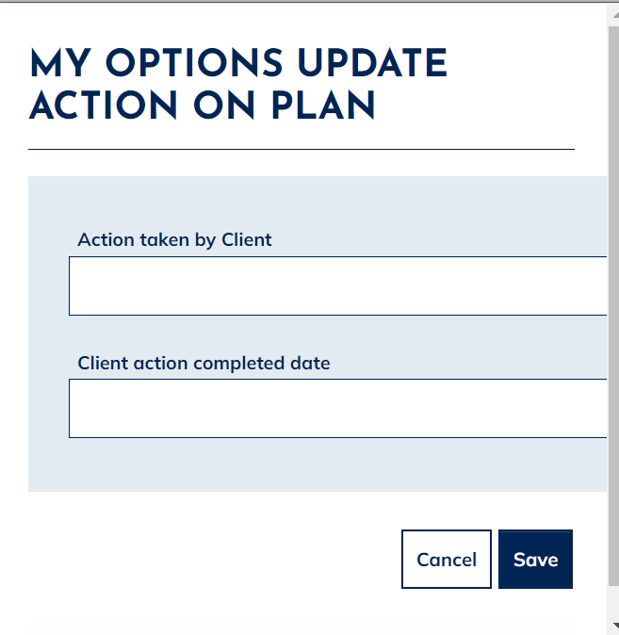
- To add an update without completing the task, simply type in your comments in the field under ‘Action taken by Client’ and select ‘Save’. This will then pull through into RMBC’s system where your Homeless Officer will be able to review your update.

Complete Task
Once successfully logged in you will see the ‘My Summary’ page as per the below:
- The ‘My Summary’ page shows. show Select ‘Homeless Case Details’
- The ‘Homelessness Advice’ page will show as per the below:
- From here, select the ‘Actions’ menu then select ‘View Personalised Plan’
- The ‘My Options Personalised Plan Summary’ will show:

- Select ‘My Incomplete Actions’. This will show any tasks you have been assigned by your Homeless Officer that you need to complete.
- To complete a task, select the ‘Actions’ menu then select ‘Update Action on Plan’

- The ‘My Options Update Action on Plan’ page shows:

- Enter any information/comments you want your Homeless Officer to see in the field under ‘Action taken by Client’ then click under ‘Client action completed date’ and select the date you completed the task. Once you have done this, select ‘Save’.
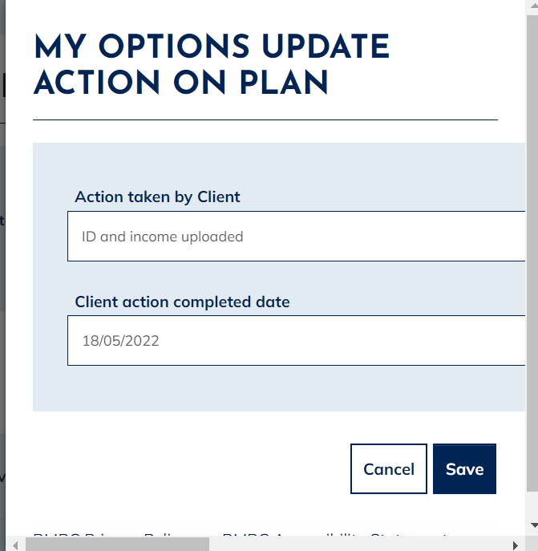

- You will then be returned to the below screen. Your task will no longer show under ‘My Incomplete Actions’ and will have moved to ‘My Completed Actions’. Your Homeless Officer will be able to see any comments you added and the date when you completed your task. 