Housing Online – Get in Touch User Guide
This guide specifically ‘Get in Touch’. Should you need help finding your way around other parts of your Housing Online account, please refer to the All User Guides section which you can access by clicking here: https://www.rotherham.gov.uk/downloads/download/415/housing-services-user-guides

Contents Page Number
Accessing Get in Touch | 2
How to submit a Get in Touch contact | 3
Viewing Enquiries and Requests details | 6
Get in Touch – Remaining Forms | 7
- Credit Refund Request | 7
- Home Contents Insurance – Request a Claim Form | 8
- Permission for Pets Request | 9
- Request Permission for Tenant Alterations | 10

Accessing Get in Touch
There are five ‘Get in Touch’ reasons where you can contact us online via your Housing Online account. These are as follows:
- Contact us about your Rent
- Credit Refund request
- Request a Home Contents Insurance claim form
- Request Permission for a Pet
- Request Permission for Tenant Alterations
With th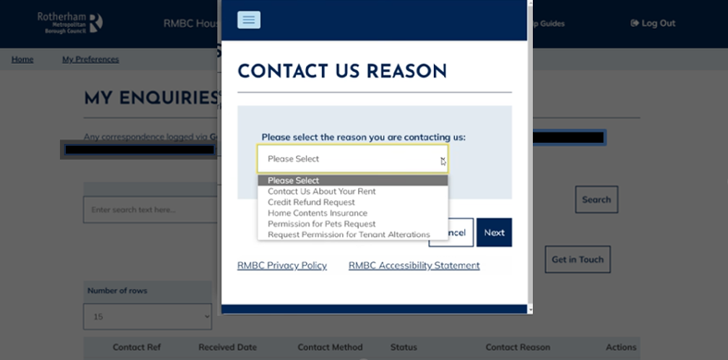
Any online forms not included on your Housing Online account, can be accessed on our website by clicking here: https://www.rotherham.gov.uk/xfp/forms

How to Submit a Get in Touch Contact - Rent
Once you have successfully logged into your account, you will see the ‘My Summary’ page where you can click on the ‘Get in Touch’ button as per the below:
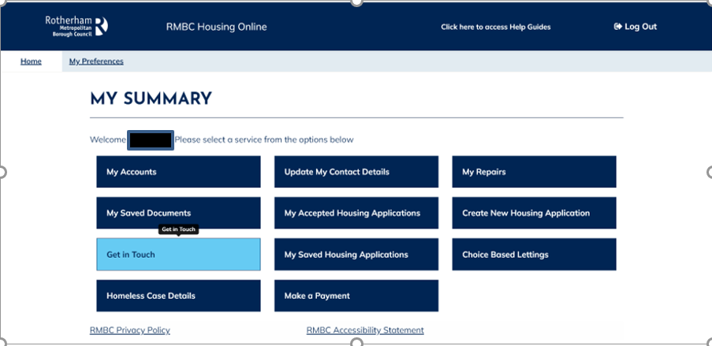

The ‘Your Enquiries and Requests Summary’ page will show. Select the ‘Get in Touch’ option as per the below:
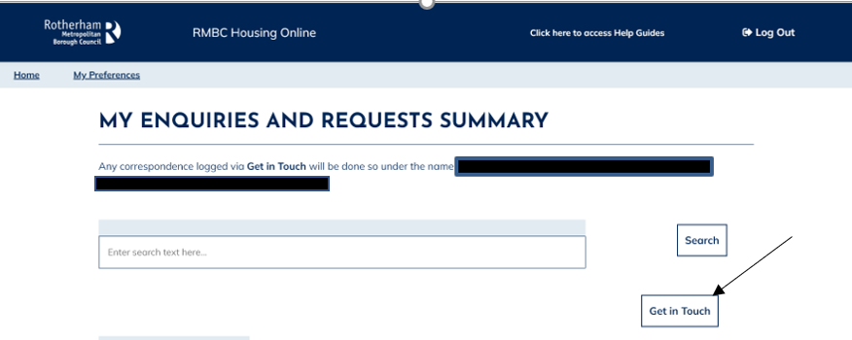

The ‘Contact Us Reason’ will show in the drop-down options list, select the contact reason required.

If you wish to contact us about your rent, then you would select this option from the drop-down options list as per the below:
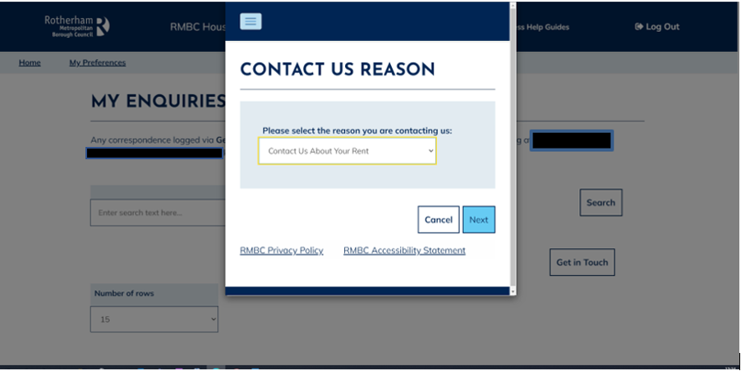

Once you have selected an option, the ‘Contact Details’ page is visible as per the below:
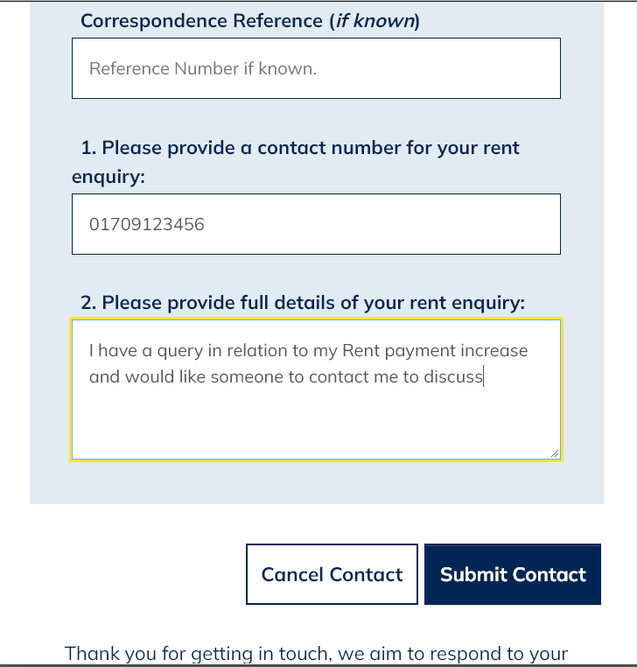

Once you have entered all details, select the ‘Submit Contact’ option.
You will then return to your ‘Enquiries and Requests Summary’ screen where you will now see details of the contact you have just submitted as per the below:
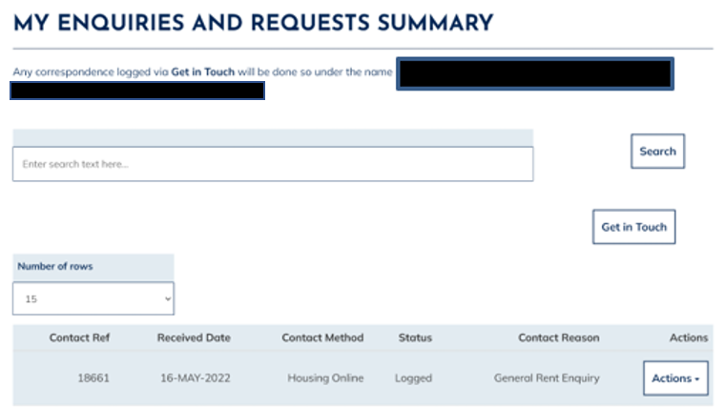

Viewing Enquiries and Requests details
The ‘Actions’ button at the end of each row of your contact reasons provides you with options to select ‘More Details’ and ‘Upload a Document’ (please refer to the Uploading Documents User Guide).
If ‘More Details’ is selected, then the ‘My Enquiries and Requests Details’ will show as per the below:
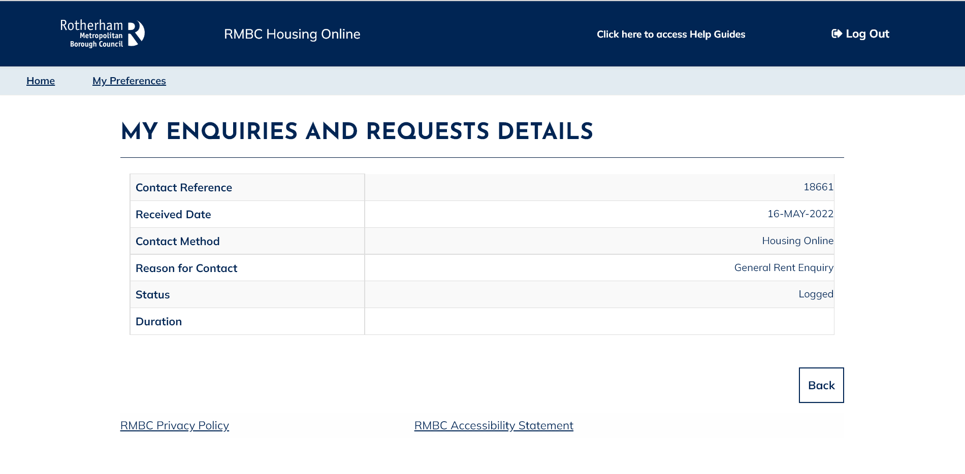

Get in Touch – Remaining Forms
The following show the remaining Contact Us Reasons and the relevant information you will be asked to provide on the online form:

Credit Refund Request
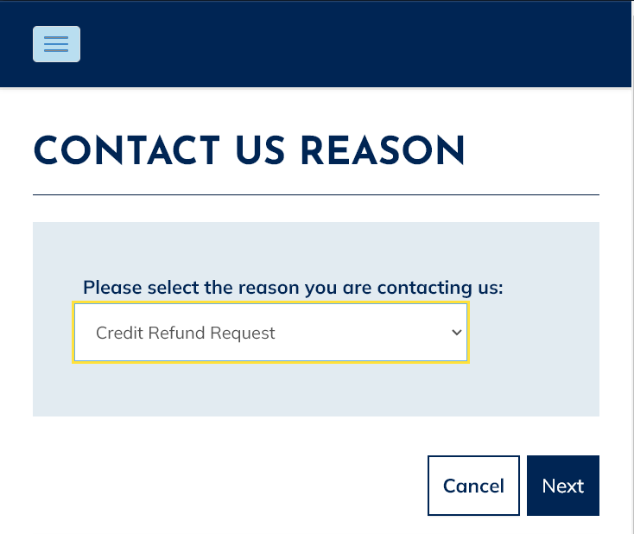

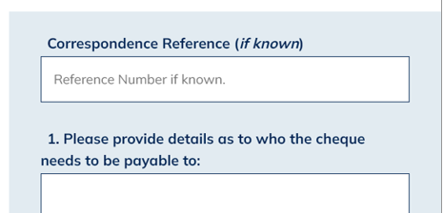
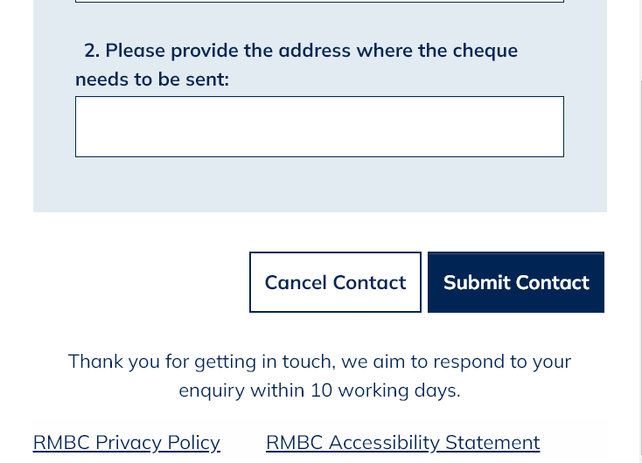

Home Contents Insurance – Request a Claim Form
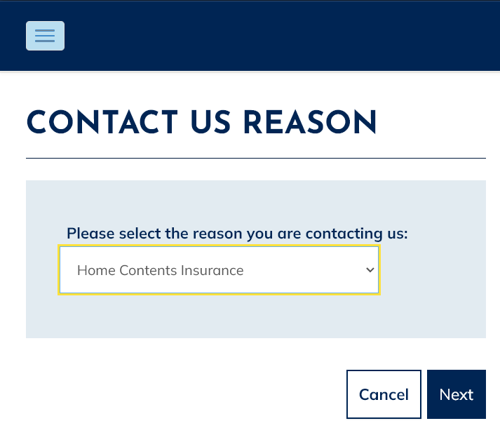
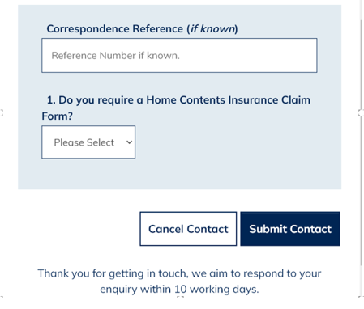

Permission for Pets Request
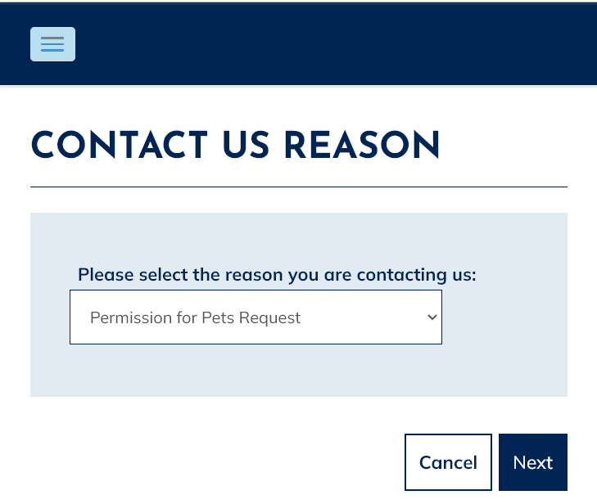
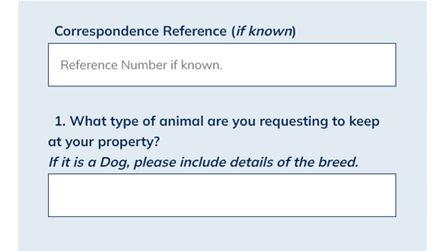

Request Permission for Tenant Alterations
