16 August 2022
David Phiri
Rotherham Metropolitan Borough Council
16 August 202
Section 19 Flood Investigation Report for Delves Lane, Wales.

Contents
Introduction 1
Legislation 1
Pitt Review (2008) - Flood and Water Management Act (2010) 1
Local Flood Risk Management Strategy 2
Overview. 3
Risk Management Authorities 4
Risk Management options. 5
Option 1. Property flood resilience. 5
Option 2. Increase Attenuation 6
Option 3. Updating the existing system. 6
Conclusion 6
Miscellaneous 7

Introduction
The year started with heavy rainfall and flooding caused by three separate storm events, Dudley, Eunice, and Franklin that caused widespread flooding to both properties and businesses across the UK. Rotherham experienced some external flooding and large areas of highway flooding, with some main arterial routes having to be closed. Main Rivers and watercourses did reach peak levels and some overtopping occurred, however not to the magnitude witnessed in 2019.
Intense heatwaves were experienced in the United Kingdom and in several parts of Europe and North Africa during the summer. The first of three heatwaves occurred in June: the second for three days in July, and finally for six days in August. During August the weather changed to thundery showers over some areas of the UK. Within Rotherham, many areas had flash downpours of rainfall that caused drainage systems to quickly reach capacity. This caused ponding to occur for short periods on the highway. However, no weather warnings were issued at that time by the Met Office.
Wales in Rotherham experienced an isolated rainfall event on the 16th of August 2022 that affected six properties with internal flooding. Both from surface water and foul water.

Legislation

Pitt Review (2008) - Flood and Water Management Act (2010)
The Pitt Review was published in 2008 following the catastrophic floods in 2007 which resulted in 13 fatalities and widespread destruction. The review contained 92 recommendations from lessons learnt. These were addressed to the government, local authorities, Local Resilience Forums (LRF), insurers, the public, and providers of essential services.
In response to the Pitt Review, a new Act of Parliament called The Flood and Water Management Act was implemented.
The Flood and Water Management Act was published in 2010 to take forward the Pitt Review recommendations and create a national approach to flood risk management across England and Wales. The creation of Lead Local Flood Authorities (LLFA) formed part of the Act along with Risk Management Authorities (RMA) all of whom have responsibilities in the management of flood risk.
As LLFA, Rotherham Metropolitan Borough Council is responsible for the coordination and management of local flood risk (ordinary watercourses, surface water, and groundwater) and is required to work in cooperation with relevant authorities and RMAs. Other agencies and authorities defined as the RMAs (Part 1.1 Section 6) include:

• the Environment Agency

• a District Council for an area for which there is no unitary authority

• an internal drainage boards.

• a water company.

• a highway authority

Under Section 19 of the act (Part 1.3 Section 19), as the LLFA, RMBC has the duty to investigate flood incidents and publish the results of the investigation.

The act states that:

- On becoming aware of a flood in its area, a lead local flood authority must, to the extent that it considers it necessary or appropriate, investigate—

- which risk management authorities have relevant flood risk management functions,

and b) whether each of those risk management authorities has exercised, or is proposing to exercise, those functions in response to the flood.

- Where an authority carries out an investigation under subsection (1) it must—

- publish the results of its investigation

b) notify any relevant risk management authorities.

The extent to which a particular flood is investigated is determined on a case-by-case basis considering factors such as the source, duration, geographical spread, and severity of impact. In some circumstances, a flood enquiry triggers a formal investigation. The trigger for a formal investigation is when the enquiry meets or exceeds locally agreed criteria. This was the case with the August 2022 rainfall event and therefore a formal flood investigation was implemented in line with Section 19 of the Act as set out in this report.

Local Flood Risk Management Strategy
The Local Flood Risk Management Strategy was originally produced by Rotherham Metropolitan Borough Council in 2014 and has recently been updated taking into consideration the recent devasting floods of 2019 and recent changes from climate change. This sets out how the local flood risk within the borough will be managed.
The general principles of the Local Flood Risk Strategy are:
- Community focus & partnership working
- Sustainability
- Risk-Based Approach
- Multiple benefits

The Strategy identifies objectives that have recently been met, and how they have been achieved. It also Includes new objectives more suited to the ever-changing climate.

Overview.
On the 16th of August 2022 it was reported to Rotherham Metropolitan Borough Council that Delves Lane and School Road, in Wales, had flooded (the photo below shows the flooding at Delves Lane). The flooding followed heavy rainfall and resulted in damage to the last five properties on Delves Lane, and one property on School Road (barn house). All 6 properties were flooded internally. The water brought with it loose debris from the road, refuse and waste
from the village.
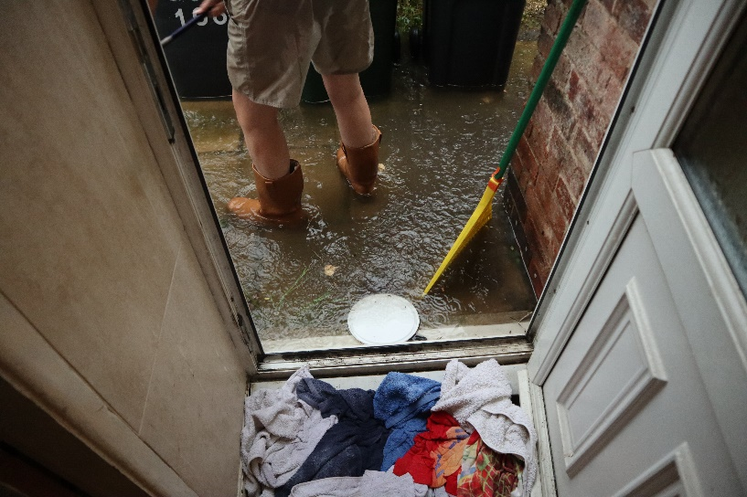
DELVES LANES
.

Due to the extreme weather event; the surface water from the playing fields behind the houses on Delves Lane ran down, flooding the terraced houses. It is assumed the current drainage system in the area cannot handle the sheer volumes water due to a lack of entry points or capacity. This caused the highway surface water to rise over the kerb; run off onto private property, and backflow into the sewers. Yorkshire waters’ system on these private properties connect to a manhole owned by RMBC, and upon inspection the 4-inch pipe between houses 103 and 104 was clear. However, the water level in the gullies from the highway (connected to this manhole) was high. This is because the 4-inch clay pipe connecting the gullies to the manhole was blocked.
A Yorkshire water engineer was sent to have a look at the drainage system and see if there were any blockages. A CCTV survey was carried out on properties 99-104 and no issues or defects where present.
The property on School Road and the Barn House, flooded due to surface water running down from the village and entering the property driveway at a substantial rate of flow causing the property to quickly flood.

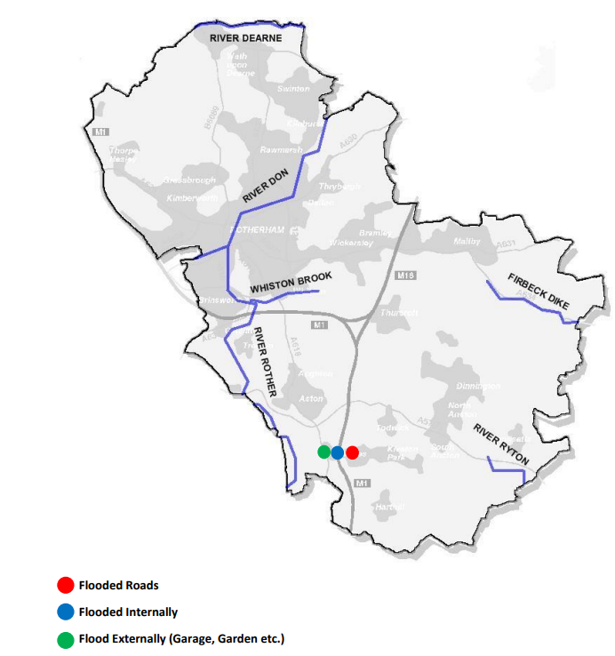

Risk Management Authorities
Risk Management Authorities (RMA) have flood risk management functions according to the type of flooding as follows:
- Main Rivers - Environment Agency
- Ordinary Watercourses - LLFA
- Surface Water Flooding - LLFA
- Public Sewers - Water Company
- Highway Flooding - Highway Authority
The identification of an RMA as having these functions does not imply that the RMA has responsibility or liability for the flooding, or for taking any action beyond investigation.
Risk Management Authorities that have flood risk management functions relating to this flooding incident are:
Residential Property address | Number of properties flooded internally | Risk Management Relevant Flood Risk Management Functions | Risk Management Function Exercises or Proposed to be Exercised
Delves Lane 104, 105, 106, 107, 108, 109 | 5 | Rotherham MBC and Yorkshire water as LLFA | Yes
Barn house, School Road | 1 | Rotherham MBC and Yorkshire water as LLFA | Yes

Risk Management options.
Several of the flooding incidents investigated for this report followed a similar pattern. Highway drainage systems were overwhelmed by the high-intensity rainfall over a short period, which led to water flowing from the highway towards residential properties.

Rotherham’s Section 19 policy states that investigations will be carried out if there are 5 or more properties flooded internally. However, the definition of internal flooding is unclear. During this event, several of the properties had peripheral parts such as inside toilets flooded and it is uncertain whether this should be classed as internal flooding. It is proposed that in the future, internal flooding will be defined as flooding above floor level in habitable rooms. The Planning Portal definition of a habitable room will be adopted. It states ‘any room used or intended to be used for sleeping, cooking, living, or eating purposes. Enclosed spaces such as bath or toilet facilities, service rooms, corridors, laundries, hallways, utility rooms, or similar spaces are excluded from this definition.
During these investigations, it became apparent that there was information about highway drainage systems recorded on easements held by the Council’s Land Terrier section. As part of the operation to map highway drainage assets, information about these easements will be added to the highway drainage records.

Option 1. Property flood resilience.
Flood Resilience generally means that damage is minimised during times of flooding, resulting in less risk to people and infrastructure. It also means that flood recovery may be less expensive allowing people to recover more quickly than in past flood events. This would also prevent the water resource from being negatively affected and would allow it to recover on its own. It is a way of helping people and communities live with, and plan for flooding.

Several measures can be implemented to limit water entry to a property.
- Barriers can be fitted to openings such as doors and windows, providing a seal to limit floodwater entry.
- Automatic flood doors can be closed and locked on receipt of a flood warning.
- Non-return valves (NRVs) can be fitted to drains around your home to prevent floodwater or sewage from backing up into the property.
- Airbricks can be replaced with automatically closing airbricks to create a seal against floodwater.
- Pumps can help keep floodwater at manageable levels for those at risk of rising groundwater entering through the floor.

Option 2. Increase Attenuation
The second option would be to increase the area attenuation. This would mean that we can store more water and slow down the flow. The water would be collected and routed into the sewer the normal way, but with the use of flow controls this allows a controlled volume to flow through into the main system. Installing a retaining wall on the playing field would prevent water flowing from the field to the private properties. This would also allow the water to be routed to the main system without causing flooding by retaining water on the fields for longer.

Option 3. Updating the existing system.
The third and final option would be to increase the capacity of the current drainage system. We believe the short burst of rain that occurred 16th of August 2022 and caused internal flooding overwhelmed the current drainage system. Therefore, upgrading the system could mitigate the risk of flooding to the surrounding properties. This can be done by increasing the pipe sizes allowing a greater rate of flow. This is more costly than the other two options but could also prove to be more effective.

Conclusion
This Section 19 Report identifies the Risk Management Authorities relevant to each flood location, but detailed consideration of further investigations and action is beyond the scope of this report.
Where the principal RMA identified is not Rotherham Council, the relevant RMA will be the primary contact for further information.
Where the Council has been identified as the principal RMA, investigations are ongoing. The investigations will identify where flood alleviation measures may be feasible and where applicable schemes will be promoted, but this is subject to funding being available.
For further inquiries about surface water flood risk please contact LLFA@rotherham.gov.uk or 01709 822152

Miscellaneous

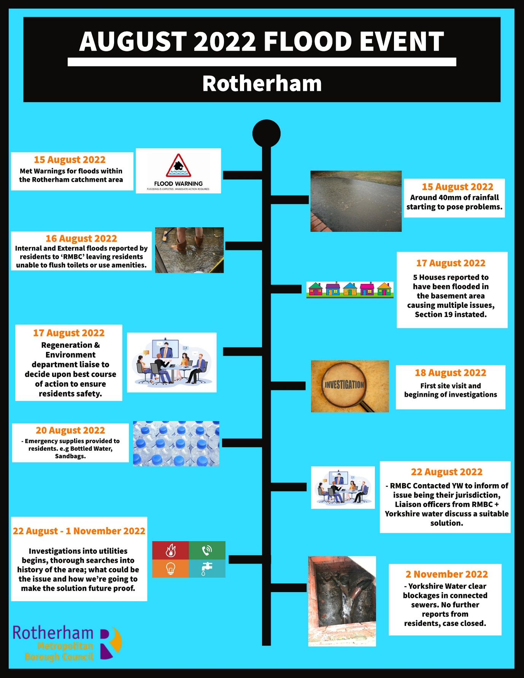

Community – Barn House, Sheffield
Location | Church Street
Overview Location Map  (Google Maps) | 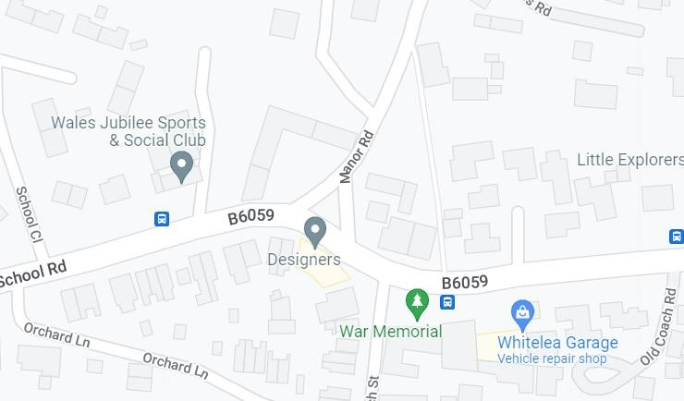
Number of properties affected | 1
Fluvial Risk | Source | Risk | Flood Zone | Responsible risk management authority
 | Rainfall | Very Low | 1 | RMBC & YW
Tidal Risk | Risk |  | Details
 | No |  | N/A
Surface Water Risk | Risk |  | Details
 | Low |  | Surface water overflowed from highway into private driveway, blocking both the entrance and exit.

Community – Wales, Sheffield
Location | Delves Lane
Overview  Location Map  (Google  Maps) | 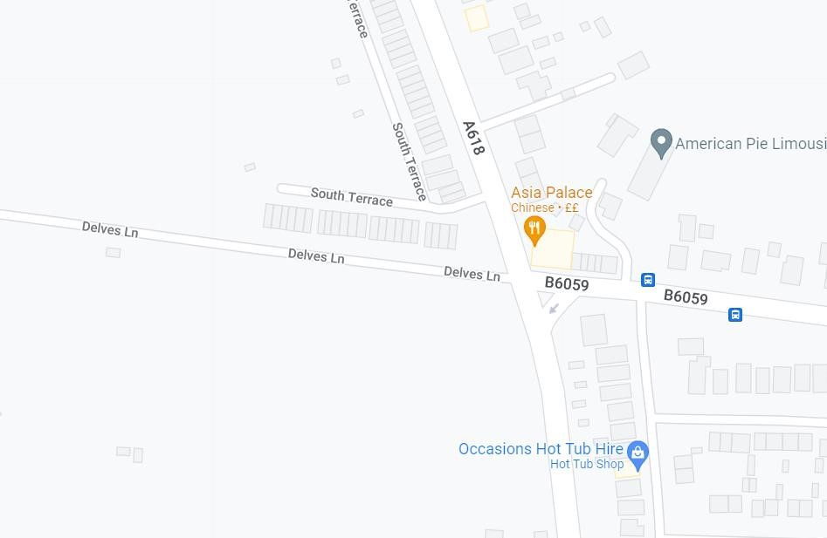
Number of properties affected | 5
Fluvial Risk | Source | Risk | Flood Zone | Responsible risk management authority
 | Rainfall | Very Low | 1 | RMBC & YW
Tidal Risk | Risk |  | Details
 | No |  | N/A
Surface Water Risk | Risk |  | Details
 | Low |  | Water culminated from the field to the rear of No. 104  Back-Alley flooded, basements flooded due to connected sewers  Water spread down alleyway, onto adjacent road.

