My Transition Passport 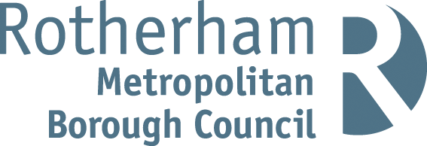
This is me
(add photo with permission from parent/carer)
My full name is
I like to be called
My date of birth
Home Language/ EAL

My attendance in setting is cause for concern
Yes | No
Comments

People who are important to me / my family and support network
(This section is about acknowledging the child’s relationships and their wider support network.)

Details of any funding that I receive and why I have it
(Do I have an EHCP, ISG or receive any support?)

People/services who support me and my family
Early Help | Yes/No
Social Care | Yes/No
CDC | Yes/No
Inclusion Support | Yes/No
SALT | Yes/No
Any others

The most important things that have happened in my life so far
(This may include either positive or negative events that the child has experienced in their lives so far.)

The most important things to remember when supporting me are
(This may include needing lots of time, needing encouragement, preferring to be away from others, needing quiet spaces etc.)

SEN | SEMH | S and L | Intimate Care | Medical / Allergies | Other:
Additional Resources / Strategies:  For example: PECS, Visual timetable |  | Add information if needed |  | Add information if needed
Whole child

Where am I with my learning and development
Area of Learning | On track (tick) | Not on track (tick)
Communication and Language
Listening, Attention and Understanding
Speaking
Personal Social and Emotional Development
Self-Regulation
Managing Self
Building Relationships
Physical
Gross Motor Skills
Fine Motor Skills
Literacy
Comprehension
Word Reading
Writing
Mathematics
Number
Numerical Patterns
Understanding the World
Past and Present
People, Culture and Community
The Natural World
Expressive Arts and Design
Creating with Materials
Being Imaginative and Expressive

What support or additional action is needed to support my development
(Where the child is not on track for an area of learning – use this box to indicate what actions have been taken so far, what discussions have been made with parents, have referrals been made, is an IEP in place or support from other agencies. If a child is on track in all areas what are your plans next for this child)

Name of setting/room child is transitioning from
Name of setting/room child is transitioning to

Name of person completing this form
Contact details

