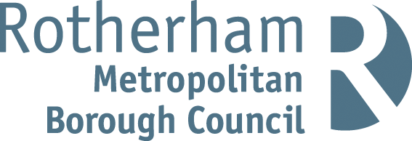
Rotherham MBC Parking Account 2022 / 23
Statistical Information
Number of higher-level Penalty Charge Notices (PCNs) issued | 6,916
Number of lower-level PCNs issued | 5,019
Number of PCNs paid | 8,433
Number of PCNs paid within 14 days | 6,572
Number of PCNs against which a formal or informal representation has been made | 2,758
Number of PCNs cancelled (i.e., where an informal or statutory representation is successful) | 1,403
Number of PCNs written off | 462
Number of vehicles impounded | 57

The above statistics are accurate as of 16th October 2023. These statistics can be subject to change on a daily basis due to the ongoing debt collection procedures.
Financial Information
The total income and expenditure of the on-street and off-street parking account for 2022 / 23 was as follows:
Expenditure £953,111
Income
Income source | £
Penalty Charge Notices | 308,000
Off street paid parking | 368,877
On street paid parking | 286,029
Permits | 93,262
Enforcement Agents (bailiffs) | 50,469
Miscellaneous income | 104
Total income | 1,106,641

Net Surplus £153,530
Note: Income for PCNs issued in 2022/23 may increase because, in cases where PCNs remain unpaid beyond the statutory period, the Council has a policy of registering the debts at the Traffic Enforcement Centre (TEC) at Northampton County Court. This is the Court which deals with all parking debt in England (outside London). Once a debt is registered the debtor is given a further 21 days to settle the debts before Enforcement Agents (formerly known as bailiffs) are appointed. Any income collected after 31/03/2023 from PCNs issued during 2022/23 will be credited to the Parking Account for 2023/24.

