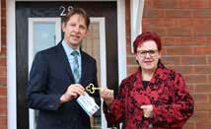
The magazine for Rotherham Council tenants and leaseholders
HOME
WINTER 2023

matters

Open Day 500 new homes Garden winners
HERO TASH
CHAMPIONING OUR YOUTH

www.rotherham.gov.uk/housing

HOMEmatters

Welcome to the winter 2023 edition of Home Matters
efforts and standards against what are challenging times for many residents.
The spring and summer has continued to be a difficult time for residents in the face of health, social and economic challenges caused by the rising cost of
living and in particular soaring energy prices.
Remember that there is a range of support out there if you are
has done so much for the local community and rightly deserves to be recognised (page 8).
The Winter brings with it its own challenges and some of this issue is dedicated to some of the problems that can arise.
There are details around the new Damp and Mould Policy that the Council has introduced and reminders to have your boiler checked (Page 15).
I’m also pleased to see a new Health Matters column which features some helpful advice for residents as we move into the festive season.
I finish by reminding you that the wellbeing of residents

Hello! I’m Councilor Sarah Allen and I’m honoured to introduce my first foreword in Home Matters.
I would like to begin by acknowledging the efforts of my predecessors in making the housing service the success that it is and I hope to maintain the
feeling stressed or anxious with the rising cost of living, including the Open Arms Community Support Hubs which are run by RotherFed (page 14).
Against this backdrop, it is very pleasing to see that this edition features an inspiring story of one of our tenants, Tash, who
continues to be of the upmost
importance to the Council, and the housing team are here to help you however they can.
Councillor Sarah Allen Deputy Leader of Rotherham Council and Cabinet member for Housing

GET TO KNOW YOUR AREA MANAGER
Name: James Smith
Job title: Tenant Engagement Manager
Length of service: Seven months

Favourite film: Lord of the Rings – seen too many times!
Favourite hobbies:
Swimming and cycling
Favourite snack: It used to be chocolate Hobnobs, but I’ve shelved the sugar so at the minute it’s grapes and nuts!

James and his daughter snow sledging
Something that makes you happy: I volunteer at a youth club on weekends for autistic children, which I really enjoy.
“I love providing opportunities for tenants to give their feedback and encouraging our housing teams to use them wisely and do the right things for our tenants.” – James Smith

2 WINTER 2023 Discover more online www.rotherham.gov.uk/housing

TENANTS OPEN DAY 2023
Rotherham Council’s Housing Service and Rotherham Federation’s tenants and residents open day was back bigger and better than ever at the
New York Stadium on 31 October.
The event provided an opportunity for tenants to find out what was happening in housing services, discover more about key achievements over the last year, find out about local groups, meet other tenants and put questions to members of Council staff.

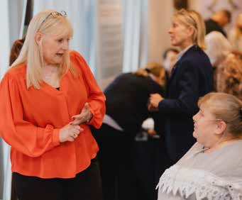
There was also a ceremony for Rotherham Federation staff.
Tenant Diane Rice said: “I went to the Tenant Open Day with my friend who doesn’t live in Council housing. She was very surprised with the services there and their freebies.
“She was surprised how tenants have a say and the communities that come together too.”
Tenants also enjoyed a delicious pie and pea lunch as part of the celebration.

Discover more online www.rotherham.gov.uk/housing WINTER 2023 3

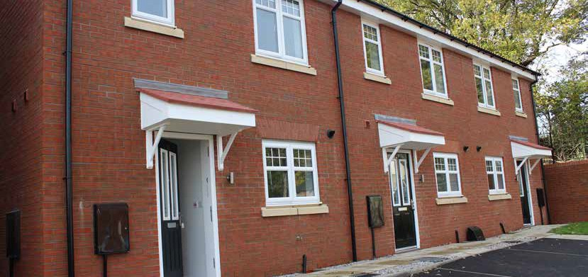
CELEBRATING 500 NEW HOMES IN ROTHERHAM

Over the last few years, the Council has been working to create hundreds of new homes for residents across Rotherham.

Recently, the Council celebrated a key milestone when it had the formal handover of keys to the 500th new property this week.
The house, located in the Paddocks development, Wickersley, will be a Council house with a new tenant expected to move in before Christmas.
The house has been built by Harron Homes and will offer the occupier a spacious two-bedroom home with its own garden and handy features built in such as a shed base, outside tap and under the stairs storage.
We’re hoping the lucky new occupier will love this house as much as our team did when they went to have a look around the property and cut the ceremonial ribbon in November.
Rotherham Council’s Deputy Leader, Cllr Sarah Allen, said: “Reaching the 500 home mark in the Council’s pledge to create more affordable, high quality homes for residents has been an incredible journey for everyone involved, from our own members of staff to our contractors and private home builders to those who have made these properties their homes.
“We are grateful to Harron Homes for participating in the scheme and helping us reach this all- important milestone. Rotherham Council works to provide support for all those in our community and we are glad we can offer affordable housing to those who need it most. As a Council we have an important part to play in addressing the challenges faced and achieving better outcomes for the people of Rotherham.
“We are proud that we have been able to offer a range of properties including apartments, bungalows, and family homes either through social housing, private sale or shared ownership.
I look forward to seeing the next 500 homes being built and giving more residents and families the opportunity to make their own homes in the future.”
Paul Walters, Harron Homes North Midlands Sales Manager, said: “It was an honour to celebrate this important milestone with Councillor Allen. Our teams dedicate themselves to delivering the highest quality in all areas and we are proud our homes can assist Rotherham Council in its goal of providing families with affordable housing. We look forward to continuing this relationship to support our local communities.”

4 WINTER 2023 Discover more online www.rotherham.gov.uk/housing

500 HOMES ACROSS THE BOROUGH
Did you know that 500 homes have all been built or acquired by the Council since 2018?
There are lots of developments happening across the borough, big and small to provide more housing for residents. Some of these have been built directly by the Council’s contract partners or have been purchased from private developers.
Earlier in 2023, the Council’s flagship housing developments in Rotherham town centre were complete with 171 new homes being made available for rent, shared-ownership or private purchase in Wellgate Place, Westgate Riverside and Millfold Rise.
Similar schemes are currently being developed or have been completed in areas such as Rawmarsh, Maltby, Broom, Dinnington and Treeton.
In October, Cabinet agreed to 76 new Council homes in Eastwood and Maltby and in November, it agreed to build 13 homes in Canklow. It’s an exciting time for housing projects and we look forward to giving you more updates about the projects in future editions of Home Matters.
Are you one of the first
500 TENANTS who have moved into the NEW COUNCIL HOMES?
If you are then we’d love to hear about your experiences. Please get in touch by emailing sarah.watts@rotherham.gov.uk

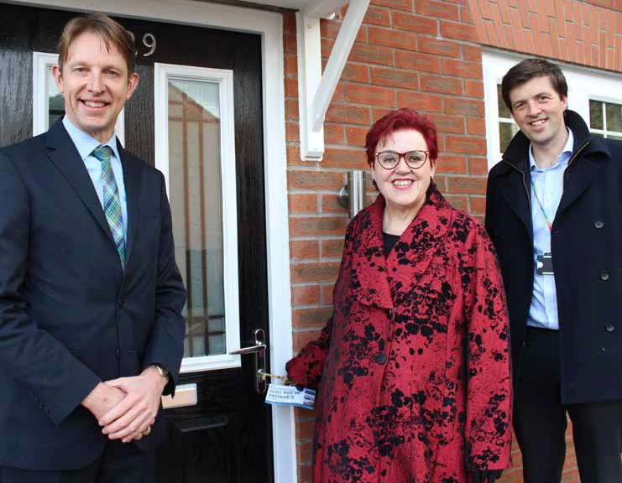

From left, Paul Walters, Harron Homes North Midlands Sales Manager, Rotherham Council’s Deputy Leader, Cllr Sarah Allen and James Clark, Rotherham Council’s Assistant Director of Housing.
Further information about housing in Rotherham can be found on the Council’s website at www.rotherham.gov.uk/housing

Discover more online www.rotherham.gov.uk/housing WINTER 2023 5

HEALTH MATTERS
Be active. Regular physical exercise is a great way to improving your physical health, fitness, and your mental wellbeing. It can positively raise your mood and also help raise your self- esteem, which in turn can help you set goals and achieve them. Take a 15 minute walk in the park or how about a gentle bike ride?
C

Give. Even small acts of giving and kindness can help improve your mental wellbeing by creating positive feelings and a sense of reward, giving you a feeling of purpose and self-worth and helping you connect with other people.
I
N
A
G
O
E
C
B
E
K
G
E
T
V
C
I
E
E
T
N
V
Welcome to the new Health Matters column. This regular column features information and advice from local services.

BE PREPARED FOR WINTER
Winter can add challenges to people already managing their health conditions, especially during periods of severe weather. The dark nights are upon us and the temperature has dropped.

Connect. Pick up the phone and call a loved one, or pop in on that neighbour you’ve been meaning to catch up on.
Five Ways
to Wellbeing
The Five Ways to Wellbeing on the Wellness Hive – RotherHive identify things you can do to help yourself stay well during the Winter.

To visit the Wellness Hive website by visiting rotherhive.co.uk/wellness-hive There are also practical steps you can take to help you to provide support to your loved ones.

Take Notice. Paying more attention to the present moment can improve your mental wellbeing. This includes your thoughts and feelings, your body and the world around you. Some people call this awareness ‘mindfulness’.

Keep Learning. Learning new skills can improve your mental wellbeing by boosting self- confidence and raising self-esteem – helping you to build a sense of purpose and helping you to connect with others.
N
E
L
E
P
K
E
A
T
E
N
C
I
I
N
T
R
O
A
It’s important to get your seasonal flu and COVID-19 vaccinations if you’re at higher risk of getting seriously ill from these illnesses. You can book these at your local GP practice or you can check if your local pharmacy offers the vaccination service. Prescriptions for any medications you take regularly should be ordered with plenty of time, especially at busy times. such as the week before Christmas.
Get more advice and support online at yourhealthrotherham.co.uk

6 WINTER 2023 Discover more online www.rotherham.gov.uk/housing

TO FEWER HANGOVERS THIS FESTIVE SEASON

It’s that time of year when we start to get into the festive spirit when people meet up with family and friends. It’s also that time of year where harmful levels of alcohol can take their toll, which can impact on your health, your relationships and can lead to long term harm.
If you or a loved one are looking to take control of your drinking then DrinkCoach can offer you support to cut down on your alcohol intake so that you can make the most of the festive season.
DrinkCoach offers free advice and counselling to residents living in Rotherham which you can access online or through their app.
Visit drinkcoach.org.uk
RotherHive has lots of advice and information on various areas including how help you cut down on your alcohol intake, the signs to look out for if you are concerned with the amount someone is drinking and local and national support groups

Visit: www.rotherhive.co.uk/wellness-hive.
A self-help guide is available at www.selfhelpguides.ntw.nhs.uk/rotherhamccg

TAKE THE TIME TO TALK
If you’re feeling a bit under the weather, it’s OK to talk to someone about how you’re feeling. Others may be feeling the same way too, so it’s important to support family, friends and loved ones through the winter months by keeping in touch with them.
Across Rotherham, there is a range of mental health and loneliness support.
Take a look below to see what works for you:
RotherHive – an online bank of verified practical mental health and wellbeing information, support and advice for adults in Rotherham.
Visit www.rotherhive.co.uk
IESO – sessions take place online, writing to one another via computer, smartphone or tablet.
Visit www.iesohealth.com
NHS Rotherham Talking Therapies – talking therapies for adults who are experiencing common mental health problems such as depression, anxiety and stress. Visit talkingtherapies.rdash.nhs.uk
Kooth – a British Association for Counselling and Psychotherapy accredited service, providing a free, safe and non-judgemental place for young people to connect with others and know they are not alone. Visit www.kooth.com
Qwell – The service runs alongside Kooth.com and is for over 18s only. It’s a platform that can be accessed from any internet device 365 days, 24/7. Visit www.qwell.io
Warm Welcome Spaces – There are several Warm Welcome Spaces across the borough that offer
a warm, safe place they can go to get advice, guidance or stay connected with family or friends. Visit www.welcomewarm.uk
Be the One – This website has lots of information on about spotting the signs someone may be thinking about suicide, having conversations
and what the response should be. Visit www.be-the-one.co.uk/
Amparo – A suicide liaison service offering practical and emotional support to all those bereaved and affected by suicide. Phone 0330 088 9255 and leave a message and a member of the team will call you. Visit amparo.org.uk
Walk with Us – A resource for children, young people and families bereaved by suicide.
Visit chilpep.org.uk

Discover more online www.rotherham.gov.uk/housing WINTER 2023 7

Did you know that there are a number of youth clubs in Rotherham each working to foster a sense of community among young people?
LOCAL HERO
TASH VAUGHAN
Changing Rotherham’s Youth Scene for the Better
We’ll touch on clubs covering Blackburn, Rawmarsh, Dinnington and Dalton in this article and be shouting about youth clubs covering our other areas in future editions.
Our spotlight is on New Inn Phoenix FC where our very own tenant and award-winning volunteer Tasha Vaughan is making a big impact.
Tash proudly identifies as non-binary and embraces their ADHD and autism, bringing a burst of energy to our communities with activities centred around football, fun, and development for local youth.
In Tash’s words, joining the team wasn’t just about filling a role; I was answering a calling.
Tash explains: “I joined because I saw a need for real commitment. It’s not just about participation; it’s about building a community that believes in the potential of every individual.”
Tash adds: “We wanted to do something great rather than just good. Bringing the community together takes belief. It only takes one person to make that difference.” Tash and their team believe community building goes beyond just showing up - it’s about making a real impact in people’s lives.
Tash’s initiatives focus on the power of sports, especially among youth people. By connecting kids and adults through football, Tash creates affordable opportunities for parents to enable their children to take part in activities.
“We want to form clubs and get adults involved. We’ve wanted to do this by making it as affordable as possible for parents, providing something meaningful for a couple of hours on a Saturday.”
Tash’s commitment to community-building has led to success. Their work was recognised nationally in September when they were highly commended by The Association of Retained Council Housing at the Community Champion Awards 2023.
Collaborating with other volunteers and receiving support from the Council has been integral to Tash’s success.
“Working with other volunteers and support from the Council enables us to do our best by the people in our care. It’s a collective effort to make a positive impact on the community.”
Tash’s unique perspective shapes their approach to inclusivity. They actively challenge gender binaries and works towards creating a welcoming
environment for everyone. Conversations take place on topics like autism, ADHD, and LGBTQ+ issues.

8 WINTER 2023 Discover more online www.rotherham.gov.uk/housing

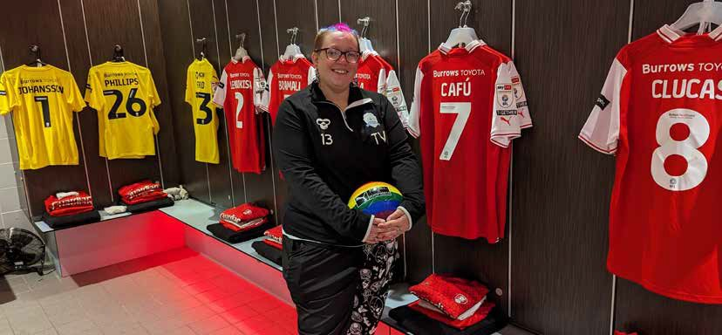
Tash envisions expanding their youth intervention schemes to include more diverse groups. They aim to create a safe space for individuals within the LGBTQ+ community by collaborating with individuals and organisations.
Tenant and award-winning volunteer, Tash Vaughan
“We’re looking to expand, making our initiatives accessible to more people. It’s about creating a
group that welcomes everyone, regardless of their background or identity.”
“We need more volunteers. Even if it’s just lending a helping hand or offering support, it all starts with one conversation. All you need to do is to give an hour of your day to make a massive impact.”

It’s not just Tash that’s championing the causes of our youth. Here’s some info about three more fantastic clubs that are going strong in Rotherham:

Youth Club Name | Purpose | Contact
The Send Youth Club and Peer Support Programme | The youth club covers Dinnington and Dalton and provides a nurturing space for young people with special educational needs and disabilities, and a safe space for parents and carers to get together and talk about their experiences. | Search for the club on Facebook  or email: Send.youthclub@gmail.com  for more info
Rotherham Blackburn Club for Young People | The club covers the area of Blackburn and runs engaging activities and a friendly atmosphere for local youth. | Visit: www.rotherhamblackburncyp.com/  Or call 07834765013 for more details
Rotherham Parent and Carers Forum | A registered charity in Rawmarsh, run by and for families of children and young people (aged 0-25) who have Special Educational Needs and/or Disabilities (SEND). | Call 01709 296262  or email: admin@rpcf.co.uk
If you’re a parent or young person that could benefit from these fantastic clubs, don’t hesitate to get in touch with them directly.
To find out what other youth clubs are doing in the borough or to let us know of something that is happening for young people in your area, please email the Tenant Engagement Team:
customerinvolvement@rotherham.gov.uk

Discover more online www.rotherham.gov.uk/housing WINTER 2023 9

KIDS’ CORNER
There are lots of fun things happening in Rotherham over the next few months, especially as we get closer to Christmas. If you’d like to get into the Christmas spirit, here are some events and activities taking place this holiday season:
GIANTS OF ROTHERHAM WORDSEARCH
Can you find all 10 words?
GIANTS BOOK
CLIFTON
STORY MUSEUM ART
PAINT
FUN
DANCE
MUSIC

Cinderella Pantomime
at Rotherham Civic Theatre, showing until Sunday 7 January.

Childrens Christmas Craft Sessions
at Aston Library and Neighbourhood Hub
from Friday 1 December to Saturday 23 December from 10am and at Wickersley Library and Neighbourhood Hub from Tuesday 5 to
D | G | M | U | S | E | U | M | H | Y
F | S | F | W | C | M | U | S | I | C
D | T | G | G | L | T | B | O | O | K
A | O | P | B | I | U | X | W | J | F
N | R | A | O | F | A | L | A | Z | U
C | Y | I | O | T | G | N | R | L | N
E | T | N | X | O | A | B | T | P | Y
A | A | T | O | N | C | V | Q | S | R

Tuesday 19 December at 4pm to 5pm.

Festive Fun
at Dinnington Library and Neighbourhood Hub on Monday 18, Wednesday 20, and Friday
22 December from 3.30pm to 5pm.
Libraries across the borough have a range of Christmas events and activities available
throughout December, visit the libraries webpage at www.rotherham.gov.uk/libraries or visit Rotherham Libraries Facebook and X (Twitter) page.

A MAGICAL CHRISTMAS ADVENTURE
Step into a world of wonder and excitement with our unique and extraordinary holiday experience. Get ready for an adventure like no other, filled with enchanting activities and delightful surprises.

Ticket prices:
£15 to £22 Adults /
£20 to £25 Children over 2 / £9 Children under 2 (Children’s tickets include a gift).
Sat 9, Sun 10, Sat 16,
Sun 17, Sat 20, Thu 21,
Fri 22, Sat 23 and
Sun 24 Dec

Clifton Park

For more details and to book your tickets visit: www.cliftonparkrotherham.co.uk/special- events/christmas

10 WINTER 2023 Discover more online www.rotherham.gov.uk/housing

RESIDENTS BLOOM
at annual garden competition celebration event
Winners of Rotherham Council’s much loved annual garden competition were crowned at a celebration event held at Clifton Park’s Garden House on Monday 12 September 2023.

The competition celebrates residents who make a real difference to their communities by taking pride in their gardens and, in turn, making Rotherham estates cleaner, greener and safer places to live.
This year there were 56 gardens entered into the competition across a variety of categories, including Best Garden, Best Pots, planters and hanging baskets, Best Wildlife or Sustainable Garden and Best Young Gardener.
June Smith was the winner of the best pots and planters and hanging baskets category.
She often has people stopping outside her home to admire the dozens of impressive displays she has created.
June said: “I had a hip replacement last year and gardening has helped me to get back on my feet.
“I love it. It’s so good for your health and I would encourage everyone to do it.”

Best Young Gardener
Harry

Awards for all four categories were presented by the Mayor of Rotherham, Councillor Robert Taylor. The first-place winners of each category received a £100 high street voucher while the runner up of each category received a £50 high street voucher.
All winners and runners up received a certificate so that they can show off their gardening prowess in their homes.

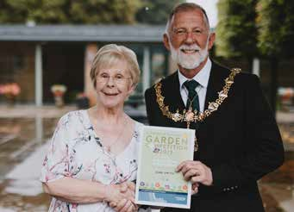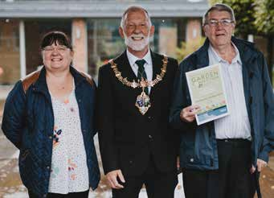

Best Pots, planters and hanging baskets winner
June Smith

Best Pots, planters and hanging baskets runner-ups
Steve and Sharon Smith
To learn more about improving local areas go to the tenant involvement web page at
www.rotherham.gov.uk/housing
Council tenants who are inspired to enter next year’s competition should look out for entry forms usually available from spring.

Discover more online www.rotherham.gov.uk/housing WINTER 2023 11

NEIGHBOURHOOD CENTRES

Did you know that the Council’s Housing Service manages 45 neighbourhood centres around the borough, which form part of the service offer to designated tenancies?
The centres offer a space for tenants and community groups to get together to plan and deliver activities for residents and the wider community. These activities include lunch clubs, gardening groups, ‘knit and natter’ sessions, arts and crafts groups and much more!

The Council is keen to make the centres as welcoming and as vibrant as possible. Please get in touch with us if you would like help setting something up and making better use of your centre. Our friendly team will be happy to give you all the advice and support you need.
We would also like to hear from you if you’re currently using your neighbourhood centre for something that benefits your local area. We may even feature your centre in a future edition of the Home Matters.
In this edition, we’re taking a closer look at the Peregrine Way Neighbourhood Centre, in Harthill.
There are several different groups and activities happening at this centre on a weekly basis with more than 50 people attending across the week.
The centre can be booked for one-off activities and events, with past examples including a special celebration for the King’s Coronation, a tabletop sale and a local craft fair.
We asked the chair of the local Tenants and Residents Association, Sue Macdonald, what the centre meant to her and the people that use it.
Sue told us: “The activities and groups are not just for tenants; they are there for the whole community to enjoy. Anyone is welcome to attend, the more the merrier”.
“Our activities run every day between Monday and Thursday and include a coffee morning, arts and craft sessions, knit and natter sessions and
a two-course lunch provided by the Dinnington Resource Centre.
“Our music group will be returning very soon, and we run a gardening club on most days throughout the spring and summer.”
Council officers attend the centre with a regular housing drop-in session, attended by local Councillors, every eight weeks.

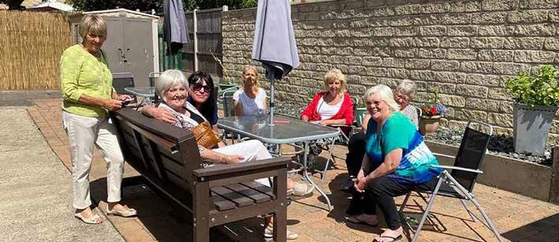

A group enjoying the outdoor space at Peregrine Way Neighbourhood Centre.
Visit: www.rotherham.gov.uk/housing
and use the Neighbourhood Centre booking form.

12 WINTER 2023 Discover more online www.rotherham.gov.uk/housing

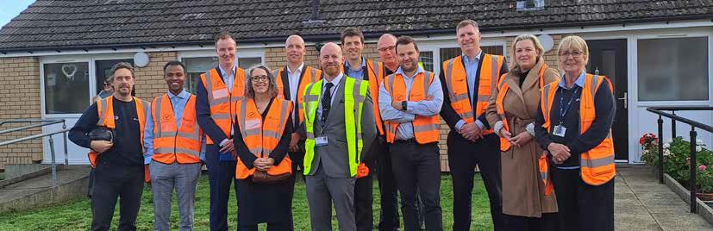
COUNCIL TENANTS GIVE A WARM WELCOME TO NEW ENERGY SAVING RETROFIT

Council Leader Cllr Chris Read and Chief Executive Sharon Kemp with representatives from Rotherham Council and Northern Housing Consortium.

Council tenants living on a Maltby estate have expressed their appreciation to Rotherham Council and energy and regeneration experts Equans, for the innovative retrofit of their homes.

130 properties in and around the Maltby area, have been part of a pilot project to install up to four thermal improvement measures including external wall insulation, cavity wall insulation, loft insulation and high performance windows and doors. Some properties also received new roofs.
The works could save them in excess of £400 in energy costs per year.
Maltby tenant Mrs Russell said: “This whole process has been more than worth it. In previous years I would have had to put my heating on in September, but not now. It’s lovely and warm and I’m already starting to notice a difference in my energy bills, which would have gone up substantially had the work not been carried out.”
Over the last year, Rotherham Council and Equans have been working with tenants to install the improvements, ensuring that their lives were impacted as little as possible throughout the build.
Steve Batty, Director of Sustainability at Equans, commented: “It’s been great to work together on this project, which has transformed the look of the homes, as well as improving their energy efficiency.
“Residents have told us that their homes feel much warmer in cold weather, and also cooler when it’s been hot - we’re so pleased they are already seeing the positive impact of the work that’s been done.”
On a visit to the site, tenants welcomed guests from the Northern Housing Consortium along with Council Leader Cllr Chris Read and Chief Executive Sharon Kemp into their homes to see the improvements.
Chief Executive of Northern Housing Consortium, Tracy Harrison said: “It was fantastic to see the work Rotherham Council has undertaken and to hear the difference it’s already making to people’s lives. The transformation we’ve seen to people’s homes in Maltby will make them warmer, more comfortable to live in and really help to address rising energy bills, which is urgently needed.”
Rotherham Council’s Leader, Cllr Chris Read, said: “This is just one of many ways the Council is looking to provide residents with high quality
homes that are more energy efficient and a lower cost to maintain. By working with tenants, we’re ensuring that their needs are met and we work around their commitments – just as any landlord should do.
“The project has been a great success. It also ties in with the Council’s climate change priorities where just last week we pledged to improve the quality of life for everyone in Rotherham, by delivering innovative projects. This is a fantastic first step for the Council, partners and tenants to become carbon neutral.”

Discover more online www.rotherham.gov.uk/housing WINTER 2023 13

If you’re feeling stressed or anxious about money or bills, there is a range of support available across Rotherham, including the Open Arms Community Support Hubs which are run by RotherFed.
COST OF LIVING SUPPORT

The Open Arms Community Support Hubs will be welcoming residents to get advice and support throughout the winter period. These community- based drop-in sessions are a one stop shop for information with local voluntary and community groups such as Citizens Advice, Laser Credit Union and Voluntary Action Rotherham attending to offer their advice and guidance.
We talked to Phil Hayes, CEO of RotherFed, about the Open Arms Community Support Hubs to find out more.
Phil said: “The Open Arms Community Support Hubs were set up last year and during that time we supported more than 800 residents with a range of questions, worries and situations. We’re delighted that we’re able to continue supporting residents this year.
“We run the Community Support Hubs across the borough including East Dene, Wath, Dinnington, Maltby, Ferham and Canklow. There are 10 venues in total and they are right in the heart of the community so they’re easy for residents to get to. That was the main aim of the project, to make this support available to everyone and make it as easy as possible to access.
“The best thing about the Community Support Hubs is that you get to talk to a real person who isn’t there to judge you, they’re there to listen and to give you advice so that you get the support you need.
“There are so many things we can offer advice on from applying for the right benefits, energy saving and paying energy bills, training if you’re out of work – honestly, there is so much we can offer.
If you have any questions or worries, please don’t keep them to yourself. Come along to your local Community Support Hub and have a chat with our friendly team.”
The project has been made possible by the UK Shared Prosperity Fund, part of the national government’s Levelling Up agenda, which was successfully secured by Rotherham Council and South Yorkshire Mayoral Combined Authority.
Drop-in sessions occur once every fortnight, 9.30am to 3.30pm.
Go online to find dates and locations of your local hub.

14 WINTER 2023
Discover more online www.rotherham.gov.uk/housing
If you are struggling with your bills, managing your tenancy or just have general money worries then please get in touch with the Rotherham Council’s Tenancy Support Team at rotherhamtenancysupport@rotherham.gov.uk
There are also more details regarding support and money-saving tips offered to Rotherham residents on the Council’s website www.rotherham.gov.uk/money-matters
Visit www.rotherhamfederation.org to find dates and locations of your local hub.

THE NEW DAMP AND MOULD POLICY

We know that having damp and mould in your homes can be a frustrating and concerning time. This is why in September, Rotherham Council’s Cabinet approved the new Damp and Mould Policy.

The main reason for having the new policy is that it not only has tips for residents to reduce their risk of developing problems with damp, mould and condensation, it also includes what is expected of the Council to support residents.
The Council has adopted a zero-tolerance,
pro-active approach to reports of damp, mould and condensation in all of its Council-owned properties.
This means that if you have a case of damp, mould or condensation in your home, the Council will:
- Arrange appointments to visit 100% of all damp, mould and condensation requests while prioritising those where the tenants or their families have been identified as being at an increased risk.
- Triage against the three-stage process which includes a more in-depth inspection and assessment at each stage of the process.
- Attend and investigate within 10 working days to determine the cause of damp, mould and condensation.
- Diagnose the cause of damp and deliver effective solutions. This includes dealing with the cause of the damp not just the symptoms and, wherever possible, “fixing first time”
and looking beyond the mould approach.
- Technical Officers will remove any mild cases of mould on the first visit and advise tenants on how to manage low levels of mould.
- Refer to a specialist damp contractor for bigger scale issues such as a defective damp proof courses or decayed timberwork. The Technical Officer will explain what will happen next.
- Refer to a specialist mould contractor where there is evidence of severe black spot mould and explain to the tenant what will happen next.
- Depending on the extent of works and tenant’s circumstance (health conditions), alternative temporary accommodation may be required in severe cases. The Council will support the tenant through this process.

To report any mould or damp issues, or get more information, go online to www.rotherham.gov.uk/housing
BOILER TESTING REMINDER
With the cold weather now upon us it’s important to make sure your boiler is working properly and if it needs any repairs to get them done as soon as possible so you are not left without heating.
If you have a problem with your boiler at any time during the year, contact our Housing Repairs team online or call us on 01709 336009.

Discover more online www.rotherham.gov.uk/housing WINTER 2023 15

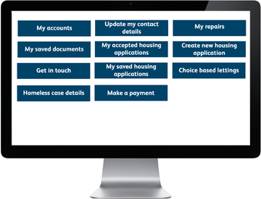
HOUSING ONLINE SERVICE

The Housing Online service allows you to perform several housing related tasks quicker and easier than ever before.

So far, 21,000 people have signed up to the service, which is available 24 hours a day, 7 days a week.
The service makes reporting a non-emergency repair and choosing an appointment slot simple to do
and enables you to do it anytime, without waiting and allowing you to schedule a repair at a time convenient to you.

HOW TO SIGN UP
If you are an existing tenant or a former tenant, you will need to register for an account using your rent reference number.
If you are not the tenant and live in one of our properties, please call us on 01709 336009 and we will provide you with your personal reference number so that you can register online.
For anyone wanting to join the housing register for the first time you simply need to enter your personal details to create an account.
HOW TO ACCESS IT

To access the online services please visit: www.rotherham.gov.uk/housing

GAS AND ELECTRICAL
CHECKS TO KEEP YOU SAFE!

In England and Wales, around 25 people die each year from carbon monoxide poisoning, and around 200 people are admitted to hospital for treatment.
It is a legal requirement for all landlords that an annual gas safety check is carried out in your home by a Gas Safe Registered Engineer.
A Carbon Monoxide Detector should be installed in the same room as a fuel burning appliance (e.g,
gas boiler). If your Council property has not had one installed, please contact us on 01709 336009.
An Electrical Fixed Wired test will also be carried out to your Council property every five years, to ensure that the electrics are safe and operating correctly.

REF: 87619/2023
CONNECT TO OUR SERVICES
ONLINE
All of our services are available 24/7 online www.rotherham.gov.uk
For housing information visit www.rotherham.gov.uk/housing

TELEPHONE
For housing enquiries and repairs call 01709 336009

