DIGNITY
THIRTY- FIVE YEAR PLAN
Current Strategic Overview
30th January 2024

Author: Richard Shepherd, Business Leader

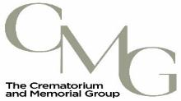

Table of Contents:

1 Introduction
2 Background
3 Current Strategic Overview – Open Cemeteries
3.1 Greasbrough Lane Cemetery
3.2 Haugh Road Cemetery
3.3 Maltby Cemetery
3.4 Wath Cemetery
3.5 East Herringthorpe Cemetery and Crematorium
4 Current Strategic Overview – Closed Cemeteries
4.1 Greasbrough Town Lane Cemetery
4.2 High Street Cemetery
4.3 Masbrough Cemetery
4.4 Moorgate Cemetery
5 Summary

1 Introduction
This strategic thirty-five-year plan, is designed to provide a current position overview to the Council, outlining the remaining levels of capacity within the nine municipal cemeteries that Dignity are contracted to manage, whilst also enabling more accurate forecasts on how best to manage the future service provision for the communities of Rotherham.

2 Background
The cemeteries highlighted in the plan have served the people of Rotherham for several generations and have provided a dignified and safe place to lay their loved ones to rest.
Despite the continued upward trend in requests for cremations remaining the most popular choice nationwide, burial requests are still very much sought after, and a healthy provision is needed and required to cater for families wishes and beliefs.
Several cemetery sites have already reached their capacity limit based on developed land at existing sites prior to the contractual agreement between Dignity and the Council commencing in 2008. Some of these cemeteries are considered closed sites, due to their age and restrictions on suitable land within, to carry out future burials.
However, this only limits the availability of new graves in each cemetery. Any cemetery deemed closed will still serve families who have existing family plots. Interments of both ashes and full burials are continuing to date in these existing plots.
Traditionally, the provision of a grave space would have served a family with the option for three full burial spaces and the provision to inter up to 6 sets of ashes in the upper section of the grave.
For the purpose of this plan, the capacity figures will only focus on the provision to provide new burial space for the future, within the defined boundaries of the existing sites.

3 Current Strategic Overview – Open Cemeteries
The following will break down the current capacity and highlight potential development within the existing boundaries of the 5 currently open cemeteries. A colour will be applied to each cemetery to give a RAG rating to provide a visual reference.
Less than 5 operational years remaining – RED
5 – 10 operational years remaining – AMBER
10+ operational years remaining – GREEN
Open Cemeteries:
- Greasbrough Lane Cemetery - GREEN
- Haugh Road Cemetery - GREEN
- Maltby Cemetery - RED
- Wath Cemetery - GREEN
- East Herringthorpe Cemetery & Rotherham Crematorium – GREEN
  - Muslim Burial Section - AMBER
3.1 Greasbrough Lane Cemetery
RAG Rating – GREEN
Greasbrough Lane, Rotherham, S62 7AR – Opened April 1993
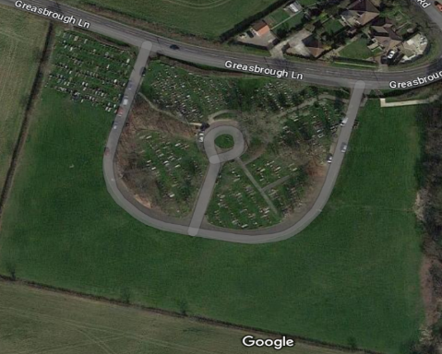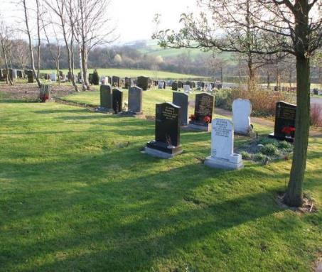
Greasbrough Lane Cemetery was created to fulfil the need for new burial capacity for the community, in the local area. The site was identified at a time when Greasbrough Town Lane cemetery was nearing the end of suitable grave space. It also helped with reducing the impact on another historical site close by, Haugh Road Cemetery. This cemeteries’ new location solved both the needs of the two historic cemeteries and increased capacity for several generations.
Greasbrough Lane is situated on a steep hill side. Therefore, it’s historically suffered with water and drainage issues with the runoff from adjacent housing and farmland. Works have been carried out by Dignity to increase the amount of tarmac paths and introduce and improve drainage and run off, to aid with the aesthetics and water issues.
You can see from the aerial view that despite its age there is still a considerable amount of unused land in which to cater for new burials to take place. The cemetery is RAG rated Green to reflect this and Greasbrough Lane will continue to serve the community for years, long after the current contract deadline expires.
To work out a suitable estimate, we’ve taken a dissection of a current area that is now nearing completion. The aerial view shows E section in the upper NW corner of the image, separated from the main central area by a road.
E section had its first burial interment in 2004 and it’s taken almost 20 years to fill each row within that section. Given the size of that area, it yielded 274 new graves within that one section alone. Given that we can replicate this across the rest of the existing estate it bodes well that the site will serve the community and the Council well beyond the current contract term.
There are things however to consider that may impact on the suitability of the remaining land. The area is not flat and due to the sloping nature of the site it may impact development in certain areas.
Not only does it need to be safe for grave digging duties and the community, but it also needs to be able to allow headstones and memorials to be placed on the grave with little impact to their safe installation. An extreme angle would hamper the safe install and prevent kerb sets being able to be placed around the graves evenly. Another consideration that needs to be accounted for are that there are several drain covers and suspected drainage in key areas that would need to be avoided.
Dignity doesn’t hold any of the original plans or drawings to accurately predict where drainage or electrical cables for housing may sit within the cemetery. Dignity would require the Council’s support to understand more to move forward with future development.
In the SW corner of the cemetery there is a newly created environmentally friendly burial space, which was earmarked and created in 2022. The area will serve families with an additional choice, if they wish to have a natural burial going forward. The area will develop overtime to resemble a meadow with wildflowers screening the area and acting like a natural divide between the traditional grave spaces.
It will depend on uptake and demand but if the natural area takes off then more land within the cemetery may need to be considered to expand in the same vein. It would reduce the amount of traditional grave space, but it’s too early to predict a viable trend given the short length of time it’s been in place.
Additional access gates were planned for and are in place already to aid with any future development at Greasbrough Lane.
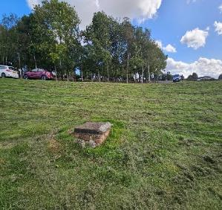
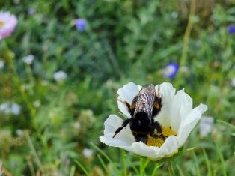
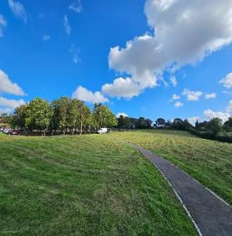

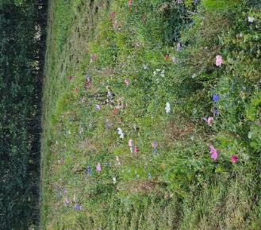
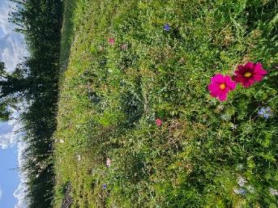

3.2 Haugh Road Cemetery
RAG Rating – GREEN
Haugh Road, Rawmarsh, Rotherham, S62 7AN – Opened October 1909 – Active Cemetery
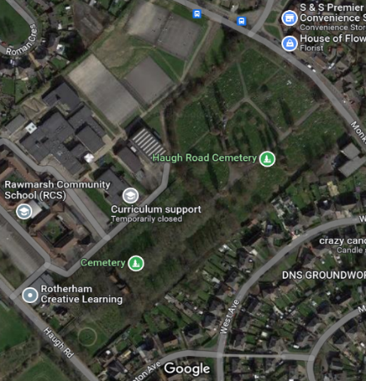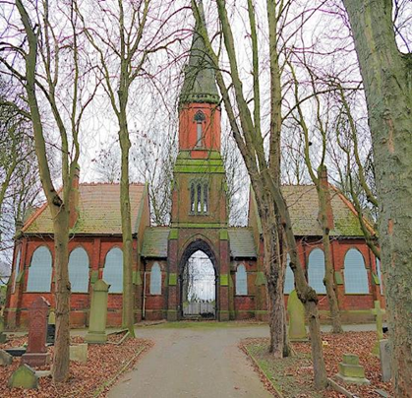
Haugh Road Cemetery is situated only a short walk from Greasbrough Lane Cemetery and is surrounded by housing on one side and Rawmarsh Community School on the opposite boundary. The cemetery is still currently active and provides both full burial plots and cremated remains plots for families. Due to it’s age the site is predominantly made up of historic burial plots which have reached their capacity limit. There is now only a hand full of small pockets of land within to offer a more modern burial option. The large burial chapel is in poor repair and options are being considered by the Council to its future purpose.
At the SW corner near to the entrance on Haugh Road. There are sections of land currently still being developed. The current rate of burials is slow, and the land left to be developed will serve the community for a further 10 years approximately.
The wardens using their knowledge and experience have marked out the remaining area that can be developed whilst using the graves already in situ as a guide, alongside cemetery maps. They worked out the future provision in the SW section and Dignity concur. There is potential to create a further 97 full grave spaces and another 30 cremated remains plots.
With the proximity of Greasbrough Lane being so close many families are choosing to bury loved ones there rather than at Haugh Road. The additional plots above will serve families who already have family members in Haugh Road and wish to have a choice to be buried in the same cemetery.
The site is land locked and would limit any expansion to the site, but Greasbrough Lane is the natural expansion already in place.

3.3 Maltby Cemetery
RAG Rating – RED
Grange Lane, Maltby, Rotherham, S66 7DA – Opened February 1913 – Active Cemetery
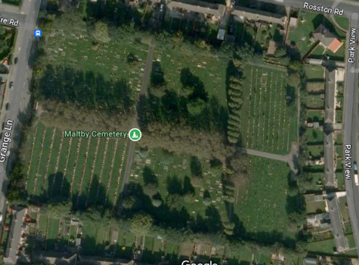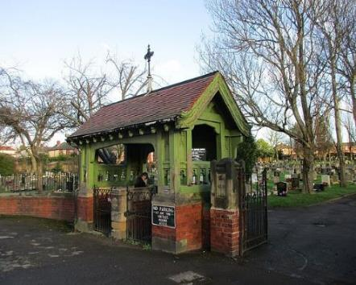
Maltby Cemetery is similar to Wath Cemetery, in that they both sit on the boundary perimeter of the borough and solely serve those communities.
The site is surrounded by the local housing estate with no land in which to explore additional expansion options. This site is currently RAG Rated red but still has new burial provision for approximately 95 new graves but has a history with issues with tree roots and boulders which could impact this number.
The confines of existing burials and memorialisation limit the use of being able to use burial equipment in certain sections. Many of the graves moving forward will soon now need to be dug by hand.
Given the current requests for Maltby the site will be suitable for approximately another 4 to 5 years dependant on demand.
For this reason, the site will be a key site in which to monitor. With the lack of opportunities to increase capacity for the people of Maltby, it will soon require another dedicated site to bury their loved ones. The Council may wish to scope new areas now within the local area to ensure the provisions are met and can continue once the space and capacity is taken.
It would be difficult to see how the community of Maltby would be prepared to consider travelling to East Herringthorpe (the nearest cemetery, within a 16 minutes’ drive) to bury loved ones when there is no connection to the area. The distance alone may force people to seek burial opportunities in neighbouring boroughs.
Viable options for future provisions will need to be explored to ensure continuity once the site reaches its final capacity.

3.4 Wath Cemetery
RAG Rating – GREEN
Cemetery Road, Wath-upon-Dearne, S63 7SH – Opened October 1868 – Active Cemetery
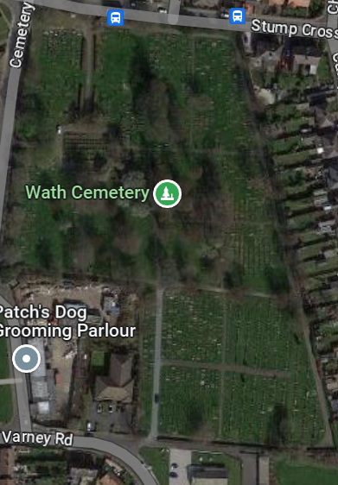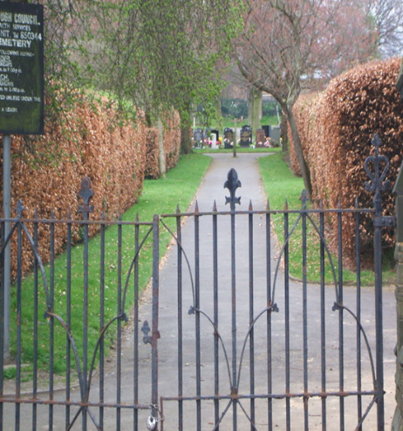
Wath Cemetery like Maltby is on the outer boundaries of the borough. Due to its popularity and isolated location the cemetery is now very close to being full and only a hand full of new grave spaces remain. At the time of this report there are only 4 full grave spaces left within the general section of the original part of the cemetery and 16 graves left in the Catholic section.
The local community will be looking to bury loved ones in the area and would not likely wish to travel to Greasbrough Lane for a burial. Like Maltby, Wath has a rich mining heritage, and the communities are very close knit. Travelling out of the area would upset many residents.
To alleviate the current position. A new piece of land that connects on to the existing cemetery was identified (see below) and it will provide the cemetery with an estimated 20 - 30 years of additional burial capacity in the area. Planning permission was granted for the new development in October 2023 and ground works will commence asap to bring the site into operational use.
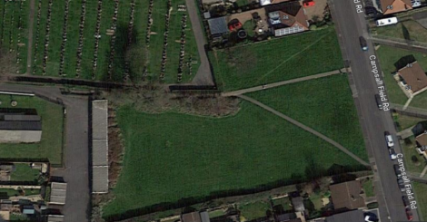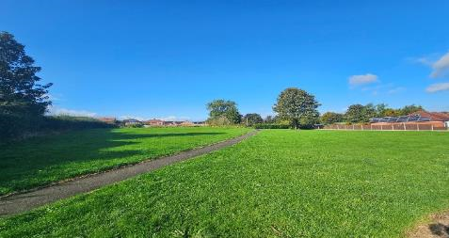

3.5 East Herringthorpe Cemetery & Rotherham Crematorium
Overall Cemetery - RAG Rating – GREEN
Muslim Burial Section – RAG Rating – AMBER
Ridgeway, East Herringthorpe, S65 3NN – Opened October 1953 – Active Cemetery
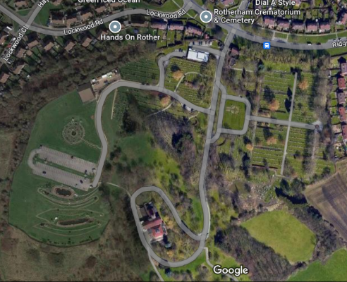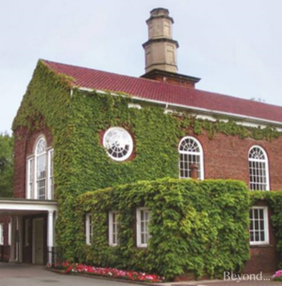
Rotherham Crematorium located at East Herringthorpe Cemetery is the central focal point for many residents of Rotherham. Serving the communities and neighbouring boroughs, the crematorium provides a peaceful and dignified place to say goodbye to loved ones.
As previously stated, the choice of cremation services far outweighs the demand for burial provisions. The gap and trend between the two are increasing year on year and more and more families are looking for alternative cremation options. In the image below you can see the existing gardens with the more modern memorial options available within the cemetery. These types of ashes plots are sort after and move away from the more traditional grave space options provided in the outlying cemeteries currently. The compact size means that they take up less space and provide a pleasing park like feel through the area in which these types of ashes plots are situated.
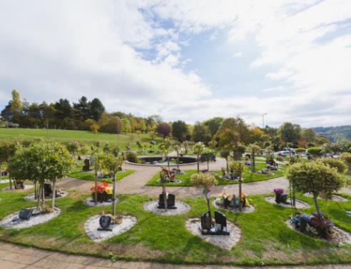
Currently there is a section within the cemetery grounds dedicated to these types of memorials that will serve the borough for approximately 50 years or more dependent on future demand.
Given the popularity of these Dignity introduced memorial options. The success could be replicated and burial capacity for ashes could be increased and introduced in the outlying cemeteries that are deemed suitable where full burial space is restricted. A plot of land that may not be suitable for full burials could be developed under these conditions.
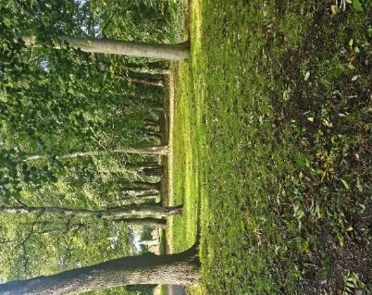
An example of an area in which this would be suitable would be at Greasbrough Town Lane Cemetery. In looking at future burial capacity at the site, an area of land that wouldn’t be suitable for burial could be utilised to provide memorial options. The existing trees would cause problems for deep excavation, but shallow ashes plots would not face the same issues. The trees would then form a nice area in which families could visit and pay their respects. In the above image you can see the potential of the area which is situated at the entrance. It would transform a closed cemetery and provide options for the residents in the area. The gardens are 32” in diameter and the area of land would yield approximately another 10 – 15 years of memorial options for families.
The traditional sections within East Herringthorpe are still considered GREEN currently. Provision for new grave space is healthy and despite the age of the cemetery, there are no immediate concerns overall. Many existing sections have been planned to allow expansion and naturally follow on from the previous section. Taking a closer look at the site there are several examples of areas in which burial provision can continue to be created. See the below images of existing areas within the cemetery that would aid in boosting provision if developed. The areas below would approximately create a further 10 years of new grave allocations within the existing cemetery.
With the demand increasing in East Herringthorpe to provide support for the sites that are now closed or nearing capacity the demand for grave allocations will see that approximate time frame dwindle if nothing is done within the outlying cemeteries, or new ground sourced to ease that pressure.

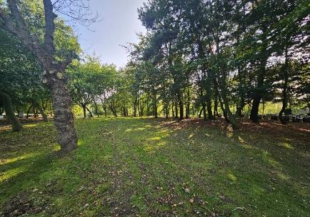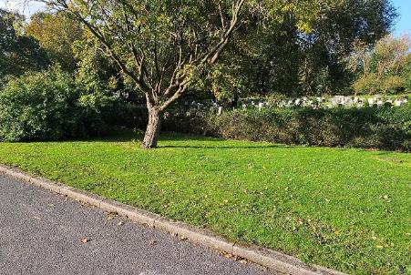

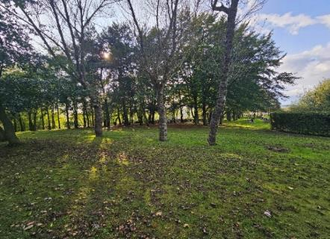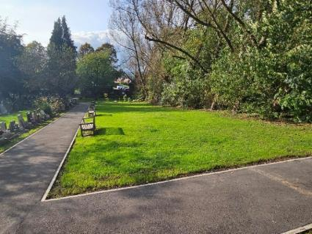

Concerns are low at present, however there are sections of concern within the site that cater for various religious beliefs, and it is within these areas that the need for provision requires action now to future proof the site for all faiths who wish to use Rotherham’s facilities.
The site has specifically dedicated sections for faiths, that adhere to the Catholic faith and the Muslim faith. The demand on the Catholic section isn’t what it once was due to families opting for alternatives and the provision is currently stable.
However, the area of most concern is within the Muslim section. The current rate of provision and concerns are based on the lined graves that are left. Dignity recently installed a large number of lined graves and there are concerns around the current demand for burial provision in the section. On average there are around 20 burials taking place in the section on an annual basis. At that rate the provision will struggle at around the two-year mark from the date of this report.
A lot of work and investments have been carried out in consultation, and in partnership with the community and Dignity, to better manage and provide a peaceful atmosphere for all their families and their loved ones.
The impact of improving the provision is now having a positive effect on the demand for graves from within the community. Having gone some way to rebuild trust and provide assurances that historic issues are being addressed. The community are now seeing positive changes being made in a short period of time. Many other burial authorities have praised the work carried out and have asked to learn more about the improvements that have been implemented.
The positives however have resulted in an increased demand which impacts on the provision that is currently left.
Given the timescales and time left, the Muslim community are rightfully concerned about the provision for the future. Unlike many residents that may opt to use another cemetery within the borough, East Herringthorpe is the only cemetery within Rotherham that offers Muslim faith burials. The Muslim community do not have another option within Rotherham once the current area is full. The nearest cemetery is then at Shiregreen in Sheffield or at Doncaster.
For many reasons, similar to Wath and Maltby it would be a difficult choice to bury loved ones in another cemetery or borough that isn’t connected to the people or the existing site.
Within the boundary of East Herringthorpe, in the Southeast corner there is a large expansion of land which is being considered for future development. The site is currently being tested for suitability as the Environment Agency have raised concerns regarding the suitability of the area in certain sections at this current time.
Given the size of the land being earmarked and provided permissions are granted, the land could be developed into a new section. This new area would provide a substantial amount of new burial capacity that would provide the people of Rotherham with a new viable burial area for several years. However, concerns over bedrock in certain sections could see the volume of potential new graves reduced.
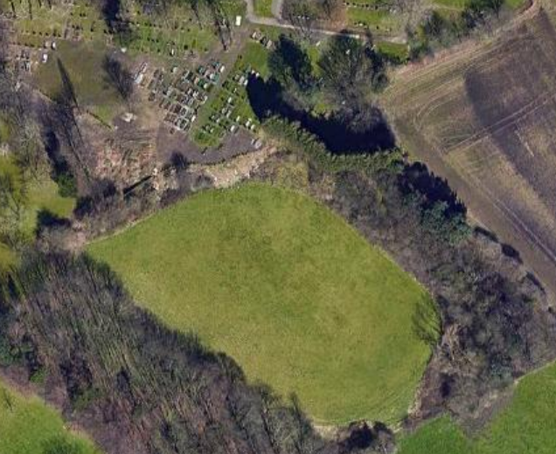
New investment in infrastructure of pathways and roads would need to be incorporated and substantial drainage would be needed. The area is sloping and would also require work to level and step down each section to make safe for digging and for visitors.
The Muslim section can be seen in the above image to the North of the area. Dignity would ultimately decide on the usage of the land based on the final planning approval once received. Subject to the outcome of suitability testing, the entire area may not be able to be developed and this would leave less capacity than originally envisaged.
Ultimately if the land is not deemed suitable in its entirety, then the current service provision for the Muslim community in the existing area, would be at full capacity within seven years. The amber rating reflects the need to explore and discuss this issue further.
The Council may wish to explore new areas of land in which to develop for this service provision.

4 Current Strategic Overview – Closed Cemeteries
The following will break down the current capacity and highlight potential development within the existing boundaries of the 4 currently closed cemeteries. As these cemeteries are closed for new burials and interments and have been for some time, they will be RAG rated as Green in terms of priority of need for development.
Closed Cemeteries:
- Greasbrough Town Lane Cemetery - GREEN
- High Street Cemetery - GREEN
- Masbrough Cemetery - GREEN
- Moorgate Cemetery - GREEN

4.1 Greasbrough Town Lane Cemetery
RAG Rating - GREEN
Town Lane, Rotherham, S61 4JH – Opened April 1900 – Closed Cemetery
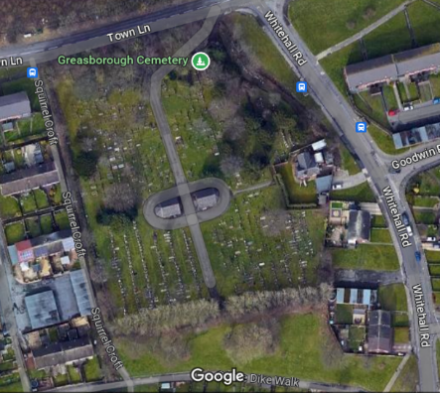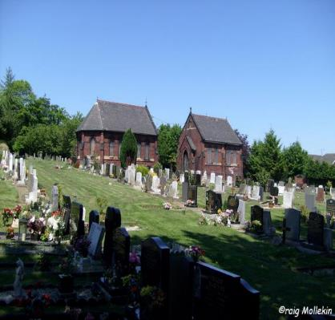
Due to the age of Greasbrough Town Lane, the cemetery is now considered closed.
The cemetery served the community since 1900 and reached capacity in the early 1990’s. Looking at the overview of the site, the cemetery is surrounded by housing, allotments, and infrastructure. There are two historical burial chapels that are not in use currently. The contract states that any buildings of this nature remain in the hands of the Council, and any decisions, improvements or responsibilities sit with the Council.
When walking the site to identify key areas, it is clear from the onset that there isn’t any suitable land within to develop or offer new grave spaces. However, on the boundary at the south end of the cemetery there is large tree lined area that backs on to what appears to be greenspace. If the trees there could be removed, or a route created through them the boundary then could be renegotiated. It would open up a substantial amount of burial space, but the land would need to be suitable and made secure for all, providing consultation.
It is a very similar situation at the northeast section near to Whitehall Road, close to the main entrance. There is a large hedgerow and vegetation, that if removed could see the grass verge adjacent to the road utilised. Both areas would need a thorough inspection to check for drains and electrical cables. The Council’s plans would prove useful in this regard to ascertain any issues.
Looking at both areas, it would be possible to create several rows and in effect open a new section to the community.
A rough estimate based on suitability and the size of the area would add an additional 15 – 20 years of increased burial capacity within the cemetery.
However, when the cemetery was nearing capacity back in the early nineties, it was decided at the time to explore creating a new cemetery and grave space that would cater for residents of both Greasbrough and Rawmarsh.
A new area was developed within a short distance from Town Lane and Greasbrough Lane was created. The burden on Town Lane ceased and any further development surrounding capacity was focused around Greasbrough Lane.
The image on the left shows the potential of the land at the entrance to the cemetery and the second image is a snapshot of the land beyond the current boundary line.
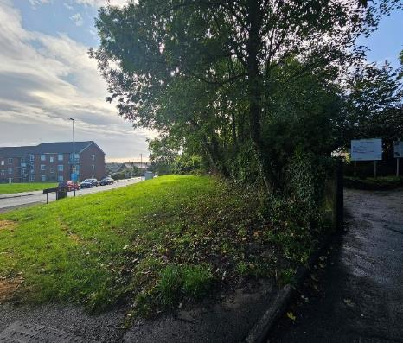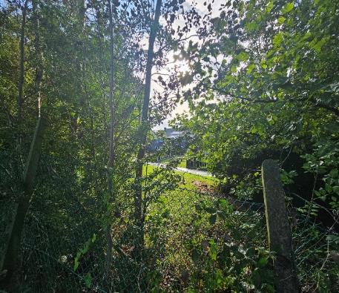
For the purpose of this report, I believe investment at Town Lane would have minimal impact. Due to the location of Greasbrough Lane Cemetery distance and location are not a factor like it may be for some of the other sites. The option is there to increase capacity if the Council deemed it was warranted subject to suitability and approval.
4.2 High Street Cemetery
RAG Rating – GREEN
High Street, Rawmarsh, Rotherham S62 6LN – Opened July 1861 – Closed Cemetery
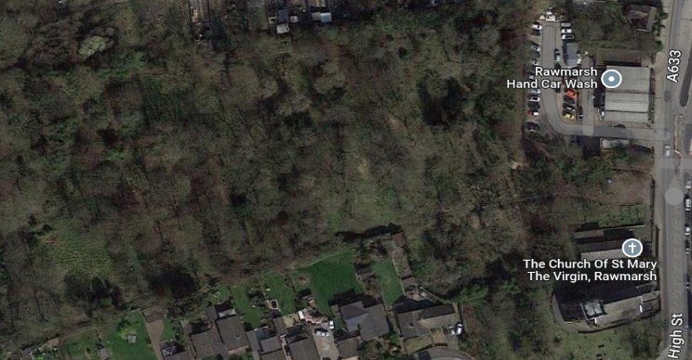
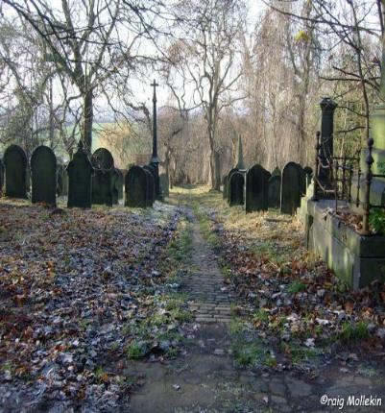
High Street Cemetery is another historical burial ground and is located within a mile of both Greasbrough Lane and Haugh Road. The site is closed and covers an impressive area of semi woodland that leads down towards farmland at the east boundary. Due to the age and the closed nature of the cemetery, there have been no requests at all since 2002 for an interment in any existing grave and the area is more an historically important memorial site, that commemorates past residents of Rawmarsh.
Within the boundaries of the site, it was agreed with the Council after consultation with ecology specialists and local friends’ groups that maintenance be sympathetically done to preserve the biodiversity of the cemetery but still be maintained periodically on a schedule to upkeep the pathways and green spaces reducing the opportunity for overgrowth to become unmanageable.
The scope for development is poor and High Street is a good example of a closed cemetery in the truest sense.

4.3 Masbrough Cemetery
RAG Rating – GREEN
Psalters Lane, Rotherham, S61 1HP – Opened October 1871 – Closed Cemetery
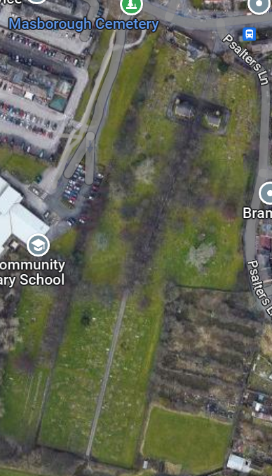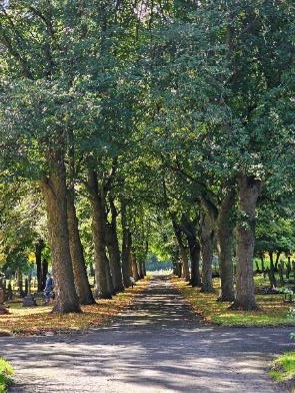
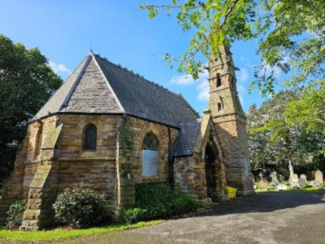
Masbrough cemetery is considered closed and is similar in design and location to Haugh Road, in that it is surrounded with housing and borders school land.
At the main entrance on Psalters Lane there are two unused burial chapels and a single-track path that runs the length of the remaining cemetery. At the south side of the site there is a small turning circle which is just outside of the boundary of the cemetery on green space that serves the community.
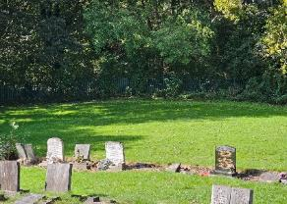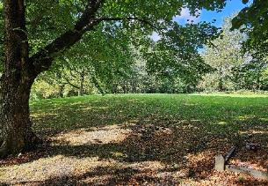
Due to opening in 1871, the site has naturally reached its capacity limit. The cemetery was heavily used and provided public graves for those less fortunate. There are areas within the cemetery that appear to not have been developed but under further inspection, the plans show large areas of land used for burial space for those less fortunate to not be able to afford a headstone etc. This is not uncommon for a cemetery of this age.
It is difficult to see where additional capacity could be created within the existing boundary of the site.
There are options that could be explored but would require the Council’s guidance and would require consultation with local communities.
At the bottom of the satellite image in the SE corner you can see an area of green land which after further inspection appears to be an allotment. However there appears to be very little signs of development or allotment usage. The area is relatively even and is bare field currently.
The Council may wish to explore the viable expansion to utilise the land. There is a hedgerow dividing the current boundary (see image below) which could easily be removed to gain access to the plot of land. It would provide an estimated 15 -20 years of additional new grave capacity.
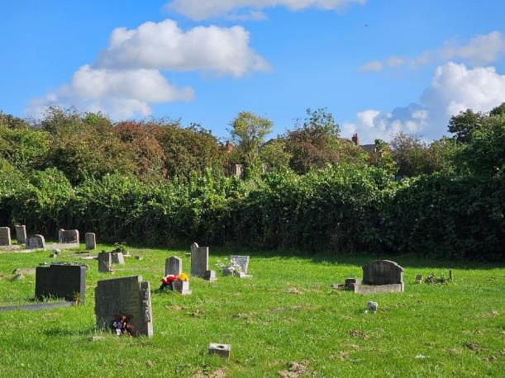
At the south boundary fence. The cemetery backs onto what appears to be green space that serves as a walk through. There are several trees that border the cemetery boundary that if removed could provide additional rows for grave space. This may not be suitable given the terrain and further inspections would need to be considered for drainage and water issues. Removing the trees would naturally reduce the amount of water uptake and could make the soil unsafe, unsuitable to dig and restrict safe headstone placement.
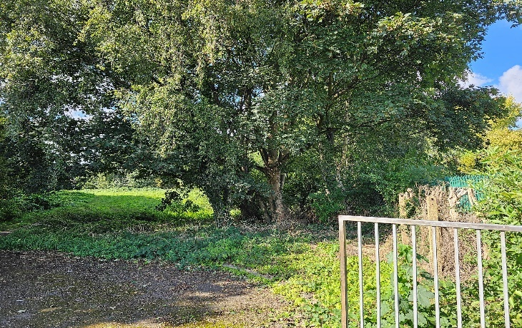
In the image you can just make out the green palisade fencing marking the cemetery boundary to the right. The turning circle can just been seen in the bottom left. The fence line runs approximately 50 meters along. Removing the trees along this stretch and creating a new secure boundary would be another option to explore to increase capacity.

4.4 Moorgate Cemetery
RAG Rating – GREEN
Boston Castle Grove, Rotherham, S60 2BA – Opened October 1841 – Closed Cemetery
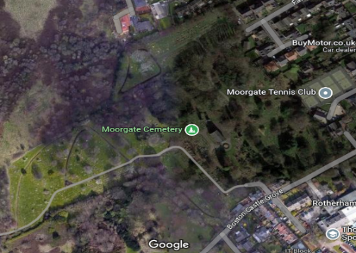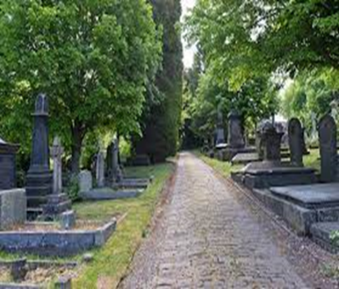
Moorgate Cemetery is the oldest cemetery within this report and its central location helped to serve a large population of Rotherham’s residents for well over 100 years since its inception.
The sites been considered closed for many years now and with sites like East Herringthorpe close by the necessity for provisions is extremely low. The demand for interments at Moorgate is very low, even in existing graves. The last request was back in 2004.
Local friends’ groups, probationary services, alongside Dignity, the Council and Glendale have been working together to clear vegetation and thick overgrowth in the cemetery. By doing so the site is being rejuvenated and becoming more appealing to visitors. The original burial chapel needs renovation and the local friend’s group are in discussions with the Council in relation to the chapel and its potential use.
In removing the overgrowth from the site. There is now the potential to reintroduce new burial provision. The site is accessed by a narrow cobble pathway seen in the above photograph but once down the path it starts to open up. At the rear of the chapel there are large sections of woodland and scrub that historically will have divided the original burial sections.
Upon inspection the land may be suitable to reintroduce additional burial capacity. Extensive work would need to be carried out in order to ascertain suitability. At the time of this report work is still on going to clear large areas and it would be wrong to provide misleading guidance on Moorgate without taking further steps to establish the ease and suitability of reintroducing new grave space.
One thing to consider is the local friend’s group have concerns about the reintroduction of new graves as certain areas of the site are Grade II listed. They feel the demand is so low and the age and heritage of the site would be lost by introducing new graves and headstones with modern themes.
With East Herringthorpe being so close to Moorgate, my initial recommendations would be to focus on the provision initially there, where the most current demand is before considering the re-opening of a closed cemetery.
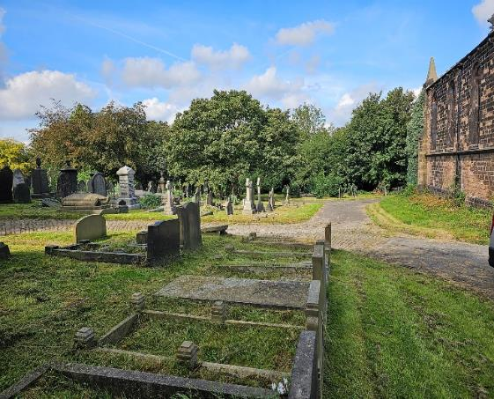
Current image of the historic chapel and site at Moorgate.
The image below demonstrates areas of land that if suitable could provide new burial capacity within the current boundary of Moorgate cemetery.
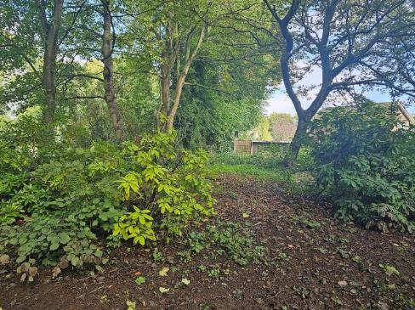

5 Summary
This report outlines the current overview, and the potential of expansions is a positive one, but one that is still currently subject to approval for East Herringthorpe. Considering that those permissions may not be granted, the sites that need to take priority are East Herringthorpe and Maltby as will be detailed further in subsequent operational planning.
All cemeteries within Dignity’s care will continue to be maintained and developed where possible, granted suitability and permission.
Dignity will continue to monitor and report to the Council the current provision via the Annual Performance Report and operational planning activities.

