Page 1 -
Welcome to the Housing Annual Report for 2023/24
Housing for me is very much about people as well as property and there’s a suitable emphasis on that in this report.
This report covers the Council’s Housing Service’s performance and key projects from April 2023 to March 2024. It hasn’t been an easy year, with the cost-of-living crisis, Storm Babet, and other national issues affecting our services. However, we remain committed to providing the best support possible to our residents.
Right at the end of 2023/24, the Social Housing Regulator introduced a new proactive inspection regime. Part of the new standards are a suite of measures on tenant satisfaction, so we’ll be able to report on how well our tenants think we deliver our services.
Despite the challenges posed by the cost-of-living crisis, we've assisted 1,020 tenants, preserving 31 tenancies at risk of eviction. We also issued 2,147 energy crisis payments totalling £536,750. We have helped some of our most vulnerable residents access over £3million in benefits support through our Macmillan Cancer Care team.
One of our major accomplishments was completing 171 homes in the town centre which is a significant contribution towards our new homes building target of 1000 homes by 2026. These homes offer affordable options, including Council Rent, Shared Ownership, and Market Sale.
We also launched our first 'no gas' scheme in East Herringthorpe, which is a huge step towards our net zero goal and is a shining example of social value in using only tradespeople from the S65 area to build the scheme. In Maltby, we improved the thermal efficiency of 130 properties through decarbonisation works.
There are lots of statistics and information in the report to illustrate our work and I hope you enjoy reading the report and learning more about what we’re doing.
Yours sincerely,
Councillor Sarah Allen
Cabinet Member for Housing

Page 2-

Looking After Tenants Homes
Safety and Quality Standard

Case Study
Catcliffe experienced severe flooding as a result of Storm Babet in October 2023, which caused significant damage to homes, and left many residents displaced.
Our Housing and Neighbourhoods teams activated an emergency plan to help residents who had to leave their homes and quickly found new suitable homes for them.
We focused on keeping residents informed and reassured, as we supported them through the process of moving to temporary alternative accommodation, whilst their homes were repaired and made ready for them to return to.
To help people get back on their feet, we organised a tenant choice event where residents could choose their new kitchen designs, countertops, and tiles for their homes. Despite the challenging time, this event aimed to make residents feel actively involved in making the necessary decisions about the repairs to their homes and make their homes feel like a special place again. Deciding these things early also helped us to plan and make sure there were no delays to repairing these homes.
Once residents moved back into to their homes, we checked on them every week to address any ongoing needs. We regularly had meetings with the Council’s contractors to gather information and update residents on how their homes were being fixed and to make sure everyone knew what to expect.
Our promise to talk openly and give personalised care shows how much we care about helping our community during tough times.

Before and After Photos
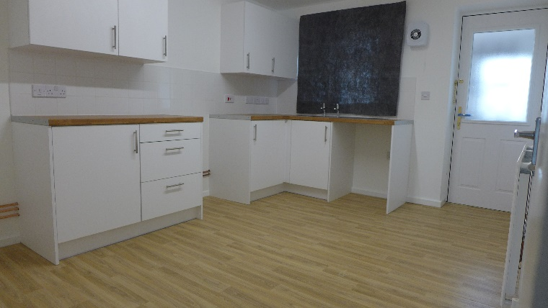
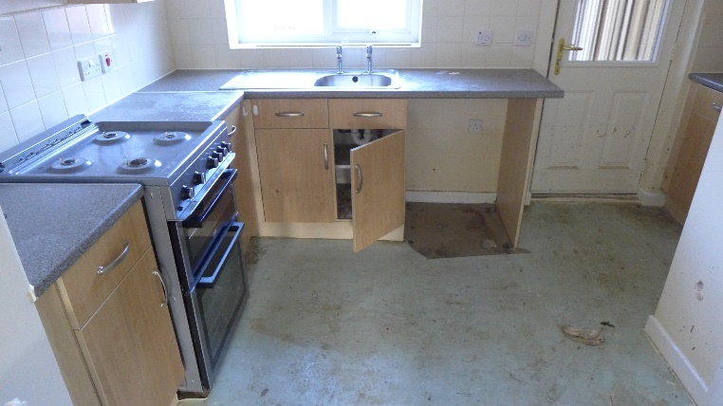

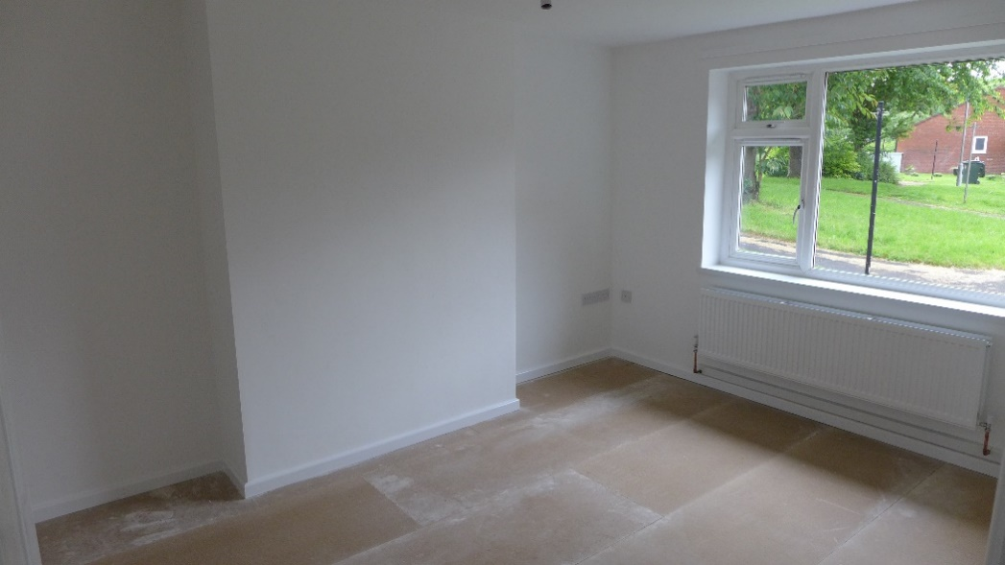
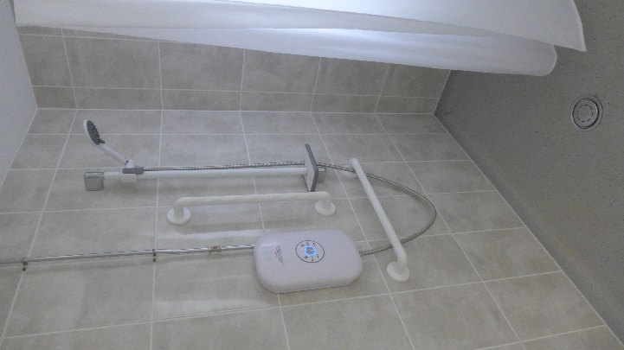
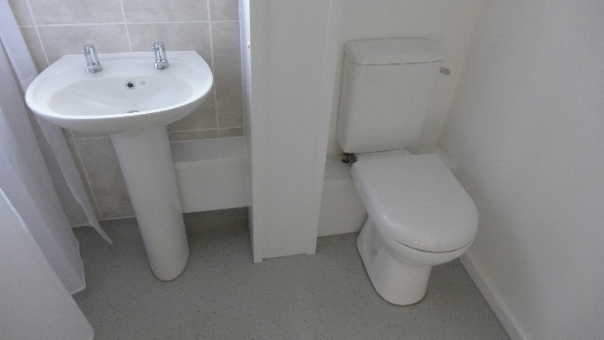
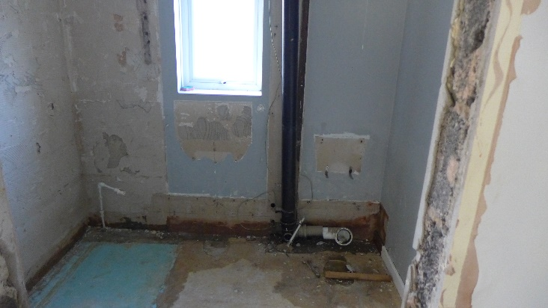

Data [Presented as infographics]:

- 94.28% - Repairs completed right first time, target 87% (up from 92.79% last year).

- 3402 – Damp, Mould, and Condensation cases dealt with (up from 1726 last year).

- 53 - External Wall Insulations.

- 132 - Cavity Wall Insulations.

- 1621 - Gas Boiler Installs.

- 227 - Loft Insulation installs.

In the next 12 months, we plan to:

- Ensure the Council follows all property safety rules, including gas, electrical, fire safety, asbestos, legionella, and lifts, to reduce risks and keep everyone safe.
- Start a programme to check the condition of our homes and make sure they meet decency standards.
- Create a plan to improve energy efficiency, aiming to achieve EPC C by 2030 and meet net zero requirements for our housing.

Page 3-

Enhancing Tenant Engagement
Transparency, Influence and Accountability Standard

Case Study
In June 2023, the Screen Team was created as a result of a recommendation from our Tenant Scrutiny Panel’s 2022/23 report into how we communicate with our tenants.

The Screen Team is a group of Council tenants who meet online every month to scrutinise how we communicate with customers. The Screen Team looks at our letters, forms, surveys, website, and the Home Matters magazine to make sure they are easy to read and understand.

The team worked with us to co-create its own terms of reference and meeting guidelines and to come up with a team name.

Over the year the Screen Team has looked at lots of our communications. Here are some of their biggest impacts:
The Home Matters Magazine
You said:
The Screen Team worked with our marketing department to co-create the autumn 2023 edition, and suggested we should promote youth services in the borough and provide information on some of Rotherham’s opportunities for young people.
We did:
We made sure that the magazine focussed on youth, telling the story of one of our Screen Team members that volunteers within the youth sector and publishing some of the fantastic clubs that are available to young people.

The Tenant Engagement Web Page
You said:
The Screen Team suggested that our home page should be less information heavy and should consist of a number of tiles with sub-pages sat behind, so tenants can choose the areas of the sit they want to look at.
They tested our web page and suggested that we simplify lots of the language that we use.
We did:
We designed our new look web page using the tile format with pictures to make it more user friendly, and we simplified lots of the language we use. The Screen team tested and signed off our page to make sure we got it right.

Asbestos Explainer Letter
The Screen Team worked with us to create an understandable asbestos letter which we are sending to tenants to help keep them safe.

In the next 12 months, we plan to:
- Obtain TPAS Exemplar re-accreditation for the Council’s tenant engagement efforts.
- Implement a Customer Experience dashboard to track tenant satisfaction, as their feedback informs service improvement.
- Continue to enhance tenant engagement, support existing community groups, and develop new ones to meet diverse needs.

Page 4-

Positive Contributions to Neighbourhoods and Communities
Neighbourhood and Community Standard

Case Study
We proposed to create a small children’s play area on a field located between Keble Martin Way, Bushfield Road, Mathews Avenue, and Cutts Avenue in Wath-upon-Dearne. This project aimed to improve the play spaces for young children in the community, giving them a safe and fun place to play and meet friends.

To see if the community liked the idea and to get their input, we held some engagement events. These events allowed residents to share their opinions and preferences about the project. The feedback showed that many residents wanted more permanent play facilities in the area.

Recognising the community’s enthusiasm and the benefits of this project, we used funding from the Ward Housing Budget to plan and complete the project by spring 2024.

The new play area is now a great addition to the neighbourhood, providing a lively and inclusive space where children can play, learn, and grow.

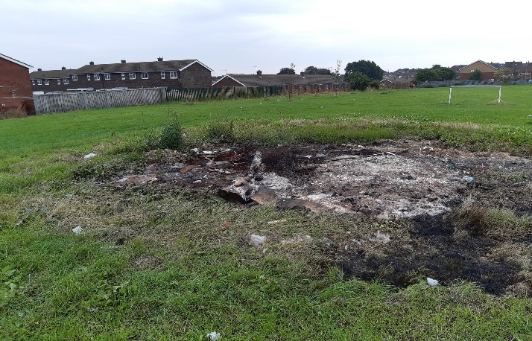
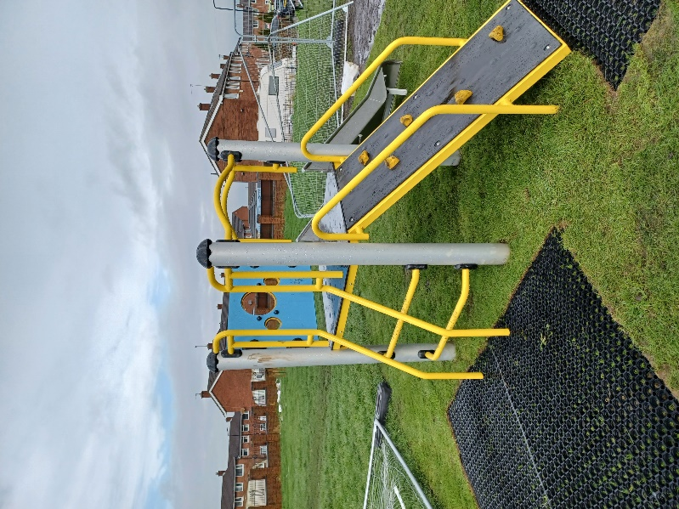
Before & After Photos:
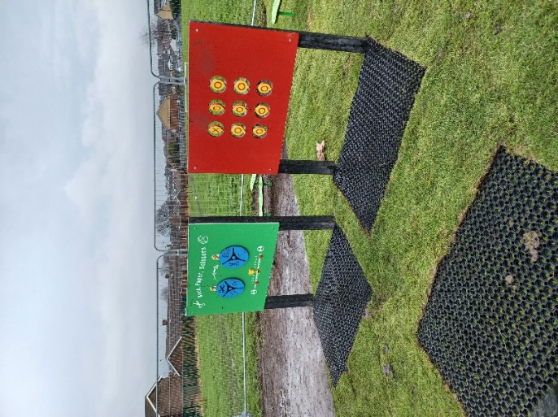

In the next 12 months, we plan to:

- Further elevate the quality of our homes and neighbourhoods to create more vibrant and welcoming communities.
- Improve how we handle Housing Anti-Social Behaviour (ASB) cases, reducing incidences and providing better support for affected residents.

Page 5-

Meeting Customer Needs
Tenancy Standard

Case Study
A young person leaving care faced homelessness following a family bereavement. The Housing Advice Team, Housing Assessment Panel Facilitator, and their Personal Advisor worked together to support them. They helped gather documents, apply for housing and complete assessments, including checking income and conducting a pre-tenancy interview to confirm eligibility.

With this support, the care leaver secured Band 1 housing status and was offered a suitable onebedroom flat in a good location. They were happy with the offer and delighted to sign the tenancy. They also received help to access a carpet and white goods package. Our Leaving Care Team continues to provide regular visits and support, ensuring the care leaver can enjoy a stable and hopeful future ahead.

This shows our commitment to meeting the tenancy standard by supporting vulnerable individuals. We work together to ensure fair housing allocation, strong support for tenancy sustainment, and suitable accommodation that meets individual needs. Our ongoing assistance and compliance with statutory requirements show our dedication to tenant’s long-term well-being and stability.

Data [Presented as infographics]:

- 217 - Homes delivered with Council support, including affordable homes – Target 200 (down from 373 last year).
- 1398 - New lettings made (down from 1407 last year).
- 121 - Right to buy completed (down from 202 last year).
- 32.15 – Average days to relet, target 42 days (down from 53.49 last year).
- 56 – New builds and Council input homes delivered (24 rent, 18 shared ownership, 14 open market sale) (down from 163 (127 rent,16 shared ownership, 20 open market sale) last year).

In the next 12 months, we plan to:

- Develop and deliver a plan for long-term empty homes.
- Enhance the Tenancy Health Check process, with a key focus on knowing our customers, property condition and safety, sustainable tenancies and combatting tenancy fraud.
- Help 400 people get support from the Employment Solutions service.

Page 6-

Learning from Feedback

We appreciate the positive feedback we receive from our tenants about our services. Equally, we value constructive feedback when tenants feel we may have fallen short, as it helps us improve and better meet your needs.

Here are examples from 2023/24 of how we are using your feedback to deliver better results:

You Said, We Did
You Said:
You wanted a tenant-friendly guide to the lettable standard so new tenants know what to expect when moving in, including details about decoration, cleanliness, and heating.
We Did:
The Housing Property Service is developing a tenant-friendly guide to the lettable standard. This guide will be available on our website and included in the handover pack for new tenants.

You Said:
You wanted it to be easier to adjust settings on our website and remove any confusing language.
We Did:
Our panel of tenants, Screen Team, met with us to review the accessibility of our web content and made necessary adjustments. Over the past year, the Screen Team has reviewed more than twelve pieces of content to ensure they are easy to use.

You Said:
You wanted a more direct and transparent way to address your concerns and complaints about housing issues.
We Did:
We plan to set up a Tenant’s Complaints Panel during 2024/25. This panel will provide a dedicated space for tenants to raise concerns, give feedback, and work with us to resolve issues and improve our services.

Data [Presented as infographics]:

203 – Compliments received (up from 179 last year).
615 – Complaints received (up from 607 last year).
503 – Number of complaints responded to within corporate timescales (for all Housing Services).

Compliments across the service:

Compliments for Housing and Estates Services: “Thank you for taking the time to listen to my opinions and concerns. It’s really appreciated, and I fully feel listened to, and I hope this leads to positive changes for everyone involved”.

Compliments for Housing Property Services and Mears: “The staff went above and beyond by working over their normal hours to resolve the issue, fully understanding the impact it had on me. They kept me updated throughout the process and successfully restored my gas supply that evening. I deeply appreciate their dedication and professionalism, as their sole focus was on resolving the problem and ensuring I had a working gas supply as quickly as possible.”

Page 7-

Making sense of the money

Rotherham Council owns and manages over 20,000 council homes. In 2023/24 the income was £92,298,620.

Below is an overview of how your rent was spent during the year.

Capital Charges* | 40,066,141 | 43%
Repairs & Maintenance | 21,186,781 | 23%
Estate Management | 1,737,348 | 2%

Staff & Service Charges
Housing Management | 5,335,960 | 6%
Anti-Social Behaviour | 123,398 | 0.5%
Central Services** | 10,015,027 | 11%
Income Management | 1,994,901 | 2%
Tenant Involvement | 99,002 | 0.5%
New Housing and Housing Strategy | 2,129,452 | 2%
Housing Options, Allocations and Homelessness | 6,916,210 | 7%
Housing Property Services | 2,694,399 | 3%
Total Expenditure | 92,298,620 | 100%
*This includes interest on debt and funds for new builds.
**Management, admin, and business support for the Neighbourhood service.

Focus on Income
Most of the income comes from rent but tenants and leaseholders are also charged for services and facilities that the Council provides.
House rents
  86,732,578
Garages and ground Rent | 732,082
Furnished packages | 5,487,535
District heating | 1,061,610
Communal facility charges | 549,398
Right to Buy receipts | 157,300
Leaseholder contributions to services | 316,000
Aids and adaptations | 266,126
Miscellaneous income | 1,456,642
Total Income | 96,759,270
Transferred from reserves | -4,460,650
Total funds used | 92,298,620

For every £1 of rent you pay
- 44p is used for major repairs and investments, new Council housing, and interest on borrowing and depreciation charges.
- 23p goes toward day-to-day repairs of houses.
- 20p is allocated to managing estates and tenancies, including house letting and rent collection.
- 2p is dedicated to developing new housing projects.
- 11p supports central services like management, administration, and business support.

Page 8-

Tenant Satisfaction Measures (TSMs)

The Government has introduced new Tenant Satisfaction Measures (TSMs) which are designed to assess and monitor how well social landlords are doing in providing good quality homes and services.

The Council will:
• Annually submit our performance against the TSMs to the Regulator of Social Housing.
• Annually publish our performance against the TSMs on our website and in publications.

In total there are 22 TSMs:
• 10 Landlord Measures – based on information we hold in our systems.
• 12 Tenant Perception Measures – based on a tenant perception survey of a sample of our tenants.

The TSMs relate to five areas:
• Keeping homes in good repair: We want to know if your home is in good condition and if it is getting the repairs it needs.
• Maintaining building safety: We want to know if your home is safe and if it meets all the safety standards.
• Being respectful and helpful: We want to know if we are respectful and helpful when you need us.
• Effective handling of complaints: We want to know if we are handling your complaints quickly and fairly.
• Responsible neighbourhood management: We want to know if we are managing your neighbourhood well and if we are keeping it safe and clean.

Keeping homes in good repair
12% of our homes do not meet the Decent Homes Standard.
77.6% of tenants are satisfied their home is well maintained.
71.6% of tenants are satisfied communal areas are clean and well maintained.
99% of emergency repairs completed in time. 97% of non-emergency repairs completed in time.
74.1% of tenants are satisfied with the repairs service.
72.1% of tenants are satisfied with the time taken to complete their most recent repair.

Maintaining building safety
81.1% of tenants are satisfied their homes are safe.
100% of fire safety assessments carried out.
99.9% of gas safety checks have been completed.
100% of asbestos checks have been completed.
100% of water safety checks have been completed.
91.3% of lift safety checks have been completed.

Being respectful and helpful
76.9% of tenants are satisfied with the overall service we provide.
74% of tenants are satisfied we keep them informed about things that matter to them.
70.5% of tenants are satisfied we listen to their views and act upon them.
83.6% of tenants agree we treat them fairly and with respect.

Effective handling of complaints
36.2% of tenants are satisfied with our approach to complaints handling.
26.9 stage 1 complaints received (per 1000 homes). 0.9 stage 2 complaints received (per 1000 homes).
82.3% of stage 1 complaints handled within the Housing Ombudsman’s timescales. 55.5% of stage 2 complaints handled within the Housing Ombudsman’s timescales.

Responsible neighbourhood management
72.4% of tenants are satisfied we make a positive contribution to neighbourhoods
69.6 anti-social behaviour cases (per 1000 homes) 0.3 of anti-social behaviour cases involved Hate Crime (per 1000 homes) 64.9% of tenants are satisfied with our approach to handling anti-social behaviour

Page 9 –

Highlights from 2023/24

Working with tenants to re-purpose our Housing Involvement Panel.
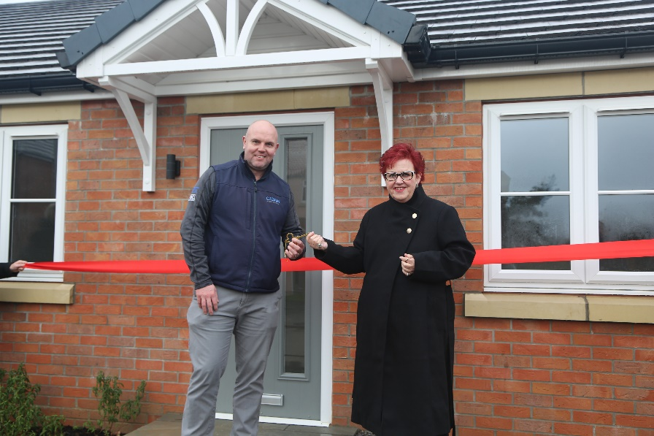

Celebrating the new build bungalows in Thorpe Hesley.

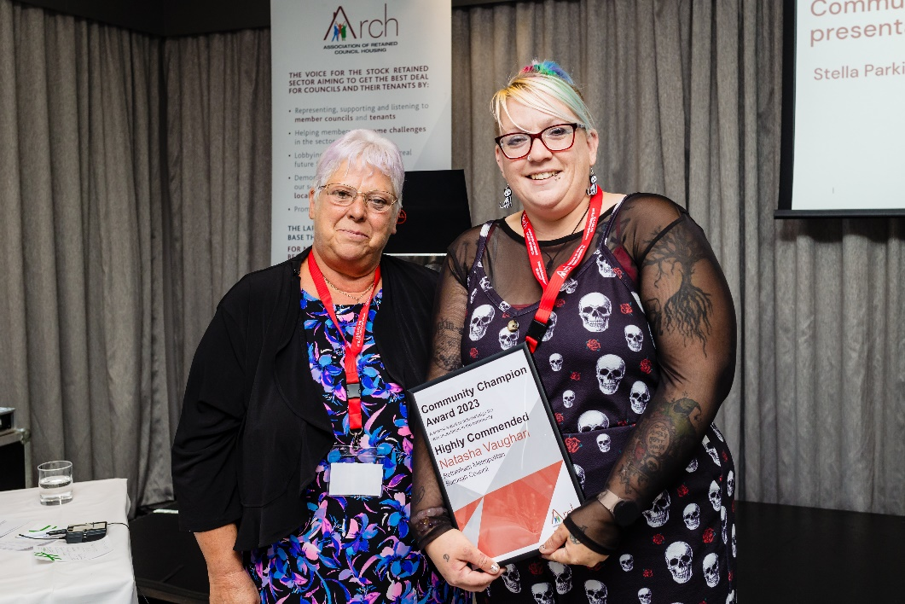

Tasha Vaughan was awarded an ARCH Community Champion award for her dedication and willingness to give to the community by starting a youth football team with mentoring programmes, workshops, and extracurricular activities that have positively impacted the lives of countless young people in Ferham.


Tenant Open Day 2023

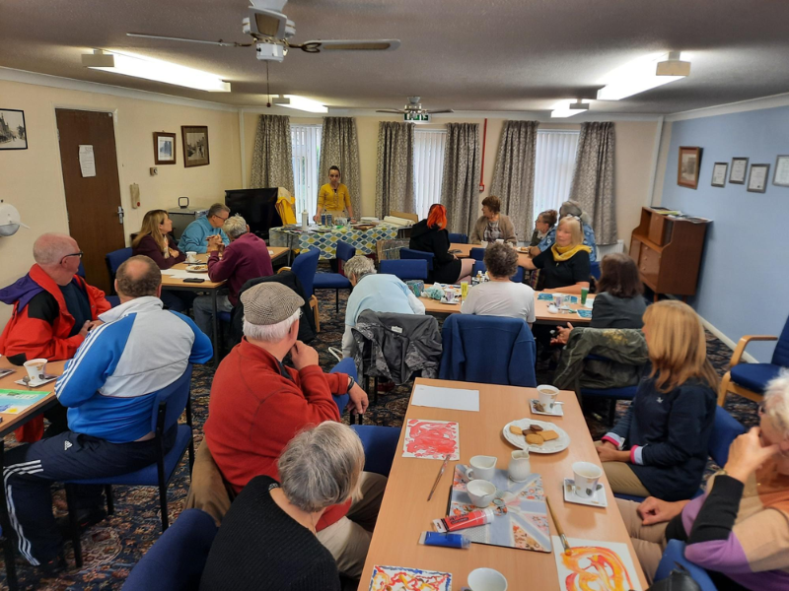
Residents enjoying an activity at Peregrine Way Neighbourhood Centre.

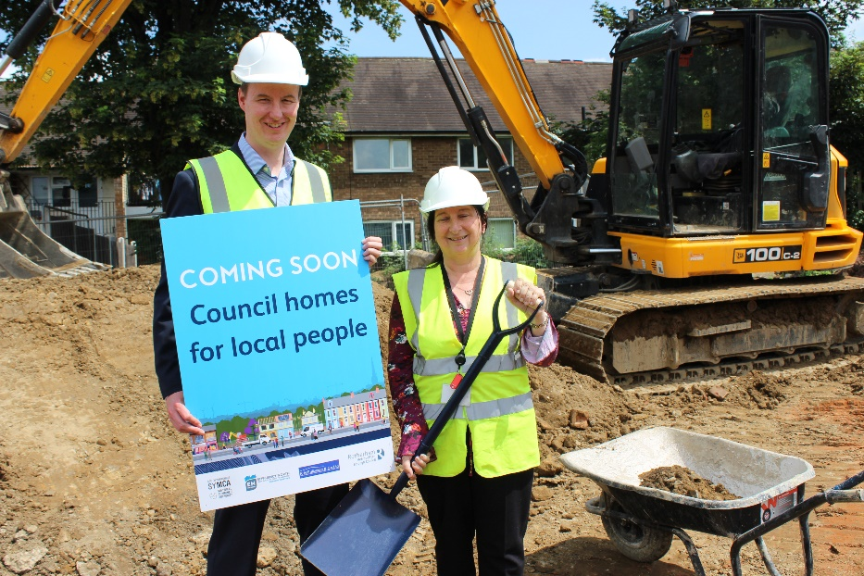
Breaking ground at Greenfield Road in Herringthorpe.


A skip day in Maltby.


Celebrating the retrofitted homes in Maltby.


Small Site Builders Initiative at Infirmary Road, Parkgate.

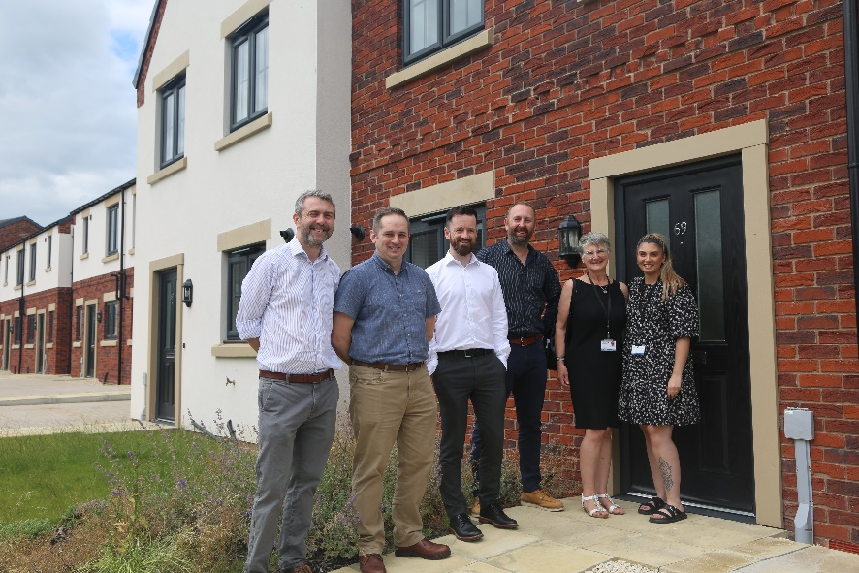
Celebrating the completion of more new build properties in Wath.

