
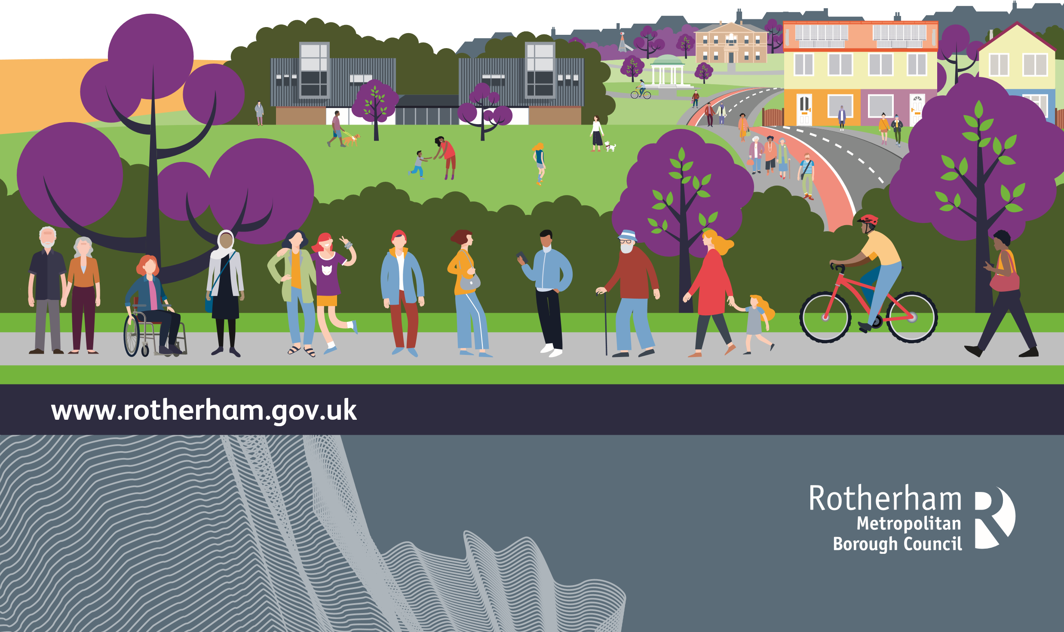
DIRECT PAYMENTS
An Easy Read Guide

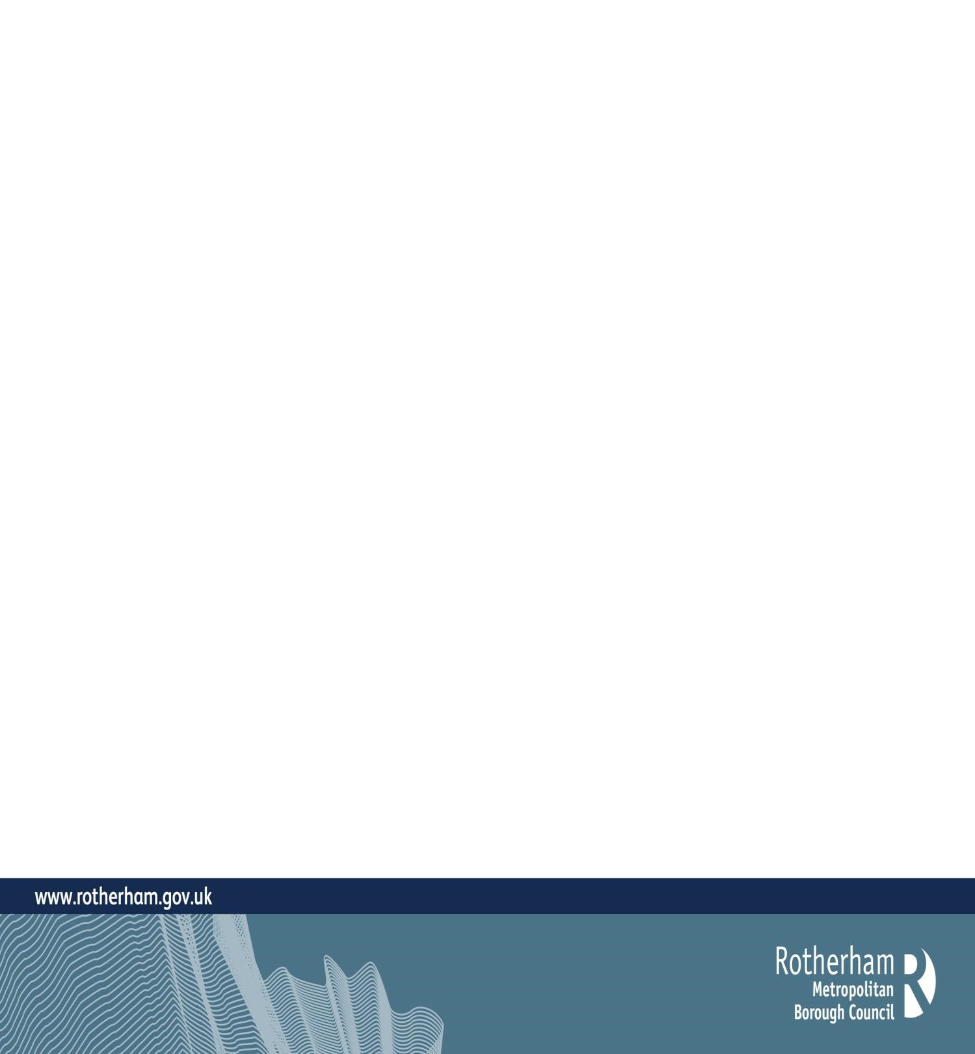
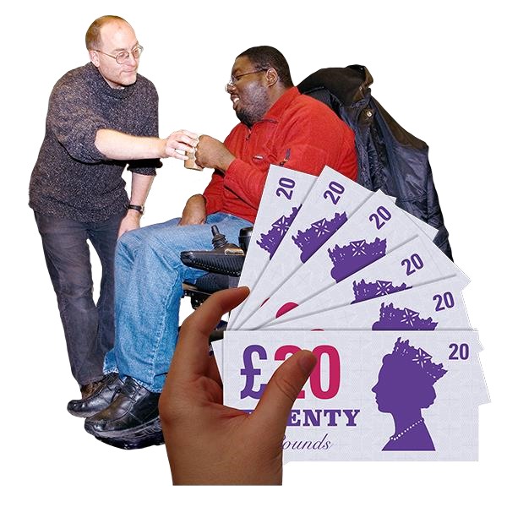

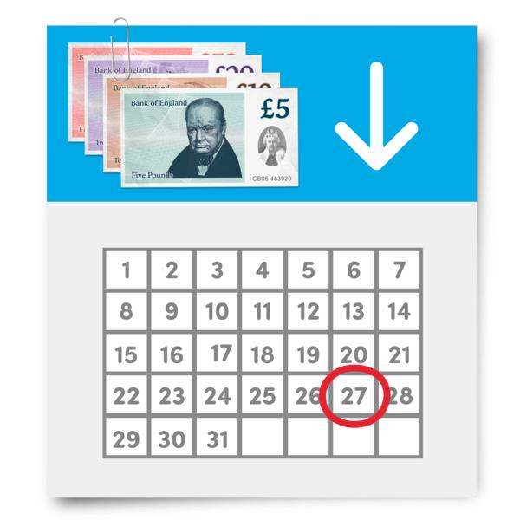
Direct Payments are sums of money
paid directly to you from Rotherham
Council.
You can use the Direct Payments to sort
out and pay for the care and support in
your support plan.
You can use Direct Payments to
meet your assessed needs.
You do not need to have a Direct
Payment. Your assessed needs
can be met in other ways.
We will help you with this.
What are Direct Payments?

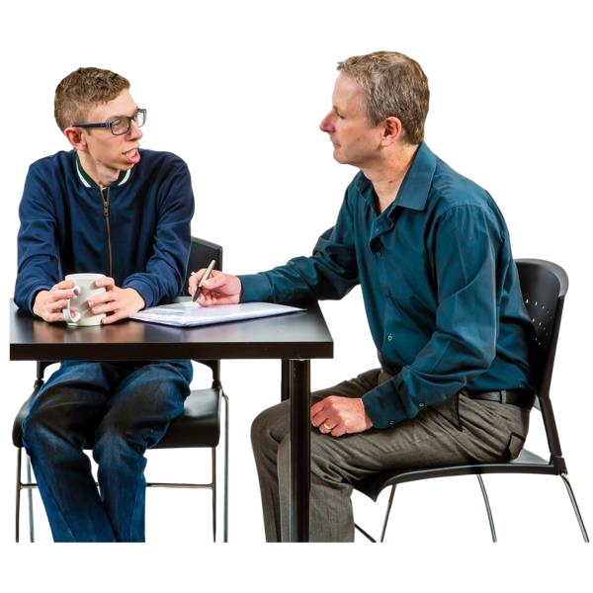

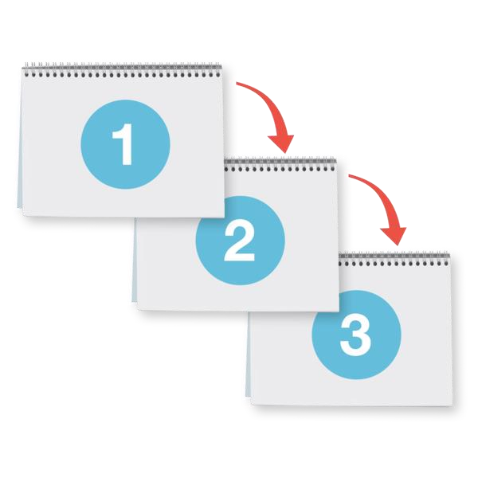
Most people who get help from social
care can get Direct Payments.
If you cannot have a Direct Payment, we
will tell you why and explain the next steps.
You can only have Direct Payments
after you have had an
assessment

from us.
Who can have Direct Payments?
An

assessment

is checking if
something is possible or not.
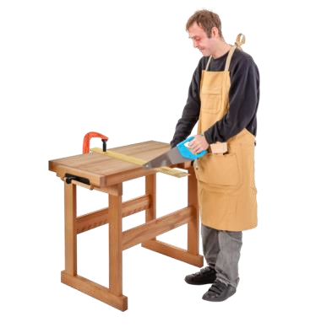


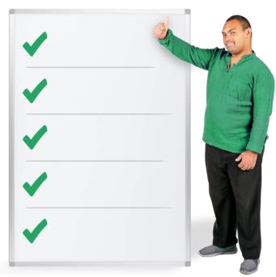
To go on a course or go to
college.
To go out and enjoy yourself.
To go to work
.
To take a break.
To pay people to support you at
home. These people are called
Personal Assistants.
What can Direct Payments be used for?
You can spend the Direct Payment
money to get the help and equipment
that your assessment says you need.
For example:
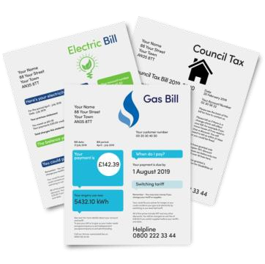

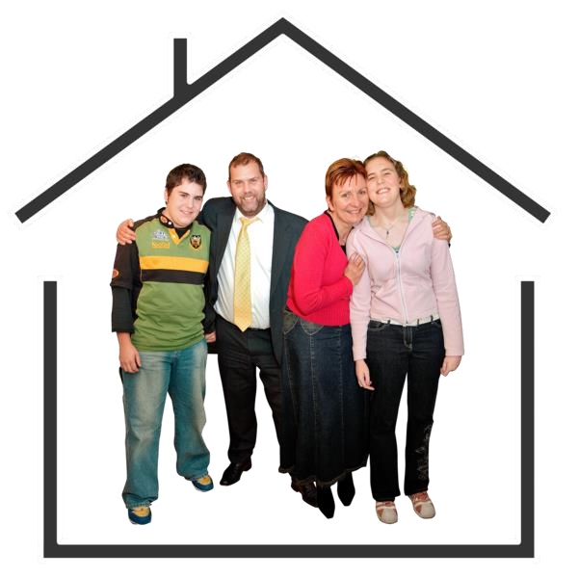

You cannot spend
your Direct
Payment

on:
Your Household bills.
Any social care services you receive that
are already paid for by the council.

Paying one of your family members who
lives in the same house as you to provide
care for you. Unless Rotherham Council
says this is ok.
Your housing needs.
Your health services.
Long term
residential care.
What can’t Direct Payments be used for?
Residential care
is when you live in
a care home because you cannot
live on your own, even with support.
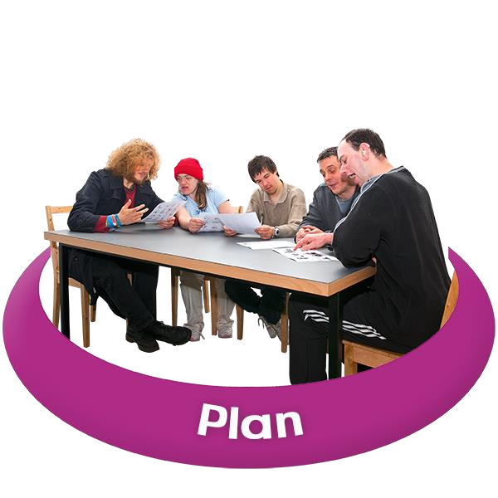


What will l need to do?
You will need to have an assessment
to check if you can have services.
If you can, we will write a
support
plan

with you.
The plan will show what is going to
happen and when it will happen.
You will need a back
-
up support
plan.
If something goes wrong, a
social
worker

will help you with your
back
-
up support plan.
A
support plan
is a document which will
tell you what services you will use. How
they will meet your needs. When they will
start and who will help you.
A
social worker
is a trained person who
will support you to work through
challenges in your everyday life.
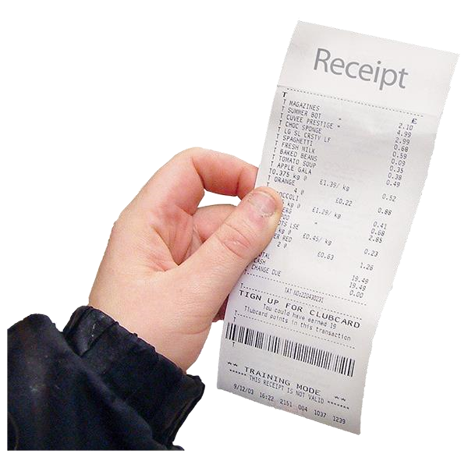
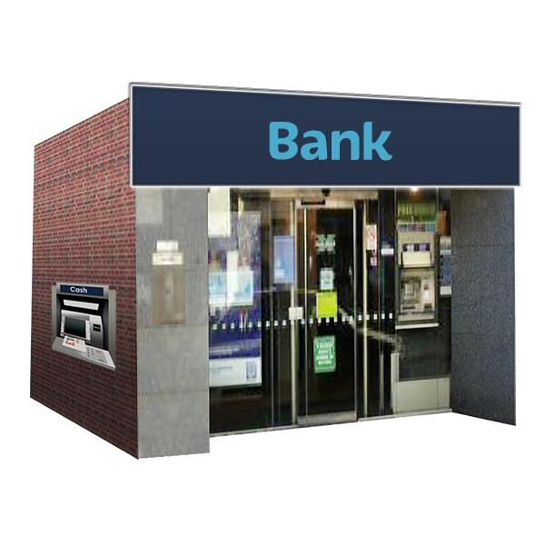
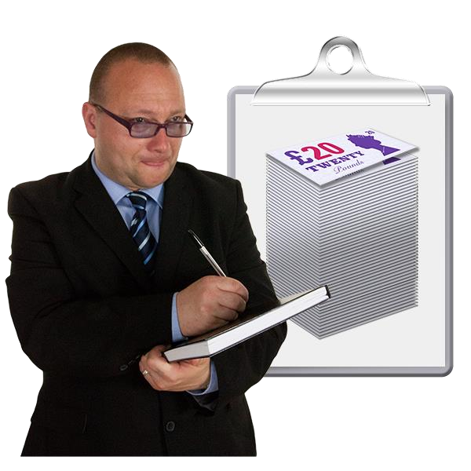
What will l need to do?
You will need a separate bank
account for your Direct Payments.
We will help you with this.
We will make checks to make sure
that you are using the money properly
for your care and support needs.
You will need to keep a record of how
much you spend and proof of what
the money was used for.
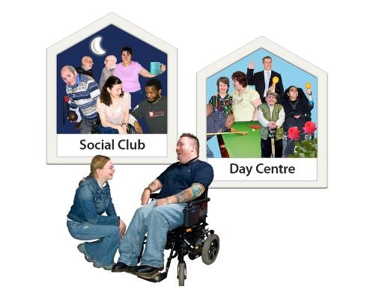


Who can help me with my Direct Payment?
We will provide help and
information about your Direct
Payments.
You can also choose a paid
organisation to manage your Direct
Payment for you.
We will support you to set this up and
provide advice about it, if you chose
this option.
You can manage your Direct Payment
yourself, or your family or friends can
support you.

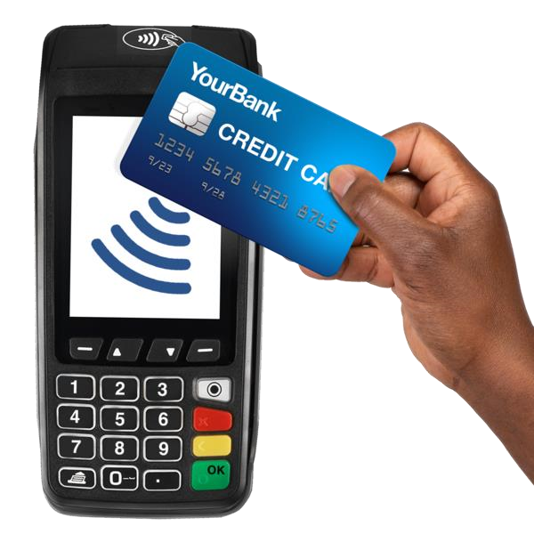
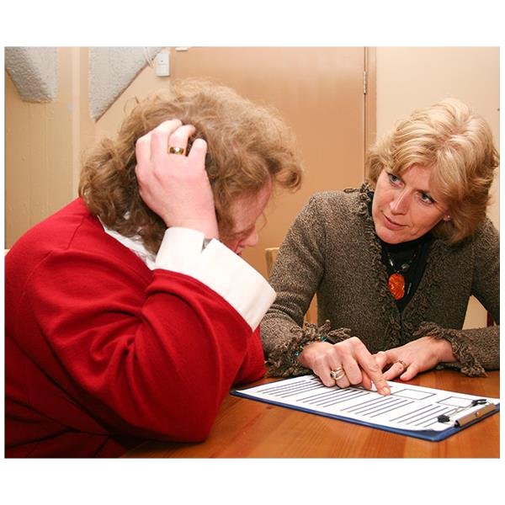
Will I need to pay anything myself?
We will work with you to find out how much
you can afford to pay towards your Direct
Payment.
This is called a
financial assessment
.
If you are asked to pay something towards
your care and support costs, we will tell
you how to do this.
A
financial assessment
tells us how
much you can afford to pay towards your
care and support
If you feel that you cannot afford to pay
towards your care and support costs, then
you can ask us to look at your financial
assessment again.


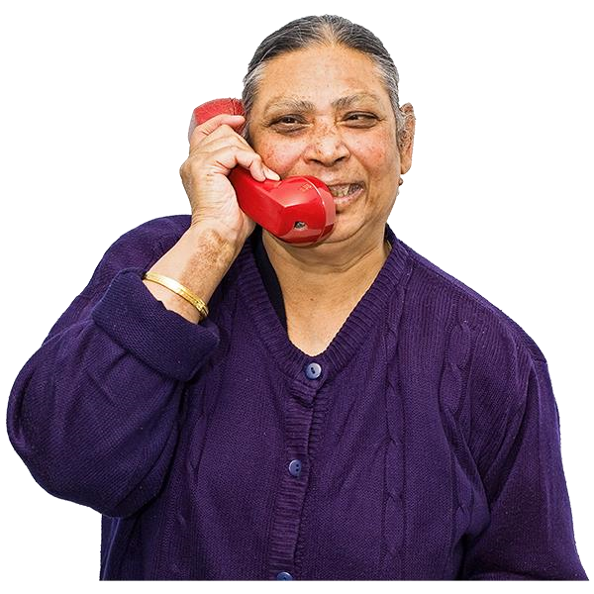
No, you do not have to have a
Direct Payment.
If you decide
that you would like to
try out Direct Payments, you can let
us know.
Do I have to have a Direct Payment?
If you want more information you
can telephone

the Customer
Contact Team 01709 822330

or you
can look online
www.rotherham.gov.uk

