FOCUS



# Improving oral health for adults in care homes

A quick guide for care home managers



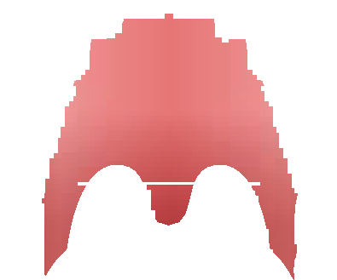

More than half of older adults who live in care homes have tooth decay, compared to 40% of over 75s who do not live in

care homes.

## Poor oral health can affect people’s ability to eat, speak and socialise normally.

People living in care homes are at greater risk of oral health problems for several reasons:

Long-term conditions (including arthritis,



Parkinson’s disease and dementia) can make it harder

to hold and use a toothbrush, and to go for dental treatment.

People now keep their natural teeth for longer, but this can mean they need more complex dental care than people who have dentures.



## Oral health assessment

Many medicines reduce the amount of saliva produced and leave people with a dry mouth.

Thorough assessments, and supportfrom skilled and knowledgeable staff can help prevent the pain, disturbed sleep and health problems that poor



oral health can cause.

All residents should have an oral health assessment when they move into the care home, with the result recorded in their care plan. Care staff should start by asking the following questions:

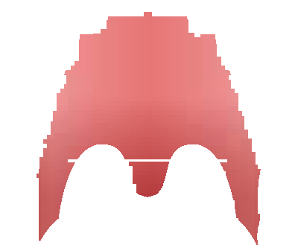

How do you usually manage your daily mouth care and what help would you like?

What dental aids do you currently use? For example, manual or electric toothbrush, mouthwash, floss.

Do you have dentures, and if so are they marked with your name? If not, would you like them to be marked?



When did you last see a dentist, and who did you see?

If you don’t have a dentist, would you like help to find one?

Using an oral health assessment tool, such as the example included on the next page, will highlight any areas where residents need specific care and support. Using it for reassessments will indicate any changes that may need action.

## Oral health assessment tool

Resident: Completed by: Date:

Scores – You can circle individual words as well as giving a score in each category

(* if 1 or 2 scored for any category please organise for a dentist to examine the resident)

0 = healthy 1 = changes* 2 = unhealthy*

2

1

signs (swelling of cheek or gum, broken teeth, ulcers), as well as verbal and/or behavioural signs (pulling at face, not eating, aggression)

No behavioural, verbal, or physical signs of dental pain

There are verbal and/or behavioural signs of pain such as pulling at face, chewing lips, not eating, aggression

There are physical pain

0

1

2

0

No decayed or broken teeth or roots

1–3 decayed or broken teeth or roots or very worn down teeth

4+ decayed or broken teeth or roots, or very worn down teeth, or less than 4 teeth

1

2

0

Smooth, pink, moist

Dry, chapped, or red at corners

Swelling or lump, white, red or ulcerated patch; bleeding or ulcerated at corners

Lips:

Dental pain:

Natural teeth Yes/No:

 Organise for resident to have a dental examination by a dentist  Resident and/or family or guardian refuses dental treatment

Saliva:

Moist tissues, watery and free flowing saliva 0

Dry, sticky tissues, little saliva present, resident thinks they

have a dry mouth 1

Tissues parched and red,

little or no saliva present,

saliva is thick, resident thinks

they have a dry mouth

2

1

2

Pink, moist, smooth, no bleeding

Dry, shiny, rough, red, swollen, 1 ulcer or sore spot under dentures

Swollen, bleeding, ulcers, white/red patches, generalised redness under dentures

1

2

Normal, moist roughness, pink

Patchy, fissured, red, coated

Patch that is red and/or white, ulcerated, swollen

 Complete oral hygiene care plan and start oral hygiene care interventions for resident

 Review this resident’s oral health again on date:

TOTAL: SCORE: 16

With kind permission of the Australian Institute of Health and Welfare (AIHW). Source: AIHW Caring for oral



of dentures or severe halitosis (bad breath) 2

Clean and no food particles or tartar in mouth or dentures

Food particles, tartar or plaque in 1–2 areas of the mouth or on small area of dentures or halitosis (bad breath)

Food particles, tartar or plaque in most areas of the mouth or on most

1

0

2

More than 1 broken area or tooth, denture missing or not worn, loose and needs denture adhesive, or

not named

daily, or dentures not named, or loose

No broken areas or teeth, dentures regularly worn, and named 0

1 broken area or tooth or dentures only worn for 1–2 hours

1

0

Gums and tissues:

0

Tongue:

Oral cleanliness:

Dentures Yes/No:

health in Australian residential care (2009).

Modified from Kayser-Jones et al. (1995) by Chalmers (2004).

## Care staff knowledge and skills

Care staff need to know how and when to reassess the oral health of a resident, and how to support residents with their daily mouth care to:

Brush their natural teeth at least twice a day with fluoride toothpaste.



Use their choice of cleaning products for dentures.



Clean their dentures (brushing, removing food debris, removing dentures overnight).

Use their choice of toothbrush, either manual or electric/ battery powered, and mouth care products.

They also need to understand how dental pain or a mouth infection can affect residents’ general health, wellbeing and behaviour.



Make sure staff know who to ask for advice, how and when to report any concerns about a resident’s oral health, and how changes in a person’s condition might affect their ability to manage their mouth care.

## What the Care Quality Commission expects

The [Care Quality](http://www.cqc.org.uk/)  [Commission](http://www.cqc.org.uk/) expects registered managers to take account of nationally recognised guidance, including guidance from NICE.



Evidence about how you support residents to maintain good oral health will help you demonstrate that your service is both effective and responsive.

NICE’s guideline on oral health for adults in care homes, including the baseline assessment tool, can be used as part of your preparation for inspection and to support requests for help to other services. If you are concerned about the availability of dental services inform your local [Healthwatch](http://www.healthwatch.co.uk/find-local-healthwatch) and public health teams. Your local oral health promotion team should be able to provide you with educational materials, support and training.

## Further information

[Oral health for adults in care homes](https://www.nice.org.uk/guidance/ng48) – NICE guideline

[Oral health for adults in care homes – tools and resources](https://www.nice.org.uk/guidance/ng48/resources) – NICE

[Using quality standards to improve practice in care homes for older people](https://www.nice.org.uk/guidance/qs61/resources/using-quality-standards-to-improve-practice-in-care-homes-for-older-people-62241661) – NICE

[Dental care and oral health](https://www.alzheimers.org.uk/site/scripts/documents_info.php?documentID=138) – Alzheimer’s Society factsheet

This content has been co-produced by NICE and SCIE and is based on NICE’s guideline on oral health for adults in care homes.

National Institute for Health and Care Excellence

[www.nice.org.uk](http://www.nice.org.uk/) © 2016 National Institute for Health and Care Excellence. All rights reserved

Social Care Institute for Excellence

[www.scie.org.uk](http://www.scie.org.uk/)