Rotherham Empty Homes Plan 2025-29
TABLE OF CONTENTS
INTRODUCTION - 1
CONTEXT - 2
MEETING HOUSING NEED - 6
PROGRESS MADE - 8
COMMITMENTS AND ACHIEVEMENTS - 10
ROTHERHAM’S EMPTY PROPERTY PICTURE - 12
HOW WILL SUCCESS BE MEASURED? - 13
TARGETS - 14
APPENDIX 1 – EXAMPLE CASE STUDIES - 15
APPENDIX 2 – CHARTS 19 - 20

Introduction
For the purpose of this Action Plan, an empty property refers to privately owned residential properties that have been un-occupied and unfurnished for two years or more. In order to actively bring long-term empty properties back into use, the Council may choose to support owners of problematic short-term empty properties as well.
The Rotherham Empty Homes Plan sets out a number of ways in which the Council will support and encourage homeowners to bring empty properties back into use whilst working to reduce the number of long-term empty properties, which cause blight in our neighbourhoods. This intervention will range from working with owners, providing information, advice, or incentives through to using enforcement activity to address the negative impact that problematic long-term properties can have on our communities.
Rotherham’s Empty Homes Plan, first published in 2019, set out the Council’s vision for dealing with Rotherham’s empty private properties. This current Plan maintains the same key objectives.
- Identify and maintain information about the empty property picture across the Borough and share intelligence across services.
- Make it easy for members of the public and officers to report empty properties.
- Take a strategic approach to dealing with empty properties and prioritise the most problematic properties.
- Be proactive by encouraging and supporting empty property owners to bring them back into use.
- Understand and make use of appropriate initiatives and work collaboratively to make the most of all available resources, including considering a contribution to the Council’s Housing Delivery Programme.
- Be prepared to take enforcement action where appropriate.
- Monitor progress and communicate positive intervention.

Context

National context
According to statistics analysed by Action on Empty Homes, the national campaigner for empty homes to be brought into use for people in housing need, there are approximately 720,000 homes in England that are unfurnished and standing empty, accounting for approximately 2.83%
of all properties. Over 265,000 of these are classed as ‘long-term empty’.
When holiday short-lets and second homes are added to these figures, total vacancy sits at over one million homes, almost 4%, meaning that across England, one in every 25 homes is empty.

Local context
Empty properties account for 2.65% (Chart 1 - Appendix 2) of the housing market in Rotherham. Almost half of these can be considered part of a well- functioning housing market, referred to as the ‘churn’ with these primarily being properties empty for less than six months. There are also properties that will remain empty because they are furnished or second homes, equating to almost 15% of all empty properties, and those properties that are progressing to or in probate or have an exemption that restricts the Council from bringing them back into use accounting for a further 17%. However, a quarter of all empty properties may be more problematic, causing issues for neighbours and communities, and further work is needed to help owners to progress the most suitable option for them and their property.
From April 2013, councils have had the discretion to decide on the level of discounts available to owners of empty properties to function as an incentive to bring them back into use, as well as the option to place a premium on the Council Tax of properties that have been empty more than two years.

Rotherham Council has taken advantage of this option and owners of empty properties that have been left empty for more than two years are charged the following premiums in addition to the annual Council Tax charge.
Period of time property empty | Amount of premium | Premium charge introduced
Over 2 years | 100% | 2018/19
Over 5 years | 200% | 2020/21
Over 10 years | 300% | 2021/22

The aim of this initiative is to try to discourage homeowners from leaving properties empty for an excessive period of time.

Why do properties become empty?
We know from supporting empty property owners that their homes may become empty for a variety of different reasons including:
- The normal process of buying, selling, and letting properties (market churn).
- A property that is difficult to rent or sell due to its physical state, requiring renovation beyond the budget of the owner.
- A property that is difficult to rent or sell due to location, poor facilities, infrastructure, etc.
- When the property has been abandoned by an owner who is now untraceable.
- When there is an issue of unresolved ownership, often as a result of the previous owners’ death. Resolving ownership can be a lengthy legal process, during which time the property may remain empty.
- Property holding – when a property is left empty due to speculative investment, acquiring property through inheritance, or where partners co-habit leaving the second property empty. Also, where the property is adjoined to a business and the owner does not wish to sell or let it.
- Due to an aging population, older property owners may move into alternative accommodation for care or support needs.
They may choose not to sell the property which can result in it remaining empty for the short or long term.

How can bringing empty properties back into use help?
In summary, it releases owners of the burden of an unviable home, any renovation creates jobs and income for local businesses, it removes what is often an eyesore for the local neighbourhood, and most importantly, it gives someone a much-needed new home.
Bringing empty properties back into use is recognised, within the Council’s Housing Strategy, as an opportunity to bring more (affordable) housing units to the market as well as meet challenges that empty properties cause.
- Neighbourhoods – empty homes can cause unnecessary blight in our neighbourhoods. Successful work in the Borough has shown that focused intervention can bring about estate-based improvements.
- Housing need – there is an increasing need for more homes across the Borough. Housing supply has not kept up with demand for many years, bringing back existing empty properties can also contribute to meeting the historic shortfall.
- Homelessness – there are increasing numbers of people homeless or facing homelessness.
- Affordable Housing – there are over 7,500 applicants on the Councils waiting list who are trying to access good quality, affordable homes.
- Owners – empty homes cost money, including increasing Council Tax rates and charges, security, and maintenance/upkeep.

Meeting Housing Need
How bringing empty homes back into use can help meet housing need
The Council recognises the difficulties residents face when trying to find a good quality, affordable home. There is extreme pressure on the housing market;
- increased demand on the homelessness team
- a long waiting list on the Common Housing Register
- unaffordable private sector housing
- a shortage of affordable housing, especially for those most in need such as first-time buyers.
We know from analysing key data sources and from monitoring access to Council services that many people continue to struggle to access good quality, affordable accommodation throughout the Borough. The cost of owning or privately renting a home continues to increase year on year, exacerbating the affordability issue further.
At the time of writing, there are currently over 7,000 applications on the Council’s Housing Register from people requiring social housing, increasing year on year. There has also been an increase in the number of people seeking homelessness assistance from the Council and requiring temporary accommodation to alleviate their situation. Increasing the supply of accommodation in the Borough by returning empty homes back into use helps the Council mitigate some of these housing pressures.
The Council continues to deliver on its largest development programme in decades in order to increase the number of new homes to the levels needed; bringing back empty homes is part of the solution.
The approach taken is described in the graphic below. This approach is influenced by the willingness of the empty property owner to engage with the Council, the options available to bring a property back into use and the resources available to deliver an outcome.

INFORM INCENTIVISE ENFORCE

0-6 months | 6-24 months | 2-5 years | 5 years and over
- Initial contact  - Online support/measures  - Highlight benefits.  - Enforcement notices | - Technical advice  - Support with planning issues.  - Escalation of Enforcement  - Consider option to acquire as part of Councils Housing Delivery Programme  - Leasing / lettings options | - Prepare for Enforced Sale, Empty Dwelling Management Order (EDMO), Compulsory Purchase Order (CPO)  - Council Tax premium increase | - Action an Enforced Sale, EDMO, CPO  - Further Council Tax premium increases

Progress made

What have we done since publishing the Housing Strategy 2022-25?
The Council’s Housing Strategy 2022-25 introduced, for the first time, a priority to bring empty properties back into use and, as a result, identified a number of commitments that would contribute to this priority.
COMMITMENT | ACTION | PROGRESS MADE
We will continue to deliver against the Empty Homes Plan. | Increase the number of empty homes brought back into use. | Annual increase in properties brought back into use:  - 2021/22 = 12  - 2022/23 = 17  - 2023/24 = 33  Annual target set at 25 properties for 2024/25
We will help owners understand how they can help meet local housing need, for example by promoting success stories. | Communications/case studies to demonstrate empty homes work. | Promoted national Empty Homes Week, annually.  Communications, including use of case studies, data, etc., targeted towards Wards with high levels of empties.
We will explore options to transform empty homes into new affordable homes. | Explore opportunities to bring homes back into use to address housing pressures. | Supported a social housing provider to secure Affordable Housing Programme funds to improve long-term empty property.
We will make use of enforcement tools available. | Case work escalated to Regulation & Enforcement as appropriate. | The use of enforced sale powers was considered for two cases however, a resolution was found.
We will consider how other empty spaces (such as derelict buildings and spaces above shops) could be repurposed to provide more homes. | Conversation with partners | Progressing discussions with property owners around the borough, as appropriate.
Broader service activity contributing to this priority. | Linking empty properties into current housing pressures i.e., to support homelessness.  Increasing supply of additional affordable homes through acquisition/ delivery programme. | Council void properties brought back into use faster, moving from an average of 40 days to 25 days.  To use empty homes data to target properties suitable for acquisition where they meet strategic need.

Commitments and achievements
Commitments identified in and achieved since last Empty Homes Plan;
- Recruited a permanent Empty Homes Officer.
- Mapped the customer reporting journey and put a new process in place to capture and monitor empty properties.
- Created an Empty Homes webpage, introduced an online form and a dedicated inbox to receive enquiries.
- Undertook an empty property survey and produced an associated leaflet for empty property owners.
- Increased Council Tax charges for long term empty homes.
- Included ‘Empty homes back into use’ as a commitment in the Housing Strategy 2022-25

Achievements, in numbers, 2021-2024
EMPTY DESCRIPTION | MAR 2023 | APR 2023 | MAY 2023 | JUN 2023 | JUL 2023 | AUG 2023 | SEP 2023 | OCT 2023 | NOV 2023 | DEC 2023 | JAN 2024 | FEB 2024 | MAR 2024
Number of cases received | 9 | 5 | 14 | 11 | 5 | 6 | 8 | 7 | 11 | 6 | 3 | 7 | 28
Number of cases forwarded to other services | 7 | 5 | 10 | 10 | 5 | 6 | 7 | 7 | 11 | 5 | 2 | 6 | 11
Number of cases closed by Empty Homes Officer | 4 | 5 | 6 | 8 | 7 | 6 | 6 | 7 | 8 | 5 | 1 | 5 | 18
Number of cases pending | 48 | 46 | 52 | 56 | 56 | 50 | 52 | 56 | 57 | 55 | 56 | 54 | 64
Number of live cases | 55 | 53 | 60 | 64 | 64 | 60 | 62 | 64 | 64 | 60 | 60 | 58 | 70
Number of properties in 'new' ownership | 6 | 4 | 0 | 0 | 3 | 5 | 2 | 0 | 0 | 0 | 5 | 1 | 0
Number of properties brought back into use | 2 | 3 | 1 | 7 | 0 | 3 | 1 | 1 | 3 | 1 | 1 | 11 | 1

Rotherham’s Empty Property Picture (as of October 2024)

2.7% of all residential housing stock is empty. Appendix 2: Chart 1

0.79% empty properties have been empty for over 6 months. Appendix 2: Chart 2

260 (0.23%) empty properties have been empty for over 2 years. Appendix 2: Chart 3

111 cases received by the Council’s Empty Homes Officer during 2023/24.

33 properties brought back into use, with Council support, in 2023/24.

Target of 25 properties to be brought back into use 2024/25.

How will success be measured?
The Council’s dedicated Empty Homes Officer will be responsible for delivery of the plan and will co-ordinate the Councils response to empty homes enquiries across the Borough. The officer will be responsible for demonstrating successes via an Empty Homes dashboard which will include the following.
- The contribution that empty properties brought back into use make towards Rotherham’s housing offer.
- The total number of empty properties in the Borough. – Broken down by short / long term properties.
- The total number of empty properties brought back into use.
  - Through Council intervention where there is a target of 25 empty properties brought back into use for 2024/25.
  - Without Council intervention to reflect demand in the housing market and the impact of the empty homes premium.
- Number of empty property enquiries.
- External funding secured to support bringing empty properties back into use.
- Wider value of property brought back into use.
An annual update report will be presented to the Housing Senior Management Team during the first quarter of each year providing the current position, an update on progress of annual targets and future work.

Targets

Empty Homes Plan – Forecasted targets for bringing properties back into use.
A commitment has been included within this year’s Housing Service Plan to bring 25 empty private properties back into use during 2024/25 and, based on historical and current activity, stretching targets have been forecasted for the life of this Plan, as shown below. These targets will be reviewed on an annual basis and will be adjusted, if necessary, based on the availability of resources and ongoing activity at the time of monitoring and setting.

EMPTY DESCRIPTION | 2024/25 | 2025/26 | 2026/27 | 2027/28 | 2028/29 | TOTAL
Number of properties to be brought back into use | 25 | 30 | 35 | 40 | 45 | 175

Appendix 1 – example case studies

CASE STUDY 1 - ASTON
Empty Since: 2016
Occupied: 2022
- This property was empty due to the owner moving away to care for their elderly parent.
- The property was reported as being empty and in need of maintenance in 2021.
- The Empty Homes Officer contacted the Owner to understand their future intentions for the property, discussed potential outcomes and responded to the complaint received.
- With the owner’s consent, the Empty Homes Officer arranged for the property to be valued and marketed.
- The property was sold at auction to a contractor, who renovated and marketed it. The property is now occupied.

Appendix 1 – example case studies

CASE STUDY 2 - MALTBY
Empty Since: 2016
Refurbished: 2024
- This property was empty due to being prohibited, and the owner had moved into Housing Association accommodation.
- The property was reported as being empty and in need of extensive maintenance by Regulation & Enforcement in 2021.
- Following a prohibition order being served, the Empty Homes Officer had a lengthy dialogue with the owner who was reluctant to consider selling the property due to the potential impact on their financial position and social housing status.
- The Empty Homes Officer discussed the situation of rehousing with the owner and housing provider to ensure that the owner would not be disadvantaged by selling.
- The owner agreed to sell the property at auction, with the property selling for £56,000.

Appendix 1 – example case studies

CASE STUDY 3 - BRINSWORTH
Empty Since: 1993
Occupied: 2022
- This property was empty due to the owners separating and both moving away.
- The property was reported as empty in 2021, as it was attracting vandalism and ASB.
- The owner refused to engage with the Empty Homes Officer. Contact was eventually made when the owners daughter responded to a card left at his rental property, and she convinced her father to market the property.
- The property sold for more than £20,000 over the guide price.
- The property was extensively refurbished by the new owner and was retained as a private let which is currently tenanted.

Appendix 1 – example case studies

CASE STUDY 6 - ASTON
Empty Since: 2021 Marketed for Sale: 2025
- This property was empty due to the owner moving away and being unable to maintain the property remotely.
- There was a leak in the roof void which had caused water damage and excessive black mould and damp.
- The owner was assisted by the Councils Empty Homes Officer to consider their options and chose a ‘no fee’ option of selling at auction.
- The property received a lot of interest and sold first time, for above the guide price.
- The property was renovated and is currently being marketed for sale.

Appendix 1 – example case studies

CASE STUDY 7 – MALTBY
Empty since: 2018
Two properties occupied: 2023 (One still unoccupied).
- One property was reported as being empty, in 2021, which resulted in a visit that led to identifying that a further two properties were also empty.
- A combined approach of assistance and enforcement resulted in all three properties being sold at auction.
- Two properties have been extensively refurbished and occupied with the original empty property remaining empty. Engagement with the ‘new’ owner continues.

Appendix 2

TOTAL NUMBER OF EMPTY PROPERTIES IN ROTHERHAM
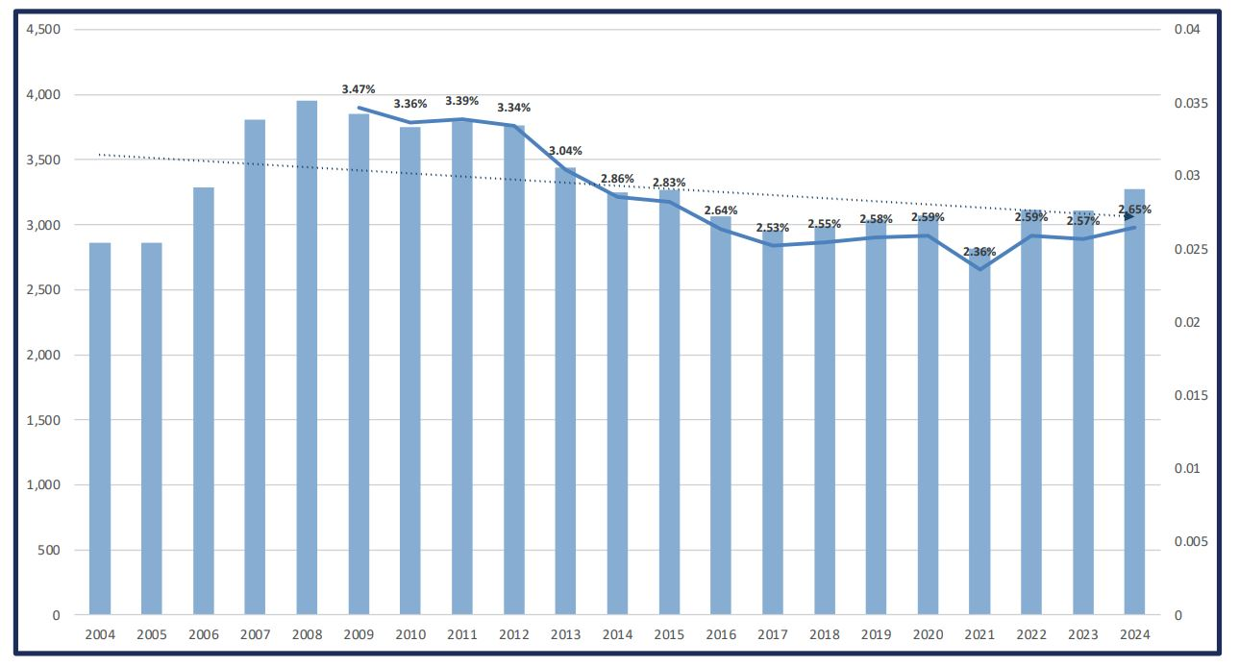
Chart 1: Number and percentage of empty properties calculated annually (October) and published Table 615

Appendix 2

PROPERTIES EMPTY OVER 6 MONTHS AND 2 YEARS
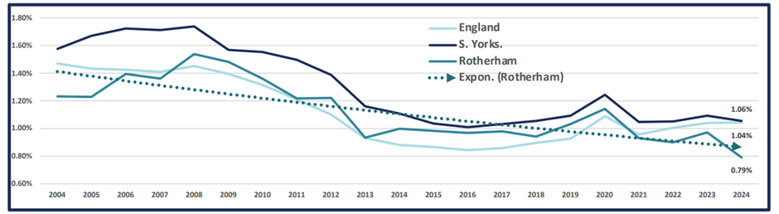
Chart 2: Long-term (over 6 months) empties as reported annually and published Table 615

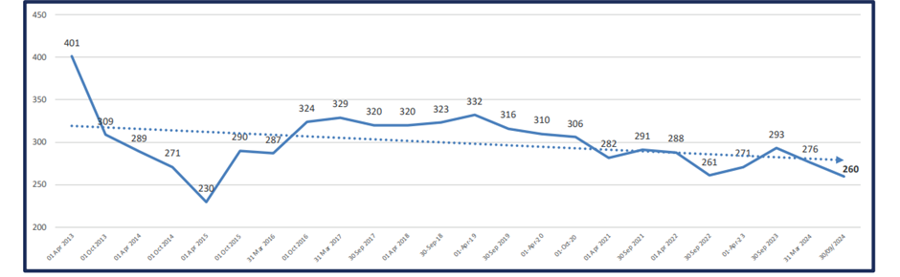

Chart 3: No. properties receiving Empty Homes Premium (empty 2 years or more) based on data provided by Council Tax Service

