District Heating Guide

WELCOME
This is an informational guide explaining how Rotherham Council’s District Heating service works.

WHAT IS DISTRICT HEATING?
District Heating, also known as a heat network, is a system that uses a singular central heat source to distribute hot water through a network of insulated pipes to multiple individual dwellings.
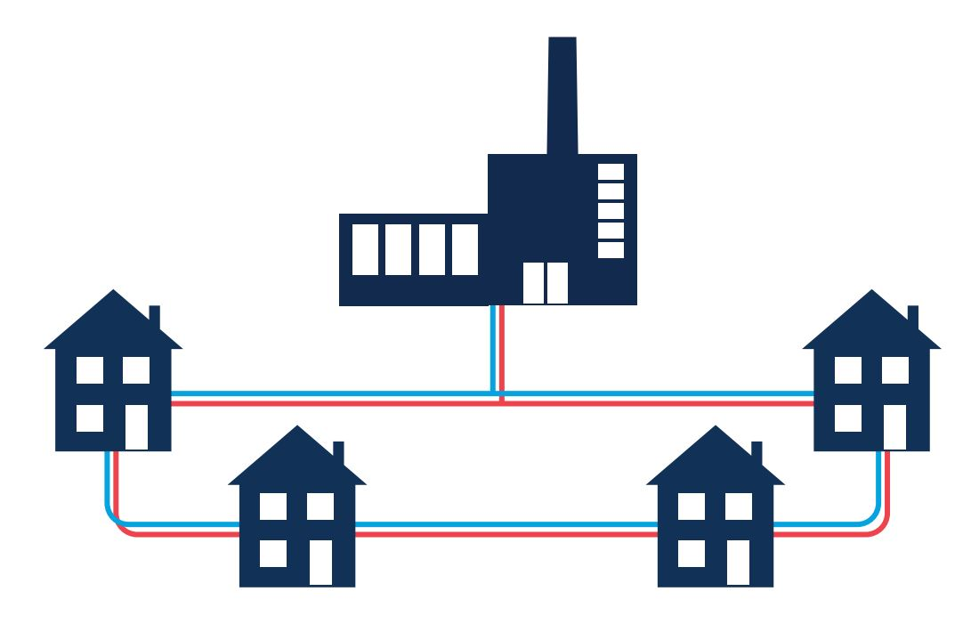
For more information please visit the Energy Saving Trust: energysavingtrust.org.uk/service/district-heating/

THINGS YOU NEED TO KNOW ABOUT YOUR DISTRICT HEATING SYSTEM
You have accepted a property with a District Heating charge.
Your District Heating charge:
• Is a fixed contribution amount which is paid each week for the heat and hot water you use.
• Is added to your rent account each rent week.
• Is not covered by Housing Benefit or Universal Credit.
• Takes into account the number of bedrooms the Council states your property has.
• Is based on average usage; your actual bill may be higher or lower depending on your own usage.

YOUR DISTRICT HEATING METER READING
Your property is fitted with a meter. This records the amount of hot water and heat you use. Your bill is calculated using the meter reading.
Meter readings will usually be taken remotely, however if access to your property is required, we will give at least seven days prior notice.
Your meter is read four times a year; at the end of each quarter: March, June, September, and December.
We will aim to send you a quarterly statement within twenty-eight days of your quarter end.
The statements show you how much heat and hot water you have already used and how much it is costing you.

You can submit a meter reading online at any time by visiting the Council’s website, www.rotherham.gov.uk/housing

YOUR DISTRICT HEATING BILL
You will receive a letter and year end bill which shows the annual cost of the heat and hot water you have used; and how much you should have paid in the whole year.
The letter, alongside your year-end bill, will explain if you are in credit and a refund is due, or if you are in debit and you need to make a further payment.
If you are in credit – where you have used less than you have paid for – you will be entitled to a refund if your rent account is up to date. This will happen automatically, and you will be informed in your year-end letter.
If you are in arrears with your rent, any credit will be transferred to your rent account.
If you are in debit – where you have used more heat and hot water than you have paid for – the amount will automatically be debited to your rent account, and you will need to make arrangements with our Income Recovery team to clear this.
We aim to send year-end letters out within 28 days. Please then allow a further 14 days for cheque refunds.

UNDERSTANDING YOUR TARIFF
Kilowatt-hour (kWh)
• Your meter measures your energy use in Kilowatt-hour (kWh).
• We use this to calculate how much energy you’ve used so we know how much to charge you.
• kWh pricing is subject to change however you will be given 28 days notice of any change.
Standing Charge
• There is currently no daily Standing Charge for Rotherham Council District Heating customers.

WHAT TO DO IF YOU NEED A REPAIR
• Please do not tamper with or ‘bleed’ your radiators in any way. Doing so, may cause them to break down, affecting the whole system.
• If your heating breaks down, please call 01709 382121 to report a fault.
• It is very important to report faults straight away, as your fault may affect the whole District Heating
System, causing problems for multiple properties.
• Our engineers will attend any reported fault, at the latest, by close of business the next working day.
• If your issue is classed as an emergency, we will aim to respond within four hours.
• Your system will be serviced every year by an appointed contractor, who will contact you in writing or by telephone to arrange an appointment.
• Remember at always check the identification of any staff who visit your home. All our staff must carry an identification card and are required to show you this before they enter your home.

WAYS TO PAY YOUR DISTRICT HEATING
Your District Heating forms part of your rent, and any payments should be made directly to your rent account. There are various payment methods that can be used:
Direct Debit
Payments are made directly from your bank account. If the amount you need to pay changes, the Direct
Debit will automatically adjust your monthly payment. You will receive a letter notifying you of the new payment amount before it is collected.
You can choose to pay weekly (on Thursdays or Fridays) or monthly on the 1st, 12th, 18th, 24th or 28th of the month.
Paying via Direct Debit means that you are covered by the Direct Debit Guarantee, which is a safeguard for customers using Direct Debit payments. Further information can be found here:
www.directdebit.co.uk/direct-debit-guarantee
To set-up a Direct Debit please visit www.rotherham.gov.uk/council-social-housing/housing-rent
Recurring Card Payment
Also known as a Continuous Payment Authority (CPA), this is a type of payment arrangement where you authorise Rotherham Council to take payments from your debit or credit card on a regular basis.
You can choose to pay weekly, fortnightly, four-weekly, or monthly on a day of your choice; however, you do not have the same level of protections offered by a Direct Debit.
For any assistance with setting up a Recurring Card Payment, please contact the Income Recovery team.
Standing Order
An instruction you give to your bank to make regular, fixed payments from your account to another account.
Unlike Direct Debits, Standing Orders are for fixed amounts and is managed between you and your bank.
You should allow three working days for payments made by Standing Order to reach your rent account.
You will need your rent reference number so that the payment is added to your account. Please note that payments made after close of business on Friday will be allocated to your account on the following Monday.

Automated Card Payment Line
You can call the Automated Card Payment Line 24 hours a day on 0300 456 2723.
You will need your rent reference number so that the payment is added to your account.
Please note that payments made after close of business on Friday will be allocated to your account on the following Monday.

WHAT TO DO IF YOU FALL BEHIND WITH PAYING YOUR RENT AND/OR DISTRICT HEATING
When you have rent and/or district heating debt, we will do all we can to help you and will only take legal action against you as a last resort. However, we can’t help unless you work with us.
What we expect you to do:
• Contact us as soon as you start having difficulty making payment.
• If we try to contact you, please get back in touch with us as soon as you can.
• Rent and district heating payments are a priority and should be paid before most other obligations – more information about priority debts and bills can be found via MoneyHelper.
www.moneyhelper.org.uk/en/everyday-money/credit/how-to-prioritise-your-debts
• If we agree a payment plan you must pay as agreed. If you can’t, please contact us straight away.
• Keep in touch with us on a regular basis and particularly if your circumstances change – we don’t know what’s happening unless you tell us.
What you can expect from us:
• We will attempt to contact you using a variety of methods.
• We will not take any form of legal action without warning you first, giving you chance to resolve the problem.
• If you are unable to clear your debt in full, we may agree a repayment arrangement and will not take any further action against you provided you pay exactly as agreed.
• If you need some time to deal with problems affecting the payment, we will agree a timescale for such issues to be dealt with and will we not take further action against you provided you keep to the agreed timescales.
• If you have other debts or you would just like some help to manage your finances, you can find the contact details for several free and impartial advisory services within this guide.

SAVE MONEY ON ENERGY BILLS
There are steps you can take to help you to stay warm in your home, save money and reduce carbon emissions:
• Familiarise yourself with your heating controls.
• Turn your heating off when you don’t need it.
• Turning down your thermostat by just 1°C can make a difference.
• Close your curtains at dusk to keep the heat in
• Have a quick shower rather than a bath – showers use a lot less hot water.
• Keep internal doors closed to reduce draughts.
• Make use of timers for your hot water.

For further information
GOV.UK
Government advice on how to stay well in cold weather.
www.gov.uk/government/publications/keep-warm-keep-well-leaflet-gives-advice-on-staying-healthy-in-cold-weather/top-tips-for-keepingwarm-and-well-this-winter

Met Office
How to get your home and property winter ready.
www.metoffice.gov.uk/weather/warnings-and-advice/seasonal-advice/
your-home/protecting-your-property-from-winter-weather

NHS
Winter vaccinations and winter health.
www.nhs.uk/live-well/seasonal-health/keep-warm-keep-well/

YOUR CONSUMER RIGHTS
As a Rotherham Council District Heating customer, you have certain rights regarding the service you receive.
Here are some useful contacts, should our service fall below expected standards:

Citizens Advice Rotherham
Provides free, independent, and confidential advice on energy disputes.
0808 278 7911 • www.citizensadvicerotherham.org.uk

Energy Ombudsman
Handles all heat network related complaints, including breaches of regulation.
0330 440 1624 • www.energyombudsman.org

Housing Ombudsman
Manages disputes involving tenants and leaseholders of social landlords when complaints are against
landlords for breaching contractual obligations.
0300 111 3000 • www.housing-ombudsman.org.uk

USEFUL CONTACTS
Age UK Rotherham: 01709 835214
www.ageuk.org.uk/rotherham

Stepchange Debt Charity: 0800 138 1111
www.stepchange.org

Citizens Advice Rotherham: 0808 278 7911
www.citizensadvicerotherham.org.uk

Find Your Credit Union:
www.findyourcreditunion.co.uk

Energy Ombudsman: 0330 440 1624
www.energyombudsman.org

Rotherham Council Main Switchboard:
01709 382121

Housing Ombudsman: 0300 111 3000
www.housing-ombudsman.org.uk

Rotherham Council Money and Benefit Advice Service: 01709 255526
Money Helper: 0800 138 7777
www.moneyhelper.org.uk

Rotherham Council Automated Telephone
Payment Line: 0300 456 2723

Department for Work and Pensions (DWP):
www.gov.uk/government/organisations/department-for-work-pensions

Green Doctor (Groundwork UK):
0121 236 8565

If you or someone you know needs help to understand or read this document, please contact us on 01709 382121.
If you have any comments regarding this guide, please send these, in writing to:
The District Heating Team, Housing Income, Floor 3, Wing B, Riverside House, Main Street, Rotherham. S60 1AE.

