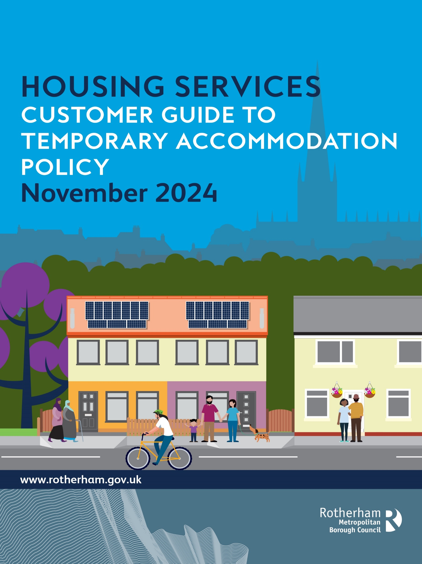


Customer Guide to Temporary Accommodation Placement Policy

Phrase | Definition
Accommodation providers | Companies or businesses who work with the Council who have properties available to use.
Allocated | When a property is matched to a household.
Bedsits | A small property with one room.
Council’s complain policy | A system that is in place for complaints to be processed and responded to in a timely manner.
Decant procedures | What the Council is required to do when a council tenant needs to temporarily move out of their property.
Flats | A property that has rooms on one level, rather than having an upstairs and downstairs.
Houses | A property that has rooms both upstairs and downstairs.
Identification | Documents that are used to prove who you are e.g. passports, driving licenses.
Intentionally homeless | A legal decision made by the Council when satisfied a household has become homeless by their own actions.
Legal duties | Something the Council has to do by law.
Notice to quit | A legal notification the Council must provide when looking to gain possession of a property.
Personal housing move-on plan | A plan explaining what the Council and household will do to find housing.
Placements | When a household uses temporary accommodation.
Statutory review | An official review of a decision made by the Council.

Contents

1. Introduction 4
2. Types of temporary accommodation 4
3. Hotels/Bed and Breakfast 4
4. Other Types of Temporary Accommodation 5
5. Accessible Temporary Accommodation 5
6. Temporary Accommodation for Council Tenants 5
7. Out of hours service 5
8. Suitability of temporary accommodation placement 5
9. Prioritisation of placements and moving within temporary accommodation 6
10. Offers, refusals and right to review 6
11. Rights to a Statutory Review 7
12. Temporary accommodation agreements 7
13. Households who are not using temporary accommodation 7
14. Support and resettlement 7
15. Households with pets 8
16. Definition of a Domestic Pet 8
17. Temporary accommodation costs 8
18. Ending temporary accommodation placements and discharging duties 9
19. Storage and protection of personal belongings 9
20. Repairs 9

Introduction
This is a guide to Rotherham Temporary Accommodation Placement Policy. The policy says how:
- The Council wants to help prevent people becoming homeless and encourages anyone worried about losing their home to contact them as soon as possible.
- If you are homeless and in need temporary accommodation, the Council will consider what their legal duties are to provide temporary accommodation, whilst they make enquires about your homeless case.
- The Temporary Accommodation Placement Policy considers different guidance and sets out the Council’s approach to placing homeless households in temporary accommodation. It explains the factors that will be considered to make sure that good quality temporary accommodation is being offered is suitable and allocated fairly. The Council aims to meet a high standard of customer satisfaction, ensuring households feel safe and supported.
- If you want to read the full Temporary Accommodation Placement Policy, then you can find it online: Homelessness: Temporary accommodation – Rotherham Metropolitan Borough Council

Types of temporary accommodation
Temporary housing includes different types of properties. Most of these homes are owned and managed by the Council. They range in size from one-bedroom to larger family homes and include bedsits, flats, and houses, located throughout Rotherham. Sometimes, the Council uses privately owned homes, which could be outside of Rotherham. While the Council isn't required by law to provide furnished housing, Council-owned temporary homes are furnished and come with everything needed to live in them.

Hotels/Bed and Breakfast
The Council sometimes uses hotels or bed and breakfasts for emergency housing, but availability is limited, and some placements may be outside the local area. This type of accommodation is used in emergencies or when no other housing is available. If a household is placed in a hotel or bed and breakfast, the Council will try to find other temporary housing as soon as possible.
The Council is not required to provide or pay for food or cooking facilities, although breakfast might be included at some places. Hotels and bed and breakfasts do not have cooking facilities, but the Council will provide information on local shops, food banks, and emergency food services.

Other Types of Temporary Accommodation
The Council works with different accommodation providers who provide accommodation for people with different needs. This includes shared accommodation, accommodation for young people, accommodation for rough sleepers and refuge space for victims of domestic abuse.

Accessible Temporary Accommodation
The Council will provide accessible temporary accommodation including wheelchair accessible temporary accommodation.

Temporary Accommodation for Council Tenants
Sometimes, a council tenant might need to move temporarily due to major repairs, safety issues, or emergencies like fire or flood. The Council will arrange alternative housing following their Decant Procedures.
For urgent moves, the Council will handle this as a homelessness case and provide temporary housing, which could be a hotel, bed and breakfast, or a furnished council property. The Housing Allocation Policy also looks for a suitable property for a managed move instead of using emergency temporary accommodation.

Out of hours service
The Council operates its homelessness service 24 hours a day and 365 days of the year. If you are in need of temporary accommodation you should come to Riverside House as early as possible in normal office opening hours, 08:30 to 17:00. You will need to provide identification where possible, but the council understands in some cases this will not be possible. For example, the Homeless Service have an emergency out of hours service, the telephone number is: 01709 336009. If you contact the Council outside of normal office hours, the on-duty homelessness officer will decide whether temporary accommodation can be provided. You will be asked to come to Riverside house the next working day (Monday to Friday, excluding bank holidays).

Suitability of temporary accommodation placement
If the Council agrees to provide temporary accommodation, it will assess your needs to ensure the placement is suitable and safe. This includes considering:
- The location of the accommodation, especially if it is outside Rotherham and how far it is from local services.
- The impact on jobs, care responsibilities, or education.
- Distance from medical facilities and other support services.
- Accessibility to local services, amenities, and transport.
- In some cases, moving a household outside the area might be necessary for their safety.
The Council will look at what temporary accommodation is available, however, sometimes families might be placed in hotels or bed and breakfasts in emergencies. The Council will look for alternative temporary accommodation as soon as it is possible. The Council aims to ensure that no family with children or anyone who is pregnant stays in hotel or bed and breakfast for more than 6 weeks.
The suitability of the accommodation will be reviewed regularly, and adjustments will be made if circumstances change.
The Council will take an effective approach to managing temporary accommodation placements by assessing and monitoring the impact on communities where there is or is likely to be a high volume of households occupying a particular accommodation at one given time.

Prioritisation of placements and moving within temporary accommodation
The Council decides how to prioritise temporary accommodation based on each individual’s needs risks and what temporary accommodation is available at the time. If needed, you might be moved to different temporary accommodation. The Council aims to limit these moves to avoid unnecessary disruption. If you refuse, the Council may end its duty to provide further temporary accommodation.
When providing temporary housing, the Council will consider your personal preferences, but the Council cannot always guarantee we can meet your personal preferences and will consider what you need. Temporary accommodation is generally allocated on the day it's needed, but some temporary accommodation may be reserved for planned moves or specific needs.

Offers, refusals and right to review
If the Council offers temporary accommodation before deciding on your homelessness application and you refuse the offer, you will need to find your own housing until a final decision is made. If the Council later agrees it has a duty to provide housing, it will make one final offer. If you refuse this offer, the Council won’t have to offer any more accommodation.
Upon accepting a temporary accommodation offer, the rules of the temporary accommodation will be explained, which you must agree to. If you refuse or do not want to move into temporary accommodation, you must explain your reasons, this will be recorded on a form, which a senior manager will review. You will be informed in writing about the consequences of the refusal and your rights for a statutory review. If you are unhappy with the service, you have right to make a complaint according to the Council’s Complaints Policy.

Rights to a Statutory Review
If you refuse the temporary accommodation and the Council finds it suitable upon review, you will be notified in writing that you will not receive any more offers of temporary housing. This means the Council will end its duty to provide accommodation under the Housing Act 1996. If the Council agrees the refusal was for valid reasons and the offer was unsuitable, a new final offer of accommodation will be made.

Temporary accommodation agreements
You will need to sign an agreement in person, which outlines the Council’s rules and conditions. If rules are broken, thorough investigations will be undertaken by officers of the Temporary Accommodation team, along with the homeless officer, to decide whether further action is required. This could range from a verbal warning to an immediate notice to quit being issued, depending on the situation.
You might be responsible for covering the costs if there is damage to temporary accommodation, fittings and furniture and lost, sold or disposed of, or due to behaviour from anyone in your household or visitors.

Households who are not using temporary accommodation
If you are placed into temporary accommodation and the Council believes you are not using your temporary accommodation, we will try to contact you. If this is not possible and you have not been in touch a notice will be given to end your placement and if it's a hotel, you will be booked out.
If there are concerns for your safety, such as its suspected you have gone missing, the Council will follow safeguarding policies and take appropriate action.

Support and resettlement

The Council will provide support whilst you are in temporary accommodation to help you move into a permanent home quickly. You will be assigned a Move on and Support Officer or a similar role from a support service. This officer will make sure you understand the temporary accommodation rules and help you with your Personal Housing Move-on Plan.

The Council is committed to providing a high-quality service, promoting safe, secure and supportive environments for all households in temporary accommodation. The service will make sure everyone has fair access to housing services and will be consider to each households needs and circumstances.

Temporary accommodation provided by the Council will meet the required housing standards including health and safety, hygiene and fire regulations. It will also meet the physical needs of the household.

Regular visits to the property regarding support, move on plans, property health and safety checks will be carried out. The Council Officer carrying out these visits will attempt to contact the households to make prearranged visits.

Households with pets
The Council do not have a legal duty to consider accommodating your pet(s) into temporary accommodation. You will be encouraged to make your own arrangements. The Council will discuss these options and can provide information for dog kennels and catteries. However, the Council recognises that pets can be important for emotional support and you may have no other options for your pets. While it’s not always possible to allow pets in temporary housing, the Council will carefully consider each case. You will be asked to complete a questionnaire as part of the assessment about your pet. A range of factors will be taken into consideration when deciding if you are able to take your pet (s) with you into the temporary accommodation provided. These are detailed within the main policy.

Definition of a Domestic Pet
A domestic pet is defined as: -
- Dog (excluding any dogs highlighted by the Dangerous Dogs Act 1991)
- Cat
- Bird (such as a budgie and cockatoo)
- Fish
- Small, caged rodent
- Small non-poisonous caged reptile
- Non-poisonous contained insect or amphibian
- Guinea pig
- Rabbit
If you or a member of your household has an assistance dog, the Council will make reasonable adjustments as required under the Equality Act 2010.

Temporary accommodation costs
Temporary accommodation must be affordable for it to be considered suitable. Therefore, the Council will need to assess that you are able to pay for it after covering basic living costs and child support.
If you don’t get full housing benefits, you will have to pay the difference between your benefit amount and the accommodation cost. If you aren’t eligible for housing benefits, you must pay the full cost.

Ending temporary accommodation placements and discharging duties
The Council can stop providing temporary accommodation under Section 188 of the Housing Act 1996 by giving reasonable notice. This might happen if the household breaks the rules of the accommodation or is found not to be a priority after homelessness investigations.
The Council doesn’t need to give a 4-week Notice to Quit and will decide how much notice to give based on each case.

Storage and protection of personal belongings
No furniture or large items are allowed in temporary accommodation unless they are needed for a medical or health reason, with the Council’s permission.
If you are or a household member living with you is at risk of losing or damaging their belongings and can't protect them or make other arrangements, the Council may need to help protect their possessions. Due to limited storage and issues around cost, the Council cannot store household possession indefinitely; this is particularly important when there is no forwarding address. This will be explained at the sign up of your temporary accommodation.

Repairs
Repairs and maintenance work that is identified by households using temporary accommodation should be reported to the appropriate service at the earliest possible opportunity. If a household is placed into a private accommodation provider, such as a hotel, then any issues must be reported to them directly. If repairs are required in temporary accommodation that is owned by the Council, this must be reported to the repairs service, the telephone number is: 01709 336009, option 1, so the repair works can be coordinated with the appropriate contractor at the earliest opportunity.

FAQs
- How long will I be in temporary accommodation for? – This depends on the circumstances and why the household has been placed. The Council will aim to move households on from hotels as soon as possible.
- Can I take all my furniture with me? – Furniture cannot be taken to temporary accommodation placements as temporary accommodation properties are fully furnished. However, in some cases the Council will assist with storing furniture.
- How much does emergency accommodation cost? – This depends on the household’s circumstances. Households that are employed will need to contribute, as housing benefit allowance will not cover the full cost.
- Can I take my pets into temporary accommodation? – This will be looked at on a case-by-case basis and the circumstances of the household.
- What bills am I responsible for? – Gas and electric are the responsibility of the household. The Council covers water and council tax. Other utility bills, such as water and TV licenses will need to be paid for by the household too.
- Can I get Wi-Fi installed? – Wi-Fi cannot be installed in temporary accommodation properties.
- Do I have to stay at the temporary accommodation every night? – It is expected that households using temporary accommodation will stay at the property every night.
- Can a friend or family member stay overnight? – This will be assessed on the circumstances of why the household has been placed into temporary accommodation.
- Am I responsible for repairs? – Households placed into temporary accommodation are responsible for reporting repairs. This should be done directly to the repairs service, so that they can discuss availability to allow contractors to plan visits to complete repair work.
What day do my bins get collected? – Information can be found online at Bin collections – Rotherham Metropolitan Borough Council

