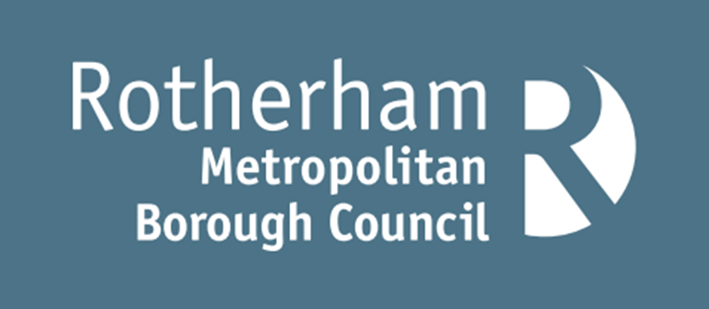

Damp, Mould & Condensation Policy

CONTENTS
Damp, Mould & Condensation Policy 1
INTRODUCTION 3
POLICY SCOPE 4
CAUSES AND DEFINITIONS OF DAMP, MOULD AND CONDENSATION 5
CONDENSATION 5
DAMP 5
MOULD 6
WHAT YOU CAN DO TO PREVENT DAMP, MOULD AND CONDENSATION IN YOUR HOME 8
OUR APPROACH TO DEALING WITH DAMP, MOULD AND CONDENSATION 9
Tenants of housing associations or private landlords 9
Council tenants 9
Pro-active approach 10
Zero tolerance when damp and mould occurs 11
Tenant Responsibility 12
Leaseholder responsibility 12
No Access 12
HOW TO REPORT AN ISSUE 12
Private and housing association tenants 12
Council tenants 13
How to make a complaint 13
FURTHER INFORMATION AND GUIDANCE 14

INTRODUCTION
Damp and mould in the home can be a hazard to health, causing respiratory problems and increasing allergies.
The Council is committed to making sure your home is free from damp, mould and condensation and treats all reports very seriously.
There was a 338% increase in reports of damp and mould in January 2023 following the tragic death of Awaab Ishak and the cost-of-living crisis. The Council have committed to providing a pro-active and responsive service and have increased staffing and financial resources to reflect demand.
In October 2025, Awaab’s Law was introduced. This legislation sets out legal duties for landlords for dealing with Housing Health and Safety Rating System (HHSRS) hazards, including damp and mould. Landlords must assess hazard severity and respond appropriately to emergency and significant hazards. Tenants may take legal action if duties are not met, with phased implementation beginning with damp, mould, and emergency issues, followed by other hazard categories over subsequent years.
Emergency hazards must be investigated and made safe within 24 hours and significant hazards must be investigated within 10 working days.
The key aim of the policy is to raise awareness of damp, mould and condensation, provide advice to residents, and to detail our approach to dealing with reports of damp in mould in Council owned and private sector properties.
The policy is underpinned by some principles:
- All residents should expect to be able to live in a safe and healthy home environment free of damp, mould and condensation.
- Residents should be empowered to spot, treat and prevent damp, mould and condensation in their homes where it is safe, practical and reasonable to do so.
- There is a clear and accessible way to report cases of damp, mould and condensation available for all residents.
- Council staff and contractors should always treat residents in a fair and empathetic manner, taking into account individual circumstances including language barriers, age, health conditions, and any contributing factors such as fuel poverty, insulation defects and overcrowding.
- Landlords, including the Council, should take responsibility and be proactive. A data driven, risk and solution focused approach should be adopted to identify and prevent damp and mould quickly.

POLICY SCOPE
The scope of the policy covers our approach to working with residents to prevent and eradicate damp, mould and condensation. The policy includes:
- The definitions and causes of condensation, damp and mould, and steps that can be taken prevent and treat it.
- The role of the Council as a landlord.
- The role of the Council as the enforcement body for private sector homes.
- How the Council is ensuring compliance with Awaab’s Law, introduced 27 October 2025.
- The council, housing associations and private landlords operate under different legal and regulatory frameworks, but all bear responsibility for ensuring tenants’ homes are habitable and safe.

CAUSES AND DEFINITIONS OF DAMP, MOULD AND CONDENSATION
The three main types of damp that may lead to mould are rising, penetrative and condensation. Damp can be caused by a variety of factors and there can be more than one type of damp present at any time.

CONDENSATION
Condensation is the most common cause of damp and mould within properties, particularly during winter months.
Condensation occurs when moisture held in warm air meets a cold surface and then condenses producing water droplets, or when levels of humidity inside the property are too high. Condensation can take the form of:
Surface condensation, arising when the inner surface of the structure is cooler than the room air.
Condensation inside the structure (interstitial) where vapour pressure forces water vapour through porous materials (such as walls), which then condenses when it reaches colder conditions within the structure.
It is often seen as water on windows and is more noticeable when the weather gets colder and the outside temperature drops. Moisture in the air can cause mould growth on walls and ceilings as well as on furniture and possessions.
Condensation can be caused by:
- Inadequate heating within the property
- Poor ventilation and lack of circulating fresh air
- High humidity levels resulting in excessive water vapor in the air
- Poor insulation and building design
- Overcrowding within the property leading to additional levels of condensation and humidity
The risk of condensation can be reduced through:
- Adequate ventilation such as, opening windows and trickle vents, air bricks, ensuring space around furniture to assist air flow and mechanical extractors
- Adequate heating such as, energy efficient boilers and radiators which maintain an appropriate heat level
- Adequate thermal insulation such as, wall and loft insulation.
- Reducing levels of water vapour in the air.

DAMP
Rising Damp: Rising damp is the movement of moisture from the ground rising through the structure of the building. This can be caused by a missing or defective damp proof course, or where ground levels, access ramps, etc. breach the damp proof course.
A damp proof course is a barrier, usually formed by a membrane, built into walls of a property, typically 150mm above ground level, to prevent damp rising through the walls.
The presence of rising damp can create or add to an existing condensation problem.
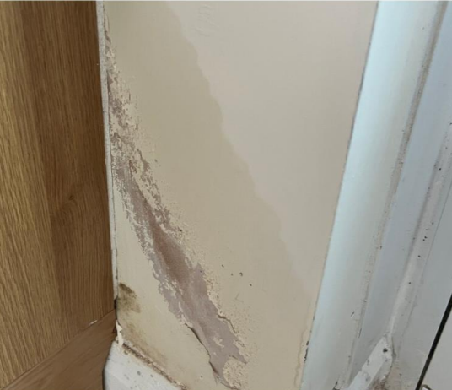
Picture 1: Rising damp to side of kitchen unit on external wall.
Penetrating Damp (including internal leaks): Penetrative damp is caused by water penetrating the external structure of the building or internal leaks causing damp, rot and damage to internal surfaces and structure. The cause can be the result of, for example:
- Water ingress - When water from outside makes its way into a building through defective components such as roof coverings, flashings and external doors and windows;
- Defective or blocked rainwater gutters and pipes
- Leaking internal water pipes, defective wall tiles to shower area.
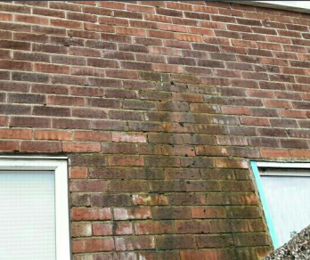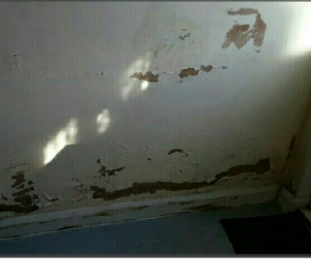
Picture 2: Defective overflow pipe Picture 3: Penetrating damp to internal wall with defective wall tiles to shower area at other side

MOULD
Mould is a fungus that grows and spreads on damp or decaying matter. It grows best in damp and poorly ventilated areas and reproduces by making spores. It is important that your home has good ventilation to minimise internal moisture and prevent mould growth.
Condensation and damp in homes can lead to mould growth. Mould spores are potent airborne allergens. Exposure to high concentrations of allergens over a prolonged period can cause allergic type reactions, the development or worsening of asthma, respiratory infections, coughs, wheezing and shortness of breath.
Living in a cold home can worsen asthma and other respiratory illnesses and increase the risk of heart disease and cardiac events. It can also worsen musculoskeletal conditions such as arthritis.
Cold or damp conditions can have a significant impact on mental health, with depression and anxiety more common among people living in these conditions.
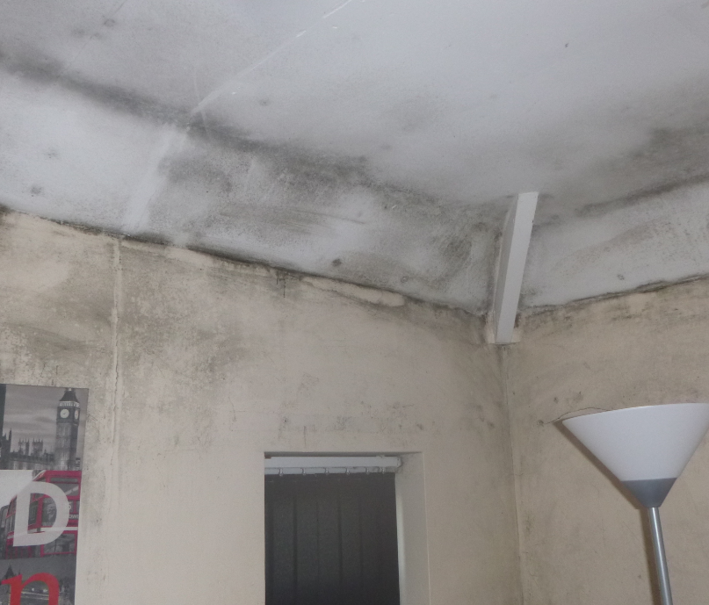
Picture 4: Black spot mould following condensation to walls and ceiling.

WHAT YOU CAN DO TO PREVENT DAMP, MOULD AND CONDENSATION IN YOUR HOME
There are a number of simple steps that you can take to help keep your home free of damp and mould. It is recommended that you:
- Air your property regularly – opening windows regularly, even in winter, allows some moisture to escape.
- Keep doors closed – when having a shower or bath or cooking keep the room door closed. This will stop moisture spreading to other parts of the property.
- Wipe away condensation – use a cloth or towel to wipe away condensation from windows and frames each day. This will minimise the development of mould.
- Turn your heating on – this can dry out damp and reduce your chance of getting mould.
- Keep an eye out for leaks – if you see a leak report to your landlord as soon as possible to avoid further damage to your property.
- Dry clothes in a ventilated room – dry clothes on an airer in a well-ventilated room keeping the door shut to minimise the spread of moisture to other rooms.
- Dehumidifiers and damp traps – these will help take moisture out of the air.
- Use extractor fans – always use when having a bath, shower or when cooking to allow moisture to escape.
- Don’t overfill your home – leave a gap between furniture and the wall and avoid overfilling wardrobes. Check regularly for signs of damp, mould and condensation.
- Grow moisture loving plants – some plants absorb moisture and pollution from the air, for example, peace lilies, tillandsia, palms and ferns.
If mildew or mould is seen to be forming it can be cleaned off with a damp cloth, making sure to ventilate the room afterwards to allow the area to dry.
If damp and mould persist, then you should report the problem to your landlord who has a duty to ensure that properties are fit for human habitation. Properties need to be free from hazards and damp, and mould and excess cold could amount to a category 1 hazard under the Housing Health and Safety Rating System (HHSRS).

OUR APPROACH TO DEALING WITH DAMP, MOULD AND CONDENSATION

TENANTS OF HOUSING ASSOCIATIONS OR PRIVATE LANDLORDS
Tenants of housing associations or private landlords should first contact their landlord about any damp and mould issues.
Tenants can request an inspection by a Community Protection Officer/Environmental Health Officer (EHO) if their landlords have failed to carry out appropriate repairs. If a severe ‘category 1’ hazard is identified the landlord must take action to remove it. If the landlord fails to comply, then the Council will take enforcement action.
On receipt of a complaint about damp and mould, the Council will aim to contact you within five working days. The team will ask you some questions regarding the severity of the issue. This may include asking for photographs. This information will then determine how the team deals with your complaint.
Where low or medium risk is identified, the matter will be dealt with informally with your landlord unless they refuse to rectify the issue.
Where a high or severe risk is identified, or your landlord has refused to carry out work at the informal stage, the team will organise a full inspection of your property and will take appropriate enforcement action to ensure work is carried out to rectify the issue. Timescales for the works to be completed will be discussed as this can vary between individual cases.

COUNCIL TENANTS
The Council’s responsibility is to ensure our tenants’ homes are safe and healthy. All council homes must comply with the Decent Homes standard, which includes being free of serious hazards like damp and mould.
The Housing Service are utilising business intelligence, geographic information systems (GIS) and data referencing, to target areas which have a disproportionately high level of damp and mould referrals. Proactive mould surveys are being undertaken in these areas to identify damp and mould followed by treatment works.
Preventive measures to ensure that council properties are kept in good repair, free from damp and mould are also being undertaken. This includes capital investment including re-roofing schemes (where loft insulation top-ups beyond 300mm is required), new heating installations, ensuring baths, sinks etc are properly installed (kitchen and bathroom refurbishments), well maintained rainwater goods and planned ventilation improvement works.
The Council recognises the impact that damp, mould, and condensation can have on our tenants, including distress and concerns about health and wellbeing. We will take prompt action to remedy issues and support our tenants by offering guidance, advice, and assistance throughout the process.
In dealing with damp and mould in our homes, the Council adopts the following principles:
- Our tenants should be listened to and treated in a fair and empathetic manner.
- All Council officers and contractors have a role to play in identifying and reporting damp and mould adopting an ‘eyes and ears’ approach
- We will embed a culture where Council officers and contractors are trained to see safety as their responsibility and do not blame lifestyle as the cause of damp, mould and condensation.
- A data driven, risk and solution focused approach to deal with damp, mould and condensation. We will seek to understand what is causing damp and mould in our homes, and we will ensure this intelligence informs our investment plans for the future.
- We will utilise our tenant communications and engagement channels to adopt a pro-active marketing campaign so that tenants are aware of how to spot damp and mould issues in their home and how they can report them.

PRO-ACTIVE APPROACH
We want to make sure that our tenants know how to spot and report issues, and that we are proactive in our approach to prevent damp and mould issues in our properties.
We have undertaken proactive mould surveys to Council houses in geographic areas identified as having a disproportionately high number of mould-related issues. This has subsequently resulted in mould treatment works and extractor fans being fitted. In addition to this, proactive checks are also undertaken for damp and mould during the mould process where all necessary damp proofing and mould treatment works are carried out.
Resources have also been increased so that we can pro-actively respond to reports of damp and mould.
Our ongoing pro-active approach includes:
- Identifying the prevalence of hazards including damp and mould through stock condition surveys and predictive modelling. Using this information to plan and deliver pro-active investment in ‘hotspot’ areas and poorly designed properties.
- Analysing complaints data to identify potential trends, themes and learning opportunities ensuring processes are re-engineered based upon the learning.
- Undertaking thorough damp and mould inspections when properties are vacant, ensuring the necessary damp and mould treatment works are completed before a property is re-let.
- Identifying damp and mould issues during mutual exchange inspections to ensure it is rectified prior to the exchange taking place.
- Providing annual training to Council officers on Customer Care and how to spot damp, mould and condensation. Regular ‘toolbox talks’ with Council contractors will ensure operatives entering properties are trained to an appropriate level.
- Each room within a property is checked during a programme of Tenancy Health Check visits to identify damp, mould and condensation.
- Undertaking spot checks (MOT) of properties where tenants have not reported a repair within a 12-month period.
- Reviewing information provided to customers to raise awareness around damp, mould and condensation on an annual basis e.g., through publicity in Home Matters, the Council’s webpages, and all social media platforms.
- Providing all new Council tenancies the leaflet ‘How to keep you and your Home, Safe, Well and Warm - A guide for tenants and leaseholders’ in their starter pack. They will also be shown how to use their heating and ventilation systems and will be provided with up to date running costs of the appliance for their information.

ZERO TOLERANCE WHEN DAMP AND MOULD OCCURS
Following a report of damp, mould or condensation the repairs service will:
- Use a rigorous and proactive triage approach for all reports of damp and mould. This will support with determining the severity of the case.
- Check who is living in the property to see if necessary works are to be escalated due to tenant(s) personal circumstances e.g., age (both young and old), ill health or disability. This is completed at triage stage.
- Investigate emergency hazards within 24 hours of becoming aware of them.
- Remedy emergency hazards as soon as reasonably practicable, ideally within the same 24-hour window or decant tenants to suitable alternative accommodation if works cannot be completed safely within the required timeframe.
- Investigate significant damp and mould within 10 working days.
- Begin remedial works within 5 working days of the investigation concluding.
- If works can't begin within 5 days, they must start within 12 weeks at the latest.
- Complete works within a reasonable timeframe.
- Arrange appointments to visit reports of damp, mould and condensation where further investigation is required.
- Low-level cases are referred directly to the contractors for eradication works within 28 days.
- Diagnose the cause of damp and deliver effective solutions, dealing with the cause of the damp, not just the symptoms and wherever possible, “fixing first time” and looking beyond the mould approach, i.e., cause of mould issue beyond the surface, for example, loft insulation rolled back away from edge roof space, leak, inadequate ventilation, poor heating system etc.
- Refer to a specialist damp contractor where there is evidence of defective damp proof courses or decayed timberwork and explain what will happen next, i.e. contact will be made by specialist contractor to book in survey or works.
- Written summaries are provided to tenants that documents hazard investigation findings. These explain the hazard, the outcome, and any planned actions, and is issued shortly after the investigation concludes.
- Refer to a specialist mould contractor where there is evidence of severe black spot mould and explain to the tenant what will happen next, i.e., contact will be made by specialist contractor to book in survey or works.
- Depending on the extent of works and tenant’s circumstance (health conditions), alternative temporary accommodation may be required in severe cases. The Council will support the tenant through this process.

TENANT RESPONSIBILITY
The Tenancy Agreement states that tenants must keep their homes in good, clean condition and immediately report any faults, damage or repairs. It is therefore the shared responsibility of tenants and the Council to make sure that incidents of damp and mould are reported and acted upon in a timely manner, in a collective effort to minimise damp and mould in Council homes.
Tenants should regularly check their homes for damp and mould and ensure they report an issue as soon as it is noticed so that necessary actions can take place to prevent it from getting worse. Access must be provided to the Council or its contractors so that relevant works can be undertaken.
Tenants should try to reduce condensation damp by ensuring their homes are well ventilated and adequately heated. Where this is not possible, for example because of the costs of heating, tenants should get in contact with the Council for advice.

LEASEHOLDER RESPONSIBILITY
Leaseholders are responsible for managing and maintaining their own properties including damp, mould, and condensation, in accordance with their lease agreement. Leaseholders are responsible for any repairs to their own flat which are due to their actions or inactions.
As the freeholder the Council is responsible for all repairs to the fabric of the building, such as roof repairs, and we will conduct appropriate repairs to rectify any issues. We are only responsible for repairs to a leaseholder’s property if we have not complied with this obligation. Any neglect by the leaseholder to manage or conduct repairs for which they are responsible, and that has a direct impact on the condition of a Council owned property, will be dealt with in accordance with the lease.

NO ACCESS
Awaab’s Law states that landlords should make every effort to gain access to properties promptly to investigate and carry out safety works, maintaining clear records of all attempts and engaging with tenants in a way that meets their individual needs.
The Council has developed a proactive approach to no access for reports of damp and mould.
Rotherham Council follows a structured three-stage process for gaining access to properties in damp and mould cases, involving multiple contact attempts and written notices. The three-stage documented access process enables the Council to demonstrate that reasonable attempts for access have been sought, in accordance with Awaab’s Law. Legal action may be initiated where the tenant is preventing access to the property to undertake eradication works or repairs.

HOW TO REPORT AN ISSUE

PRIVATE AND HOUSING ASSOCIATION TENANTS
If your landlord has failed to deal with your report of damp and mould in your home you should report the issue to the Environmental Health team who can be contacted on 01709 823118, by email env.health@rotherham.gov.uk or through our website www.rotherham.gov.uk
If your landlord is a housing association, they will have their own complaints procedure and you have the option of seeking a referral to the Ombudsman if you feel your complaint has not been handled appropriately. Check your landlord’s website for more information.

COUNCIL TENANTS
Please report the issue via the online form https://www.rotherham.gov.uk/xfp/form/1519 or telephone 01709 336009.

HOW TO MAKE A COMPLAINT
If the Council has failed to provide a service or if you are unhappy with the service you have received, then we welcome this information and feedback. In most cases we hope to be able to resolve problems with the member of staff that you have dealt with. We will use all feedback to help make improvements. When this is not possible, we have a formal complaints procedure to manage complaints.
If you have a complaint, suggestion or compliment you can contact us in a number of ways:
- Via the online form on the Council website: http://www.rotherham.gov.uk/complaints
- Email: complaints@rotherham.gov.uk
- By post: Using a complaint form or by letter. No postage is required for posting forms or letters to us, as you may use our freepost address below.
The Complaints Manager
Rotherham Metropolitan Borough Council
(FREEPOST RTCT-XKLS-ZHAZ)
Riverside House
Main Street
Rotherham
S60 1AE

- By telephone: Our contact number is (01709) 382 121. The customer service representative handing your call will direct you to the appropriate department.
- By text: Our contact number is 07860 021 447
- In person: At one of our Customer Service Centres or any Council reception point.
If you are not satisfied with how we have handled your complaint, then you may wish to complain directly to the Housing Ombudsman Service. The Housing Ombudsman will not act until any complaint has been considered under the Council’s complaint procedure and after more than eight weeks have elapsed since the completion of the Stage 2 complaint. During the eight-week waiting period you have the choice of taking your complaint to a Designated Person. A designated person can be a MP, a local Councillor or a Tenant Complaint Panel.
The designated person may resolve the complaint directly, refer the complaint to the Housing Ombudsman or may decline doing either. If they decline you may approach the Housing Ombudsman directly if more than eight weeks have elapsed since the completion of the Council's internal complaint procedure.
The Housing Ombudsman service can be contacted as follows:
Address:
Housing Ombudsman
Service 81
Aldwych
London
WC2B 4HN

Phone: 0300 111 3000
Email: info@housing-ombudsman.org.uk

FURTHER INFORMATION AND GUIDANCE
Further help and guidance can be found within the ‘How to keep you and your home safe and well’ guidance leaflet, along with a video the Council has produced on preventing mould. Both are available on the Council’s website:
https://www.rotherham.gov.uk/private-housing/information-for-private-tenants
The Council recognises that many residents are struggling to pay household bills, including for heating, which can add to the issue of damp and mould. You can access information and support to help at:
- https://www.rotherham.gov.uk/money-matters
- https://www.rotherham.gov.uk/housing-grants-finance/apply-energy-crisis-support-scheme
You may also receive support by contacting your energy provider. Contact information can be found on your most recent bill.
Citizens Advice may provide support and advice by visiting your local branch in Rotherham or on the website at www.citizensadvice.org.uk

