**DAMP, MOULD & CONDENSATION POLICY**

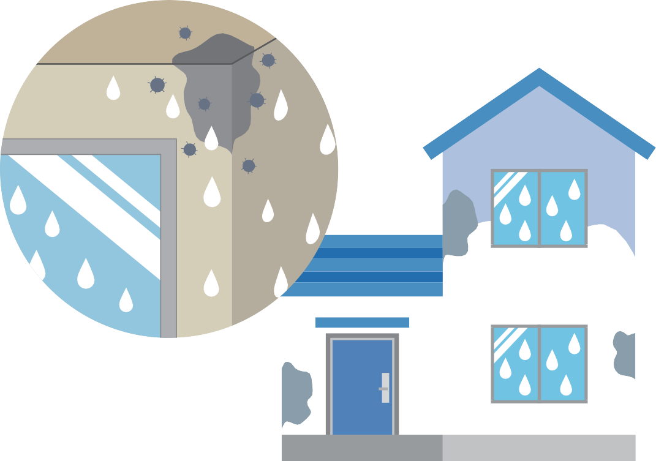

[**www.rotherham.gov.uk**](http://www.rotherham.gov.uk/)

INTRODUCTION 3

**CONTENTS**

THE FACTORS CONTRIBUTING 5

TO MOULD

WHAT CAN BE DONE TO PREVENT 10

CONDENSATION AND MOULD IN YOUR HOME

OUR APPROACH TO DEALING WITH 12

CONDENSATION, DAMP AND MOULD

Owner occupiers

Tenants of housing associations or private landlords Council tenants

TENANT AND LEASEHOLDER 18

RESPONSIBILITY

Tenant responsibility Leaseholder responsibility

HOW TO REPORT AN ISSUE 19

FURTHER INFORMATION AND GUIDANCE 21



3

Damp and mould in the home can be a hazard to health, causing respiratory problems and increasing allergies.

**INTRODUCTION**

The Council is committed to making sure your home is free from damp, mould and condensation and treats all reports very seriously.

The Council has seen a 338% increase in reports of damp and mould during January 2023, following the tragic death of Awaab Ishak and as a consequence of the cost-of-living crisis. We are committed to providing a pro-active and responsive service and have increased staffing and financial resources to reflect the demand in damp and mould enquiries.

*The key aims of this policy are to:*

* Raise awareness of the impact of condensation, damp and mould
* Provide advice to all Rotherham residents, and
* Detail our approach to dealing with reports of damp and mould in council owned and private sector properties.

*The policy is underpinned by the following principles:*

* All residents should expect to be able to live in a safe and healthy home environment free of damp, mould and condensation.
* Residents should be empowered to identify, treat and prevent damp, mould and condensation in their homes where it is safe, practical and reasonable to do so.
* There is a clear and accessible way to report cases of damp, mould and condensation available for all residents.
* Council staff and contractors should always treat residents in a fair and empathetic manner, taking into account individual

circumstances including language barriers, age, health conditions, and any contributing factors such as fuel poverty, insulation defects and overcrowding.

* All landlords, including the Council, should take responsibility and be proactive. A data driven, risk and solution focused approach should be adopted to identify and prevent damp and mould quickly.

The scope of the policy covers our approach to working with residents to prevent and eradicate damp, mould and condensation.

*The policy includes:*

* An overview of condensation, damp and mould,
* Steps that can be taken to prevent and treat mould
* The role of the Council as:
  + A landlord
  + The enforcement body for private sector homes

The council, housing associations and private landlords operate under different legal and regulatory frameworks, but all bear responsibility for ensuring tenants’ homes are habitable and safe.

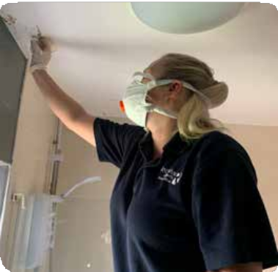

The main contributors that may lead to mould being present in your home are condensation, rising and penetrative damp. ‘Damp’ is a general term which covers a range of different issues connected to excess moisture. It is important to establish what the source of the problem is and its origin. Damp can be caused by a variety of factors and there can be more than one type of damp present at any time.



**THE FACTORS CONTRIBUTING TO MOULD**

# Condensation

Condensation is the most common cause of dampness contributing towards creating mould within homes, particularly during winter months and is often caused by poor heating and ventilation.

Condensation occurs when moisture held in warm air meets a cold surface and then condenses producing water droplets, or when levels of humidity inside the property are too high.

*Condensation can take the form of:*

* Surface condensation, arising when the inner surface of the structure is cooler than the room air.
* Condensation inside the structure (interstitial) where vapour pressure forces water vapour through porous materials (such as walls), which then condenses when it reaches colder conditions within the structure.

It is often seen as water on windows and is more noticeable when the weather gets colder and the outside temperature drops. Moisture in the air can cause mould growth on walls and ceilings as well as on furniture and possessions.

*Condensation can be caused by:*

* **Inadequate heating** within the property.
* **Poor ventilation** and lack of circulating fresh air.
* **High humidity levels** resulting in excessive water vapor in the air.
* **Poor insulation** and building design.
* **Overcrowding** within the property leading to additional levels of condensation and humidity.



*The risk of condensation can be reduced through:*

* **Adequate ventilation** such as, opening windows and trickle vents, air bricks, ensuring space around furniture to assist air flow and mechanical extractor fans.
* **Adequate heating** such as, energy efficient boilers and radiators which maintain an appropriate heat level.
* **Adequate thermal insulation** such as, wall and loft insulation.
* **Reducing levels of water vapour** in the air from drying clothes outside where possible, opening windows and putting lids on pans when cooking.



# Damp

If your property suffers from a build-up of condensation, better ventilation might fix the problem, as highlighted above. However, condensation is not the only cause of damp and your home may experience damp for other reasons.

**Rising Damp:** Rising damp is the movement of moisture from the ground rising through the structure of the building. This can be caused by a missing or defective damp proof course, or where ground levels, access ramps, etc. breach the damp proof course.

A damp proof course is a barrier, usually formed by a membrane, built into walls of a property, typically 150mm above ground level, to prevent damp rising through the walls.

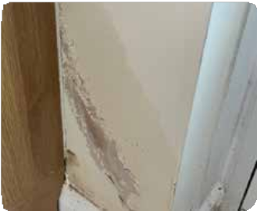

The presence of rising damp can create or add to an existing condensation problem.

*Rising damp to side of kitchen unit on external wall.*

**Penetrating Damp (including internal leaks):** Penetrative damp is caused by water penetrating the external structure of the building or internal leaks causing damp, rot and damage to internal surfaces and structure. The cause can be the result of, for example:

* Water ingress – When water from outside makes its way into a building through defective components such as roof coverings, flashings and external doors and windows.
* Defective or blocked rainwater gutters and pipes.
* Leaking internal water pipes, defective wall tiles to shower area.

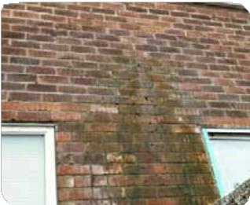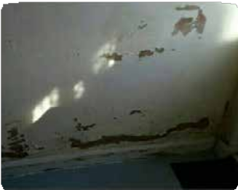

*Defective overflow pipe. Penetrating damp to internal wall with defective wall tiles to shower area at other side.*

# Mould



9

Mould is a fungus that grows and spreads on damp or decaying matter. It grows best in damp and poorly ventilated areas and reproduces by making spores. It is important that your home has good ventilation to minimise internal moisture and prevent mould growth.

Condensation and damp in homes can lead to mould growth. Mould spores are potent airborne allergens. Exposure to high concentrations of allergens over a prolonged period can cause allergic type reactions, the development or worsening of asthma, respiratory infections, coughs, wheezing and shortness of breath.

Living in a cold home can worsen asthma and other respiratory illnesses and increase the risk of heart disease and cardiac events. It can also worsen musculoskeletal conditions such as arthritis.

Cold or damp conditions can have a significant impact on mental health, with depression and anxiety more

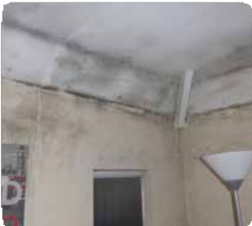

*Black spot mould following condensation to walls and ceiling.*

If you have mould, caused by damp, it is important to find out why you have excess moisture in your home. When you know what’s causing the damp, you can make sure your home is repaired or take steps to limit the moisture in the air. You may need to get a professional to remove mould for you or, in the case of tenants, you

**WHAT CAN BE DONE TO PREVENT CONDENSATION AND MOULD IN YOUR HOME**

need to highlight the problem to your landlord, but if it’s only a small amount you may be able to remove it yourself.

*There are a number of simple steps that you can take to help keep your home free of damp and mould. It is recommended that you:*

* **Air your property regularly** – opening windows regularly, even in winter, allows some moisture to escape.
* **Keep doors closed** – when having a shower or bath or cooking keep the room door closed. This will stop moisture spreading to other parts of the property.
* **Wipe away condensation** – use a cloth or towel to wipe away condensation from windows and frames each day. This will minimise the development of mould.
* **Turn your heating on** – this can dry out damp and reduce your chance of getting mould.
* **Keep an eye out for leaks** – if you see a leak report to your landlord as soon as possible to avoid further damage to your property.



* **Dry clothes in a ventilated room** – dry clothes on an airer in a well-ventilated room keeping the door shut to minimise the spread of moisture to other rooms.
* **Dehumidifiers and damp traps** – these will help take moisture out of the air.
* **Use extractor fans** – always use when having a bath, shower or when cooking to allow moisture to escape.
* **Don’t overfill your home** – leave a gap between furniture and the wall and avoid overfilling wardrobes. Check regularly for signs of damp, mould and condensation.
* **Grow moisture loving plants** – some plants absorb moisture and pollution from the air, for example, peace lilies, tillandsia, palms and ferns.

If mildew or mould is seen to be forming it can be cleaned off with a damp cloth, making sure to ventilate the room afterwards to allow the area to dry.

If damp and mould persist, then you should report the problem to your landlord who has a duty to ensure that properties are fit for human habitation. Properties need to be free from hazards and damp and mould and excess cold could amount to a category 1 hazard under the Housing Health and Safety Rating System (HHSRS).



# Owner Occupiers



**OUR APPROACH TO DEALING WITH DAMP, MOULD AND CONDENSATION**

If you own or have a mortgage on your home, it is still important to deal with damp and mould. The Councils Community Energy Team will be able to advise you on keeping your home properly heated and ventilated as well as providing opportunities to access funding to improve the insulation of your home. Further information can be found under section 6 Further Information and Guidance.

# Tenants of housing associations or private landlords

Tenants of housing associations or private landlords, if you experience damp related problems that result in mould, you should first contact your landlord, who has a duty to ensure that properties are fit for human habitation. Rented properties need to be free from hazards and damp and mould and excess cold could amount to a Category

1 hazard when assessed using the Housing Health and Safety Rating System (HHSRS).

Tenants can request an inspection by a Community Protection Officer/ Environmental Health Officer (EHO) if their landlords have failed

to carry out appropriate repairs. If a severe ‘category 1’ hazard is identified the landlord must take action to remove it. If the landlord fails to comply, then the Council will take enforcement action.

On receipt of a complaint about damp and mould, the Council will aim to contact you within five working days. The team will ask you some questions regarding the severity of the issue. This may include asking for photographs. This information will then determine how the team deals with your complaint.

Where low or medium risk is identified, the matter will be dealt with informally with your landlord unless they refuse to rectify the issue.

Where a high or severe risk is identified, or your landlord has refused to carry out work at the informal stage, the team will organise a full inspection of your property and will take appropriate enforcement action to ensure work is carried out to rectify the issue. Timescales for the works to be completed will be discussed as this can vary between individual cases.

Further information regarding how to raise an enquiry with the Council’s Community Protection and Environmental Health team is included in section 5. How to Report an Issue.

# Council Tenants

The Council’s responsibility is to ensure our tenants’ homes are safe and healthy. All council homes must comply with the Decent Homes standard, which includes being free of serious hazards like damp and mould.

The Housing Service are utilising business intelligence, geographic information systems (GIS) and data referencing, to target areas which have a disproportionately high level of damp and mould referrals.

Proactive mould surveys are being undertaken in these areas to identify damp and mould followed by treatment works.

Preventative measures to ensure that council properties are kept in good repair, free from damp and mould are also being undertaken. This includes capital investment including re-roofing schemes (where loft insulation top-ups beyond 300mm is required), new heating installations, ensuring baths, sinks etc are properly installed (kitchen and bathroom refurbishments), well maintained rainwater goods and planned ventilation improvement works.

The Council recognises the impact that damp, mould, and condensation can have on our tenants, including distress and concerns about health and wellbeing. We will take prompt action to remedy issues and support our tenants by offering guidance, advice, and assistance throughout the process.

*In dealing with damp and mould in our homes, the Council adopts the following principles:*

* **Our tenants should be listened to** and treated in a fair and empathetic manner.
* **All Council officers and contractors have a role to play** in identifying and reporting damp and mould adopting an ‘eyes and ears’ approach.
* **We will embed a culture** where Council officers and contractors are trained to see safety as their responsibility and do not blame lifestyle as the cause of damp, mould and condensation.
* **A data driven, risk and solution focused** approach to deal with damp, mould and condensation. We will seek to understand what is causing damp and mould in our homes, and we will ensure this intelligence informs our investment plans for the future.
* **We will utilise our tenant communications** and engagement channels to adopt a pro-active marketing campaign so that tenants are aware of how to spot damp and mould issues in their home and how they can report them.



# Pro-active approach



15

We want to make sure that our tenants know how to spot and report issues, and that we are proactive in our approach to prevent damp and mould issues in our properties.

We have undertaken proactive mould surveys to Council houses in geographic areas identified as having a disproportionately high number of mould-related issues. This has subsequently resulted in mould treatment works and extractor fans being fitted. In addition to this, proactive checks are also undertaken for damp and mould during the void process where all necessary damp proofing and mould treatment works are carried out.

Resources have also been increased so that we can pro-actively respond to reports of damp and mould.

*Our ongoing pro-active approach includes:*

* Identifying the prevalence of hazards including damp and mould through stock condition surveys and predictive modelling. Using this information to plan and deliver pro-active investment in ‘hotspot’ areas and poorly designed properties.
* Analysing complaints data to identify potential trends, themes and learning opportunities ensuring processes are re-engineered based upon the learning.
* Undertaking thorough damp and mould inspections when properties are vacant, ensuring the necessary damp and mould treatment works are completed before a property is re-let.
* Identifying damp and mould issues during mutual exchange inspections to ensure it is rectified prior to the exchange taking place.
* Providing:
  + Annual training to council officers on customer care and how to identify condensation, damp, and mould.
  + Regular ‘toolbox talks’ with council contractors to ensure operatives, entering properties, are trained to an appropriate level.
* Each room within a property is checked during a programme of Tenancy Health Check visits to identify damp, mould and condensation.
* Undertaking spot checks (MOT) of properties where tenants have not reported a repair within a 12-month period.
* Reviewing information provided to customers to raise awareness around damp, mould and condensation on an annual basis e.g., through publicity in Home Matters, the Council’s webpages, and all social media platforms.
* Providing all new Council tenancies the leaflet ‘How to keep you and your Home, Safe, Well and Warm - A guide for tenants and leaseholders’ in their starter pack. They will also be shown how to use their heating and ventilation systems and will be provided with up to date running costs of the appliance for their information.

# Zero tolerance when damp and mould occurs

*Following a report of damp, mould or condensation the repairs service will:*

* Check who is living in the property to see if works and necessary support needs to be escalated due to vulnerabilities of tenant(s) e.g., age (both young and old), ill health or disability that may make the tenant or family member more vulnerable.
* Arrange appointments to visit 100% of all damp, mould and condensation requests, prioritising those where the tenant or family member has been identified as being at increased risk.
* Triage against the three stage process which includes a more

in-depth inspection and assessment at each stage of the process dependent upon whether damp and mould has been reported previously.

* Attend and investigate within 10 working days to determine the cause of damp, mould and condensation through a robust and extensive internal and external inspection of the property and, if appropriate, neighbouring properties.
* Diagnose the cause of damp and deliver effective solutions, dealing with the cause of the damp, not just the symptoms and wherever possible, “fixing first time” and looking beyond the mould approach, for example, loft insulation rolled back away from edge roof space, leak, inadequate ventilation, poor heating system etc.
* Technical Officers will remove low levels of mould for tenants on the first visit; this may not require any further works at this time, and advice will be left with the tenant to manage low levels of mould.
* Refer to a specialist damp contractor where there is evidence of defective damp proof courses or decayed timberwork and explain what will happen next, i.e. contact will be made by specialist contractor to book in survey or works.
* Refer to a specialist mould contractor where there is evidence of severe black spot mould and explain to the tenant what will

happen next, i.e., contact will be made by specialist contractor to book in survey or works.

* Depending on the extent of works and tenant’s circumstance (health conditions), alternative temporary accommodation may be required in severe cases. The Council will support the tenant through this process.

# Tenant Responsibility

**TENANT AND LEASEHOLDER RESPONSIBILITY**

The Tenancy Agreement states that tenants must keep their homes in good, clean condition and immediately report any faults, damage or repairs. It is therefore the shared responsibility of tenants and the Council to make sure that incidents of damp and mould are reported and acted upon in a timely manner, in a collective effort to minimise damp and mould in Council homes.

Tenants should regularly check their homes for damp and mould and ensure they report an issue as soon as it is noticed so that necessary actions can take place to prevent it from getting worse. Access must be provided to the Council or its contractors so that relevant works can be undertaken.

Tenants should try to reduce condensation damp by ensuring their homes are well ventilated and adequately heated. Where this is not possible, for example because of the costs of heating, tenants should get in contact with the Council for advice.

# Leaseholder responsibility

Leaseholders are responsible for managing and maintaining their own properties including damp, mould, and condensation, in accordance with their lease agreement. Leaseholders are responsible for any repairs to their own flat which are due to their actions or inactions.

As the freeholder the Council is responsible for all repairs to the fabric of the building, such as roof repairs, and we will conduct appropriate repairs to rectify any issues. We are only responsible for repairs to a leaseholder’s property if we have not complied with this obligation. Any neglect by the leaseholder to manage or conduct repairs for which they are responsible, and that has a direct impact on the condition of a Council owned property, will be dealt with in accordance with the lease.

# Private and housing association tenants

**TENANT AND LEASEHOLDER RESPONSIBILITY**

If your landlord has failed to deal with your report of damp and mould in your home you should report the issue to the Community Protection and Environmental Health team. They can be contacted:

**By telephone:** (01709) 823118,

**By email:** [env.health@rotherham.gov.uk](mailto:env.health@rotherham.gov.uk) or

**On the website:** [www.rotherham.gov.uk](http://www.rotherham.gov.uk/)

If your landlord is a housing association, they will have their own complaints procedure and you have the option of seeking a referral to the Ombudsman if you feel your complaint has not been handled appropriately. Check your landlord’s website for more information.

# Council tenants

Please report the issue via **email:** [repairs@rotherham.gov.uk](mailto:repairs@rotherham.gov.uk) or telephone 01709 336009.

# How to make a complaint

If the Council has failed to provide a service or if you are unhappy with the service you have received, then we welcome this information and feedback. In most cases we hope to be able to resolve problems with the member of staff that you have dealt with. We will use all feedback to help make improvements. When this is not possible, we have a formal complaints procedure to manage complaints.

*If you have a complaint, suggestion or compliment you can contact us in a number of ways:*

**Online form:** on the Council website: [www.rotherham.gov.uk/complaints.](http://www.rotherham.gov.uk/complaints)

**Email:** [complaints@rotherham.gov.uk.](mailto:complaints@rotherham.gov.uk)

**By post:** Using a complaint form or by letter. No postage is required for posting forms or letters to us, as you may use our freepost address below.

**The Complaints Manager**

Rotherham Metropolitan Borough Council (FREEPOST RTCT-XKLS-ZHAZ)

Riverside House, Main Street, Rotherham. S60 1AE.

**By telephone:** Our contact number is (01709) 382 121.

The customer service representative handing your call will direct you to the appropriate department.

**By text:** Our contact number is 07860 021 447.

**In person:** At one of our Customer Service Centres or any Council reception point.

If you are dissatisfied with how we have handled your complaint then you may wish to complain directly to the Housing Ombudsman Service.

*The Housing Ombudsman service can be contacted as follows:* **Address:** Housing Ombudsman Service 81 Aldwych London WC2B 4HN **Phone:** 0300 111 3000

**Email:** [info@housing-ombudsman.org.uk](mailto:info@housing-ombudsman.org.uk)

Further help and guidance can be found within the ‘How to keep you and your home safe and well’ guidance leaflet, along with a video the Council has produced on preventing mould. Both are available on the Council’s website:

**FURTHER INFORMATION AND GUIDANCE**

**Information for tenants -**

**Rotherham Metropolitan Borough Council**

**Link to the ‘How to keep you and your home safe and well’ leaflet**

**Dealing with damp and condensation at home - Energy Saving Trust**

## Condensation, damp and mould -

**Centre for Sustainable Energy (cse.org.uk)**

**DEALING-WITH-DAMP-AND-CONDENSATION.pdf (nea.org.uk)**

The Council recognise that many residents are struggling to pay household bills, including for heating, which can add to the issue of damp and mould. You can access information and support to help at:

## Money matters – Rotherham Metropolitan Borough Council Energy – Rotherham Metropolitan Borough Council

**Energy Crisis Support Scheme – Rotherham Metropolitan Borough Council**

You may also receive support by contacting your energy provider. Contact information can be found on your most recent bill.

Citizens Advise may provide support and advice by visiting your local branch in Rotherham or on the website at: [**www.citizensadvice.org.uk**](http://www.citizensadvice.org.uk/)