# **Shared Ownership**

# **Your New Home**



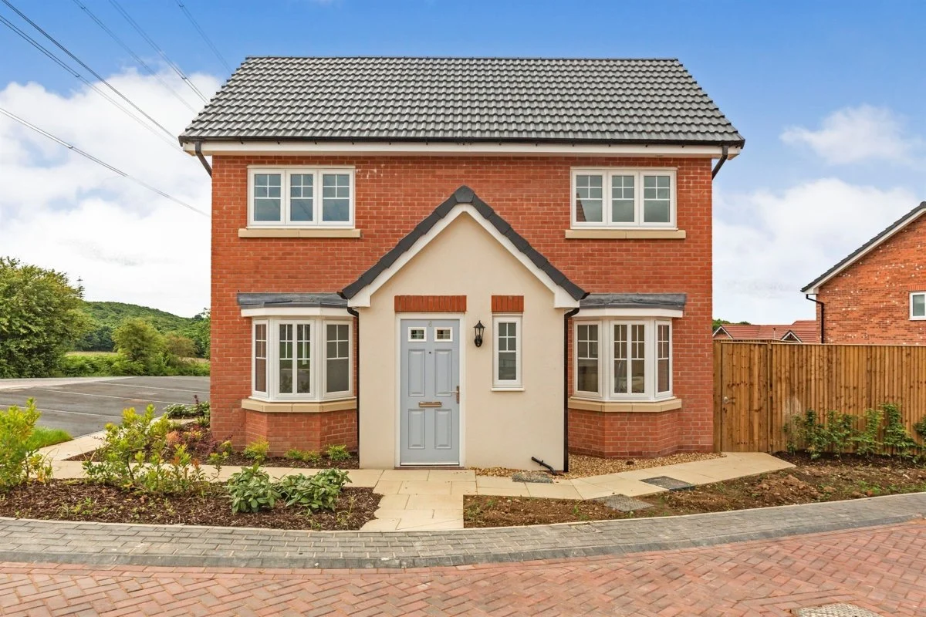



**To find out more visit www.rotherham.gov.uk**



## Contents Page

|  |  |
| --- | --- |
| **Introduction** | **3** |
| **What is in my lease?** | **5** |
| **Rent and Service Charges** | **6** |
| **Repairs, Maintenance and Improvements** | **9** |
| **Statutory Consultation Process** | **13** |
| **Buying More Shares and Selling your Home** | **14** |
| **Responsibilities** | **16** |
| **Complaint, Comment or Compliments** | **17** |
| **Useful Information** | **19** |
| **Frequently Asked Questions** | **22** |

## Introduction

This booklet is intended as a quick reference guide to help you understand what it means to be the owner of a Shared Ownership House. It is not a replacement for your Lease, which sets out all your legal rights and responsibilities. If you have any specific questions, please consult the terms of your lease first.

### Rother Living

Rother Living is Rotherham Council’s brand for all new build housing developments in Rotherham, including Shared Ownership. From this point on, the terms ‘the council’, ‘the landlord’, and ‘Rother Living’ are interchangeable.

### Your Ownership

As a Shared Owner, you own your home by way of leasehold.

Leasehold is just another form of home ownership.

It is like owning a home:

* You can sell it on the open market
* You are responsible for its repair and maintenance
* You are responsible for all associated bills and costs.

However, there are several differences:

* You have a landlord
* You may have service charges to contribute towards
* You are obliged to meet the terms set our in your lease.

### What is a lease?

A lease is a legal contract between you (the Lessee) and your Landlord, Rotherham Metropolitan Borough Council (RMBC). It contains all your rights and responsibilities, and those of your landlord. As such, your lease should be the first document that you read if you have any questions relating to the ownership of your home.

There are usually two plans attached to your lease:

* One setting out ‘the property’ which includes your home, garden, car parking space etc.
* The other sets out ‘the estate’ which includes shared rights of way, areas of responsibility, communal/common parts etc.

You will have been provided with a copy of your lease from your solicitor on completion of the purchase of your home. However, if you have lost it, we can provide you with a copy subject to an administration charge.

(A list of all current payments and charges for shared ownership can be found on the RMBC website. (www.rotherham.gov.uk)

## What is in my lease?

Your lease contains all your rights and responsibilities, and those of the Landlord. Whilst the following list isn’t exhaustive, some important points to be aware of include:

### Your Rights

* You have the right to quiet enjoyment of your home, without unnecessary interference from your neighbours or landlord.
* You have a right to decorate the inside of your home. However, you will need the Landlords written consent before making any structural alterations/improvements.

### Your Responsibilities

* To pay your rent, service charges and all other bills associated with the property (Including your mortgage if you have one)
* To keep your property in good repair, condition and decoration
* To abide by the terms of your lease
* To use the premises for residential use only.

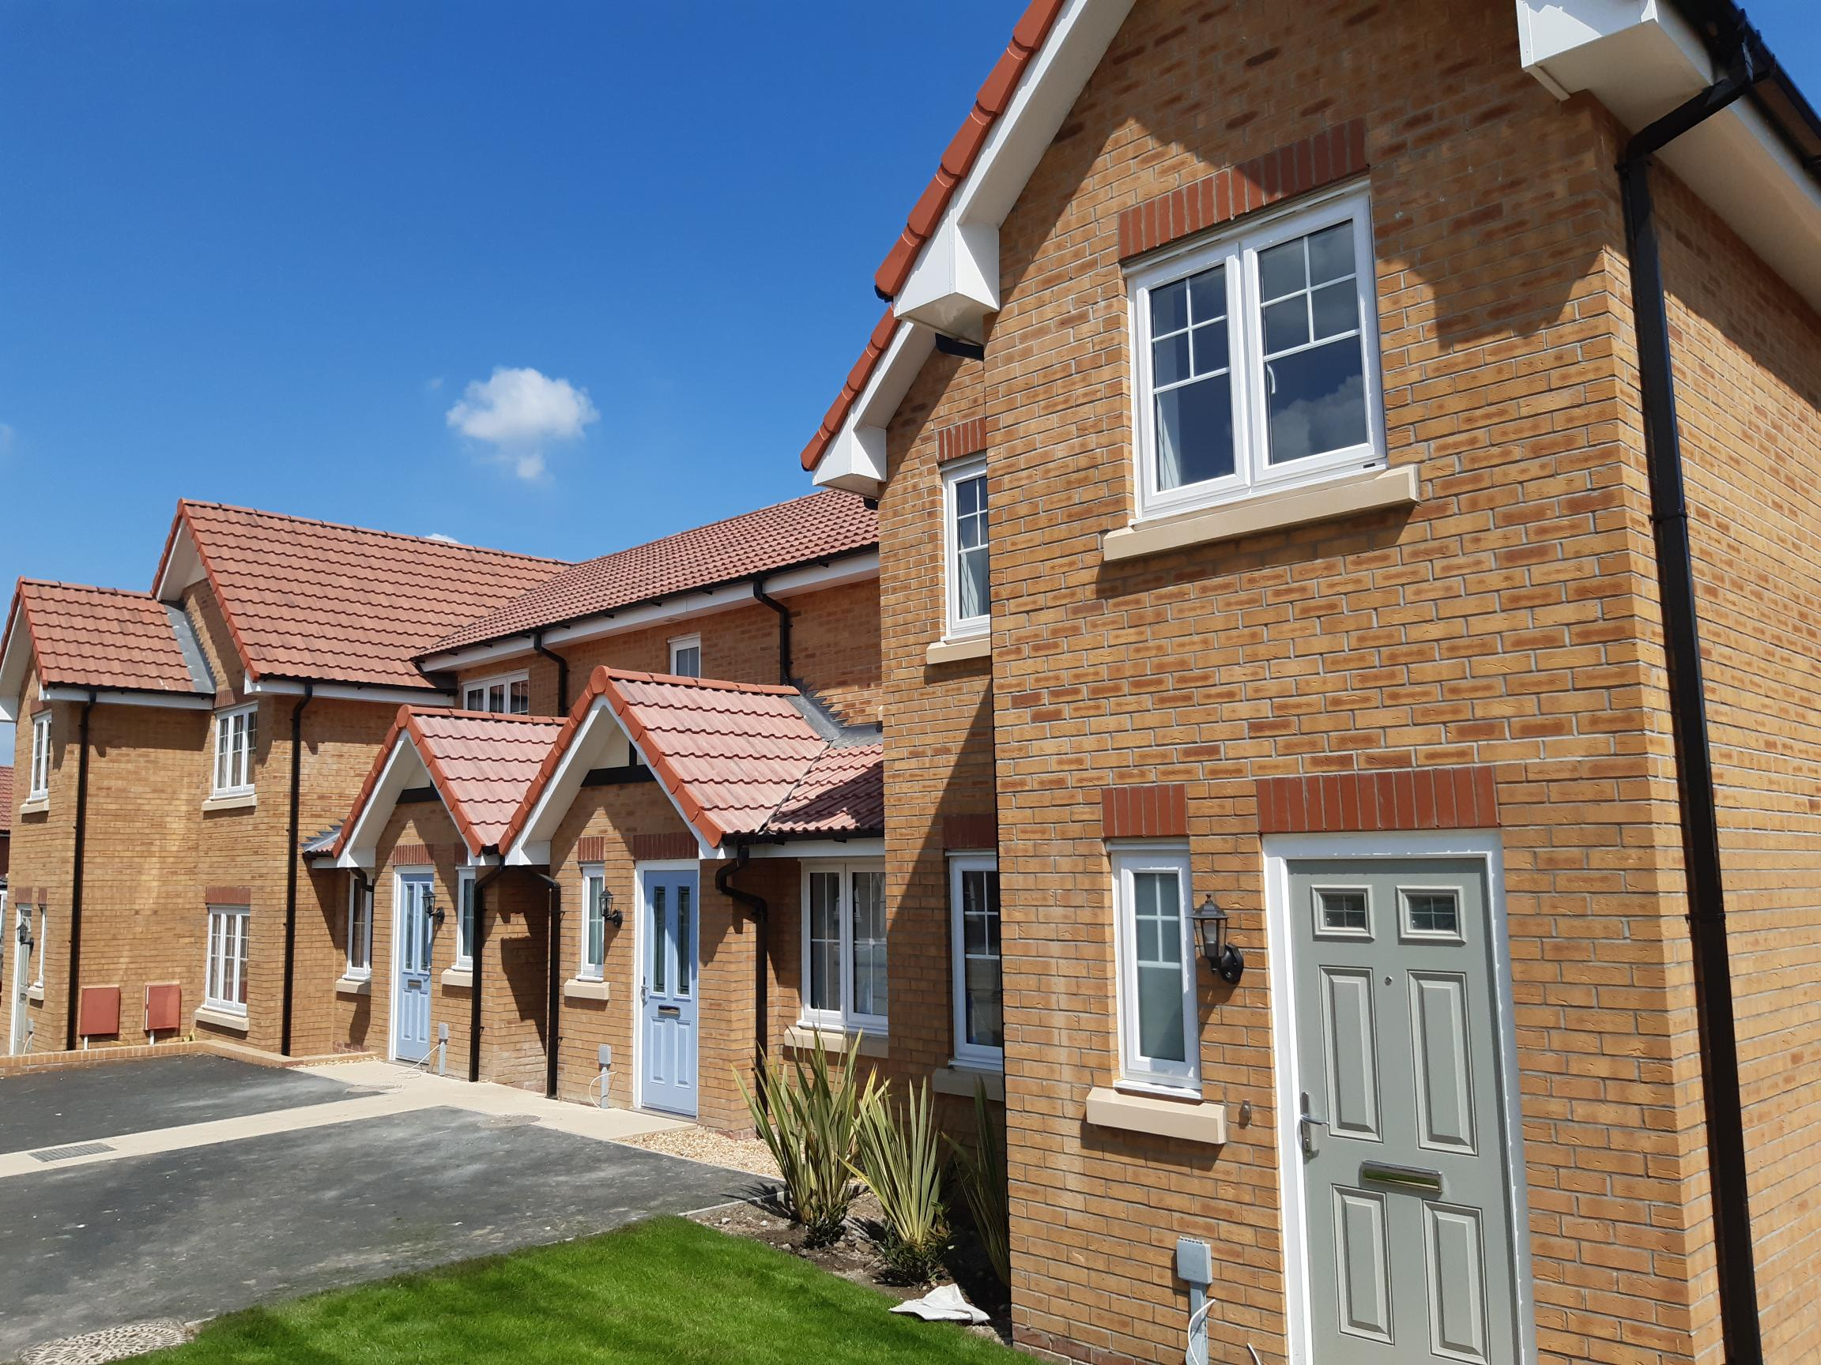

## Rent and Service Charges

### Rent

As a shared owner you will have to pay a rent to the landlord for the share of the property that you do not own. Payment is due monthly and is payable by Direct Debit on the 1st of every month.

Your rent will be reviewed annually, using a process set out in your lease. We will write to you regarding any changes to your rent at least one calendar month before any change is implemented.

### Service Charges

As a shared owner you are liable for a share of the costs incurred by the Council following the provision of services such as:

* Administration and management of leasehold services
* The provision of buildings insurance

Also, depending on the location of your home, you may be liable for the costs of maintaining parts of the estate, such as:

* Grounds Maintenance
* Provision of shared spaces
* Un-adopted roads

These costs are recovered using the Service Charge mechanism in your lease, and because they are variable it means that your yearly contributions can go up or down.

The annual service charge process is as follows:

* On or around the 1st of April, we will send you an Estimated Service Charge demand’ which will cover the forthcoming year
* You can pay these charges off in either a lump sum payment, or monthly by direct debit (default payment being by Direct Debit)
* On or around the 1st of October, we will write to you with your ‘Reconciled Service Charge Demand’ in relation to last year’s charges
* The result of the reconciliation process will be to raise either a debit or credit against your account, and your monthly direct debit payments will be adjusted accordingly.

Whilst we make all efforts to make this process as simple and understandable as possible, we recognise that it can be confusing. As such, if you have any questions following the receipt of a demand, please do not hesitate to contact us.

### Sinking Funds (sometimes called Usage or Depreciation Charge)

Sinking Funds act as ‘savings accounts’ that are specifically designed to cover the costs of replacing high-cost items (sometimes referred to as ‘major works’ or ‘capital works’). Examples include

* Re-surfacing un-adopted roads
* Re-pointing/replacing retaining walls
* Rebuilding communal bin stores

While the purpose of these funds differs from the other service charge items, the charges incurred will still form part of your annual service charge demand. As the landlord, we will make it clear in your demand what payments are for what purposes.

The method used to calculate each individual item is as follows:

* Confirmation of installation cost
* Item given estimated lifespan (the date by which it may need to be replaced)
* Uplifting the installation costs using a predetermined annual inflation amount (compounding) based on the estimated lifespan (in years)

**Please note:** As this is an estimated process, the final balance of the sinking fund may not cover the full costs to be incurred replacing the high-cost item. In these instances, the parties responsible for contributing towards these costs will be jointly responsible for the difference in costs.

### What happens if I don’t pay?

Nonpayment of your rent and or service charge would result in a breach of your lease – and potentially arrears action being taken.

Should arrears action be taken then you would incur additional costs, and in serious cases there is a risk that you could lose your home and any equity you have in it.

We appreciate that people can get into financial difficulties. As such, given these potential risks, it is essential that you contact us as soon as possible if you think you might have difficulties paying. We can offer you the relevant advice, consider an arrears management plan and/or signpost you to external support agencies.

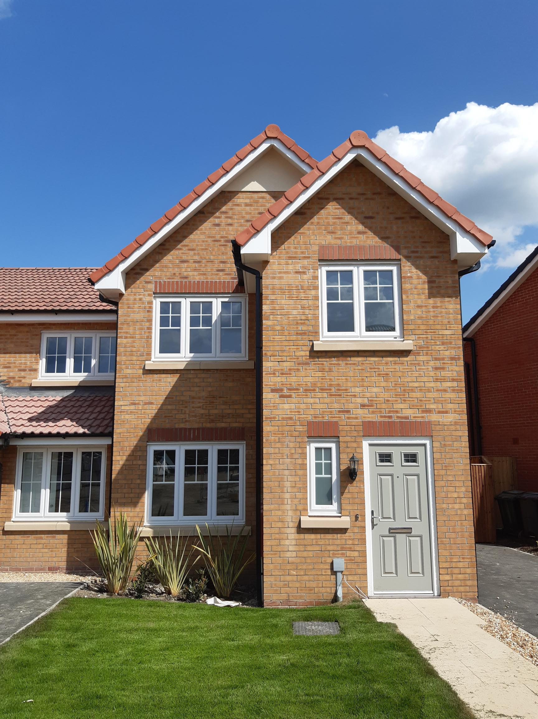

**Repairs and Maintenance Summary of Responsibilities**

As owner of your home, you are responsible for its upkeep, including all associated costs, regardless of the share you own.

The only exception to the above being those less than 12 months old – as it is the builder’s responsibility to resolve any defects identified within the first year of construction. For confirmation of all relevant dates, contacts, responsibilities and warranties please see your property handover pack.

### Defects period

Newly built properties come with a one-year defects period, which starts from the ‘practical completion date’ (the date the property was handed over to the Landlord) not the date from which you purchase your home. This date will be clarified for you in your property hand over pack.

During this period the builders are responsible for repairing any problems that are the result of faulty workmanship and or materials. If you notice any defects in your home during this period please report them to us as soon as possible, we will then liaise with the builder.

To report a defect please email sharedownership@rotherham.gov.uk, providing your name, contact number and a description of the repair.

### Building warranty

All new build properties come with a 10-year warranty, which covers major structural defects, again starting from the ‘practical completion date’.

Your building warranty certificate will be provided to your solicitor at the point of sale, which sets out who the warranty provider is. We do not keep copies of your building certificate, if you need a replacement you would need to contact the company that supplied the building warranty directly.

Please note: Any defects identified during the first 12 months should be dealt with under the 12 months defects period. To resolve any defect outside of this window you would need to contact the builder and or warranty provider directly.

## Repairs and Maintenance Summary of Responsibilities

|  |  |
| --- | --- |
| **Your Responsibility** | **Rotherham Council responsibility (to carry out work, chargeable through the service charge.** |
| Internal and external decoration | Communal gardens and associated fences, gates and steps |
| Internal and external repair and maintenance (including structural work) | Unadopted roads, pathways and streetlights |
| Internal and external doors and windows | Communal car parking spaces |
| Internal plaster, floorboards, tiling, wall covering, ceiling coverings, floor coverings | Arranging buildings insurance (hared owners/leaseholder pay through service charge |
| Radiators | Any other communal facilities available to you |
| Boilers |  |
| Water and sanitary equipment |  |
| Gas and Electrical products |  |
| Pipes, drainage and wires |  |
| Light fixtures and fittings (including bulbs, sockets, switches and fuses |  |
| Kitchen fixtures and fittings (including cookers) |  |
| Bathroom Fixtures and fittings |  |
| Gas/electric fire (including fire surrounds) |  |
| Smoke alarms |  |
| Door frames, skirting boards |  |
| Contents insurance |  |
| Roof and roof space |  |
| Garden area including fences, paths, gates and steps (please refer to your lease for the red line drawings) |  |

### Property Alterations and Improvements

Before making any structural improvements, additions or alterations to your home you must first obtain the council’s written consent.

Carrying out works without permission would be considered a breach of lease, resulting in you being asked to revert the change or the Council doing so, both at your own expense.

Should permission be granted, you will be responsible for all costs incurred, including any costs incurred by the council. You would also be responsible for obtaining any necessary building regulations or planning approval

All work must be carried out by experienced and qualified persons, and once completed they will be inspected by the council for final approval.

### Buildings Insurance

The council is responsible for arranging the buildings insurance for your home. As such, annual cover will be provided from 1st April to 31t March annually. The cost will be included in your annual service charge.

We will endeavour to provide copied of the insurance policy along with your service charge demand, along with any other relevant information. However, where this has not been received, please contact us directly to request a copy.

Claims will be managed by the council however you will be responsible for any costs incurred – including any expenses payable.

You are responsible for arranging your own contents insurance.

### Gas Servicing

You are responsible for the repair, maintenance and servicing of any gas appliances in your home. However, you may be asked to provide us with a copy of your current gas safety certificate, so please ensure you keep a copy.

### Communal/common/shared areas

It is the council’s responsibility to keep any shared areas on your estate in a good state of repair, including:

* Green spaces
* Soft Landscaping
* Children’s playgrounds
* Parking spaces

Maintenance costs will be recovered as part of your service charge

### Communal area repairs

To help us manage your estate, and to keep costs to a minimum, we ask that you contact us to report any repairs or services that are needed to these areas. Please note that you do not have the authority to carry our any of these repairs or services yourself.

If you or any visitors to your home cause any damage to such areas, you will have to pay for any costs incurred individually.

### Maintaining your garden

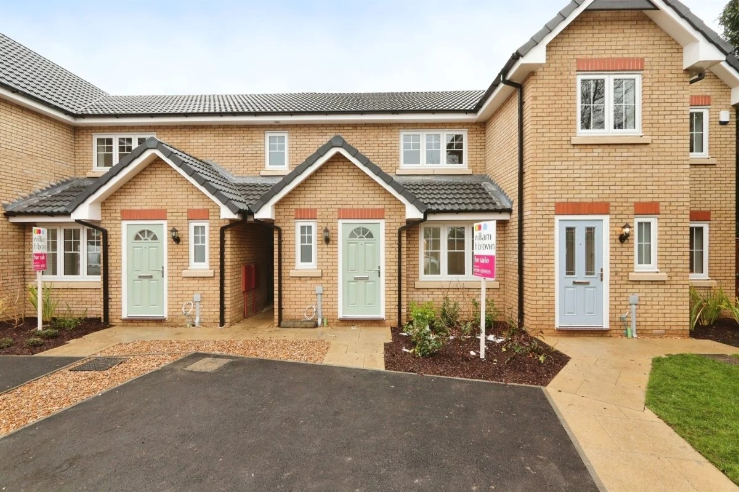You are responsible for keeping your garden well maintained, at all times.

## Statutory Consultation process

As your Landlord the Council is obliged to notify you of any:

* Major works schemes where your share of the costs would exceed £250, or
* Long-term arrangement where your annual contribution would exceed £100

This is a legislative process and is commonly referred to as the section 20 consultation process. As such you will always be notified of these triggers in writing, starting with an initial ‘Notice of Intention’, which includes:

* A general description of the proposed works / long-term arrangement
* Why the works or arrangement is necessary, and
* The costs that you are likely to incur

It is important that you read these formal consultation notices as they will explain to you your rights as a leaseholder and provide important information regarding the works/services.

Where the proposed works are to an item that is covered by a Sinking Fund, we will use what is in the fund to cover the costs of the works. However, if there isn’t enough in the fund to cover all the costs you will be asked to top up the remainder of your share.

Sometimes we may need to carry out works urgently without consultation, but we will only do so where there is a risk to people’s health and safety, or there is a risk to a building. We will always make every effort to start the consultation process as early as we can.

## Staircasing and selling your home

### Staircasing

Staircasing enables you to increase the share of the property you own, all the way to 100% outright ownership. And, as you increase your shares in the property, your monthly rent decreases.

**Please note:** before applying to staircase please ensure that your rent and service charges are paid up to date.

### How to apply

To start the staircasing process you must first formally apply to us, in writing. This will result in our formal acknowledgement, along with us setting out what happens next.

You will then be required to obtain a valuation from a RICS qualified surveyor. You will be responsible for arranging and paying for this service.

Please be aware, there are a number of other costs associated with staircasing, including but not limited to:

* The cost of purchasing the additional shares
* Mortgage arrangement and valuation fees (if applicable)
* Your own professional fees (e.g. surveyors, valuations, solicitor costs etc.)
* The Councils fees (e.g. costs of administering the process, any professional fees incurred)

Once the staircasing process has concluded, your rent will be adjusted accordingly. However, even after you staircase to 100% ownership, depending on the location of your home there may be estate service charges still to pay.

### Selling your home (Resales)

If you wish to sell your home, you must first notify us in writing. We will then respond to acknowledge your request and confirm the process.

You will be required to get a valuation for the property from a RICS qualified surveyor.

This will start the nomination process, which is where we will try and find a qualifying person to buy your home. If we are unable to nominate a suitable purchaser within the allotted period, you will then be able to find a buyer on the open market through your preferred estate agent.

If we do not have any applicants on our waiting list, we may waiver our right to a nomination period.

**Please note**: the Shared Ownership eligibility criteria will still apply to subsequent owners, unless they purchase the property outright.

### Costs and fees

As with staircasing, there are a number of other costs associated with selling your home, including but not limited to:

* Your own professional fees (e.g. surveyors, solicitors, moving costs and estate agents)
* The Council’s administrative fees and professional fees (e.g. legal costs etc.)

### Will

If you are a joint owner you may pass on your share in the property, so long as the eligibility criteria are met.

### Amending your lease

We understand that your circumstances may change during the period in which you own your home. As such, it’s important that you keep us informed of any changes to your circumstance - as these changes may need to be accounted for in your lease.

For example: requesting a change in ownership from sole to joint or following a relationship breakdown.

## Responsibilities

### Anti-Social behaviour

You are responsible for the behaviour of every person living in or visiting your home (including children), and while they are on the estate.

All complaints relating to anti-social behaviour will be investigated in accordance with our policies and procedures, and the terms of your lease. If you are found to be in breach of your lease there could be serious consequences, which include losing your home and any equity you have in it.

### Reporting ASB

If you experience any anti-social behaviour, you should contact us as soon as possible at:

* www.rotherham.gov.uk/housing
* calling 01709 336009, or
* by writing to us (address at the back of this booklet)

As the reporter of a compliant you may be asked to record details of any further incidents.

You can also call the Police on 999 for emergency assistance, or 101 for any non-emergencies.

### Customer Involvement

If you would like to be part of our customer involvement program, please let us know. We will then notify you of any community engagement, surveys or workshops that we hold. You may be interested in our Tenant Involvement pages on the Rotherham Council website.

You can also opt-out of our customer involvement program at any time. Just let us know and we will remove your details.

## Complaint, Comment or Compliment – We Want to Know

We welcome all feedback on how we can improve our services. You can make a compliment, comment or complaint using any of the following methods:

Email: **sharedownership@rotherham.gov.uk**

Call: **01709 822215**

Write: **Home Ownership Team, Strategic Housing Floor 2C, Riverside House, Main Street, Rotherham, S60 1AE**

Or alternatively:

Via our online form at **www.rotherham.gov.uk**

Email: **complaints@rotherham.gov.uk**

Write: **Complaints Section, Riverside House, Main Street, Rotherham, S60 1AE**

Please note: For formal Service Charge disputes you will need to follow the Service Charge dispute process. This will be set out in your annual service charge demand pack.

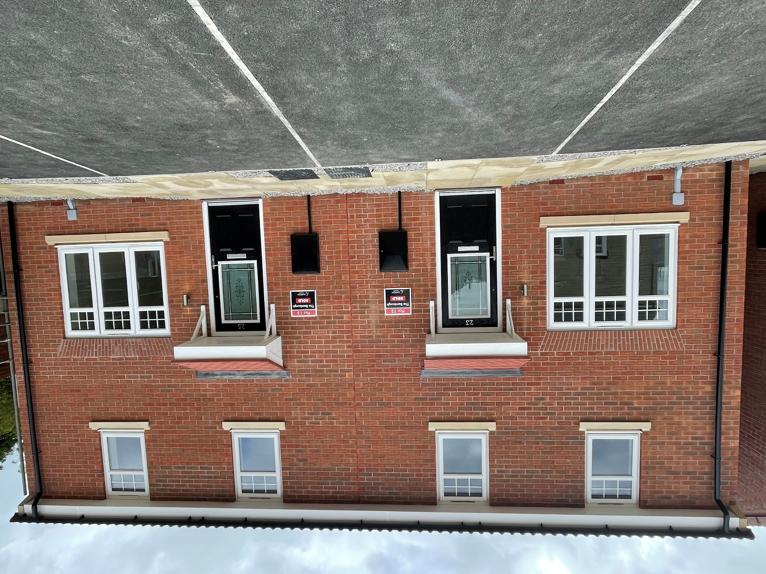

### Other agencies for leaseholders

**First-tier tribunal**

If you think a service charge is unreasonable you may appeal to the first-

tier tribunal for a ruling on this. There will be a cost associated with this.

**Citizens Advice Bureau**

The Citizens Advice Bureau can offer advice to anyone about a number of problems various ways. We would advise you to contact your local branch for more information.

**LEASE**

LEASE are an independent advisory service that specialise in leasehold issues. Please visit their website for more information:

**www.lease-advice.org**

### Department of Works and Pensions

You may be entitled to get partial or full benefit contributions towards your rent and service charges. If you think you are eligible, please contact them directly.

### Data Protection

Rotherham Metropolitan Borough Council and its partners are committed to protecting your data. For more information on how we will hold, manage and process your data please visit [**www.rotherham.gov.uk**](http://www.rotherham.gov.uk)**.**

## Useful Information

**Subletting** – Subletting is not permitted for shared ownership properties. If you think you need to sublet, and no other options are available, please contact us directly.

**Pets** – Your lease allows you to keep 1 domesticated animal in your home. However, no dogs under the Dangerous Dog Act 1991 are allowed.

Please note: If you want more than 1 domestic pet, you must contact RMBC for permission.

**Carbon Monoxide Poisoning** – Carbon monoxide is a poisonous gas that has no smell or taste. Breathing it in can make you unwell, or even kill if you are exposed to high levels.

Symptoms can often be mistaken for flu and include headaches, dizziness, nausea and exhaustion. We recommend that you buy a carbon monoxide detector that will alert you if there is excess carbon monoxide in your home.

If you suspect you have a carbon monoxide or gas leak, please call the national grid on **0800 111999.**

To reduce the risk of Carbon Monoxide poisoning it is recommended that you have your gas appliances serviced regularly and take any advice given by your Gas Engineer seriously.

**Electricity** – Any electric repair should always be carried out by a qualified electrician. When your appliances are not in use, we recommend you unplug them. Take care not to overload sockets and always follow manufacturer’s instructions. If you have any emergency electrical concerns, please contact the National Grid Emergency Service on **0800 404090.**

**Fire** – Fire Kills! As such it is important that you have working smoke alarms in your home and change the batteries regularly, it could save your life, or your family’s.

For this reason, any requests to install open fires or log burners will carefully be considered in the wider health and safety context.

**Burst Pipes** – During cold weather or if you are away from your home for an extended period of time it is recommended that you take additional precautions to prevent pipes bursting in your home. This could include making sure your home is satisfactorily heated during especially cold weather and turning off your water at the stop tap and draining down the system if you and your family are away from your home for a week or more.

**Preventing condensation and mould** – Condensation is the most common cause of damp in people’s homes and is more common in places of high moisture, poor air circulation and a warm temperature.

The causes of condensation and black mould are often found to be due to the habits and lifestyle of the people living in the property. As such some preventative steps you can take include:

* Not drying clothes indoors (if you do, keep your home well ventilated)
* Keep rooms warm and well aired
* When cooking and bathing keep a window open to let the moisture escape
* Keep trickle vents on windows open and wipe away condensation on windowsills in the morning if needed.

If you do have mould growth in your property, we advise using a cleaning solution or household bleach and wipe it away gently. Avoid contact with your skin and eyes, and always do a test patch on a discrete area to make sure that the cleaning solution does not damage your property.

**Legionella** – The risk of legionella in your home is low because your water is usually stored in small quantities. However, even though the risk is low, it can increase if the property is stood empty for a week or more.

While your home is fitted with a combination boiler, thus reducing the risk of legionella, some additional steps you can take if your home has been empty for a week or more include letting your taps run for at least two minutes per week and running your shower for at least fifteen minutes before using it.

**Keys** – When you first move into your property you will be provided with all the keys that have been cut for your lock. We do not keep any copies. In the event that you lose all your keys you would need to get a locksmith to replace the lock to your home.

**Car Parking** – Please only use the parking that has been allocated to you in your lease, or through any other arrangement you have made with your landlord.

Respect the parking needs of other residents, especially in schemes with designated parking. You are not permitted to use anyone else’s parking space, even for a short period of time. And visitors to your property should park on nearby streets.

**Running a business from your home** – Your lease restricts the property to domestic use only; the property should only be used as a private, single residence. If you need any more information about this, please contact us.

**TV license** – You will have to apply for your own TV licence or transfer this over from your previous address. Please contact TV licensing direct on **www.tvlicensing.co.uk**

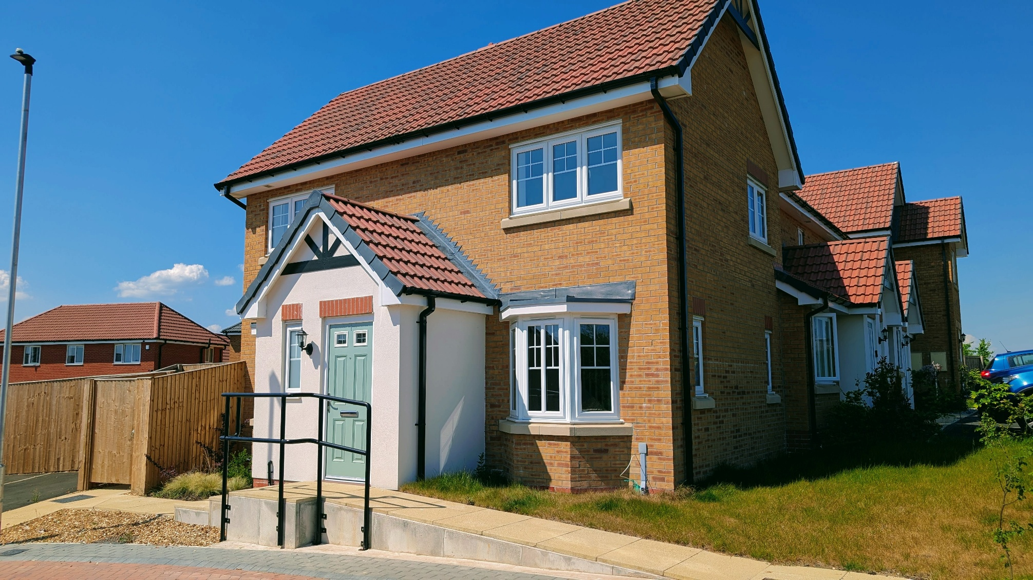

## Frequently asked questions

**Q: What are my repair responsibilities in my home?**

A: All the repairs to your home (internal and external) are your responsibility. Your lease will set out any example of where this is not the case.

**Q: I only own half the property; does Rother Living pay towards 50% of any repairs or bills?**

A: No, you are responsible for the full costs associated with keeping your property in a good state of repair and for any other bills/charges/taxes associated with the property.

**Q: I do not use the communal/common/shared areas; do I still have to pay for these?**

A: Yes, even if you do not use these areas, you will still have to contribute towards their maintenance/upkeep. You can find more information about your specific charges in your lease.

**Q: I know the repairs are my responsibility, but is this something Rotherham Council could do, and I would pay them?**

A: We do not currently offer a repair service to owners of a Shared Ownership House. We recommend that all repairs are carried out by a suitably qualified professional.

**Q: Is my insurance covered in my rent?**

A: No, your buildings insurance is organised by Rotherham Council to which you must contribute towards the costs of through your service charges. You are responsible for arranging your own contents insurance cover.

In the event that you staircase to 100% ownership, and therefore become the freeholder, you will then become responsible for arranging your own buildings insurance.

**Q: Why are Service charge demands complicated?**

A: While we do our best to make our service charge demands clear and transparent we understand that they sometimes can be confusing.

There are a number of specific pieces of information and documents that we must include/send when raising a service charge demand, so that we meet our legal obligations. However, if you have any questions, please contact us and we will be happy to explain your service charge demand.

**Q: Why is the lease complicated?**

A: The lease is a legal document and is based on the model lease as set out by Homes England; this should be interpreted by a legal professional. Your solicitor should explain the contents of the lease before you purchase the property, and make sure you fully understand your obligations as a shared owner.

**Q: I have not got my 10-year Building Warranty certificate; can the Rotherham Council provide me with a copy?**

A: All copies of this document were passed onto the solicitor acting for the first buyer before completion of the property. If these haven’t been passed onto you, you would need to contact your solicitor or request a new certificate from the Warranty provider.

**Q: If I sell my home, can I use any estate agent, or do Rotherham Council tell me who to use?**

A: When selling your home, you must first go through the nominations process, during which Rotherham Council will help try to find a purchaser. However, in the event we are unable to find a purchaser within the specified timeframe you can appoint your own chosen estate agent.

**Please note:** we will need to be informed of who you have selected to manage the sale, as we will need to liaise with them.

**Q: Will Rotherham Council buy my property back?**

A: No, we are unable to buy back your property. If you want to sell your property you would need to go through the sale process. If you are in financial difficulties, please contact us as soon as possible so that we can run through your options with you.