

RISK ASSESSMENT FINDINGS

Department/Service
Date
Assessor
Approved By
Review Date

Relevant Legislation:

The Management of Health and Safety at Work Regulations 1999

RISK ASSESSMENT RECORD

ACTIVITY and/or ENVIRONMENT TO BE ASSESSED: Animals in School (Educational)
DATE:

KEY (People at risk) | Likelihood (L) | Severity (S) | Risk Calculation | Risk Rating
E = Employee YP = Young Persons  P = Public  C = Contractors  V = Visitors  EM = Expectant Mothers | 1. Very Low (rare/very unlikely)  2. Low (unlikely)  3. Medium (could occur/possible)  4. High (likely to occur/probable)  5. Very High (near certain to occur) | 1. Insignificant (nuisance/discomfort)  2. Minor (no lost time)  3. Moderate (time loss)  4. Significant (serious/incapacity to work)  5. Major (Death) | Likelihood x Severity  =  Rating | 1- 6 LOW RISK Monitor  - MEDIUM RISK Monitor, review & reduce risk where possible  14-25 HIGH RISK Further Action Required

1.Hazards Identified and potential harm it could cause | 2. People  At Risk | 3.Controls in Place | 4.Risk Rating |  |  |  | 5. Further Action Required/ Recommendations | 6.Target Date for Completion
1.Hazards Identified and potential harm it could cause | 2. People  At Risk | 3.Controls in Place | L | S | Score | Risk | 5. Further Action Required/ Recommendations | 6.Target Date for Completion

Bites  Scratches/other injuries  Illness e.g. allergy |  | - Minimise human contact (to prevent unnecessary distress to animals and potential bites etc.)  - Adequate hand washing / hygiene procedures.  - Written parental consent to participate (e.g. allergy) |  |  |  |  | Rules for appropriate behaviour.  First aid and accident reporting procedures.
Biological hazards – faeces /urine |  | Cleaning procedure for mopping up of biological hazards.
Infestation e.g. flees |  | Preventative measures such as flea treatment carried out on animals such as Cats, Dogs and Rabbits.
Escape of animal |  | - Larger animals must be securely harnessed and supervised  - Small animals/rodents should be transported and kept in an appropriate cage/case etc.
Animals fighting |  | Animals kept separate |  |  |  |  | If any animal shows signs of aggression due to the unfamiliar surroundings, it must be isolated safely away and removed from school premises as soon as possible.
Damage to property |  | - Larger animals must be securely harnessed and supervised  - Small animals/rodents should be transported and kept in an appropriate cage/case etc.

Birds, reptiles, farm animals, protected species, wild animals, banned or dangerous animals should not be brought onto site by individuals. Ensure a registered/licenced provider facilitates any school visits.

RMBC insurance for schools would not cover an accident for unauthorised animals being on site in the event of an accident. It may be necessary to consider extra insurance cover.
For more insurance advice contact RMBC Risk and Insurance Section on: 01709 822088.

External organisations, petting zoos etc. will have their own public liability insurance cover.
NB school to check licence / insurance etc. prior to approval.

NOTE:
The RSPCA is opposed to the use of animals for education, where distress or suffering is, or is likely to be caused.

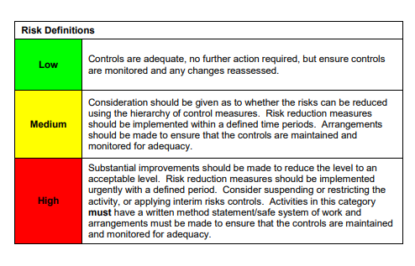

ACKNOWLEDGEMENT OF RISK ASSESSMENT Version:

PLEASE READ THE NOTICE BELOW BEFORE SIGNING THIS FORM
I acknowledge that I have read and understood the Risk Assessment/s associated with this task/event/equipment etc

Forename | Surname | Employee Signature | Date | Manager’s Signature

