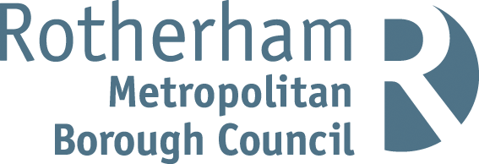

RISK ASSESSMENT FINDINGS

Department/Service
Date
Assessor
Approved By
Review Date

Relevant Legislation:

The Management of Health and Safety at Work Regulations 1999

RISK ASSESSMENT RECORD

ACTIVITY and/or ENVIRONMENT TO BE ASSESSED: Art, design and craft room
DATE:

KEY (People at risk) | Likelihood (L) | Severity (S) | Risk Calculation | Risk Rating
E = Employee YP = Young Persons  P = Public  C = Contractors  V = Visitors  EM = Expectant Mothers | 1. Very Low (rare/very unlikely)  2. Low (unlikely)  3. Medium (could occur/possible)  4. High (likely to occur/probable)  5. Very High (near certain to occur) | 1. Insignificant (nuisance/discomfort)  2. Minor (no lost time)  3. Moderate (time loss)  4. Significant (serious/incapacity to work)  5. Major (Death) | Likelihood x Severity  =  Rating | 1- 6 LOW RISK Monitor  - MEDIUM RISK Monitor, review & reduce risk where possible  14-25 HIGH RISK Further Action Required

1.Hazards Identified and potential harm it could cause | 2. People  At Risk | 3.Controls in Place | 4.Risk Rating |  |  |  | 5. Further Action Required/ Recommendations | 6.Target Date for Completion
1.Hazards Identified and potential harm it could cause | 2. People  At Risk | 3.Controls in Place | L | S | Score | Risk | 5. Further Action Required/ Recommendations | 6.Target Date for Completion

Paints, inks etc. – harm to health |  | Only low hazard paints and inks to be used |  |  |  |  | Refer to CLEAPSS guidance where necessary/appropriate.
Inhalation of dust – illness |  | - If working with clay/pottery, avoidance of spillages;  - Spillages of clay slip not allowed to dry out, dry dust avoided  - Controlled allocation of small quantities of glaze materials
Sharp blades – cuts |  | - Safety blades used where possible.  - Controlled storage and allocation of craft knives etc.
Electricity – electric shock |  | - Electrical equipment is subject to portable appliance testing  - Visual inspection regime  - Fixed appliance testing
Hot kiln – burns |  | - Kiln used only under teacher supervision  - Provision of appropriate personal protective clothing and equipment.
Fume inhalation (kiln) – ill health |  | Kiln room has effective extracting ventilation installed
Damaged asbestos in kilns – health risks |  | If damaged do not use, prompt attention required by competent licensed asbestos contractor.

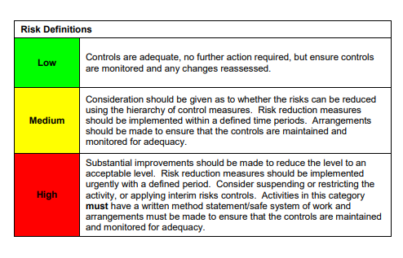

ACKNOWLEDGEMENT OF RISK ASSESSMENT Version:

PLEASE READ THE NOTICE BELOW BEFORE SIGNING THIS FORM
I acknowledge that I have read and understood the Risk Assessment/s associated with this task/event/equipment etc

Forename | Surname | Employee Signature | Date | Manager’s Signature

