

RISK ASSESSMENT FINDINGS

Department/Service
Date
Assessor
Approved By
Review Date

Relevant Legislation:

The Management of Health and Safety at Work Regulations 1999

RISK ASSESSMENT RECORD

ACTIVITY and/or ENVIRONMENT TO BE ASSESSED: Asthma
DATE:

KEY (People at risk) | Likelihood (L) | Severity (S) | Risk Calculation | Risk Rating
E = Employee YP = Young Persons  P = Public  C = Contractors  V = Visitors  EM = Expectant Mothers | 1. Very Low (rare/very unlikely)  2. Low (unlikely)  3. Medium (could occur/possible)  4. High (likely to occur/probable)  5. Very High (near certain to occur) | 1. Insignificant (nuisance/discomfort)  2. Minor (no lost time)  3. Moderate (time loss)  4. Significant (serious/incapacity to work)  5. Major (Death) | Likelihood x Severity  =  Rating | 1- 6 LOW RISK Monitor  - MEDIUM RISK Monitor, review & reduce risk where possible  14-25 HIGH RISK Further Action Required

1.Hazards Identified and potential harm it could cause | 2. People  At Risk | 3.Controls in Place | 4.Risk Rating |  |  |  | 5. Further Action Required/ Recommendations | 6.Target Date for Completion
1.Hazards Identified and potential harm it could cause | 2. People  At Risk | 3.Controls in Place | L | S | Score | Risk | 5. Further Action Required/ Recommendations | 6.Target Date for Completion

Environmental Factors  Dust  Pollen Count  Cleaning Chemicals -(Aerosols) |  | Closing of windows  Good Housekeeping  Indoor play at break times  Since classroom windows will be open in warmer periods, pupils with asthma should not be placed close to the window to reduce exposure to outdoor seasonal aeroallergens.  Parents reminded to dress children appropriately to maintain thermal comfort.  At break and lunch times when playing outside, pupils should wear a suitable coat to maintain thermal comfort. |  |  |  |  | Complete a ‘My Asthma Plan’  Always keep a reliever inhaler and spacer close by.
Behavioral Factors  The implementation of environmental controls to reduce exposure to asthma triggers requires a behavioral change for the individual with asthma and others. |  | Prohibit smoking and/or in the individuals presence.
Exertion |  | Reasonable adjustments made for P.E. and Sports  Additional time to move from lessons |  |  |  |  | Complete a ‘My Asthma Plan’  Always keep a reliever inhaler and spacer close by.
Dust particles articles from Woodworking and/or Metal Working |  | Extraction System in place with PPE/RPE where appropriate |  |  |  |  | Complete a ‘My Asthma Plan’  Always keep a reliever inhaler and spacer close by.  Extractor system checked before use and annually serviced
Gases/smoke from chemical reactions in Science Lessons |  | Extraction System in place with PPE/RPE where appropriate |  |  |  |  | Complete a ‘My Asthma Plan’  Always keep a reliever inhaler and spacer close by.  Extractor system checked before use and annually serviced

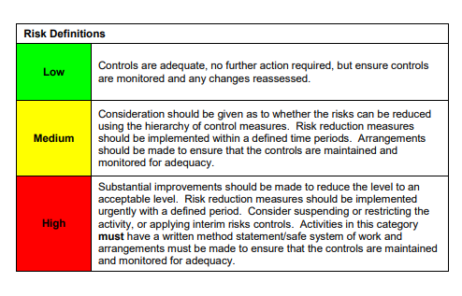

ACKNOWLEDGEMENT OF RISK ASSESSMENT Version:

PLEASE READ THE NOTICE BELOW BEFORE SIGNING THIS FORM
I acknowledge that I have read and understood the Risk Assessment/s associated with this task/event/equipment etc

Forename | Surname | Employee Signature | Date | Manager’s Signature

