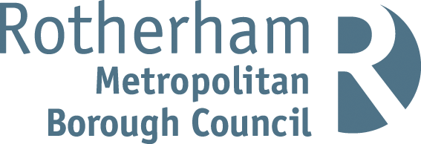

RISK ASSESSMENT FINDINGS

Department/Service
Date
Assessor
Approved By
Review Date

Relevant Legislation:

The Management of Health and Safety at Work Regulations 1999

RISK ASSESSMENT RECORD

ACTIVITY and/or ENVIRONMENT TO BE ASSESSED: Biology Laboratory
DATE:

KEY (People at risk) | Likelihood (L) | Severity (S) | Risk Calculation | Risk Rating
E = Employee YP = Young Persons  P = Public  C = Contractors  V = Visitors  EM = Expectant Mothers | 1. Very Low (rare/very unlikely)  2. Low (unlikely)  3. Medium (could occur/possible)  4. High (likely to occur/probable)  5. Very High (near certain to occur) | 1. Insignificant (nuisance/discomfort)  2. Minor (no lost time)  3. Moderate (time loss)  4. Significant (serious/incapacity to work)  5. Major (Death) | Likelihood x Severity  =  Rating | 1- 6 LOW RISK Monitor  - MEDIUM RISK Monitor, review & reduce risk where possible  14-25 HIGH RISK Further Action Required

1.Hazards Identified and potential harm it could cause | 2. People  At Risk | 3.Controls in Place | 4.Risk Rating |  |  |  | 5. Further Action Required/ Recommendations | 6.Target Date for Completion
1.Hazards Identified and potential harm it could cause | 2. People  At Risk | 3.Controls in Place | L | S | Score | Risk | 5. Further Action Required/ Recommendations | 6.Target Date for Completion

Glassware – cuts |  | - Controlled storage and allocation of glassware  - Appropriate supervision  - Breakages cleaned up promptly by staff member |  |  |  |  | :
Electrical equipment - electric shock |  | Portable appliance testing, visual inspection and fixed appliance testing
Gas Bunsen burners - burns, fire |  | - Appropriate supervision of pupils  - Regular inspection of apparatus
Chemicals hazardous to health – illness, health issues |  | - Standard laboratory procedures in operation and communicated to all at risk  - Fume cabinets receive thorough examination and test and periodic in-house checks  - Pupils equipped with personal protective equipment as indicated by CLEAPSS assessments
Contact with animals and waste – bites, illness, infection |  | - Application of CLEAPSS science risk assessments and guidance for procedures /experiments  - No unnecessary contact with animals, controlled and supervised handling only  - Adequate hygiene arrangements  - Cleaning procedures within laboratory
Micro-organisms - infection |  | - Standard laboratory procedures in place and communicated to all at risk  - Fume cabinets receive thorough examination and test as well as periodic in house checks  - Pupils equipped with appropriate personal protective equipment as indicated by CLEAPSS assessments

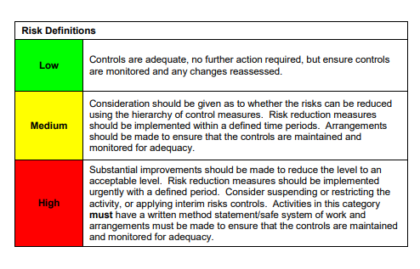

ACKNOWLEDGEMENT OF RISK ASSESSMENT Version:

PLEASE READ THE NOTICE BELOW BEFORE SIGNING THIS FORM
I acknowledge that I have read and understood the Risk Assessment/s associated with this task/event/equipment etc

Forename | Surname | Employee Signature | Date | Manager’s Signature

