

RISK ASSESSMENT FINDINGS

Department/Service
Date
Assessor
Approved By
Review Date

Relevant Legislation:

The Management of Health and Safety at Work Regulations 1999

RISK ASSESSMENT RECORD

ACTIVITY and/or ENVIRONMENT TO BE ASSESSED: Bricklaying (Vocational Training)
DATE:

KEY (People at risk) | Likelihood (L) | Severity (S) | Risk Calculation | Risk Rating
E = Employee YP = Young Persons  P = Public  C = Contractors  V = Visitors  EM = Expectant Mothers | 1. Very Low (rare/very unlikely)  2. Low (unlikely)  3. Medium (could occur/possible)  4. High (likely to occur/probable)  5. Very High (near certain to occur) | 1. Insignificant (nuisance/discomfort)  2. Minor (no lost time)  3. Moderate (time loss)  4. Significant (serious/incapacity to work)  5. Major (Death) | Likelihood x Severity  =  Rating | 1- 6 LOW RISK Monitor  - MEDIUM RISK Monitor, review & reduce risk where possible  14-25 HIGH RISK Further Action Required

1.Hazards Identified and potential harm it could cause | 2. People  At Risk | 3.Controls in Place | 4.Risk Rating |  |  |  | 5. Further Action Required/ Recommendations | 6.Target Date for Completion
1.Hazards Identified and potential harm it could cause | 2. People  At Risk | 3.Controls in Place | L | S | Score | Risk | 5. Further Action Required/ Recommendations | 6.Target Date for Completion

Falling from height |  | - All training/laying to be at floor level  - Refer to working at height risk assessment
Slips and trips |  | - Refer to slips and trips risk assessment  - All operators wear safety boots.  - Good housekeeping, e.g. debris such as mortar bags put in skip, brush available to use to keep work area clear.  - All trailing cables in work area hung up or otherwise kept out of harm’s way.  - Safe route to job agreed with tutor based on site health and safety plan.
Manual handling |  | - Refer to manual handling risk assessment  - Mortar mix/bricks transported to the work areas using powered/non-powered equipment supplied by the college and operated by a competent person.  - Dry mortar mix supplied in bags weighing less than 25 kg.  - Students know and follow safe system of work such as knowledge of maximum weight for an individual manual lift.
Hazardous  substances  (mortar mix) |  | - Risk of dermatitis or cement burns and precautions explained to all students.  - Use cement or cement containing products within the use-by date.  - Students know the risks of dry mortar powder and know to avoid skin contact, excessive dust build-up and contact with eyes.  - Work area suitable to prevent excessive dust build-up.  - Water supply nearby to wash dust off skin.  - Students wear eye protection when mixing  - Students keep work area clean.  - Gloves and barrier creams available.
Electricity |  | - Tutor and students know to check all cables, leads etc of all powered tools/ equipment before use, and how to report all faults.
Welfare/First Aid |  | - Toilets, washing facilities with hot and cold water and break out room/kitchen.  - First Aider/ Kit location known by Staff and Students  - First aid arrangements include emergency eyewash procedures.
Falling objects hitting head or body, including feet |  | - Safety helmets and protective footwear (with steel toecaps and mid-soles) supplied and always worn.  - Brick courses built to an agreed height
Hazard to eyes,  cutting bricks |  | - Safety goggles (EN 166 B standard) worn when breaking bricks.
Dust from cutting bricks |  | - Angle grinders replaced with block splitter, removing the risk of significant dust exposure.  - The use of a grinder for chasing etc is not needed for this work.
Noise from use of  equipment, e.g. angle  grinder |  | - Angle grinders replaced with block splitter, removing high noise levels from the work.  - Provision of appropriate ear defenders if noise levels from machinery and work process are apparent.
Vibration from use of  equipment such as  angle grinder |  | - Angle grinders replaced with block splitter. No significant  vibration left.
Operating cement  mixer |  | - Cement mixer located on firm, level ground.  - Mixer is fully guarded and guards in place during operation.  - Mixer is 110 volts, and PAT tested every three months. |  |  |  |  | Tutor to check mixer daily for obvious damage

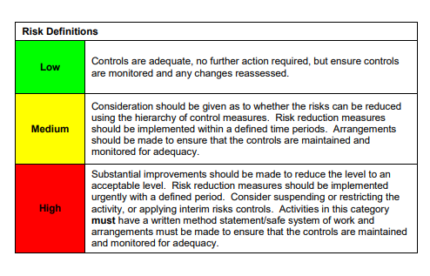

ACKNOWLEDGEMENT OF RISK ASSESSMENT Version:

PLEASE READ THE NOTICE BELOW BEFORE SIGNING THIS FORM
I acknowledge that I have read and understood the Risk Assessment/s associated with this task/event/equipment etc

Forename | Surname | Employee Signature | Date | Manager’s Signature

