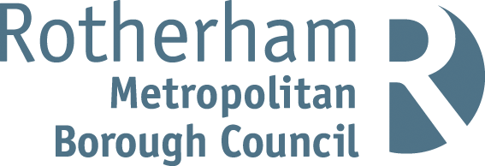

RISK ASSESSMENT FINDINGS

Department/Service
Date
Assessor
Approved By
Review Date

Relevant Legislation:

The Management of Health and Safety at Work Regulations 1999

RISK ASSESSMENT RECORD

ACTIVITY and/or ENVIRONMENT TO BE ASSESSED: Caretaking duties
DATE:

KEY (People at risk) | Likelihood (L) | Severity (S) | Risk Calculation | Risk Rating
E = Employee YP = Young Persons  P = Public  C = Contractors  V = Visitors  EM = Expectant Mothers | 1. Very Low (rare/very unlikely)  2. Low (unlikely)  3. Medium (could occur/possible)  4. High (likely to occur/probable)  5. Very High (near certain to occur) | 1. Insignificant (nuisance/discomfort)  2. Minor (no lost time)  3. Moderate (time loss)  4. Significant (serious/incapacity to work)  5. Major (Death) | Likelihood x Severity  =  Rating | 1- 6 LOW RISK Monitor  - MEDIUM RISK Monitor, review & reduce risk where possible  14-25 HIGH RISK Further Action Required

1.Hazards Identified and potential harm it could cause | 2. People  At Risk | 3.Controls in Place | 4.Risk Rating |  |  |  | 5. Further Action Required/ Recommendations | 6.Target Date for Completion
1.Hazards Identified and potential harm it could cause | 2. People  At Risk | 3.Controls in Place | L | S | Score | Risk | 5. Further Action Required/ Recommendations | 6.Target Date for Completion

Lifting and carrying – back injuries, strains, sprains. | E | - Specific Manual Handling Risk Assessment to be  carried out for all tasks involving lifting, carrying  etc. of loads with identified safe systems of work  implemented  - Appropriate Manual Handling training provided  - Manual Handling equipment provided eg. trolley
Cleaning using equipment – back injuries, strains, sprains | E | - Manual Handling Risk Assessment carried out for use of floor buffers, moving buckets etc.  - Appropriate training provided
Cleaning using chemicals – health effects | E | - Less hazardous chemicals used wherever possible  - Safety data sheets for all substances obtained from supplier and guidance followed  - COSHH Risk Assessments for all hazardous substances in use  - Appropriate Personal Protective Equipment provided and worn where identified in an assessment  - Appropriate safe storage of substances  - Cleaning activities undertaken outside of school  - hours where possible  - Immediate cleaning up of any spillages
Working at Height – falls, falling objects |  | - Specific Risk Assessment carried out for the task  and identified control measures implemented  - Appropriate selection of equipment to access heights e.g. ladders, mobile scaffold, elevating work platform etc.  - Consideration of weather conditions with outdoor work  - Staff appropriately trained for work at height  - Use of barriers to cordon off work at height  - Use of appropriate tools and equipment
Lone working – accidents, delayed assistance in an emergency |  | - Lone working Risk Assessment carried out and identified control measures implemented  - Means of communication available  - Logging procedures for whereabouts  - Lone working procedures including – out of hours  e.g. opening up / locking up  - Procedures in place – key holders, call out, emergency contacts etc.

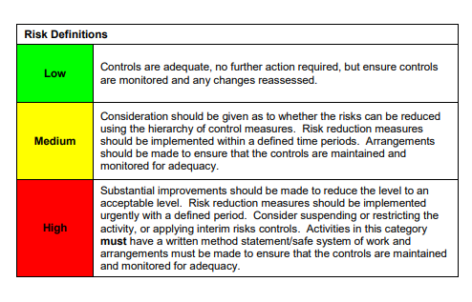

ACKNOWLEDGEMENT OF RISK ASSESSMENT Version:

PLEASE READ THE NOTICE BELOW BEFORE SIGNING THIS FORM
I acknowledge that I have read and understood the Risk Assessment/s associated with this task/event/equipment etc

Forename | Surname | Employee Signature | Date | Manager’s Signature

