

RISK ASSESSMENT FINDINGS

Department/Service
Date
Assessor
Approved By
Review Date

Relevant Legislation:

The Management of Health and Safety at Work Regulations 1999

RISK ASSESSMENT RECORD

ACTIVITY and/or ENVIRONMENT TO BE ASSESSED: Contractors on site
DATE:

KEY (People at risk) | Likelihood (L) | Severity (S) | Risk Calculation | Risk Rating
E = Employee YP = Young Persons  P = Public  C = Contractors  V = Visitors  EM = Expectant Mothers | 1. Very Low (rare/very unlikely)  2. Low (unlikely)  3. Medium (could occur/possible)  4. High (likely to occur/probable)  5. Very High (near certain to occur) | 1. Insignificant (nuisance/discomfort)  2. Minor (no lost time)  3. Moderate (time loss)  4. Significant (serious/incapacity to work)  5. Major (Death) | Likelihood x Severity  =  Rating | 1- 6 LOW RISK Monitor  - MEDIUM RISK Monitor, review & reduce risk where possible  14-25 HIGH RISK Further Action Required

1.Hazards Identified and potential harm it could cause | 2. People  At Risk | 3.Controls in Place | 4.Risk Rating |  |  |  | 5. Further Action Required/ Recommendations | 6.Target Date for Completion
1.Hazards Identified and potential harm it could cause | 2. People  At Risk | 3.Controls in Place | L | S | Score | Risk | 5. Further Action Required/ Recommendations | 6.Target Date for Completion

Hazardous substances – ill health |  | - Contractors to inform Head teacher of any hazardous substances brought onto site  - Contractors to ensure dust production is minimised  - Contractor to follow RMBC management of Asbestos arrangements  - Hazardous substances to be safely stored
Falling objects – injury |  | - Work area to be agreed contractor and Head teacher  - Area below work to be securely fenced off with  warning signs displayed  - Working platforms to be fitted with boards / panels to prevent falling objects
Trailing cables – trips, falls |  | - Avoid wherever possible  - Cable covers to be used
Electrical equipment and sockets – electrocution |  | - Electrical tools to be subject Portable appliance  - testing  - Visual inspections  - Fixed appliance testing
Contact with children – child protection issues |  | - Where possible work to be carried out, outside school hours  - Agreed programme of work  - Work areas to be fenced off to prevent children being in close proximity with contractors and to  prevent injury on site  - Adequate supervision of pupils  - Contractors who are not DBS checked must either be accompanied at all times by a DBS checked member of staff or work outside of school session times on site where they cannot be isolated from contact with pupils or work within a restricted compound to conduct their work in segregation from pupils.
Stored materials – injury, fire |  | - Materials stored on site to be kept to a minimum  - Storage only in agreed designated secure compound
Waste material – health risks, fire |  | - Frequent removal of waste from site to keep to a minimum by a registered waste carrier.  - Waste stored on site to be kept in suitable containers according to the type of waste and in a secure compound

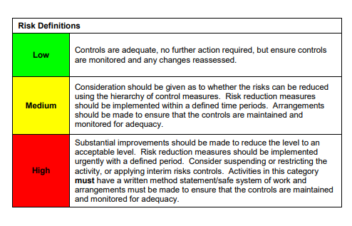

ACKNOWLEDGEMENT OF RISK ASSESSMENT Version:

PLEASE READ THE NOTICE BELOW BEFORE SIGNING THIS FORM
I acknowledge that I have read and understood the Risk Assessment/s associated with this task/event/equipment etc

Forename | Surname | Employee Signature | Date | Manager’s Signature

