

RISK ASSESSMENT FINDINGS

Department/Service
Date
Assessor
Approved By
Review Date

Relevant Legislation:

The Management of Health and Safety at Work Regulations 1999

RISK ASSESSMENT RECORD

ACTIVITY and/or ENVIRONMENT TO BE ASSESSED: Control of Substances Hazardous to Health C.O.S.H.H.
DATE:

KEY (People at risk) | Likelihood (L) | Severity (S) | Risk Calculation | Risk Rating
E = Employee YP = Young Persons  P = Public  C = Contractors  V = Visitors  EM = Expectant Mothers | 1. Very Low (rare/very unlikely)  2. Low (unlikely)  3. Medium (could occur/possible)  4. High (likely to occur/probable)  5. Very High (near certain to occur) | 1. Insignificant (nuisance/discomfort)  2. Minor (no lost time)  3. Moderate (time loss)  4. Significant (serious/incapacity to work)  5. Major (Death) | Likelihood x Severity  =  Rating | 1- 6 LOW RISK Monitor  - MEDIUM RISK Monitor, review & reduce risk where possible  14-25 HIGH RISK Further Action Required

1.Hazards Identified and potential harm it could cause | 2. People  At Risk | 3.Controls in Place | 4.Risk Rating |  |  |  | 5. Further Action Required/ Recommendations | 6.Target Date for Completion
1.Hazards Identified and potential harm it could cause | 2. People  At Risk | 3.Controls in Place | L | S | Score | Risk | 5. Further Action Required/ Recommendations | 6.Target Date for Completion

Name of product: |  | Product: |  |  |  |  | Equipment:  Training / information:
Does it have a warning label on it? |  | Usage:
If the product has a warning label on it - is there a data sheet for the product on the premises? |  | Hazard:
Type of hazard (e.g. irritant, harmful, flammable). |  | - Data sheet location:  - Storage guidelines
What will it be used for? |  | Tasks the product is to be used for:
How is it used safely – refer to data sheet. |  | Mixing guidelines (e.g. 1 part product/10 parts water and procedure):
How is it disposed of after use – refer to data sheet. |  | Disposal guidelines:
Where will the product be stored? |  | Locked container/cabinet
Are there any storage guidelines (e.g. temperature guidelines)? |  | Information / training required:
When will the product be used (e.g. cleaning products in school) |  | - Usage outside of school hours/ other (e.g. specified times to use product)  - Appropriate signage (slippery floor etc.)
Emergency procedures – splashes on skin, spillages, slips etc. – refer to data sheet. |  | First aid (are any further procedures required other than standard first aid arrangements)
Is any personal protective equipment required to use the product safely (e.g. gloves, apron etc.)? |  | Personal protective equipment required:

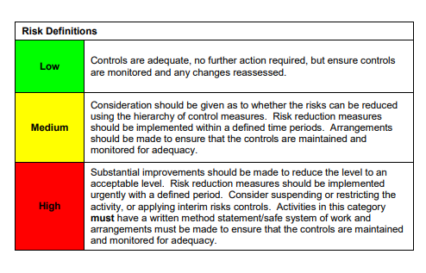

ACKNOWLEDGEMENT OF RISK ASSESSMENT Version:

PLEASE READ THE NOTICE BELOW BEFORE SIGNING THIS FORM
I acknowledge that I have read and understood the Risk Assessment/s associated with this task/event/equipment etc

Forename | Surname | Employee Signature | Date | Manager’s Signature

