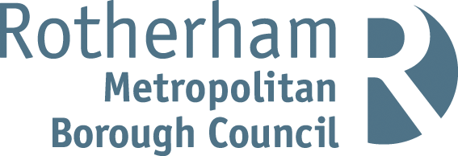

RISK ASSESSMENT FINDINGS

Department/Service
Date
Assessor
Approved By
Review Date

Relevant Legislation:

The Management of Health and Safety at Work Regulations 1999

RISK ASSESSMENT RECORD

ACTIVITY and/or ENVIRONMENT TO BE ASSESSED: Corridors and Stairs
DATE:

KEY (People at risk) | Likelihood (L) | Severity (S) | Risk Calculation | Risk Rating
E = Employee YP = Young Persons  P = Public  C = Contractors  V = Visitors  EM = Expectant Mothers | 1. Very Low (rare/very unlikely)  2. Low (unlikely)  3. Medium (could occur/possible)  4. High (likely to occur/probable)  5. Very High (near certain to occur) | 1. Insignificant (nuisance/discomfort)  2. Minor (no lost time)  3. Moderate (time loss)  4. Significant (serious/incapacity to work)  5. Major (Death) | Likelihood x Severity  =  Rating | 1- 6 LOW RISK Monitor  - MEDIUM RISK Monitor, review & reduce risk where possible  14-25 HIGH RISK Further Action Required

1.Hazards Identified and potential harm it could cause | 2. People  At Risk | 3.Controls in Place | 4.Risk Rating |  |  |  | 5. Further Action Required/ Recommendations | 6.Target Date for Completion
1.Hazards Identified and potential harm it could cause | 2. People  At Risk | 3.Controls in Place | L | S | Score | Risk | 5. Further Action Required/ Recommendations | 6.Target Date for Completion

Defective flooring – slips, trips and falls |  | - Inspection of flooring  - Prompt maintenance/repair of defects
Items stored in corridors – trips, falls, fire risk, obstructed escape |  | - Good housekeeping procedures  - Regular inspection  - Ensure bags, coats and other items are not blocking corridors  - Identify designated storage areas
Liquid spillages – slips, falls |  | - Reporting procedure for spillages with prompt action to clean up  - Safe cleaning procedures including: Precautions for cleaning up bodily fluids.  Referral to data sheets for hazardous substances
Trailing electrical cables – trips, falls |  | - Avoid use of extension cables  - Ensure sufficient sockets  - Use of cable covers where necessary
Electrical equipment & sockets – electrocution |  | - Portable appliance testing and regular visual inspection  - Fixed installation testing  - Not to be located on designated escape routes
Defective fire doors |  | - Fire doors to be fitted with self-closure devices  - Fire doors must not be propped open unless by magnetic holders with release linked to fire detection system  - Regular inspection
Hot radiators / heaters |  | Low surface temperature radiators / appropriate cover guards where pupils are present
Open or broken windows – falls, cuts injury |  | - Opening limiters fitted to windows above ground level  - Selection of appropriate glazing in doors and door panels with consideration given to location and height of glazing, traffic volumes etc.

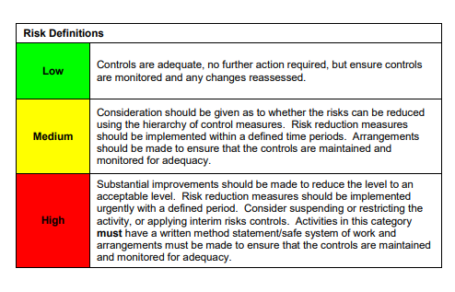

ACKNOWLEDGEMENT OF RISK ASSESSMENT Version:

PLEASE READ THE NOTICE BELOW BEFORE SIGNING THIS FORM
I acknowledge that I have read and understood the Risk Assessment/s associated with this task/event/equipment etc

Forename | Surname | Employee Signature | Date | Manager’s Signature

