

RISK ASSESSMENT FINDINGS

Department/Service
Date
Assessor
Approved By
Review Date

Relevant Legislation:

RISK ASSESSMENT RECORD

ACTIVITY and/or ENVIRONMENT TO BE ASSESSED: Diabetes
DATE:

KEY (People at risk) | Likelihood (L) | Severity (S) | Risk Calculation | Risk Rating
E = Employee YP = Young Persons  P = Public  C = Contractors  V = Visitors  EM = Expectant Mothers | 1. Very Low (rare/very unlikely)  2. Low (unlikely)  3. Medium (could occur/possible)  4. High (likely to occur/probable)  5. Very High (near certain to occur) | 1. Insignificant (nuisance/discomfort)  2. Minor (no lost time)  3. Moderate (time loss)  4. Significant (serious/incapacity to work)  5. Major (Death) | Likelihood x Severity  =  Rating | 1- 6 LOW RISK Monitor  - MEDIUM RISK Monitor, review & reduce risk where possible  14-25 HIGH RISK Further Action Required

1.Hazards Identified and potential harm it could cause | 2. People  At Risk | 3.Controls in Place | 4.Risk Rating |  |  |  | 5. Further Action Required/ Recommendations | 6.Target Date for Completion
1.Hazards Identified and potential harm it could cause | 2. People  At Risk | 3.Controls in Place | L | S | Score | Risk | 5. Further Action Required/ Recommendations | 6.Target Date for Completion

Person suffers a Hypo attack during work time/school day.  As blood sugar levels drop normal senses become impaired.  May appear confused, aggressive, disorientated,  (Often described as appearing drunk).  Skin becomes paler and sweaty. |  | - School staff trained in first aid e.g. First Aid at Work, Emergency First Aid, Pediatric First Aid.  - Discussion with the staff member / pupils parents to find out the best way to manage a Hypo attack. Ensure a care plan is established and relevant staff training provided to implement the treatment / action.  - Develop an Emergency procedure with the staff member / pupil highlighting what to do, when to contact a relative and when to dial 999 for an ambulance.  - Ensure first aiders are aware of procedures agreed.  - Ensure confidentiality is maintained.  - If the staff member/pupil is having regular attacks advise them to consult their GP. |  |  |  |  | - Are there any reasonable adjustments required to the person’s role (Equality Act 2010) to manage the illness e.g. time out for injection/ medications etc.?  - Are there any additional training needs for first aid staff e.g. medication training etc.  - Agreed Emergency Procedure:
The person may eventually lose consciousness. |  | Emergency communication arrangements e.g. in a large building ‘walkie-talkies’/panic alarm etc. may be necessary to raise the alarm.
Storage of Medication |  | Ensure a locked cabinet/ cupboard is available for the staff member/pupil if they are required to have prescribed medication at school e.g. insulin injections, tablets etc.

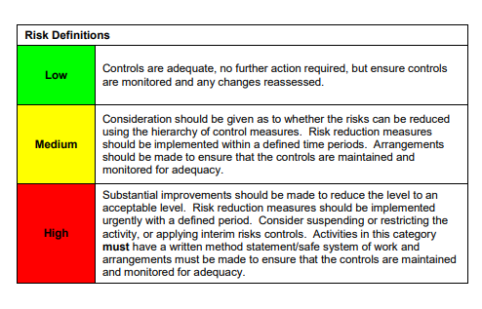

ACKNOWLEDGEMENT OF RISK ASSESSMENT Version:

PLEASE READ THE NOTICE BELOW BEFORE SIGNING THIS FORM
I acknowledge that I have read and understood the Risk Assessment/s associated with this task/event/equipment etc

Forename | Surname | Employee Signature | Date | Manager’s Signature

